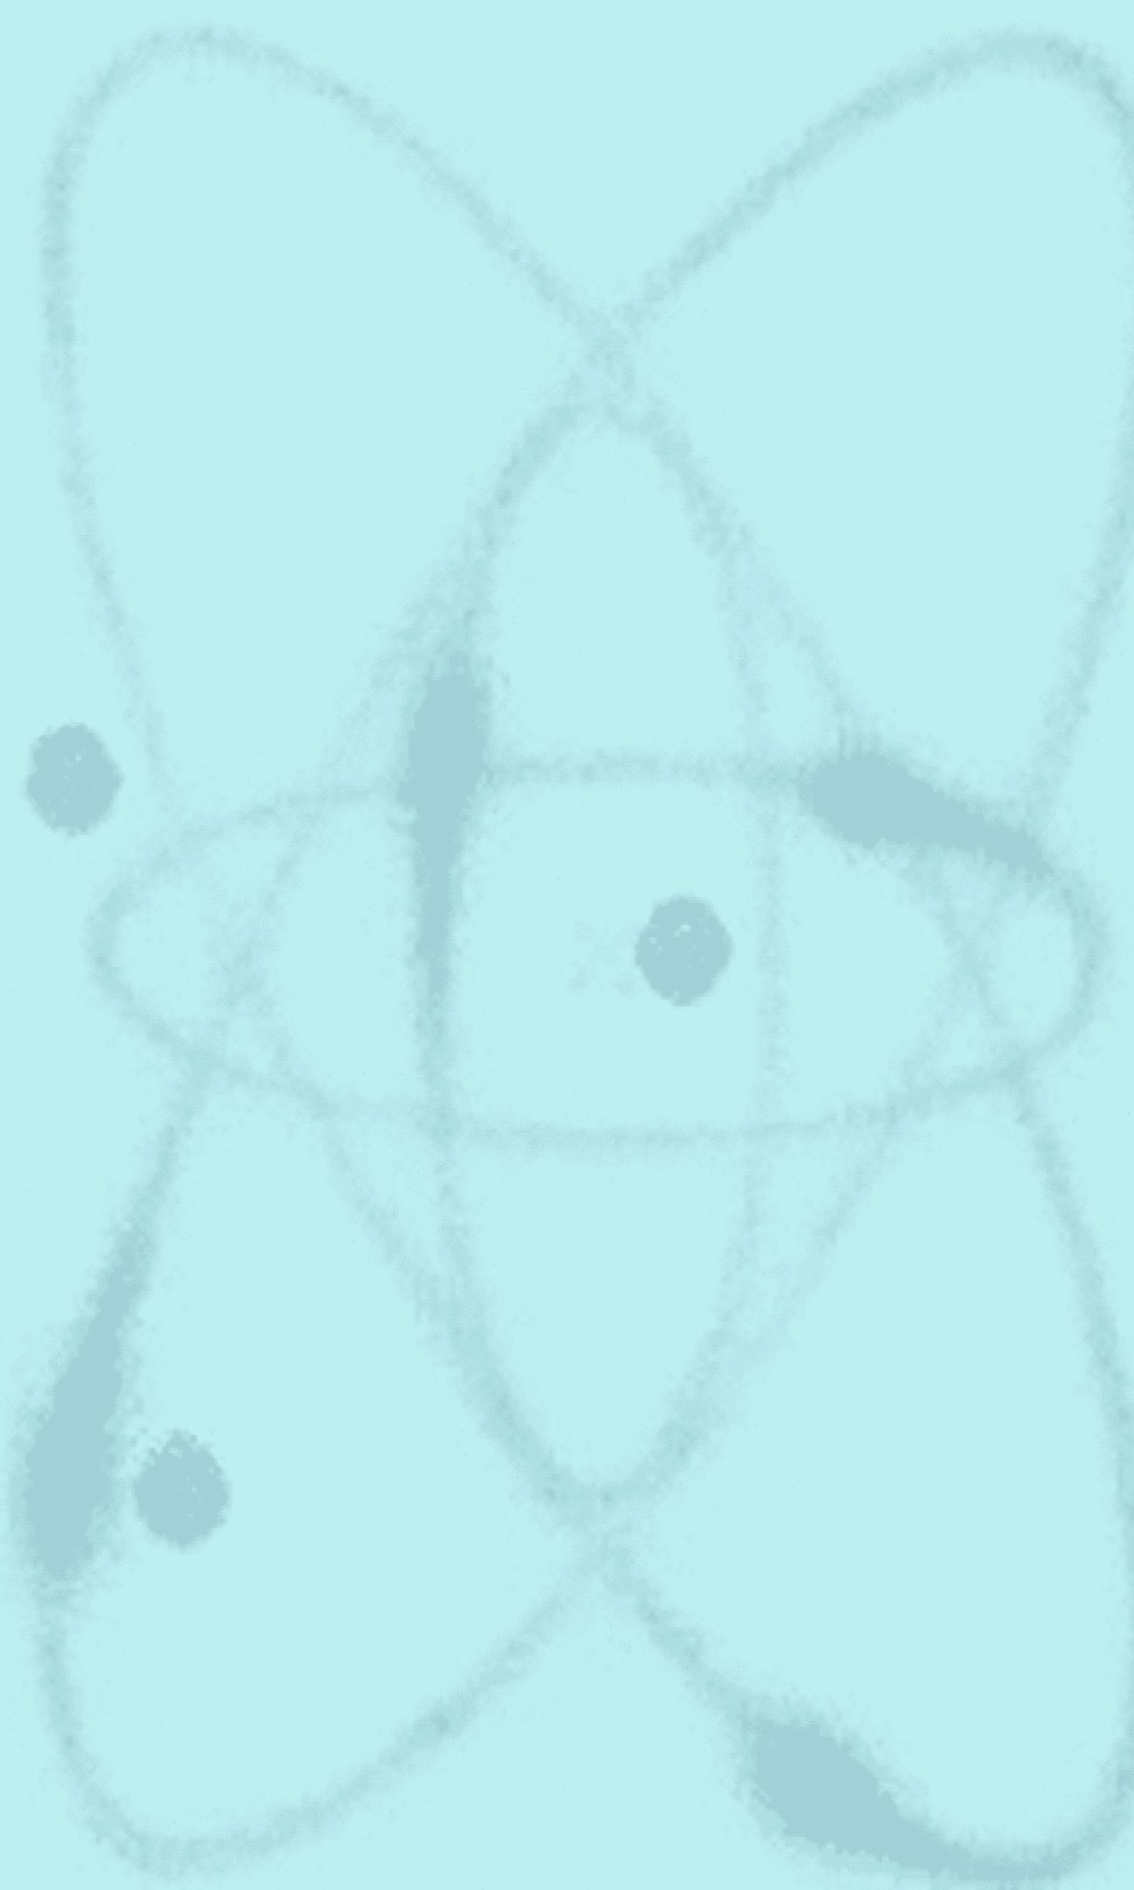
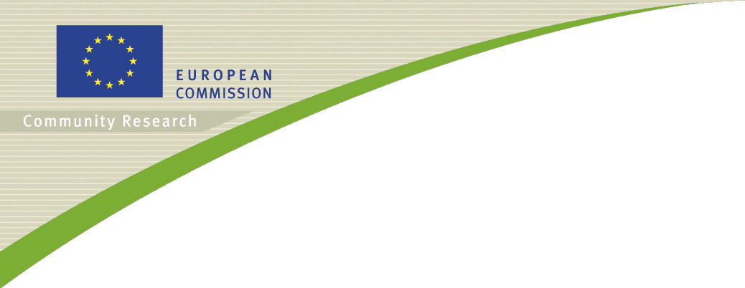
Conference on
FISA 2006
EU Research and Training in Reactor Systems
13-16 March 2006
Luxembourg
Organised by the European Commission

Context

The year 2010 is the deadline proposed for a number of important EU policies. The Lisbon strategy was launched in March 2000 (“the EU aims to become the most competitive knowledge-based economy by 2010”) with its corollary the European Research Area, an innovative global approach to restructure European research, development and training. The Commission Green Paper of November 2000 Towards a European Strategy for the security of Energy supply until the year 2010 recommended to keep the nuclear option open in a mix of commercial energy sources. In addition, in some European countries, there is a serious concern about the decreasing level of nuclear competences.

As a result, Euratom research, in particular, has been reshaped so as to better serve the end-user needs. Besides the production of scientific knowledge in Community research, special attention is put on exploitation of this knowledge by the main stakeholders. Special attention is also put on the dissemination of this knowledge. For example, nuclear education and training activities are networked throughout Europe with the aim to optimise resources and exchange of both instructors and students.

The European Union plays its role in the international research and development effort to modernise current reactors ranging from the former Soviet to the most advanced Western designs, and to evaluate the potential of the main concepts proposed for the next generation of reactors (the so-called Generation III+ at horizon 2010 and Generation IV at horizon 2030).

The scope of the present FISA 2006 conference is quite broad: Besides political/industrial discussions about the challenges of the year 2010, it will encompass European research in nuclear plant life management for existing reactors, severe accident management, assessment of future nuclear fission systems, partitioning and transmutation systems, and nuclear education and training.

Conference programme

An average of 300 participants attended the previous FISA conferences, organised in Luxembourg biannually since 1995. The proceedings of the last FISA conference (Luxembourg, 10-13 November 2003) are available on http://www.cordis.lu/fp5-euratom/src/ev-fisa2003.htm.

The present conference, FISA 2006, will be a good opportunity to share the preliminary results of the 6th Euratom Framework Programme (FP-6) projects related to the above areas and to discuss relevant education and training activities. A short report will be given about the status of the Community discussions related to the 7th Euratom Framework Programme for research and training (2007-2011). A number of plenary invited lectures will also be presented in connection with political, economic, scientific, and technical issues of common interest for the nuclear fission and radiation protection community.

The lectures are intended to be addressed to a wide audience of nuclear scientists and decision makers. All stakeholders of the European nuclear fission arena are expected to be represented, in particular research organisations (both public and private), academia, industry (both manufacturers and utilities), regulators as well as decision makers.

As a result, new ideas are expected to be proposed and new initiatives may be launched. This will strengthen the networking across the EU-25 countries interested in nuclear fission and radiation protection, thereby contributing to the success of Euratom FP-6.

Conference structure

13-15 March 2006 (no parallel sessions):

- introductory invited lectures of broad interest (half of the first day)
- plenary sessions devoted to:
  - Safety of Existing Installations (covering materials research, severe accident management, emergency management, advanced numerical models etc.)
  - Innovative Concepts (covering electricity and process heat cogeneration and various Generation IV reactor systems)
  - Partitioning and Transmutation (including actinide science, impact of P&T on waste management)
  - Nuclear Education and Training
- invited technical overview lectures, panel discussion, and conclusion (the last day).

16 March 2006:

Like at previous FISA conferences, a series of one-day post-FISA workshops will be organised. They will address EU nuclear fission research in specific domains. A number of networking initiatives will also be discussed with the aim to prepare future collaborative projects.

Posters will be presented throughout the duration of the conference with emphasis on bridging initiatives (e.g. projects across barriers) and on research conducted by young nuclear scientists.

A selection of the best FISA 2006 papers will be published in a special topical issue of the scientific journal Nuclear Engineering and Design.

The complete agenda of the FISA 2006 conference and of the post-FISA workshops will soon be available on this site.

There are no registration fees.

For further information, please contact marianne.antoine@cec.eu.int, European Commission, DG RTD J.4, Building CDMA 1/66, B-1049 Brussels (tel. +32 (0)2 298 67 74, fax +32 (0)2 295 49 91).

