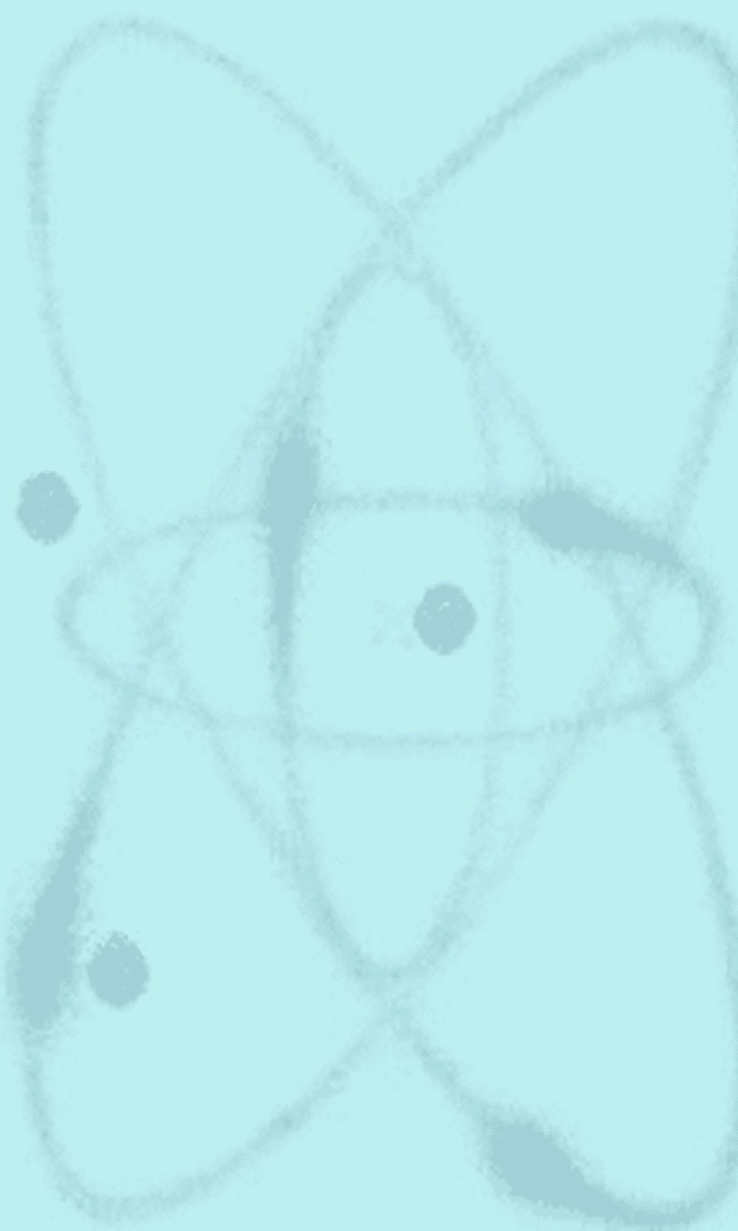
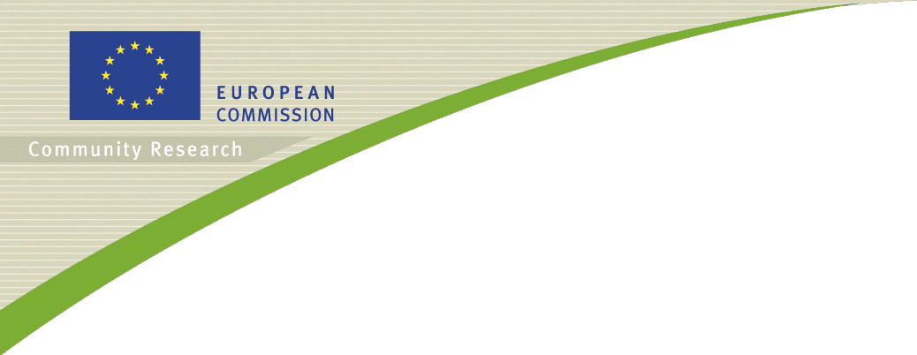

FISA 2006
Conference on
EU Research and Training in Reactor Systems
13-16 March 2006
Luxembourg
Organised by the European Commission

Preliminary Agenda

Monday 13 March 2006
Morning session (9:30-12:30): Introduction

Community research, education and innovation in nuclear fission: lessons learnt from the 6th framework programme and future prospects (by the European Commission)

A European utility opinion about a long term nuclear strategy — need for an objective, consistent, and predictable environment (by utilities)

A regulatory opinion about the impact of the European Research Area — consequences for plant operation and maintenance of competences (by regulators)

Next generation (GEN IV) nuclear energy systems and fuel cycles — an industrial view of the role of European Commission co-sponsored research (by vendors)

International programmes in nuclear fission research and training — common needs, shared vision, and practical implementation instruments (by international organisations)

Challenges left in the achievement of the Lisbon 2010 strategy — funding and networking of large RTD infrastructures of common interest (by the European Investment Bank)
Afternoon session (14:00-17:30): Safety of Existing Installations

Invited lecture Meeting Europe's energy needs through new NPP construction — public versus private research in the international collaboration

COVERS VVER Safety Research

PERFECT Prediction of Irradiation Damage Effects on Reactor Components

NURESIM European Platform for Nuclear Reactor Simulation
SARNET Network of Excellence for a Sustainable Integration of European Research on Severe Accident Phenomenology

EURANOS European Approach to Nuclear and Radiological Emergency Management and Rehabilitation Strategies

Tuesday 14 March 2006
Morning session (9:00-12:30): Innovative Reactor Concepts

Invited lecture 1 Engineering and training challenges of evolutionary Generation III reactors — impact of international research on competitiveness and enhanced safety

Invited lecture 2 Integration of international research in innovative Generation IV systems — impact of international research on nuclear sustainability and cogeneration

RAPHAEL Reactor for Process Heat, Hydrogen, and Electricity Generation (VHTR FP-6 Project)
GCFR Gas Cooled Fast Reactor (FP-6 Project)

SFR Sodium Fast Reactor

LFR Lead Fast Reactor

MSR Molten Salt Reactor

SCWR Super Critical Water Reactor
Afternoon session (14:00-17:30): Partitioning and Transmutation

Invited lecture 1 An integrated approach to partitioning research — challenges left on the way to industrial applications

Invited lecture 2 An integrated approach to transmutation research — challenges left on the way to industrial applications

ACTINET Network for Actinide Sciences

EUROPART European Research Program for Partitioning of Minor Actinides and some Long-Lived Fission Products from High Active Wastes Issuing from the Reprocessing of Spent Nuclear Fuels

EUROTRANS European Research Programme for the Transmutation of High Level Nuclear Waste in an Accelerator Driven System

RED IMPACT Impact of Partitioning, Transmutation, and Waste Reduction Technologies on the Final Nuclear Waste Disposal

Wednesday 15 March 2006
Morning session (9:00-12:30): Education and Training — Infrastructures

Invited lecture 1 Role of international programmes in knowledge transfer, education, and training — synergies with national programmes and impact on recruitment of new staff

NEPTUNO Nuclear European Platform of Training and University Organisations

CETRAD Coordination Action on Education and Training in Radiation Protection and Radioactive Waste Management

ENETRAP European Network on Education and Training in Radiological Protection

Invited lecture 2 Renewal of large nuclear infrastructures for materials research and training — integration of national programmes and impact on future European RTD

JHR Jules Horowitz Reactor Coordination Action

HOTLAB European Network on Hot Laboratories

NUDAME Neutron Data Measurements at IRMM
Afternoon session (14:00-16:00): Conclusion

ENFTP Towards a European Nuclear Fission Technology Platform

Invited lecture Challenges of current and future Euratom research and training in nuclear fission (by FISA reviewers and the European Commission)

Thursday 16 March 2006
Post-FISA workshops:

1 Very High Temperature Reactors and Materials, and Hydrogen Production

2 Commonalities between Fusion and Fission Research (achievements and prospects)

3 Education and Training Focusing on Generation III and IV Reactor Systems

4 Numerical Simulation as Support to Decision Making in Research and Industry

5 Selected Topics and Main Achievements in Collaborative Research with Non-EU Countries

6 Clustering of Partitioning and Transmutation Activities

7 Identification of Nuclear Expertise in Europe and Sharing of Existing Research Programmes and Large Test Facilities

