Gevaert Fleur 2001 - 2002

Maîtrise de physique

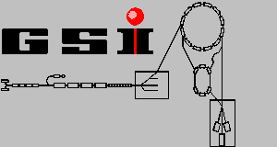

REPORT ON THE EFFICIENCY OF THE ISOLDE FACILITY

UNIVERSITE BORDEAUX I GSI LABORATORY
France DARMSTADT germany
CONTENTS:

• French summary | 1
• Introduction | 2
• Properties of ISOLDE | 3
• A closer look at processes in the ISOLDE target | 5
• GSI experiment in inverse kinematics | 6
• Comparison of extracted ISOLDE yields with calculated primary YIELDS | 7
• RESULTS | 8
• Conclusion | 14
• References | 15

RÉSUMÉ :

La méthode ISOL est aujourd’hui utilisée pour la création de faisceaux nucléaires d’isotopes purs et intenses. Actuellement, les laboratoires tels que le GSI et le CERN et d’autres en Amérique et au Japon utilisent cette méthode. En effet ISOL est un procédé employé pour l’extraction des nuclides créés grâce à des réactions nucléaires dans une cible épaisse. Ainsi, au CERN, la spallation induite par des protons de haute énergie est le mécanisme de base de ces réactions, alors qu’au GSI c’est plutôt la fusion de deux noyaux lourds. D’autres installations du GSI permettent d’induire la spallation avec l’utilisation d’un faisceau d’ions lourds et une cible d’hydrogène, suivant le même principe réactionnel que pour ISOLDE mais dans une cinématique inverse.

En effet, pour ISOLDE, installée au CERN, le principe est le suivant: Un faisceau de protons bombarde une cible de noyaux lourds. Des nuclides sont créés par fragmentation ou par fission (cela dépend de la cible utilisée). Puis, la cible est chauffée afin de récupérer les produits de réaction par diffusion. Ces derniers sont ensuite ionisés et dirigés vers un séparateur de masse. Une caractéristique essentielle de la méthode ISOL est une variation importante du rendement disponible en fonction de l'élément extrait. Cela peut être un inconvénient ou un avantage suivant le type de nuclide désiré. Un autre problème est que le temps d’extraction est parfois trop lent devant la période des éléments. La désintégration ß peut changer la nature du noyau produit. De plus, d’autres réactions peuvent alors avoir lieu tel que la capture de neutrons produits dans l'interaction du proton primaire avec un noyau de la cible. Ainsi, on peut considérer que l’efficacité d’extraction des nuclides dépend, entre autre, de trois points :
- Le type de matériau utilisé pour la cible ; en effet les propriétés chimiques et la densité de celui-ci peuvent affecter par exemple l’extraction des éléments.
- Les propriétés chimiques du produit et son temps de demi-vie.
- Les réactions secondaires comme cause d’une production supplémentaire.
- L’émission de ß qui peut influencer les rendements d’isotopes, en les diminuant ou en l’augmentant suivant si ceux-ci sont proches ou loin de la vallée de la stabilité.

Les installations expérimentales du GSI permettent d’éviter cet inconvénient. En effet le procédé utilisé est basé sur une cinématique inverse, qui fait que les produits sont identifiés au bout de 100 ns. Ici, un faisceau énergétique d’ions lourd vient bombarder une cible mince de protons (hydrogène liquide). Les produits de la réaction sont focalisés dans un cône étroit dans la direction du faisceau, puis analysés par un spectromètre qui détermine la section efficace de la réaction.

De par ces mesures, des calculs théoriques de la production d’isotopes ont été effectués, afin d’être comparés à ceux fournis par ISOLDE. A l’échelle européenne, ce travail permet une meilleure connaissance en vue d’un projet international nommé EURISOL.

Mon travail, durant ce stage, a consisté à comparer les rendements fournis par ISOLDE avec les taux de production, calculés à partir des sections efficaces expérimentales du GSI, et de regarder l’influence que peut avoir l’élément et le temps de demi-vie sur la production de nuclides par la méthode ISOL.
INTRODUCTION:

The ISOL (Isotope Separator On-Line) method is used for creating of nuclear beams of rare, mostly radioactive isotopes. This method is applied for example at GSI and CERN. Beside some differences, the extraction and separation processes of the produced nuclei are the same at both facilities. Within the scope of the EURISOL project the possibilities for building a European secondary-beam facility based on the ISOL method are studied. Part of the tasks defined in the project are the predictions of the production yields in a future ISOL facility, based on measured reaction data and theoretical reaction and transport calculations.

In the present work, a comparison between the measured and expected production yields of different isotopes produced at the ISOLDE facility at CERN is made. The results are based on the following sources of information:
• Previous results on production yields at ISOLDE
• Recent experimental results on cross sections from GSI
• Calculations of production yields based on theoretical predictions of reaction cross sections

At CERN a large variety of isotopes partially with extremely low production cross sections are produced. However, the detection of the products is not as quick as in the experiments at GSI that use the inverse-kinematics technique. The production yields at ISOLDE also depend strongly on the chemical properties of the produced isotopes but also on their radioactive-decay properties. The selectivity of the ionisation sources is also a major factor determining the final release.
With the well-known relation between the production yield and the production cross-sections of a certain isotope we can access to two types of information:
- Based on the known target composition and thickness combined with the beam intensities we can estimate the primary production of a certain isotope in the ISOLDE production target.
- If we compare the measured ISOLDE yields with the calculated production from the previous step using the predicted cross sections, we can deduce information about the amount of the successfully extracted isotopes.

First I will describe the ISOLDE facility and the GSI experiments. Secondly, I will show the results of the comparison between the two methods, in order to determine the influences of the secondary production on the ISOL method.

PROPERTIES OF ISOLDE:

At the recently operated ISOLDE facility at CERN a 600 MeV proton beam impinged on a set of different thick targets. (In the last time also higher energies have been used.) The composition of the targets was chosen in order to optimize the production yields of the isotopes of interest. The reactions occurring in the ISOLDE production targets can be subdivided in two groups:
• Proton-induced fragmentation reactions
• Proton-induced fission reactions

In the proton-induced fragmentation reaction few nucleons from the target nucleus are abraded by the high-energy proton (abrasion step). Since the produced pre-fragment is highly excited, the abrasion is followed by the evaporation of protons, neutrons or clusters like alpha particles, this process is also called ablation. The further de-excitation is followed by the emission of gamma rays. In the proton-induced fragmentation of non-fissile stable nuclei a large variety of mainly neutron-deficient radioactive isotopes of different masses are produced.

In the proton-induced fission, the highly excited pre-fragment has energy enough to overcome the fission barrier. After fission, two heavy fragments are produced. In the case of high-energy fission, the symmetric split of the pre-fragment is the most probable. However, the distribution of the products covers a large part of the nuclide chart and is extended down to very light elements as Na, Ne [1]. The proton-induced fission of heavy fissile isotopes as ²³⁸U, ²³²Th is a powerful tool which gives also access to very neutron-rich isotopes, which cannot be produced in any other kind of reaction. [2]

After production, the residues are collected after their diffusion from the target. In the next step, the isotopes are ionised in order to provide their separation by use of the standard mass-spectrometry techniques. Depending on the element which has to be extracted, different ionization sources are used:
• The surface ion source for most atoms produced in the target (maximum at 2400°C)
• The plasma ion source for ionizing elements that cannot be surface ionized.
• The laser ion source for the elements that cannot be ionized efficiently by the methods quoted above.

The choice of the ion source depends on the type of target used. For example, if carbides are to be used in combination with a plasma ion source, the transfer line between target and ion source should be cooled in order to preserve a high ion-source efficiency which otherwise may be destroyed by the material out gazing from the large target. Positive surface ionisers are less sensitive to this kind of impurities. [3]

After the ionisation, the particles are accelerated in an electrostatic field and are separated using a mass separator. Using the selectivity of the ion source and the mass separator, isotopes of a certain element are extracted and can be used for creating exotic beam, as shown in fig.1. [4, 5]

Diffusion of the products
Proton beam

Mass separator

Target
Ion source

Fig.1: Scheme of the ISOLDE facility.

During the multi-step extraction process, a part of the primary products can be lost due to radioactive decays, since the diffusion and the ionisation are separated in time and do not occur immediately after the reaction. If the half-life is too short, the extracted amount can be reduced for example by fast ß decays. As a consequence, the production is changed. The type of target could also affect the extraction. That is why different kind of targets have been elaborated; powder metal, carbides, thin foils, and liquid-metal targets. Low-density targets provide higher yields for the isotopes that have a short half-life, because the diffusion process is much faster. A disadvantage of low-density targets is the lower primary production rate per target volume. On the other hand, dense targets are better suited for the production of long-living isotopes, since the extracted amount is less affected by the slow diffusion process. Furthermore, to provide a faster diffusion of the residues, the temperature of the target must remain high as long as possible and the target must be kept stable. The latter represents a special technical challenge, and often composite targets like carbides are used to provide the thermal stability up to high temperatures. Therefore, the choice of the target material is done in order to optimize the yield. [6, 7]

As a summary, the extraction efficiency depends on three points:
• The type of target that we use can affect the extracted yield (geometry, chemistry).
• The extracted amount depends on the chemical properties of the isotope and its half-life.
• The ß decay from precursors that have stronger influence if the isotopes of interest are closer to the stability line.
These facts can help us to understand what is the difference between the yields calculated from detection and the intrinsic yields. In addition, secondary reactions induced by high-energy protons and neutrons emerging from the abrasion stage of primary reactions may contribute to the nuclide production in the target. Since the secondary particles have lower energies than the primary projectiles, the distribution of secondary reaction products on the chart of the nuclides differs considerably from the primary production.

A CLOSER LOOK AT PROCESSES IN THE ISOLDE TARGET:

These are examples of what is happening in the processes of the ISOLDE target in order to understand better what are the parameters that could be adjusted to have higher nuclide yields. For example, we consider a 600 MeV proton beam, and we look for the energy and the intensity lost progressively when the beam enters the target. Examples are considered for a liquid target (lanthanum) and a metal target (tantalum). The calculations of the energy loss have been made with the help of a program called AMADEUS [8] using the Bethe-Bloch-theory of the electron part of energy loss of charged particles in dense media. For the intensity loss we use the following formula:
$P\left(d_{\text{tg}}\right)=\text{exp}\left(\frac{−d_{\text{tg}}\text{.}σ_{\text{tot}}\text{.}N_{a}}{A_{\text{tg}}}\right)$
(1)

d_{tg} : Target thickness passed by the beam (g/cm²)
σ_{tg} : The total interaction cross section (cm²)
A_{tg} : Atomic mass of the target material
N_{a} : Number of Avogadro

As shown on fig.2, in both cases, at the exit of the target, the beam has lost half of its intensity and one third of its energy.

a)

Fig.2: Energy and Intensity loss of a proton beam:
- La target
- Ta target

b)
An explicit consideration of the nuclide production due to secondary processes is beyond the scope of this report.

GSI EXPERIMENT IN INVERSE KINEMATICS:

At GSI, the proton-induced spallation and fission reactions are investigated in inverse kinematics: as represented on fig.3, a high-energy heavy-ion beam is impinging on the protons. In these experiments, a liquid-hydrogen target is used. The reaction mechanism is the same as for the cases of experiments made in direct kinematics used at ISOLDE. The major advantage of the experiments made in inverse kinematics is that the reaction products are identified after about 100ns after the reaction in the target. The measured yields do not depend on unobservable intermediate steps, so they give a direct measure of the production cross sections. Since the reaction products are focused in a narrow cone in the beam direction, they are analyzed by the use of the FRS magnetic spectrometer, which provides their identification in nuclear charge and mass. The high resolution of the FRS allows also the measurement of the velocities of reaction products, once they are identified in mass and charge. Based on the knowledge of the velocities of the products, the reaction mechanism of their production, fission or fragmentation, can be identified. Experiments on reactions as (⁵⁶Fe,p), (¹⁹⁷Au,p) [9, 10], (²³⁸U,p), (²⁰⁸Pb,p) [11] at different beam energies up to 1 GeV per nucleon have been performed. Investigations on electromagnetic-induced fission of ²³⁸U using the (²³⁸U,²⁰⁸Pb) [12] system have also been made. The electromagnetic-induced fission of ²³⁸U, induced by electrons, is also discussed as a possible option for the production of intense beams of neutron-rich isotopes in a future ISOL facility.
Heavy Ion beam
H2 target
FRS Spectrometer

Fig.3: Scheme of the experiments in inverse kinematics at GSI.

Simulations have been made. For example, the figure 4 represents the production cross sections for a 600 A MeV heavy-ion beam of uranium, impinging on a liquid hydrogen target.
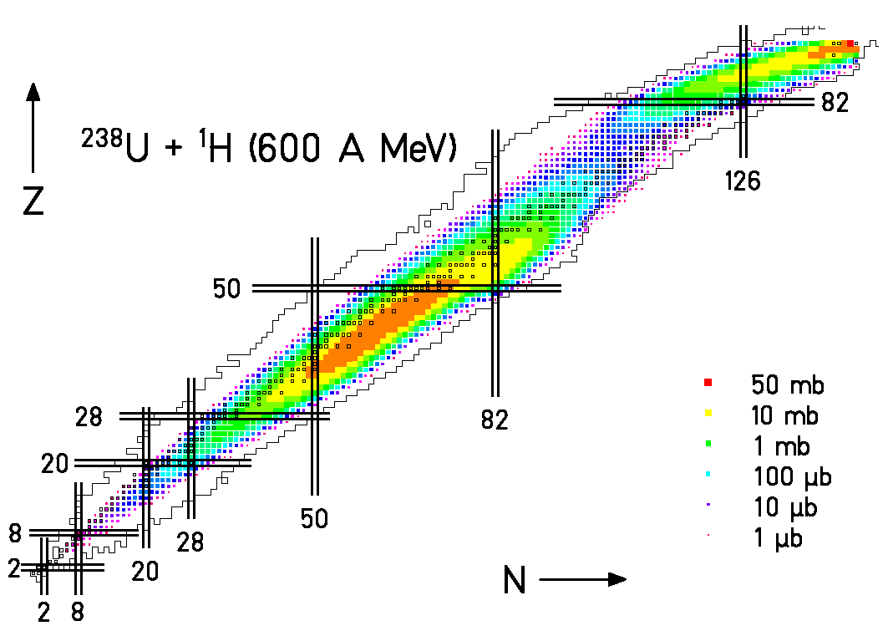

Fig.4: Calculated production cross sections for the reaction U238 + p, 600 MeV

Comparison of extracted ISOLDE yields with calculated primary YIELDS:

For each element, we can access the ISOLDE yields for different kind of targets [4, 5]. I chose those with the best statistics. The elements can be obtained by fragmentation or fission, depending on the target that we use. Thus, the cross section will be different and so the production yields too. So, for each specific isotope that will be produced, different targets are selected using the same ion source. By this way, it is possible to see more precisely how strong the half-life influences the release to production ratio (RPR). So, I have plotted four graphs for each isotope:
- The first represents the ISOLDE yields [4, 5] as a function of the neutron number.
- The second shows the cross section as a function of the neutron number.
- The third gives the release-to-primary production ratio (RPR). In fact, it is calculated by dividing the measured ISOLDE yields by the calculated primary production rate, based on the GSI cross-section data, see equation (2), (3), (4).
- The last shows the half-life of the isotope of a certain element. (We attribute a half-life of 10000 seconds to stable isotopes in the figure.)
Different programs are used: KAROL [13] in order to evaluate the total cross section in each target and ABRABLA [8] to calculate the reaction cross-section.
Let us assume that in a reaction the isotope i, with a production cross-section $σ_{i}$, is produced and that the target has a thickness d_{tg}. Then the probability for the production of this isotope if one beam particle is impinging on the target is given by the integral:

$$P(σ_{i})=\int_{0}^{\text{xm}}{\frac{ρ_{\text{tg}}\text{.}\text{dx}\text{.}σ_{i}\text{.}N_{a}}{A_{\text{tg}}}}\text{*exp}(\frac{−ρ_{\text{tg}}\text{.}x\text{.}σ_{\text{tot}}\text{.}N_{a}}{A_{\text{tg}}})=\frac{σ_{i}}{σ_{\text{tot}}}(1−\text{exp}(\frac{−d_{\text{tg}}\text{.}σ_{\text{tot}}\text{.}N_{a}}{A_{\text{tg}}}))$$
(2)

ρ_{tg} : Target density
d_{tg} : Target thickness
A_{tg} : Atomic mass of the target material
N_{a} : Number of Avogadro
σ_{tot} : Total cross section
σ_{I} : Production cross section

If the primary-beam intensity is known and denoted as $I_{\text{beam}}$ (particles/sec), than the expected yield $Y_{i}^{\text{exp}}$is:

$$Y_{i}^{\text{exp}}=I_{\text{beam}}∗P(σ_{i})$$
(3)

In our case, the release-to-production ratio (RPR) is calculated as:

$$\text{RPR}=\frac{Y_{i}^{\text{ISOLDE}}}{Y_{i}^{\text{exp}}}$$
(4)

The $Y_{i}^{\text{ISOLDE}}$and $Y_{i}^{\text{exp}}$are normalised to 1μA (about 6,25.10¹² part/sec) of the beam intensity. Furthermore, when a target is made with the composition of two materials, the cross section are added with a coefficient, $n_{C,O}$, which refers to the number of atoms in the molecule. Here, for the carbides and the oxides the total cross section becomes:

$$σ_{\text{tot}}^{\text{eff}}=σ_{\text{tot}}^{U,\text{Th}}+n_{C,O}∗σ_{\text{tot}}^{C,O}$$
(5)

Results:

In the following chapter, the results of the analysis of selected elements and their isotopes produced at the ISOLDE facility are shown. I made also a comparison between different targets and reactions used for the production.
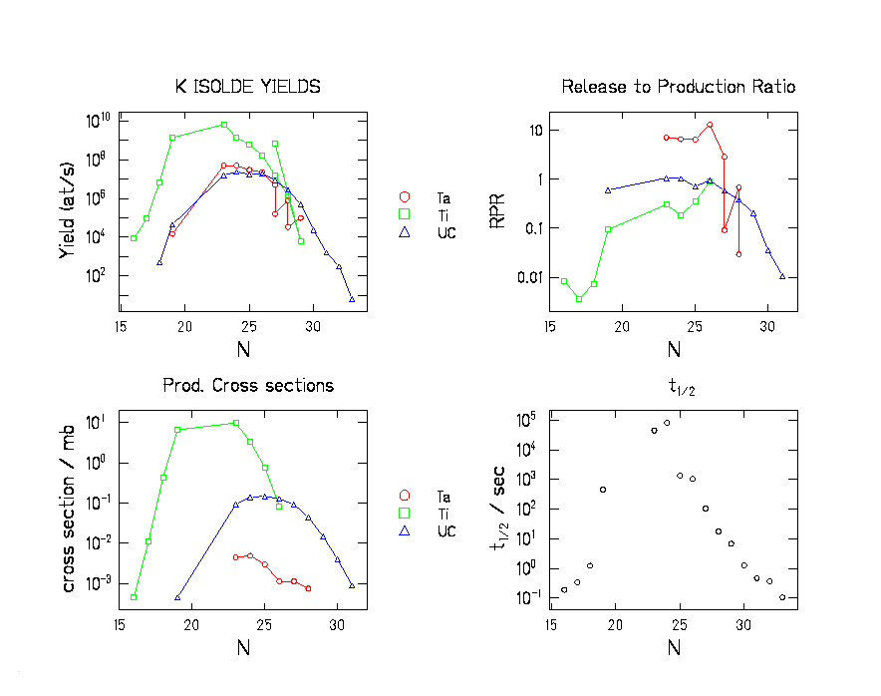
Fig.5: Results for K (Z=19) produced with Ta(red symbols), Ti(green symbols) and UC(blue symbols) targets
The element created is potassium with three different targets using a proton beam: a metal foil of tantalum (Ta; 122g/cm²), a metal foil of titanium (Ti; 40g/cm²) and a uranium carbide (UC; 13g/cm²), with a tungsten surface as ion source. We can see on fig.5 that the RPR increases, reaches a maximum and finally decreases, as the half-life also does.
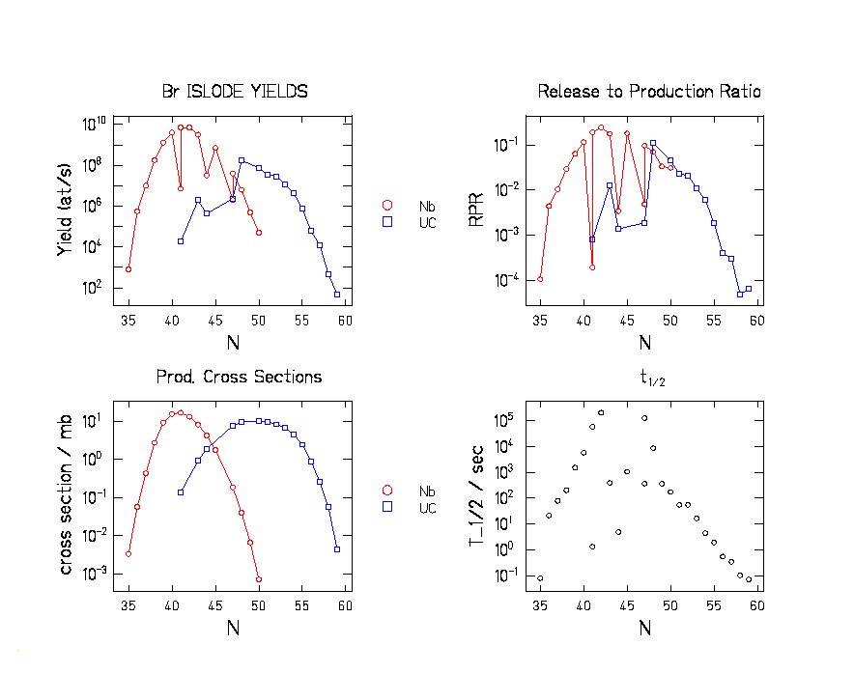
Fig.6: Results for Br (Z=35) produced with Nb(red symbols) and UC(blue symbols) targets
The element created is bromine with two different targets using a proton beam: a powder niobium (Nb; 85.2g/cm²) and a uranium carbide (UC; 13g/cm²), with a negative surface as ion source. As shown in fig. 6, the yields of neutron-rich isotopes are higher for the UC target, than for the Nb target. In fact, Bromine is created by fission with a UC target and by fragmentation with a Nb target; that explains the difference. Furthermore, the RPR graph follows exactly the same trends as the half-life graph.
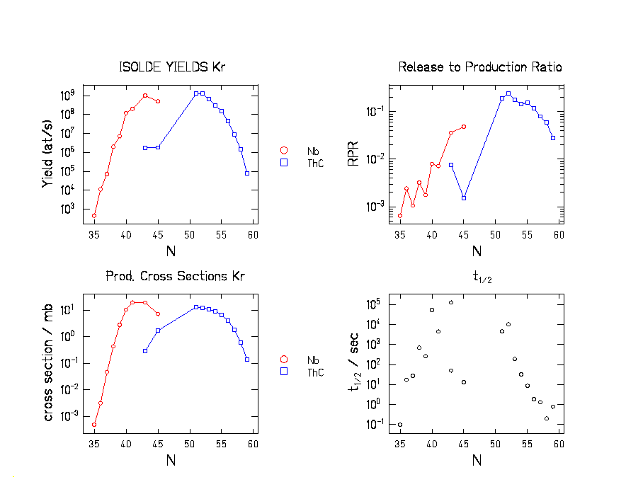
Fig.7: Results for Kr (Z=36) produced with Nb(red symbols) and ThC(blue symbols) targets
The element created is krypton with two different targets using a proton beam: a niobium powder (Nb; 50g/cm²) and a thorium carbide (ThC; 55g/cm²), with a plasma-cooled transfer line as ion source. From fig. 7 we see that the RPR increases in the beginning, and decreases at the end; the half-life graph follows the same trends.
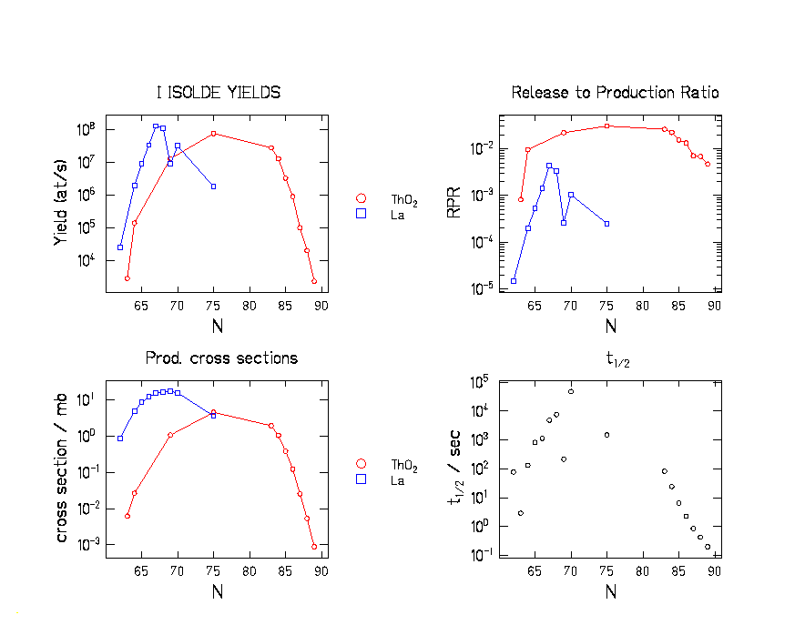
Fig.8: Results for I (Z=53) produced with ThO(red symbols) and La(blue symbols) targets

The element created is iodine with two different targets using a proton beam: a thorium oxide (ThO; 46.7g/cm²) and a liquid lanthanum (La; 120g/cm²), with a plasma-cooled transfer line as ion source. On fig.8 we can observe that the RPR is higher for the oxide than for the liquid target.
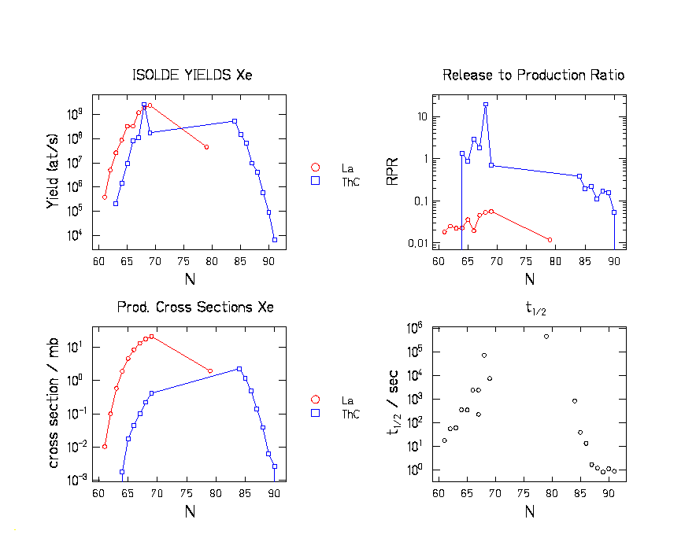
Fig.9: Results for Xe (Z=54) produced with La(red symbols) and ThC(blue symbols) targets
The element created is xenon with two different targets using a proton beam: a liquid lanthanum (La; 124g/cm²) and a thorium carbide (ThC; 55g/cm²), with a tungsten surface as ion source. With the ThC target, we have an abnormal ISOLDE yield for some isotopes (RPR normally cannot exceed 1), see fig. 9. Furthermore, we can note that in the same time, the half-life increases. So, other isotopes created may populate this element (by a ß decay).
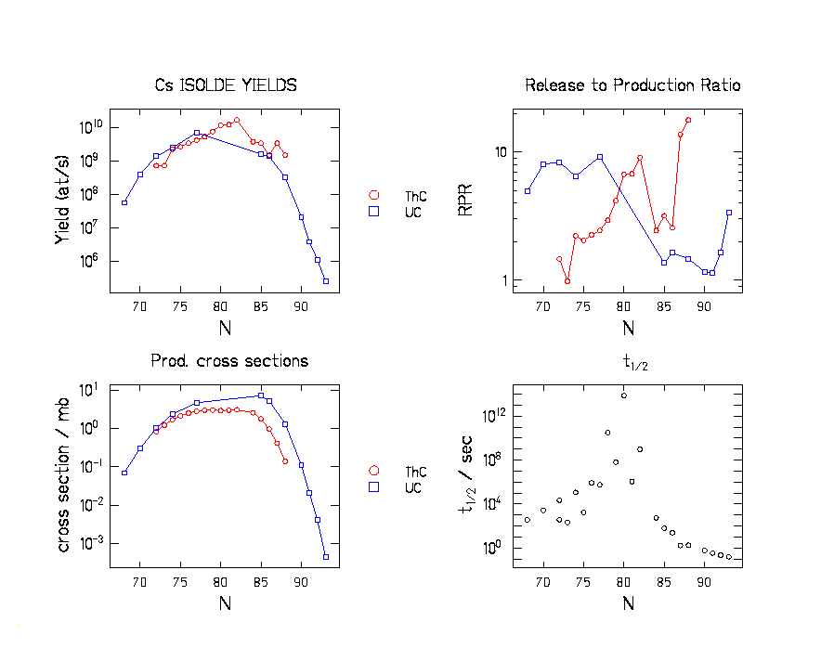
Fig.10: Results for Cs (Z=55) produced with ThC(red symbols) and UC(blue symbols) targets
The element created is caesium with two different targets using a proton beam: a thorium carbide (ThC; 54g/cm²) and a uranium carbide (UC; 13g/cm²), with a tungsten surface as ion source. On fig. 10 the same conclusions can be drawn as from the previous graph, because the values of the RPR graph exceed 1, and so the yields are higher than expected.
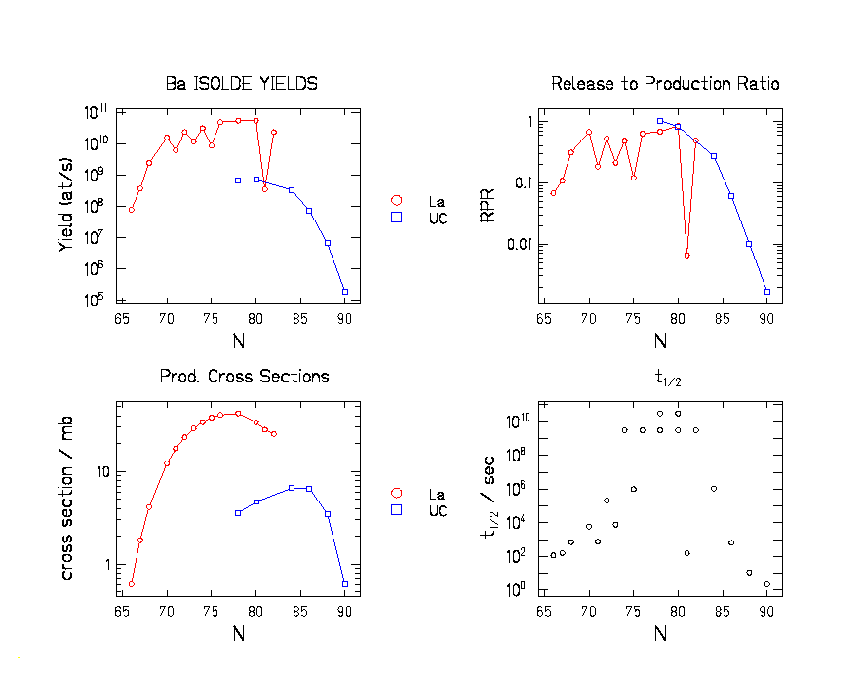
Fig.11: Results for Ba (Z=56) produced with La(red symbols) and UC(blue symbols) targets
The element created is barium with two different targets using a proton beam: a liquid lanthanum (La; 120g/cm²) and a uranium carbide (UC; 15g/cm²), with tungsten surface as ion source, see fig.11. In this case, the same conclusions can be drawn as from the fig.6; neutron-rich isotopes are more created with a UC target, than with a La target.
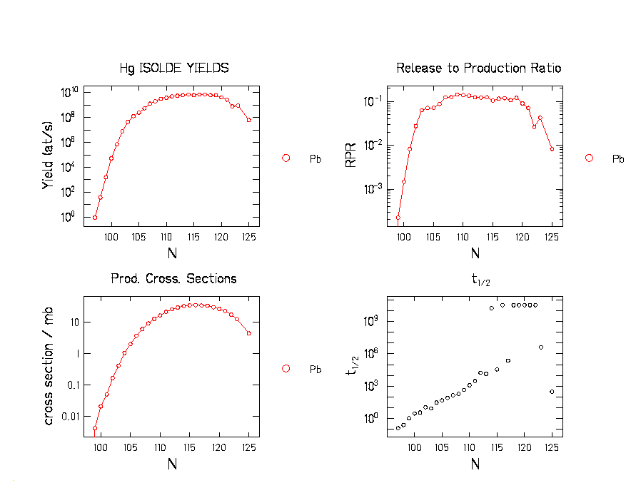
Fig.12: Results for Hg (Z=80) produced with Pb target
The element created is mercury with one target using a proton beam: a liquid lead (Pb; 170g/cm²), with a plasma heated line as ion source. First, these figures are interesting because of the high statistics. Secondly, the RPR graph follows the same trends as the half-life graph, until it saturates at a level. The results are shown on fig. 12.
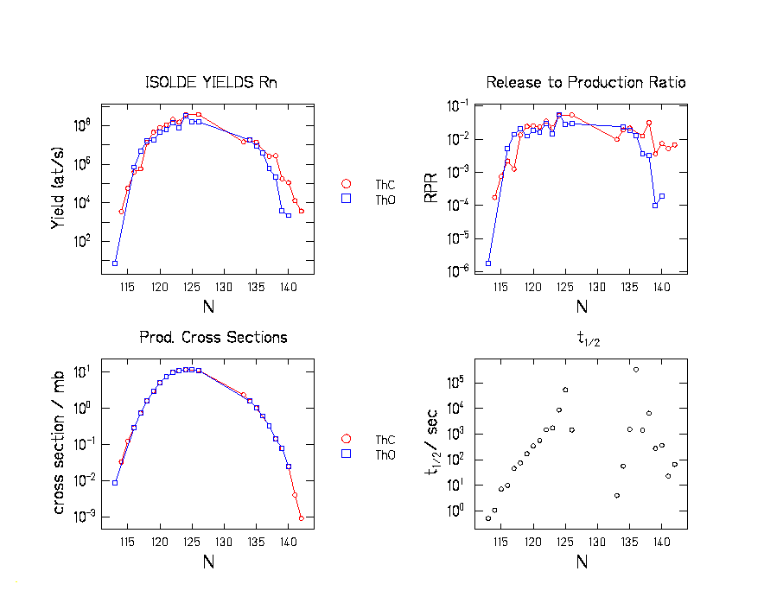
Fig.13: Results for Rn (Z=86) produced with ThC(red symbols) and ThO(blue symbols) targets
The element created is radon with two different targets using a proton beam: a thorium carbide (ThC; 55g/cm²) and a thorium oxide (ThO; 40g/cm²), with a plasma-cooled transfer line as ion source. On fig. 13 we can observe that the RPR and the half-life curves increase at the beginning. However, the RPR saturates at a level.
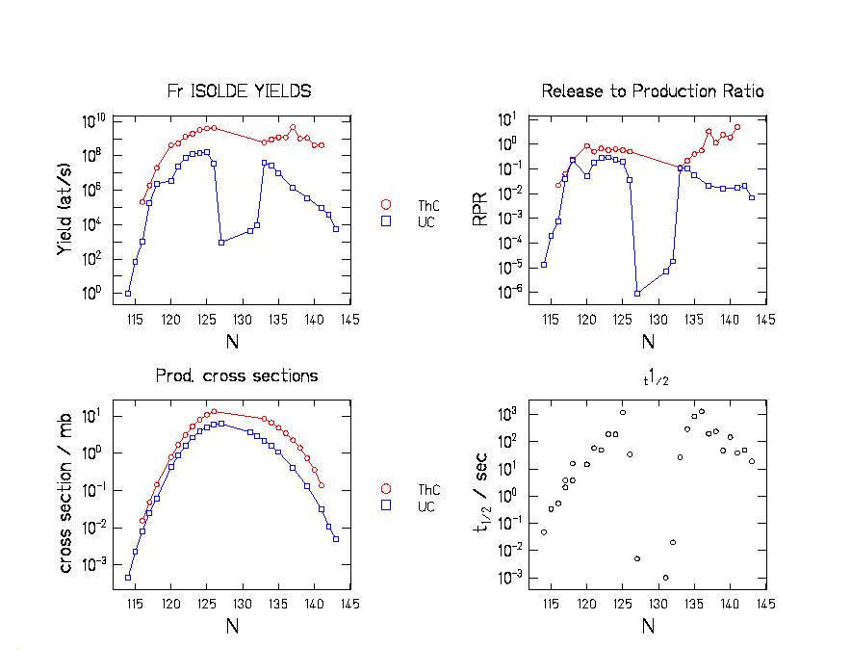
Fig.14: Results for Fr (Z=87) produced with UC(red symbols) and ThC(blue symbols) targets
The element created is francium with two different targets using a proton beam: a uranium carbide (UC; 13g/cm²) and a thorium carbide (ThC; 55g/cm²), with a tungsten surface as ion source. From fig. 14 we can see that isotopes which have the smallest half-life, have been detected with a UC target but not with a ThC. Thus the RPR reaches a maximum for elements which have a long half-life, so ISOLDE works very well for them.

CONCLUSION:

Measured ISOLDE yields of a number of nuclides were compared with calculated primary production rates. The model calculations were performed with codes developed at GSI on the basis of experimental nuclide production cross sections, measured in inverse kinematics. From this comparison, information on the efficiency of the ISOLDE method has been extracted that is important for the EURISOL project.

The ISOL efficiency differs appreciably for different extracted elements. The sensitivity of the ISOL efficiency on the half-life of the reaction product and on the properties of target and ion source is clearly seen. Although these dependencies are qualitatively known, the good predictive power of the model codes allows for new quantitative results. In particular, the specific sensitivity of the ISOL efficiency on the half-life of the extracted isotope is documented for a large number of elements.

In addition, the different isotopic distributions obtained with different target material are explained by the different reaction mechanisms responsible for the production. In general, more neutron-rich isotopes emerge from fission reactions in heavy target material, while more neutron-deficient isotopes emerge from fragmentation reactions in lighter target material.

Indications for an important contribution from secondary reactions to the extracted yields, which are expected to predominantly produce neutron-rich isotopes were not found. However, for some isotopes of xenon and caesium the extracted yield exceeds the calculated primary production appreciably. The reason for this is not clear in the moment.

It can be concluded that the perspectives for the EURISOL project in creating a pure and intense secondary beam are promising, under the condition that appropriate fast extraction methods will be developed.

REFERENCES:

[1] | PHD thesis of M.V. Ricciardi, in preparation.
[2] | J. Benlliure, A.Grewe, M. de Jong, K-H Schmidt, S. Zhdanov, Nuclear Physics A 628 (1998) 458-478.
[3] | H.L. Ravn, T. Bjornstad, P. Hoff, O.C Jonsson, E. Kugler, S. Sundell, B. Vosicki, Nuclear and Methods in Physics Research B26 (1987) 183-189.
[4] | http://isolde.cern.ch
[5] | H. J. Kluge (editor), ISOLDE USER’S Guide, Geneva (1986).
[6] | U.Köster, Radiochemistry Acta 89 (2001) 77777-77785.
[7] | H. L. Ravn, Nuclear Instruments and Methods in Physics Research B26 (1987) 72-85.
[8] | http://www-wnt.gsi.de/kschmidt
[9] | F. Rejmund, B. Mustapha, P. Armbruster, J. Benlliure, M. Bernas, A. Boudard, J. P. Dufour, T. Enqvist, R. Legrain, S. Leray, K.-H. Schmidt, C. Stéphan, J. Taieb, L. Tassan-got, C. Volant, Nucl. Phys. 683 [2001] 540-565.
[10] | J. Benlliure, P. Armbruster, M. Bernas, A. Boudard, J. P. Dufour, T. Enqvist, R. Legrain, S. Leray, B. Mustapha, F. Rejmund, K.-H. Schmidt, C. Stéphan, L. Tassan-Got, C. Volant, Nucl. Phys. A 683 (2001])513-539.
[11] | ] T. Enqvist, W. Wlazlo, P. Armbruster, J. Benlliure, M. Bernas, A. Boudard, S. Czajkowski, R. Legrain, S. Leray, B. Mustapha, M. Pravikoff, F. Rejmund, K.-H. Schmidt, C, Stephan, J. Taieb, L. Tassan-Got, C. Volant, Nucl. Phys. A 686 (2001) 481-524.
[12] | T. Enqvist, J. Benlliure, F. Farget, K.-H. Schmidt, P. Armbruster, M. Bernas, L. Tassan-Got, A. Boudard, R. Legrain, C. Volant, C. Boeckstiegel, M. de Jong, J. P. Dufour, Nucl. Phys. A 658 (1999) 47-66.
[13] | P. J. Karol, Phys. Rev C 11 (1975) 1203-1209.

THANKS

I would like to thank Dr. Bertram BLANK for his help in order to find this placement.
Furthermore, I thank Dr. Karl-Heinz SCHMIDT for all the explanations and the attention that he gave me, despite all his work.
I thank also, particularly Dr. Orlin YORDANOV, who helped me so much for the physics comprehension.
Finally, thanks to all the people of the GSI, for their help during this period.

