INTERMEDIATE-ENERGY NUCLEAR DATA FOR RADIOACTIVE ION BEAMS AND ACCELERATOR-DRIVEN SYSTEMS
M. V. RICCIARDI, P. ARMBRUSTER, T. ENQVIST, F. REJMUND,
K. -H. SCHMIDT, J. TAIEB
GSI, Planckstrasse 1, D– 64291 Darmstadt, Germany
E-mail: m.v.ricciardi@gsi.de
J. BENLLIURE, E. CASAREJOS
Universidad de Santiago de Compostela, E-15706 Santiago de Compostela, Spain
M. BERNAS, B. MUSTAPHA, L. TASSAN-GOT
IPN Orsay – IN2P3, F-91406 Orsay, France
A. BOUDARD, R. LEGRAIN, S. LERAY, C. STEPHAN, C. VOLANT, W. WLAZLO
CEA Saclay, F-91191 Gif sur Yvette, France
S. CZAJKOWSKI, J. P. DUFOUR, M. PRAVIKOFF
CEN Bordeaux-Gradignan, F-33175, Gradignan, France
Formation cross sections of isotopes produced in inverse kinematics from the spallation/fragmentation and fission of ¹⁹⁷Au (at 800 A⋅MeV), ²⁰⁸Pb (at 1 A⋅GeV) and ²³⁸U (at 1 A⋅GeV) are presented. These data are extremely important for the design of accelerator-driven systems and new radioactive-ion-beam facilities. The data have been measured at GSI with the FRagment Separator, which allows precise measurements of the cross sections of the fragments and of their velocities. The knowledge of the velocity enables to deduce the reaction mechanisms and leads to a better understanding of the physics of intermediate-energy nuclear reactions. Thanks to this, nuclear models capable to predict the isotopic formation cross sections have been implemented and benchmarked with the measured data. Results are presented.

Introduction
The design of accelerator-driven systems and radioactive-ion-beam facilities requires the knowledge of formation cross sections of isotopes produced in spallation and fission reactions at intermediate energies. At the moment, the existing experimental data can by no means provide the information needed. Measuring all the reactions of interest would be a long and expensive task, therefore computational programs seem to be a more practical tool. However, the predictive power of theoretical models is often far from the performance required for the technical application, mostly due to the lack of knowledge on the mechanisms involved in these nuclear reactions. Therefore, selected nuclear reactions must be investigated experimentally in order to throw light upon the physics involved in such reactions and supply data for benchmark tests.
For this purpose, an experimental program has been started 4 years ago at GSI to measure formation cross sections of spallation and fission residues produced in the interaction of protons and deuterons with some selected nuclei (¹⁹⁷Au, ²⁰⁸Pb, ²³⁸U, ⁵⁶Fe) at relativistic energies (500-1000 MeV) in inverse kinematics. In addition, Monte Carlo codes that can predict the isotopic formation cross sections have been implemented.
In this paper, some results on proton- and deuteron-induced spallation and fission reactions are presented. Comparisons between Monte Carlo predictions and experimental data are discussed too.

Experimental results
The experiments have been performed at GSI [9] in inverse kinematics, i.e. the relativistic beams of ¹⁹⁷Au, ²⁰⁸Pb, ²³⁸U were accelerated and directed onto a H₂ or D₂ target. The spallation or fission fragment, originating from that part of the projectile that survives, was selected and identified in-flight with the fragment separator (FRS) [10]. The in-flight separation allows to measure the yields of the residues prior to their β-decay and to obtain the whole isotopic distribution for every produced element. Indeed, the measurements can cover the full (N,Z) map of produced residues in every projectile-target reaction.
As a test experiment, we firstly investigated part (due to lack of time) of the residues produced in the reaction ²³⁸U (1 A⋅GeV) + ²⁰⁸Pb [6]. At the moment, the formation cross sections of fission and spallation isotopes produced in the ¹⁹⁷Au (800 A⋅MeV) + p, in the ²⁰⁸Pb (1 A⋅GeV) + p and in the ²⁰⁸Pb (1 A⋅GeV) + d reactions are also available [1, 7, 12, 13] or will be available soon. Some data from the ²³²U (1 A⋅GeV) + p, d reactions are partially analysed whilst those from the ²⁰⁸Pb (500 A⋅MeV) + p reaction still have to be analysed. Due to the limited time for the experiments, the cross-sections have been measured down to 0.1 mbarn. The accuracy of the measurements is about 10%.
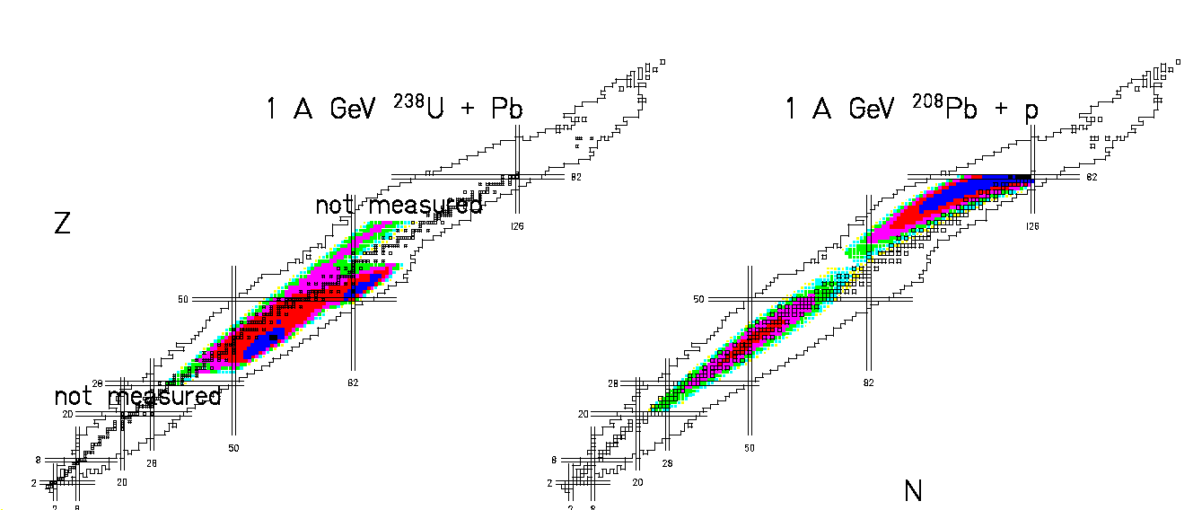
The measured formation cross sections for the isotopes produced in the reaction ²³⁸U (1 A⋅GeV) + ²⁰⁸Pb are qualitatively compared with those measured in ²⁰⁸Pb (1 A⋅GeV) + p (figure 1). The results can be interpreted on the basis of the reaction mechanisms. The data are grouped in two zones: a fragmentation (or spallation) corridor and a fission area. The corridor is filled with those residual nuclei that are formed at the end of an evaporation chain. Depending on the impact parameter, a certain amount of excitation energy is acquired by the surviving projectile nucleus, which can de-excite by evaporating nucleons and light particles. The length of the fragmentation corridor is given by the maximum energy deposited in the nucleus, which in turn is limited by the total beam energy in the centre of mass. That is why the spallation corridor is shorter in the case of ²⁰⁸Pb→p reaction (E_{c.m.} ~ 1 GeV) than in the ²³⁸U→Pb reaction (E_{c.m.} ~ 111 GeV). In competition to the evaporation of particles fission can occur, providing that the excitation energy of the compound nucleus is enough to overcome the fission barrier. The latter is very low for ²³⁸U, and the energy transferred in the electromagnetic interaction with the target can be high enough to induce fission. The fission fragments will form a double-humped yield distribution, as it is expected for the low-energy (asymmetric) fission of uranium. At the same time, the nuclear interaction can transfer a higher amount of energy, and a large group of actinides can undergo high-energy (symmetric) fission, producing fragments that, after neutron evaporation, can lie even in the area of the β-stability. In the case of Pb, due to the higher barrier, high-energy (symmetric) fission after nuclear interaction is the only possible fission channel. Since the fissility increases with Z²/A, the proton-rich Pb isotopes, produced after the evaporation of some neutrons, are the best candidates for fission. So the fission fragments will be located near the valley of stability.

Figure 1. Measured formation cross sections plotted on the chart of the nuclides for the isotopes produced in the reactions ²³⁸U (1 A⋅GeV) + Pb (left) and ²⁰⁸Pb (1 A⋅GeV) + p (right).

The models
One of the most important advantages of the FRS is that the in-flight separation allows precise measurements of the momenta of the fragments. Thanks to the measured velocity distributions of the produced isotopes, the reaction mechanisms can be deduced and fission products distinguished from spallation ones. The new experimental information has been exploited to develop nuclear models and to implement Monte Carlo codes to predict the isotopic formation cross sections. The codes are based on a first fast stage (intra-nuclear cascade from Cugnon [4] for nucleon-nucleus reactions or an abrasion model [5] for nucleus-nucleus reactions) and on a successive slow de-excitation, in which two competitive mechanisms can occur (evaporation or fission). Both the evaporation and the fission model have been developed at GSI [2]. A statistical model is used to describe the evaporation of particles. The emission probability of a certain particle is given by the ratio between its decay width and the sum of all the decay widths. In the decay widths the level densities of the initial and final states take into account the influence of shell and pairing effects, as reported in Ref. [11]. A physical quantity that plays an important role for the description of the isotopic distributions of the produced elements is the Coulomb barrier of charged particle since it affects the competition between neutrons and charged particles evaporation. In figure 2 the isotopic distribution of the isotopes of rhenium from the reaction ¹⁹⁷Au (800 A⋅MeV) + p are reproduced by the GSI Monte Carlo code. The results of two other simulations, in which the proton evaporation barrier was arbitrarily increased or decreased by 2 MeV, are also shown. The picture shows clearly how the proton evaporation affects the production of neutron-deficient isotopes.
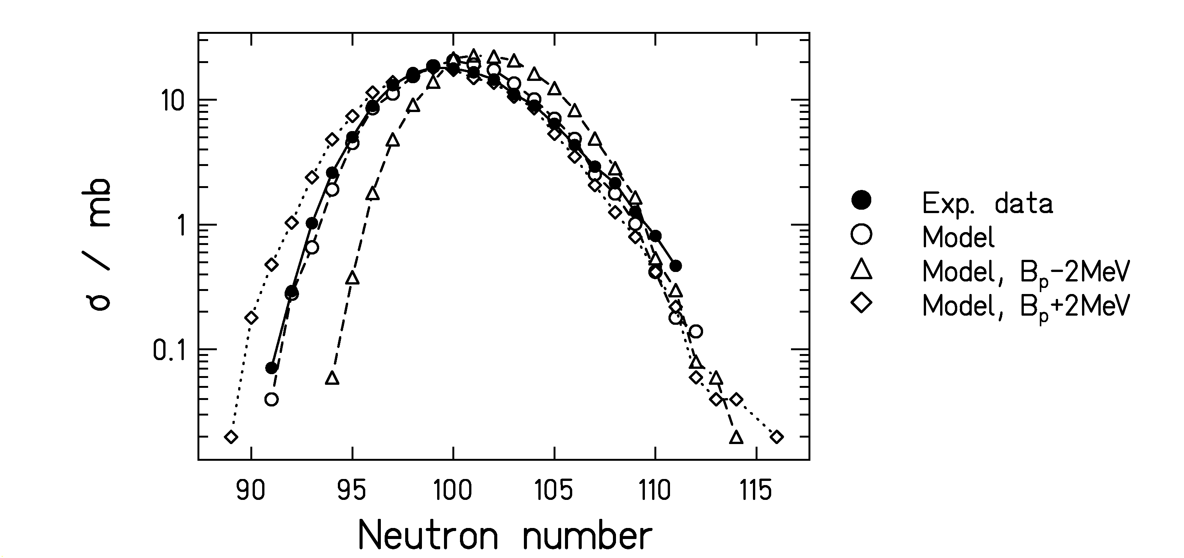
Figure 2. Influence of proton-evaporation barrier: distribution of the isotopes of rhenium (Z=75) produced in the spallation of ¹⁹⁷Au (800 A⋅MeV) + p.

The evaporation chain goes on until the excitation energy of the pre-fragment falls below the lowest particle threshold or until fission occurs.
The fission decay width is calculated by the transition-state method of Bohr and Wheeler [3]. Nuclear friction is included according to Ref. [8], with the following value of the viscosity coefficient: β = 2⋅10⁻²¹ s⁻¹. The mass distribution of the fission-fragments is based on a semi-empirical description of the fission process [2] and depends mostly on the description of the level density above the conditional fission barrier. The mean value of the N/Z-ratio of fission fragments and its fluctuations depend on the energy of the nucleus at the scission point. Excited fission fragments can evaporate particles according to the previously described model.
Some experimental data for the spallation and fission fragments of ¹⁹⁷Au (800 A⋅MeV) + p and ²⁰⁸Pb (1 A⋅GeV) + p are compared to the prediction of the GSI code in figures 3 and 4. The error bars of the experimental data correspond to the statistical error, while no error bars are given for the computational predictions.

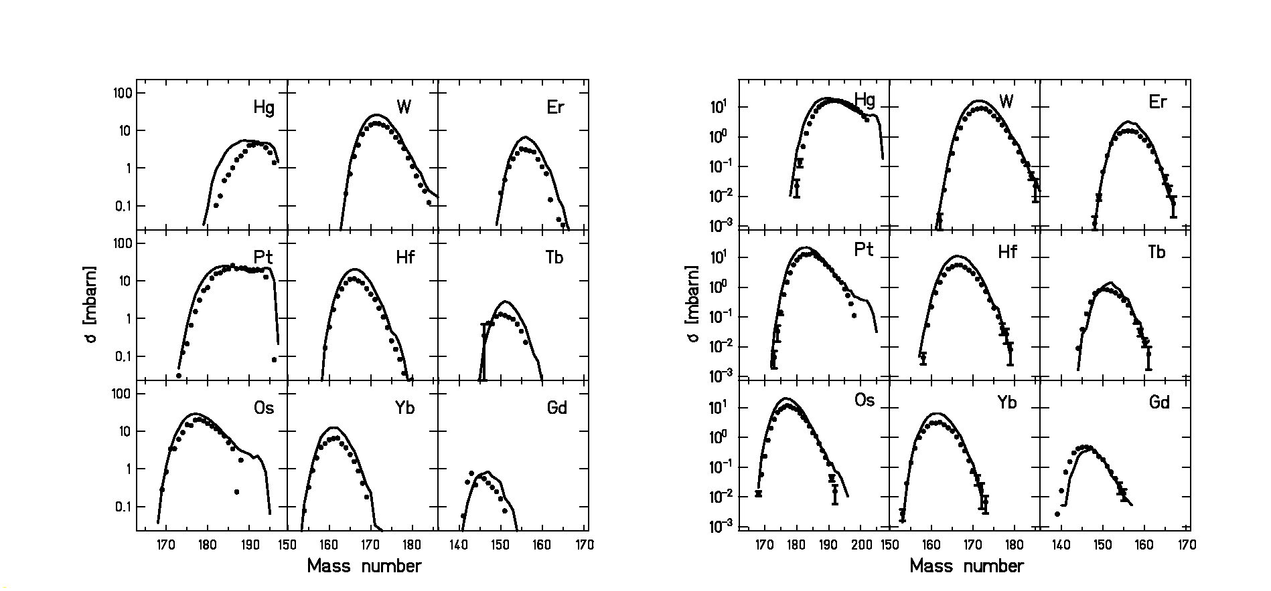
Figure 3. Measured formation cross sections for some isotopes produced in the spallation of ¹⁹⁷Au (800 A⋅MeV) + p (left) and ²⁰⁸Pb (1 A⋅GeV) + p (right). The experimental data (dots) are compared to the predictions of the GSI code (lines).

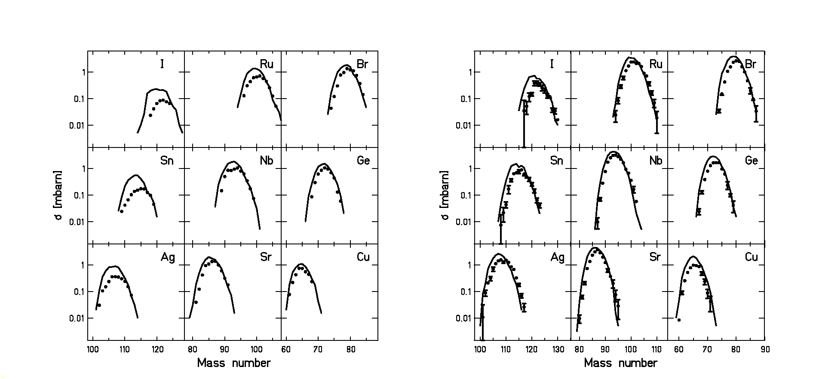
Figure 4. Measured formation cross sections for some isotopes produced in the fission of ¹⁹⁷Au (800 A⋅MeV) + p (left) and ²⁰⁸Pb (1 A⋅GeV) + p (right). The experimental data (dots) are compared to the predictions of the GSI code (lines).
References
- J. Benlliure, P. Armbruster, M. Bernas, A. Boudard, J. P. Dufour, T. Enqvist, R. Legrain, S. Leray, B. Mustapha, F. Rejmund, K.-H. Schmidt, C. Stéphan, L. Tassan-Got, C. Volant, Isotopic production cross sections of fission residues in 197Au-on proton collisions at 800 A MeV, Nucl. Phys. A 683 (2001) 513-539.
- J. Benlliure, A. Grewe, M. de Jong, K.-H. Schmidt, S. Zhdanov, Calculated nuclide production yields in relativistic collisions of fissile nuclei, Nucl. Phys. A 628 (1998) pp.458-478.
- N. Bohr, J. A. Wheeler, The mechanism of nuclear fission, Phys. Rev. 56 (1939) pp. 426-450.
- J. Cugnon, Monte Carlo calculation of high-energy heavy-ion interactions, Phys. Rev. C 22 (1980) pp. 1885-1895.
- Y. Eisenberg, Interaction of heavy primary cosmic rays in lead, Phys. Rev. 96 (1954) 1378.
- T. Enqvist, J. Benlliure, F. Farget, K.-H. Schmidt, P. Armbruster, M. Bernas, L. Tassan-Got, A. Boudard, R. Legrain, C. Volant, C. Böckstiegel, M. de Jong, J. P. Dufour, Systematic experimental survey on projectile fragmentation and fission induced in collisions of ²³⁸U at 1 a GeV with lead, Nucl. Phys. A 658 (1999) pp. 47-66.
- T. Enqist, W. Wlazlo, P. Armbruster, J. Benlliure, M. Bernas, A. Boudard, S. Czajkowski, R. Legrain, S. Leray, B. Mustapha, M. Pravikoff, F. Rejmund, K.-H. Schmidt, J. Taieb, L. Tassan-Got, C. Volant, Isotopic yields and kinetic ener-gies of primary residues in 1 A GeV ²⁰⁸Pb+p reactions, Nucl. Phys. A 686 (2001) 481-524.
- A. Heinz, B. Jurado, J. Benlliure, C. Böckstiegel, H.-G. Clerc, A. Grewe, M. de Jong, A. R. Junghans, J. Müller, K.-H. Schmidt, S. Steinhäuser, Signature of dissipation deduced from fission after peripheral heavy-ion collision, GSI Scientific Report 1999, p. 30.
- Http://www.gsi.de.
- Http://www-wnt.gsi.de/frs
- A. R. Junghans, M. de Jong, H.-G. Clerc, A. V. Ignatyuk, G. A Kudyaev, K.-H. Schmidt, Projectile-fragment yields as a probe for the collective enhancement in the nuclear level density, Nucl. Phys. A 629 (1998) pp. 635-655.
- F. Rejmund, B. Mustapha, P. Armbruster, J. Benlliure, M. Bernas, A.Boudard, J.P. Duffour, T. Enqvist, R.Legrain, S. Leray, K.-H. Schmidt, C.Stephan, J. Taieb, L. Tassan-got, C.Volant, Measurement of isotopic cross sections of spallation residues in 800 A MeV ¹⁹⁷Au+p collisions, Nucl. Phys. A 683 (2000) 540-565.
- W. Wlazlo, T. Enqvist, P. Armbruster, J. Benlliure, M. Bernas, A. Boudard, S. Czajkowski, R. Legrain, S. Leray, B. Mustapha, M. Pravikoff, F. Rejmund, K.-H. Schmidt, C. Stephan, J. Taieb, L. Tassan-Got, C. Volant, Cross sections of spallation residues produced in 1 A GeV ²⁰⁸Pb on proton reactions, Phys. Rev. Lett. 84 (2000) 5736.

