Statistical Approaches to the Even-odd Effect in Fission
K.-H. Schmidtª, A. V. Ignatyuk^{b}, F. Rejmund^{c}, A. Kelićª, M. V. Ricciardiª
ªGSI, Planckstr. 1, 64291 Darmstadt, Germany
^{b}IPPE, Bondarenko Sq. 1, 249020 Obninsk, Kaluga Region, Russia
^{c}GANIL, BP 5027, 14076 Caen cedex 5, France
Abstract. Statistical approaches have been widely used for describing the nuclear-fission process. They were quite successful in explaining several prominent features of the global nuclide distributions and many other aspects, while there are controversial conclusions on the origin of the even-odd effect in the nuclear-charge yields. We analyze the ingredients of the main statistical approaches to the even-odd effect in fission and show up that many of their deficiencies rely on unrealistic assumptions. Finally, we demonstrate that the large body of experimental results, obtained in the recent years to a great part at GSI, Darmstadt, is very successfully reproduced by a new stringent statistical approach.
Keywords: Nuclear fission; Pair breaking; Even-odd structure in fission-fragment yields; Statistical model; Superfluid nuclear model
PACS: 25.85.-w; 24.10.Pa; 21.10.Ma

iNTRODUCTION
The discovery of the even-odd structure in fission and the evolution of its theoretical interpretation is a fascinating story on the progress in a specific sub-field of research. In many aspects, it is typical for research in general, for the decisive role of experimental data in triggering new ideas and for the gradual progress in the theoretical understanding. On the one hand, it shows the growth in empirical knowledge over the time due to the progress in experimental technique. Major steps have been made, when innovative experimental approaches were introduced. On the other hand, the theoretical understanding did not proceed in a straightforward way. Theories based on inappropriate concepts or inadequate approximations were proposed and survived over long time, until their shortcomings were eventually recognized.

Experiments
Early data on fission-fragment yields, obtained with radiochemical techniques, revealed that thermal-neutron-induced fission of ²³⁵U produces even-Z fragments more abundantly than odd-Z-fragments. The global even-odd effect, quantified by the following expression

$$δ=\frac{\sum_{i}{Y_{\text{ei}}−\sum_{i}{Y_{\text{oi}}}}}{\sum_{i}{Y_{\text{ei}}+\sum_{i}{Y_{\text{oi}}}}}$$

was found to be about 25 %.
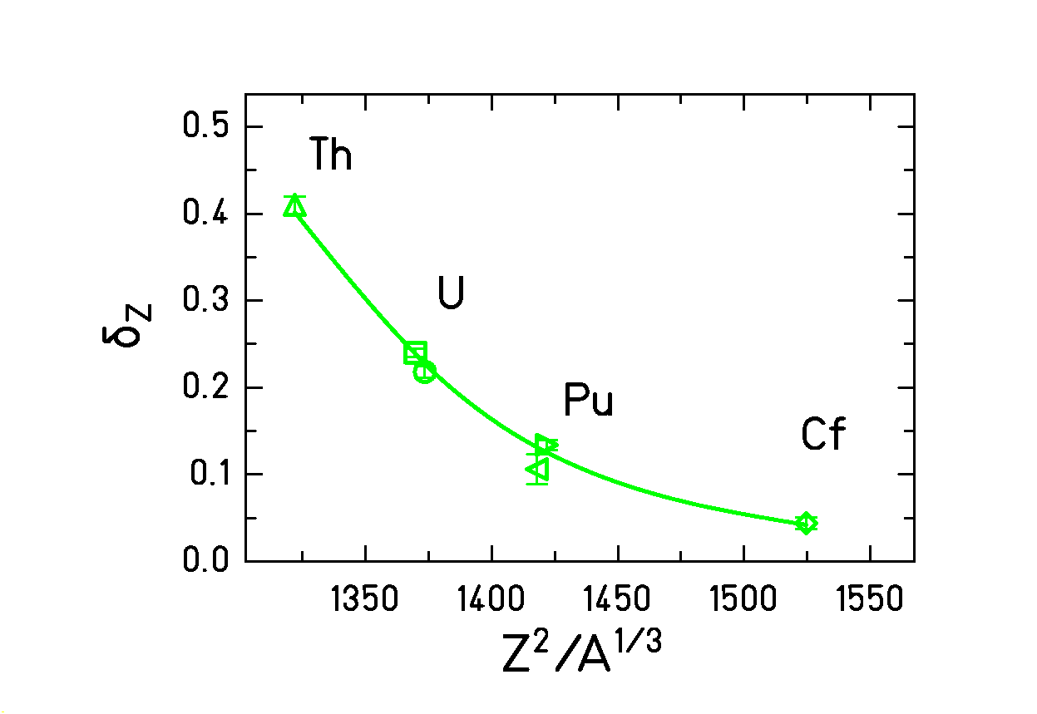
Major progress in the yield determination of individual fission fragments, fully identified in atomic number Z and mass number A, was achieved by the experimental program performed with the Lohengrin spectrometer at ILL Grenoble. The combination of the ion-optical deflection by the parabola spectrograph with a precise measurement of energy loss and residual energy provided a full overview on the nuclide production as a function of kinetic energy in the light-fragment group. The first comprehensive experimental study with this new technique was devoted to ²³⁵U(n_{th},f), yielding a strong dependence of the proton even-odd effect on the kinetic energy of the light fragment. The experiments at Lohengrin were and still are the most successful measurements for the in-flight identification of fission fragments at the energy provided by the fission process itself.

Figure 1. Global even-odd effect for thermal-neutron-induced and spontaneous fission.

An overview on the data, measured by this and similar techniques shows a systematic variation as a function of $Z^{2}/A^{1/3}$ (figure 1) and has also revealed an even-odd effect in the mean kinetic energies of the fragments as a function of Z.
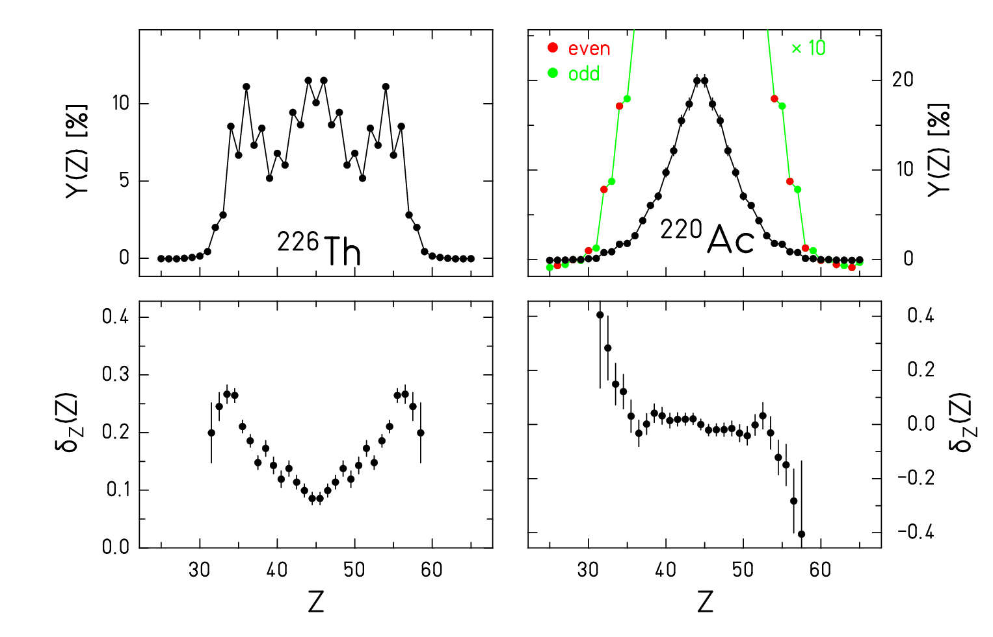
Another major step in the experimental investigation of the even-odd effect in fission has been done by introducing a novel experimental approach. Relativistic beams of fissile nuclei were excited by the electromagnetic interaction with a target nucleus, and the fission fragments were identified in flight. This was the first time that all elements over the whole distribution could be resolved. Among other results, these experiments brought clear evidence for the appearance of a proton even-odd effect also in the fission of odd-Z fissioning nuclei and on systematic variations of the strength of the even-odd effect as a function of the asymmetry of the mass split , figure 2.

Figure 2. Upper part; Elemental yields of fission fragments produced in electromagnetic fission of an even-Z (²²⁶Th) and an odd-Z (²²⁰Ac) nucleus. Lower part: Local even-odd effect. The data are taken from ref.Error: Reference source not found.

THEORY
First, we would like to make some clarifying remarks on the theoretical interpretation of even-odd structure in fission-fragment yields. It is helpful to remind that also in the case of nuclear binding energies the specific structure introduced by pairing correlations in terms of even-odd mass differences has been studied by appropriate filters. In this way, one could show that the gap parameter generally decreases with increasing mass like $1/\sqrt{A}$ and that there is a clear increase of both neutron and proton gap with increasing Z/N ratio. These conclusions could be drawn from investigations just filtering the global trends of the even-odd structure from the complex features inherent in the nuclear binding energies, and they demand for some specific explanations. In this sense, it is very helpful to analyze general trends in global and local even-odd effects in fission-fragment distributions with appropriate filters and to try to find theoretical interpretations which concentrate on this problem.
Our second remark concerns the relevance of the statistical model of nuclear reactions. Like in any problem related to nuclear reactions, the statistical model forms a basic step in the interpretation. We mean this in the sense that any more specific conclusion, e.g. indications for dynamic effects, can only be drawn if this “uninteresting” interpretation does not explain all features of the data. Appropriate efforts to interpret the data with the statistical model of nuclear reactions also help to work out those specific features of the data which contain more specific information. Thus, we stress as a general, very important statement that the statistical model has a key role in the interpretation of nuclear-reaction data.

The statistical model of Fong and its modifications
Fong formulated a statistical model with the aim to calculate the fission-fragment yields on the basis of the number of available states in the scission-point configuration for different splits of the fissioning system in neutron and proton number. He calculated the level density of the fragments with the Fermi-gas model taking into account even-odd effects as a shift of the effective excitation energies. Since such a shift exactly compensates for the even-odd staggering in the Q value as a function of proton or neutron number, this model did not predict any even-odd effect.
We would like to mention here that the shifted Fermi-gas model is not adequate to model the level density of the superfluid nucleus at low excitation energies. This is a flaw which still survives in recent publications and which is erroneously taken as a proof that the statistical model is unable to explain any even-odd effect in fission-fragment yields. In particular, the two-component character of the nuclear system is not properly accounted for. E.g. the assumption that there are no levels below Δ in an even-odd or an odd-even nucleus is not realistic. The Fermi-gas level density should be replaced by a more appropriate formulation of the super-fluid nuclear model e.g. the one developed by Ignatyuk et al..
Wilkins and Steinberg refined Fong’s model. Two formulae represent the key equations of the model. The potential energy at scission is formulated as a sum of the liquid-drop ground-state energies of the fragments (V_{LD}), their shell corrections in the neutron and proton subsystem (S), their pairing energy (P), their interactive Coulomb and nuclear potential (V_{C} and V_{n}). It is given as a function of neutron number (N), proton number (Z), deformation (β), intrinsic temperature (τ), and neck distance (d). Pairing was considered with the BCS formalism. The energy dependence of the gap parameter Δ was parameterized according to numerical results of Moretto. In a thermodynamical approach, the temperatures of the intrinsic and the collective degrees of freedom are considered as key parameters of the model. The probability for the formation of a specific fragment with neutron number N and proton number Z is given by:

$$P\left(N,Z,τ,d\right)=\int_{β_{1}=0}^{β_{\text{max}}}{\int_{β_{2}=0}^{β_{\text{max}}}{\text{exp}\left[−V{\left(N,Z,β,τ,d\right)}/{T_{\text{coll}}}\right]}}{dβ}_{1}{dβ}_{2}$$

T_{coll} is the collective temperature, which might be different from the intrinsic temperature τ. That means that the nuclide distribution is determined by a Boltzmann factor with the collective temperature T_{coll}. In contrast to the Fong model, this model predicts an even-odd effect in the fission-fragment yields, both in neutron and proton number, due to the even-odd effect in the binding energies of the fragments.
This treatment is far too simple, in particular in the implicitly used nuclear level densities by means of the thermodynamic Boltzmann factor, to yield realistic values for the even-odd effects. In particular, this formulation severely fails to properly model the characteristic influence of pairing correlations on the level density in even-even, even-odd, odd-even, and odd-odd nuclei in the superfluid phase. In this aspect, it is even less realistic than the shifted Fermi-gas formula used by Fong.
Pommé et al. proposed the following formula for the excitation-energy dependence of the even-odd effect in fission:

$$δ(E)=\left\{\begin{matrix}δ_{0} \\ δ_{0}⋅e^{− \frac{E−B_{f}−2Δ}{T}}\end{matrix} \begin{matrix}\text{ for }E<B_{f}+2Δ \\ \text{otherwise }\end{matrix}\right.$$

E = excitation energy of the initial fissioning nucleus above its ground state
B_{f} = fission barrier
T = temperature parameter
δ₀ = even-odd effect for E = B_{f}

This formulation reminds a modified version of the treatment of pairing in the model of Wilkins and Steinberg. Also this formula lacks good theoretical justification.

The combinatorial model of Nifenecker
Nifenecker et al. introduced a mathematical model, based on combinatorial methods, to explain the even-odd structure in the fission-fragment element yields. Instead of going into any detail, we just mention that Nifenecker’s model is based on statistical considerations on the basis of the number of broken pairs. This is a very peculiar kind of statistical consideration, which is not conform with the basic principles of the statistical model of nuclear reaction that is based on the number of available states in the final configuration considered. Nevertheless, this model has been usedError: Reference source not found, to deduce the thermal excitation energy at scission from the magnitude of the even-odd effect in fission-fragment charge distributions.

The statistical model of Mantzouranis and Nix
Mantzouranis and Nix developed a model for the interpretation of the even-odd effect in fission. They based their model on a characteristic value given by the number of quasi-particle excitations, normalized to the number of particle-hole excitations in an equivalent nucleus without pairing correlations. Again, this kind of statistical consideration is not based on the number of available states, and thus it is also not conform to the basic principles of the statistical model of nuclear reaction.

The question of the energy scale
Hambsch et al. and later Bouzid et al. raised the question, what is the appropriate energy scale for analyzing the even-odd structure in the fission-fragment yield as a function of the kinetic energy of the fragments. This discussion has even lead to the provocative title of ref.Error: Reference source not found: “The positive odd-even effects observed in cold fragmentation - are they real?" Since the Q value is modulated by an even-odd structure in the binding energies of the fragments, there is a systematic shift in splits with even or odd neutron or proton numbers if either the sum of the excitation energies of the two nascent fragments or the energy scale of the fissioning system is used as a reference. The relation of the energy reference to the physics of the problem will be discussed below.

The dynamical model of Bouzid et al.
Bouzid et al. were convinced that the statistical model fails to interpret the predominant production of even-Z nuclei in fissionError: Reference source not found. They developed a dynamical model Error: Reference source not found to explain the even-odd effect in fission.
Without commenting the details of this model, we state at this moment that the statistical descriptions mentioned in the previous sections suffer from severe shortcomings. Therefore their failure cannot be taken as a proof for the inadequacy of a statistical description.

The statistical model of Rejmund et al.
Recently, a new statistical approach has been formulated. It is based on a rigorous formulation of the level density in the super-fluid-nucleus model Error: Reference source not found of the fissioning system just before scission. Details may be found in ref.Error: Reference source not found.
There is an apparent difference in the formulation of the statistical model of Rejmund et al. compared to the previous formulations. In ref.Error: Reference source not found, the number of available states of the strongly deformed system just before scission is considered. These states are classified according to the number of quasi-particle excitations in the proton and in the neutron subsystem. If a subsystem stays fully paired during scission, only fragments with even numbers of that kind of nucleons are produced. Unpaired nucleons are assumed to be attached to one or the other fragment according to the number of available single-particle states in that fragment. This model predicts that the even-odd effect in proton number is much stronger than that in neutron number, see figure 3. As explicitly discussed in ref.Error: Reference source not found, it also explains the appearance of the strong even-odd effect in asymmetric splits for even-Z as well as for odd-Z systems as observed in figure 2. In some sort, this is a kind of dynamical model, since it relates the number of available states before scission to the way the nucleons are attributed to the nascent fragments at scission. In contrast, the previously proposed statistical models assumed that the production of a specific fragment pair is proportional to the phase space given by the number of states available in the two fragments right after scission. In these models, even-odd fluctuations in the yields are related to the fluctuations in the number of available states due to pairing effects in the Q value and in the level densities.
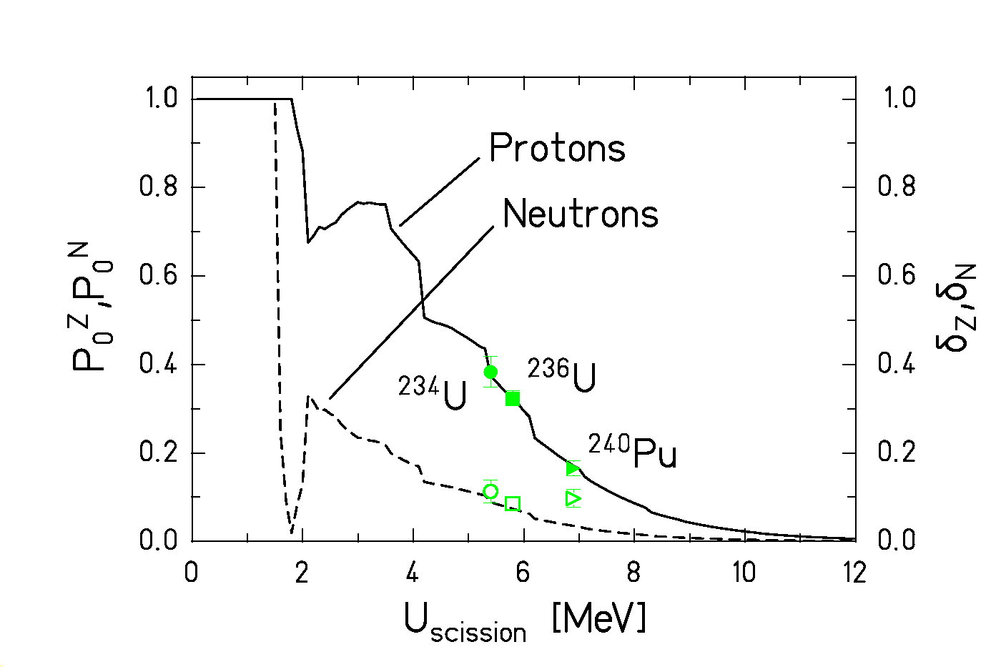
It can be shown that these two approaches give identical results. The approach of Rejmund et al. is based on an energy scale related to the ground state of the fissioning system. The alternative approach starts from the ground-state masses of the fission fragments, but by introducing the Q value, it also shifts the energy scale in each split to the ground-state energy of the fissioning nucleus.

Figure 3. Calculated dependence of survival probabilities P₀^{Z} (full line) and P₀^{N} (dashed line) of the completely paired proton and neutron configurations on the excitation energy at the effective scission pointError: Reference source not found. The experimental data on the proton and neutron even-odd effects $δ_{Z}$ and $δ_{N}$ at fixed kinetic energies of the light fission fragments are shown for the fissioning nuclei ²³⁴U (E_{kin} = 111 MeV), ²³⁶U (E_{kin} = 108 MeV), and ²⁴⁰Pu (E_{kin} = 111 MeV) by closed and open symbols, respectively.

DISCUSSION
We have seen that the experimental knowledge on the even-odd structure appearing in the nuclide distribution produced in low-energy fission has grown enormously over time. Major steps in the experimental approaches introduced were followed by major steps in the quality and the quantity of the data.
On the theoretical side, many attempts to interpret the observations with the statistical model failed due to inappropriately simplified level-density descriptions used. Several attempts to explain the even-odd structure with statistical arguments, although they were apparently rather successful, suffered from basic errors in the fundamental assumptions. In this situation, it was concluded that even-odd effects in fission cannot be explained by the statistical model of nuclear reactions. Recently, a careful investigation of Rejmund et al.Error: Reference source not found showed up the deficiencies of previous attempts based on the statistical model and succeeded to explain great part of the rich complex signatures of even-odd structure accumulated until now. This does not mean that dynamical effects are absent in creating the even-odd structure of fission-fragment yields, but it needs further efforts to clearly extract specific signatures which go beyond the statistical model of nuclear reactions, before it can be claimed that these data evidence dynamical effects in fission.

SUMMARY
As a summary, we would like to give a classification of the different models, which have been proposed to treat the even-odd effect in fission.
There is general agreement that pairing leads to a staggering of the Q value in fission. In many cases, the Q value can even be deduced from experimental masses.
On this basis there is a first school which treats the problem on the basis of the Q value with the thermodynamical formalism of an ideal gas in the grand-canonical ensemble. In this approach, the nucleus is characterized by its temperature. Energy and particle number are subject to fluctuations. It is assumed that the entropy of the nucleus is well represented by an (ideal) Boltzmann gas, disregarding the specific properties of a Fermionic system and, in particular, disregarding the even more specific properties of a super-fluid Fermi system. This school expects an even-odd effect in the fission-fragment yields which reduces exponentially with increasing excitation energy. This approach is applied by Wilkins and Steinberg, Pommé et al. and remains to be used in many recent models, e.g. the cluster-decay model of Gupta et al..
A second school replaces the Boltzmann statistics by a calculation of the level density of a super-fluid Fermi system with the BCS formalism. This approach is much more realistic. It leads to a compensation of an increased Q value of even-even splits by a reduced level density. Already Fong introduced this idea in one of his early papers. Later, different authors, e.g. Medkour et al.Error: Reference source not found, formulated this problem more quantitatively. In this approach, the level density is calculated with a shift of E_{shift} = n·Δ (n = 0, 1 or 2) for nuclei of different classes, odd-odd, even-odd and odd-even, and finally even-even nuclei. In addition, the super-fluid model also yields a gain in binding energy by the condensation energy, which decreases with increasing excitation energy, until it vanishes at the critical temperature, corresponding to the transition from the super-fluid to the normal-fluid phase. Since this condensation energy has little influence on the even-odd structure in the yields, it is often neglected, and instead the Fermi-gas level density is applied with the above-mentioned energy shifts. In this approach, the even-odd differences in the Q values are exactly compensated by the energy shift of the level density. Thus, this model leaves no room for obtaining an even-odd structure in the fission-fragment yields. This result has been adopted by great part of the scientific community engaged in this problem as a proof that statistical approaches cannot explain the even-odd structure in the fission-fragment yields.
The authors of a recent paperError: Reference source not found carried out a more careful investigation of the problem. They developed a more realistic formulation of the number of the first excited levels. Some of the essential ingredients of these considerations are the exact conservation of excitation energy in the isolated nuclear system and the explicit treatment of the quasi-particle excitations of the two subsystems (protons and neutrons) of the nucleus. As an essential characteristic of this formulation, they recognized the importance of configurations, which stay completely paired in one of the subsystems, protons or neutrons, at energies, which exceed the pairing gap. With this stringent formulation of the number of the first excited levels in the two-component super-fluid nuclear system, one predicts a sizeable even-odd structure in the fission-fragment yields, which turns out to be in rather good agreement with the observations.
The work of Nifenecker et al.Error: Reference source not found and the one of Mantzouranis et al.Error: Reference source not found play a special role. Although they took a basis for their statistical considerations, which is not consistent with the statistical model of nuclear reactions, they helped to get some systematic insight into the experimental results.
We conclude that there exists a hierarchy of models according to the degree of approximations. The treatment of even-odd effects in fission proved to be very sensitive to any approximations in the calculation of the number of excited levels. The most stringent calculation of the number of quasi-particle excitationsError: Reference source not found is finally able to explain numerous features of the even-odd effect in the fission-fragment yields in the frame of the statistical model. Dynamical effects are certainly to be expected in additionError: Reference source not found, but regarding the signatures discussed here any proof for their importance is not evident.

References

?. Amiel, S., Feldstein, H., Proc. Int. Symp. On Physics and Chemistry of Fission (Rochester 1973) (Vienna: IAEA, 1974) p. 65.
?. Moll, E., et al., Nucl. Instrum. Methods 123, 615 (1975).
?. Lang, W., et al., Nucl. Phys. A 345, 34 (1980).
?. Gönnenwein, F., “Mass, Charge and Kinetic Energy of Fission Fragments” in The Nuclear Fission Process, CRC Press, London, 1991, C. Wagemans, ed., pp 409.
?. Schmidt, K.-H., Steinhäuser, S., Böckstiegel, C., Grewe, A., Heinz, A., Junghans, A. R., Benlliure, J., Clerc, H.-G., de Jong, M., Müller, J., Pfützner, M., Voss, B., Nucl. Phys. A 665, 221 (2000).
?. Steinhäuser, S., Benlliure, J., Böckstiegel, C., Clerc, H.-G., Heinz, A., Grewe, A., de Jong, M., Junghans, A. R., Müller, J., Pfützner, M., Schmidt, K.-H., Nucl. Phys. A 634, 89 (1998).
?. Fong, P., Phys. Rev. 102, 434 (1956).
?. Medkour, G., Asghar, M., Djebara, M., Bouzid, B., J. Phys. G: Nucl. Part. Phys. 23, 103 (1997).
?. Ignatyuk, A. V., Sokolov, Yu. V., Sov. J. Nucl. Phys. 17, 376 (1973).
. Wilkins, B. D., Steinberg, E. P., Phys. Lett. B 42, 141 (1972).
. Pommé, S., Jacobs, E., Persyn, K., De Frenne, D., Govaert, K., Yoneama, M.-L., Nucl. Phys. A 560, 689 (1993).
. Nifenecker, H., Mariolopoulos, G., Bocquet, J. P., Brissot, R., Mme Hamelin, Ch., Crancon, J., Ristori, Ch., Z. Phys A 308, 39 (1982).
. Rochman, D., Faust, H., Tsekhanovich, I., Gönnenwein, F., Storrer, F., Oberstedt, S., Sokolov, V., Nucl. Phys. A 710, 3 (2002).
. Mantzouranis, G., Nix, J. R., Phys. Rev. C 25, 918 (1982).
. Hambsch, F.-J., Knitter, H.-H., Budtz-Joergensen, C., Nucl. Phys. A 554, 209 (1993).
. Bouzid, B., Asghar, M., Djebara, M., Medkour, M., J. Phys. G: Nucl. Part. Phys. 24 1029 (1998).
. Rejmund, F., Ignatyuk, A. V., Junghans, A. R., Schmidt, K.-H., Nucl. Phys. A 678 215 (2000).
. Gupta, R. K., Balasubramaniam, M., Kumar, R., Singh, D., Beck, C., Greiner, W., Phys. Rev. C. 71, 014601 (2005).

