FISSION BARRIERS OF EXOTIC NUCLEI
A. Kelić and K.-H. Schmidt
GSI, Planckstr. 1, D-64291 Darmstadt, Germany
Abstract. Using available experimental data on fission barriers and ground-state masses a detailed study on the predictions of different models concerning the isospin dependence of saddle-point masses is performed.
Keywords: Fission barrier; macroscopic models; neutron-rich nuclei
PACS: 24.75.+i, 25.85.-w, 27.90.+b

introduction
Experimental information on the height of the fission barrier is only available for nuclei in a rather narrow region of the chart of the nuclides. Therefore, in any theoretical model the constraint on the parameters defining the dependence of the fission barrier on neutron excess is rather weak. This imposes a large uncertainty in estimating the fission barriers of exotic nuclei, which are relevant in some astrophysical scenarios, e.g. the r-process. Recently, important progress has been made on developing a full microscopic approach to nuclear masses (see e.g. []). Nevertheless, due to the complexity, this type of calculations is difficult to apply to heavy neutron-rich nuclei, where one is still to deal with semi-empirical models. Often used models are of macroscopic-microscopic type. In this paper, we consider several of such models and study the behaviour of the macroscopic part when extrapolating to very neutron-rich nuclei. This study is based on the approach of Bjørnholm and Lynn [] and Dahlinger et al. [], where the predictions of theoretical models are examined by means of a detailed analysis of the isotopic trends of ground-state masses and fission barriers.
In the present work we consider the following models: 1.) Droplet model (DM) [], which is a basis of often used results of the Howard-Möller fission-barrier calculations [], 2.) Finite-range liquid drop model (FRLDM) [,], 3.) Thomas-Fermi model (TF) [,] and 4.) Extended Thomas-Fermi model (ETF) []. Fig. 1 shows the predictions of these models for the macroscopic part of the fission barriers for different uranium isotopes. Important disagreement between different models, especially for very neutron-rich nuclei, is clearly seen from the figure. In order to test the self-consistency of these models, we study, as suggested in [Error: Reference source not found,Error: Reference source not found], the difference between the experimental total mass at the saddle point ($E_{f}^{\text{exp}}+M^{\text{exp}}$) and the macroscopic part of the total calculated mass at the saddle ($E_{f}^{\text{macro}}+M^{\text{macro}}$), with E_{f} being the height of fission barrier and M the ground-state mass:

${δU}_{\text{sad}}=E_{f}^{\text{exp}}+M^{\text{exp}}−M^{\text{macro}}−E_{f}^{\text{macro}}$ (1)

Such defined quantity would correspond to the shell corrections at the barrier, and should show only local structure; any general trend should be included in the macroscopic model. Therefore, any general trend in δU_{sad} with respect to the neutron excess would indicate severe shortcomings of the model in extrapolating to nuclei far from stability.
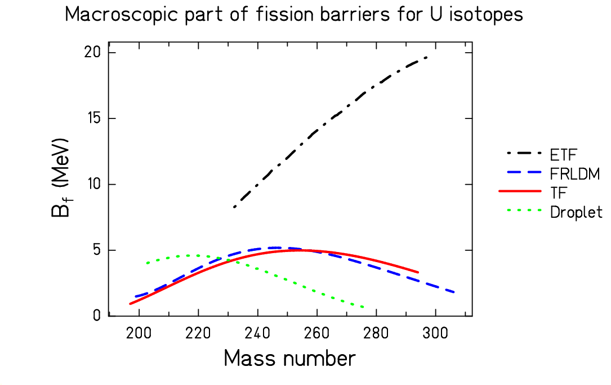
Figure 1. Macroscopic part of the fission barrier calculated for different uranium isotopes using: the extended Thomas-Fermi model [Error: Reference source not found] (dashed-dotted line), the finite-range liquid-drop model [Error: Reference source not found,Error: Reference source not found] (dashed line), the Thomas-Fermi model [Error: Reference source not found,Error: Reference source not found] (full line), and the droplet model [Error: Reference source not found] (point-line).

Fig. 2 shows a survey of nuclei used for the present study on a chart of the nuclides. The experimental fission barriers for these nuclei are taken from the compilation of Dahlinger et al. [Error: Reference source not found] and the experimental ground-state masses from the Audi and Wapstra 1995 compilation.
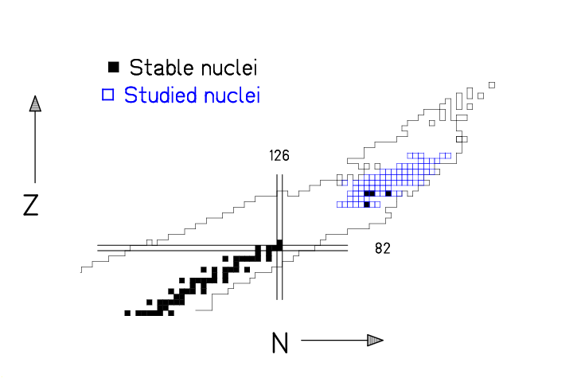

Figure 2. Blue squares represent the nuclei that were studied in the present work.

RESULTS AND CONCLUSIONS
For the case of uranium isotopes, the variable δU_{sad} as given by Eq. (1) is shown in Fig. 3 as a function of the neutron number. Results from the Droplet model (DM) show that δU_{sad} increases strongly with the neutron number, while the ETF model predicts a decrease. FRLDM and Thomas-Fermi model result in a quite similar behavior of δU_{sad} with almost a zero slope.
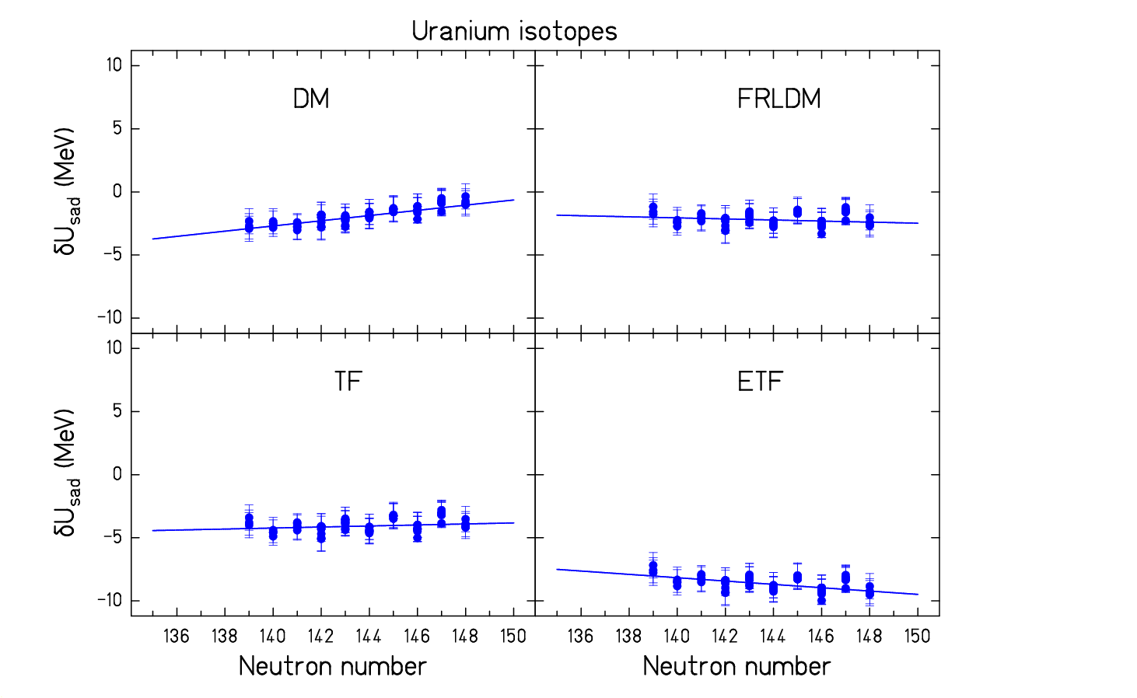
Figure 3. Difference between the total experimental energy at the saddle point (points) and the macroscopic part of the total calculated energy at the saddle point (lines) calculated with the droplet model, the finite-range liquid-drop model, the Thomas-Fermi model and the extended Thomas-Fermi model for different uranium isotopes.

We applied the same procedure for all nuclei indicated in Fig. 2. The extracted slopes (A₁) of δU_{sad} as function of the neutron excess are shown in Fig. 4 as a function of the nuclear charge number. Similar behavior seen in case of uranium is also seen for other nuclei. The droplet model predicts for all studied nuclei an increase in δU_{sad} as a function of the neutron excess. The value of the mean slope averaged over the studied Z is 0.15 MeV, and this indicates that a consistent description of the isospin dependence of nuclear masses within the droplet model is not possible. The same conclusion was obtained in Ref. [Error: Reference source not found], and shed a doubt on the applicability of the Howard-Möller tables of fission barriers [Error: Reference source not found] in regions far from the stability. In case of the ETF model we had available only the barriers for the uranium isotopes. Already in this case we see that over the range of 10 studied isotopes a clear correlation exists between δU_{sad} and N. For other nuclear charge numbers the values of the slopes were extrapolated from the uranium value based on the behavior of the FRLDM and the TF model. The average value of such obtained slopes is -0.12 MeV also indicating possible problems in the consistency of the ETF model in describing nuclear masses. Of course, for a definite conclusion one should perform the analysis with dedicated ETF calculations. The FRLDM and the TF model result both in rather small slopes of δU_{sad} functions, with average values of -0.04 MeV and 0.05 MeV, respectively. Although not zero, these average values are much lower than in case of the DM or the ETF model, and make FRLDM and the TF model to be preferential for the description of the fission barriers of exotic nuclei.
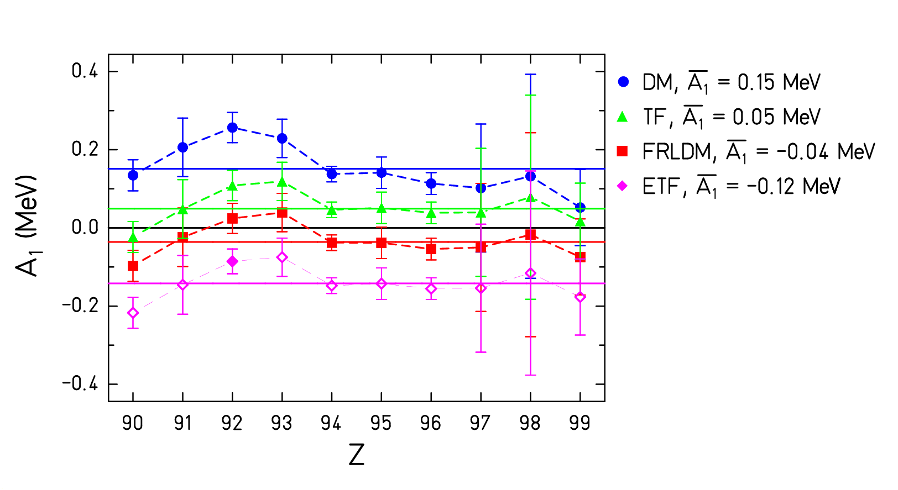
Figure 4. Slopes of δU_{sad} as a function of the neutron excess are shown as a function of the nuclear charge number Z obtained for the droplet model (points), the Thomas-Fermi model (triangles), FRLDM (squares) and the extended Thomas-Fermi model (rhomboids). The full lines indicate the average values of slopes. Average values are also written in the figure.

In conclusion, we have studied four different macroscopic models in order to find, which ones are most adapted for calculating the saddle-point masses of nuclei far from stability. The results of this study show that the preferential models should be the finite-range liquid-drop model [Error: Reference source not found,Error: Reference source not found] and the Thomas-Fermi model [Error: Reference source not found,Error: Reference source not found]. Severe doubts in the consistency of the droplet model [Error: Reference source not found] were seen, rising also the question of the applicability of the Howard-Möllers fission-barrier tables [Error: Reference source not found].

References

. J.M. Pearson and S. Goriely, Nucl. Phys. A in print.
. S. Bjørnholm and J.E. Lynn, Rev. Mod. Phys. 52 (1980) 725.
. M. Dahlinger, D. Vermeulen and K.-H. Schmidt, Nucl. Phys. A376 (1982) 94.
. W.D. Myers, „Droplet Model of Atomic Nuclei“, 1977 IFI/Plenum, ISBN 0-306-65170-X.
. W.M. Howard and P. Möller, At. Data Nucl. Data Tables 25 (1980) 219.
. A. Sierk, Phys.Rev. C33 (1986) 2039.
. P. Möller, J.R. Nix, W.D. Myers and W.J. Swiatecki, At Data Nucl. Data Tables 59 (1995) 185.
. W.D. Myers and W.J. Swiatecki, Phys. Rev. C 60 (1999) 014606-1.
. W.D. Myers and W.J. Swiatecki, Nucl. Phys. A 601( 1996) 141.
. A. Mamdouh, J.M. Pearson, M. Rayet and F. Tondeur, Nucl. Phys. A 679 (2001) 337.

