A new test for random events of an exponential distribution

Karl-Heinz Schmidt
Gesellschaft für Schwerionenforschung, Planckstraße 1, 64291 Darmstadt, Germany

Abstract: A new statistical test procedure is described to evaluate whether a set of radioactive-decay data is compatible with the assumption that these data originate from the decay of a single radioactive species. Criteria to detect contributions from other radioactive species and from different event sources are given. The test is applicable to samples of exponential distributions with two or more events.

Keywords: Statistical test; exponential distribution; radioactive decay

PACS: 02.50.-r, 06.20.Dk, 23.90.+w

1. Introduction

In the observation of radioactive-decay events it is a question of basic interest whether the data are compatible with the assumption that the measured time values originate from the decay of a single radioactive species. In the present work we will present a test particularly adapted to low counting statistics, which is based on the second moment of the logarithmic decay-time distribution. The new test provides an additional tool to validate important discoveries based on low event numbers as e.g. in the search for new heavy elements.

A radioactive nucleus is characterised by a certain decay probability per time dP/dt=λ. From a specific number n₀ of radioactive nuclei, each one decays independently of the others. Therefore, the number of remaining nuclei n(t) decreases gradually as a function of time:

dn/dt = -λ n(t). (1)

The solution of this differential equation is

n(t) = n₀ exp(-λt). (2)

The number of decay events per time is given by

|dn/dt| = λ n₀ exp(-λt). (3)

This is the density distribution of radioactive decays of one species of nuclei.

In an experiment, the times t₁, t₂, ..., t_{i},... , t_{n} of individual radioactive decays from a limited number of nuclei represent a sample of this density distribution. This sample is subject to statistical fluctuations. It is the task of a statistical analysis to deduce an estimate of the decay constant λ. This task may be complicated by the fact that the radioactive decays can only be observed in a limited time range, above a lower threshold t_{min} and below an upper threshold t_{max}. In addition, events of other species which decay with different decay constants or background events which appear with a constant rate may be mixed in. An even more complex situation appears, if daughter nuclei produced in the primary decay are also radioactive.

Elaborate methods have been developed to determine the decay constants λ of the contributing radioactive species and their statistical uncertainties (see e.g. ref. [] and the references given therein). A short review on these methods with special emphasis on their applicability to low counting statistics allows us to develop a new procedure in order to test the compatibility of measured data with the assumption of a radioactive decay. This test might be helpful to decide whether an observed sample of events originates from the radioactive decay of a single radioactive species. It also gives a handle to discover events from other sources than radioactive decay.

2. Analysis methods

2.1. First moment of the decay times

The first moment (average) of the density distribution (3) is

$\bar{t}=\frac{\int_{0}^{∞}{{tλn}_{0}\text{exp}(−λt)dt}}{\int_{0}^{∞}{{λn}_{0}\text{exp}(−λt)dt}}=\frac{{\left[\frac{−λt−1}{λ^{2}}\text{exp}(−λt)\right]}_{0}^{∞}}{{\left[\frac{1}{−λ}\text{exp}(−λt)\right]}_{0}^{∞}}=\frac{1}{λ}$ (4)

That means that the first moment of the measured decay times

${\bar{t}}_{\text{exp}}=\frac{\sum_{i=1}^{n}{t_{i}}}{n}$ (5)

is an estimate of the inverse of the decay constant 1/λ. However, there are a few prerequisites for the application of this method:
- The full time range must be covered by the measurement. (t_{min} must be very small and t_{max} must be very large compared to 1/λ.)
- Any contribution of other radioactive species and any background must be excluded.

The first moment of the measured decay times is easily evaluated and gives a good estimate for the decay constant, also in the case of low statistics, even for a single event.

The second moment could be used for testing the compatibility of the data with a radioactive decay. However, it is inconvenient that its value strongly depends on the decay constant which can only roughly be determined from the data in the case of low statistics.

2.2. Exponential decay curve

In the conventional analysis procedure of radioactive-decay data, the individual decay times are sorted into a spectrum with time intervals of constant width Δt. The channel m of the spectrum contains the number of events observed between the time t_{m} and the time t_{m}+Δt. The expected shape of this spectrum is approximately equal to the density distribution (3):

Δn/Δt ≈ dn/dt (6)

This spectrum has the shape of an exponential function. When drawn in a logarithmic scale, the data points are expected to follow a straight line. The decay constant can be determined by a fit, e.g. by the least-squares method which minimises the sum of the quadratic deviations of measured and calculated numbers of events per time interval. Contributions of another radioactive species and of background events can be recognised and extracted by using a more complex fit function.

The usage of this method is not so evident in the case of low statistics. Many time intervals may not contain any event, and the shape of the spectrum is dominated by statistical fluctuations. In this case, it is difficult to judge whether the spectrum contains decay events of a single nuclear species only. Another disadvantage of the method is that one needs a large number of channels to represent the mixture of different radioactive species with strongly differing life times.

2.3. Logarithmic time scale

An unconventional way to represent radioactive-decay data, first proposed in ref. [], consists of sorting the individual decay times into a spectrum with time intervals Δt which have a width that is proportional to the time t, that means Δt/t = constant. The representation in such logarithmic time bins allows storing the relevant information of decay times over a very large range of time with a moderate number of channels. The corresponding density distribution is given by

$\begin{aligned}\frac{dn}{d(\text{ln}t)}=\frac{dn}{dt}\frac{dt}{d(\text{ln}t)}=−n_{0}λt\text{exp}\left(−λt\right)= \\ −n_{0}\text{exp}\left(\text{ln}\left(λt\right)\right)\text{exp}\left(−\text{exp}\left(\text{ln}\left(λt\right)\right)\right)= \\ −n_{0}\text{exp}(\text{ln}t+\text{ln}λ)\text{exp}(\text{exp}\left(−\text{ln}t+\text{ln}λ\right))\end{aligned}$ (7)

or if we introduce $Θ=\text{ln}t$:

$|\frac{dn}{dΘ}|=n_{0}\text{exp}(Θ+\text{ln}λ)\text{exp}(−\text{exp}(Θ+\text{ln}λ))$. (8)

This is a bell-shaped, slightly asymmetric curve. It is obvious that the distribution does not depend in shape on the decay constant $λ$, it is just shifted by -lnλ=ln(1/λ). Only the height scales with the number of counts n₀. Its integral is equal to n₀. The maximum of this function is located at Θ_{max} which is given by:

$\frac{d^{2}n}{{dΘ}^{2}}=0→Θ_{\text{max}}=\text{ln}\left(1λ\right)$. (9)

The standard deviation (the square root of the second moment) of this curve is:

$σ_{Θ}=\sqrt{\frac{\int_{−∞}^{+∞}{{\left(Θ−\bar{Θ}\right)}^{2}|\frac{dn}{dΘ}|dΘ}}{n}}$ (10)

with

$\bar{Θ}=\frac{\int_{−∞}^{+∞}{Θ|\frac{dn}{dΘ}|dΘ}}{n}$ (11)

The value of $σ_{Θ}$ is about 1.28. The fact that a radioactive decay curve has a universal shape in this representation gives us a handle to detect if a second radioactive species contributes to the spectrum. In this case, the standard deviation of the logarithm of the measured decay times

$σ_{Θ_{\text{exp}}}=\sqrt{\frac{\sum_{i=1}^{n}{{\left(Θ_{i}−{\bar{Θ}}_{\text{exp}}\right)}^{2}}}{n}}$ (12)

with

${\bar{Θ}}_{\text{exp}}=\frac{\sum_{i=1}^{n}{Θ_{i}}}{n}$ (13)

is larger. If the standard deviation σ_{Θexp} is significantly smaller, this might be an indication that the decay-time spectrum is incomplete because the experiment was not sensitive to the whole range of decay times. If this possibility is excluded, this is a strong indication that the observed events or at least part of them do not originate from radioactive decays but from some other source.

3. Test procedure

As suggested in the preceding chapter, the universal shape of the logarithmic time distribution of radioactive decays offers the possibility for testing whether a set of measured data is compatible with the assumption that these data originate from the radioactive decay of a single nuclear species. On the basis of this idea, we will elaborate a test which compares the standard deviation of the measured logarithmic time distribution with theoretical expectations.

Like the time values t_{i} of individual radioactive-decay events, also the standard deviation σ_{Θexp} of the logarithmic decay-time distribution of a specific experiment evaluated by equation (12) is subject to statistical fluctuations. The expected magnitude of these fluctuations can be estimated. They give a measure for the expected deviation of the width of the measured logarithmic decay-time distribution from the expected value.

The basic idea of the test we propose in the present work is best illustrated for the case of two observed decay events. Let us assume that their decay times differ by a factor of two or three. Considering the spread of an exponential decay, such behaviour looks quite "normal" to us. Now take another two decay events which differ by several orders of magnitude in time. This does not look like a "normal" behaviour. One is tempted to attribute the two events to two different radioactive species with different life times. A third sample may consist of two measured events with almost exactly the same time values. Also this sample does not look "normal", it is a fortuitous, not very probable result. It will be our task to find a quantitative description for the compatibility of such observations with the assumption of the decay of a single radioactive species.

A closer view on the problem reveals that the expected distribution of the standard deviation σ_{Θexp} of logarithmic decay-time distributions (equation 12) differs systematically from the distribution of σ_{Θ} values defined by equation (10). The reason for this difference is that $\bar{Θ}$ in equation (10) is the "true" mean value of the distribution, while ${\bar{Θ}}_{\text{exp}}$ is the estimate for the mean value deduced from the observed events (equation 13). Therefore, the standard deviation σ_{Θexp} is systematically smaller than the value of σ_{Θ}, especially for small numbers of events. Some expected characteristic properties of the distribution of σ_{Θexp} values have been calculated with Monte-Carlo techniques. A number n of random decay times t₁,…, t_{n} from a given exponential distribution were chosen at random and analysed according to equations (12) and (13) to determine a statistical sample of $σ_{Θ_{\text{exp}}}$. This procedure was repeated many times. These samples of $σ_{Θ_{\text{exp}}}$ are denoted by x_{j}(n), j = 1 to k, in the following. From a large number of samples (k→∞) for different values of n, the expectation value E_{n}, the standard deviation σ_{n}, and the relative skewness γ_{n} of the distribution of the quantity $σ_{Θ_{\text{exp}}}$ as a function of n were calculated from the relations:

$E_{n}=\underset{k→∞}{\overset{}{\text{lim}}}\left\{\frac{\sum_{j=1}^{k}{x_{j}\left(n\right)}}{k}\right\}$, (14)

Table 1: Expected properties of the distribution of the standard deviation σ_{Θexp} of logarithmic decay-time distributions, defined by equations (12) and (13) for given numbers n of observed events. The values have been calculated by Monte-Carlo techniques. This explains their slightly irregular behaviour. Experimental values falling below the lower limit can be rejected with an error chance below 5 % to originate from radioactive decay. Experimental values falling above the upper limit can be rejected with an error chance below 5 % to belong to the decay of a single radioactive species.

Number of events  n | Expectation value E_{n} for  $$σ_{Θ_{\text{exp}}}$$ | Expected standard deviation  σ_{n} of$σ_{Θ_{\text{exp}}}$ | Expected relative skewness γ_{n} | Lower limit  of $σ_{Θ_{\text{exp}}}$ | Upper limit  of $σ_{Θ_{\text{exp}}}$
1 | 0 | 0 | 0 | - | -
2 | 0.69 | 0.58 | 1.42 | 0.04 | 1.83
3 | 0.89 | 0.55 | 1.24 | 0.19 | 1.91
4 | 0.98 | 0.50 | 1.13 | 0.31 | 1.92
5 | 1.04 | 0.47 | 1.12 | 0.41 | 1.90
6 | 1.08 | 0.44 | 1.10 | 0.48 | 1.89
7 | 1.11 | 0.42 | 0.99 | 0.52 | 1.87
8 | 1.13 | 0.40 | 0.96 | 0.58 | 1.85
9 | 1.15 | 0.38 | 0.95 | 0.62 | 1.84
10 | 1.16 | 0.37 | 0.90 | 0.65 | 1.82
11 | 1.17 | 0.35 | 0.84 | 0.67 | 1.81
12 | 1.18 | 0.34 | 0.84 | 0.70 | 1.79
13 | 1.19 | 0.33 | 0.82 | 0.72 | 1.77
14 | 1.19 | 0.32 | 0.78 | 0.73 | 1.77
15 | 1.20 | 0.31 | 0.78 | 0.75 | 1.76
16 | 1.20 | 0.30 | 0.76 | 0.77 | 1.75
17 | 1.21 | 0.30 | 0.74 | 0.78 | 1.74
18 | 1.22 | 0.29 | 0.72 | 0.79 | 1.73
19 | 1.22 | 0.28 | 0.69 | 0.80 | 1.72
20 | 1.22 | 0.28 | 0.68 | 0.81 | 1.71
30 | 1.24 | 0.23 | 0.57 | 0.89 | 1.64
40 | 1.25 | 0.20 | 0.55 | 0.94 | 1.60
50 | 1.25 | 0.20 | 0.55 | 0.98 | 1.57
60 | 1.26 | 0.17 | 0.44 | 1.00 | 1.54
70 | 1.26 | 0.15 | 0.45 | 1.02 | 1.53
80 | 1.27 | 0.15 | 0.45 | 1.04 | 1.51
90 | 1.27 | 0.14 | 0.40 | 1.05 | 1.50
100 | 1.27 | 0.13 | 0.37 | 1.06 | 1.49
n → ∞ | 1.28 | 1.3 / √n | → 0 | 1.28 - 2.15/ √n | 1.28 + 2.15/√n

$σ_{n}=\sqrt{\underset{k→∞}{\text{lim}}\left\{\frac{\sum_{j=1}^{k}{{\left(x_{j}\left(n\right)−E_{n}\right)}^{2}}}{k}\right\}}$, (15)

and

$γ_{n}=\underset{k→∞}{\text{lim}}\left\{\frac{\sum_{j=1}^{k}{{\left(x_{j}\left(n\right)−E_{n}\right)}^{3}}}{k}\right\}/σ_{n}^{32}$ (16)

The resulting values are listed in table 1. (Of course, only a finite value of k could be realised in the numerical calculation. This explains the slightly irregular behaviour of the values.)

By normalising the distributions obtained for $σ_{Θ_{\text{exp}}}$ from these samples and integrating up to levels of 5 % and 95 %, respectively, one obtains the limits which comprise the range of $σ_{Θ_{\text{exp}}}$ values which can be accepted with a 90 % significance level to belong to the radioactive decay of a single radioactive species. These limits are also listed in table 1. Experimental values of $σ_{Θ_{\text{exp}}}$ falling below the lower limit can be rejected with an error chance below 5 % to originate from radioactive decay. If the experiment was sensitive to the whole decay-time range, at least part of the events originates from another kind of source, may be from some periodic noise. Experimental values of $σ_{Θ_{\text{exp}}}$ falling above the upper limit can be rejected with an error chance below 5 % to belong to the decay of a single radioactive species. If any background can be excluded, there is probably another radioactive species with another life time which contributes to the observed sample. The test can easily be extended to other values of the significance level.

4. Examples

Finally, we would like to illustrate the test procedure with two examples. In the discovery of the nucleus ²⁷¹110, five events with alpha energies close to 10.74 MeV have been observed []. The decay times measured were 0.6 ms, 1.8 ms, 4.4 ms, 0.5 ms, and 2.6 ms. The analysis of these events results in a value of 0.84 for $σ_{Θ_{\text{exp}}}$. This value falls well between the limits (0.41 and 1.9) defined by a significance level of 90 % given in table 1 for 5 events. Thus, these events are consistent with the assumption, that they originate from the decay of one radioactive species, namely the same state of ²⁷¹110.

Figure 1 demonstrates the time distribution of these events on a logarithmic time scale. The expected logarithmic decay-time distribution (Eq. 7) with $\text{ln}\left(1λ\right)=0\text{.}\text{84}$ (using a time unit of 1 ms) is shown in addition. This graphical presentation gives an illustration on the scattering of the decay times of a radioactive nucleus.

As a second example we chose the three decay chains, attributed to the alpha-decay cascade of the nucleus ²⁹³118 as reported in ref. []. Since the decay times of the second, the third and the forth decay in these chains are rather close in time, we apply the test to the totality of these 9 observed decay times. The values are given in table 2. The data originate from the decay of at least 3 different states. Therefore, we expect some broadening of the distribution if compared to the decay of a single state. This means that only deviations of $σ_{Θ_{\text{exp}}}$ below the lower limit of the confidence interval are significant. They would give some indication that the source of the events is different from a radioactive decay.

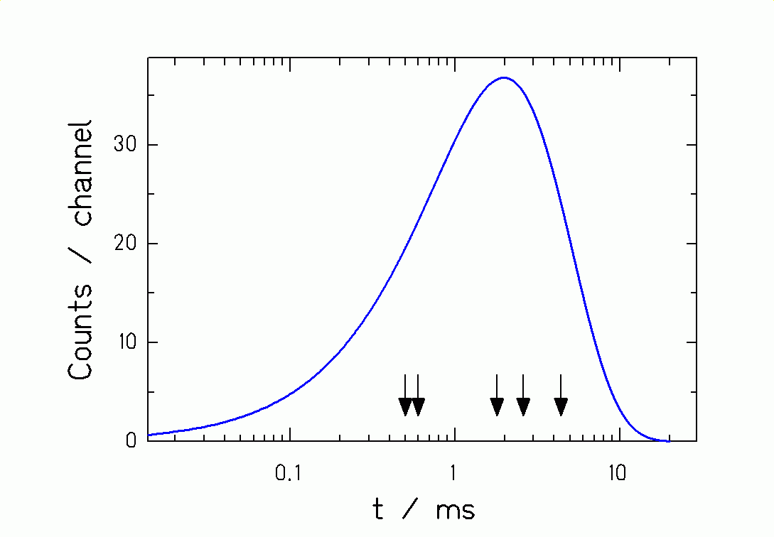

Fig. 1: Logarithmic decay-time distribution of 5 events observed in the α decay of ²⁷¹110 with alpha energies close to 10.74 MeV. Data are taken from ref. [Error: Reference source not found]. The curve shows the logarithmic decay-time distribution (Eq. 7). The units on the ordinate are arbitrary.

The resulting value of $σ_{Θ_{\text{exp}}}$ = 0.467, calculated from the values in table 2 with equations (12) and (13), is clearly lower than the lower limit of the 90 % confidence interval given in table 1 which was determined to be 0.62. According to our criterion, the assumption that these events originate from radioactive decays is statistically rejected with an error probability of less then 5 %. This value gives the probability for an error of the first kind, i.e. the probability that the rejection is not justified. We would like to stress that the level of 5% does not provide strong evidence for the interpretation of these data. The test just yields an additional criterion for the judgement of the data, to be combined with the other experimental information available.

Table 2: Measured decay times of the second, third and forth alpha decay of the three decay chains, attributed to the decay of ²⁹³118 in ref. [Error: Reference source not found].

 | First chain | Second chain | Third chain
α₂ | 1.243 ms | 1.207 ms | 0.310 ms
α₃ | 0.708 ms | 0.741 ms | 1.047 ms
α₄ | 1.201 ms | 1.750 ms | 0.939 ms

5. Conclusion

We have developed a procedure to test the hypothesis that a set of data originates from the decay of a single radioactive species. Larger fluctuations indicate that there is a continuous background or that one or more additional radioactive species with different half lives contribute to the data. Smaller fluctuations indicate that at least part of the data cannot be attributed to a radioactive decay but rather originates from a periodic noise. The test is particularly suited for small event numbers. It is applicable to any random variable governed by an exponential distribution.

E mail: k.h.schmidt@gsi.de
In these considerations we use t and λ as dimensionless numbers by implicitely introducing a time unit. The results of this work do not depend on the choice of this time unit.
[?] R. M. Barnett et al., Phys. Rev. D 54 (1996) 1
[?] K.-H. Schmidt, C.-C. Sahm, K. Pielenz, H.-G. Clerc, Z. Phys. A 316 (1984) 19
[?] S. Hofmann, Rep. Prog. Phys. 61 (1998) 639
[?] V. Ninov, K. E. Gregorich, W. Loveland, A. Ghiorso, D. C. Hoffman, D. M. Lee, H. Nitsche, W. J. Swiatecki, U. W. Kirbach, C. A. Laue, J. L. Adams, J. B. Patin, D. A. Shaughnessy, D. A. Strellis, P. A. Wilk, Phys. Rev. Lett. 83 (1999) 1104

