New Method and Data on Residue Production in Spallation by ²⁰⁸Pb on Protons for the Design of Spallation Sources

T. Enqvistª, W. Wlazlo^{b}, J. Benlliure^{c}, F. Rejmund^{d}, P. Armbrusterª,
M. Bernas^{d}, A. Boudard^{b}, S. Czajkowski^{e}, R. Legrain^{b}, S. Leray^{b},
B. Mustapha^{d}, M. Pravikoff^{e}, K.-H. Schmidtª, C. Stéphan, J. Taieb^{d},
L. Tassan-Got^{d}, C. Volant^{b}

ªGSI, Planckstraße 1, D-64291 Darmstadt, Germany
^{b}DAPNIA/SPhN CEA/Saclay, F-91191 Gif-sur-Yvette, France
^{c}University of Santiago de Compostela, E-15706 Santiago de Compostela, Spain
^{d}IPN Orsay, IN2P3, F-91406 Orsay, France
^{e}CENBG, IN2P3, F-33175 Gradignan, France

- Introduction

The design of an accelerator-driven system (ADS) requires precise knowledge of nuclide production cross sections in order to be able to predict the amount of radioactive isotopes produced inside the spallation target. Short-lived isotopes may be responsible for maintenance problems, and long-lived ones will increase the long-term radiotoxicity of the system. Recoil kinetic energies of the fragments are important for studies of radiation damages in the structural materials. Spallation of lead is particularly important since in most of the ADS concepts actually discussed, lead or lead-bismuth alloy is considered as the preferred material of the spallation target.
The accuracy of existing spallation models to estimate residual production cross sections is still far from the performance required for technical applications. This is shown, for example in the intercomparison, ref. []. These difficulties can mostly be ascribed to the lack of complete distributions of all isotopes produced which would be needed to constrain the models. Therefore, experimental data are urgently needed.
We report here on the complete isotopic production cross sections of all elements from titanium to lead, measured in the inverse-kinematics spallation reaction of 1 GeV protons with lead. In addition, the velocity distributions of all the produced isotopes were measured, giving crucial information on the reaction mechanisms involved. A detailed description of this experiment is given in refs. [, ].

2. Experiment and Data Analysis

The experimental method and the analysis procedure have been developed and applied in previous experiments [, , ]. The primary beam of 1 A GeV ²⁰⁸Pb was delivered by the heavy-ion synchrotron SIS at GSI, Darmstadt. The dedicated experimental set up is shown in Fig. 1. The proton target was composed of 87.3 mg/cm² liquid hydrogen [] enclosed between thin titanium foils of a total thickness of 36 mg/cm². The primary-beam intensity was continuously monitored by a beam-intensity monitor based on secondary-electron emission []. In order to subtract the contribution of the target windows from the measured reaction rate, measurements were repeated with the empty target. Heavy residues produced in the target were all strongly forward focused due to the inverse kinematics. They were identified using the Fragment Separator (FRS) [].
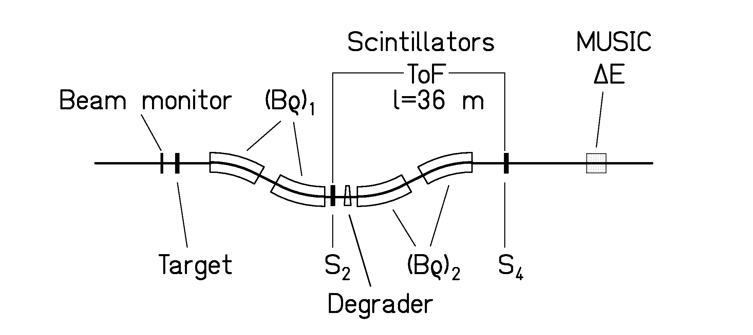

Fig. 1: Schematic drawing of the fragment separator FRS with the detector equipment. For details see text.

The FRS is a two-stage magnetic spectrometer with a dispersive intermediate image plane (S₂) and an achromatic final image plane (S₄) with a momentum acceptance of 3% and an angular acceptance of about 15 mrad around the beam axis. Two position-sensitive plastic scintillators placed at S₂ and S₄, respectively, provided the magnetic- rigidity (Bρ) and time-of-flight measurements, which allowed to determine the mass-over-charge ratio of the particles.
For an unambiguous isotopic identification of the reaction products, the analysis was restricted to ions which passed both stages of the fragment separator fully stripped. The losses in counting rate due to the fraction of incompletely stripped ions and the losses due to secondary reactions in the layers of matter in the beam line were corrected for.
To separate all residues with nuclear charges from 22 to 82, it was necessary to use two independent methods in the analysis. The nuclear charges of the lighter elements, mainly produced by fission, were deduced from the energy loss in an ionisation chamber (MUSIC). Fig. 2(a) shows a nuclear-charge spectrum combined from three different settings of the FRS. The nuclear-charge resolution obtained is Z/ΔZ = 170 for the primary beam. Combining this information with the mass-over-charge ratio, a complete isotopic identification is performed. Instead of the mass number A, the quantity A-3Z is shown in Fig. 2(b). By choosing this quantity, a good overlap of the mass of the primary beam and the masses of the fragments was obtained. A mass resolution of A/ΔA = 480 was achieved.
Since part of the heavier reaction products was not completely stripped, the MUSIC signal was not sufficient for an unambiguous Z identification. Therefore, the identification of reaction products of elements from terbium to lead was performed with the help of an achromatic energy degrader [] placed at the intermediate image plane of the FRS. Two degrader thicknesses, 5.8 g/cm² and 5.2 g/cm² of aluminium were used for the lighter and for the heavier part of the elements. The nuclear charge of the products was deduced from the reduction in magnetic rigidity by the slowing down in the energy degrader. The MUSIC signal was still essential for suppressing events of incompletely stripped ions and from nuclei destroyed by secondary reactions in the degrader. The separation of the heavy fragments is demonstrated in Fig. 3 for a FRS setting centred on ¹⁸⁴Pt. The velocity of the identified residue was determined at S2 from the Bρ value and transformed into the frame of the beam in the middle of the target, taking into account the appropriate energy loss. More than 100 different values of the magnetic fields were used in steps of about 2 % in order to cover all the produced residues and to construct the full velocity distribution of each residue.
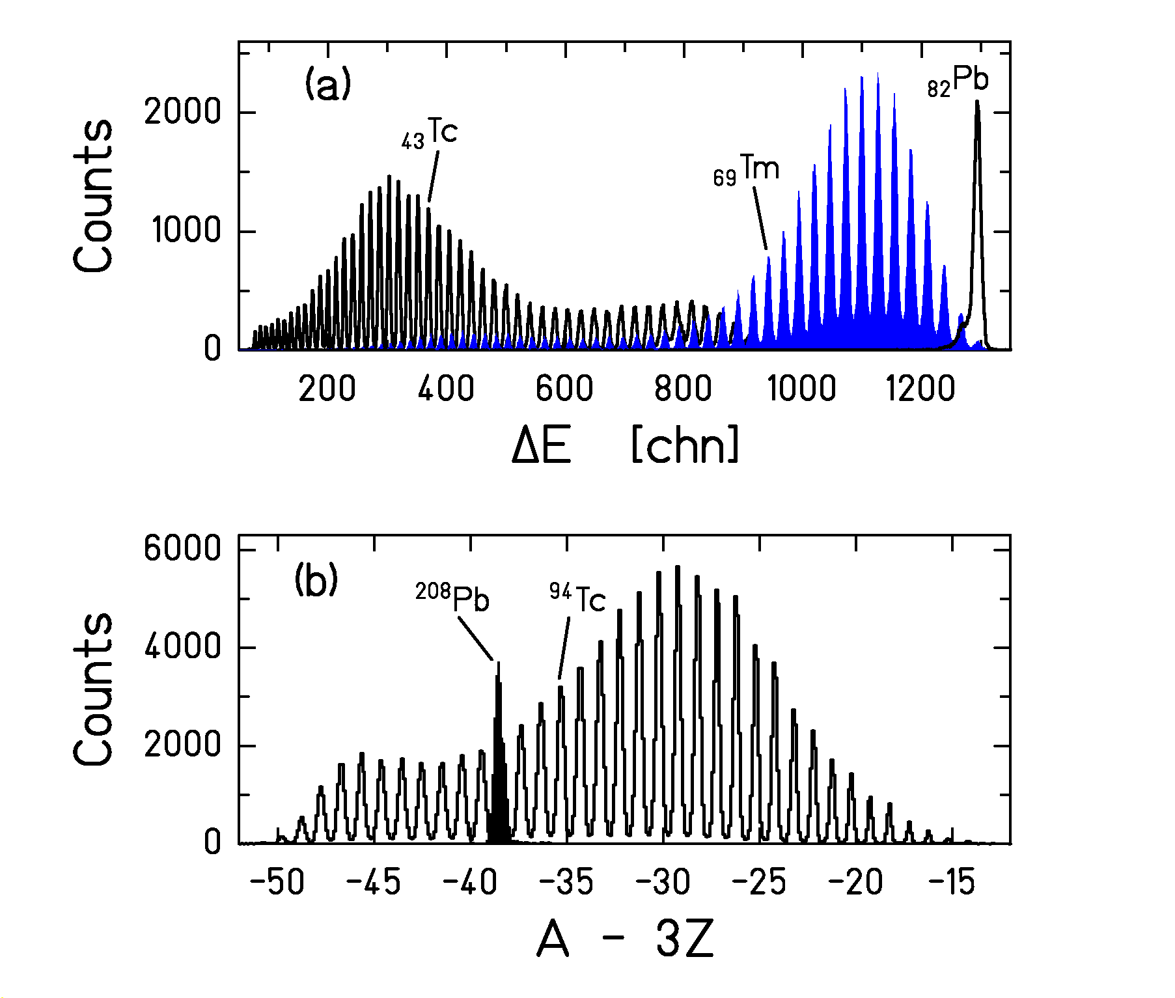
Fig. 2: (a) Energy-loss signals of the MUSIC detector recorded for three different settings of the FRS tuned on ⁹⁴Tc (left open histogram), ¹⁵⁸Tm (full histogram) and the primary beam ²⁰⁸Pb (right open histogram). (b) Mass spectrum collected in the setting centred on ⁹⁴Tc (open histogram). The mass peak of the primary beam at A-3Z=-38 (full peak) was used to calibrate the masses.

The re-construction of the full velocity distribution allows to disentangle reaction products formed in fragmentation and fission reactions due to their different kinematical properties. The velocity distributions as a function of neutron number for 12 selected elements are shown in Fig. 4 as cluster plots. It can be seen from the distributions that the reaction products can be attributed to different reaction mechanisms, i.e. fission and fragmentation. For isotopes close to the projectile produced by fragmentation, one or two settings are able to cover the whole distribution of one isotope. Around mass region 150, three or four settings are needed. For isotopes produced by fission, only those emitted either in forward or in backward direction with respect to the primary beam can be observed in a given setting of the FRS because the angular acceptance is too small for sideward emitted fragments. The production of lighter elements from fragmentation (Z ≤ 60, and mean velocity centred close to the primary-beam velocity) seen in Fig. 4, does not result from primary reactions in the liquid-hydrogen target, but from secondary reactions or from reactions in the titanium target windows
For heavy residues (Tb, Yb, Re, Hg), only contributions from fragmentation reactions can be seen as centred closely below the velocity of the projectiles. For lighter elements, also contributions of fission can be observed at backward and forward velocities due to the Coulomb repulsion of the two fission products. The averaged velocities of backward- and forward-emitted fission fragments differ from zero in Fig. 4, because the velocity of the fissioning nucleus is lower than that of the projectile due to a slowing-down process in the intra-nuclear cascade phase of the reaction.
The data are normalised to the number of projectiles recorded by the beam-intensity monitor. Corrections for dead time, for the contribution from incompletely stripped ions and for counting losses due to secondary reactions in the degrader and the scintillation detector at S2 have already been performed. The distributions shown in Fig. 4 still contain a contribution of reaction rates in the titanium windows of the target. Additional corrections account for the angular transmission of the FRS and secondary reactions inside the liquid-hydrogen target, before the production cross sections are deduced.

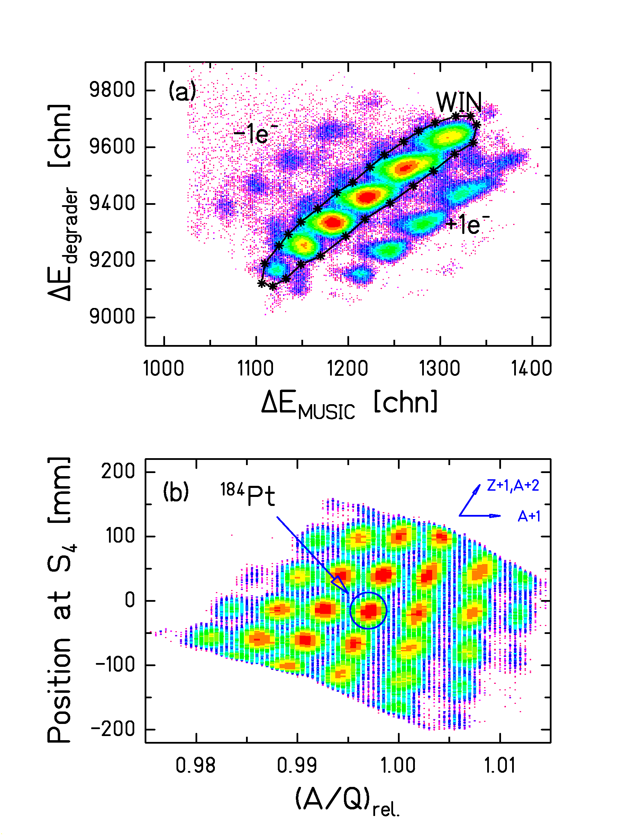
Fig. 3 (a) The figure illustrates the method used to suppress the fraction of incompletely stripped ions and ions destroyed by secondary reactions in the layers at the intermediate image plane of the FRS. The 2-dimensional condition "WIN" marks the selected events of Z=74 to Z=80. ΔE_{MUSIC} is the energy loss measured in the ionisation chamber, the ordinate value is the difference in magnetic rigidity in the first and the second halfs of the FRS. The spectrum has been accumulated in a setting centred on ¹⁸⁴Pt with 5.2 g/cm² degrader. (b) Nuclear-charge and mass calibration method of elements from terbium to lead. The arrows in the right-upper corner show the identification of other isotopes with respect to the centred isotope ¹⁸⁴Pt. Intensities in both spectra reach over 3 orders of magnitude.

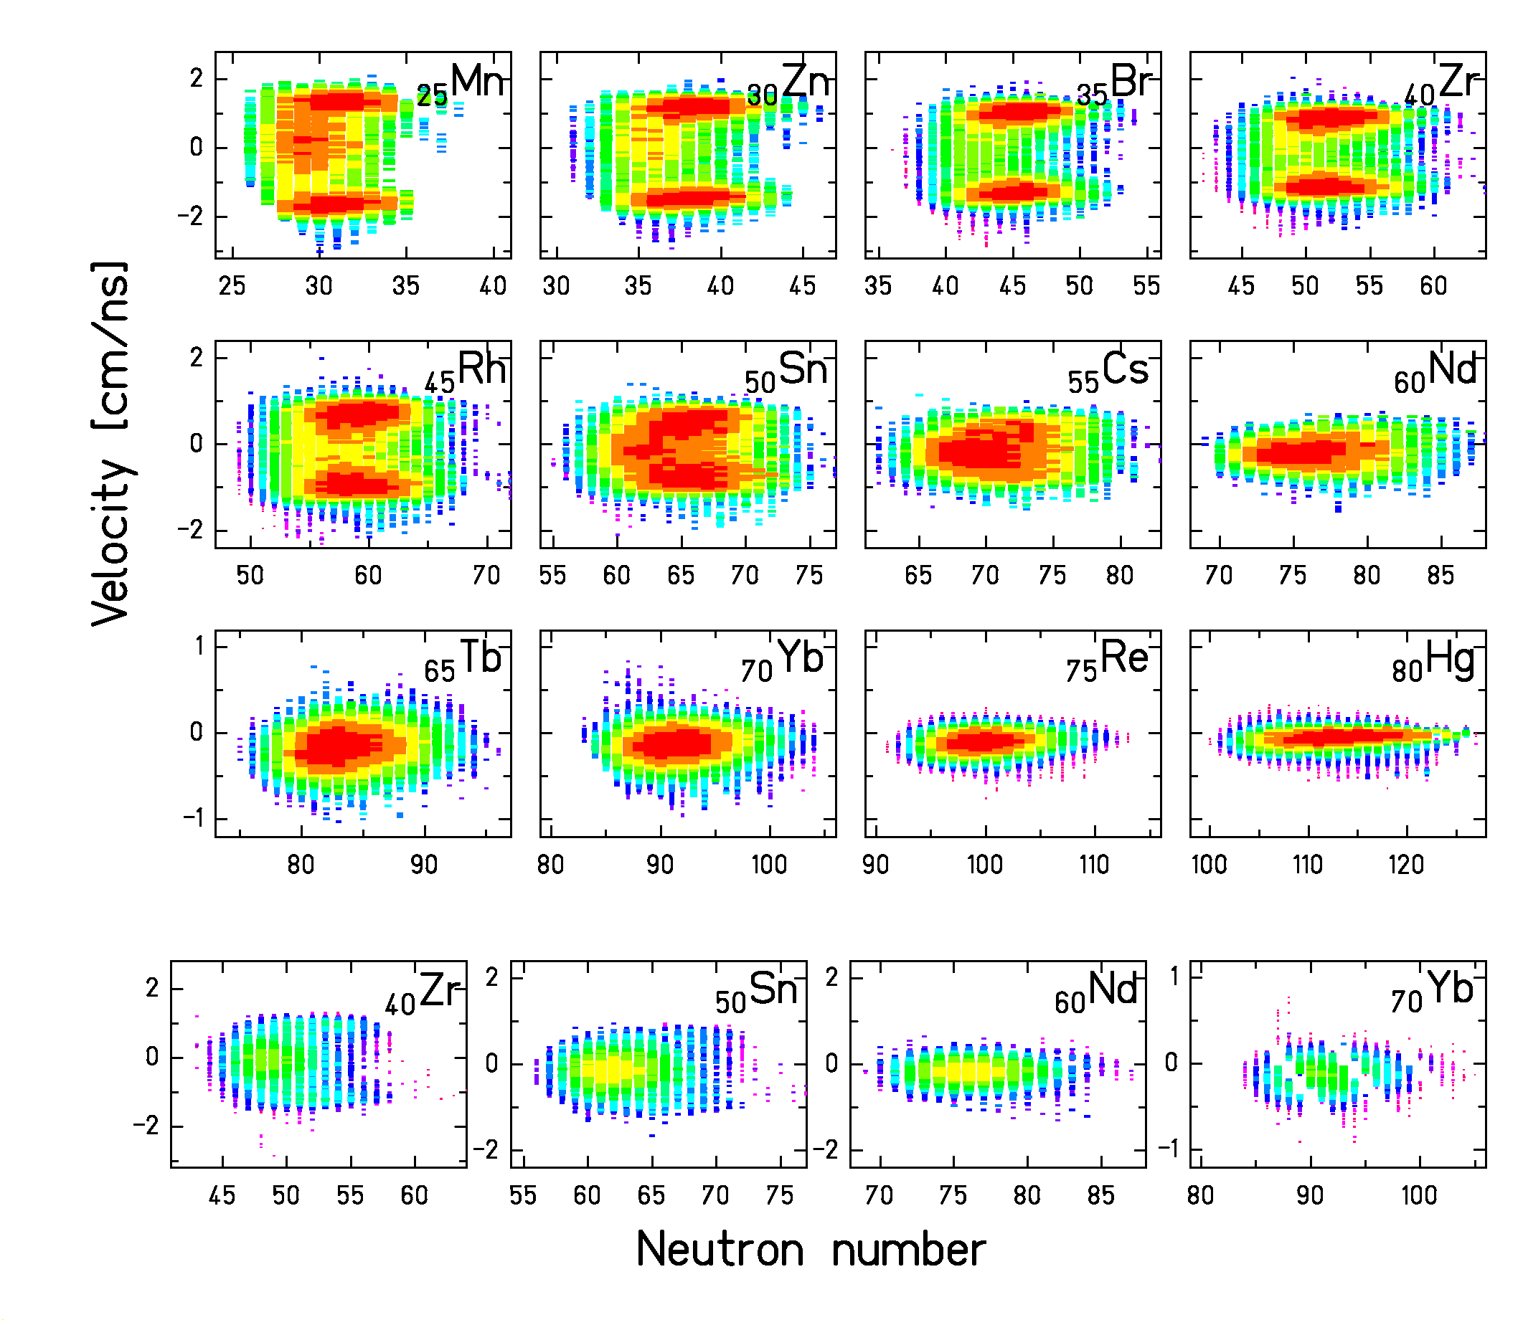
FIG. 4: Two-dimensional cluster plots of velocity versus neutron number for 12 selected elements. The three uppermost rows show the reaction rate with the full target and the lowest row with the empty target (target windows). The velocity is given in the centre-of-mass system of the primary beam in the middle of the target. The intensity scale is logarithmic and different for each element, the full and empty target contributions can directly be compared. The distribution of the ytterbium isotopes produced in the empty target was incompletely measured. Note also the different scales in velocity in different rows.
3. Results

Table 1 gives the incineration experiments performed at GSI. The measured total fission cross section from Pb+p at 1 A GeV for elements from titanium to tellurium amounts to σ_{f} = (157±7) mb in the present work. Only the statistical uncertainty is given here. The total fission cross section can be compared with previously measured values of σ_{f} = (132±13) mb and σ_{f} = (142±14) mb [] obtained in direct kinematics with 1 GeV p+Pb. In view of the 15% systematic uncertainty of our value, all the high-accuracy measurements are in reasonable agreement. The total fragmentation cross section amounts to σ_{frag} = (1.67±0.22) b. The total reaction cross section measured in the present experiment for ²⁰⁸Pb at 1 A GeV on protons amounts to σ_{tot} = (1.82 ± 0.18) b. The model of Karol [] with the modifications of Brohm [] gives σ_{tot} = 1.80 b.
The measured production cross sections for fission and fragmentation of ²⁰⁸Pb at 1 A GeV on protons have been summarised in Fig. 5 on a chart of the nuclides. It shows the production of about 900 isotopes.

Test experiment
²³⁸U (1 A GeV) + ²⁰⁸Pb (Nov. 1996) | Ref. [Error: Reference source not found]
Five experiments have been performed
¹⁹⁷Au (800 A MeV) + H₂ (Feb. 1997) | Refs. [, ]
²³⁸U (1 A GeV) + H₂, D₂ (July 1997) | Data analysis
²⁰⁸Pb (1 A GeV) + H₂, D₂ (Oct. 1997) | Refs. [Error: Reference source not found, Error: Reference source not found]
208Pb (500 A MeV) + H2, D2 (Apr. 1999) | Data analysis
56Fe + H2, D2 (Oct. 2000) | Measured

Table 1: Incineration experiments performed at GSI.
For the published and accepted papers, electronic files of the preprints and the data are accessible via the WEB address: http://www-wnt/kschmidt/publica.htm .
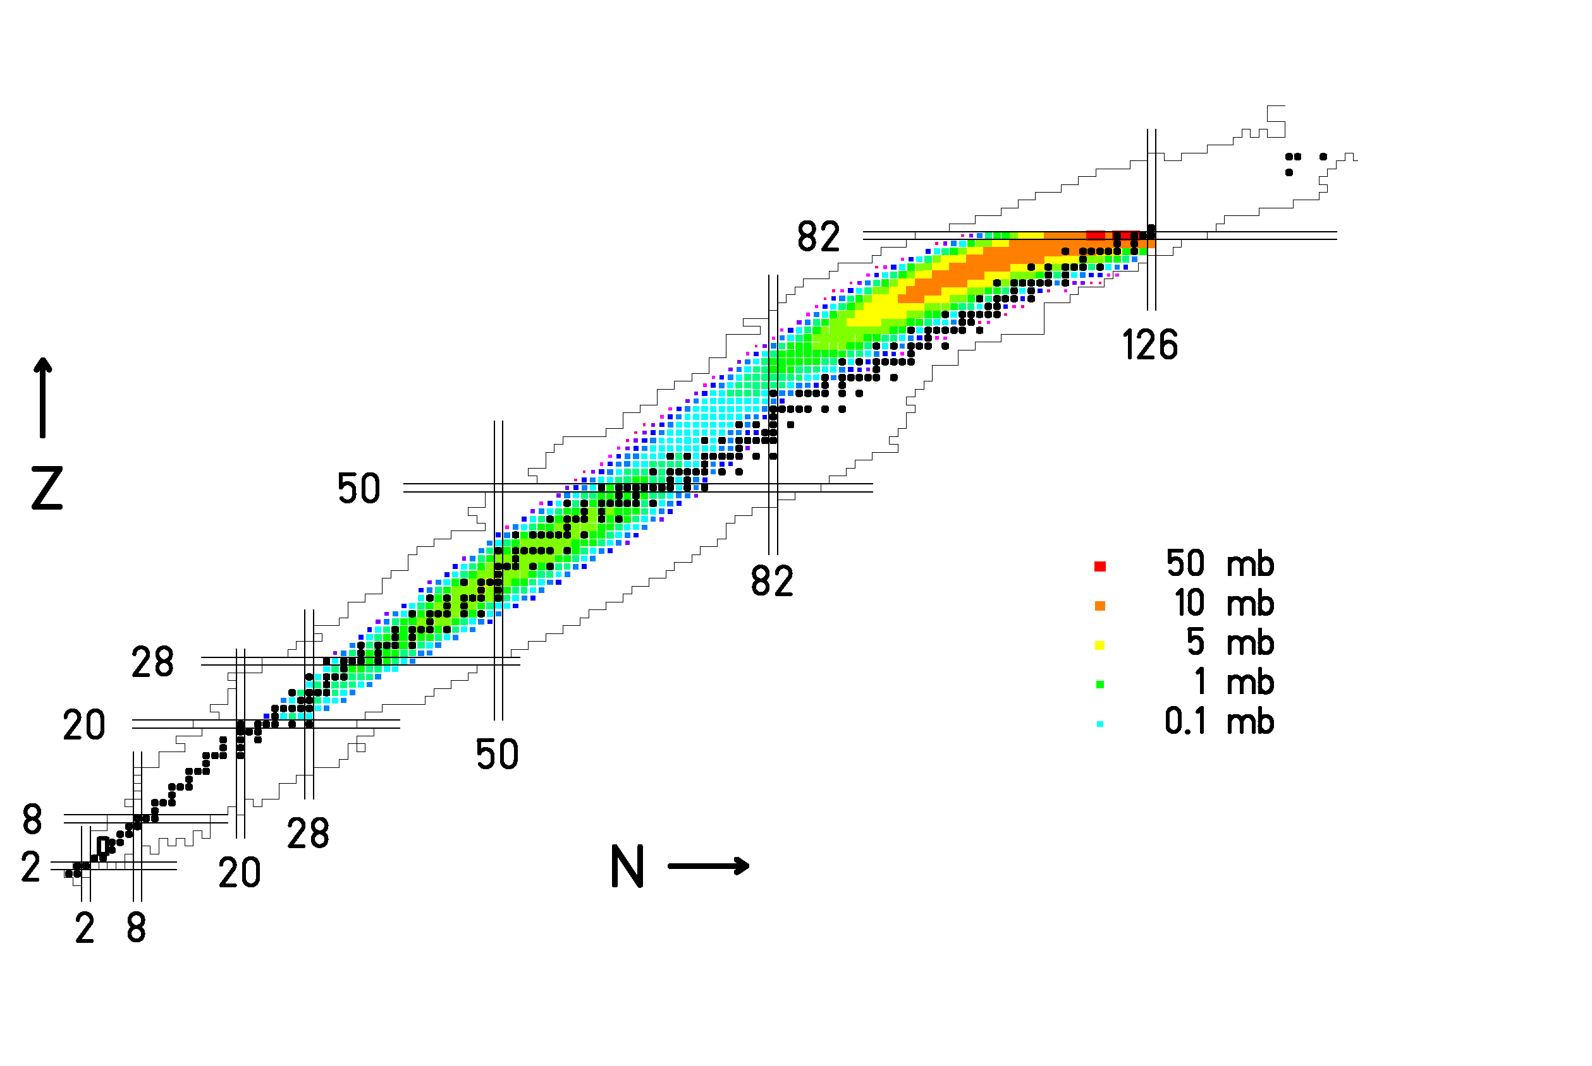

Fig. 5: Two-dimensional cluster plot of the isotopes production cross sections obtained in the present work shown as chart of the nuclides. Full black squared correspond to stable isotopes. Fragmentation-evaporation residues and fragmentation-fission residues are separated by a minimum of cross sections at Z = (53 ± 3).

The average kinetic energy of the recoil product formed by fragmentation can be determined using the measured velocity distribution, see Fig. 6. From these distributions, an average velocity ${\bar{v}}_{\text{cn}}$ and width ${\bar{σ}}_{\text{cm}}$ of the velocity component parallel to the beam axis are extracted for all isotopes. The velocity components perpendicular to the beam axis have an average velocity equal to zero and, in accordance with available systematics [] we assume that they have the same width as the parallel component. The average kinetic energy of a spallation recoil product can then be written as

${\bar{E}}_{\text{kin}}=\frac{1}{2}⋅{\text{Am}}_{0}\left({\bar{v}}_{\text{cm}}^{2}+3σ_{\text{cm}}^{2}\right)$

The kinetic energy of a spallation recoil product as a function of the proton and mass numbers, determined as the weighted average, is shown in Fig. 6a.
The average kinetic energy of a fission fragment can be calculated by the equation

${\bar{E}}_{\text{cm}}=\frac{1}{2}⋅{\text{Am}}_{0}⋅\left({\bar{v}}_{\text{fis}}^{2}+{\bar{v}}_{\text{cm}}^{2}\right)$

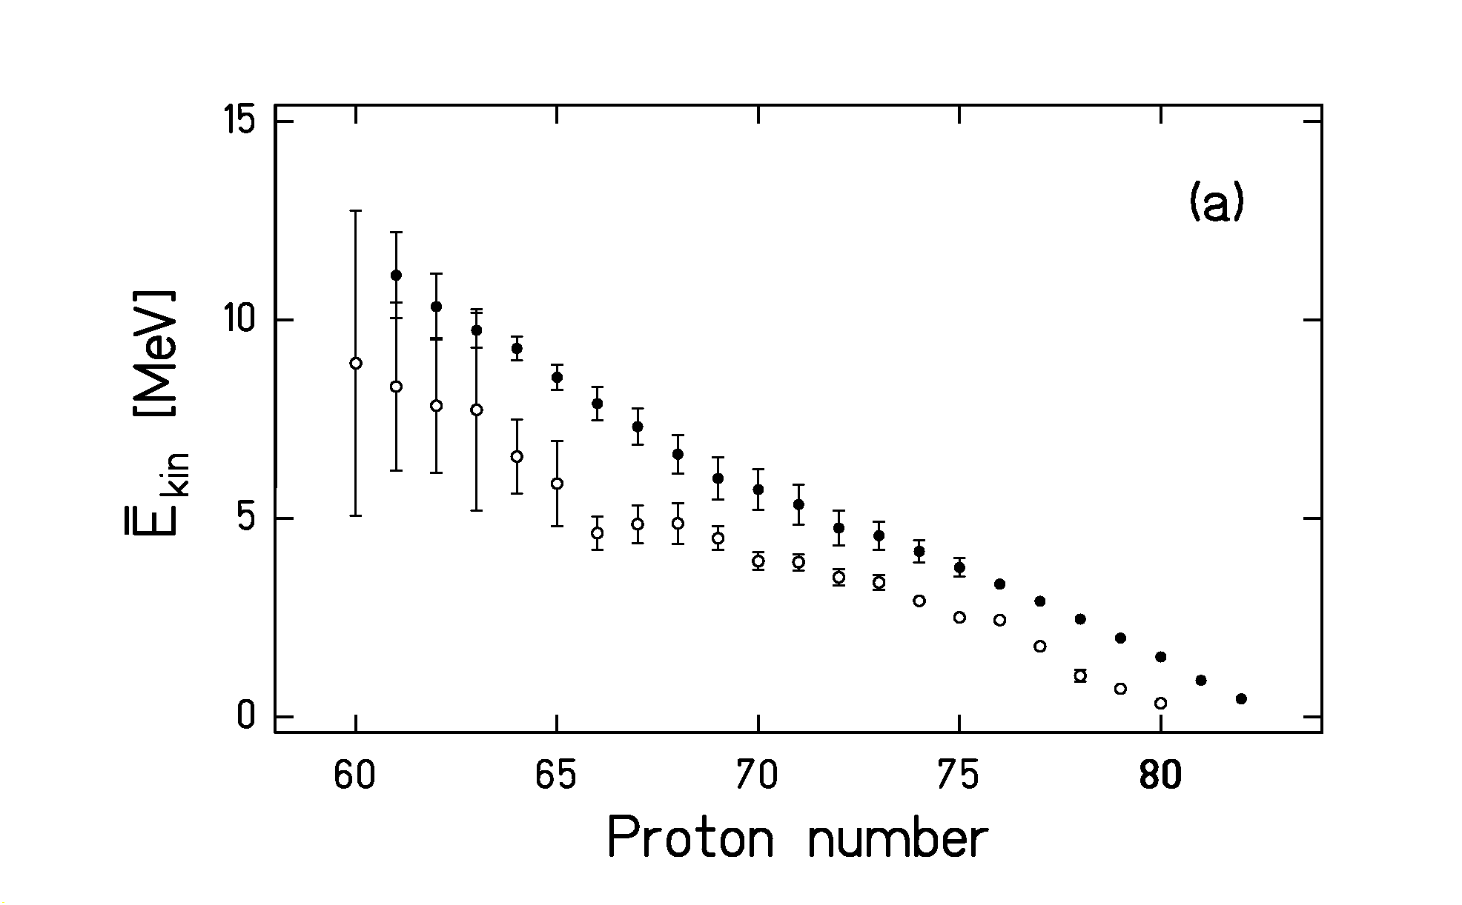
when a uniform isotropic velocity distribution is assumed; m₀ is the atomic mass unit, ${\bar{v}}_{\text{fis}}$ the average velocity of the fission fragment with respect to the fissioning nucleus. Finally ${\bar{v}}_{\text{cm}}$ is velocity of the fissioning nucleus in the frame of the projectile, determined as the average fission-fragment velocity. The kinetic energy of one fission fragment as a function of its proton number, determined as the weighted average, is shown in Fig. 6b.
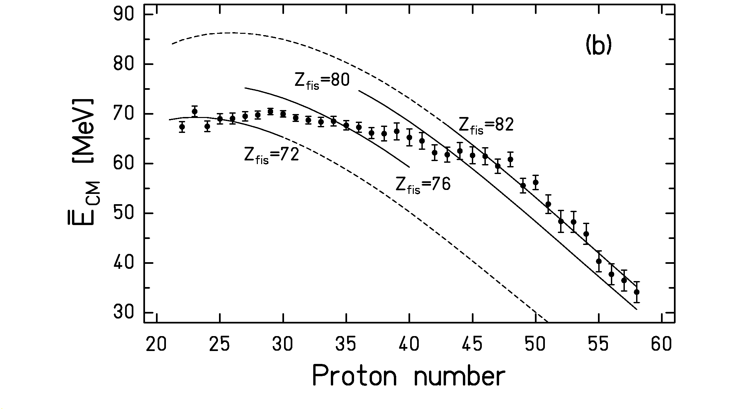
Fig 6: a) Measured spallation-residue mean kinetic-energy as a function of the mass number. The data of the present work (full symbols) are compared to the data of ¹⁹⁷Au (0.8 A GeV) + p from ref. [Error: Reference source not found] (open symbols). b): Measured fission-fragment mean kinetic energies as a function of the proton number. Error bars include only statistical uncertainties. The lines show calculated values when different fissioning elements are assumed (see ref. [Error: Reference source not found] for details).

- Conclusions

The production cross sections and the energies of about 900 nuclear species produced in the reaction of 1 A GeV ²⁰⁸Pb on proton have been determined in detail. They cover elements from titanium to lead. The reaction products were fully identified in atomic number Z and mass number A using the magnetic spectrometer FRS. Moreover, the velocity of each individual nucleus was measured.
The data, production cross sections and energies, are of highest interest for the design of accelerator-driven systems. Using the measured production cross sections, combined with the known decay properties, the short- and long-term radioactivities in the target material can be calculated. The number of atomic displacements being the reason for radiation damages in the structural materials can now be estimated from the measured kinetic-energy distributions. Most of the radiation damages are caused by spallation residues because of their higher production cross sections. The data also allow to estimate the admixtures of specific chemical elements in the liquid lead target, accumulated in long-term operation of the reactor, which enhance corrosion of the walls or any material in the container.

References

? R. Michel, P. Nagel, 1997, International Codes and Model Intercomparison for Intermediate Energy Activation Yields, OECD, 1997
? W. Wlazlo, T. Enqvist et al., Phys. Rev. Lett. 84 (2000) 5736
? T. Enqvist, W. Wlazlo et al., accepted by Nucl. Phys. A.
? M. de Jong, K.-H. Schmidt et al., Nucl. Phys. A 628 (1998) 479.
? T. Enqvist, J. Benlliure et al., Nucl. Phys. A 658 (1999) 47.
? J. Benlliure, K.-H. Schmidt et al., Nucl. Phys. A 660 (1999) 87.
? P. Chesny et al., 1996, GSI Ann. Rep. (1996) 190.
? A. Junghans, H.-G. Clerc et al., Nucl. Instrum. Methods A 370 (1996) 312.
? H. Geissel, , P. Armbruster et al., Nucl. Instrum. Methods B 70 (1992) 286.
K.-H. Schmidt, E. Hanelt et al., Nucl. Instrum. Methods A 260 (1987) 287.
L. A. Vaishnene, L. N. Andronenko et al., Z. Phys. A 302 (1981) 143.
P. J. Karol, Phys. Rev. C 11 (1975) 1203.
T. Brohm, 1994, PhD thesis, IKDA, TH Darmstadt
F. Rejmund, B. Mustapha et al., accepted by Nucl. Phys. A
J. Benlliure, , P. Armbruster et al., accepted by Nucl. Phys. A
D. J. Morrissey, Phys. Rev. C 39 (1989) 460.

