Calculated fission-product yields from collisions of ²³⁸U with protons and heavy ions

J. Benlliure¹⁾, A. R. Junghans²⁾, B. Jurado³⁾, M. V. Ricciardi³⁾, K.-H. Schmidt³⁾
¹⁾ Univ. Santiago de Compostela, ²⁾ Univ. of Washington, ³⁾ GSI

Exploring the nuclear properties up to the drip-lines firstly relies on the production of the nuclear species considered. Since a long time, neutron-rich fission fragments produced in ²³⁸U and ²³²Th targets by high-energy protons have been extracted by ISOL techniques []. More recently, two additional approaches overcame the chemical restrictions of the ISOL technique. Firstly, fission induced by protons of energies below 100 MeV in combination with the IGISOL technique [] and, secondly, fission reactions after collisions of ²³⁸U projectiles with light and heavy target nuclei [] have opened new prospects for this field of research. For optimising these methods, reliable model calculations are indispensable. However, in particular the fission process is not sufficiently well understood to allow for realistic predictions on a fully theoretical basis. Models, rather strongly based on empirical data, have been developed [,,] with variable success. We have exploited the data from systematic fission studies with relativistic secondary beams [] and comprehensive measurements of isotopic production yields in heavy-ion- and proton-induced reactions [] in order to develop dedicated nuclear reaction models for the prediction of isotopic production cross sections.
The first stage of heavy-ion- and proton-induced reactions is treated by a modern version of the abrasion model [] and the newly developed burst model [], respectively. The burst model estimates the mass and the excitation energy of the pre-fragments on the basis of the 1/E shape of the energy spectrum of the cascade nucleons emitted []. After equilibration, the de-excitation cascade is considered in which the fission competition is treated as a dissipative process. The fission process, starting from the saddle configuration, is formulated in the theory of fission channels with only a few parameters adjusted to experimental data []. The level density above the conditional fission barrier as a function of mass asymmetry and excitation energy, including shell effects, is the basis for calculating the mass distribution of the fission fragments. The stiffness of the underlying liquid-drop barrier against mass-asymmetric distortions is deduced from experiments []. The mean neutron-to-proton ratio is calculated by minimising the energy of the system in the scission configuration, and fluctuations are calculated on the basis of the nuclear states available with empirically scaled contributions of quantum-mechanical zero-point oscillations added. Excitation energies of the fragments are calculated from the initial excitation energy of the fissioning nucleus, the Q value and the kinetic energy of the fragments. The latter is determined by the scission configuration. Evaporation from the excited fission fragments is included.
In Figs. 1 and 2, the model calculations are compared to experimental data for different reaction partners and a wide range of beam energies. Since the model has not specifically been adjusted to these data, the agreement is quite remarkable.
Fig. 1 demonstrates that the most neutron-rich isotopes are produced by electromagnetic excitation of ²³⁸U in the lead target. This contribution is missing in the proton-induced fission. It is not clear in the moment, why the slope in the neutron-rich tail in proton-induced fission is not correctly reproduced. Data on residual cross sections measured in inverse kinematics for the same reaction which are presently being analysed will help to clarify this question.
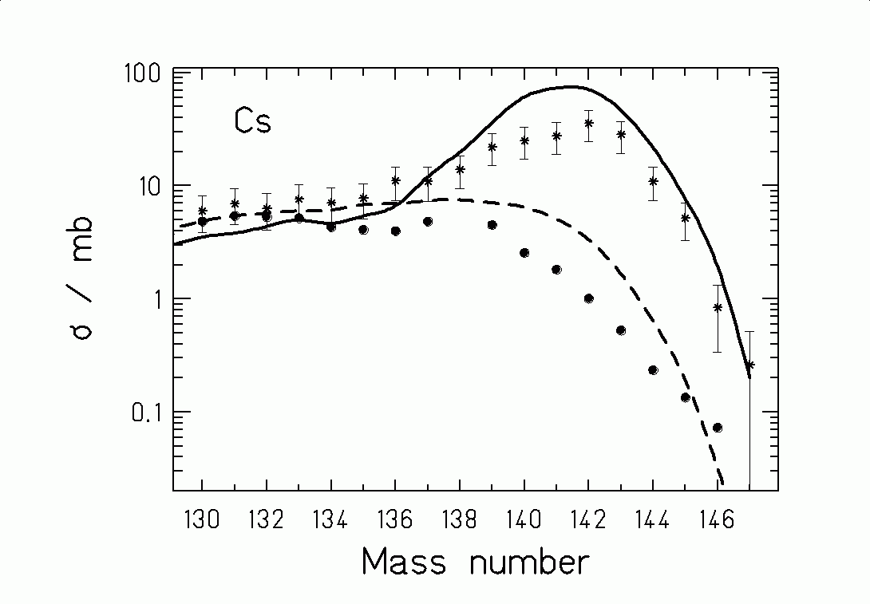
Fig. 1: Measured fission yields [Error: Reference source not found,] of neutron-rich Cs isotopes from ²³⁸U(1AGeV)+²⁰⁸Pb (∗) and ¹H(1GeV)+ ²³⁸U (•) compared to model calculations .

The calculation in Fig. 2 has only three fission channels (standard I, standard II and superlong) included. Both the positions of the distributions and the variation of the maximum cross sections from Ge to Ni are well reproduced while the width is a bit overestimated. In contrast to ref. [Error: Reference source not found] we see no evidence for an additional super-asymmetric fission channel.
These models which might be further improved on the basis of upcoming data, seem to be promising tools for realistic predictions of secondary-beam intensities from nuclear fission induced in a variety of nuclear collisions.
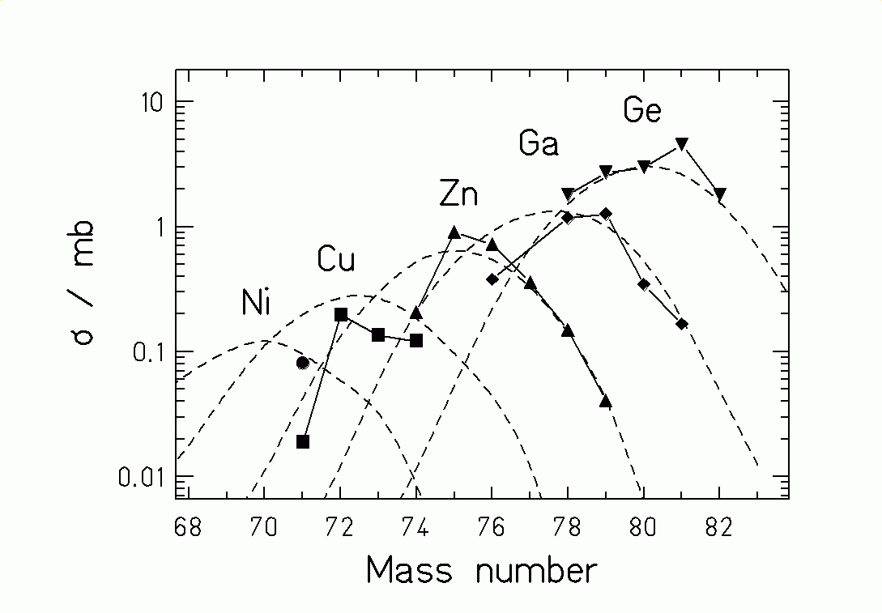
Fig. 2: Measured yields [] of light fission fragments from ¹H(25 MeV)+²³⁸U (data points, height adjusted) compared to model calculations (dashed lines).

[?] R. Klapisch, Ann. Rev. Nucl. Sc. 19 (1969) 33
[?] M. Leino et al., Phys. Rev. C 44 (1991) 336
[?] B. Bernas et al., Phys. Lett. B 415 (1997) 111
[?] E. Karttunen et al., Nucl. Sci. Eng. 109 (1991) 350
[?] R. Silberberg et al., Astroph. J. 501 (1998) 911
[?] F. Atchison, Jül-conf-34, KFA Jülich, 1980
[?] K.-H. Schmidt et al., Nucl. Phys. A, in press
[?] T. Enqvist et al., Nucl. Phys. A 658 (1999) 47
[?] J.-J. Gaimard et al., Nucl. Phys. A 531 (1991) 709
[?] K.-H. Schmidt et al., in preparation
[?] X. Ledoux et al., Phys. Rev. Lett. 82 (1999) 4412
[?] J. Benlliure et al., Nucl. Phys. A 628 (1998) 458
[?] S. I. Mulgin, Nucl. Phys. A 640 (1998) 375
[?] B. N. Belyaev et al., Nucl. Phys. A 348 (1980) 479
[?] M. Huhta et al., Phys. Lett. B 405 (1997) 230

