The Isospin Thermometer - A New Method to Determine
the Freeze-out Temperature in Fragmentation Reactions

M. V. Ricciardi, A. Botvina, T. Enqvist, P. Napolitani, K.-H. Schmidt

GSI, Planckstr.1, D-64291 Darmstadt
Abstract: The neutron excess of heavy fragmentation products is analysed in order to extract the excitation energy at the beginning of the evaporation stage of the reaction. The result gives indications for a break-up stage also in reactions in which heavy fragments are formed. The freeze-out temperature, determined with this approach, agrees with the value of about 5 MeV found in light fragment production by the caloric curve over a large range of excitation energy induced.

1 Introduction
The study of the isospin degree of freedom in nuclear reactions has evolved to a very important tool for investigating the properties of nuclear matter. The most prominent examples are the determination of the freeze-out temperature in multi-fragmentation reactions by the isotopic thermometer [, , ], the isoscaling method to check the consistency of the influence of temperature and asymmetry term on the full isotopic distributions [, ], the investigation of the symmetry term of the nuclear EOS as a function of temperature and away from normal density [], and the neutron distillation effect in the liquid-gas phase transition [, ].
The results may be summarized as follows: (See also the contribution of W. Trautmann to this workshop.) The onset of a break-up process, leading to a simultaneous emission of several intermediate-mass fragments (multifragmentation), has been observed [] if the deposited energy exceeds about 3 A MeV. The caloric curve revealed a saturation of the freeze-out temperature in the formation of these fragments at about 5 MeV over a large range of energy deposited (between 3 and 10 A MeV) [Error: Reference source not found]. It has been found that the isotopic distributions formed from colliding systems with different neutron excess scale as expected from a thermodynamical description of the break-up scenario [Error: Reference source not found]. The search for a possible variation of the nuclear symmetry term [] and for neutron distillation [] have just started. Also the variation of the neutron excess of light fragments with the size [, ], with the N/Z ratio and with the temperature of the emitting source [] has become a subject of investigation. The information from these experiments relies on the identification of rather light nuclei, mostly A ≤ 20. In part, this restriction in mass relies on the limited mass resolution of the high-acceptance experimental devices used for these investigations. But also the theoretical analysis tools used so far were best adapted to these light fragments, as will be detailed later. In contrast, high-resolution spectrometers provide much higher mass resolution, however, at the expense of a limited acceptance. With this experimental approach, more peripheral reactions, leaving essentially one large fragment, can be studied, which make up a great part of the total reaction cross section. For the interpretation of such data, the isospin-thermometer method has been introduced recently to determine the freeze-out temperature in peripheral fragmentation reactions [].
In the present contribution, we present new results on isotopic distributions of heavy fragmentation residues. In addition, we discuss the experimental requirements, the theoretical analysis tools and the deduced results of the isospin-thermometer method and compare these to the other approaches described above. All these studies are motivated by the common interest to explore the properties of nuclear matter away from normal conditions. The results are also relevant for better understanding some specific astrophysics scenarios like supernovae explosions and neutron stars.

2 Experimental requirements
The complete coverage and the full identification of heavy reaction residues in mass and atomic number are facilitated very much in inverse-kinematics experiments at relativistic energies, where the projectile-like residues leave the nuclear-reaction zone fully stripped in a small forward angular range. For the heaviest nuclei up to uranium, projectile energies of at least 1 A GeV and an adapted high-resolution spectrometer are required, which are available at GSI Darmstadt. A detailed description of the experimental approach can be found in [, ].

3 Results
Systematic investigations on the residual-nuclide production in nucleus-nucleus collisions are scares. Many experiments concentrated on the production of a certain exotic nucleus, like ¹⁰⁰Sn [] or ⁷⁸Ni [], providing cross sections in a limited zone of the chart of the nuclides, only. Recently, several survey experiments were performed in the frame of the HINDAS project [], in order to provide nuclear data for the design of an accelerator-driven system. Although the primary interest relies on the spallation reaction of heavy nuclei by 1 GeV protons, also other projectile-target combinations have been investigated. Figure 1 shows an overview of the available data on the mean neutron-to-proton ratio <N>/Z of the isotopic chains measured for a number of different systems. The results may be summarised as follows: The fragments not too far from the projectile follow the evolution of the <N>/Z value as parameterised by the EPAX description and enters into a universal line, the "evaporation-residue corridor" [], also recently discussed as "attractor line" []. Lighter fragments, however, tend to deviate from the evaporation-residue corridor, they are more neutron-rich. These findings were already reported in ref. [Error: Reference source not found].
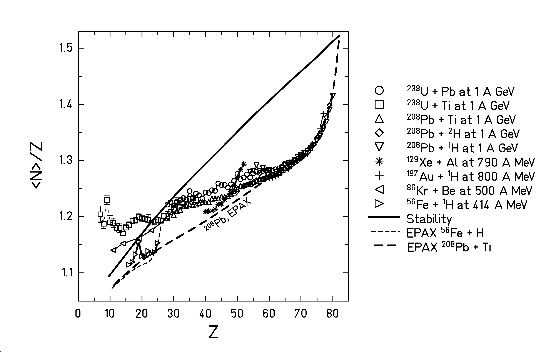
Figure 1: Mean neutron-to-proton ratio of the isotopic distributions measured in different fragmentation reactions (from top to bottom, refs. [, Error: Reference source not found, , , Error: Reference source not found, , , , ]). Any contributions from fission are suppressed. The dashed lines show the corresponding values predicted by EPAX for the reactions ²⁰⁸Pb + Ti and ⁵⁶Fe + ¹H, and the full line indicates the valley of beta stability.

From the larger number of systems investigated in the meantime, one can deduce a new and very interesting observation: The deviation in <N>/Z from the evaporation-residue corridor follows the ordering of the N/Z of the projectile. Fragments from projectiles with different N/Z are shifted in their mean N/Z values: The residues formed by fragmentation of ²³⁸U (N/Z = 1.587) are slightly more neutron rich than those formed in the fragmentation of ²⁰⁸Pb (N/Z = 1.537). Changing the target, however, does not have any influence on the N/Z of the fragments: The residues formed by fragmentation of ²³⁸U in lead and titanium show the same neutron excess. That means that there is a memory of the neutron excess of the projectile found in the projectile fragments, which are not too close to the projectile.

4 Theoretical analysis tools
It has been discussed on various occasions (e.g. [Error: Reference source not found,Error: Reference source not found]) that the evaporation stage may have a strong influence on the isotopic distributions observed after high-energy nuclear collisions. In all the approaches mentioned above to exploit the isotopic production cross sections of IMFs [Error: Reference source not found - Error: Reference source not found], the interpretation of the experimental results primarily relies on the comparison with the expected situation directly after break-up in a thermodynamical picture. The two approaches mostly applied are the isotopic thermometer and the isotopic scaling. The isotopic thermometer [Error: Reference source not found, Error: Reference source not found, Error: Reference source not found] is one of the methods to determine the temperature of the fragmenting system. Double ratios of the yields of four suitably chosen isotopes are compared with the expectation from Boltzmann statistics. The isotopic scaling [Error: Reference source not found, Error: Reference source not found] which interprets the ratios of all isotopic yields formed in the fragmentation of two projectiles with different neutron excess relies on the closely related idea that the widths of the isotopic distributions are governed by the temperature of the emitting system. For this kind of approaches, the evaporation stage, also denoted as sequential decay, is a disturbing effect, which has to be considered in the interpretation. In unfavourable cases it may even mask the relevant information.
Figure 1, however, reveals that even in the case of long evaporation chains the isotopic distributions provide interesting information. In fact, the evaporation is strongly sensitive to the symmetry energy by its influence on the neutron and proton separation energies, and thus leads to large shifts in the neutron-to-proton ratio. The isospin-thermometer method, introduced in ref. [Error: Reference source not found], exploits this idea in order to deduce the freeze-out temperature after break up by use of the rather well understood features of the statistical evaporation process. The quantitative result of a universal freeze-out temperature of 5 MeV obtained in ref. [Error: Reference source not found], was obtained with a schematic approach, a three-stage model. The characteristics of the first stage, the abrasion process, are rather well established. In the present context, the mass loss and the excitation energy induced as a function of impact parameter are the most important ones. They are given by geometrical considerations [] and experimental information [], respectively. It is further assumed that the mean neutron-to-proton ratio is preserved in the abrasion stage [Error: Reference source not found]. Also the break-up process is assumed to preserve the neutron-to-proton ratio of the projectile. Under these conditions, the reduction of the neutron excess by the evaporation cascade can directly be used to determine the excitation energy (and thus the temperature) of the compound nucleus at the starting point of the evaporation process, i.e. at freeze-out after the break-up phase.
Figure 3 compares the data of the fragmentation of ²³⁸U from Figure 1 with the result of the three-stage model. The freeze-out temperature was varied between 2 and 7 MeV. The lines are not equidistant. The smaller distance of the high-temperature curves is caused by the smaller sensitivity of the neutron and proton decay rates to the separation energies at high excitation energies, i.e. in the first part of the deexcitation process. (See the discussion in ref. [].) We also checked that the shift in neutron excess of the residues from the different projectiles is rather well reproduced assuming a common value of about 5 MeV for the freeze-out temperature, although this is not shown in the figure. In particular, the sensitivity to the N/Z of the projectile and the insensitivity to the target is reflected by the calculation. This good agreement seems to be an indication for the validity of the three-stage model and for the conclusions drawn in our previous work [Error: Reference source not found] on the existence of a rather universal freeze-out temperature.

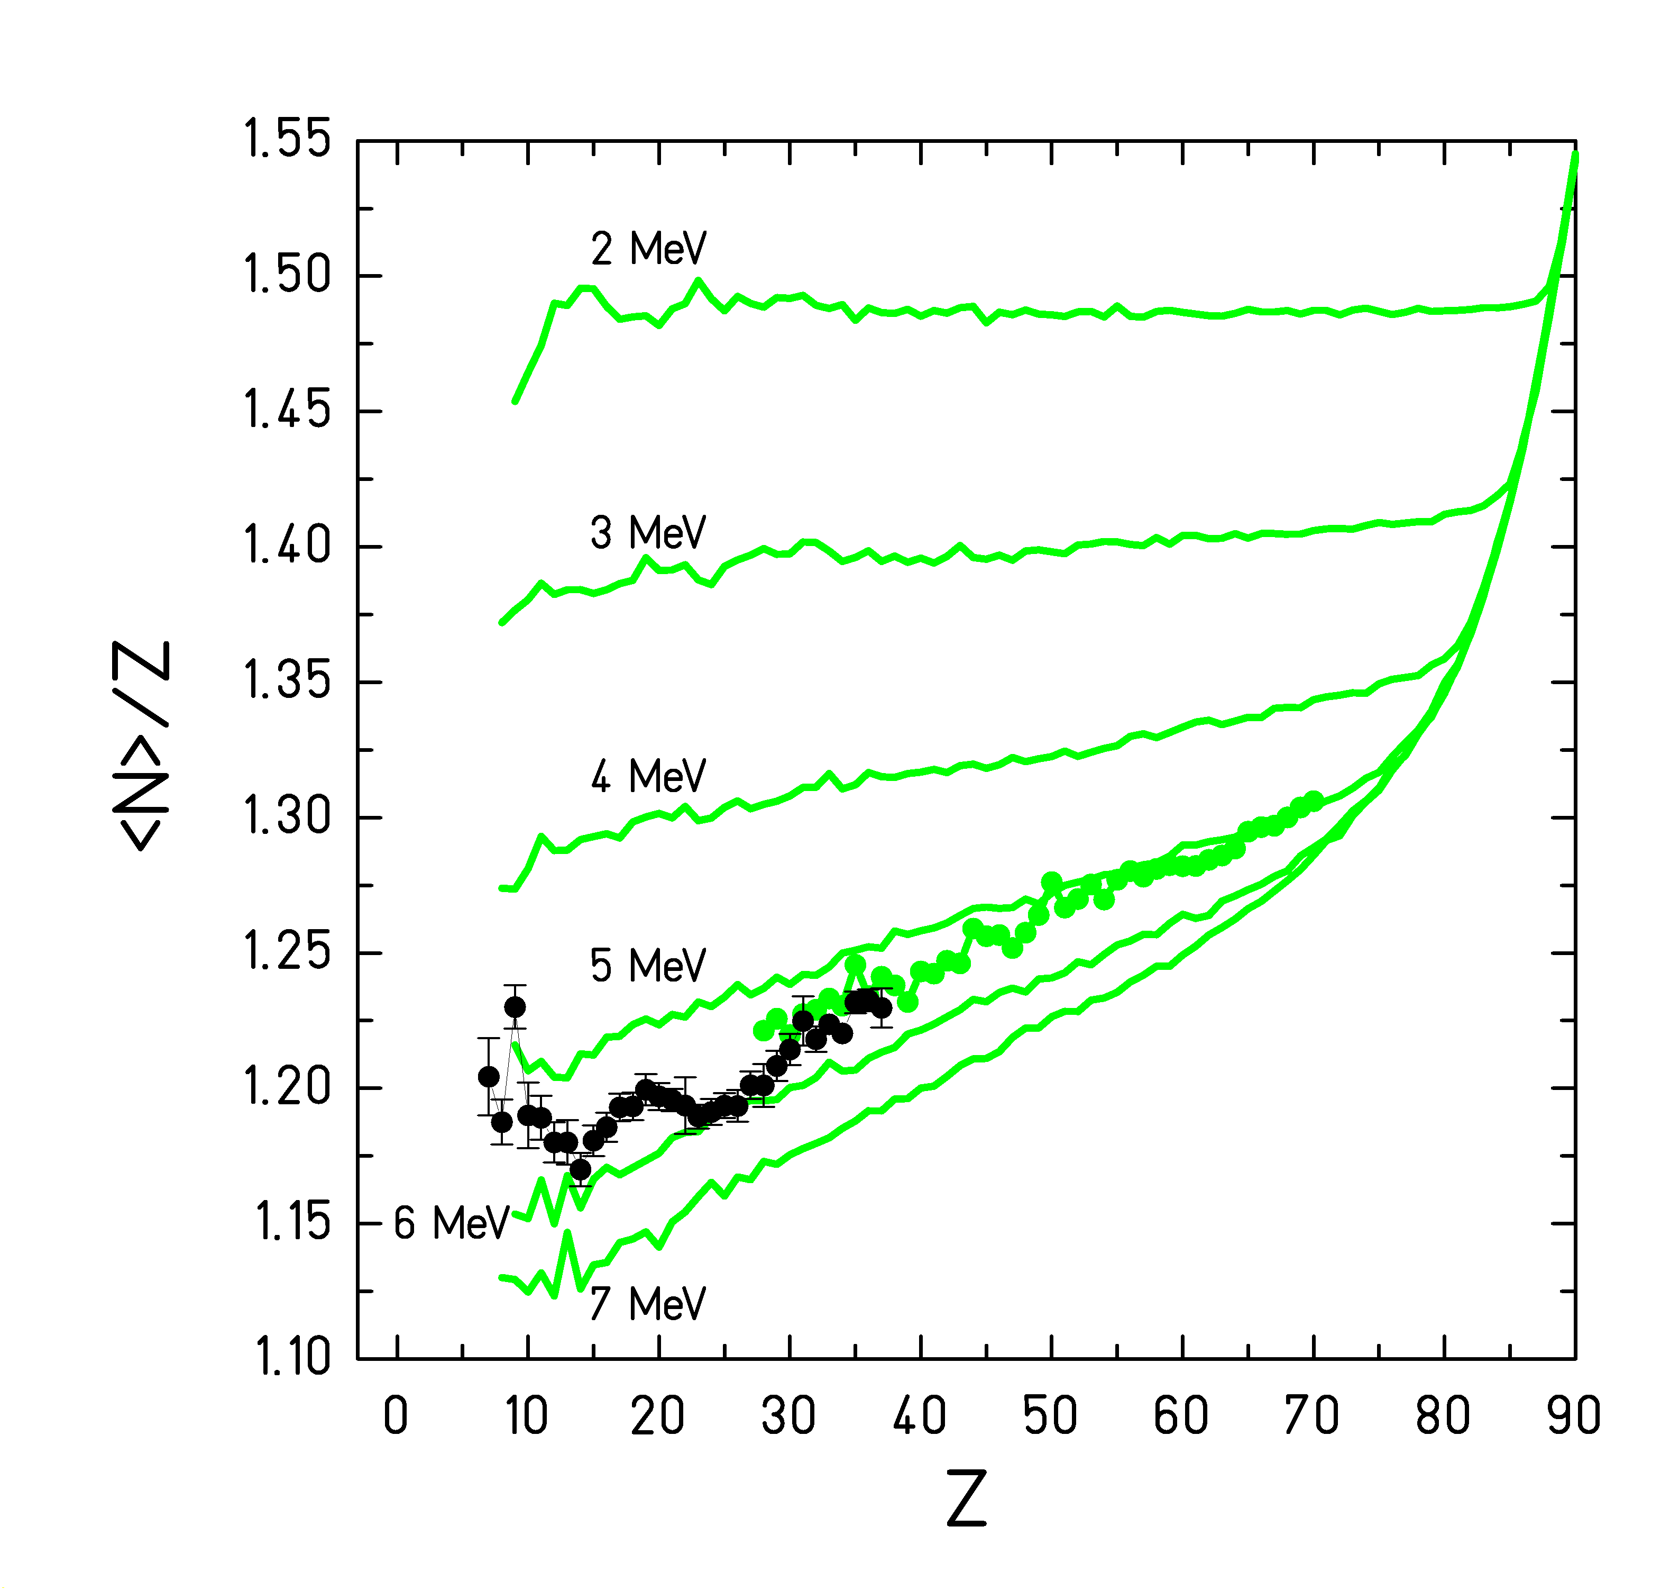

Figure 2: Experimental <N>/Z values from the reactions ²³⁸U + Pb and ²³⁸U + Ti compared with calculations using the three-stage model. The different curves correspond to different values of the freeze-out temperature used in the calculation. (The calculated results for the two systems coincide.) See text for details.

5 Discussion
We would like to concentrate our discussion on two aspects. The first one is the question on the physical interpretation of the neutron-to-proton ratio of heavy fragmentation residues. The second one is the common understanding of the results from IMF production and from the heavy residues.
In ref. [Error: Reference source not found], the neutron-to-proton ratio of heavy fragmentation residues was interpreted with the isospin-thermometer method. The quantitative result of this method relies on the separation of the fragmentation process into three stages, in the modelling of the isospin degree of freedom in the first two stages and on the treatment of the sequential decay in the evaporation code. The separation of the three reaction stages seems justified, because they can roughly be attributed to different time scales, the abrasion to the contact time, the break up to the nuclear radius divided by the Fermi velocity, the evaporation to the compound-nucleus life time. The first essential assumption that the projectile spectator keeps the neutron-to-proton ratio of the projectile seems to be well justified, since the abrasion process directly probes the neutron and proton density distributions. It was also assumed that the break-up products preserve the neutron-to-proton ratio of the projectile. In the light of the vivid discussion on the neutron distillation, this assumption seems to be in question. In fact, the very interesting phenomenon of neutron distillation would reduce the neutron excess of the final residues, since an enhancement of neutrons is expected in the gaseous phase [Error: Reference source not found, Error: Reference source not found]. Still, according to the current predictions [Error: Reference source not found, Error: Reference source not found], the quantitative effect of the neutron distillation on the isosopin of the heavy residues is not clear, but in any case, the evaporation process will provide the dominant influence on this quantity. Certainly, the quantitative result of the isospin-thermometer method also depends on some critical parameters used in the evaporation code, like the excitation-energy dependent barriers for charged-particle emission. It is a challenge to carefully consider independent experimental information concerning the evaporation process to best define the parameters of the evaporation code in order to come to most reliable results.
We would like to stress that the nuclide distributions of the heavy residues form an important test ground for any nuclear-reaction model, which complements the information from the properties of the IMFs. Nuclide distributions of heavy residues are particularly sensitive to the value of the freeze-out temperature and to the effect of neutron distillation.
The indications reported here from the properties of heavy residues for a universal freeze-out temperature of 5 MeV remind the interpretation of the caloric curve for a saturation of the temperature of the liquid phase at this very same value. In fact, the characteristics of the IMFs and those of the heavy residues fit to a common picture. They seem to be all formed at a freeze-out temperature of about 5 MeV. Only the experimental signatures exploited in the analysis were different. From on may even understand that one cannot use the same signatures over the whole mass range. Heavy residues are formed with rather high excitation energies leading to a long evaporation chain, which strongly masks the conditions after freeze-out. However, the important reduction of the neutron excess in the evaporation process can be exploited as the prominent signature for the excitation energy consumed in evaporation. Light residues, formed at the same temperature after freeze-out, have so low excitation energies that only very few nucleons can be evaporated. Therefore, the initial population of isotopes or excited states can well be exploited to determine the magnitude of the freeze-out temperature from a thermodynamical approach. In the interpretation of the production of very light fragments, however, another difficulty arises, because they may also be produced in an evaporation scenario. In some cases, it might be difficult to disentangle these from the break-up products.

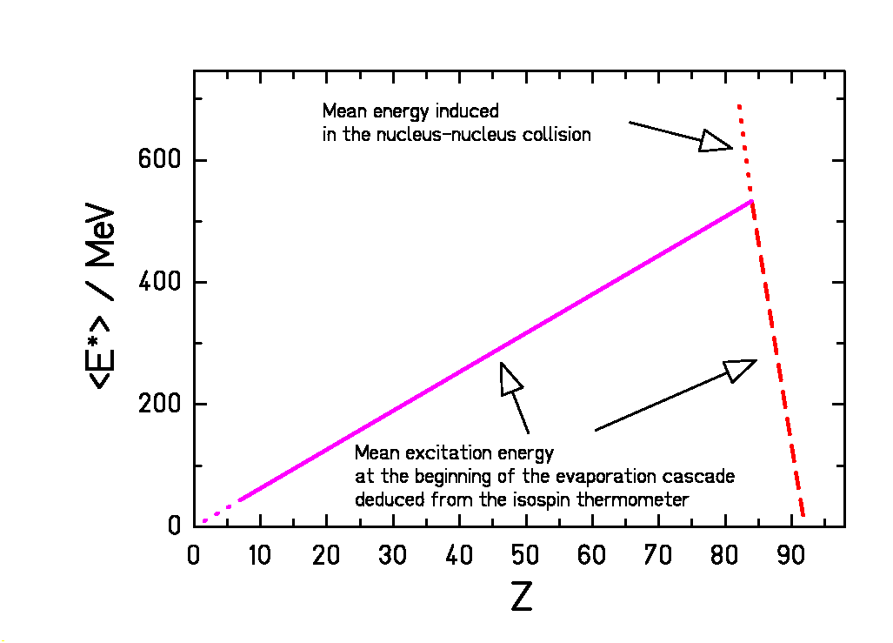

Figure 3: Schematic presentation of the mean energy induced in the reaction and the mean energy at the beginning of the evaporation stage in the fragmentation of ²³⁸U. According to this figure, an abrasion of more than 20 nucleons (more than 8 protons) leads to a break-up process.

6 Summary
The role of evaporation in the interpretation of nuclear-reaction aspects is manifold. Evaporation has a dominant influence on the isotopic distributions of heavy residues and on the production of very light fragments. There is a range of light elements where the direct production after freeze-out is accessible after some corrections for the influence of sequential decay. The isotopic distributions of heavier fragments, however, contain valuable information on the temperature at freeze-out to be exploited by the effect of evaporation on the neutron excess.
New data on nuclide distributions of heavy residues from fragmentation reactions support previous indications for the existence of a break-up stage when the abrasion phase induces very high excitation energies. Also the value of a rather universal freeze-out temperature of about 5 MeV is confirmed. A common view on the measured properties of the IMFs, in particular the characteristics of the caloric curve, and on the nuclide distributions of the heavy residues results in a uniform picture of a universal freeze-out temperature of the liquid phase after break-up over the whole mass range.

References

Permanent address: : Inst. for Nuclear Research, Russian Academy of Sciences, Moscow, Russia
Present address: Department of Physics, University of Jyväskylä, Jyväskylä, Finland
The term “isospin” is used here as a measure for the neutron-to-proton ratio in the nucleus.
[?] S. Albergo et al., Nuovo Cimento 89 (1985) 1
[?] J. Pochodzalla et al., Phys. Rev. Lett. 75 (1995) 1040
[?] S. R. Souza et al., Phys. Rev. C 62 (2000) 064607
[?] M. B. Tsang et al., Phys. Rev. Lett. 86 (2001) 5023
[?] M. B. Tsang et al., Phys. Rev. C 66 (2002) 044618
[?] V. Baran et al., Nucl. Phys. A 703 (2002) 603
[?] H. Mueller, B. D. Serot, Phys. Rev. C 52 (1995) 2072
[?] Bao-An Li, C. M. Ko, Nucl. Phys. A 618 (1997) 498
[?] C. A. Ogilvie et al, Phys. Rev. Lett. 67 (1991) 1214
[?] A. S. Botvina, O. V. Lozhkin, W. Trautmann, Phys. Rev. C 65 (2002) 044610
[?] H. S. Xu et al, Phys. Rev. Lett. 85 (2000) 716
[?] P. M. Milazzo et al., Phys. Rev. C 62 (2000) 041602(R)
[?] P. M. Milazzo et al, Phys. Rev. C 66 (2002) 021601(R)
[?] M. Veselsky et al., Phys. Lett. B 497 (2001) 1
[?] K.-H. Schmidt, M. V. Ricciardi, A. S. Botvina, T. Enqvist, Nucl. Phys. A 710 (2002) 157
[?] T. Enqvist et al., Nucl. Phys. A 686 (2001) 481
[?] M. V. Ricciardi, PhD Thesis, GSI, in preparation.
[?] R. Schneider et al., Z. Physik A 348 (1994) 241
[?] Ch. Engelmann et al., Z. Phys. A 352 (1995) 351
[?] http://www.fynu.ucl.ac.be/collaborations/hindas/
[?] J. P. Dufour et al., Nucl. Phys. A 387 (1982) 157c
[?] R. J. Charity, Phys. Rev. C 58 (1998) 1073
[?] T. Enqvist et al., Nucl. Phys. A 658 (1999) 47
[?] T. Enqvist et al., Nucl. Phys. A 686 (2001) 481
[?] T. Enqvist et al., Nucl. Phys. A 703 (2002) 435
[?] J. Reinhold et al., Phys. Rev. C 58 (1998) 247
[?] F. Rejmund et al., Nucl. Phys. A 683 (2001) 540
[?] M. Weber, GSI Internal Report (1993) GSI-93-26
[?] W. R. Webber et al., Astroph. Jour. 508 (1998) 949
[?] J. Hüfner, K. Schäfer, B. Schürmann, Phys. Rev. C 12 (1975) 1888
[?] K.-H. Schmidt et al., Phys. Lett. B 300 (1993) 313
[?] R. J. Charity, in “Isospin Physics in Heavy-Ion Collisions at Intermediate Energies”, Bao-An Li, W. U. Schröder eds., Nova Science Publishers, Huntington, 2002, pp. 341

