Data Requirements for Modelling in Nuclear Astrophysics

Fission

- Importance of fission for astrophysics
- Fission competition in de-excitation of excited nuclei
- Fission competition in radioactive decay (spont. fission)
- Nuclide production in fission
- Status and outlook on data compilations

1. Importance of fission for astrophysics
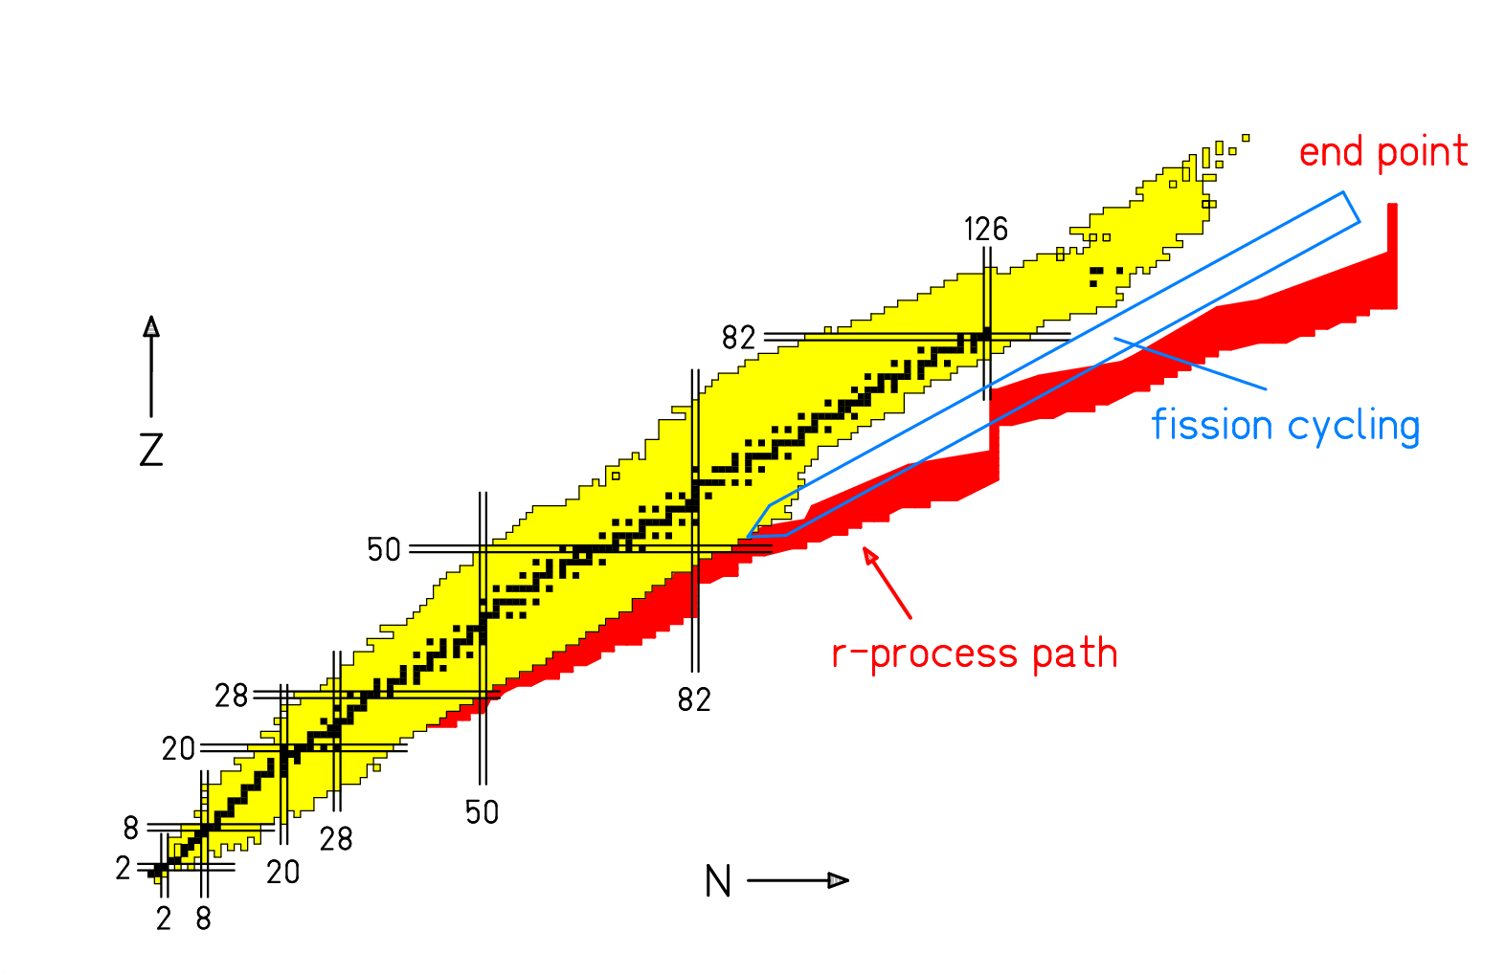

The role of fission in the r-process:

n-induced fission
spontaneous fission
beta-delayed fission
neutrino-induced fission

- r-process termination
  - Limitation in the production of superheavy nuclei
- Fission cycling
  - Depopulation of heavy region
  - Enhancement in fission-fragment region
  - Structure in nuclide distribution from fission fragments
- Fission competition in beta decay towards stability
2. Fission competition in de-excitation of excited nuclei

- Height of fission barriers
  - Experimental sources
  - Available data
  - Uncertainties
  - Divergence for n-rich nuclei
- Multi-humped barriers
  - Successive passage of two saddle points
- Level densities
  - Symmetry classes and collective excitations
- Transient effects
  - Only important for E* > 100 MeV

Height of fission barriers

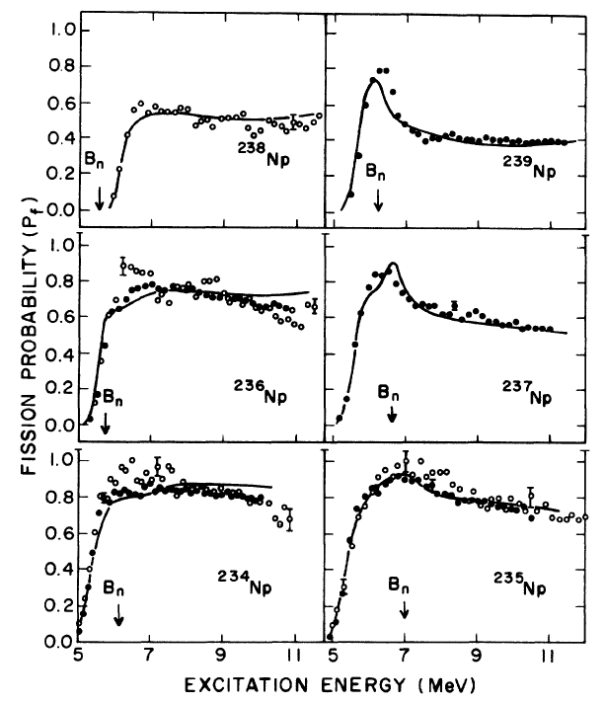

Experimental sources:

Energy-dependent fission probabilities.

Choice of systems:

Depending on long-lived target material.

Extraction of barrier parameters:

Requires assumptions on level densities.
(Collective contributions to the level
density depend on symmetry class.)

(³He,tf) and (³He,df) reactions

From A. Gavron et al., PRC13 (1976) 2374

Height of fission barriers

Topology of potential energy in fission direction

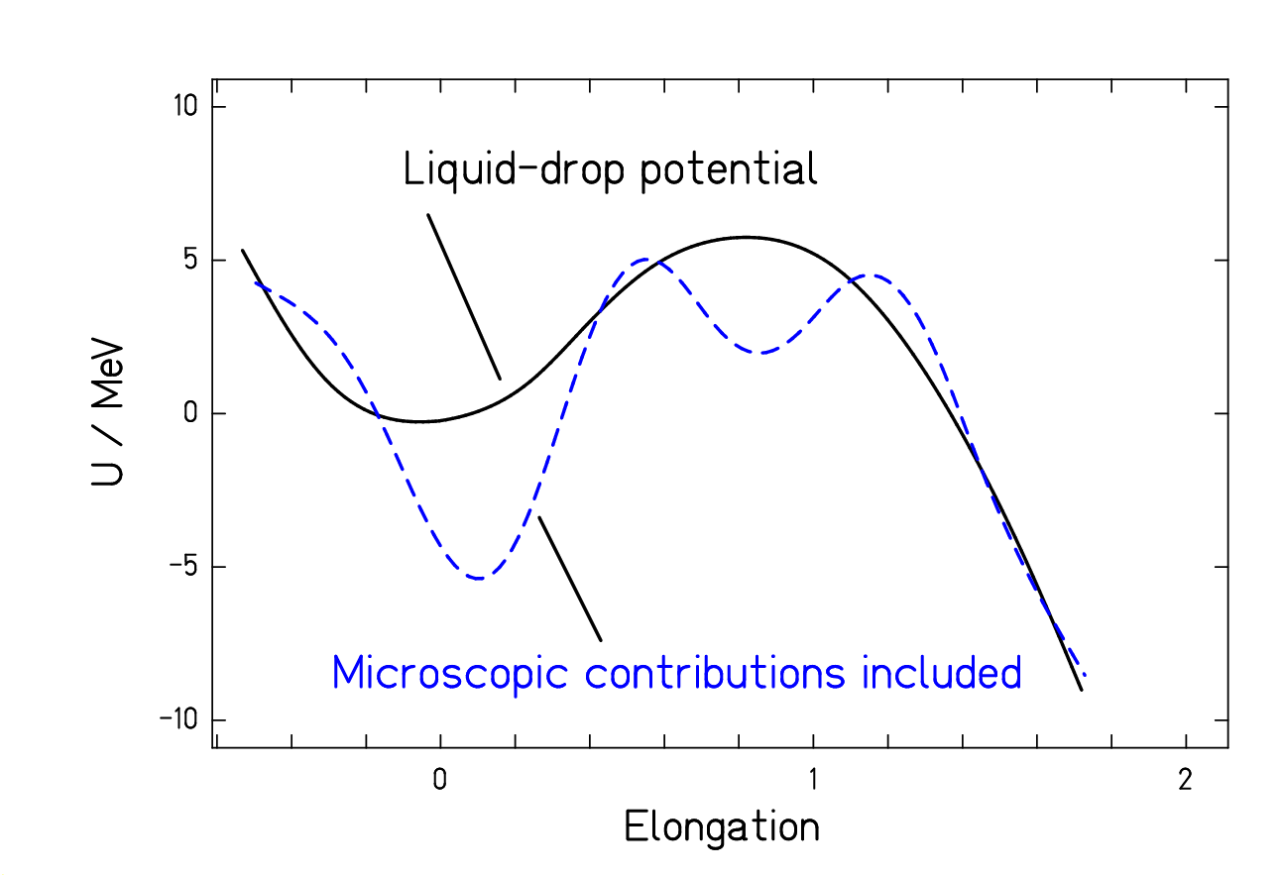

Multi-humped barrier

due to shell effects.

Height of fission barriers
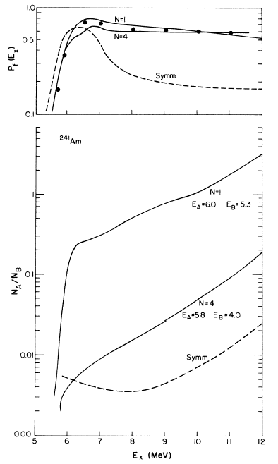

Extraction of barrier parameters :

Result (especially of lower barrier) depends on
assumptions for level densities.

Different symmetry at inner barrier assumed:

N = 1: triaxial shape

N = 4: ellypsoidal symmetry.

Symm: axial symmetry

E_{A} = inner-barrier height

E_{B} = outer-barrier height

Different results by different authors :
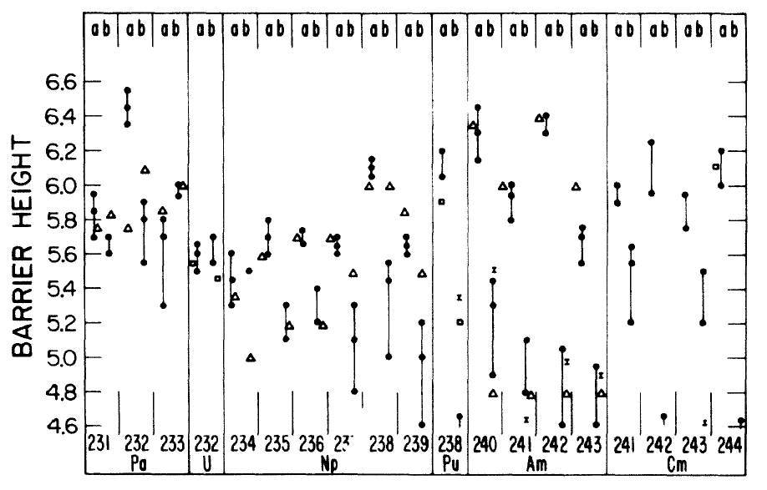

From A. Gavron et al., PRC13 (1976) 2374

Height of fission barriers
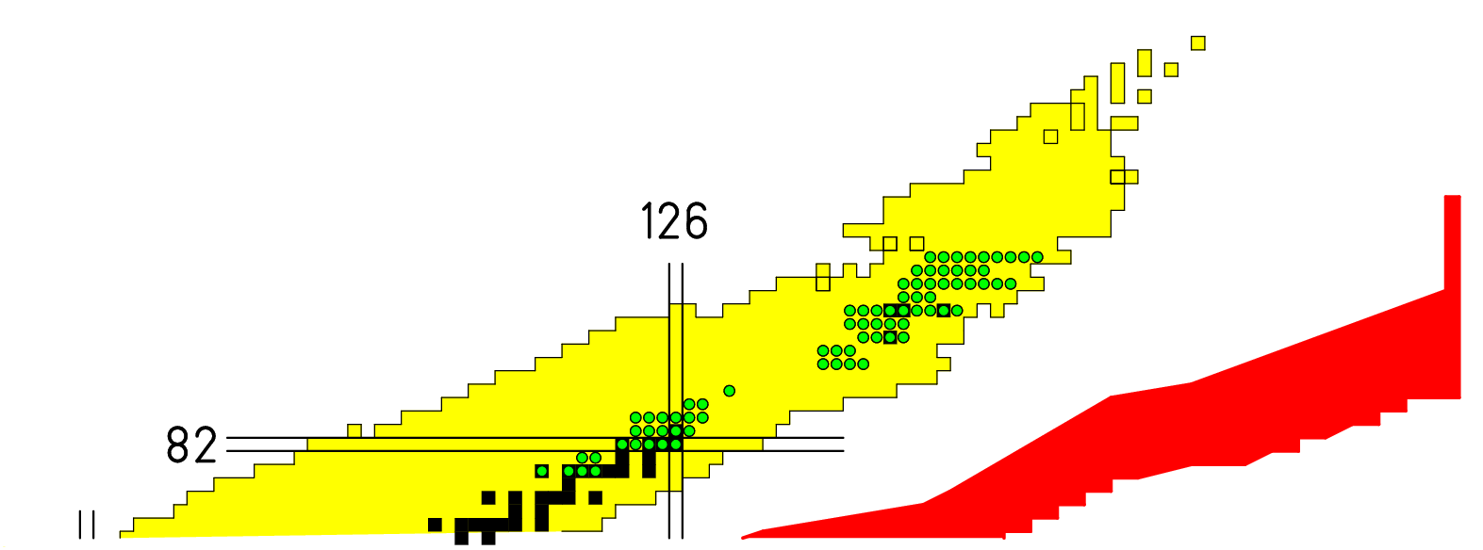

Available data on fission barriers, Z ≥ 80 (RIPL-2 library)

Height of fission barriers

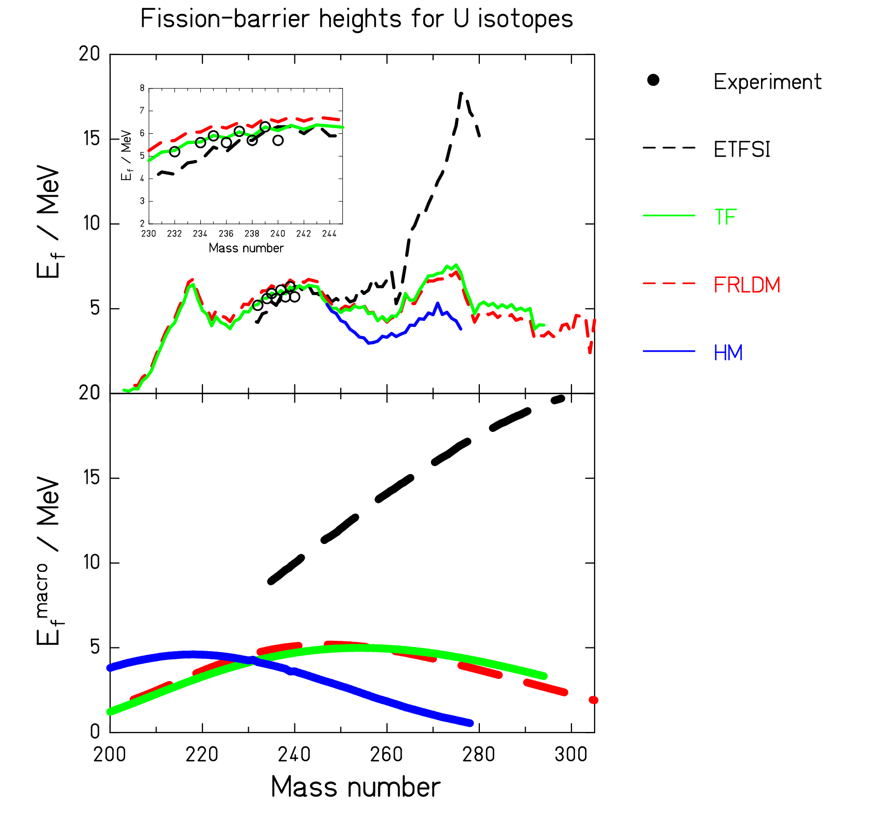

Predictions of different theoretical
models diverge far from stability.

Experimental data on short isotopic
sequences do not give enough
constraints.

From A. Kelic et al., PLB 643 (2006) 362
The topographic theorem

W. D. Myers and W. J. Swiatecki (NPA 601 (1996) 141):
Due to the topological properties of the multi-dimensional potential-energy landscape, the binding energy of the highest fission saddle is close to the binding energy of the fission saddle predicted by the liquid-drop model.

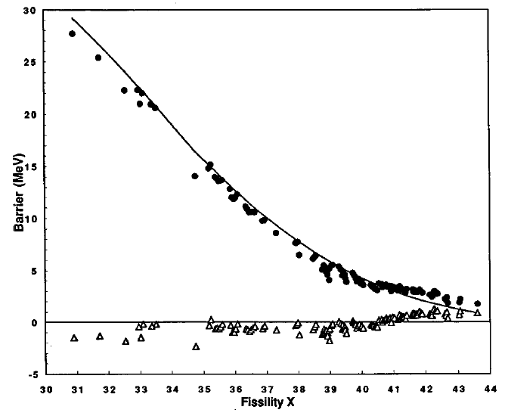
Experimental evidence:
Experimental binding energy at
highest saddle is very close to the
binding energy at saddle predicted
by the Thomas-Fermi calculations.

Shell effects at the barrier are small!

From W. D. Myers and W. J. Swiatecki NPA 60 (1999) 014606

The topographic theorem

Mathematical study (A. Karpov, GSI/Dubna)

1. The macroscopic potential

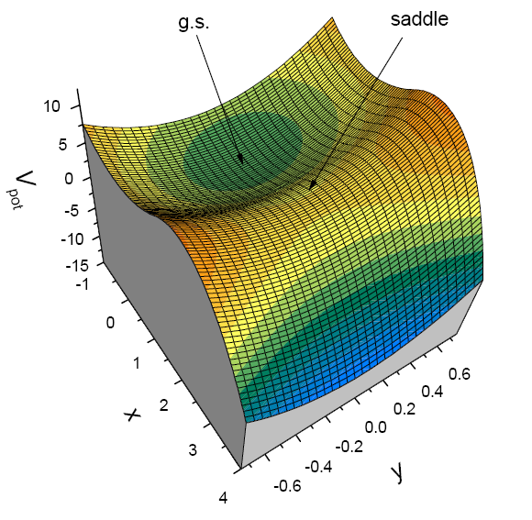

2. The microscopic potential
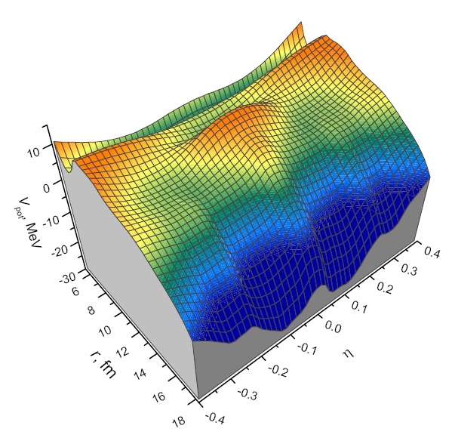
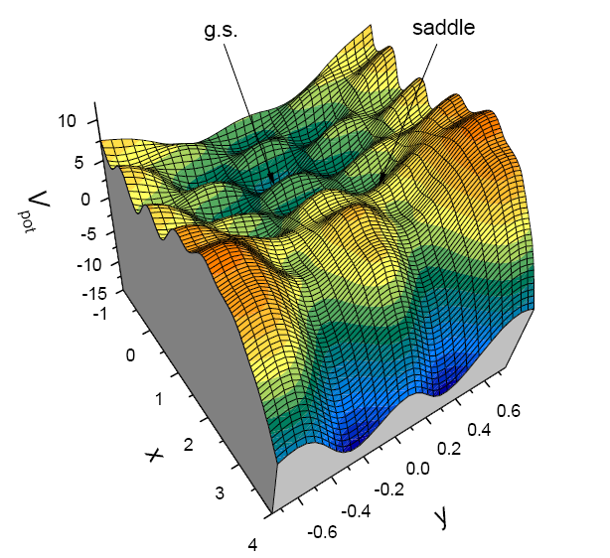
|
|
|
|
|
|
|
|
|
|
|
|
| A realistic case: ²³⁸U
|__________________________________

3. Results

Shell effect at the barrier from the schematic model
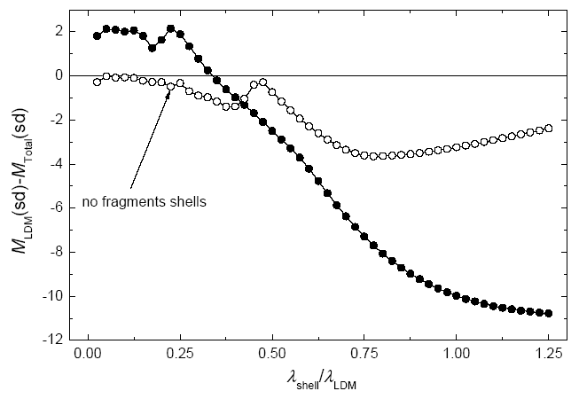
Open symbols:
Mononuclear regime (inner barrier)

Full symbols:
Dinuclear regime (outer barrier)

Conclusion:
- For small wavelength of the shell structure (λ_{shell} / λ_{LDM} < 0.3), the topographic theorem is well fulfilled at the inner barrier. This is fulfilled for most systems.
- Slight deviations are observed at the outer barrier.
- Further considerations predict that these deviations are rather constant over large range
Application of the topographic theorem

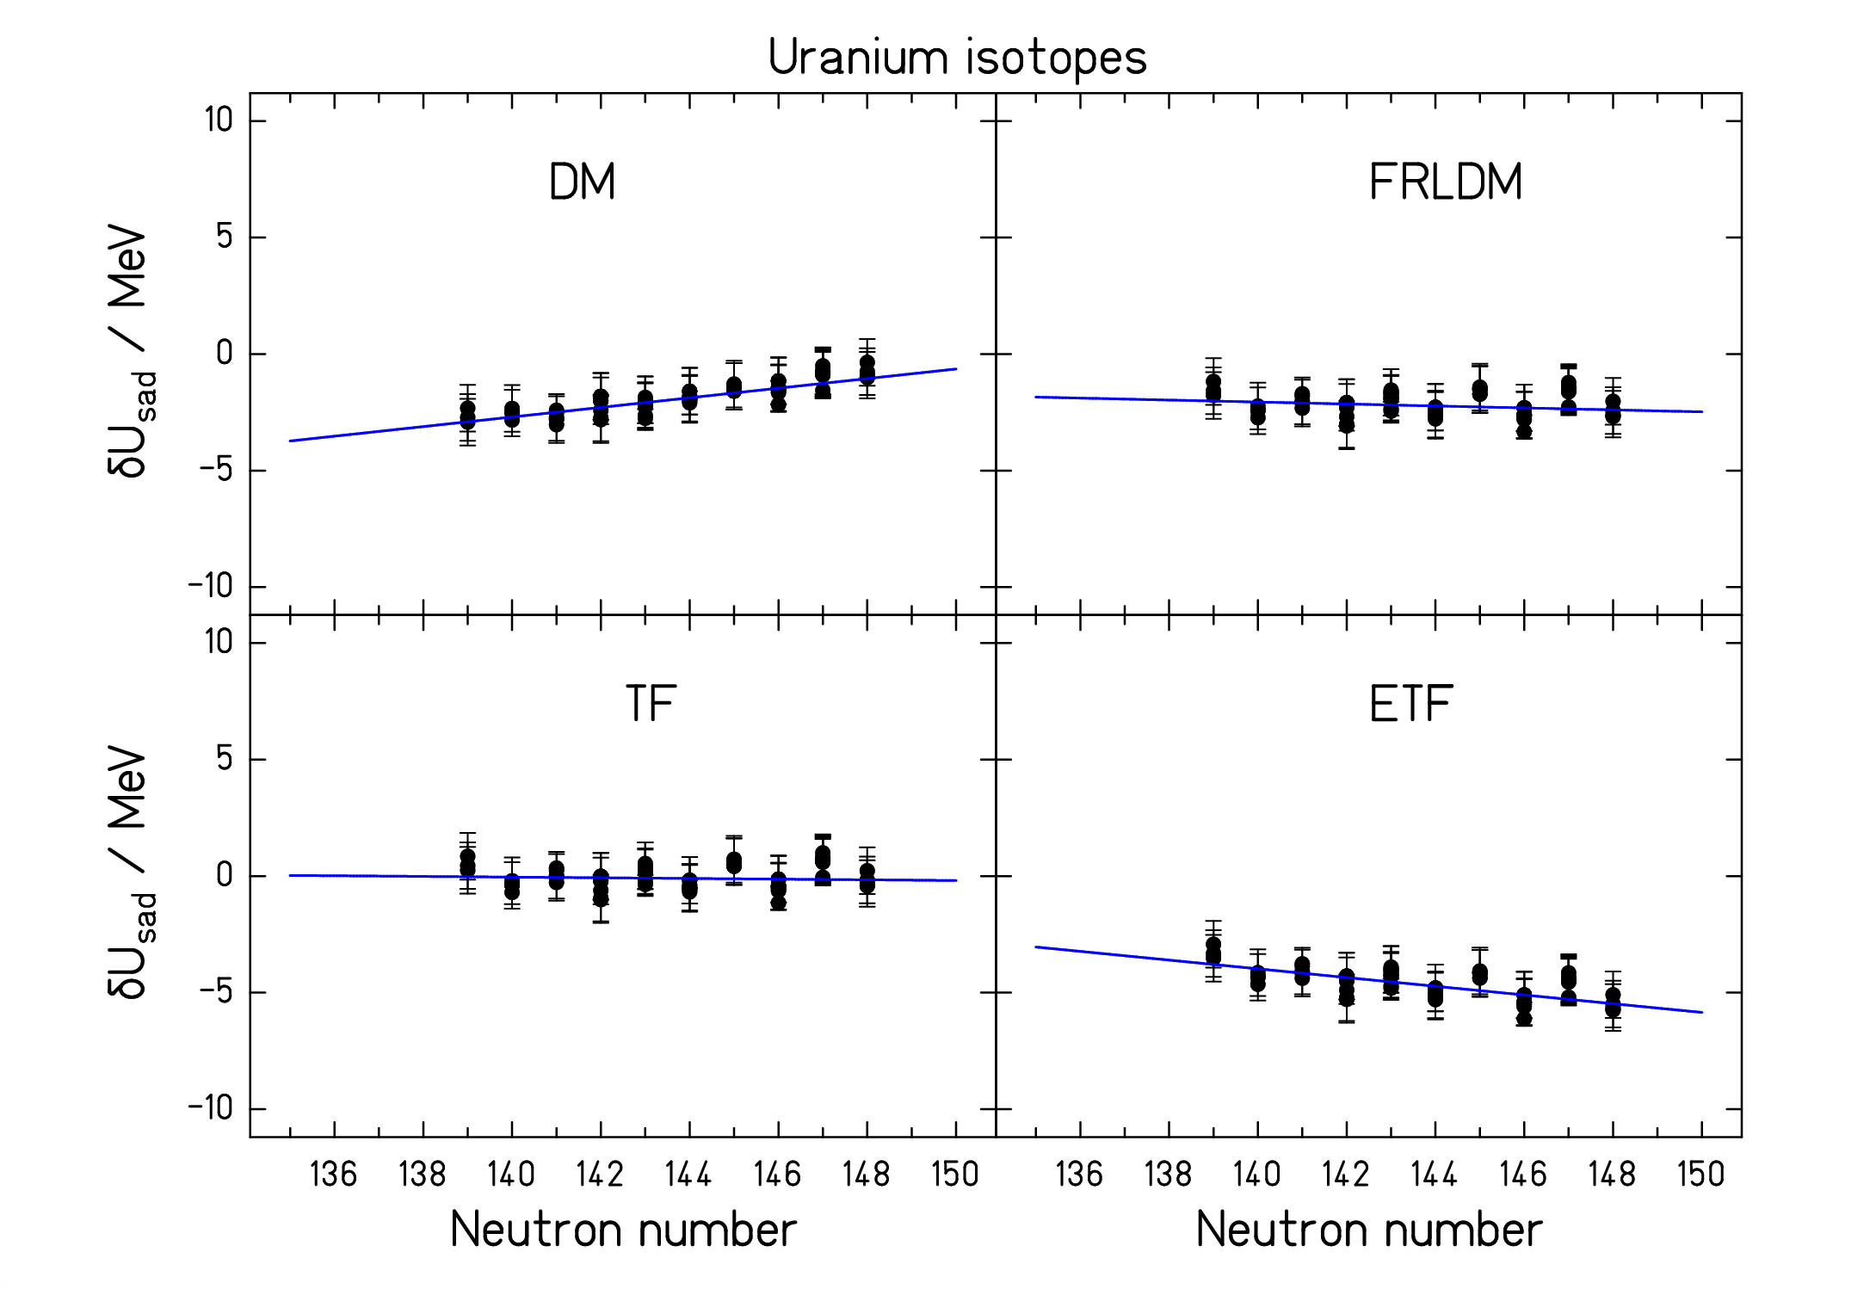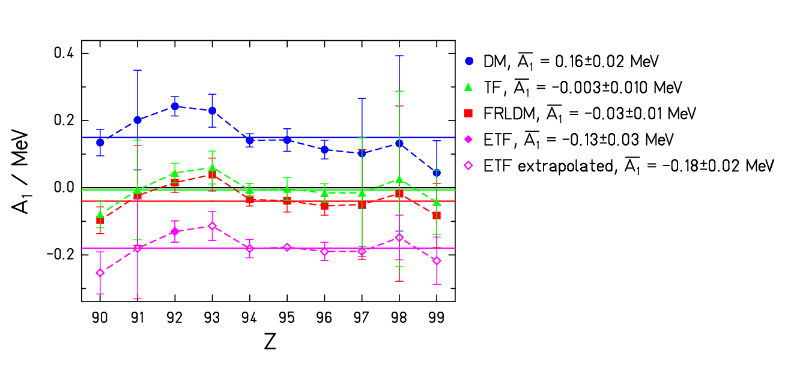

Apparent shell effect at saddle. Isotopic slope of apparent shell effect

Conclusion: Large differences in isotopic trend for different models.
Best models: TF model of Myers & Swiatecki and FRLDM of Sierk.

A. Kelic et al. PLB 642 (2006) 362
Conclusions on fission-barrier heights

- Avoid the influence of the large ground-state shell corrections when dealing with fission barriers:
  - Develop and benchmark models on the basis of experimental saddle-point binding energies, not on fission barriers.
- Profit from the topographic theorem:
  - For theoretical models: Determine the model parameters by the isotopic trends of the experimental saddle-point masses, do not just use point-by-point deviations.
  - For empirical systematics: Extrapolate experimental saddle-point masses and deduce from these the fission barriers.

3. Spontaneous fission

- Relation to other observables (fission barriers, masses)
- General influences of macroscopic and microscopic trends

Spontaneous fission: Macroscopic and microscopic trends
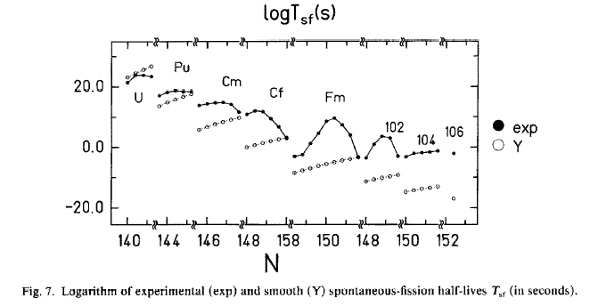
Spontaneous-fission half-lives
can be understood as a smooth
tendency given by the tunnelling
through the liquid-drop barrier
plus
a fluctuating influence mostly due
to the ground-state shell effect.
(First observed by W. J. Swiatecki in PR 100 (1955) 937.)
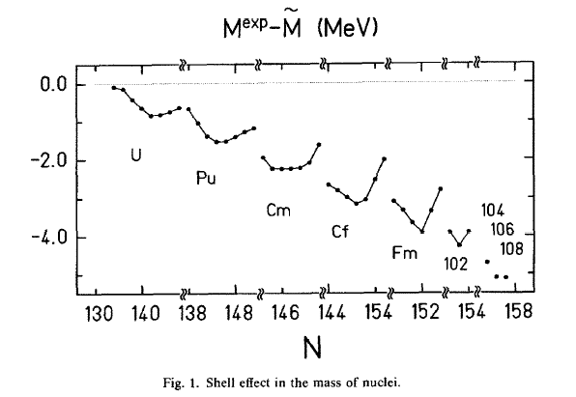

Empirical law: t_{1/2} = f(B_{f}^{ld}, δU)

Figures from Z. Patyk et al., NPA491
(1989) 267.

Conclusions on spontaneous-fission half lives

- Spontaneous-fission half-lives correlate well with
LDM fission barriers and
ground-state shell effects. *)

- For empirical systematics:
Half-lives for spontaneous fission can be estimated very reliably on the basis of
realistic LDM fission barriers and ground-state shell effects.
Empirical systematics based on the total fission-barrier height are not realistic.

- For theoretical estimations:
Theoretical models on spontaneous fission should be consistent with LDM fission
barriers and ground-state shell effects.

*) Even-odd fluctuations have to be considered in addition.
4. Nuclide production in fission

- Available data
- Empirical approaches
- Theoretical approaches
- Macroscopic trends
- Microscopic trends
- A macroscopic-microscopic approach with empirical saddle properties
Available data

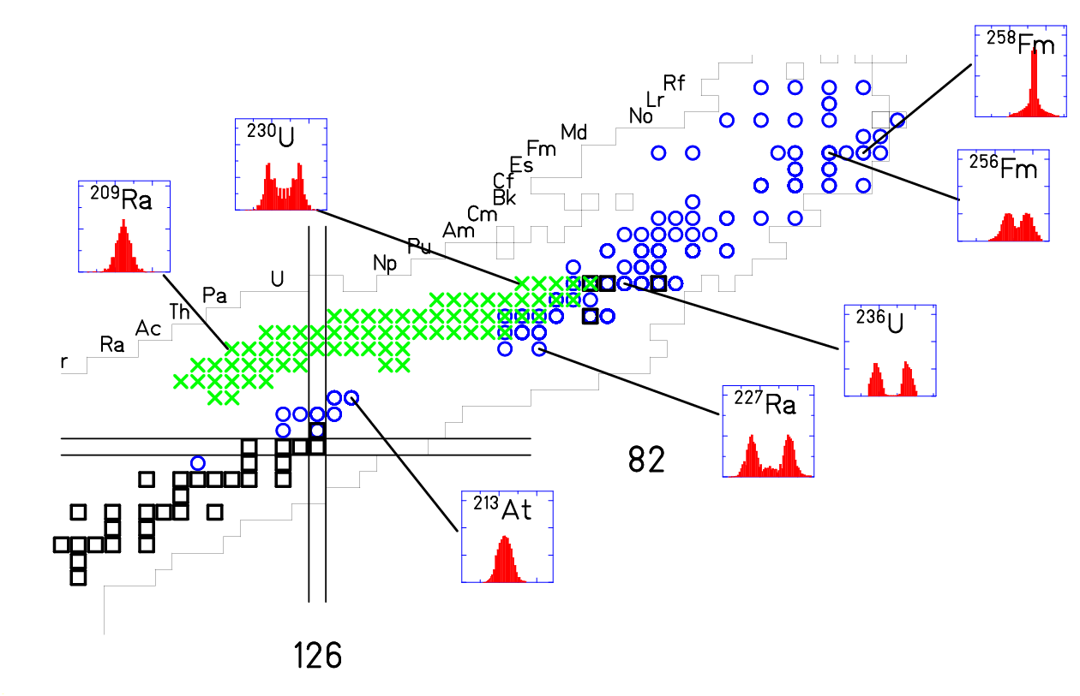
Blue circles: mass distributions accumulated.
Green crosses: Z distributions measured at GSI in inverse kinematics.

Conclusions:
- Complex features of multi-modal fission, gradual change around A = 226 and sudden change around A = 256.
- Available data far from r-process path.
(Semi-) empirical approaches

Parameterization of mass or nuclide distributions (e.g Atchison, Rubchenya)

+ Very good reproduction of measured data.
+ Reliable interpolations possible.
- Extrapolations doubtful.

Theoretical approaches

- Strutinsky-type calculations of the potential-energy landscape (e.g. P. Möller)
+ Good qualitative overview on multimodal character of fission.
- No quantitative predictions for fission yields.
- No dynamics

- Statistical scission-point models (e.g. Fong, Wilkins et al.)
+ Quantitative predictions for fission yields.
- No memory on dynamics from saddle to scission.

- Statistical saddle-point models (e.g. Duijvestijn et al.)
+ Quantitative predictions for fission yields.
- Neglecting dynamics from saddle to scission.
- Uncertainty on potential energy leads to large uncertainties in the yields.

- Time-dependent Hartree-Fock calculations with GCM (Goutte)
+ Dynamical and microscopic approach.
- No dissipation included.
- High computational effort.

Modelling of fission-fragment nuclide distributions is still a challenge.
Macroscopic trends
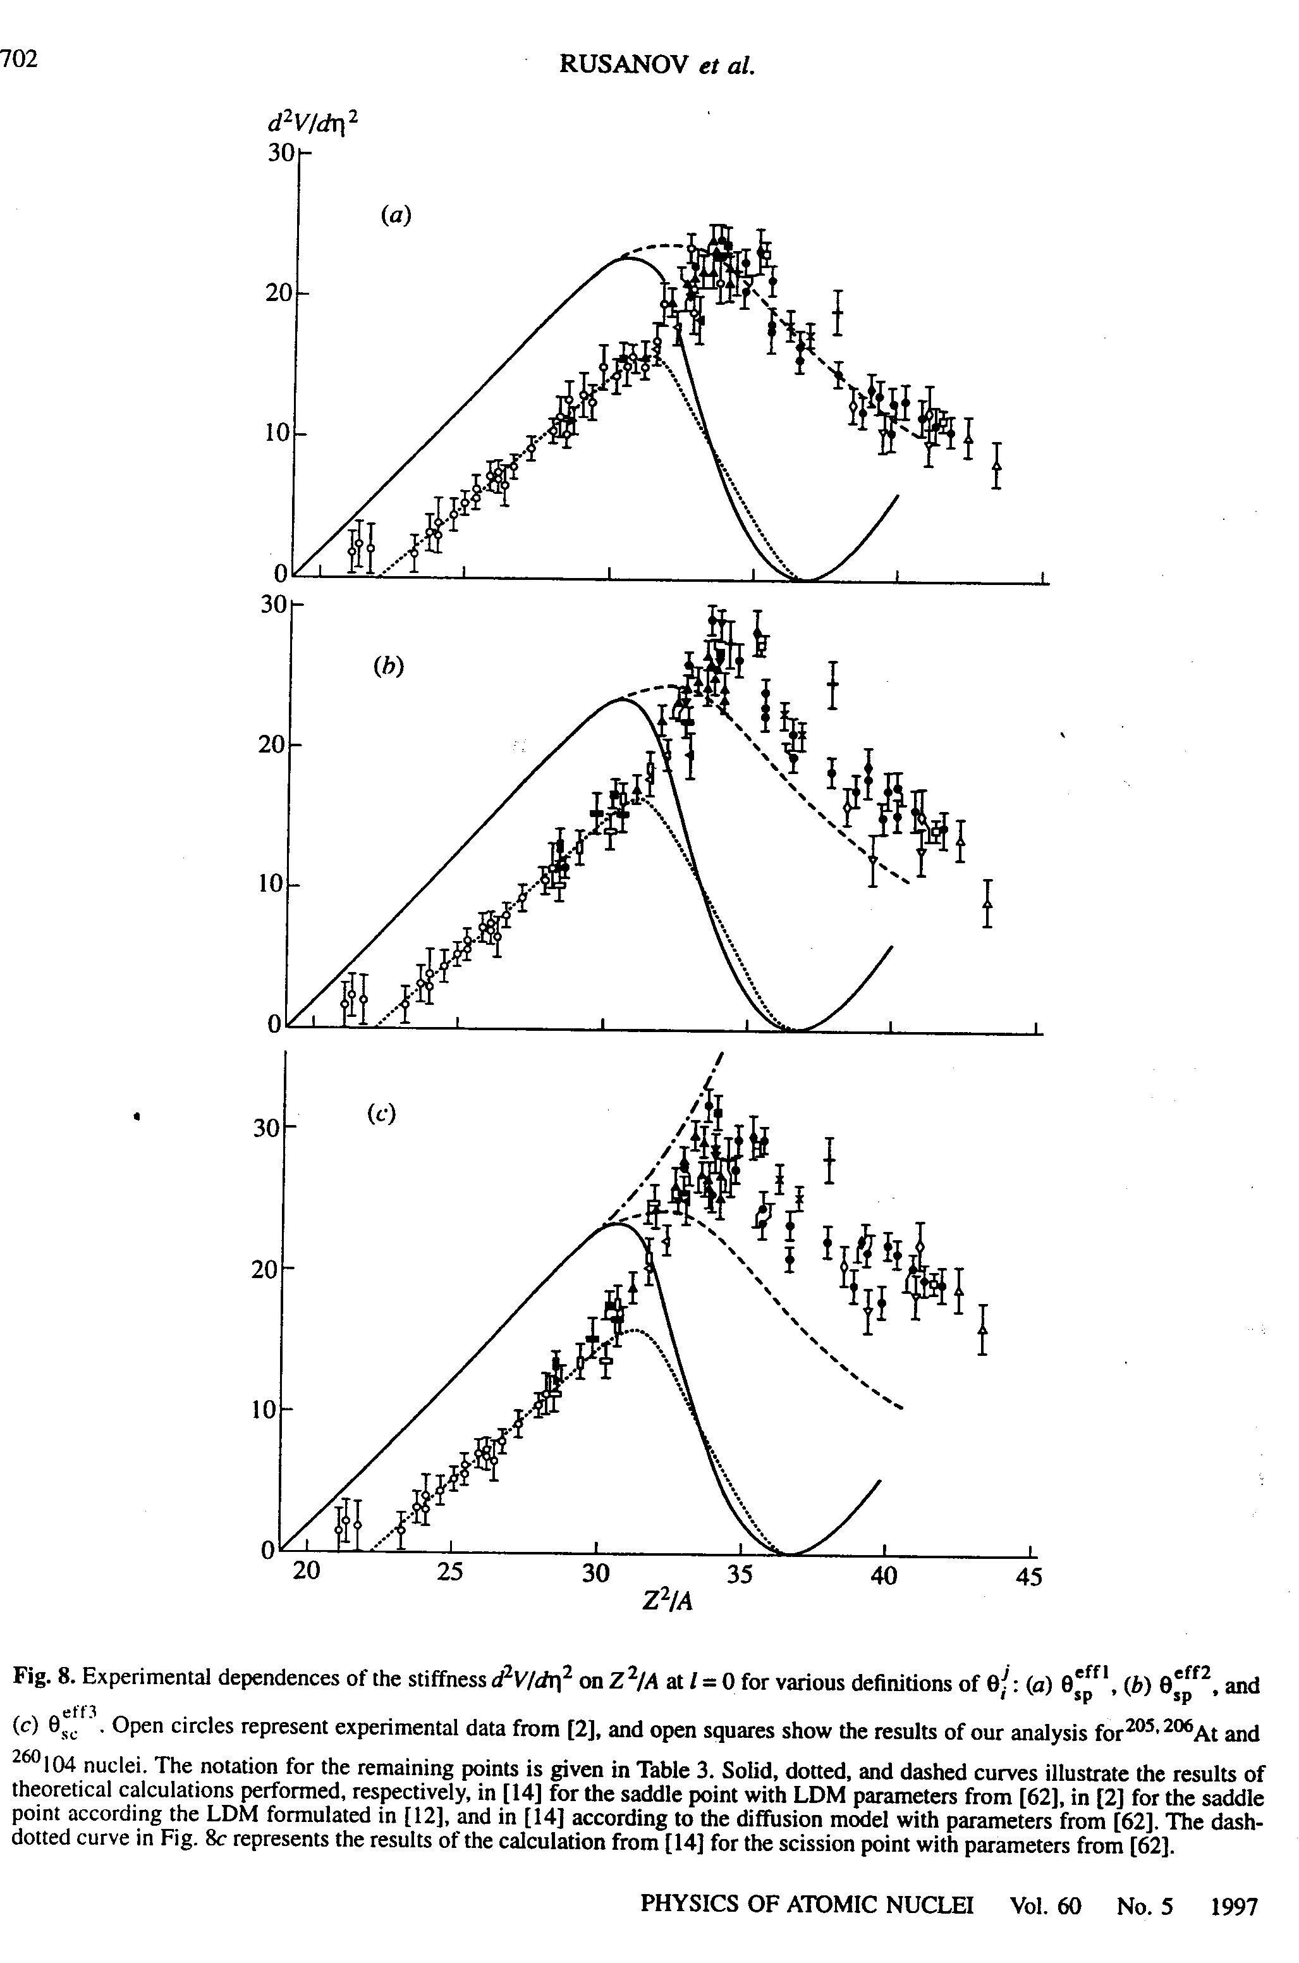
In cases when shell effects can be disregarded,
the fission-fragment mass distribution is
Gaussian.

Width of mass distribution (when shell effects can
be disregarded) is empirically well
established -→ σ_{A} = f(Z²/A, E*).

The figure shows the second derivative of the
mass-asymmetry dependent potential, deduced
from the widths of the mass distributions within
the statistical model compared to different
LD model predictions.
Figure from Rusanov et al. (1997)

Microscopic trends
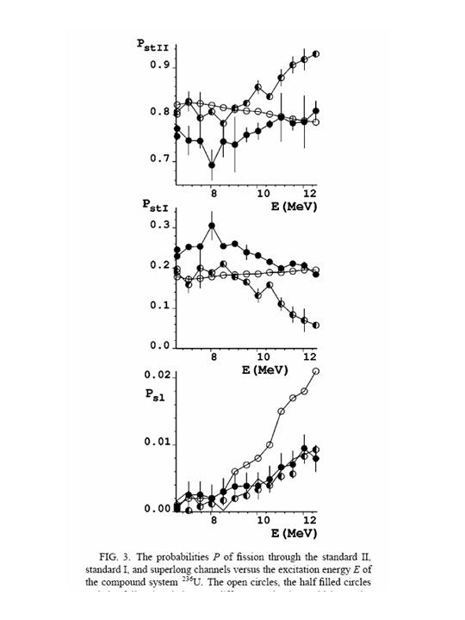
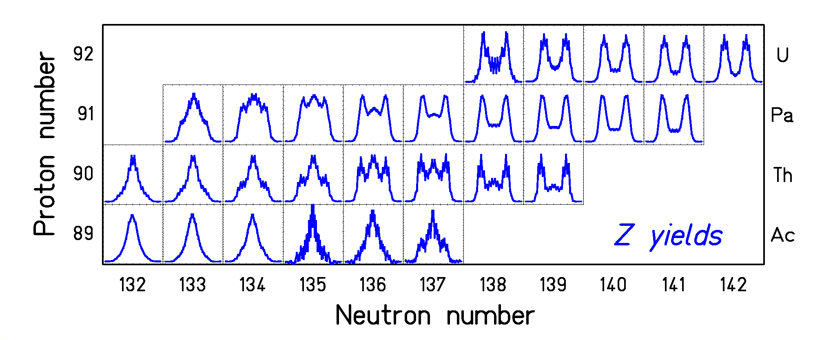
|
|
|
|
|
|
|
|
|
|__________________________________________

Multi-modal fission is clearly observed
Observed variations are complex.
Extraction of fission channels is subject to
uncertainties of the method.
The figure left e is taken from an investigation on the
model dependence of extracted channel yields
for the fission of ²³⁶U by
Brosa et al., PRC 59 (1999) 767.
Investigations on fission dynamics
(P. Nadtochy, GSI / Omsk)

Results of 3-dimensional Langevin calculations:

Mass asymmetry degree of freedom is slow compared to the motion from saddle to scission -> mass distribution mostly established at saddle is essentially frozen.

Charge-polarization (N/Z) degree of freedom is fast compared to the motion from saddle to scission -> N/Z of fission fragments decided near scission.
A macroscopic-microscopic approach with empirical parameters
How to understand the variations with A and E*

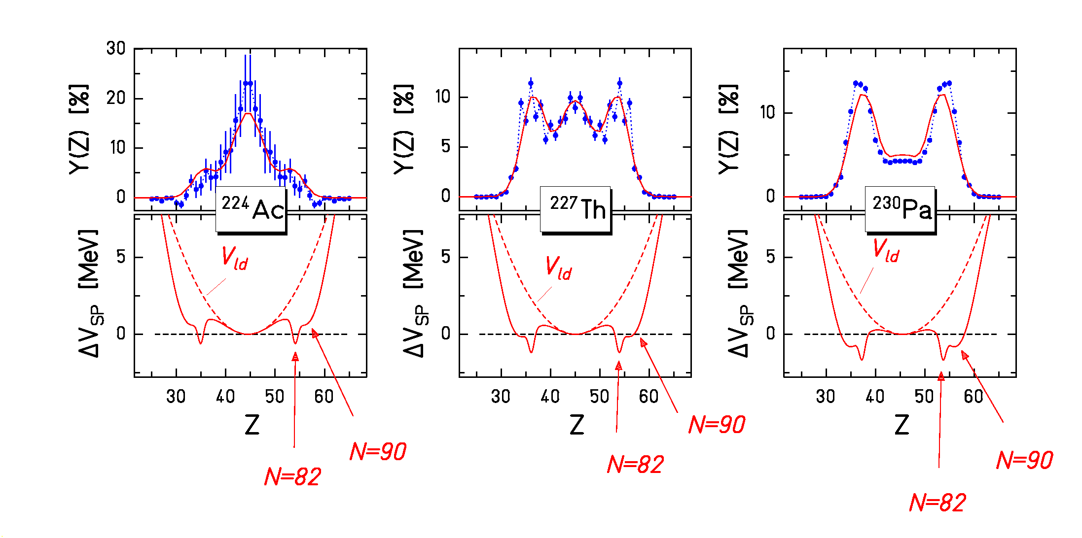
Transition from single-humped to double
humped distributions explained by
macroscipic (CN) and microscopic
(nascent fragments) properties of
fissioning nucleus near outer saddle.

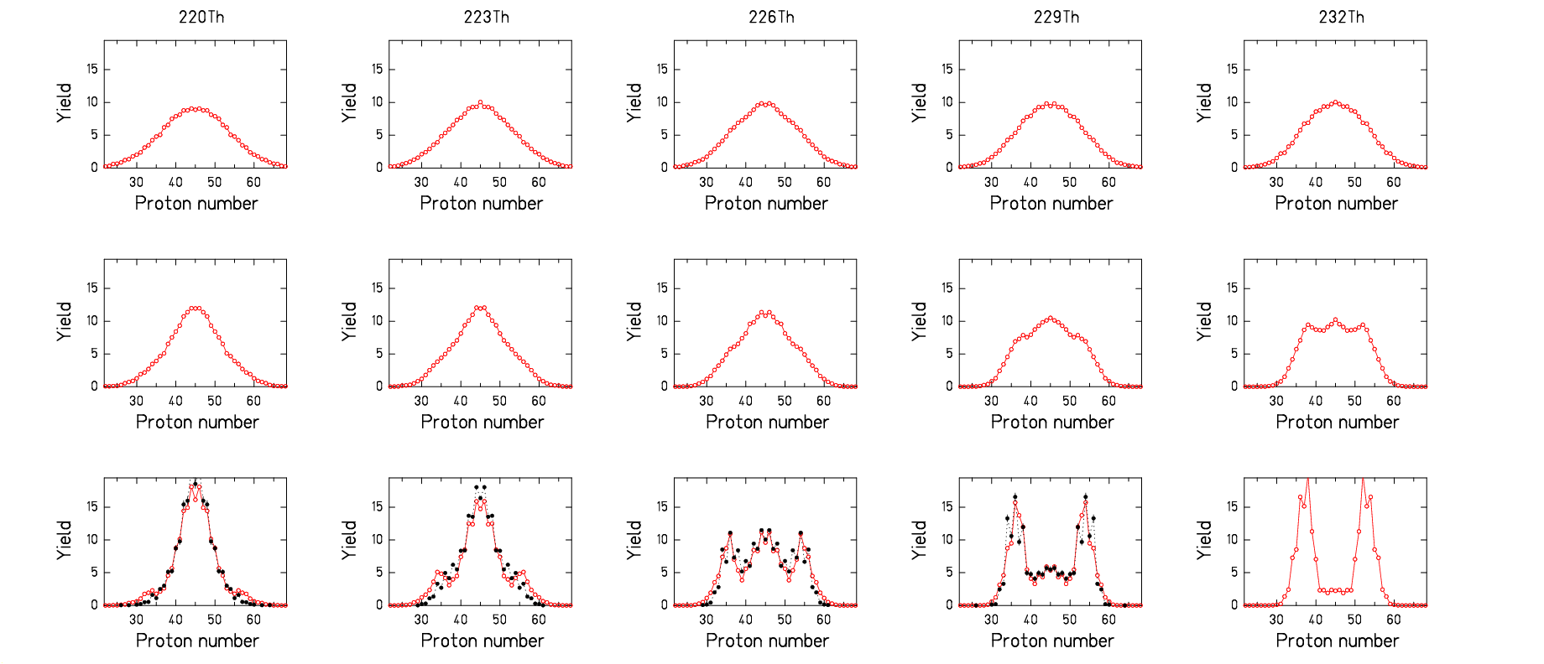
Liquid-drop potential: property of CN,
60 favours symmetric fission.
Shells: property of fragments favour
fission channels; vanish with E*.
20

10 MeV
An exercise on the mass distribution of ²³⁸U(n, f)
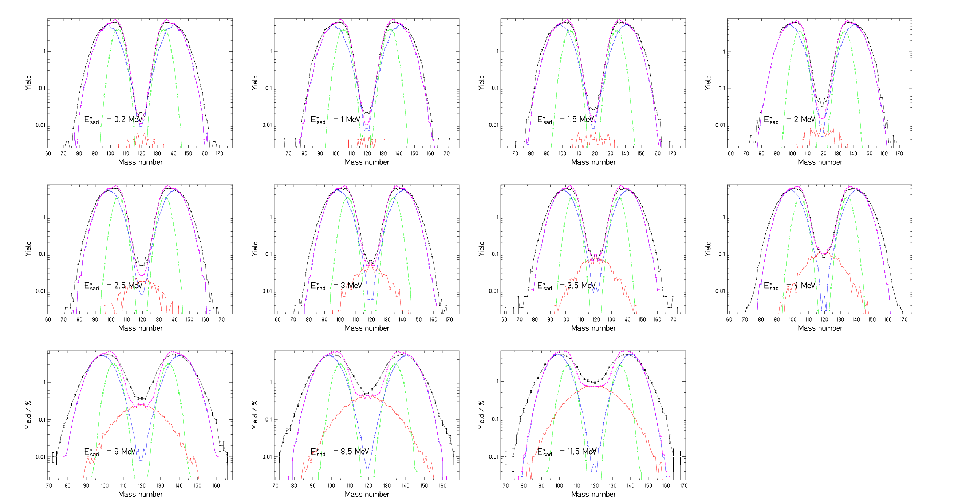
Conclusions on nuclide production in fission

Empirical systematics are not suited for astrophysical applications.
Theoretical approaches still fail to include all important features of the fission process, but they can give good orientation of major trends.
A macroscopic-microscopic approach based on macroscopic properties of the fissioning system and microscopic properties of the nascent fission fragments with simplified considerations of dynamical features seems to be promising for robust extrapolations of empirical features.
5. Status and outlook on data compilations
- Actual experimental limitations
Choice of possible systems.
Accuracy of data.
Uncertainties in extracting relevant parameters.
- Future experimental possibilities
Extension of region on chart of nuclides (very limited).
More precise data, improved extraction of relevant parameters (quite some potential).
- Robust approaches for extrapolations
Intelligent ideas, exploiting a good understanding of the physics.
Exploiting consistencies and interconnections between different
observables.
- Theories
Progress in theoretical tools and computing power expected.
Basic ingredients of theories remain subject to uncertainties.
Benchmarking of results required along the above ideas.

