Nuclear-data measurements at relativistic energies
in inverse kinematics

Peter Armbruster, A. Bacquias, Lydie Giot, Vladimir Henzl, Daniela Henzlova, Aleksandra Kelić, Strahinja Lukić, Pavel Nadtochy, Radek Pleskač, Maria Valentina Ricciardi, Karl-Heinz Schmidt, Florence Vivès , Bernd Voss, Orlin Yordanov
GSI, Planckstr. 1, D-64291 Darmstadt, Germany
Jose Benlliure, Jorge Pereira, Enrique Casarejos, Manuel Fernandez, Teresa Kurtukian
Univ. Santiago de Compostela, E-15706 Santiago de Compostela, Spain
Laurent Audouin, Charles-Olivier Bacri, Monique Bernas, Brahim Mustapha, Claude Stéphan, Laurent Tassan-Got
IPN Orsay, B.P. n. 1, F-91406 Orsay, France
Alain Boudard, Jean-Erique Ducret, Beatriz Fernandez, Sylvie Leray, Claude Volant, Carmen Villagrasa, Wojczek Wlaslo
DAPNIA/SPhN, CEA Saclay, F-91191 Gif sur Yvette Cedex, France
Julien Taieb
DEN/DM2S/SERMA/LENR, CEA Saclay, F-91191 Gif sur Yvette Cedex, France
Christelle Schmitt
IPNL, Université Lyon, Groupe Matiere Nucleaire, 4, rue Enrico Fermi, F-69622 Villeurbanne Cedex, France
Serge Czajkowski, Beatriz Jurado, Michael Pravikoff
CENBG, Le Haut Vigneau, F-33175 Bordeaux-Gradignan, Cedex, France
Paolo Napolitani, Fanny Rejmund
GANIL, B.P. 5027, F-14076 Caen Cedex 5, France
Arnd Junghans
Forschungszentrum Rossendorf, Postfach 510119, D-01314 Dresden, Germany
The problem

Nuclear data for spallation neutron sources (in particular ADS),
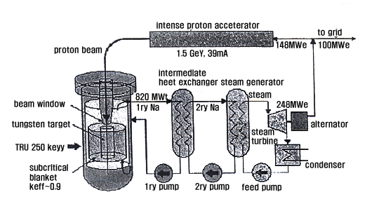
Astrophysics (reactions of cosmic rays in the interstellar medium),
Nuclear safety (shielding and radioactive inventory),
Medicine (cancer therapy with heavy-ion irradiation)
→ Need for good knowledge on nuclear reactions up to E/A ≈ 1 GeV including heavy residues.
The GSI Facility
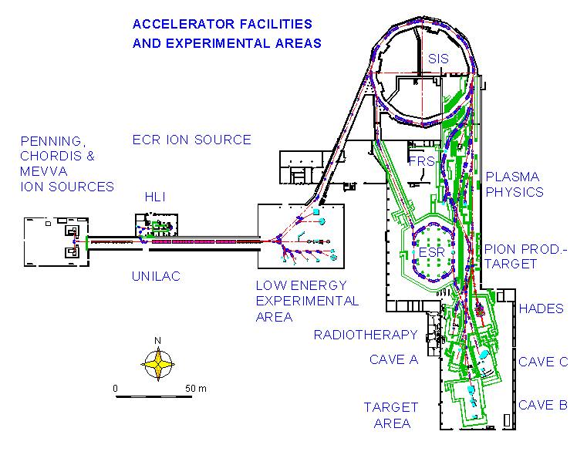

HI accelerator SIS18
18 Tm / ²³⁸U with 1 A GeV
High-resolution spectrometer FRS
18 Tm / p/Δp = 2000
Large-acceptance dipole ALADIN
Future SPALADIN experiment
Storage ring ESR, 10 Tm
Atomic masses (Talk Audi)
The Fragment separator as high-resolution magnetic spectrometer

²³⁸U (1A GeV) + ¹H
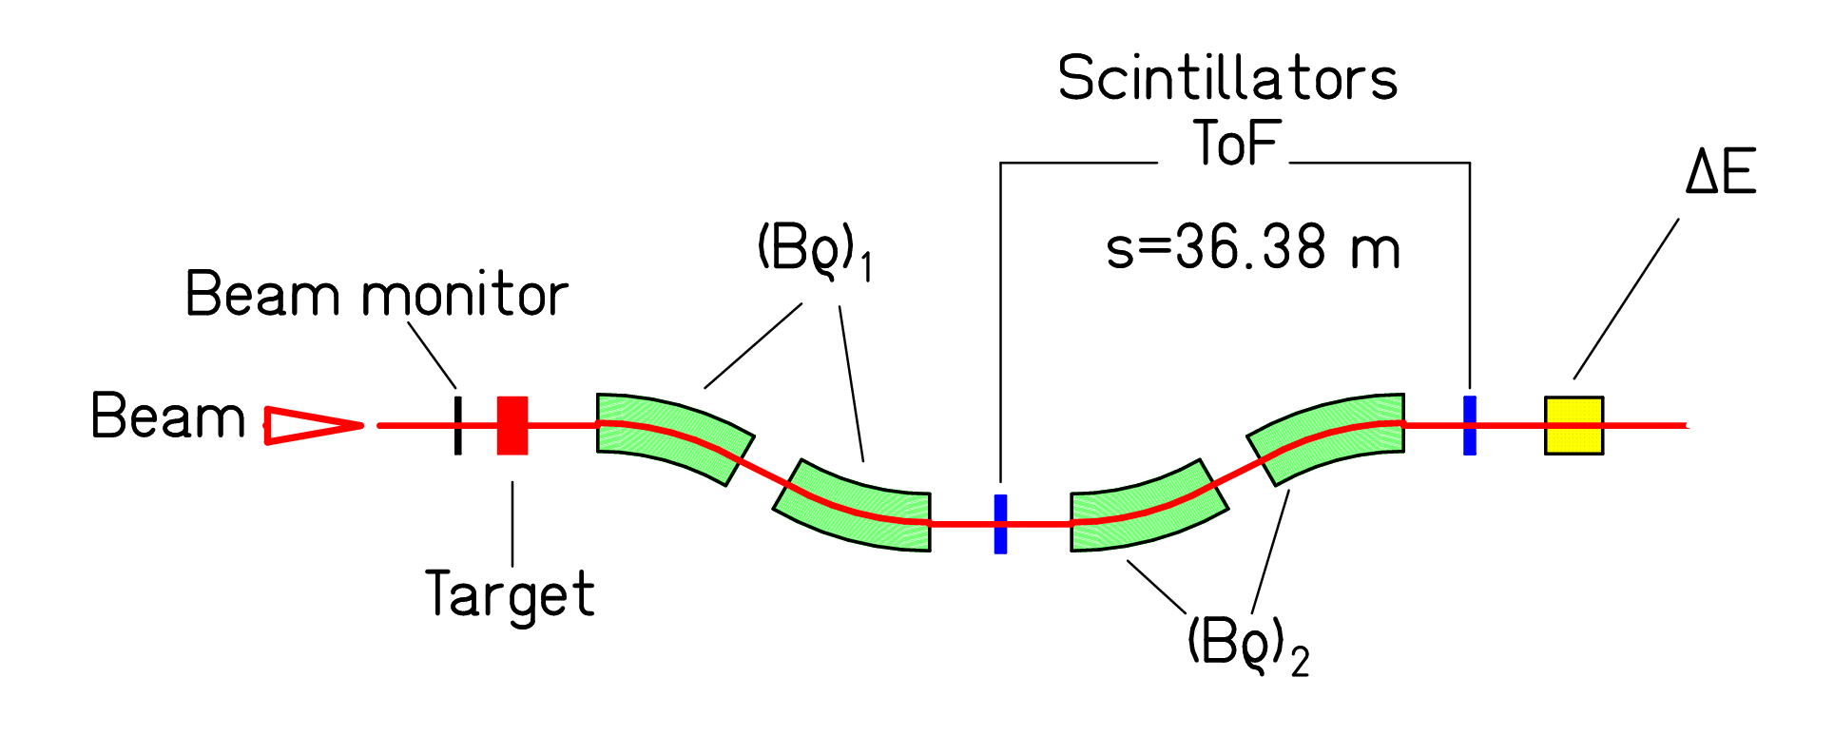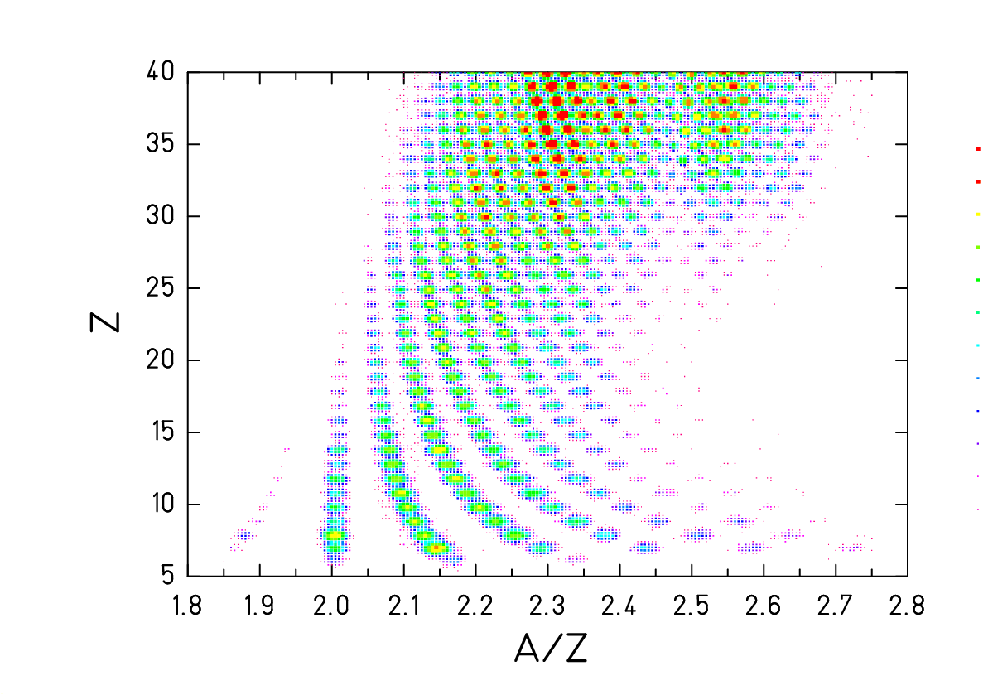
Spectrometer Identification pattern
(M. V. Ricciardi)
Resolution p/Δp ≈ 2000.
Acceptance ΔBρ/ Bρ = 3% and Θ_{max}=15 mr.
Identification in Z and A by magnetic deflection in FRS, tracking, ToF and ΔE.
Basic equations: Bρ = m₀ A c β γ / (e Z) and ΔE ∝ Z² / v²
Experimental progress by inverse-kinematics method
Example: Fission of lead induced by ≈ 500 MeV protons
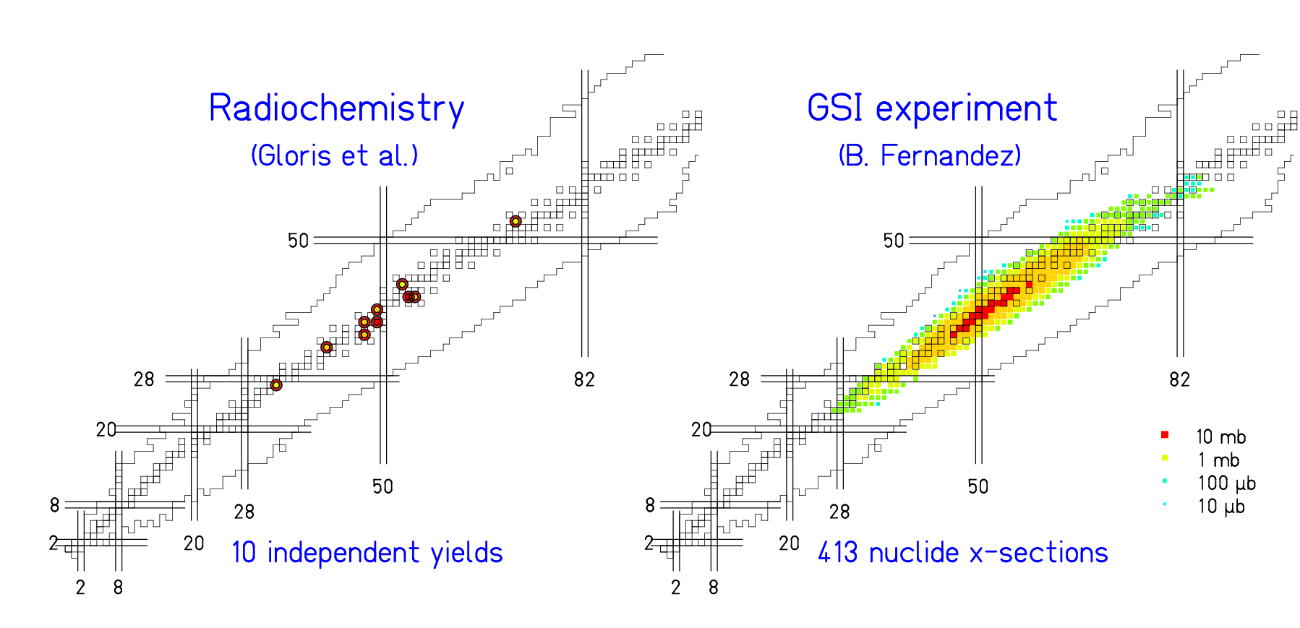
protons (553 MeV) on lead ²⁰⁸Pb (500 A MeV) on hydrogen
Some systems investigated (7732 data points)
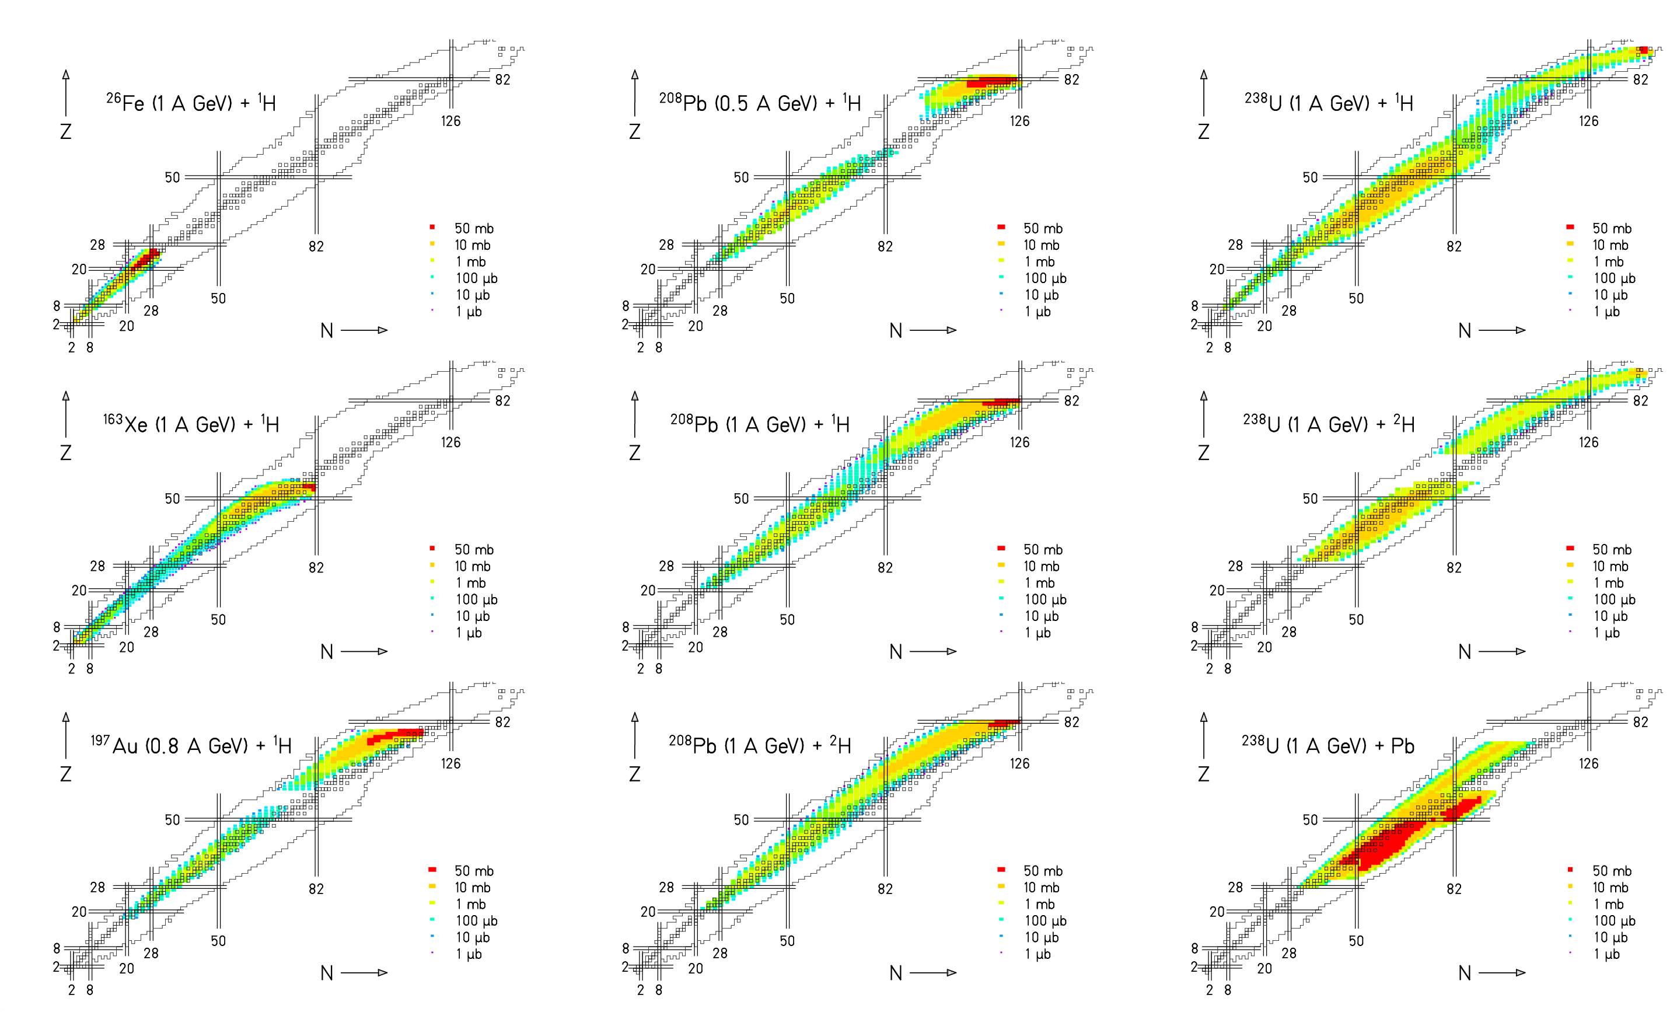
List of systems investigated
⁵⁶Fe (0.3 to 1.5 A GeV) + ¹H C. Villagrasa, PhD thesis
P. Napolitani et al., PRC 70 (2004) 054607
¹³⁶Xe(0.2 to 1 A GeV) + ^{1,2}H P. Napolitani, PhD thesis
L. Giot, in preparation
M. Fernandez, in preparation
¹⁹⁷Au (800 A MeV) + ¹H F. Rejmund et al., NPA 683 (2001) 540
J. Benlliure et al., NPA 683 (2001) 513
²⁰⁸Pb (1 A GeV) + ^{1,2}H T. Enqvist et al., NPA 686 (2001) 481
T. Enqvist et al., NPA 703 (2002) 435
A. Kelić et al., PRC 70 (2004) 064608
²⁰⁸Pb (500 A Mev) + ¹H B. Fernandez et al., NPA 747 (2005) 227
L. Audouin et al., arXiv-nucl-ex/(0503021
²³⁸U (1 A GeV) + ^{1,2}H M. V. Ricciardi et al., arXiv-nucl-ex/0508027
M. Bernas et al., NPA 725 (2003) 213
M. Bernas et al., submitted
J. Taieb et al., NPA 724 (2003) 413
J. Pereira, PhD thesis
E. Casarejos, PhD thesis
P. Armbruster et al, PRL 93 (2004) 212701
²³⁸U (1 A GeV) + Pb T. Enqvist et al., NPA 658 (1999) 47
Beyond the experimental data

Interpolation, extrapolation (nuclear systems, interaction energy) needed

a) Empirical systematics (problem is often too complex)
Examples: Rudstam, Silberberg and Tsao, Atchison

b) Theoretical model (not always precise enough)
Established and quite successful models:
Intranuclear cascade
pre-equilibrium models
evaporation of nucleons and light nuclei
Encouraging progress for a full microscopic description of fission

c) Combination of nuclear models, theory-guided systematics (exemplified on fission)
Comparison of two systems
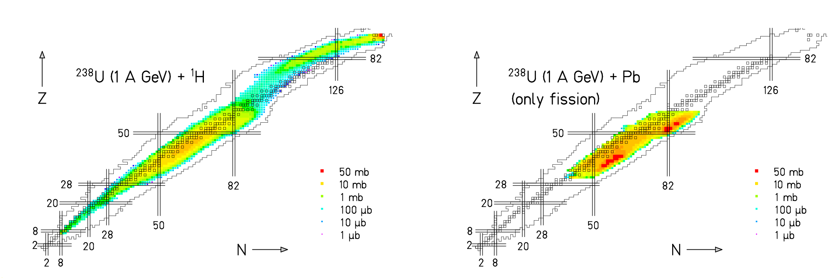

Fission of ²³⁸U induced in a proton and a lead target:
Very different nuclide distributions.
Evolution of fission distributions with A and E*
220Th 223Th 226Th 229Th 232Th
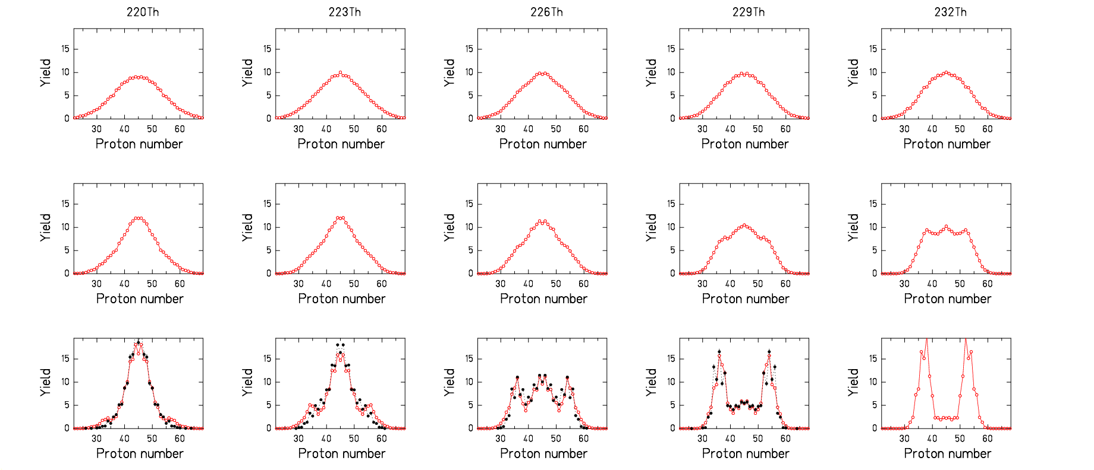
60 MeV

20 MeV

10 MeV

red: PROFI calculation, black: experimental data (K.-H. Schmidt et al., NPA 665 (2000) 221)

Ingredients of the fission model: Level densities, assumptions on dynamics, potential fitted to data.
Liquid-drop potential: property of CN, favours symmetric fission.
Shells: property of fragments (2-center shell model), favour fission channels; vanish with E*.
Nuclide distribution: superposition of fission from different nuclei at different E*.
Even-odd effect
- In low-energy fission (known since long, related to pair breaking of the superfluid system on the way to scission)
- in high-energy reactions (systematically investigated at GSI, related the fluid-superfluid phase transition in the evaporation process, similar magnitude as low-energy effect)

Observed even-odd effect in the
production of light fragments in
²³⁸U (1 A GeV) + Ti.
(Complex behaviour!)

Main features are reproduced by
the model calculations by using
realistic binding energies and level
densities. Importance of γ competition!

M. V. Ricciardi et al., Nucl. Phys. 733 (2004) 299
Application to ²³⁸U (1 A GeV) + ¹H
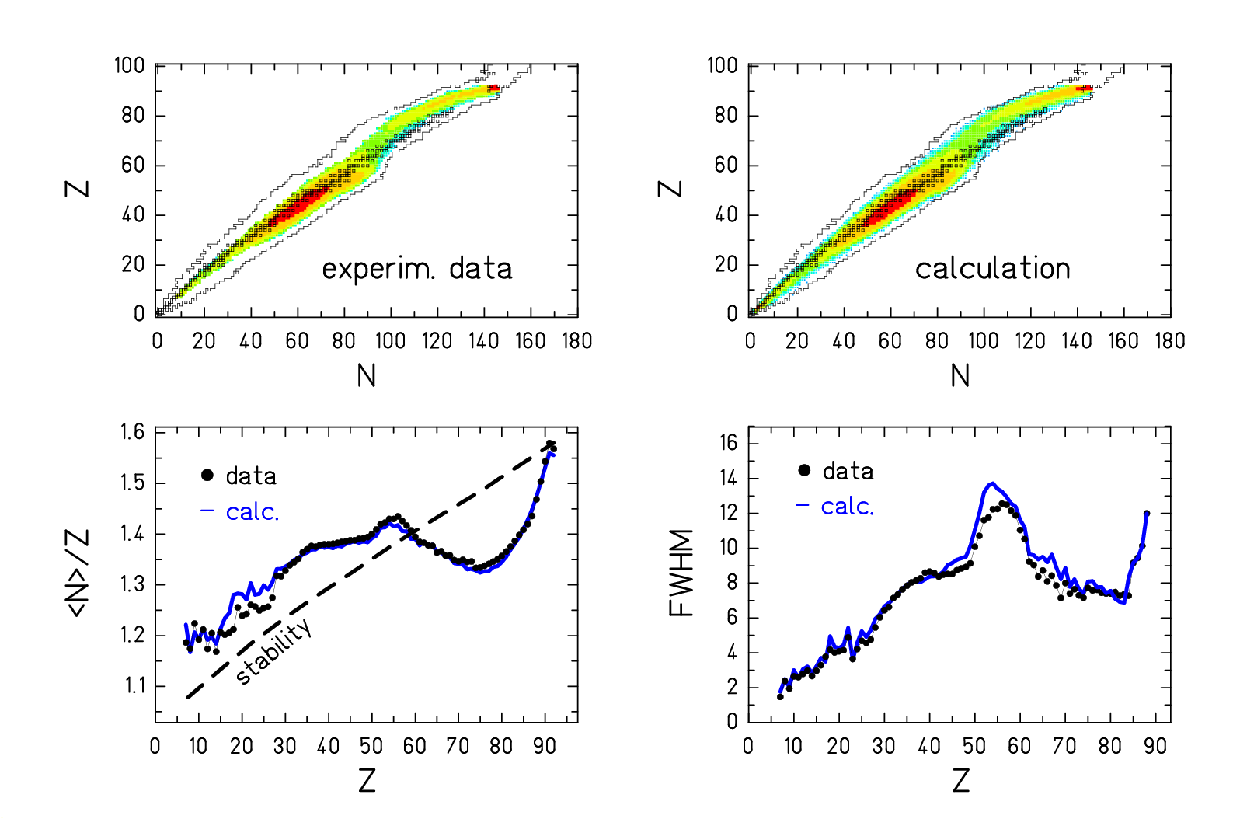
Systematics of model calculations

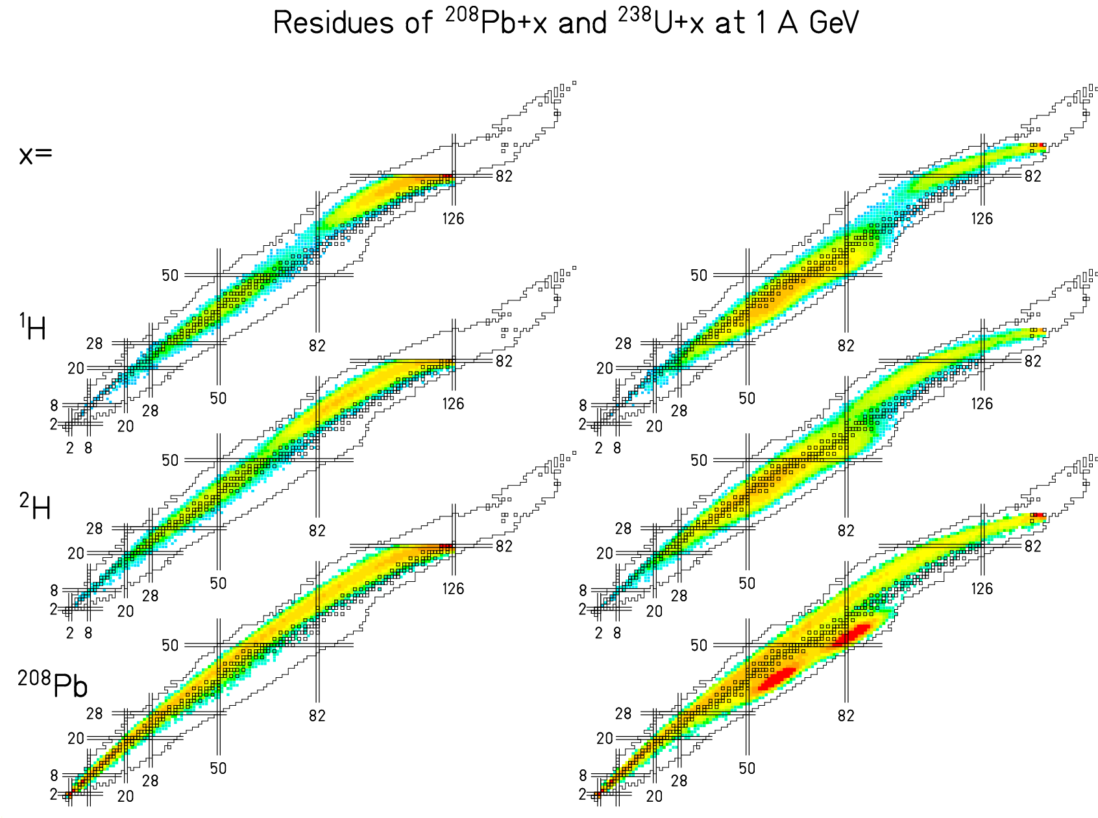

Very different isotopic
distributions for different
projectile-target
combinations!

Experimental data are
well reproduced.
The FAIR project
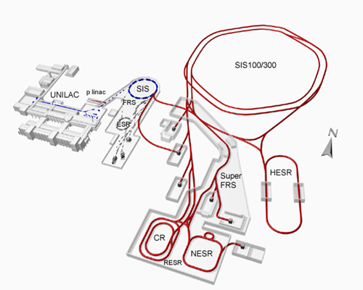
Increased beam energies and intensities
Spectrometers with larger acceptance and/or better resolution
Conclusion
- The HI-accelerator and spectrometer complex of GSI Darmstadt is unique world-wide
- Break-through in measuring full nuclide distributions in spallation reactions
in a French-Spanish-German collaboration
- Comprehensive data tables established (→ www-w2k.gsi.de/charms)
- New insight into global features of spallation and fission
- Model for nuclide production in fission on the basis of E_{pot} and ρ
- Successful modelling of all aspects of spallation-fission reactions
- Even better experimental conditions in the future FAIR facility

