Why Inverse Kinematics?

Experiments with proton beams:

The products stick in the target.
Identification by radioactive decay
→ Insensitive to short-lived nuclides

Experiments with heavy-ion beams:

The products leave the target with high velocity
Identification in-flight
→ Sensitive to all nuclides
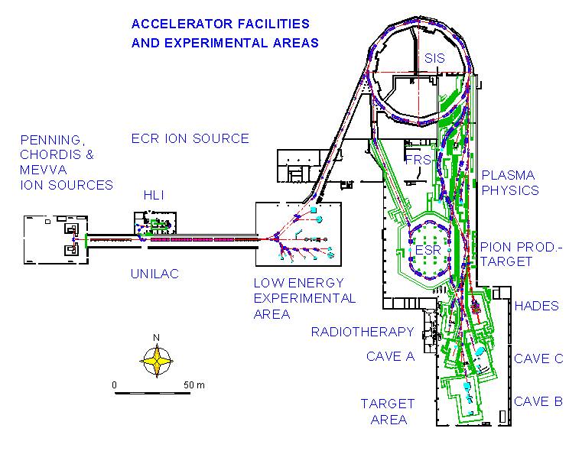
The facilities of GSI

Heavy nuclei (¹⁹⁷Au, ²⁰⁸Pb, ²³⁸U) are accelerated and hit the production target. The projectile-like residues are identified in-flight with the fragment separator (FRS).
The Fragment Separator

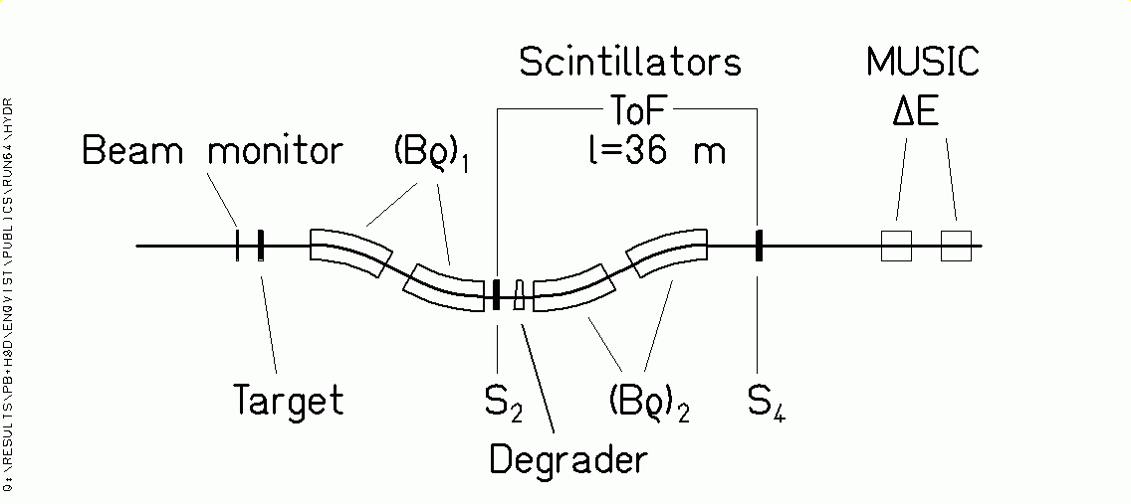

Projectile-like fragments:

Transmitted with ΔBρ/ Bρ = 3% and Θ_{max}=15 mr.

Identification in Z and A by magnetic deflection in FRS, tracking, ToF andΔE.

Bρ = m₀ A c β γ / (e Z)

ΔE ∝ Z² / v²

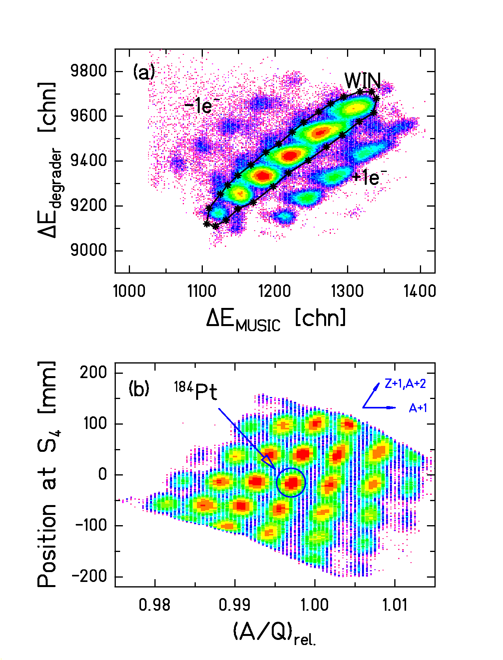
Isotopic identification
Suppression of ionic charge states (above) and isotopic identification (below).

(Data: ²⁰⁸Pb (1 A GeV) + ¹H, Timo Enqvist)
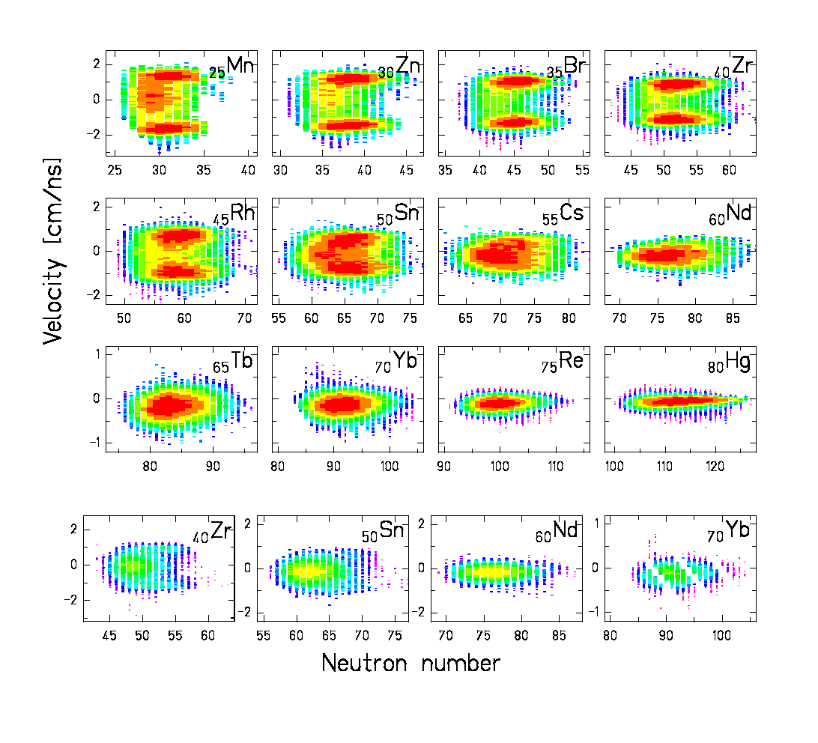
Fragment velocities
Reactions in H₂ target (above) and Ti windows (below).

Signature of the reaction mechanism:

Fragmentation (single peak) and fission (two peaks).

(Data: ²⁰⁸Pb (1 A GeV) + ¹H, Timo Enqvist)

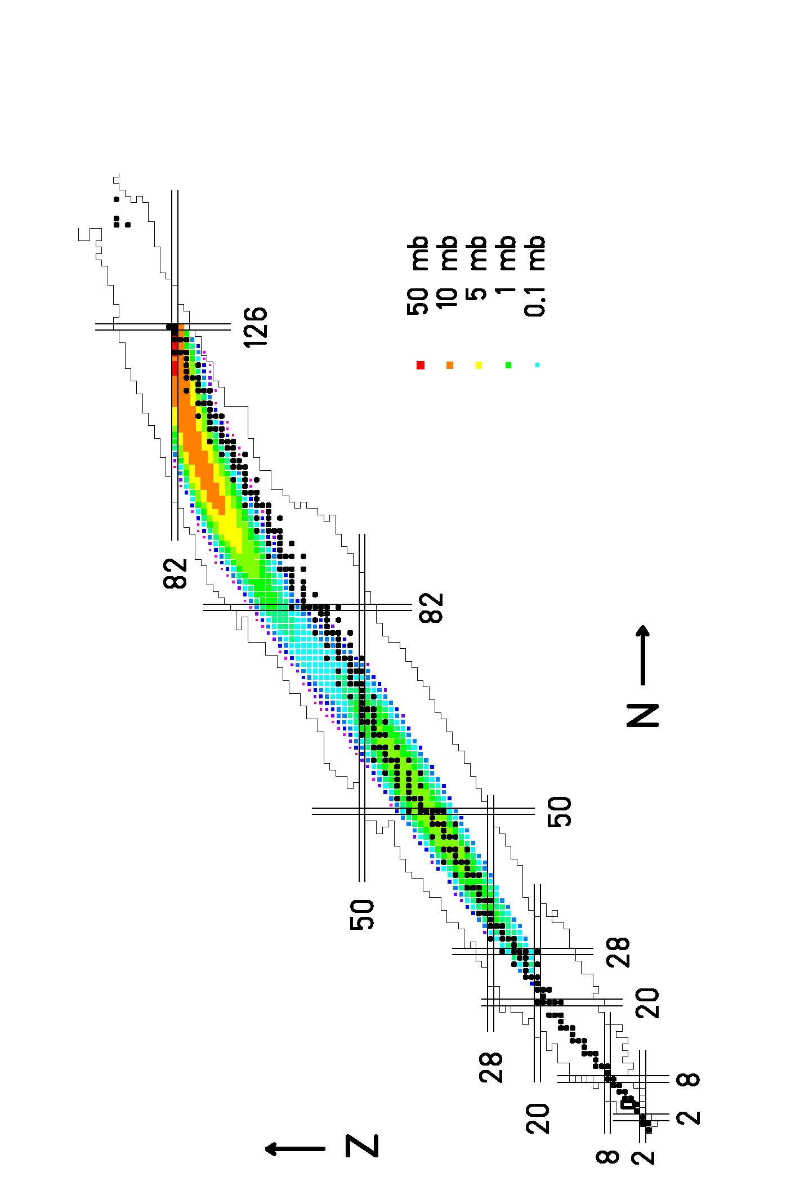
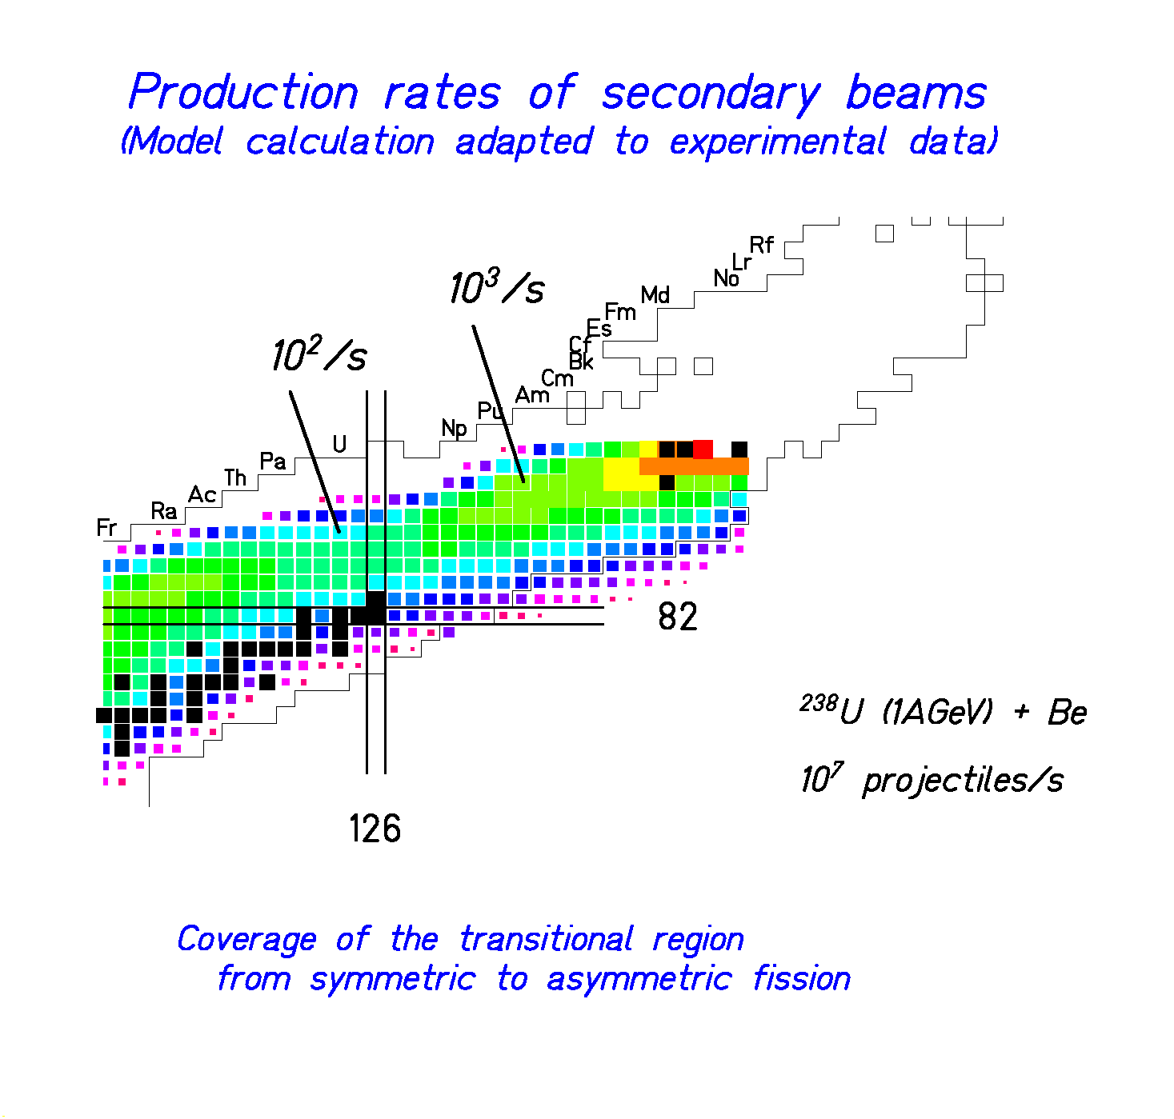
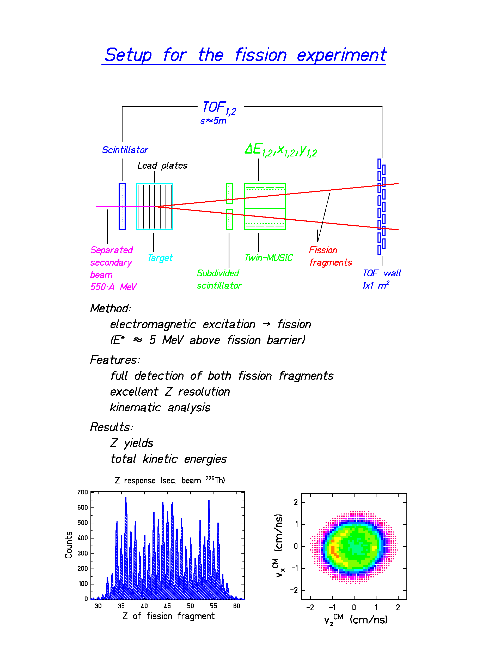
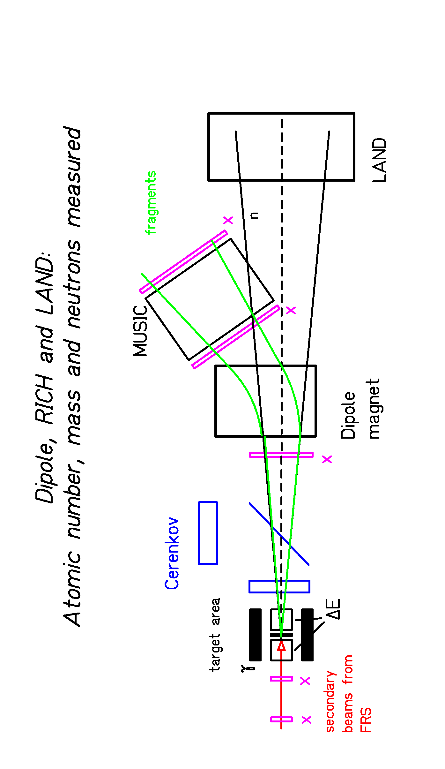
Atomic number of fissioning system
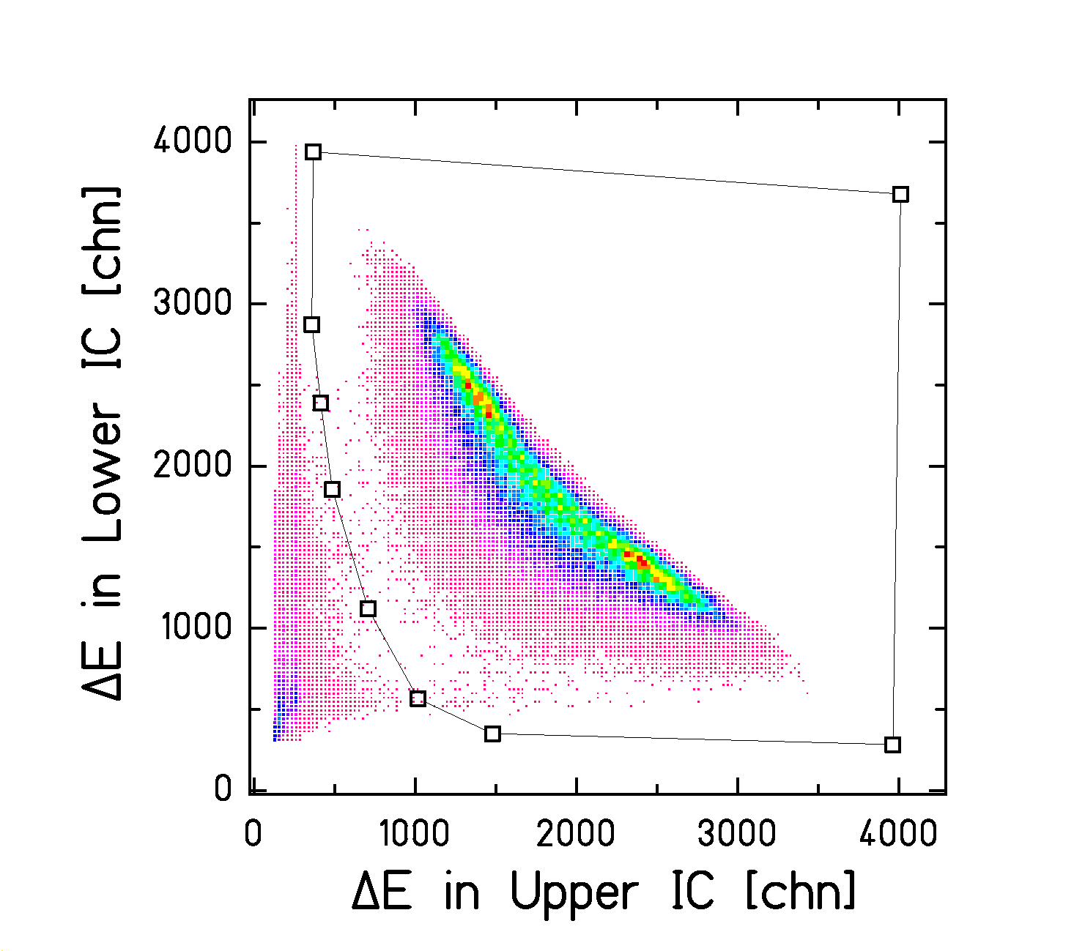
²³⁸U (1 A GeV) + ²⁰⁸Pb

From ΔE₁ and ΔE₂ →
Z₁ and Z₂ are determined.

Evaporation of protons suppressed →
Z₁+Z₂ gives atomic number of fissioning system

B. Jurado, PhD thesis, in preparation
Fission of 1 A GeV ²³⁸U induced in (CH₂)_{n}
Which are the nuclei that fission?

Z₁ + Z₂ gives Z of the fissioning nucleus.

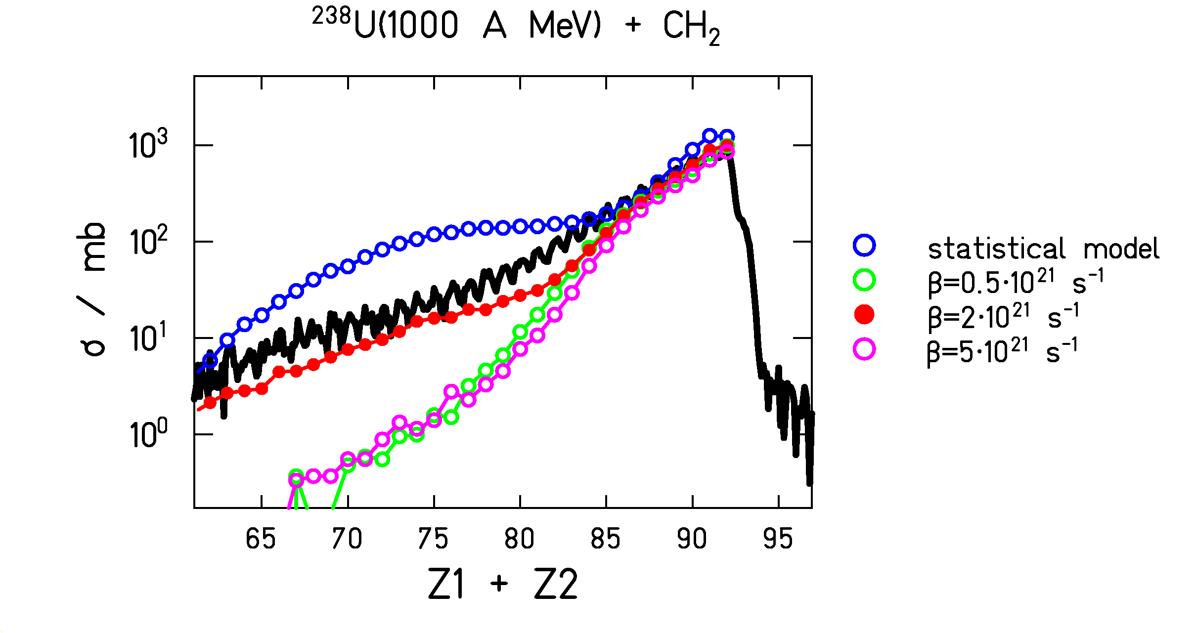

Many elements contribute to the fission-fragment distribution. There fission properties can only be studied by secondary beams.

Nuclear dissipation is a key parameter.

B. Jurado, PhD thesis, in preparation

Hindrance of fission due to dissipation
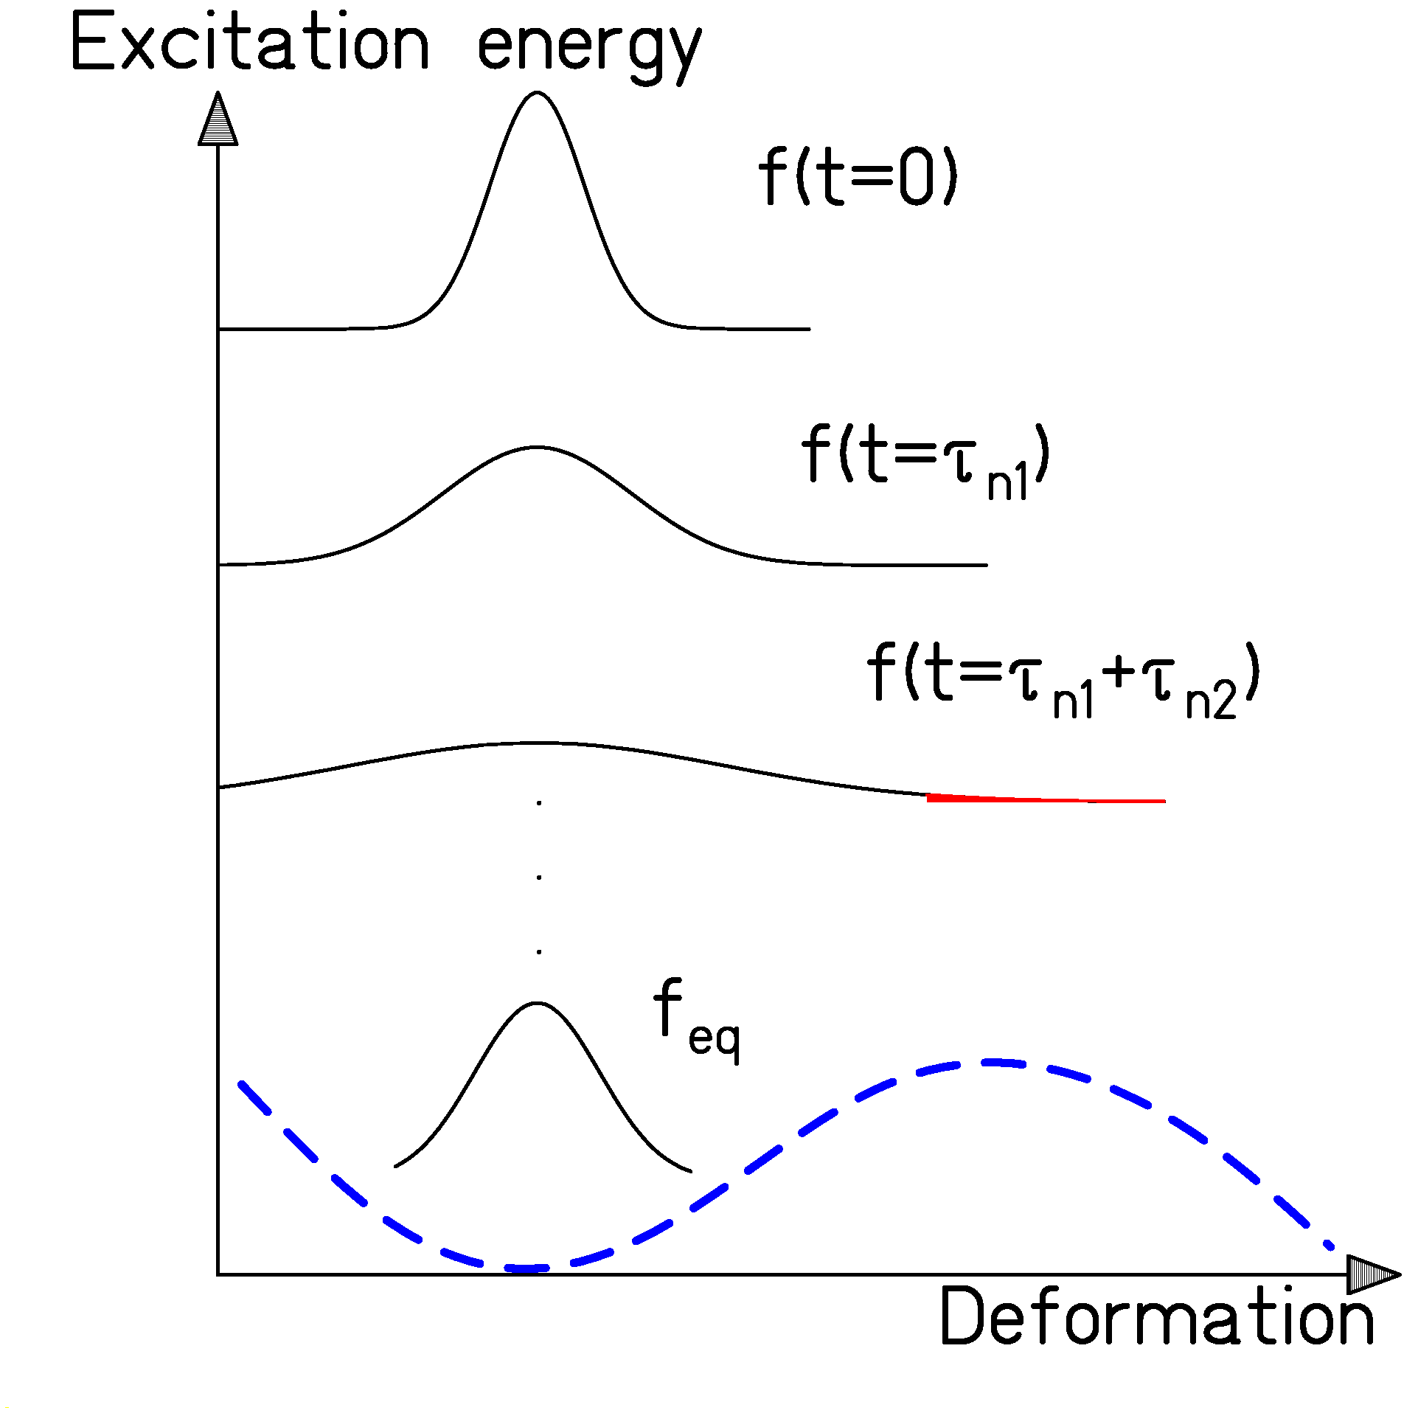

Time evolution of the deformation distribution during the deexcitation cascade.
- Fission sets in with a time delay, while evaporation starts immediately.
- Fragmentation provides unique conditions: high excitation energies with low angular momenta and small shape distortions

Mapping the fission properties of neutron-deficient actinides with secondary beams.
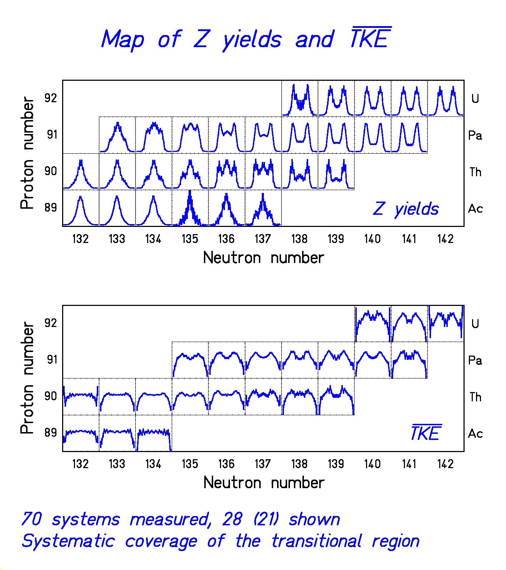

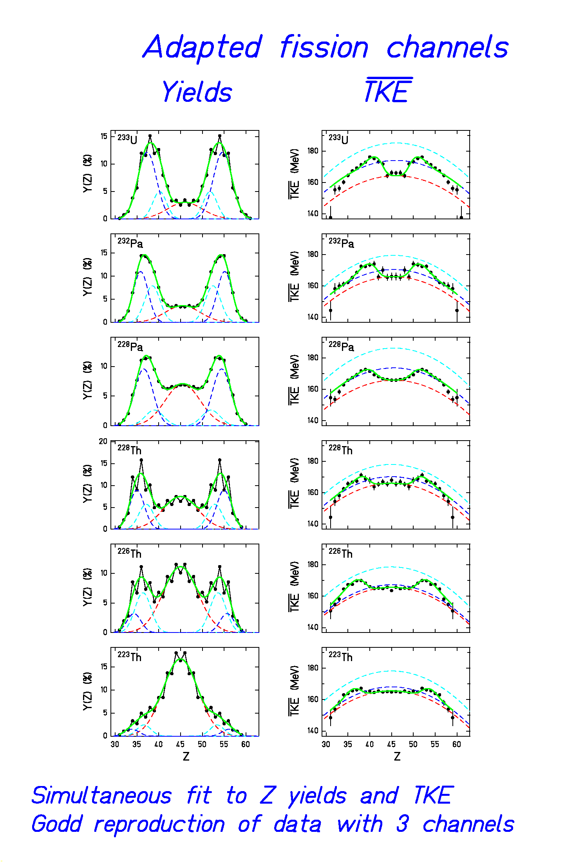
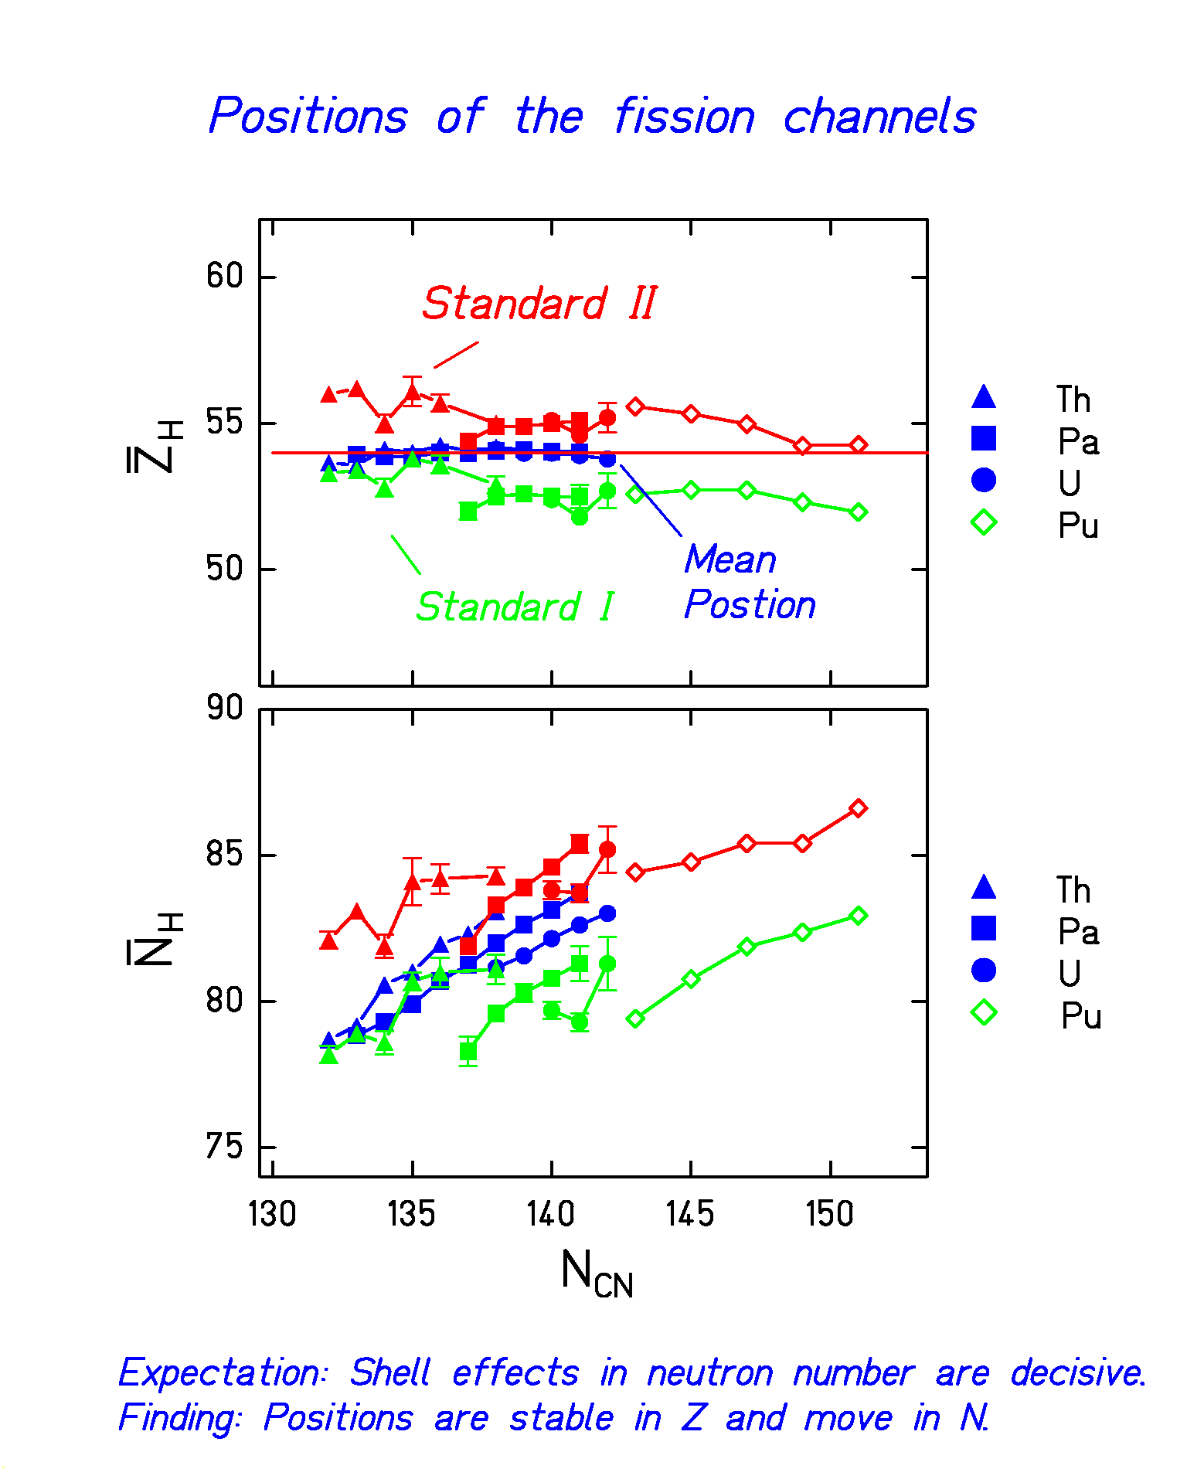
Polarisation in Fission

Charge polarisation (variation of the N/Z ratio of the fragments) is the only way to exceed the N/Z of the fissioning system.

Possible mechanisms for charge polarisation:
- Shell effects (e.g. ¹³²Sn)
(Only at low excitation energies)
- Temperature fluctuations
(but shift to neutron-deficient by evaporation)
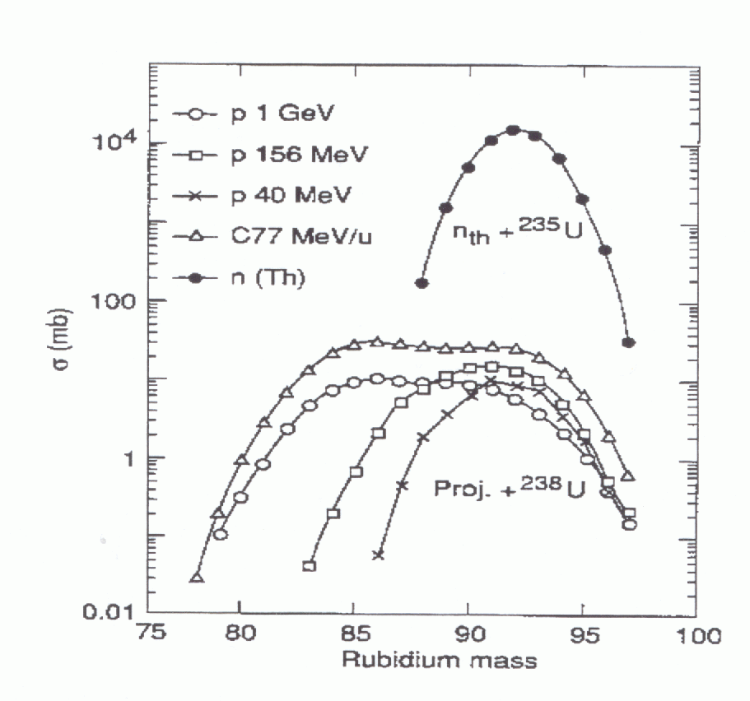
Systematics of isotopic production of Rb

Production cross sections of neutron-rich fragments are almost independent of the projectile.

From H. L. Ravn et al. Nucl. Instr. Meth. B88 (1994) 441

Fission of relativistic 238U for production of neutron-rich isotopes

Successfully applied:

"DISCOVERY AND CROSS-SECTION MEASUREMENT OF 58 NEW FISSION PRODUCTS IN PROJECTILE-FISSION OF 750 A MeV 238U"
B. Bernas, C. Engelmann, P. Armbruster, S. Czajkowski, F. Ameil, C. Boeckstiegel, Ph. Dessagne, C. Donzaud, H. Geissel, A. Heinz, Z Janas, C. Kozhuharov, Ch. Miehe, G. Muenzenberg, M. Pfuetzner, W. Schwab, C. Stephan, K. Suemmerer, L. Tassan-Got, B. Voss
Phys. Lett. B 415 (1997) 111-116
"PRODUCTION AND IDENTIFICATION OF HEAVY Ni ISOTOPES: EVIDENCE FOR THE DOUBLY MAGIC NUCLEUS 78Ni"
Ch. Engelmann, F. Ameil, P. Armbruster, M. Bernas, S. Czajkowski, Ph. Dessagne, C. Donzaud, H. Geissel, A. Heinz, Z. Janas, C. Koshuharov, Ch. Miehe, G. Muenzenberg, M. Pfuetzner, C. Roehl, W. Schwab, C. Stephan, K. Suemmerer, L. Tassan-Got, B. Voss
Z. Phys. A 352 (1995) 351-352

Low-energy fission → Yield concentrated on a few rather neutron-rich fission fragments.

High-energy fission → Broader distributions in mass and N/Z; better conditions for extremely neutron-rich?

Modelling the Width in A and N/Z
of Fission-Product Isotopic Distributions

Approximated parabolic potential

$$U\left(η\right)=C_{η}⋅{\left(η−η_{o}\right)}^{2}$$

Statistical population:

$Y\left(η\right)∝\text{exp}\left\{2\sqrt{a\left(U_{0}−U\left(η\right)\right)}\right\}$ →

$Y(η)∝\text{exp}\left\{−\frac{{\left(η−η_{0}\right)}^{2}}{2σ_{η}^{2}}\right\}$ with

$$2σ_{η}^{2}=\frac{T}{C_{η}}$$

U = potential energy,
η = either A (mass split) or N/Z (polarisation),
$C_{η}$ = stiffness of the potential,
T = nuclear temperature.
Kinematic Properties of Potassium Produced from ²³⁸U in Different Targets

Projectile: ²³⁸U, 1 A GeV
Target left: hydrogen (+ titanium window)
right: titanium

Velocity distributions of potassium isotopes
→ Production in hydrogen target
from very asymmetric fission.
→ Production in titanium target
from projectile fragmentation.

Data from M. V. Ricciardi, GSI, thesis in preparation.
Production of Potassium in p + ²³⁸U

Isotopic yields from 600 MeV protons on ²³⁸U (ISOLDE)
and
fission-product yields from 1 A GeV ²³⁸U + hydrogen (GSI)

No absolute cross sections from ISOLDE yields.

The distributions fit together:
ISOLDE yields of light elements from fission!

Data from
H.-J. Kluge, ISOLDE user's guide, CERN 86-05 (1986) and
M. V. Ricciardi, GSI, thesis in preparation

Conclusion

Design of ADS
and next-generation RIB facilities
requires detailed understanding of fission
of a large variety of nuclei
over a large range of excitation energies.

Unique conditions for systematic investigations of fission by use of inverse kinematics and powerful spectrometer.

Relativistic ²³⁸U beam allows
production of secondary beams and/or
full identification of fission products.

Data
on low-energy fission from e-m excitation and
on high-energy fission from nuclear excitations
are available.

Progress in understanding
dissipation, shell and temperature effects in fission.

Future plans to use even more elaborate experimental equipment.

