FRS as high-resolution spectrometer for identification of reaction residues

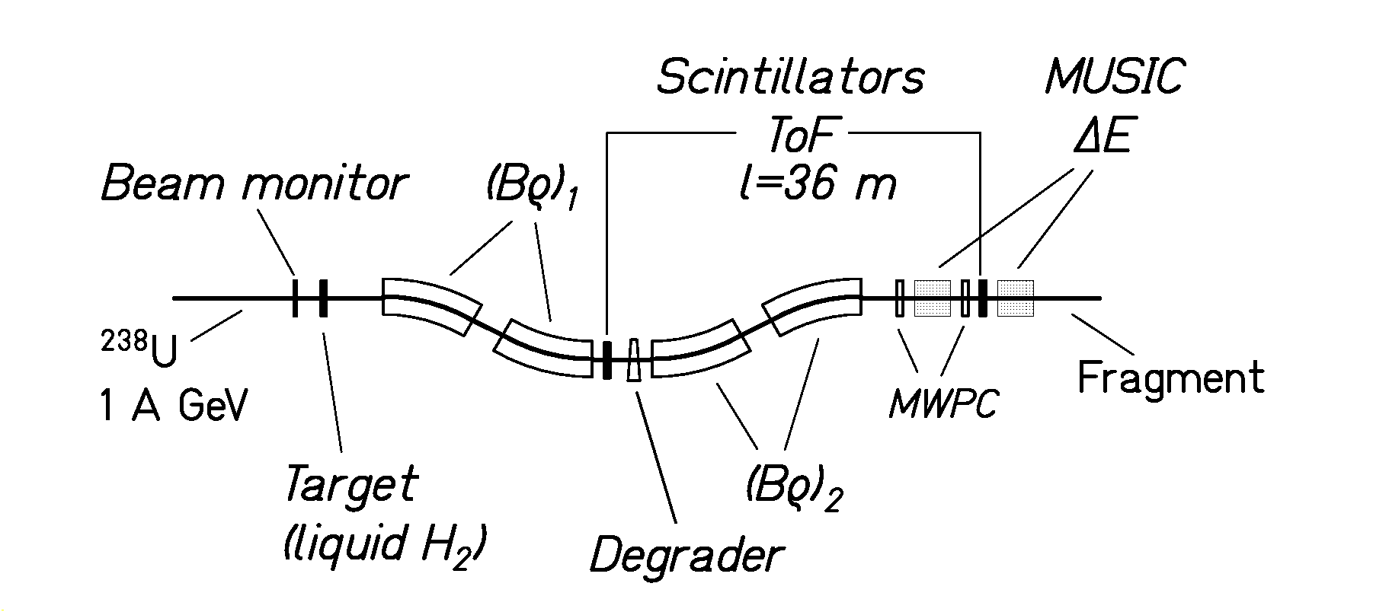

Experimental set up

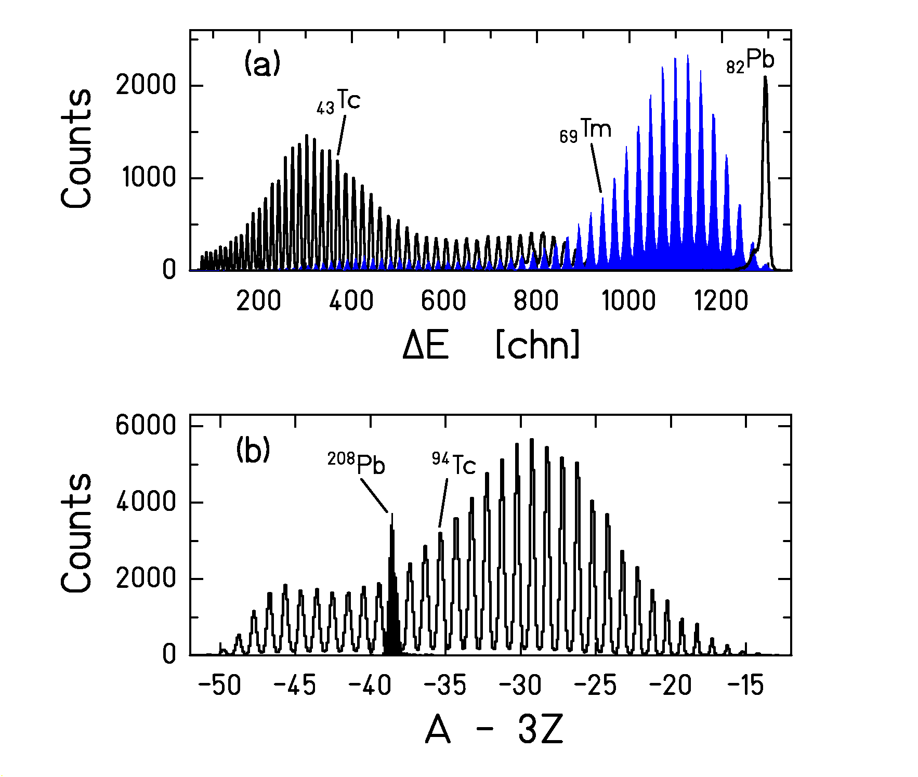
Resolution in Z and A

