Systematic survey on residual nuclide production

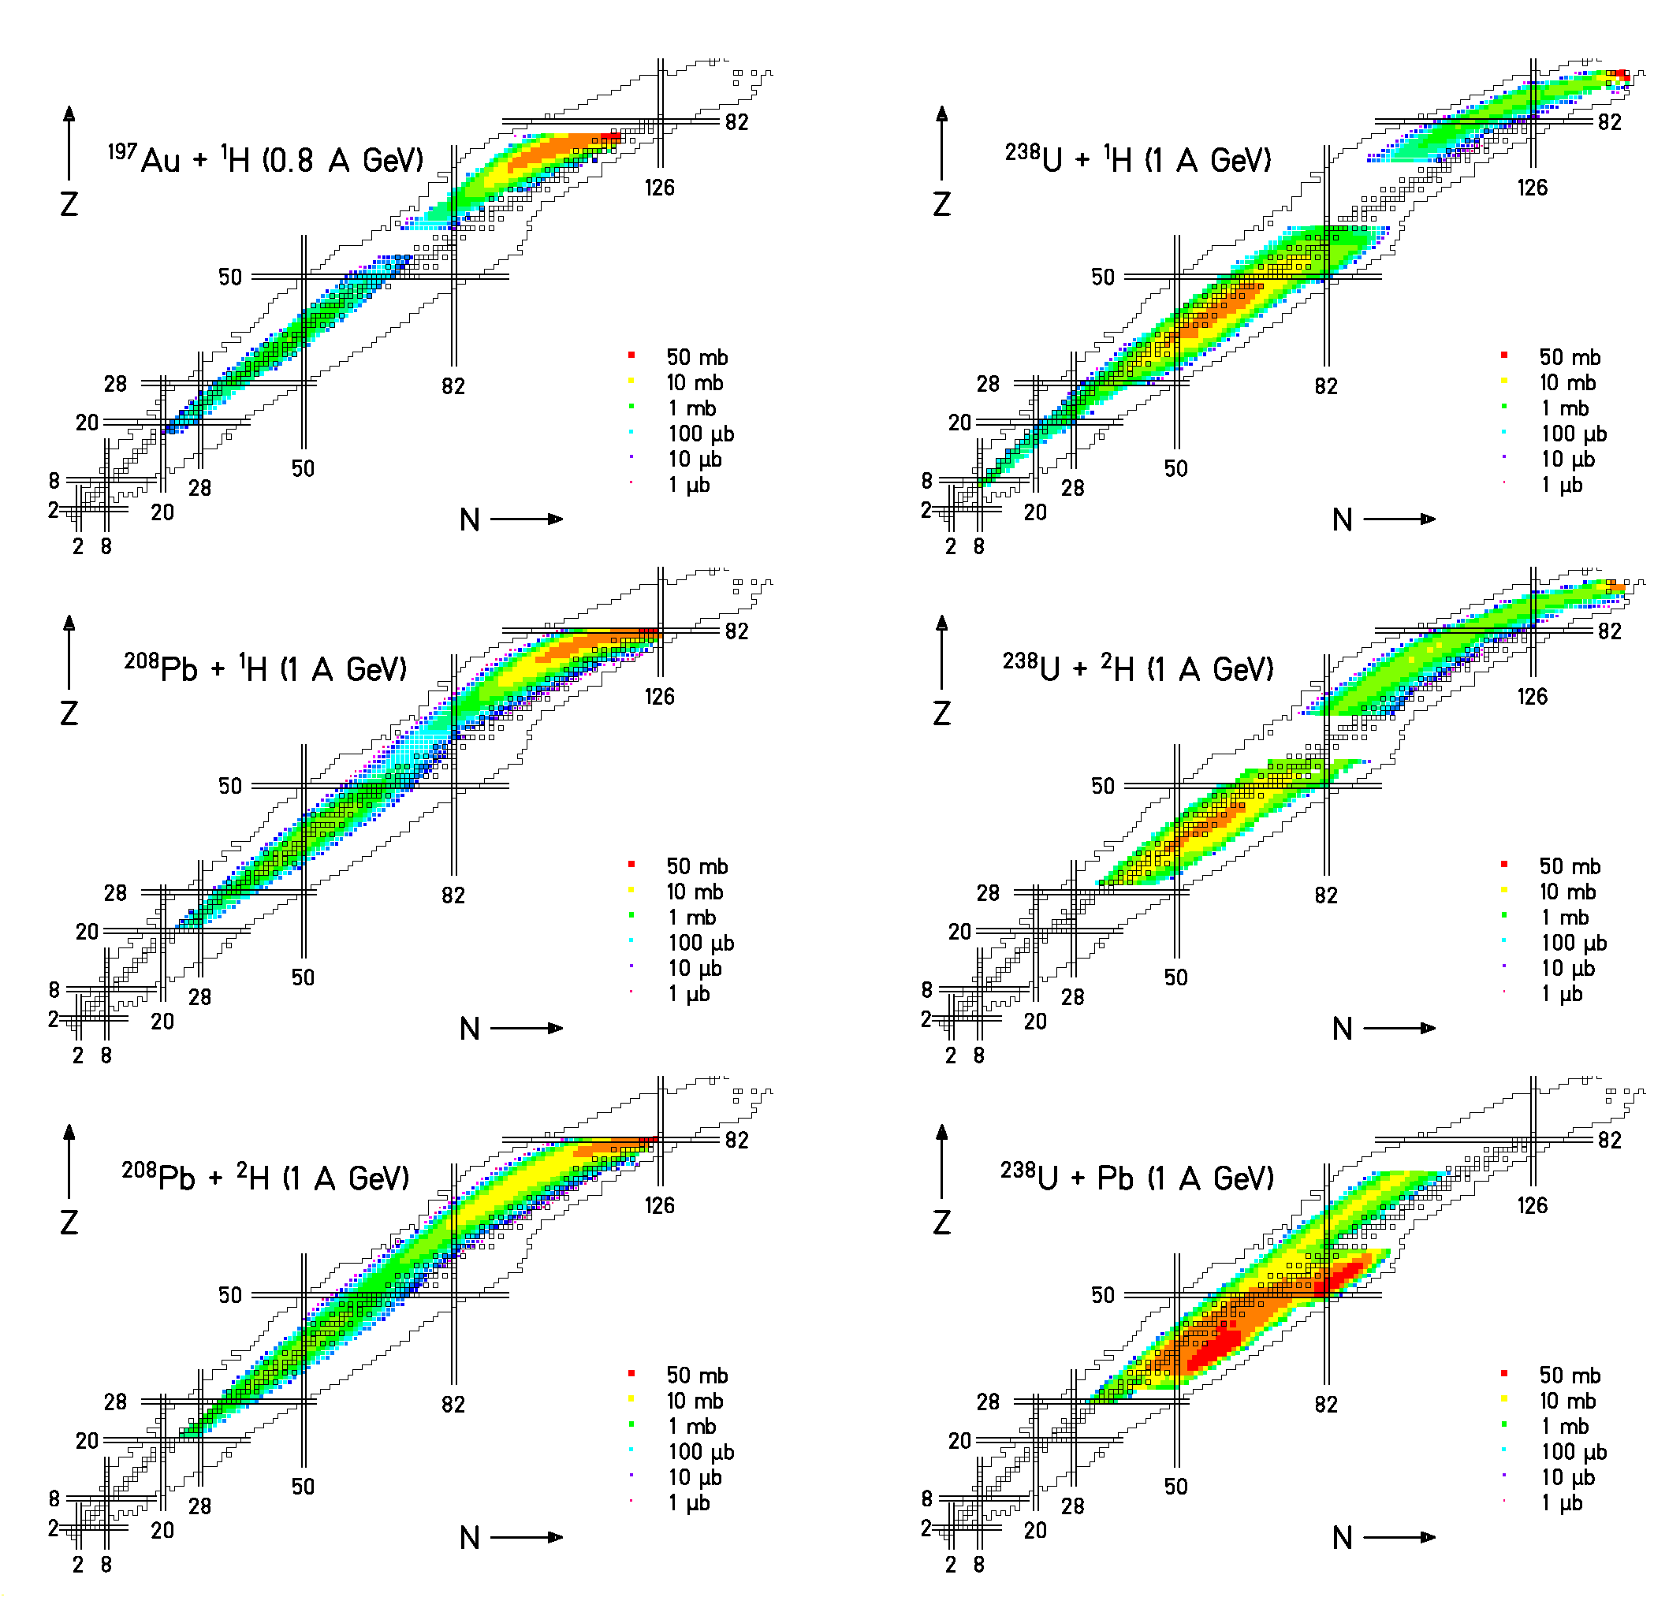

6000 individual data points!

Basic data for
- EURISOL and GSI project
  - Intensities of secondary beams
- HINDAS
  - Nuclear data for
    - Incineration of nuclear waste
    - Accelerator-driven systems
    - Spallation neutron sources

