Neutron excess of reaction residues,
a new nuclear thermometer

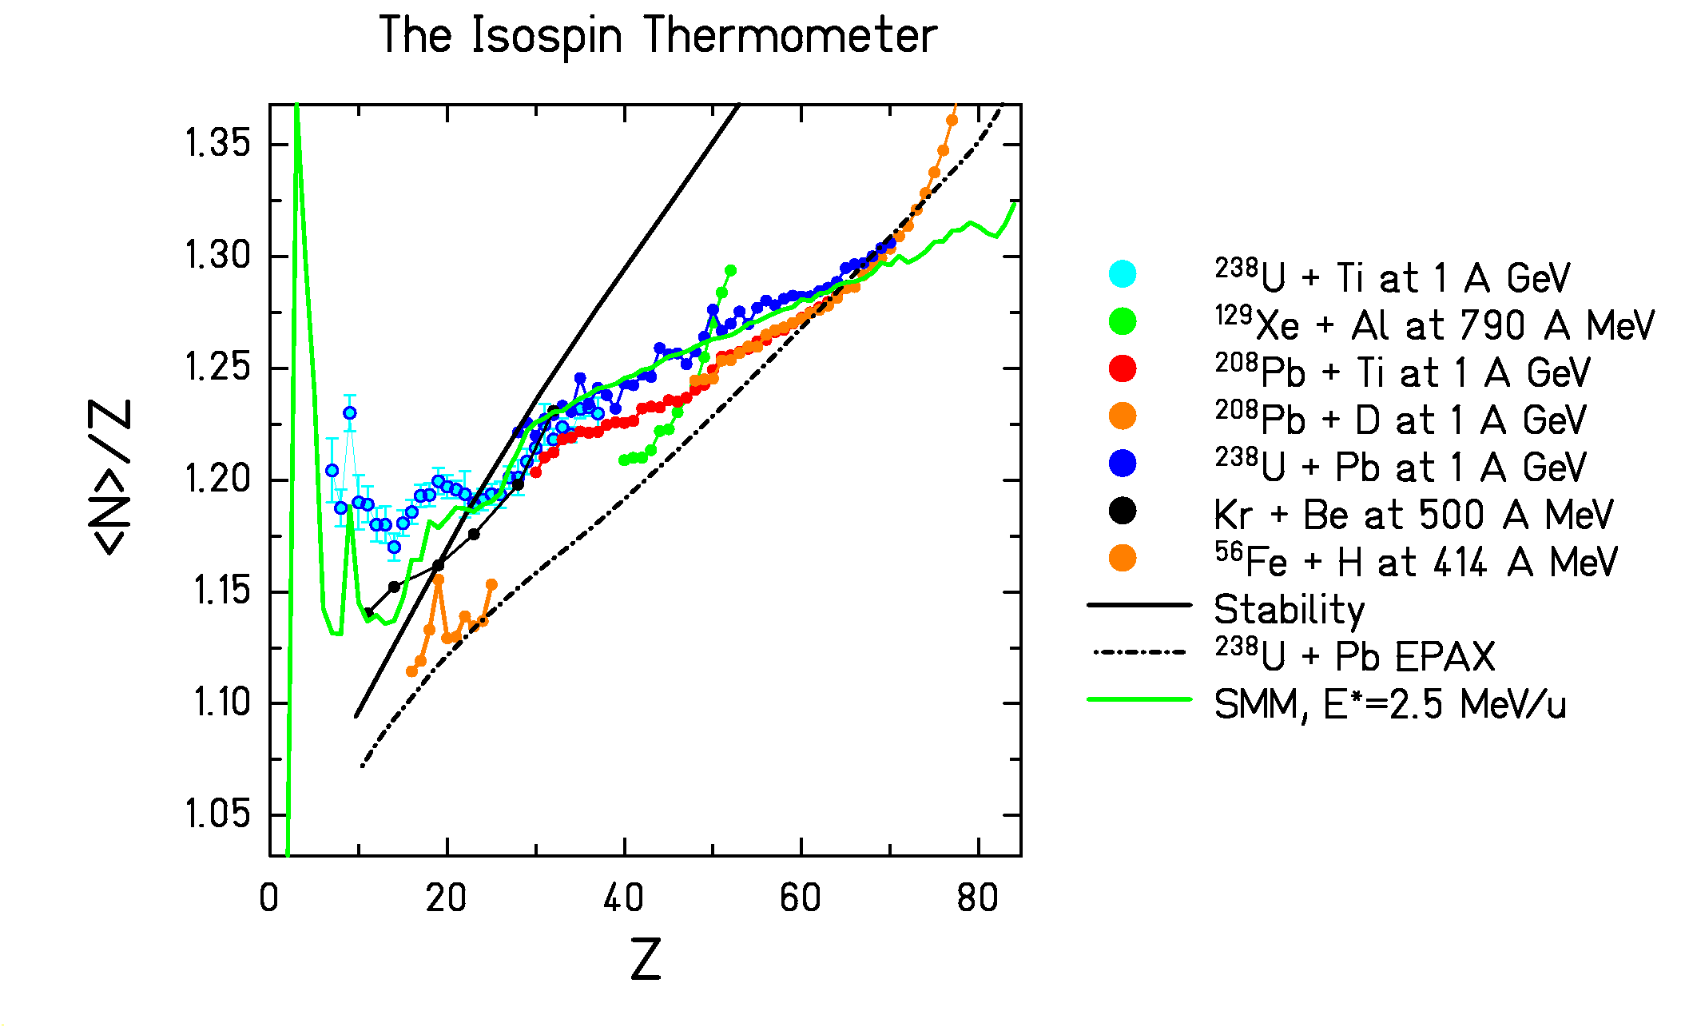
The isospin thermometer measures the excitation energy at the beginning of the evaporation stage.
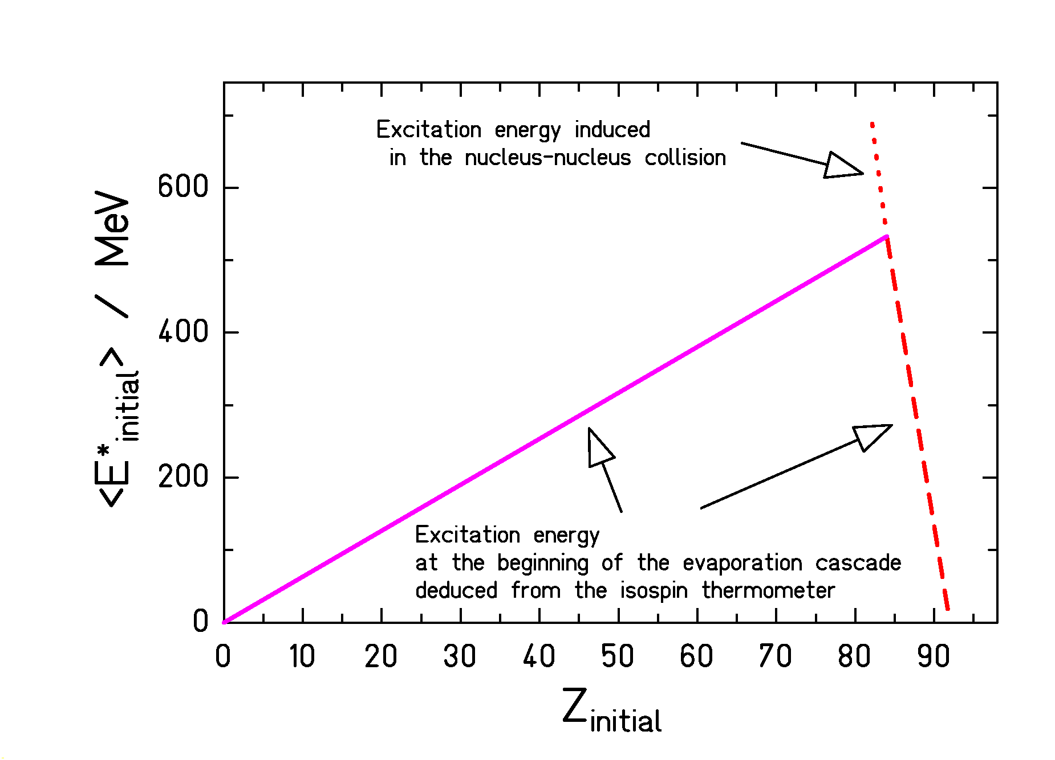

Fragmentation of
²³⁸U

Evidence for a break-up stage before the evaporation cascade.

