Identification in Z of two fission fragments
in coincidence

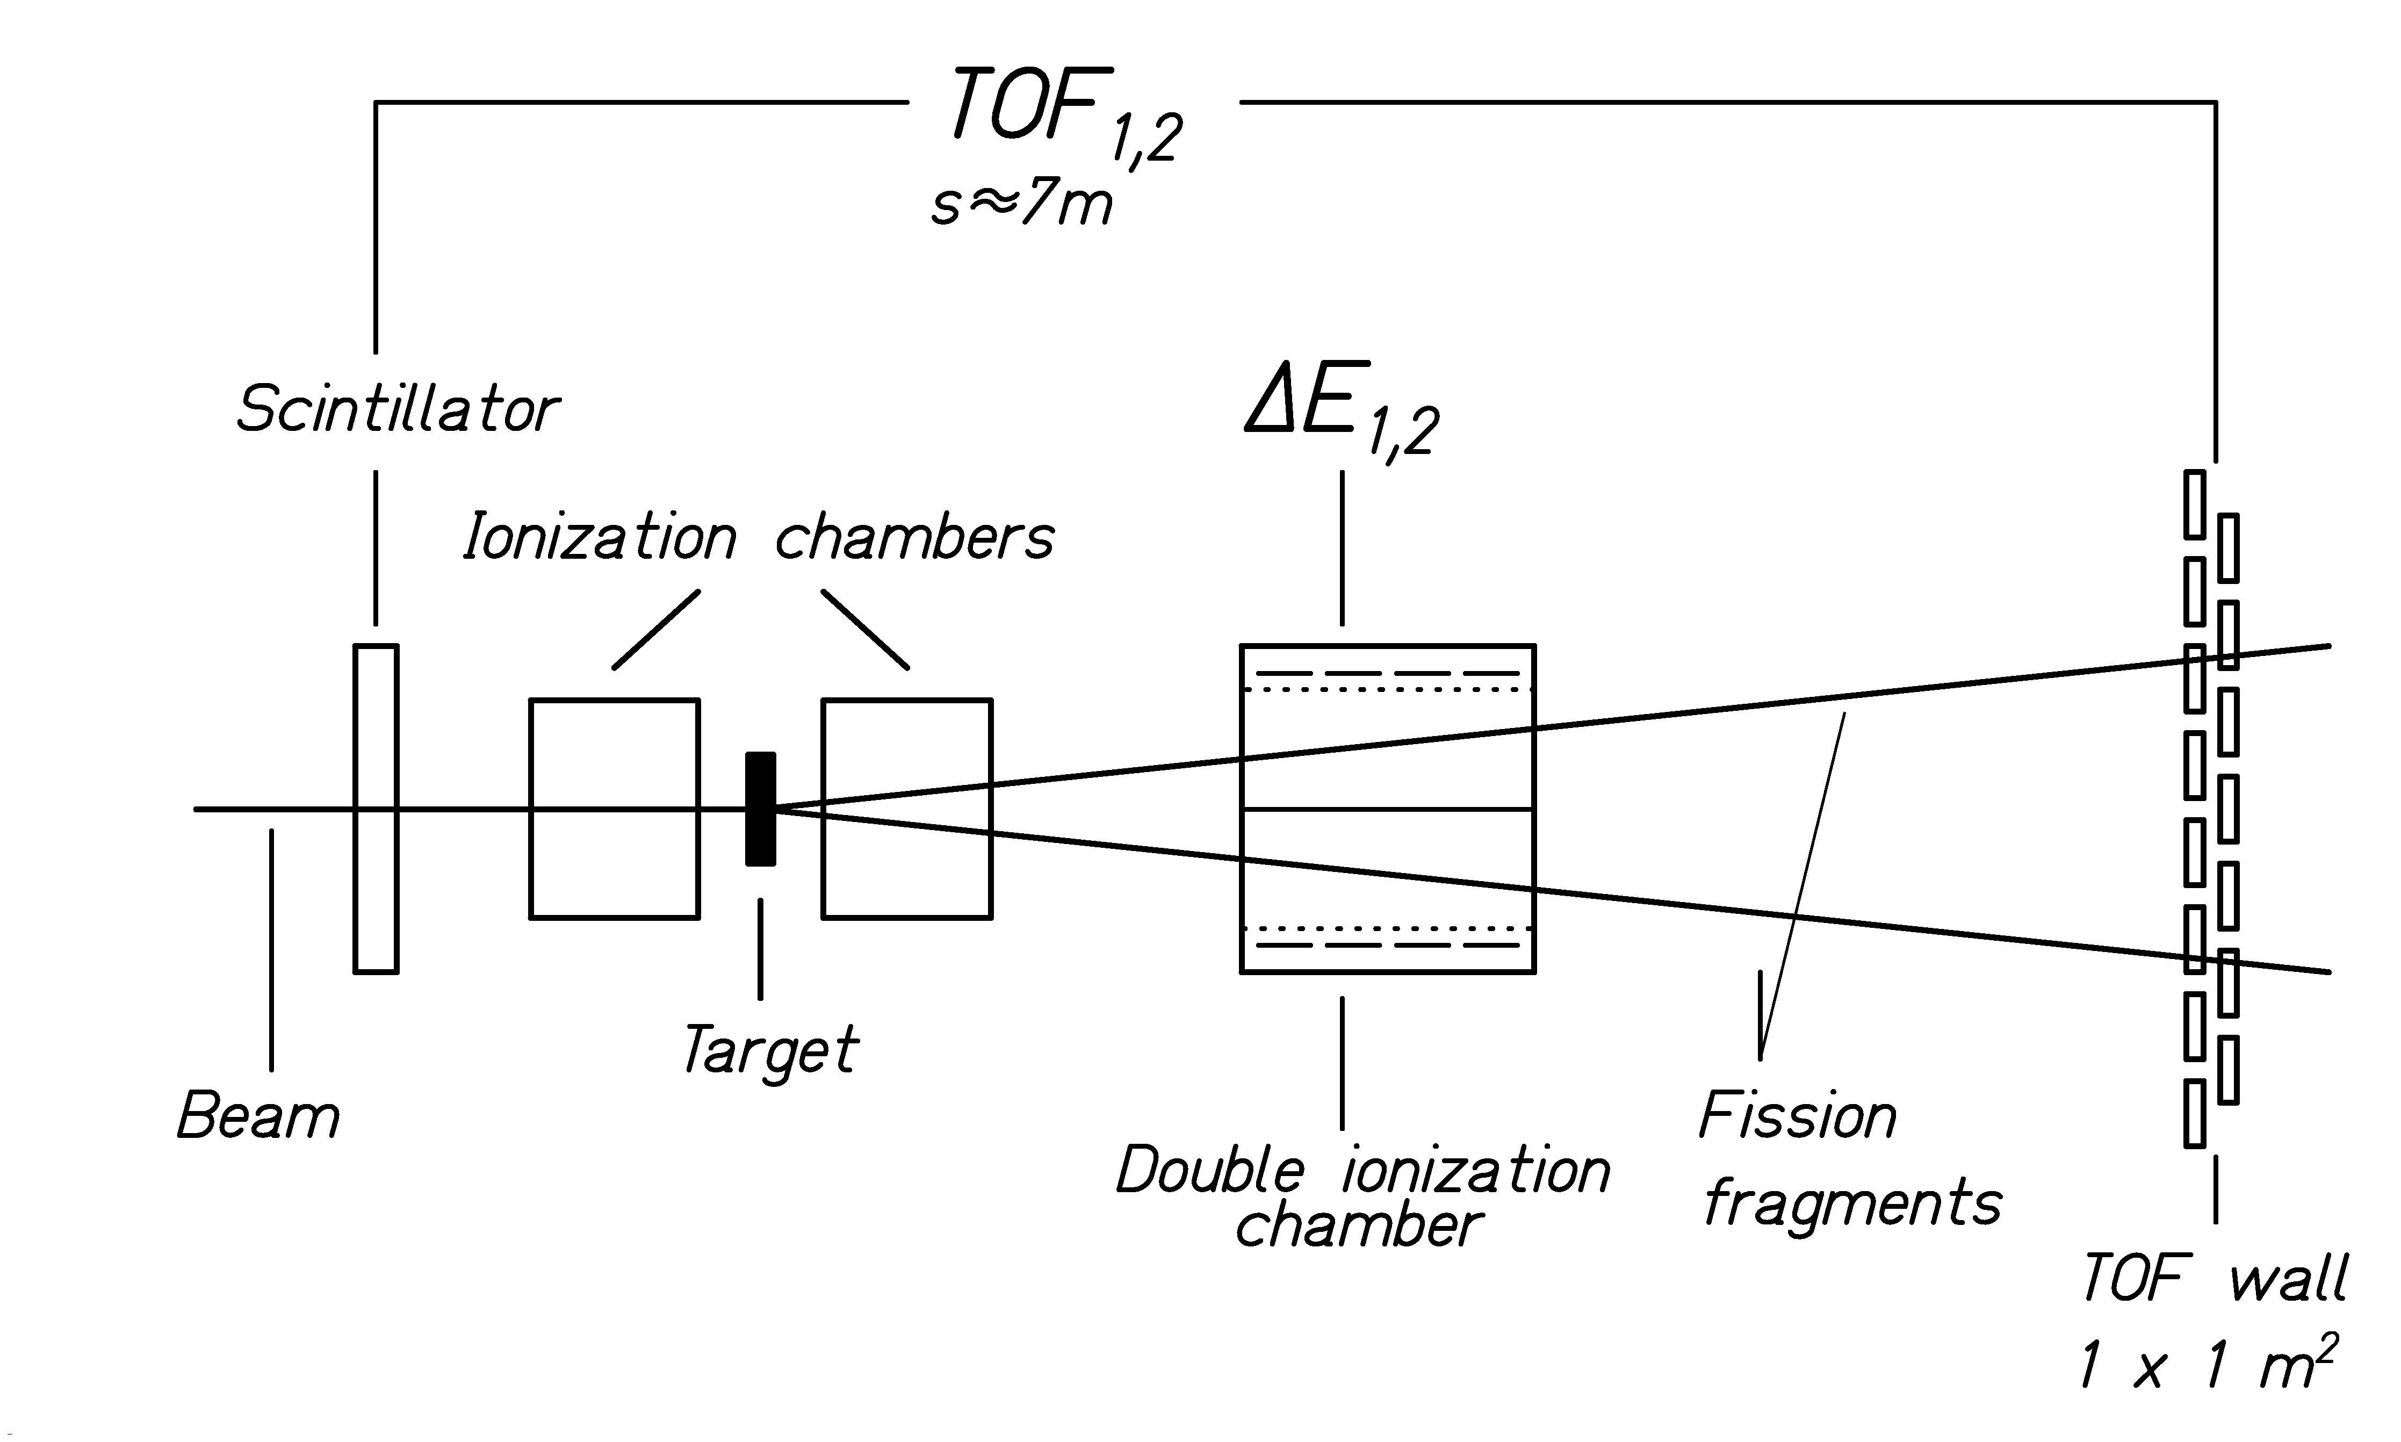
Experimental set-up

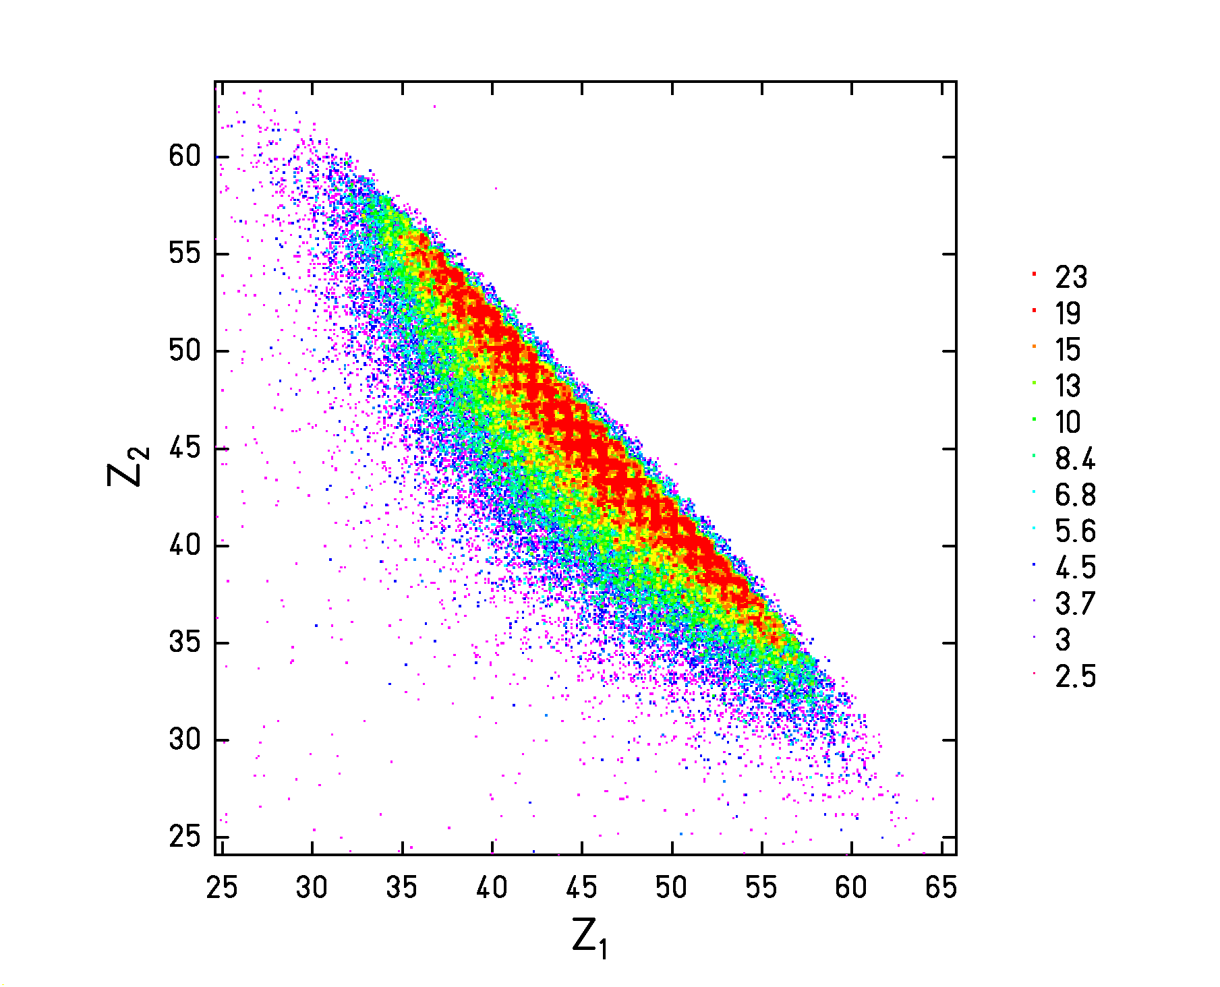
Raw data

Cuts for fixed Z1 + Z2 → Partial charge distributions

Projection for fixed Z1 + Z2 → Partial fission cross sections

