Investigation of fission with secondary beams

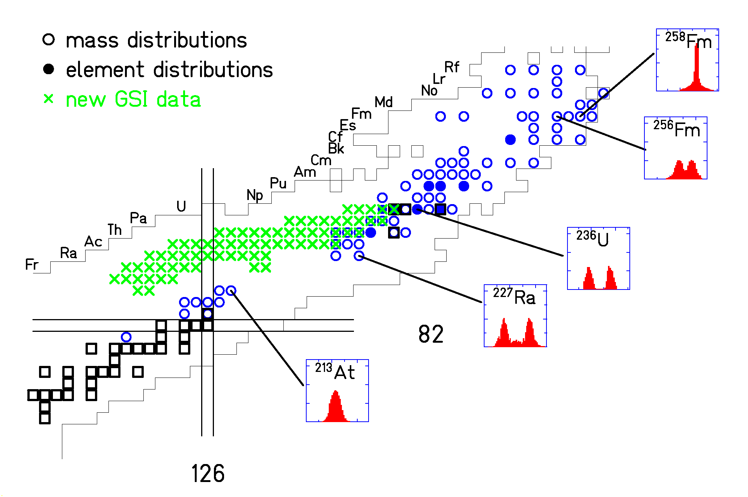

Interest in fission properties of nuclei between Pb and U:
- Transition from symmetric to asymmetric fission?
- Influence of N = 126 on stability against fission?

