Systematic survey on structure effects in fission
using secondary beams

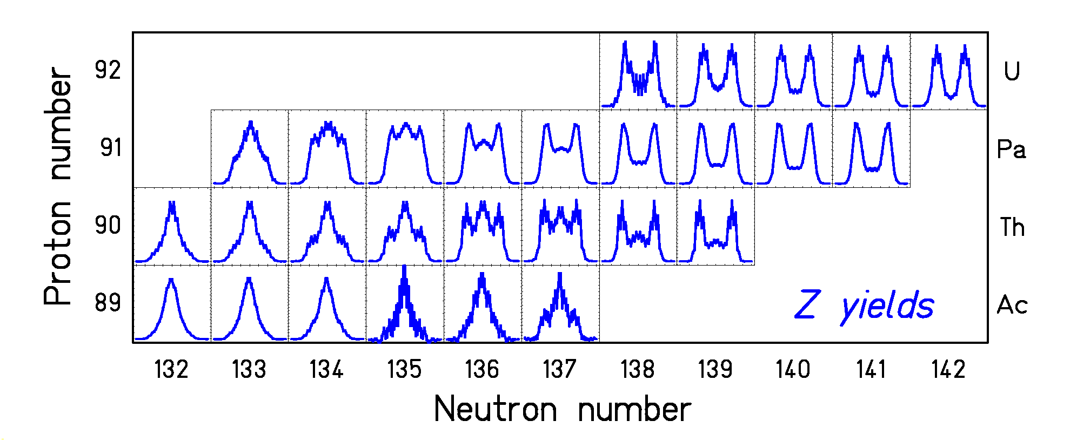

Z distributions of electromagnetic-induced fission give

new insight in features of fission channels and pair breaking

