Proton-rich nuclei near N = 126
⎯⎯⎯⎯⎯⎯⎯⎯⎯⎯

A test case for spherical superheavy elements

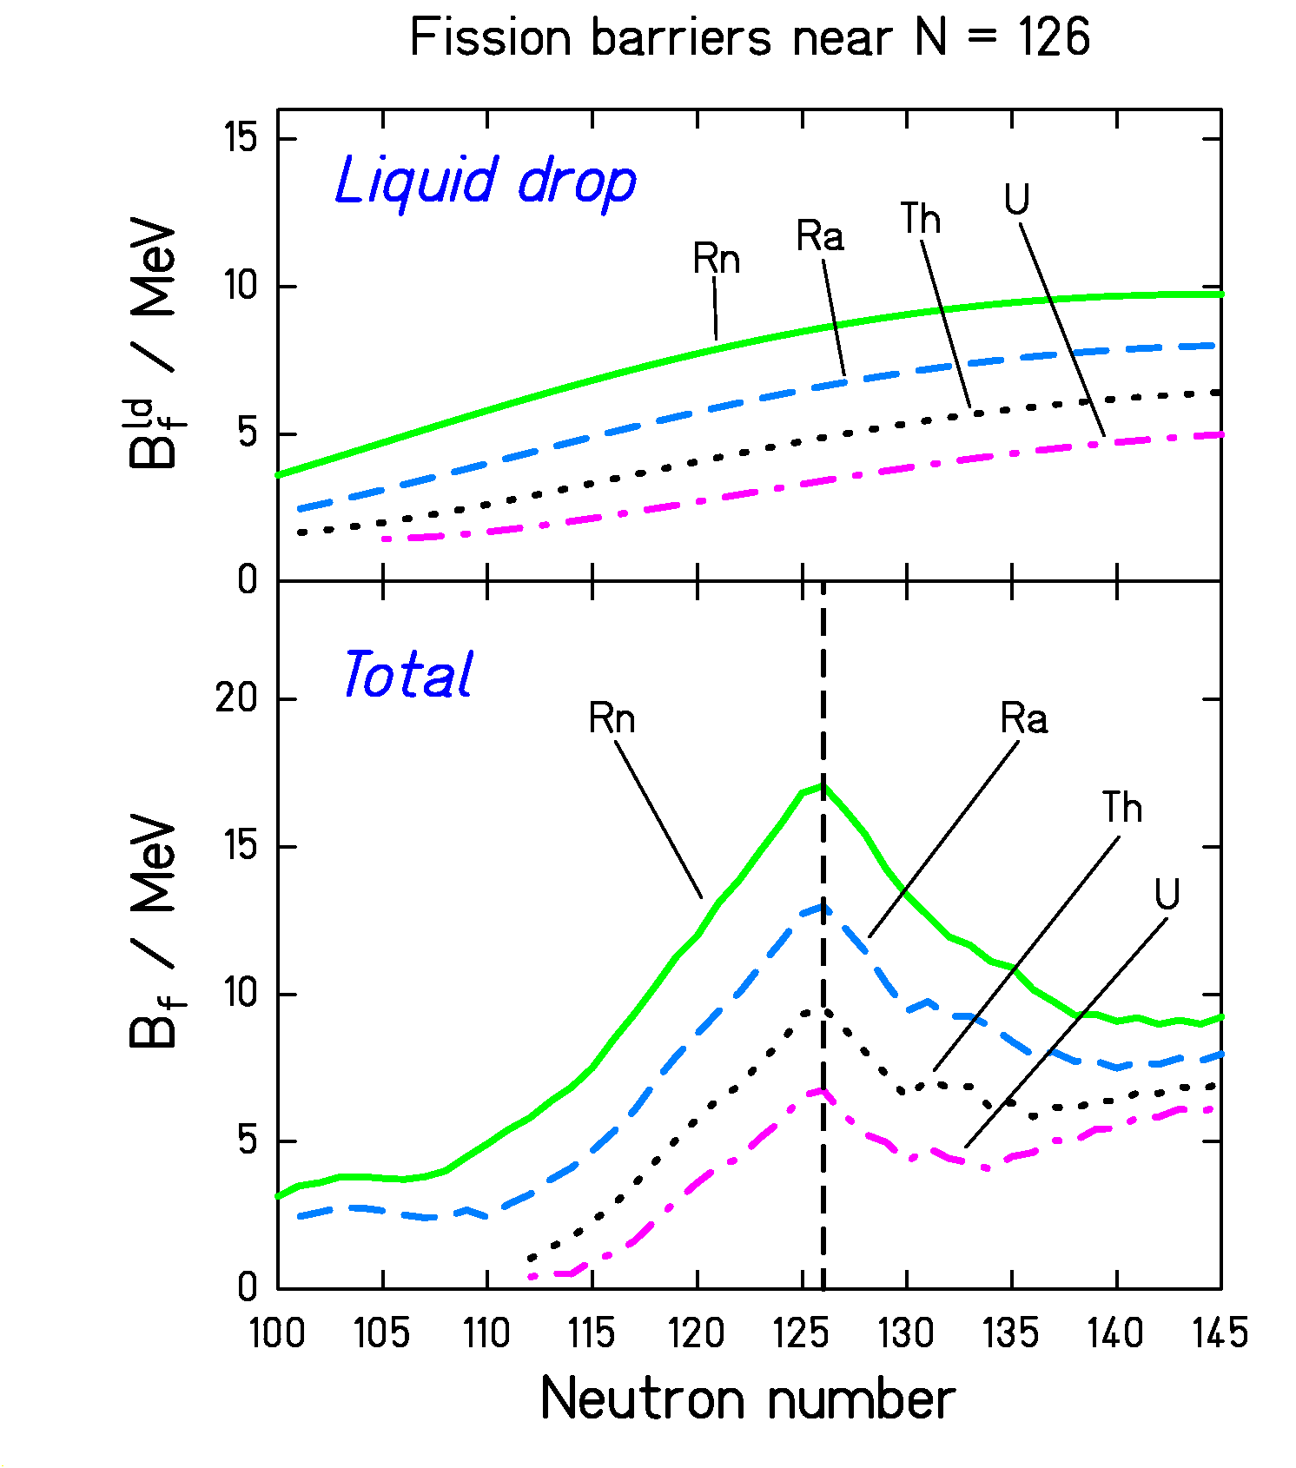

- Highly fissile nuclei.
- Half the calculated fission barrier due to shell effect!

