Dynamics of the fission process

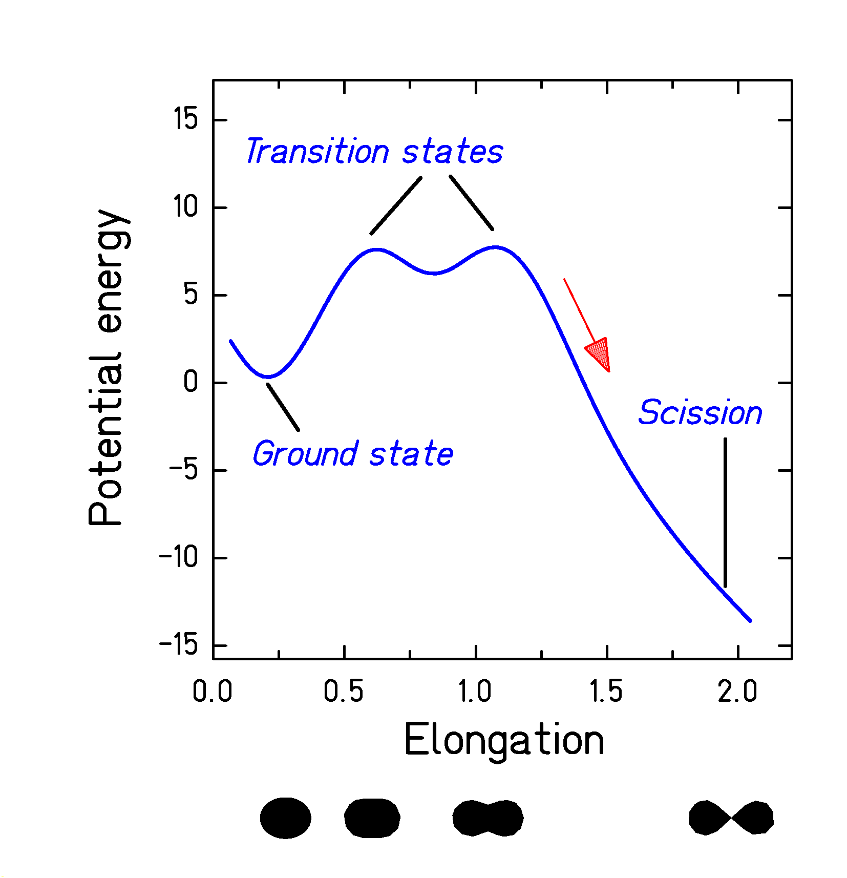

Peripheral heavy-ion collisions:
- Ideal tool to produce highly excited nuclei without shape distortion.
- Probing fission dynamics at small deformation.

