New signatures for nuclear dissipation

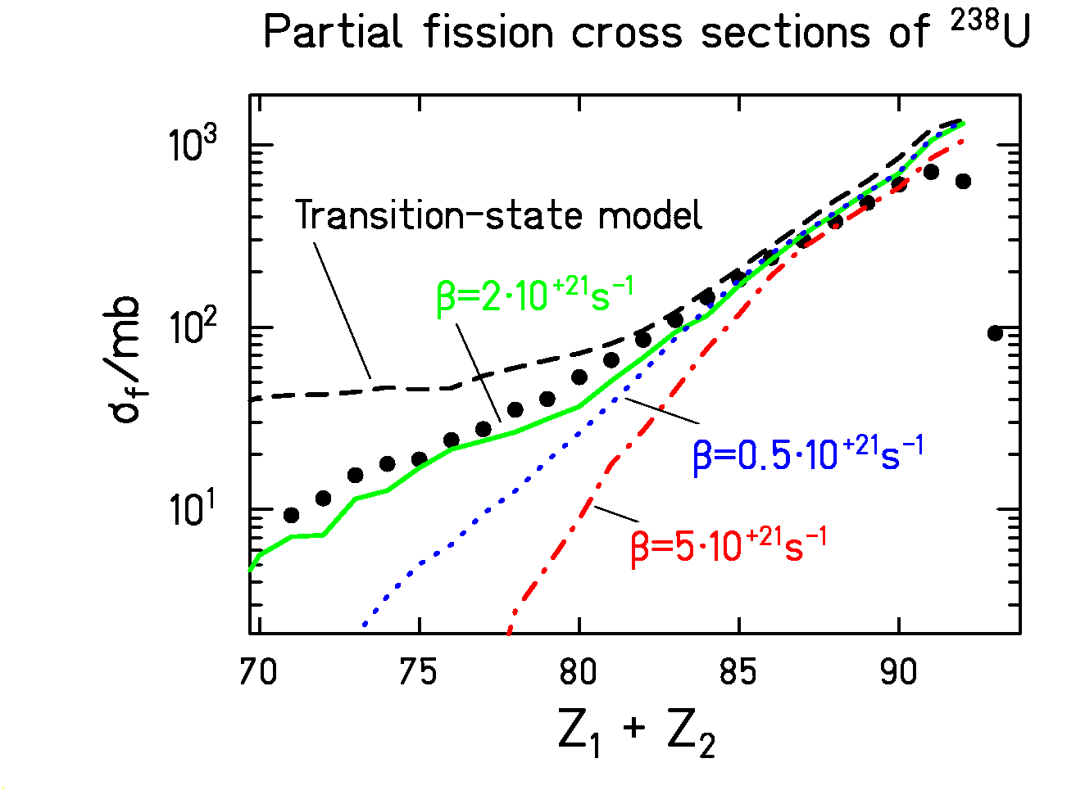

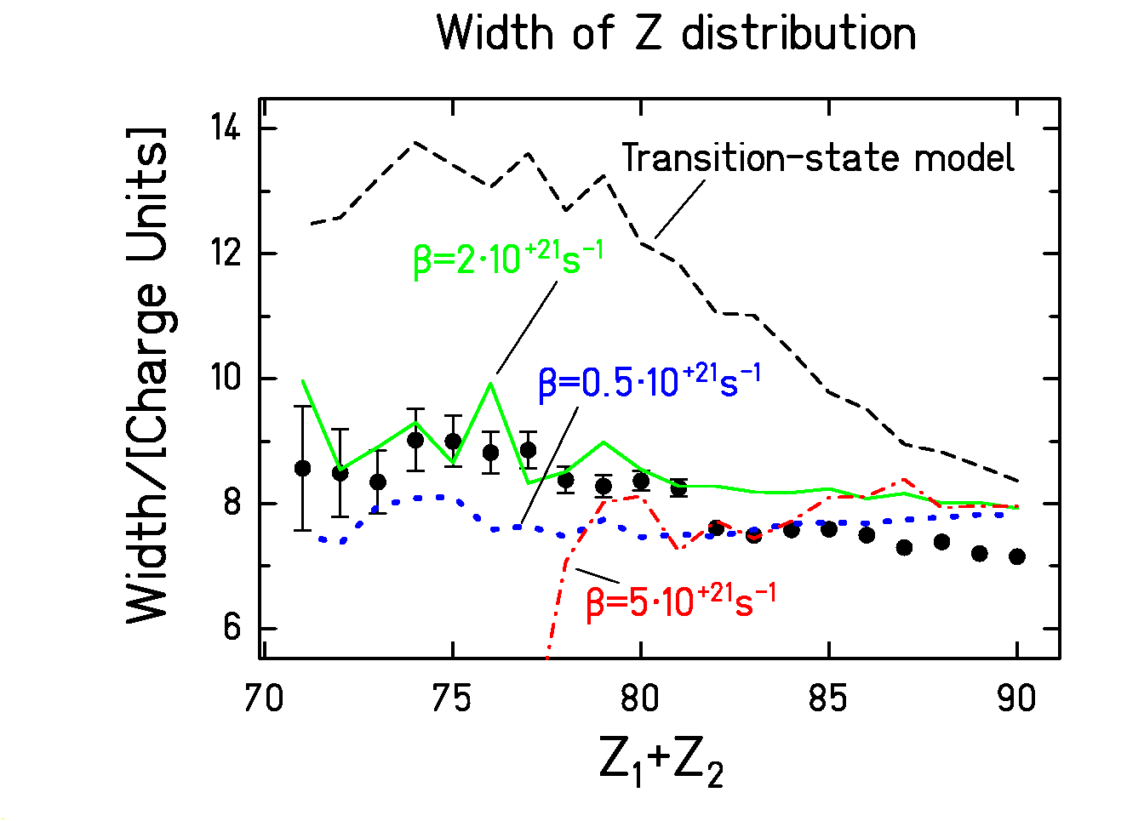

Consistent evidence for critical damping on the fission path.

