High-resolution experiments on projectile fragments
—————————————————
a new approach to the properties of hot and dense nuclear matter

Karl-Heinz Schmidt, GSI

Motivation
  - Important properties of nuclear matter
- Basic ideas
  - Similarities to a real gas
- Standard tools
  - FOPI, KAOS, ALADIN …

- Fragment separator
  - Resolution and acceptance
- Experimental results – general view
  - Velocity distributions
  - Nuclide distributions
- Experimental results – specific
  - Δ excitation in the nuclear medium
  - Dissipation in fission
  - Response of the spectator to the participant blast
  - Evolution of “isospin” in nuclear reactions
  - Fine structure in residue yields from violent collisions

- Conclusion
  - Valuable information from high-resolution experiments – complements data from full-acceptance experiments

http://www-wnt.gsi.de/kschmidt/talks.htm

The motivation

Astrophysical interest

Properties of hot and dense nuclear matter are decisive for:
- Evolution of the early universe (big bang) at high density and temperature
- Supernovae explosions, a major scenario for the formation of elements beyond iron
- Formation and stability of neutron stars against collapsing into a black hole

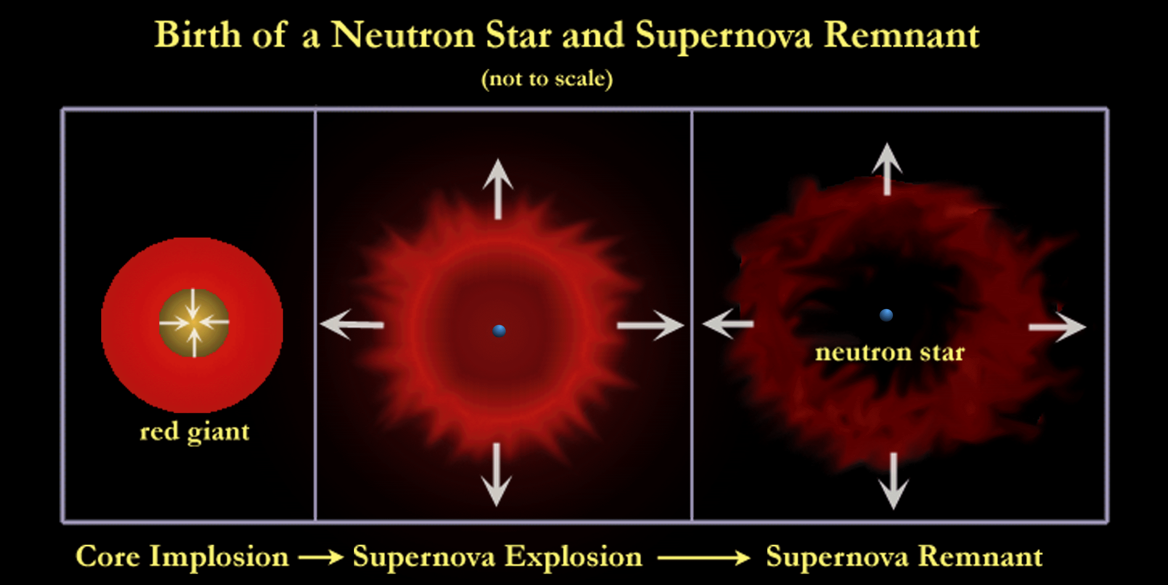

Important properties of nuclear matter

The relevant static properties are expressed by:
- The equation of state of nuclear matter (the relation between temperature, pressure and volume)

Specific features addressed in this talk:
  - Incompressibility
  - Phase transitions
  - The influence of the neutron-to-proton ratio (“isospin degree of freedom”)
  - The excitation of the nucleon
Important dynamic properties:
- The viscosity of nuclear matter
  - Dissipation in collective motion
- The momentum dependence of the mean field
  - Magnetic-equivalent nuclear forces
Basic ideas

Similarities of the Van-der-Waals potential between molecules
and the Skyrme-like potential between nucleons (schematic):

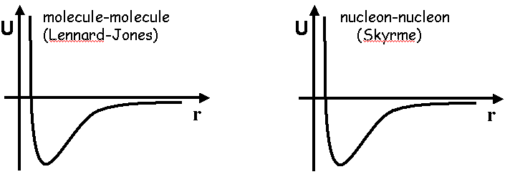

Figure: Van-der-Waals potential --- Nucleon-nucleon potential.
(units: eV and Å) (units: MeV and fm)

→ Similarities expected for the EOS

Specific features of the nucleus:
- Mesoscopic system
- Fermionic system
- Two-component system

Nuclear incompressibility

Incompressibility = stiffness of the nucleus against density variations.

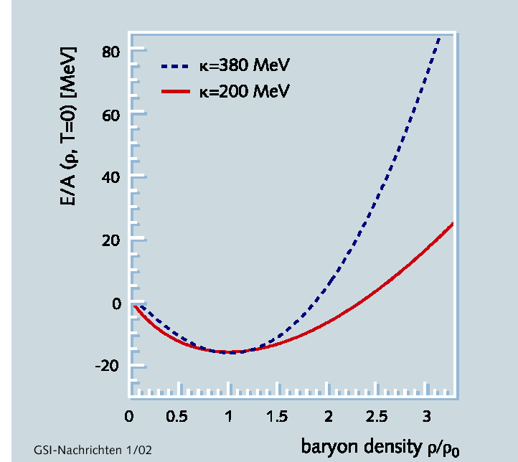

Figure: Binding energy of infinite nuclear matter as a function of density. Comparison of "soft" and "hard" equation of state.

Nuclear incompressibility is a key quantity of the nuclear equation of state.

The nuclear incompressibility depends on
- temperature (→ big bang, supernova) and
- "isospin" (→ neutron stars).
Similarities to a Van-der-Waals gas
—————————————————
Liquid-gas phase transition

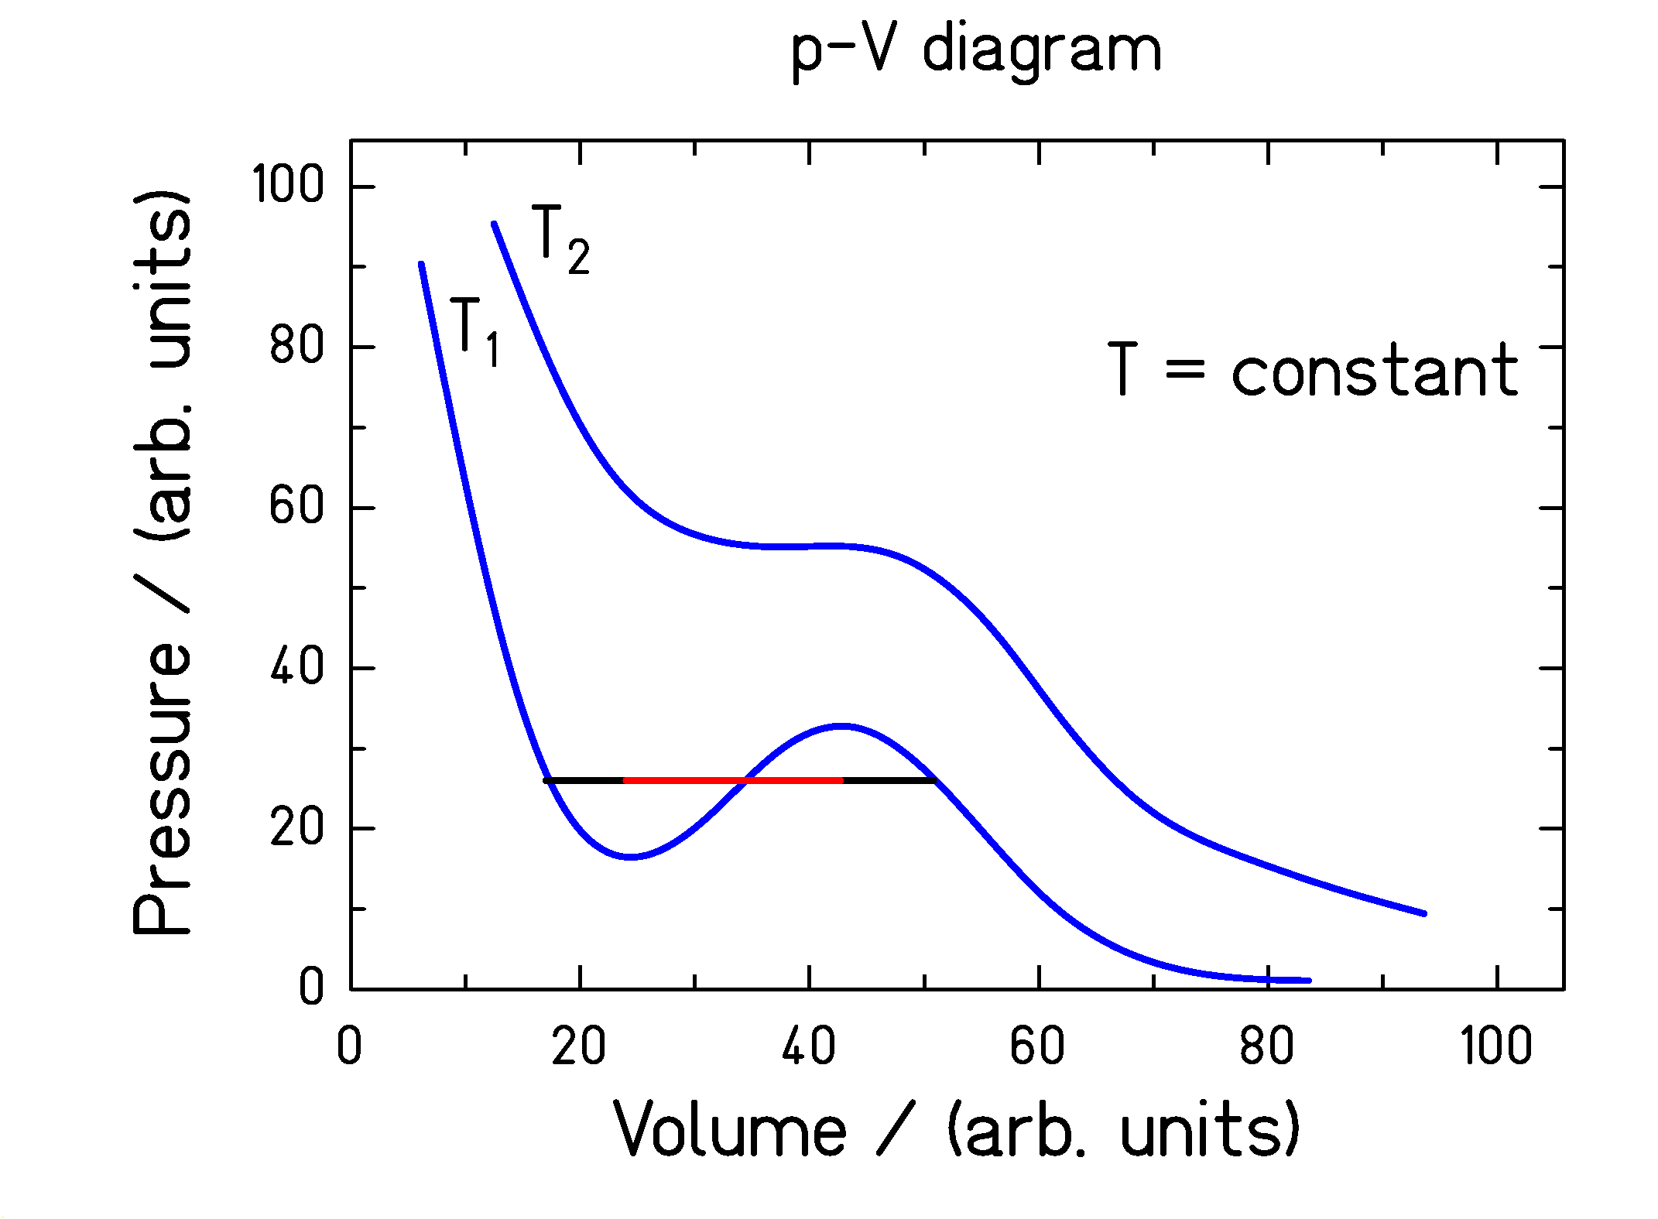

Figure: Schematic diagram - pressure versus volume - for a one-component system

Coexistence of liquid and gas phase in the spinodal region
(red line) → first-order phase transition
EOS for a two-component system

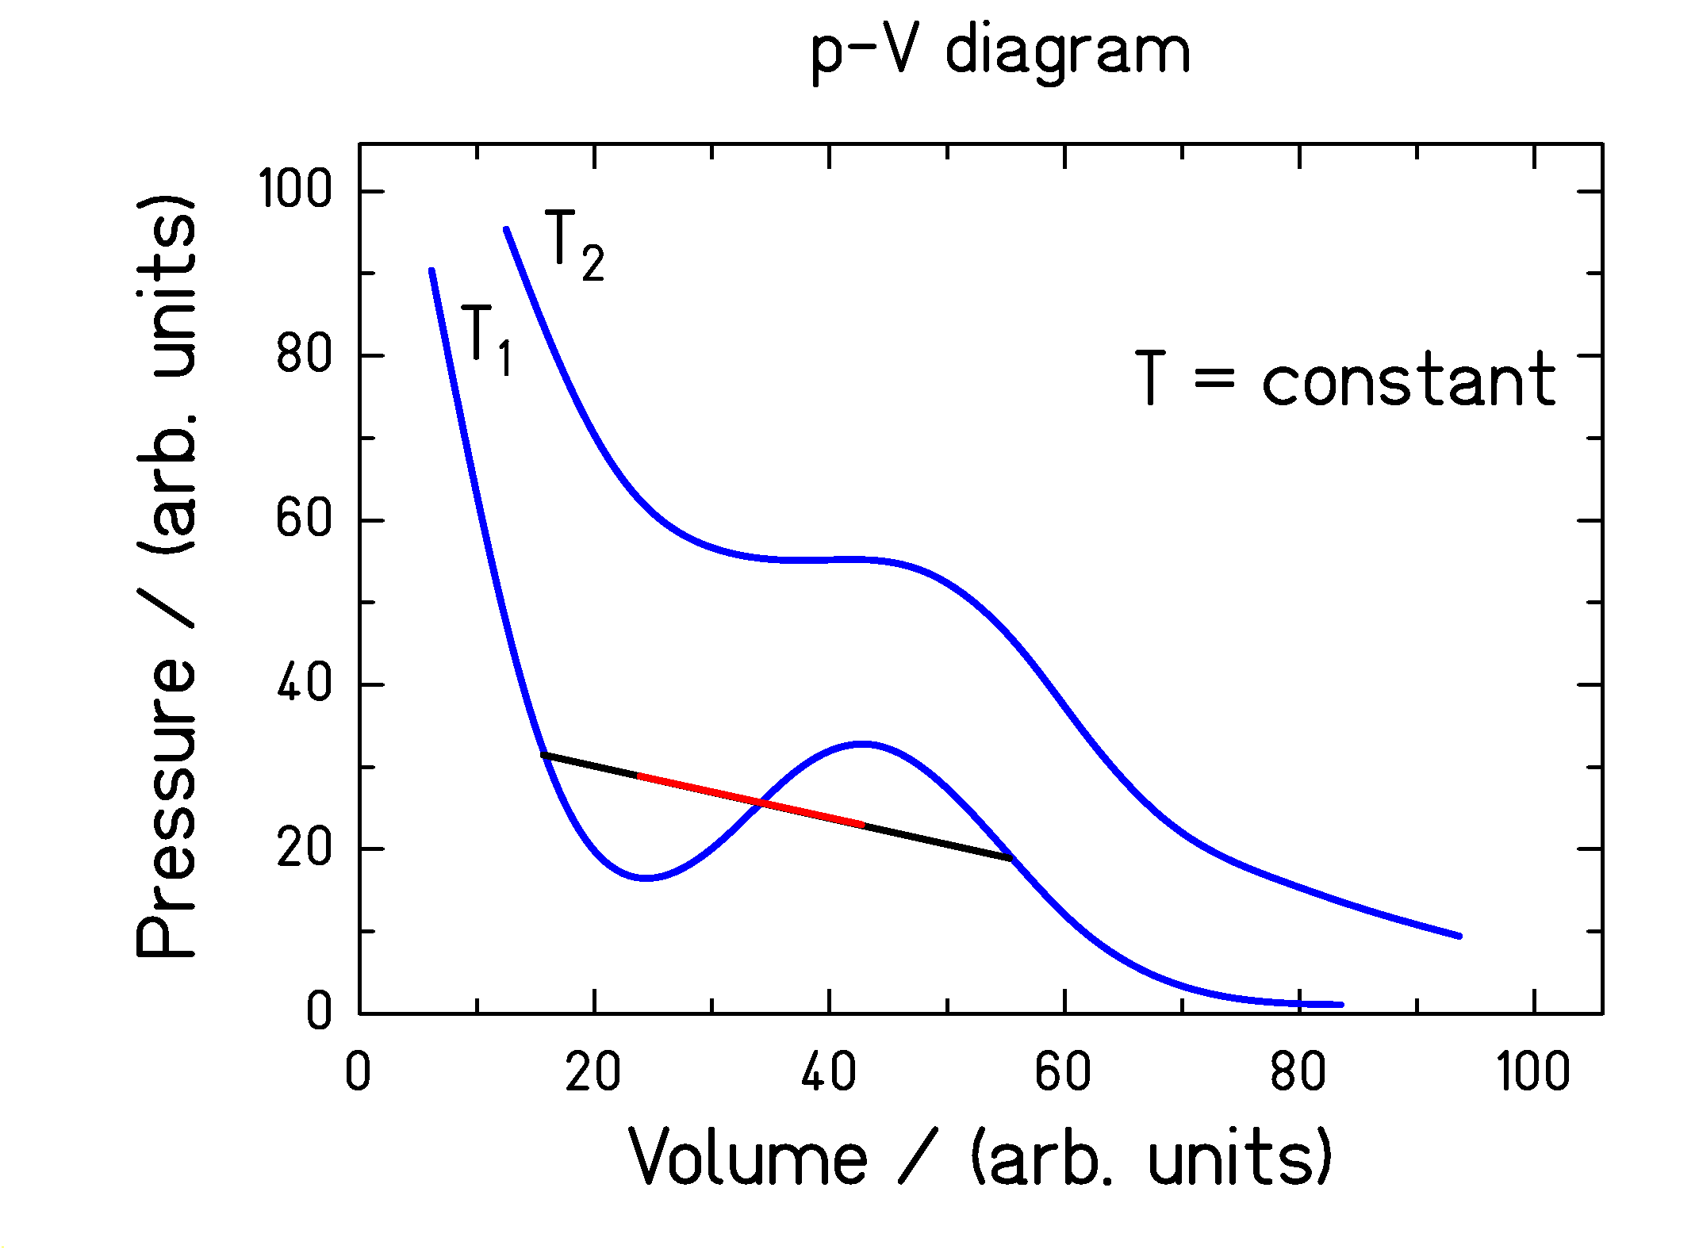

Figure: Schematic diagram - pressure versus volume - for a two-component system

Importance of the “isospin” degree of freedom:
(H. Müller, B. D. Serot, Phys. Rev. C 52 (1995) 2072)
- Two-component liquid (like alcohol-water)
  - Symmetric matter (most stable ⇔ water)
  - Neutron matter (less stable ⇔ alcohol)
- Second-order phase transition
  - Composition of liquid and gas phases varies in the spinodal region
- Neutron distillation in spinodal decomposition (“boiling”) and evaporation

Standard experimental tools

Properties of hot and dense nuclear matter are explored by the study of nucleus-nucleus collisions.

“Standard” experiments: Detection of nucleons, produced particles (mostly kaons), and very light fragments in large-acceptance (preferentially 4 π) experiments

Dynamics and non-equilibrium processes in nuclear reactions
- Necessity for dynamic (transport) calculations for interpreting experimental data

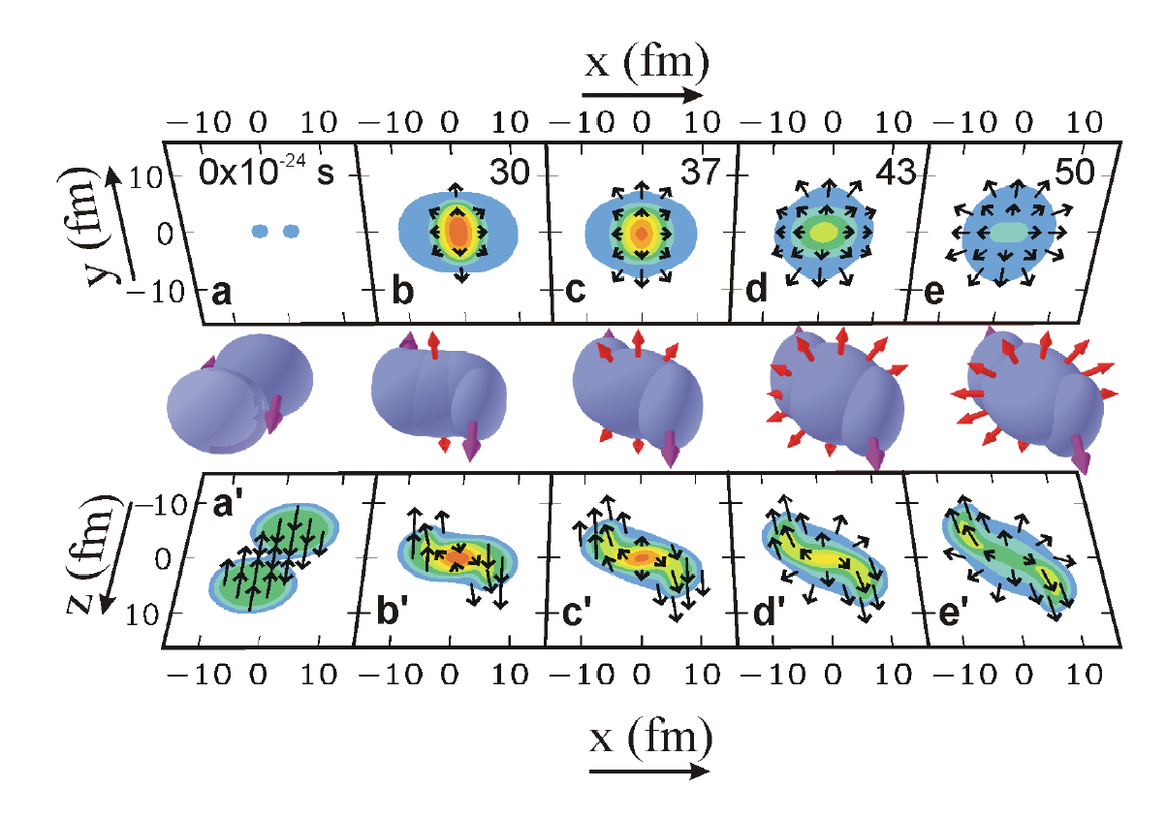
Transport calculation for the reaction: Au + Au, 2 A GeV:

"Out of plane"

"In plane"

(Figure 1 of Danielewicz, Science 298 (2002) 1592)

The standard experimental devices:

FOPI (flow with full acceptance)
KAOS (K⁺ production: early signature of the collision, flow)
ALADIN (Z for all fragments, Z and A for light fragments)
(others: Bevalac, MSU, EOS, INDRA, …)
The fragment separator

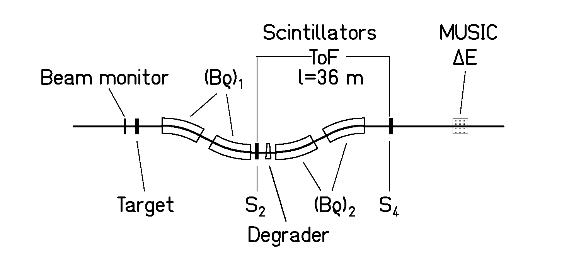

Powerful focusing magnetic spectrometer
(72 m long, sum of bending angles: 120º)

- Angular acceptance
  - 15 mrad around the beam axis
- Momentum acceptance
  - ± 1.5 % in Δp/p
- Resolution
  - Bρ: 3 mm in position → 5⋅10⁻⁴
  - TOF: 100 ps on 36 m → 2.5⋅10⁻³ in β⋅γ

TOF sufficient for mass resolution ΔA/A ≈400. $Bρ=\frac{{Am}_{o}\text{βγ}c}{Ze}$

After identification of Z and A: (Z and A are integer numbers)
Bρ provides velocity with high precision
→ resolution of 5⋅10⁻⁴ in β⋅γ !

Precise measurement of one (heavy) reaction product.
No correlation to other products, no multiplicities.

Full acceptance for most fragmentation products.
Low acceptance (≈ 10 %) for fission and very light fragmentation products.
Experimental results
Systematics on nuclide distributions and velocities
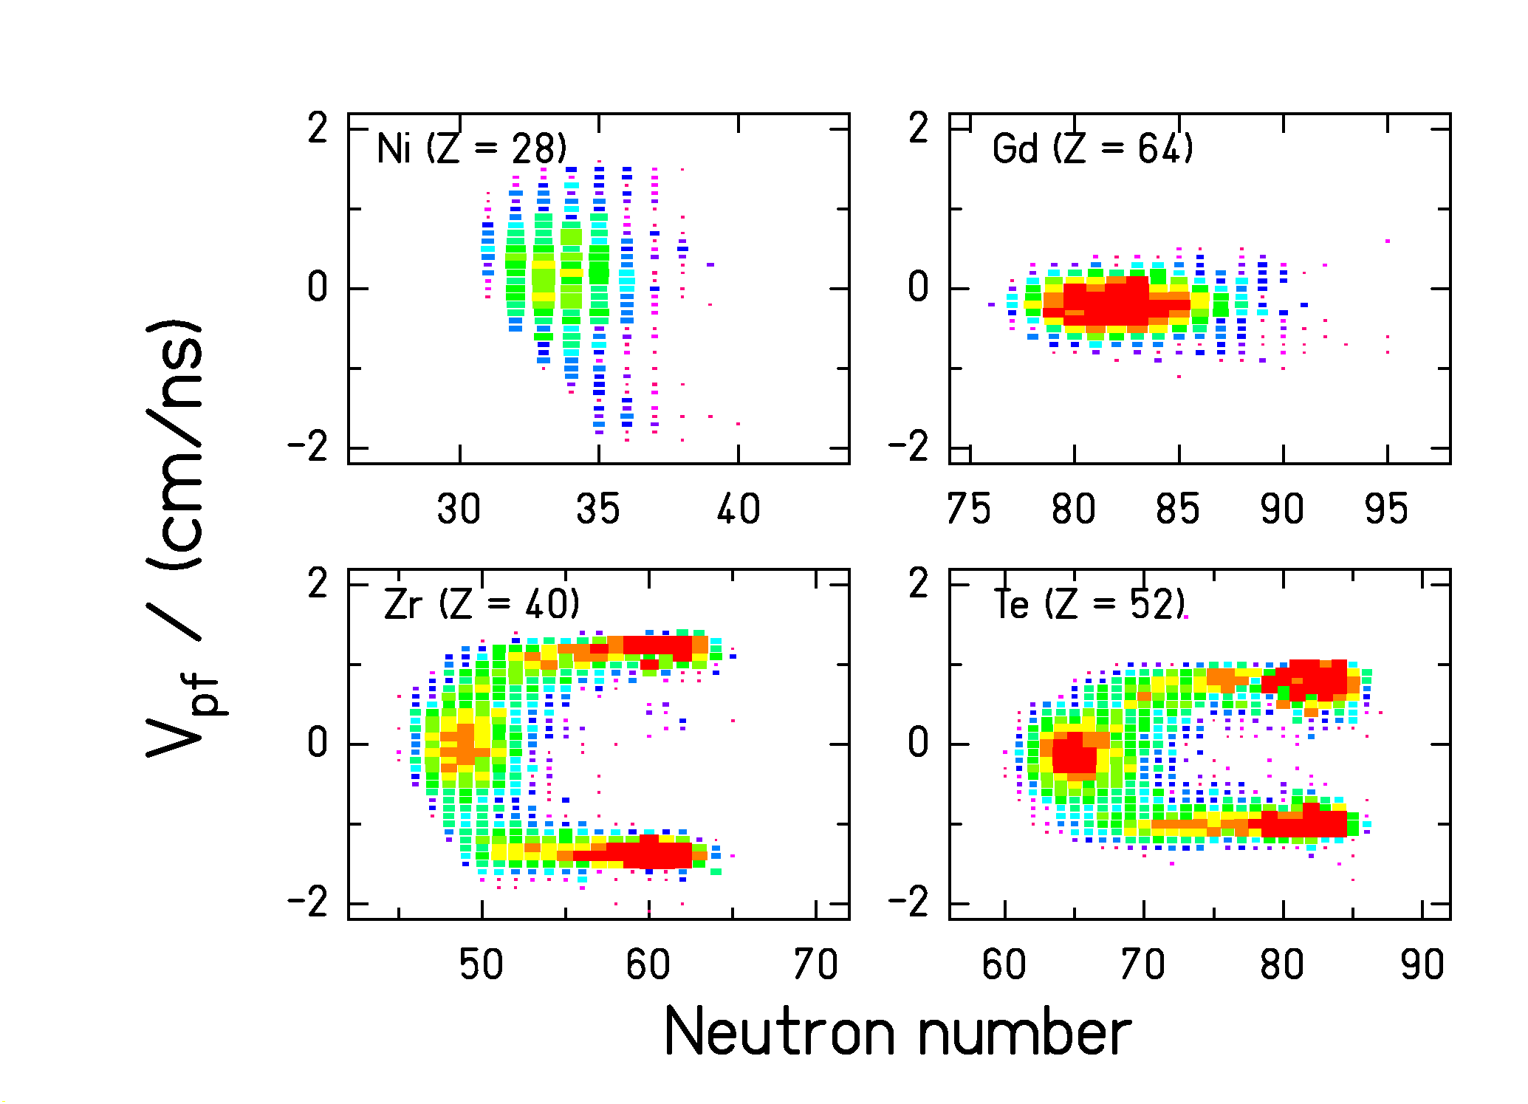
²³⁸U (1 A GeV) + Pb (many settings of the FRS combined)
(T. Enqvist et al., Nucl. Phys. A 658 (1999) 47)
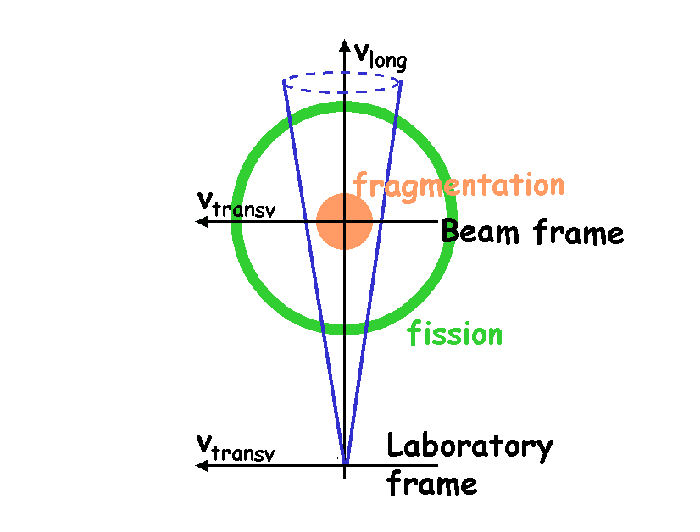
Fragmentation: Fully accepted
Fission: Only accepted forward and backward

Systematic nuclide distributions of evaporation and fission residues of projectile fragments (2 examples)
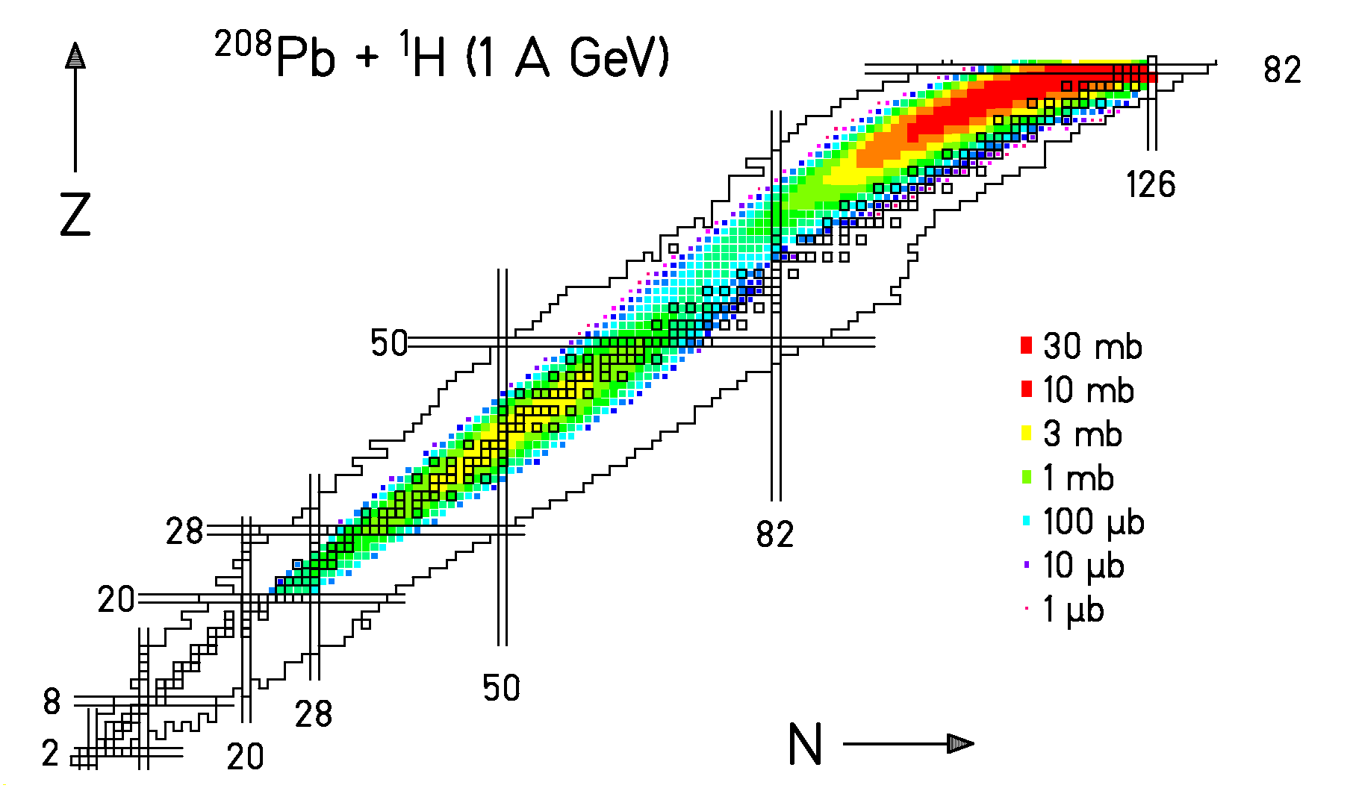
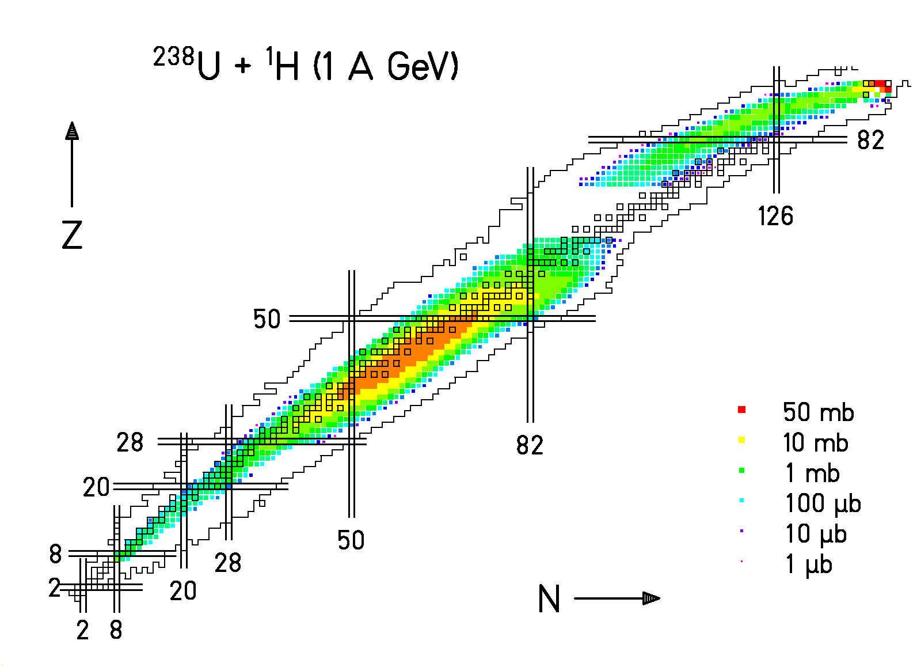
Our results obtained in the incineration program are the only full-coverage data on nuclide production (yields and velocities) available. (More than 1000 individual nuclides investigated for each system.)

(Data analysed by M. Bernas, E. Casarejos, T. Enqvist, J. Pereira,
M. V. Ricciardi, J. Taieb, W. Wlazlo)
Charge-exchange reactions
—————————————————
Excitation of the nucleon in the nuclear medium

Measured: ${}_{\text{82}}^{\text{208}}{}\text{Pb}$(^{1,2}H, x)${}_{\text{83}}^{\text{193-208}}{}\text{Bi}$, ${}_{\text{82}}^{\text{208}}{}\text{Pb}$(Ti, x)${}_{\text{83}}^{\text{193-208}}{}\text{Bi}$.

Velocity of ${}_{\text{83}}^{\text{207}}{}\text{Bi}$ in the frame of the projectile (${}_{\text{82}}^{\text{208}}{}\text{Pb}$)
${}_{\text{82}}^{\text{208}}{}\text{Pb}$(¹H, x)${}_{\text{83}}^{\text{207}}{}\text{Bi}$ at 1 A GeV
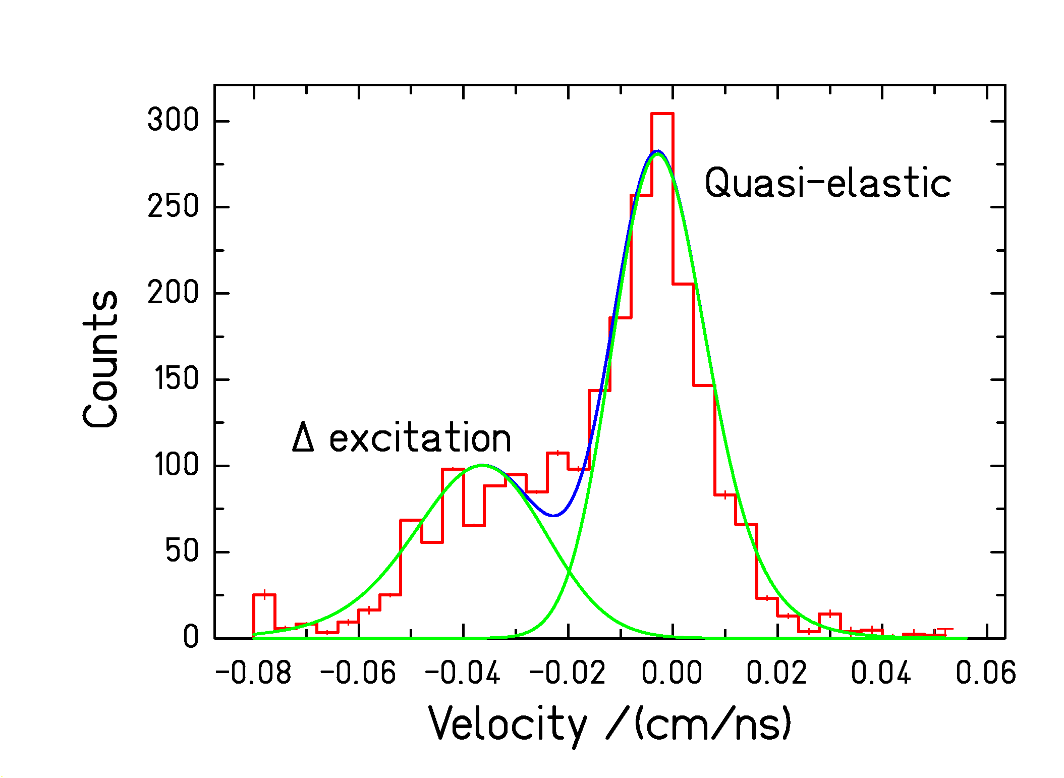
A. Kelić, in preparation

Two components can be distinguished:
- Quasi-elastic scattering (p replaces n in ²⁰⁸Pb)
- Δ excitation (e.g. n → Δ⁰ → p + π⁻)
Probability for Δ excitation and energy in the nuclear medium can be deduced.

(Previous investigation on ¹²⁹Xe + Al by K. Sümmerer et al. Phys. Rev. C 52 (1995) 1106)

Dissipation in fission

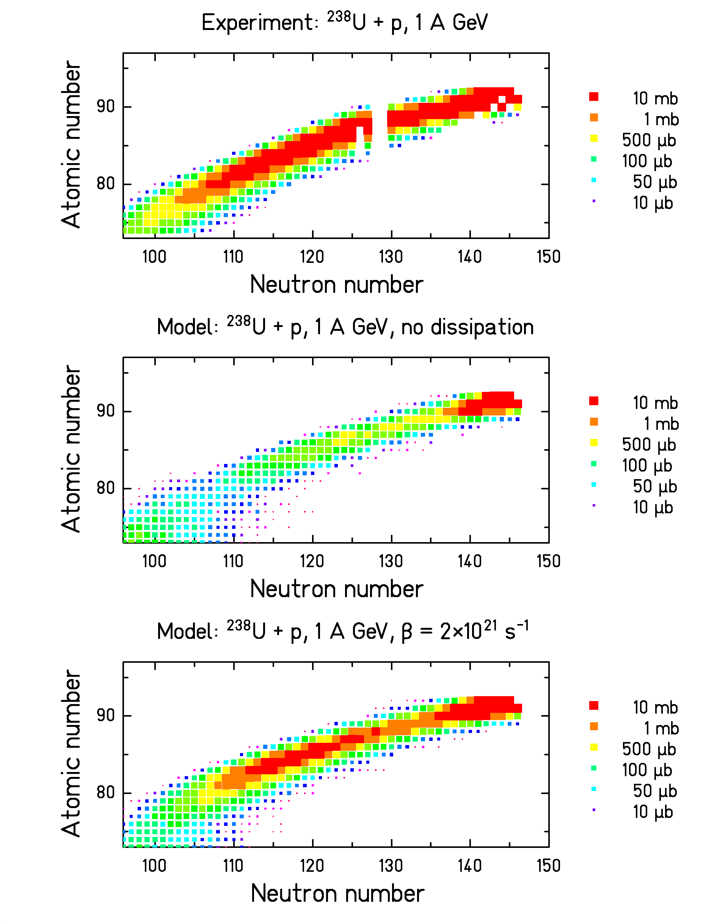

Nuclide yields are very sensitive to nuclear dissipation.

Evidence for suppression of fission at high E*.

J. Taieb et al., Nucl. Phys. A in print
Nuclear incompressibility

Incompressibility = stiffness of the nucleus against density variations.

Figure: Binding energy of infinite nuclear matter as a function of density. Comparison of "soft" and "hard" equation of state.

Nuclear incompressibility is a key quantity of the nuclear equation of state.

The nuclear incompressibility depends on
- temperature (→ big bang, supernova) and
- "isospin" (→ neutron stars).
The stiffness of the EOS

Danielewicz has analyzed the constraints from available experiments:

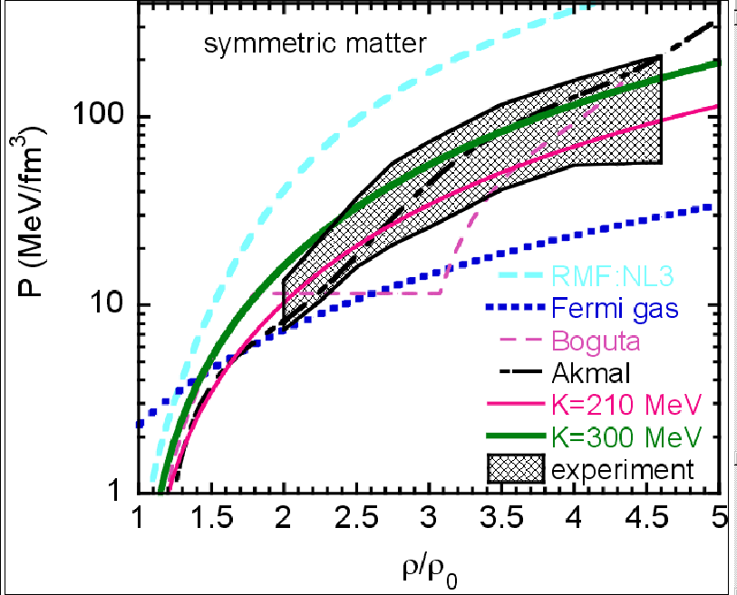

Figure 3 from Danielewicz , Science 298 (2002) 1592

The interpretation of most experiments on the EOS also depends on the momentum dependence of the mean field!
→ Ambiguities in the determination of the stiffness of the EOS.

The momentum dependence
of the nuclear mean field

Elliptic flow of protons
measured by of the KAOS collaboration
(D. Brill et al., Z. Phys. A 355 (1996) 61)
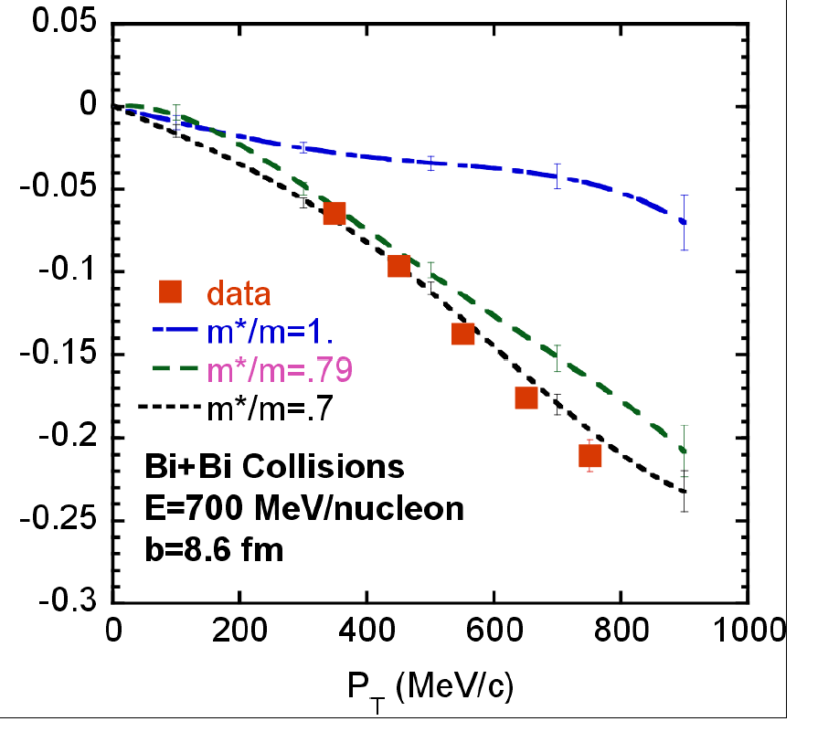

a₂

N(ϕ)∝1+a₁⋅cos(ϕ)+a₂⋅cos(2ϕ)

Calculations by
Danielewicz, Nucl. Phys. A 673 (2000) 375:
Enhanced emission of protons out-of-plane (a₂ < 0) is preferentially sensitive to the momentum dependence of the mean field.
(Momentum dependent mean field is characterized by a reduced nucleon mass in the nuclear medium.)

Interpretation is based on complex transport calculations (e.g. assumptions on the density-dependent nucleon-nucleon cross sections).
→ Danielewicz et al. propose additional signatures:

Response of the spectator to the participant blast
—————————————————
A measure of the momentum dependence of the nuclear mean field
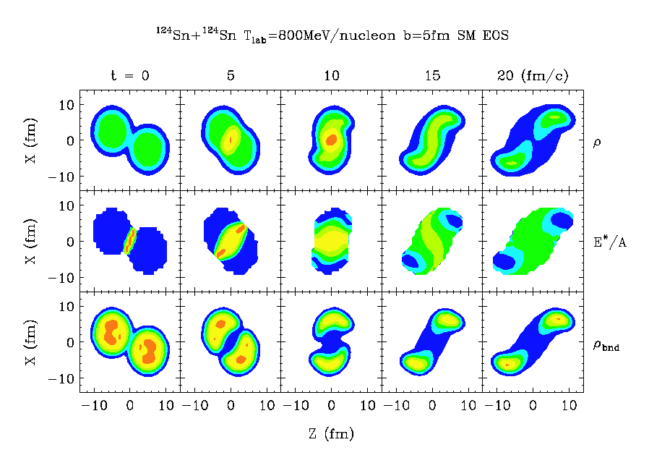
Figure 1 of Shi et al., Phys. Rev. C 64 (2001) 034601
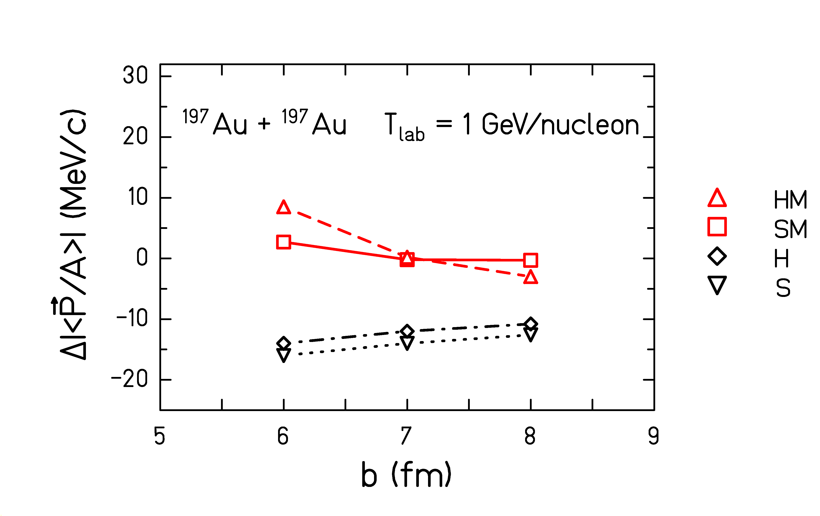
Figure 9 of Shi et al., Phys. Rev. C 64 (2001) 034601

(Idea already introduced previously e.g. by J. J. Molitoris, A. Bonasera, B. L. Winer, H. Stöcker, Phys. Rev. C 37 (1988) 1020)
New FRS results:

Response of the spectator to the participant blast

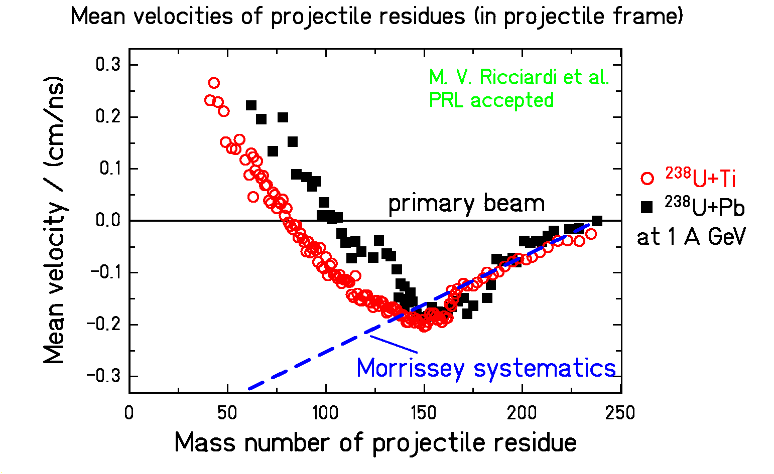

The data give an early signature (the acceleration of the spectator is acquired during contact with the fireball).

Valuable basis for general verification of transport calculations!

Evolution of the “isospin” degree of freedom in nuclear reactions

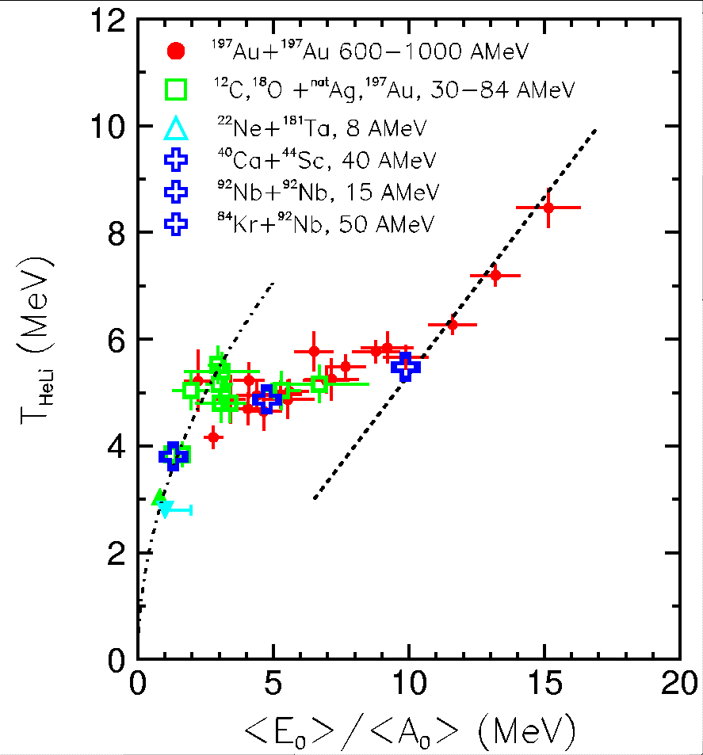

Caloric curve from ALADIN …

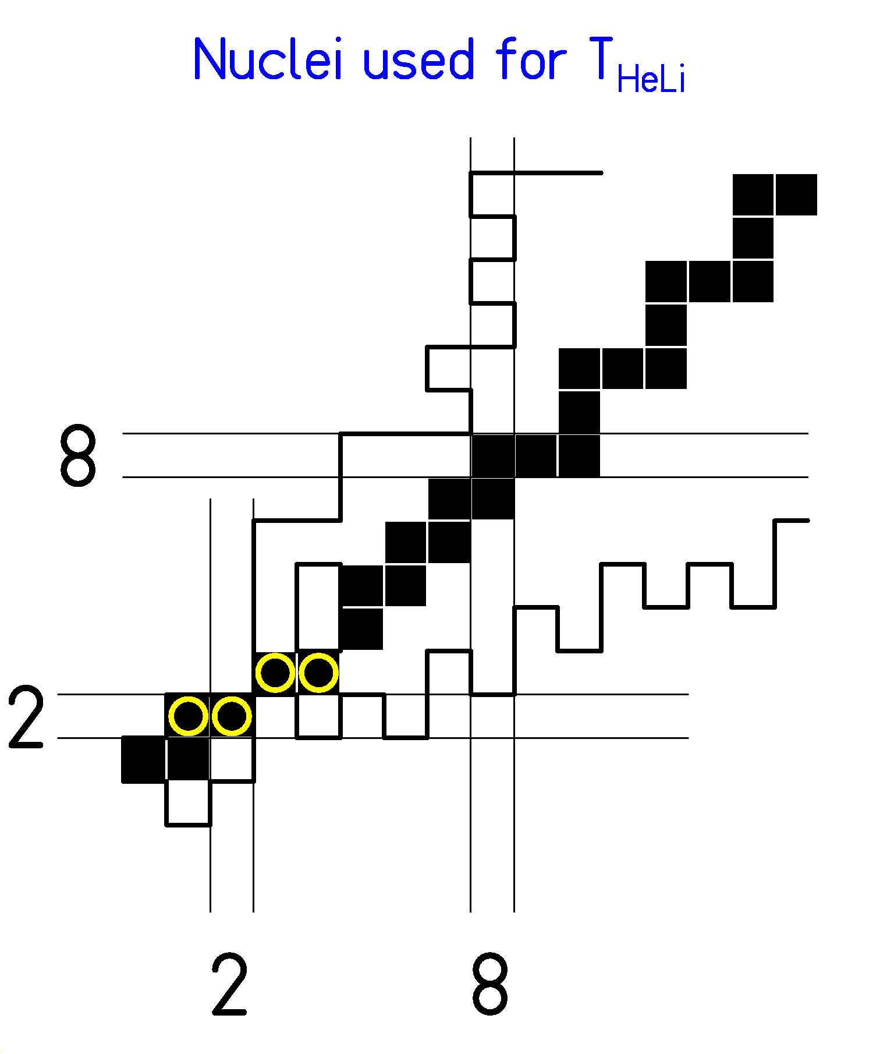

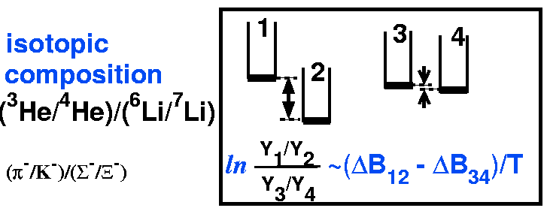

Double-isotopic ratio,

experimental binding energies → T_{HeLi}

The 4 nuclides, entering into the analysis

The major 3 stages of the reaction (schematic)

- Abrasion (Geometry)
  - Mass loss, E_{init} ≈ ΔA⋅27 MeV induced in spectator
- Break-up (Complex dynamic process)
  - Thermal expansion
  - Spinodal instability (?)
  - Multifragmentation (?)
  - Freeze-out
- Evaporation (Statistical model)
  - Standard evaporation code

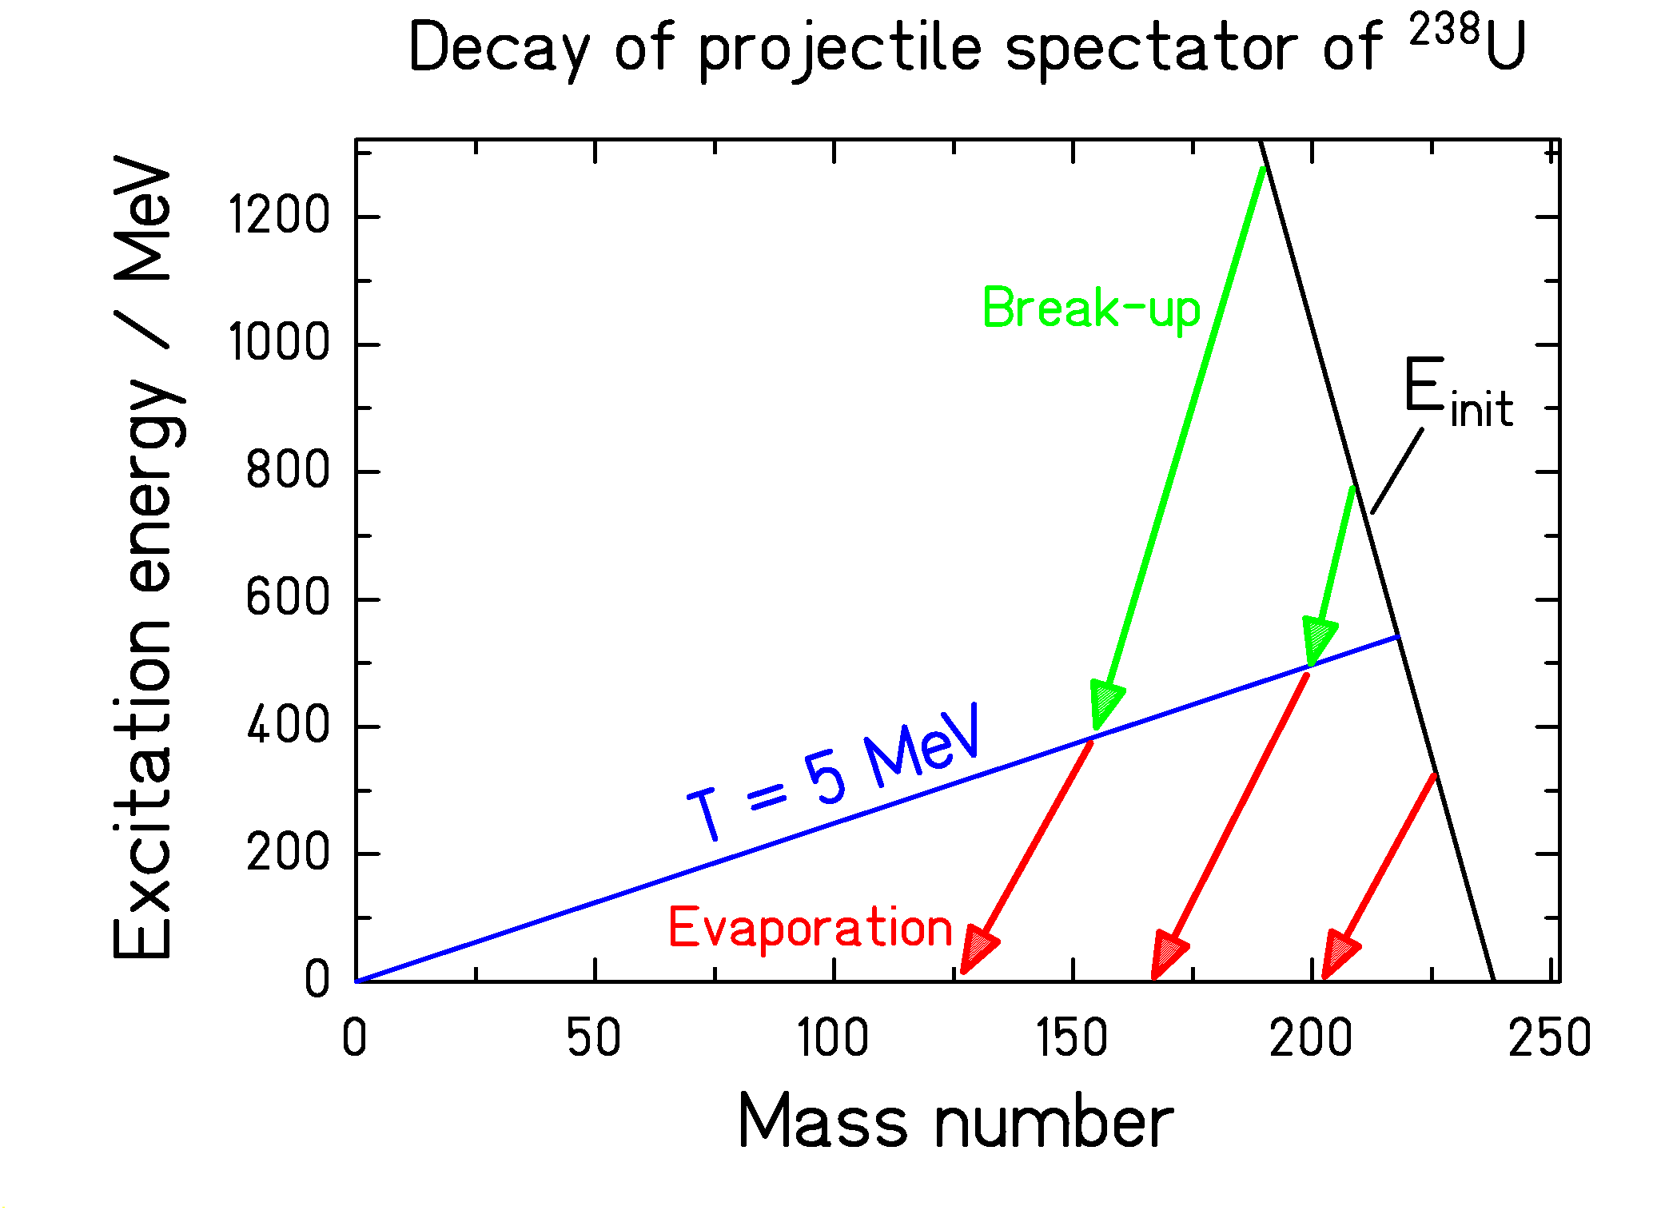

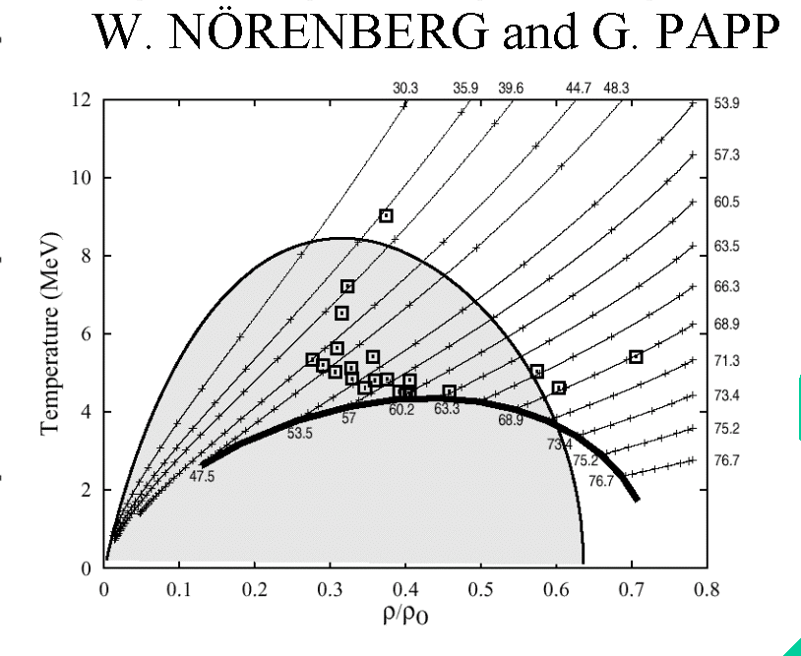

T

ρ/ρ₀

FRS data
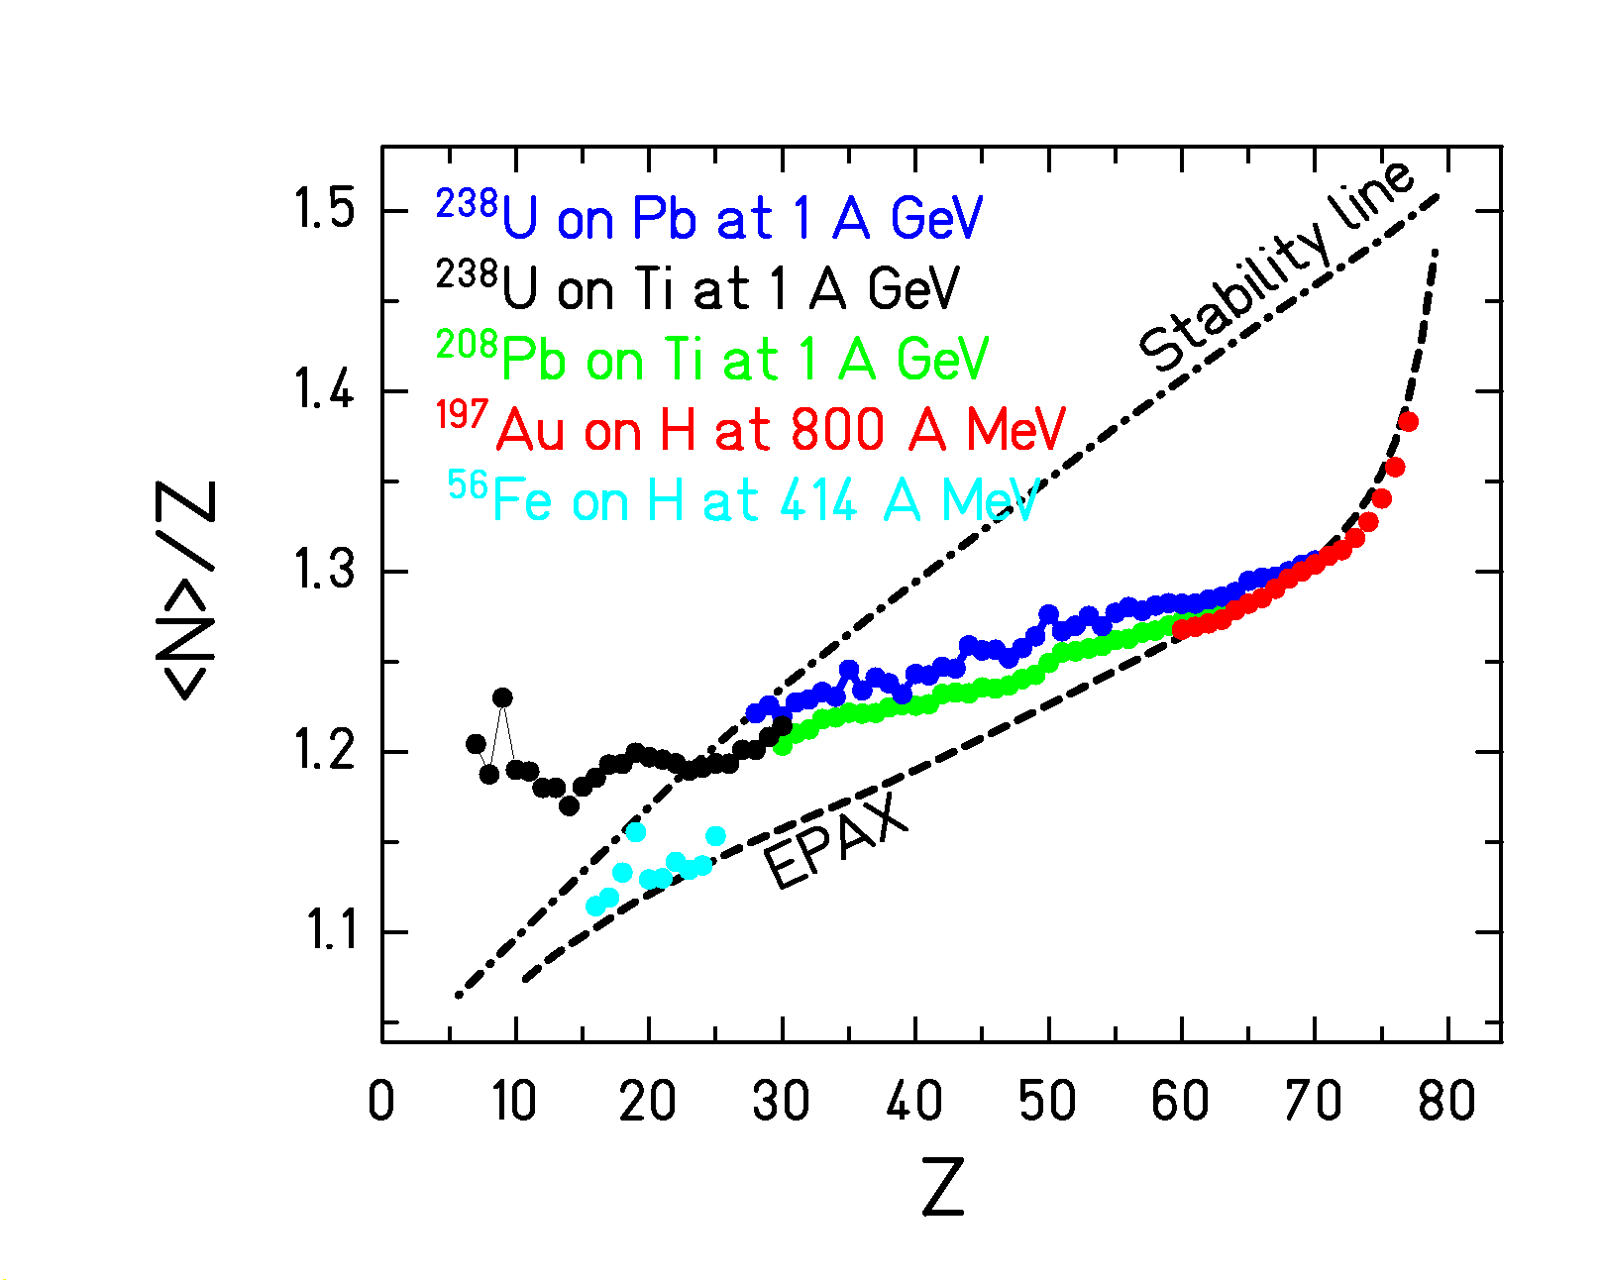

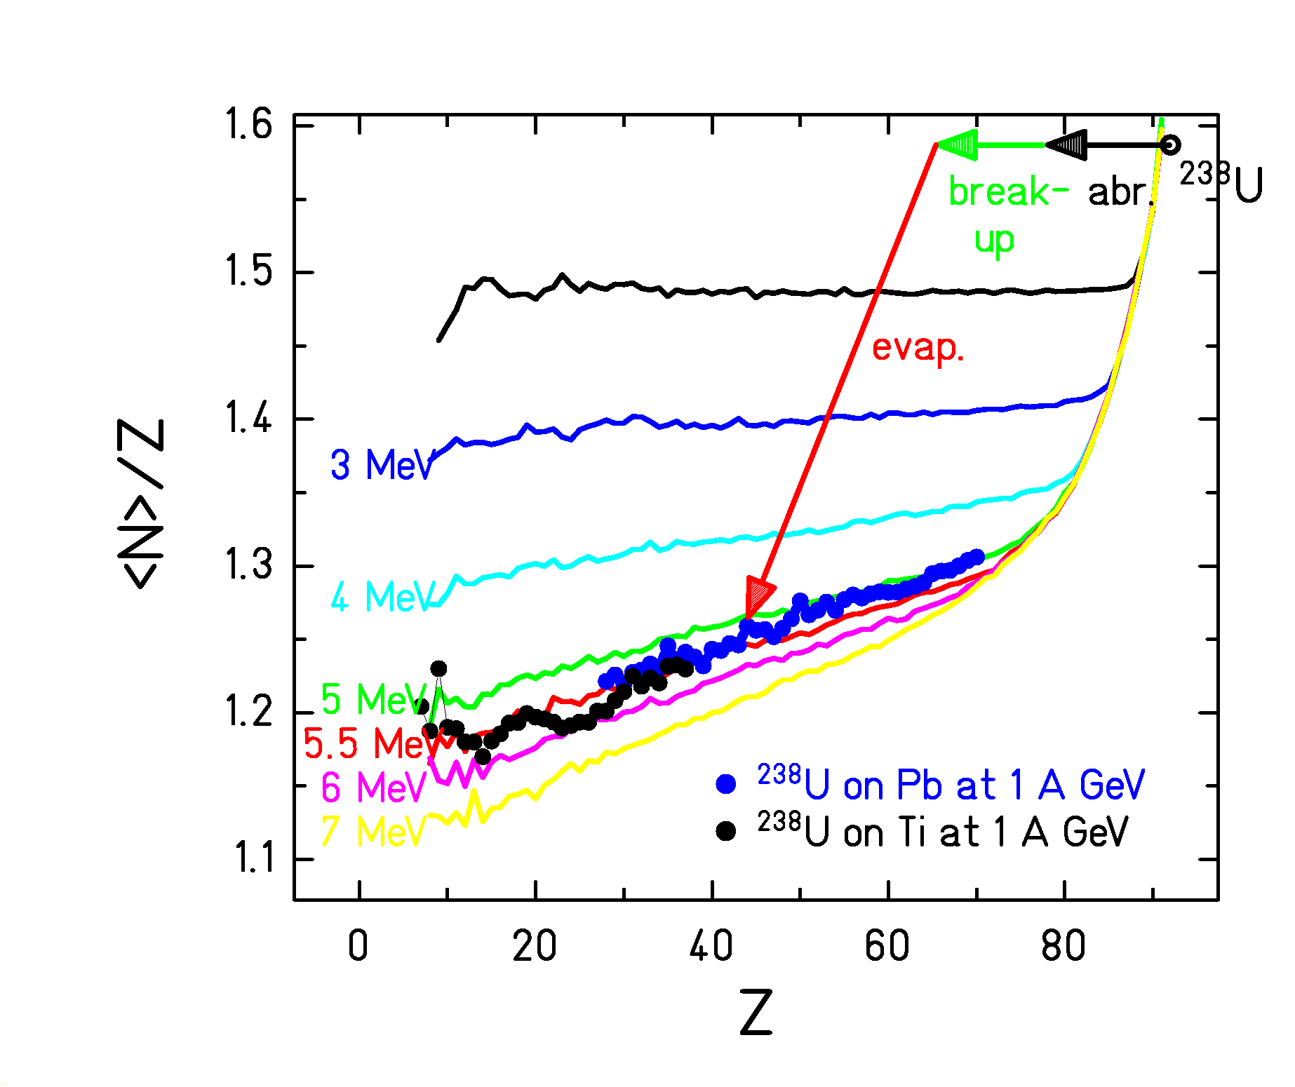

<N>/Z of ²³⁸U fragmentation residues compared to EPAX and
3-stage code ABRABLA (with different freeze-out temperatures)
K.-H. Schmidt, M. V. Ricciardi, A. Botvina, T. Enqvist, Nucl. Phys. A 710 (2002) 157

Regarding “isospin” variation in evaporation only:
T_{freeze-out} ≈ 5 MeV
This result is compatible with the caloric curve of ALADIN.
Fine structure in residue yields after violent nuclear collisions

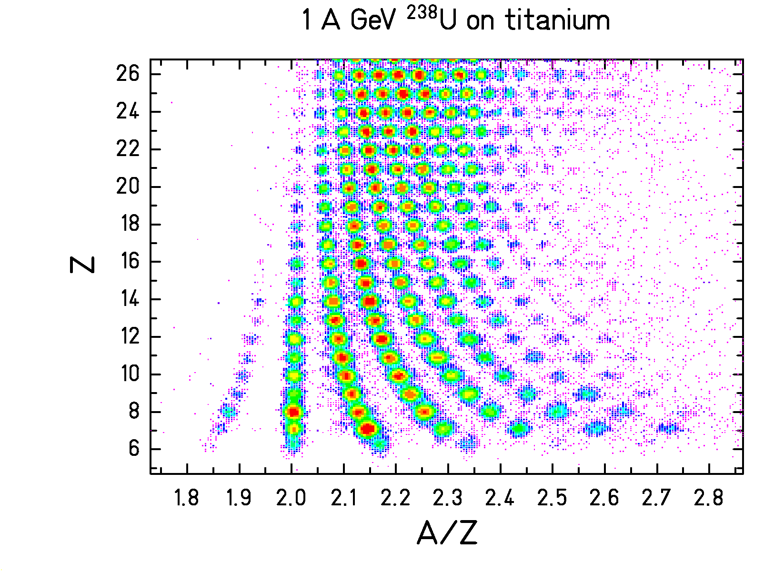
Nuclear structure even after violent nuclear collisions!

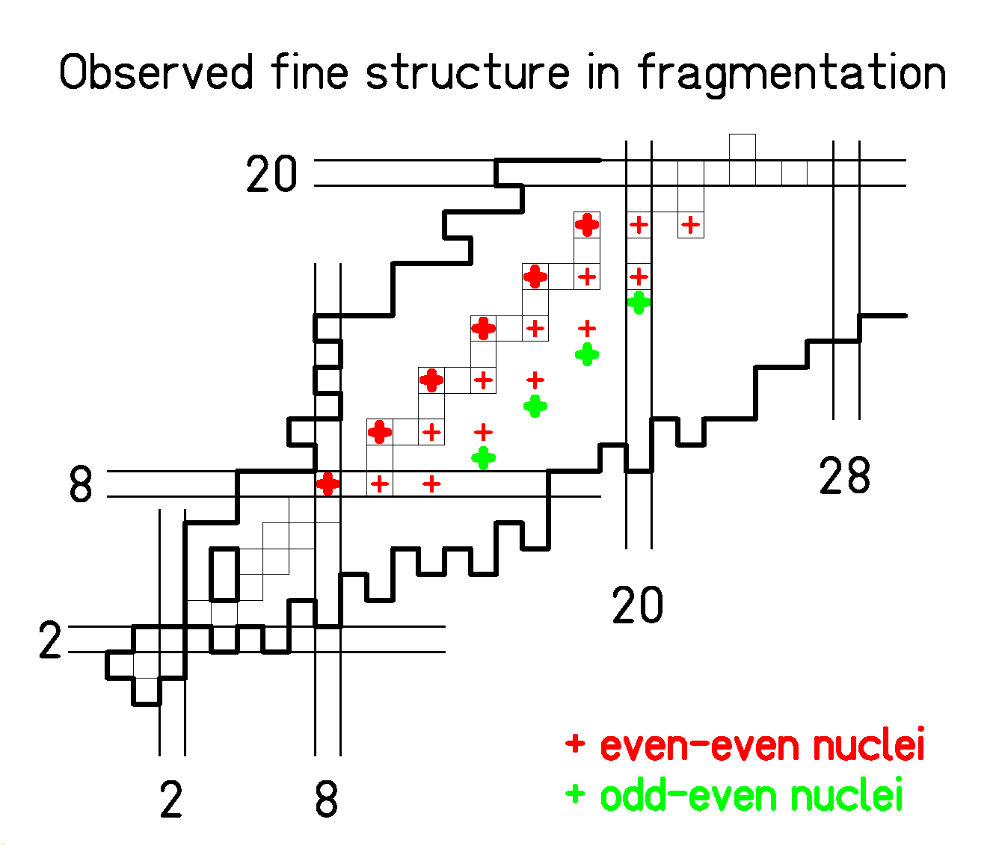

Caution when interpreting nuclide yields with thermodynamic approaches without nuclear structure!

PhD thesis M. V. Ricciardi
Conclusion

Valuable complementary information on the properties of hot and dense nuclear matter with high-resolution magnetic spectrometers

Features investigated up to now:
- Δ excitation in the nuclear medium
- Nuclear viscosity
- Momentum dependence of the nuclear mean field
- Evolution of the “isospin” in nuclear reactions
- Fine structure in residue yields

High-resolution results broaden the basis for the understanding of the properties of nuclear matter far from the conditions in our terrestrial environment.

Members of the collaboration:

J. Benlliure, E. Casarejos*, J. Pereira*
University Santiago de Compostela

A. Boudard, B. Fernandez*, R. Legrain†, S. Leray,
C. Volant, C. Villagrasa*, (W. Wlazlo)
CEA Saclay

L. Audouin*, M. Bernas, (B. Mustafa*), P. Napolitani*,
F. Rejmund, C. Stéphan, (J. Taïeb*), L. Tassan-Got
IPN Orsay

P. Armbruster, (T. Enqvist), (A. Heinz), D. Henzlova*,
V. Henzl*, (A. R. Junghans), (B. Jurado*), A. Kelić,
M. V. Ricciardi*, K.-H. Schmidt, C. Schmitt, O. Yordanov
GSI Darmstadt

*Ph.D. theses
† deceased

_________________________________
Supported by the European Union
- HINDAS
- EURISOL
- Access to large facilities

