Experimental Indications for the Response of the Spectator to the Participant Blast

M. V. Ricciardi, T. Enqvist, J. Pereira,
J. Benlliure, M. Bernas, E. Casarejos,
V. Henzl, A. Kelic, J. Taieb, K.-H. Schmidt

- Results of high-precision kinematical measurements of projectile fragments at the FRS.

- Theoretical interpretation as the "Spectator Response to the Participant Blast"

- Information on the EOS of nuclear matter

- Conclusion

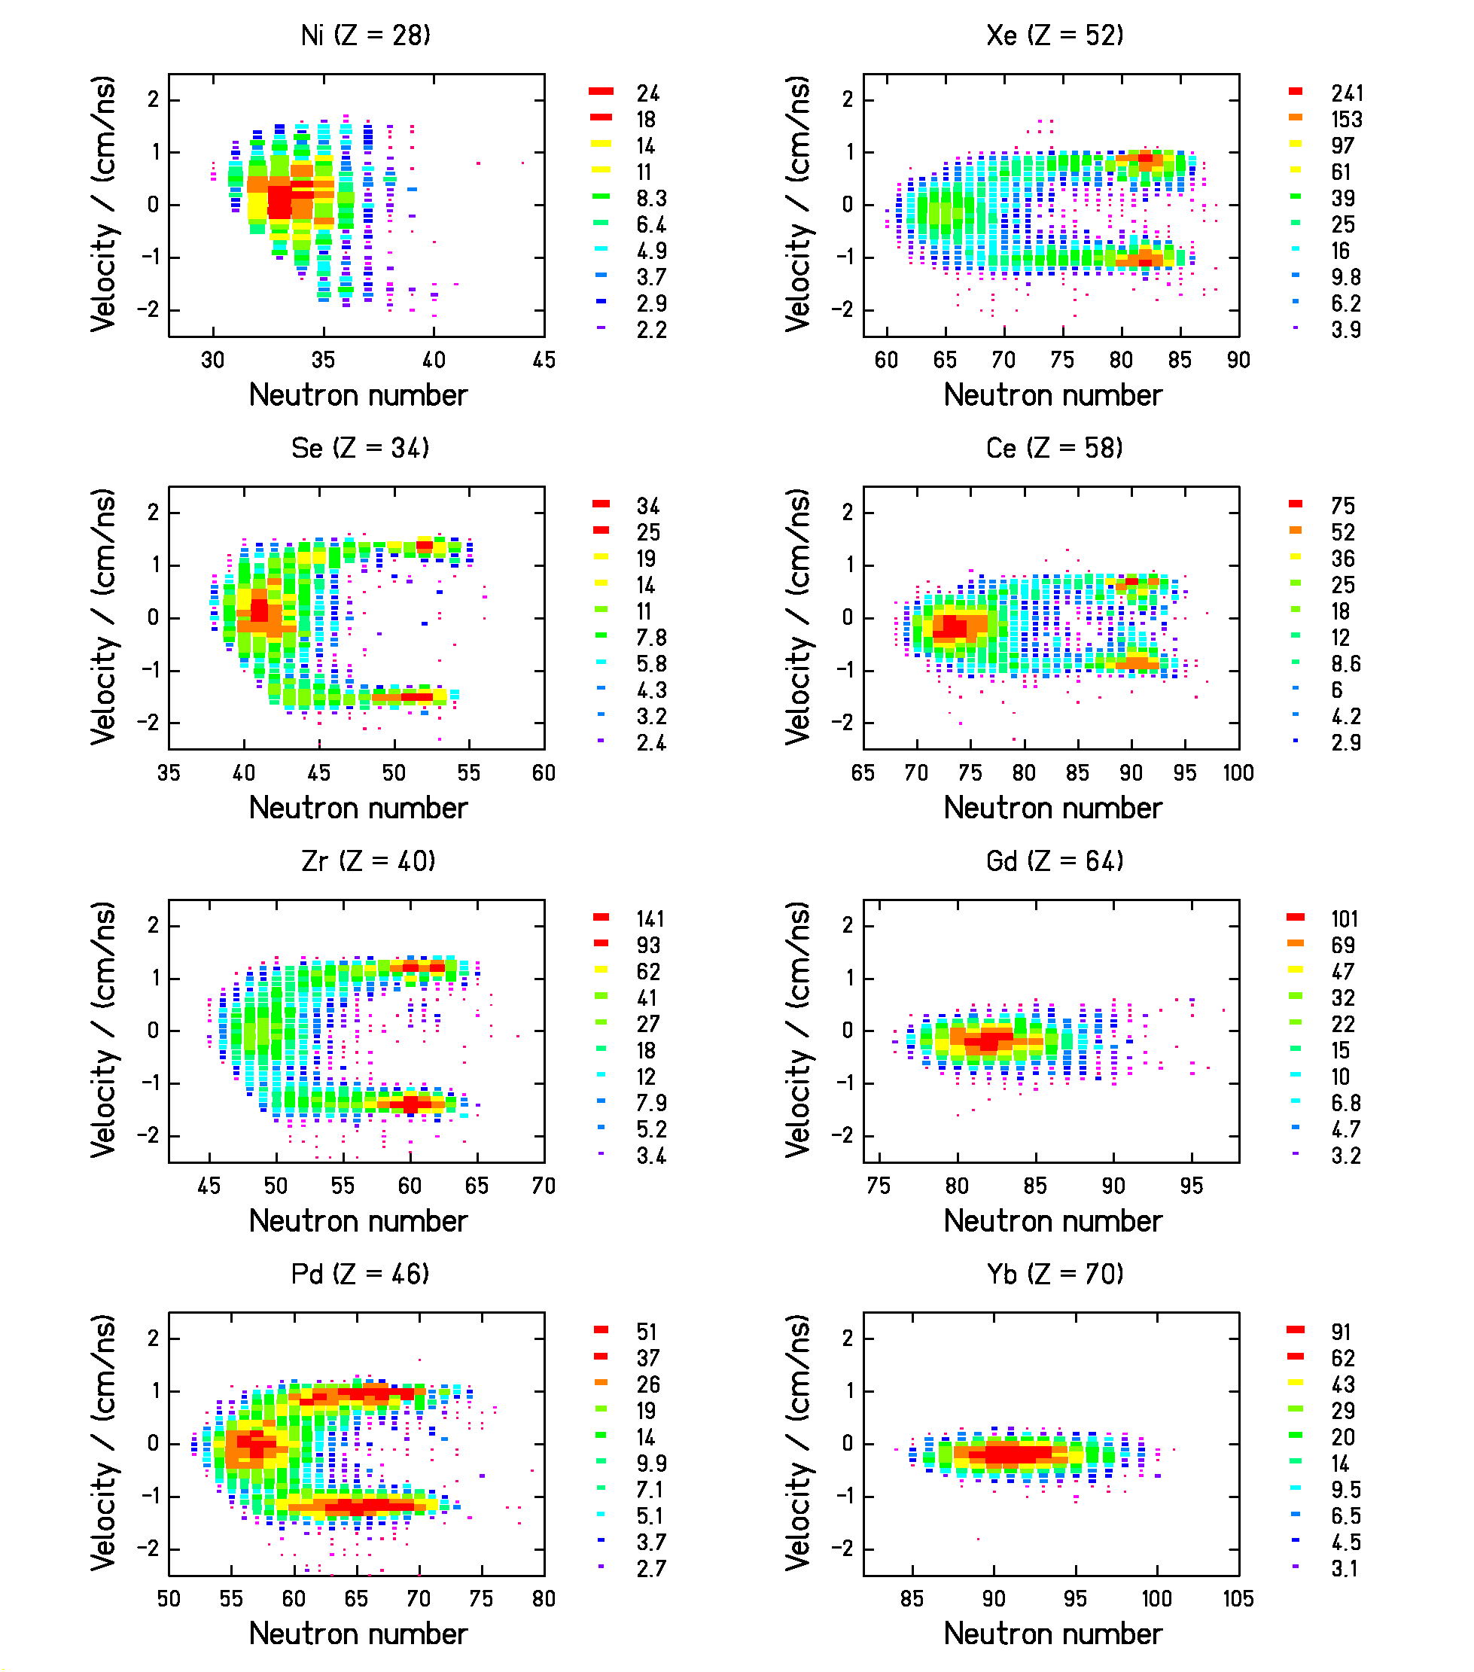

Residual nuclides from ²³⁸U + Pb, E = 1 A GeV
Fission products verify the velocity calibration!

T. Enqvist et al., NPA 658 (1999) 47
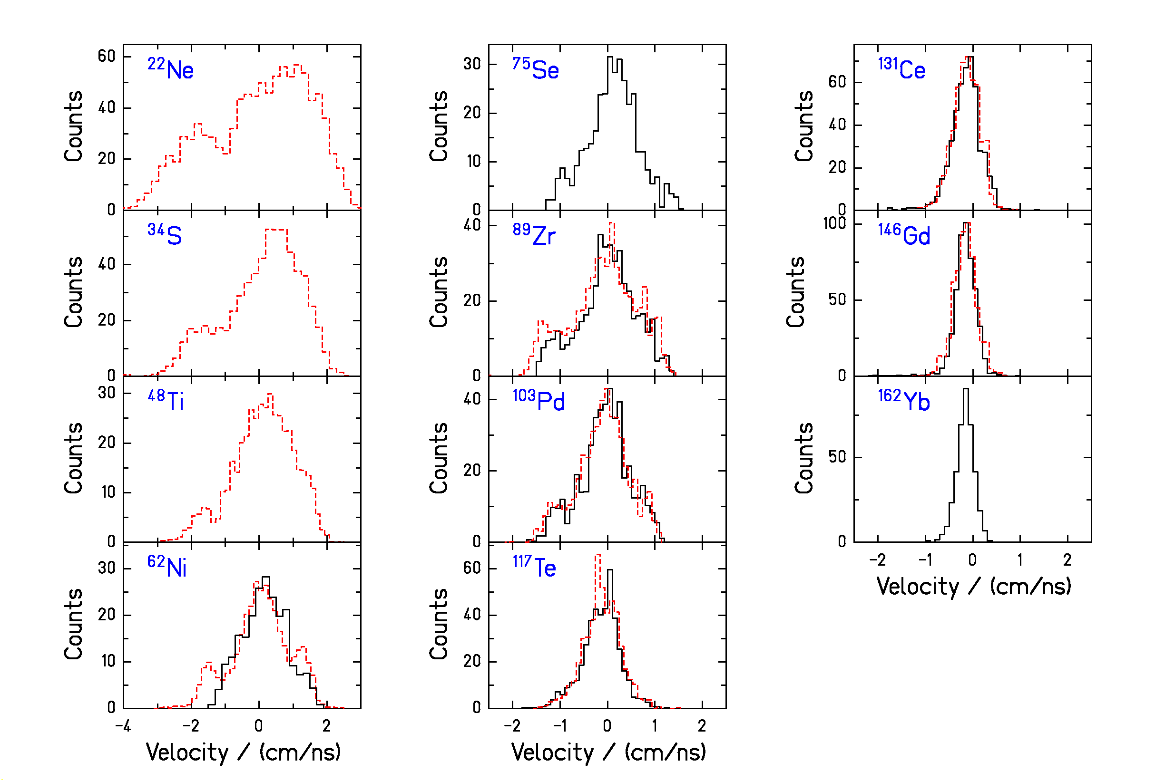

Velocity distributions of (mostly)
fragmentation products in ²³⁸U + Pb and ²³⁸U + Ti at E = 1 A GeV.
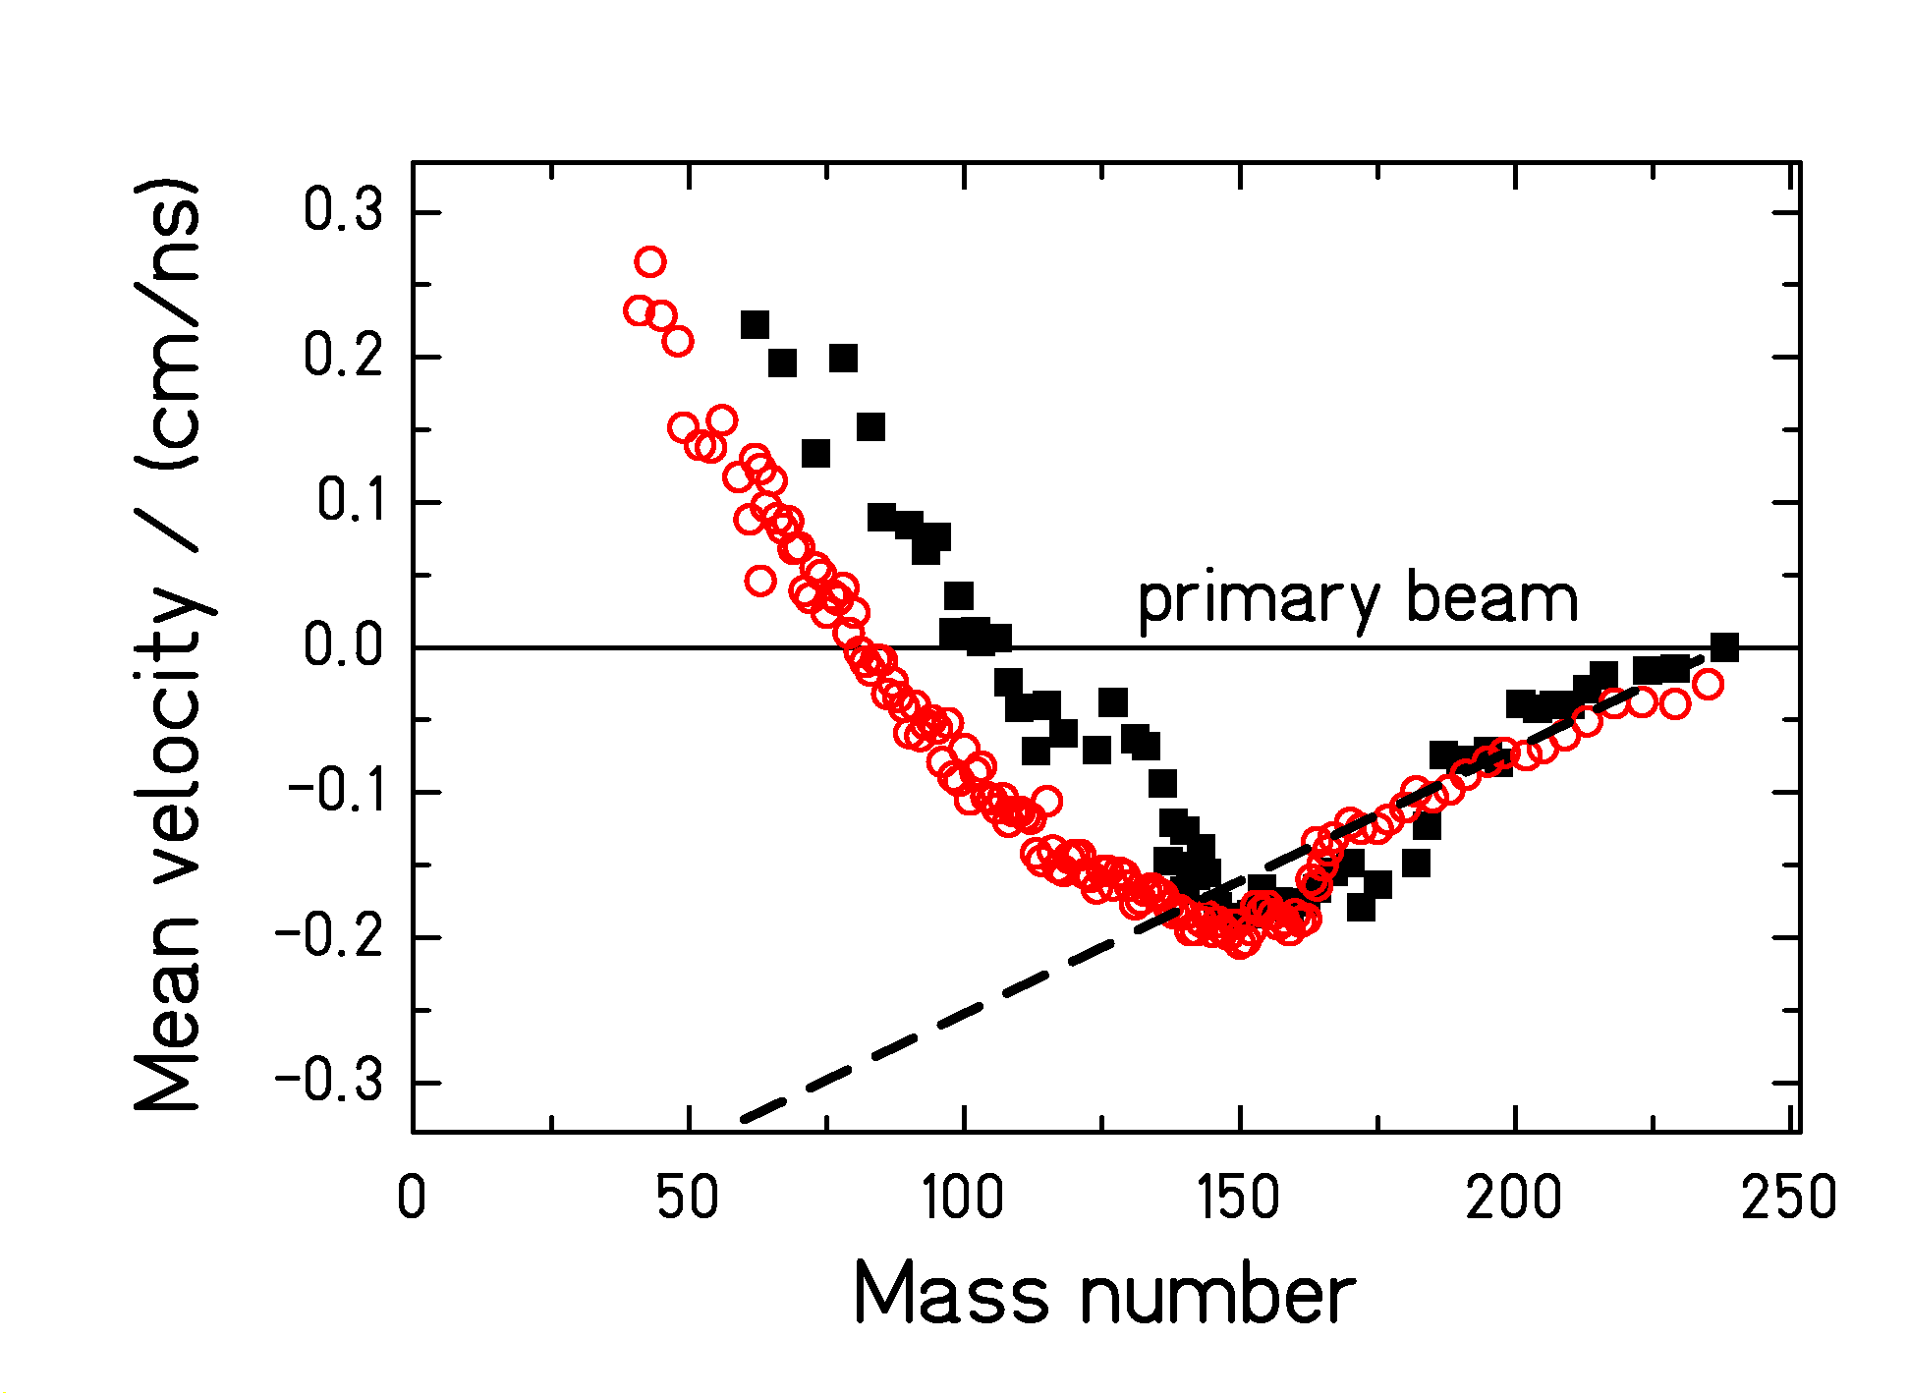

Mean velocities of fragmentation products from
²³⁸U + Pb and ²³⁸U + Ti (E = 1 A GeV) compared to the Morrissey systematics (dashed line).

Light projectile fragments are faster than the projectiles!
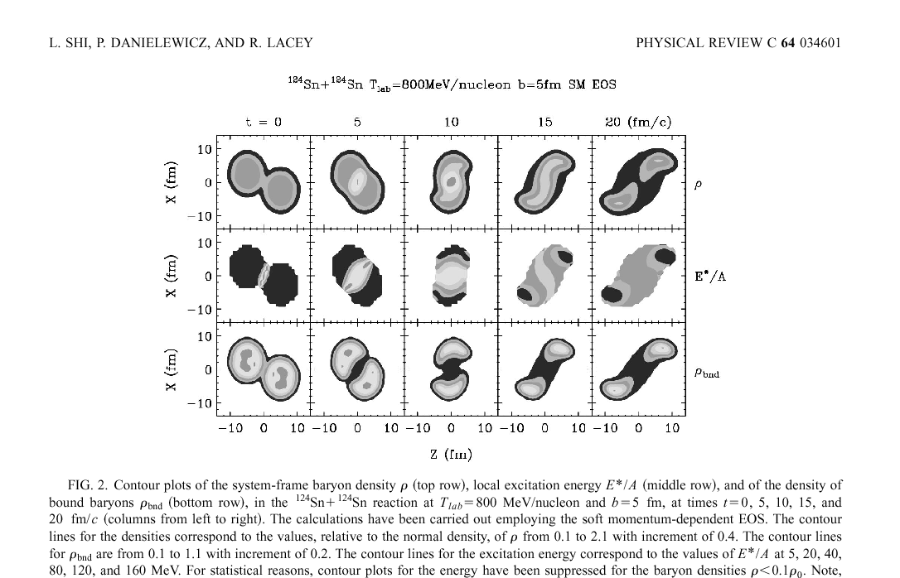

BUU calculations of mid-peripheral nucleus-nucleus collisions
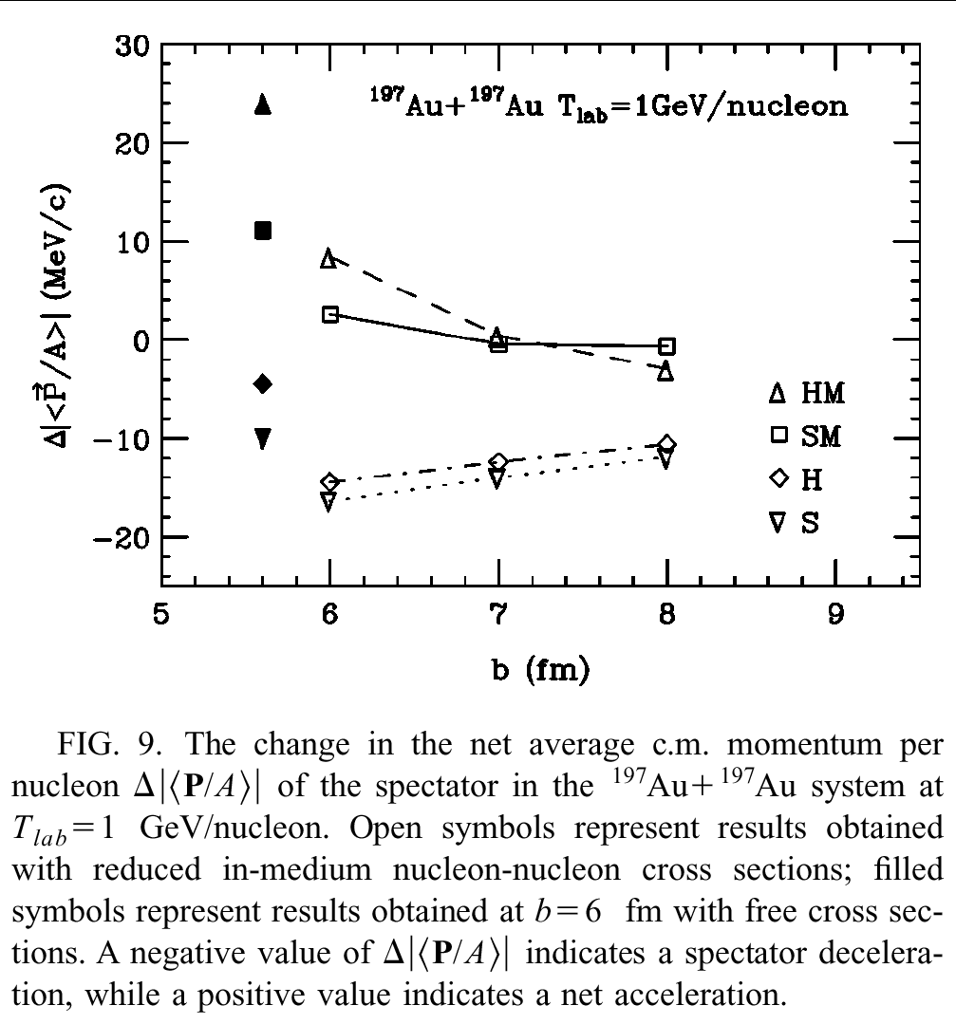

L. Shi, P. Danielewicz, R. Lacey, PRC 64 (2001) 034601

H: hard EOS; S: soft EOS
M: momentum-dependent nuclear force

c.m. momentum is selectively sensitive to the momentum dependence of the nuclear force!
Conclusion

- Indications for the postulated response of the spectators to the participant blast.

- Selectively sensitive to the momentum dependence of the nuclear force.

- Precise velocity measurement of projectile fragments is a new tool to investigate the EOS of nuclear matter.

