Effects of nuclear structure

in residual-nuclei production

M. V. Ricciardi⁽¹⁾, K. -H. Schmidt⁽¹⁾, P. Napolitani⁽¹⁾,
A. V. Ignatyuk⁽²⁾, F. Rejmund⁽³⁾

- GSI – Germany
- IPPE, Obninsk - Russia
- IPN Orsay - France

OUTLOOK

- Experiment: ²³⁸U → Ti at 1 A⋅GeV at the FRS (GSI)

- Results: production cross section of residual nuclides

- Data reveal complex structural effects

- Analysis of the results with the statistical model

- Conclusions

THE EXPERIMENT
AT THE FRAGMENT SEPARATOR

1 A GeV ²³⁸U beam into a thin Ti target

identification of Z from IC: $\text{ΔE}∝Z^{2}$

identification of A/Z from time and position:

$\frac{A}{Z}=\frac{e}{m_{0}}\frac{\text{Bρ}}{\text{cβ}γ}$ $β=\frac{v}{c}$ $\text{with}$ $v=\frac{s}{\text{ToF}}$

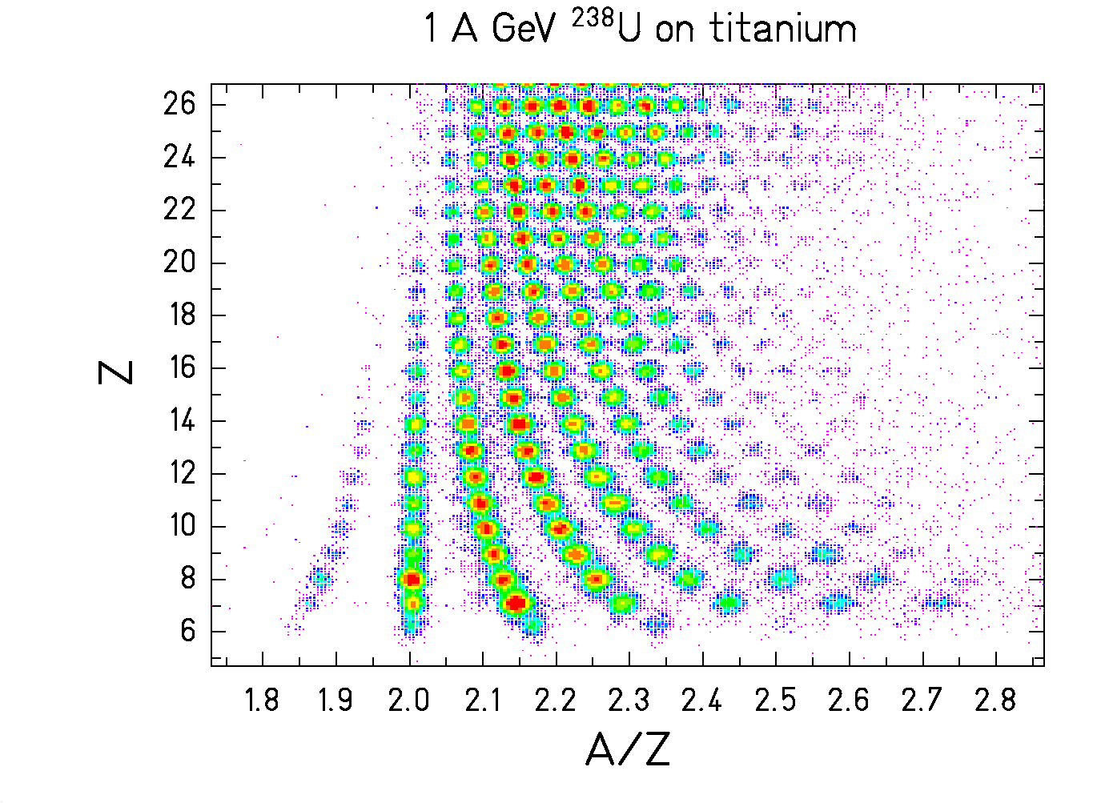
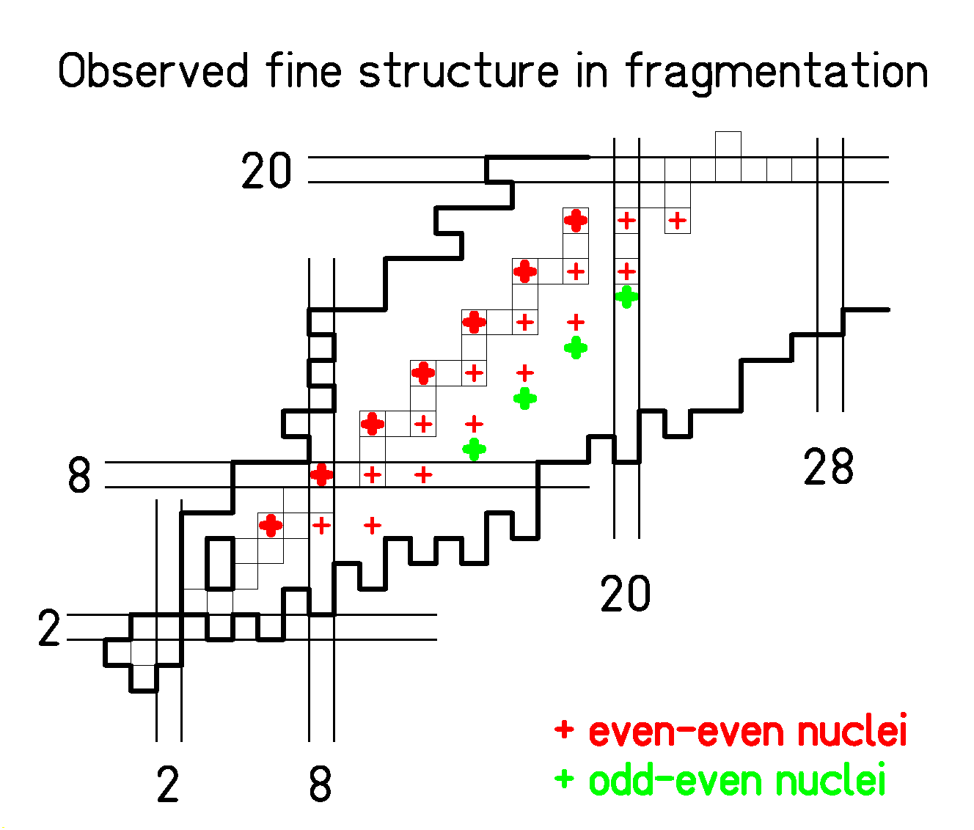
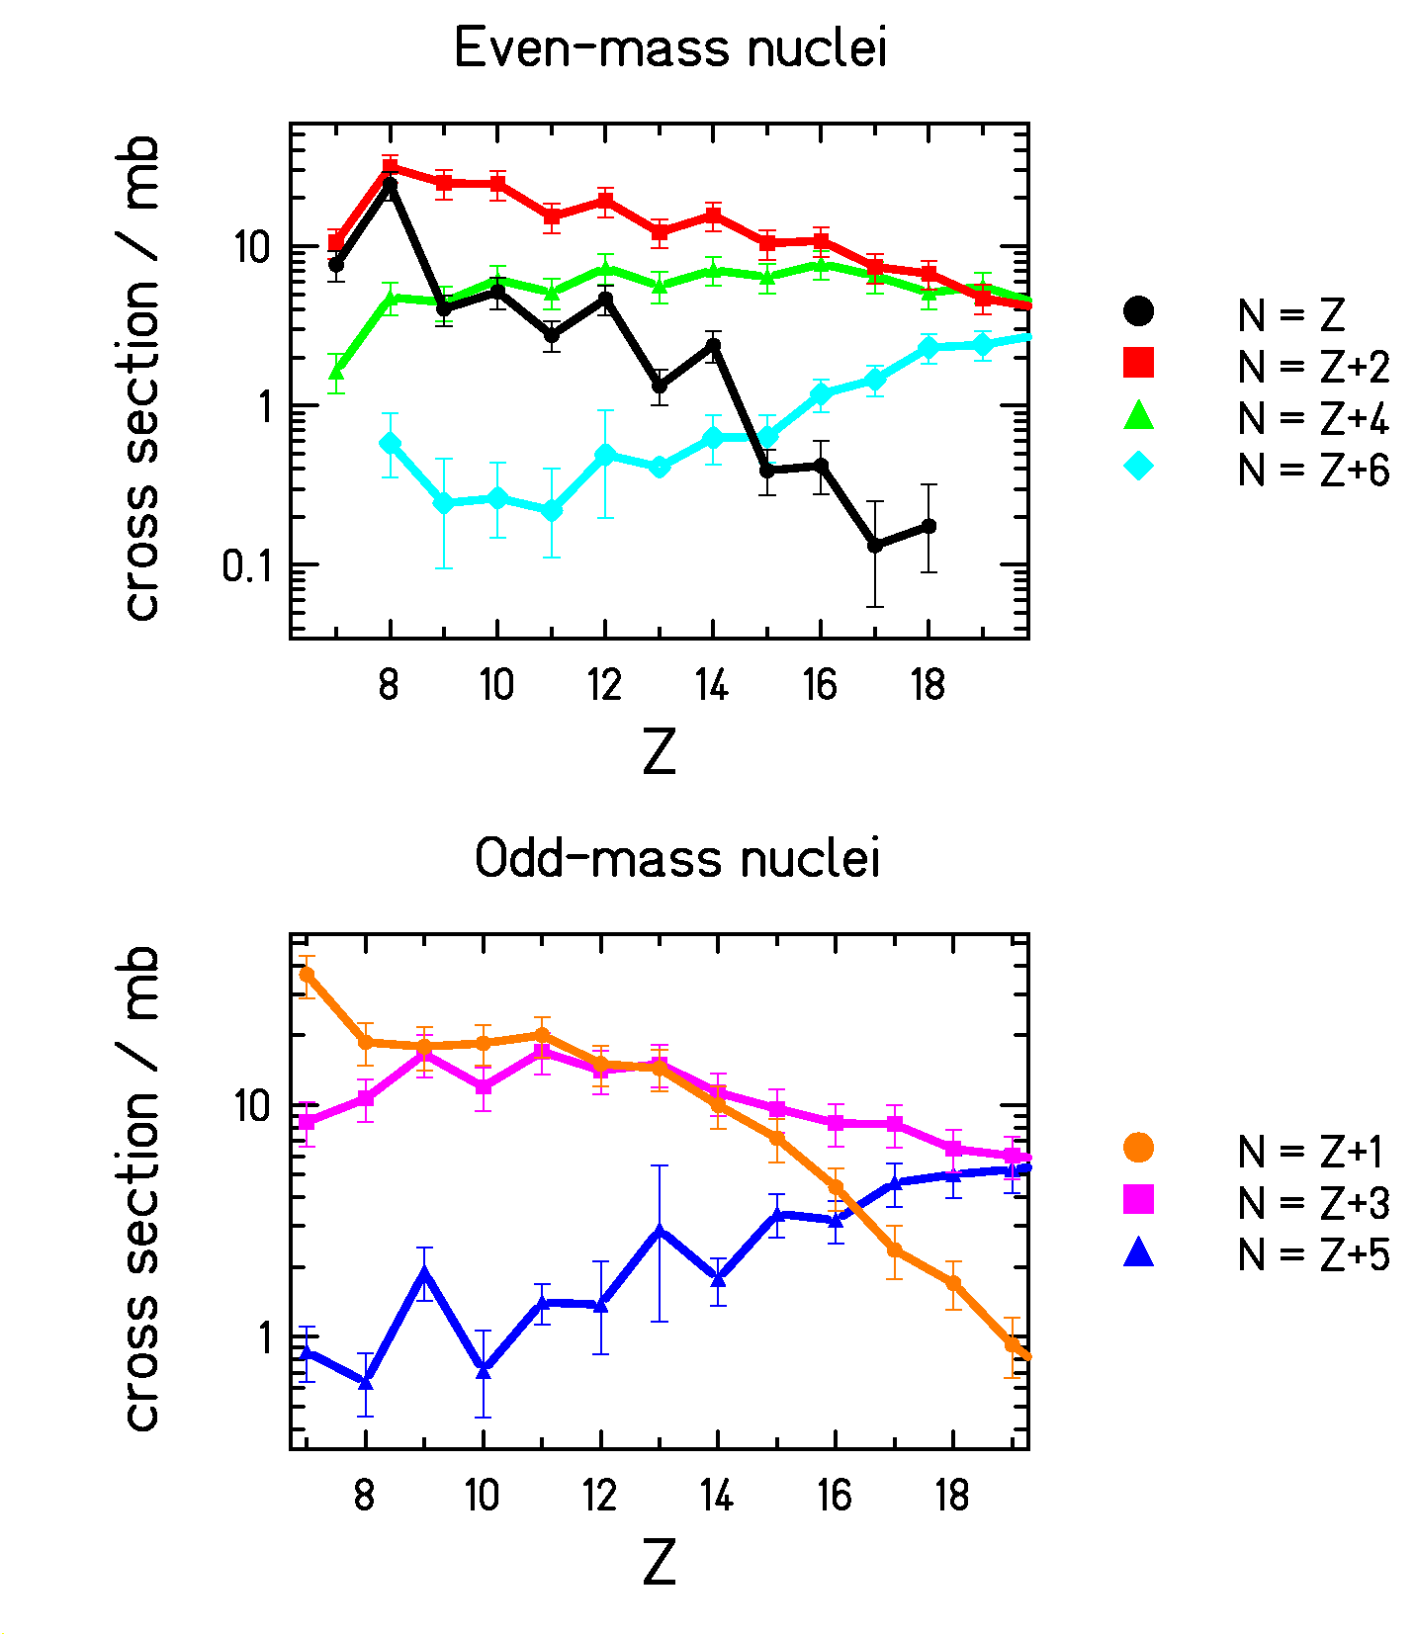
NUMBER OF FINAL STATES

STATISTICAL MODEL with the simplest description of pairing:
- in the masses: M= M_{LD} - δ δ_{oo}= 0, δ_{oe}=Δ, δ_{ee}= 2Δ
- in level density:$ρ∝\text{exp}\left(2\sqrt{a\left(E−δ\right)}\right)$

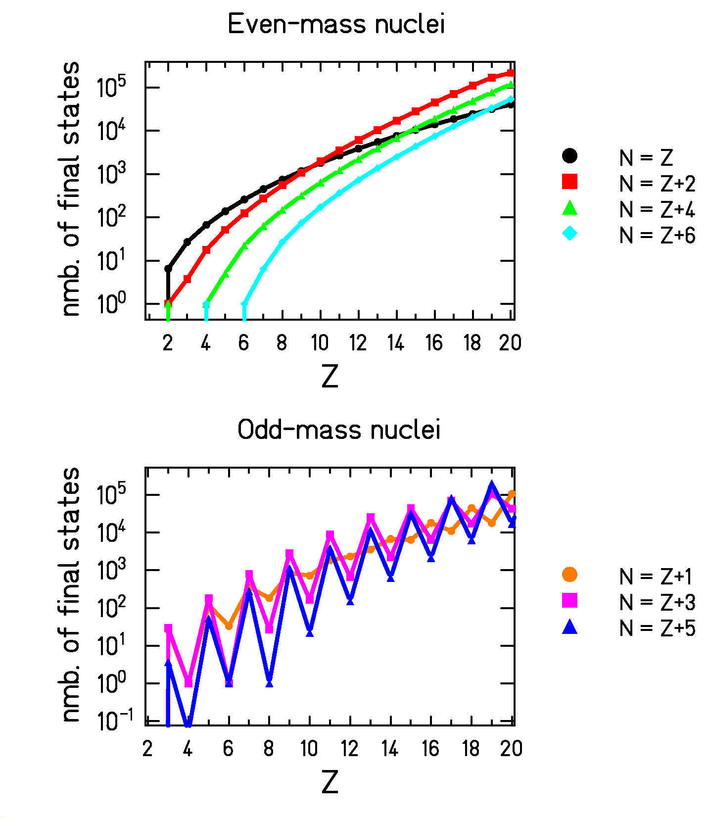
Conclusions

Experiment: light nuclides of 1A⋅GeV ²³⁸U+Ti

FRS allows full (A, Z) identification
→ formation cross section for every isotope

Results:

complex structure of nuclei produced in rather violent collisions

Explanation:

the statistical model explains the structure of odd-mass nuclei as the most prominent manifestation of pairing
→ independence of the reaction mechanisms

even-odd structure of even-mass nuclei could be related to higher-order structural effects in the level density
→ yields from highly excited nuclei are a rich
source of information on nuclear structure.

