Seminar GANIL

Caen - June 2002

The Isospin Thermometer -

A New Tool to Determine
the Freeze-out Temperature
of Heavy Residues after
Relativistic Nucleon-Nucleon
Collisions

M. Valentina Ricciardi (thesis)

Alexandre Botvina

Timo Enqvist

Karl-Heinz Schmidt

GSI

INTRODUCTION

Signatures of the
?
liquid-gas phase transition
investigation of  light clusters  (multifragmentation) | investigation of  heavy clusters  (fragmentation)

 The formation of light clusters (multi-fragmentation) has widely been exploited to search for thermal instabilities of excited nuclei

 Light clusters might be emitted by liquid and gaseous phase. - Heavy residues are clearly associated to the liquid phase.

 The identification of heavy residues needs specific experimental tools.
OUTLOOK

- Experiments at FRS of GSI
- Results
- Sequential decay or simultaneous break-up?
- Idea behind the isospin thermometer
- Comparison with a three stage model
- Comparison with SMM calculations
- Possible scenario of mid-peripheral high-energy nucleus-nucleus collisions
- Conclusions

THE EXPERIMENT AT THE FRS AT GSI

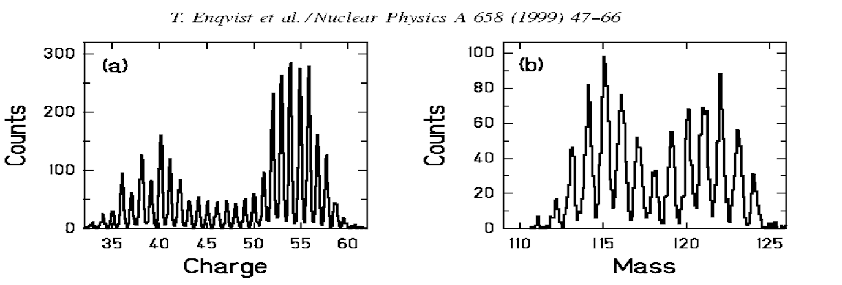
velocity is calculated from Bρ:
$γv=\text{Bρ}\frac{Z⋅e}{A⋅m_{0}}$ very precise evaluation!

DISCRIMINATION OF FISSION EVENTS

Systematic survey on residual nuclide production
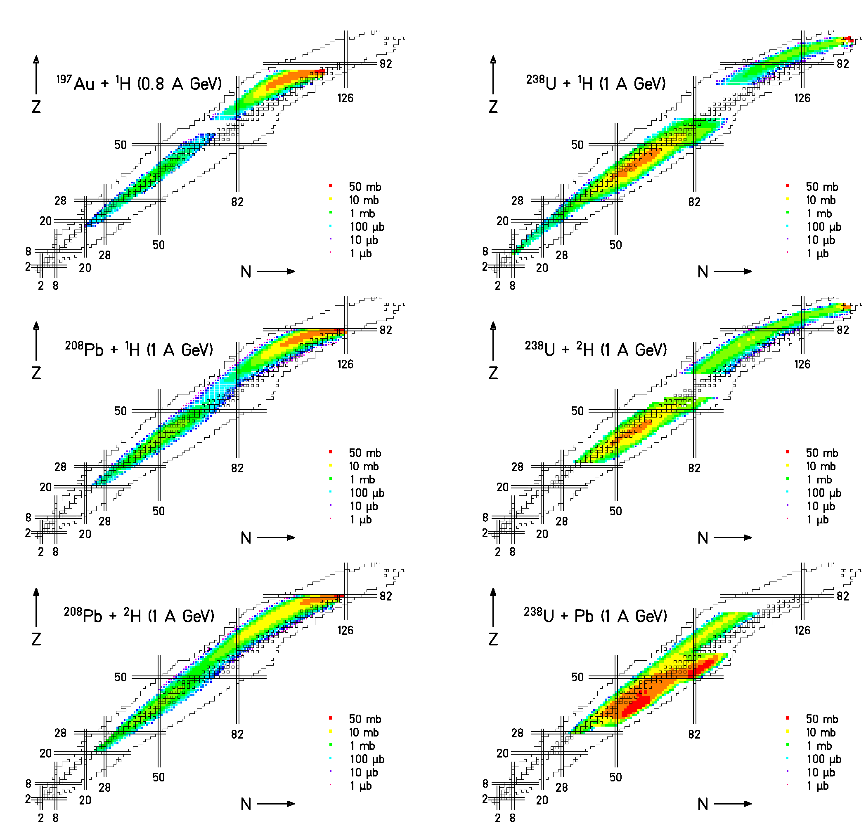

6000 individual data points!

Basic data for
- EURISOL and GSI project
  - Intensities of secondary beams
- HINDAS
  - Nuclear data for incineration of nuclear waste

From electromagnetic-induced fission
to fragmentation of ²³⁸U
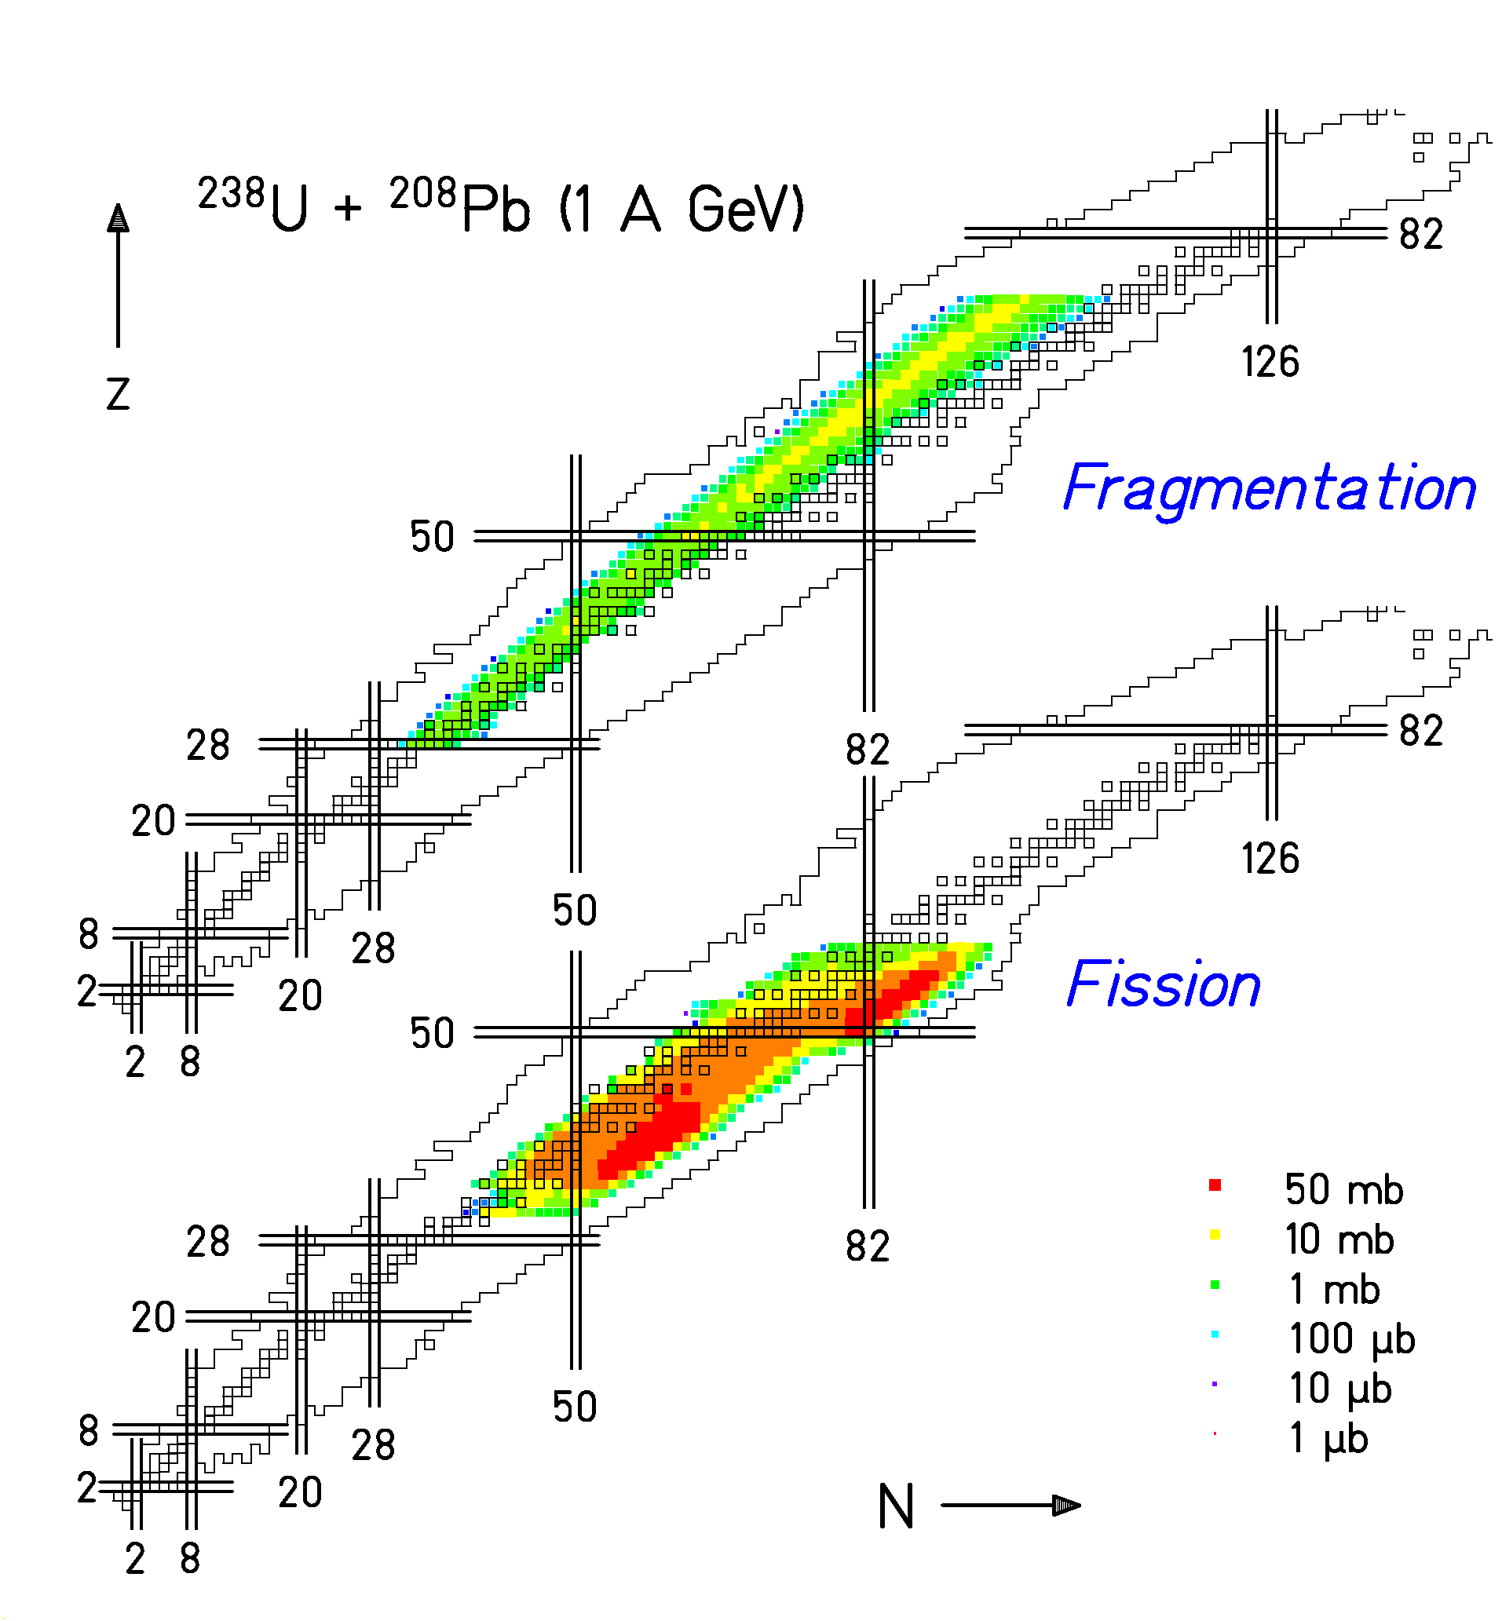

Fission from excitations of GDR and nuclear collisions
- Fragmentation in high-energy nuclear collisions
Neutron excess reflects excitation energy induced.
EXPERIMENTAL RESULTS
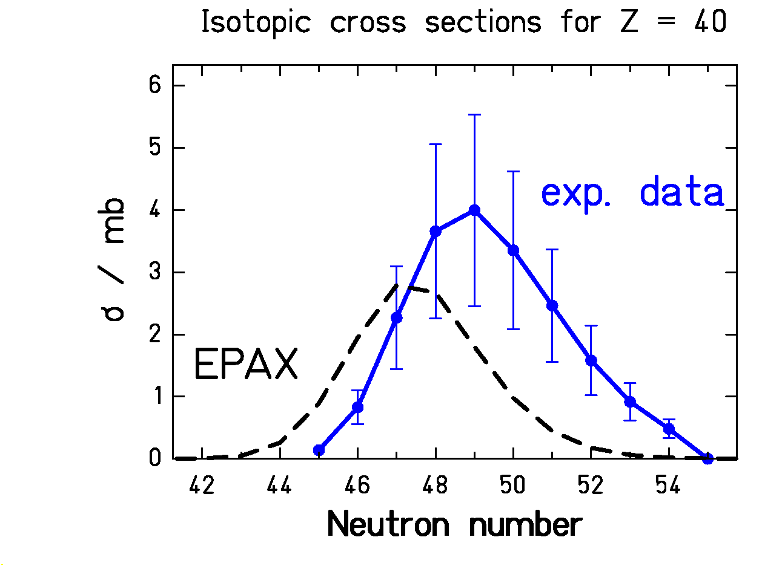
Data: ²³⁸U + ²⁰⁸Pb (1 A GeV)
(Only fragmentation, fission discharged)

EPAX: a systematics of isotopic cross sections in projectile fragmentation
(K. Sümmerer, B. Blank, Phys. Rev. C (2000) 034607)
EPAX is based on the hypothesis of
limiting fragmentation
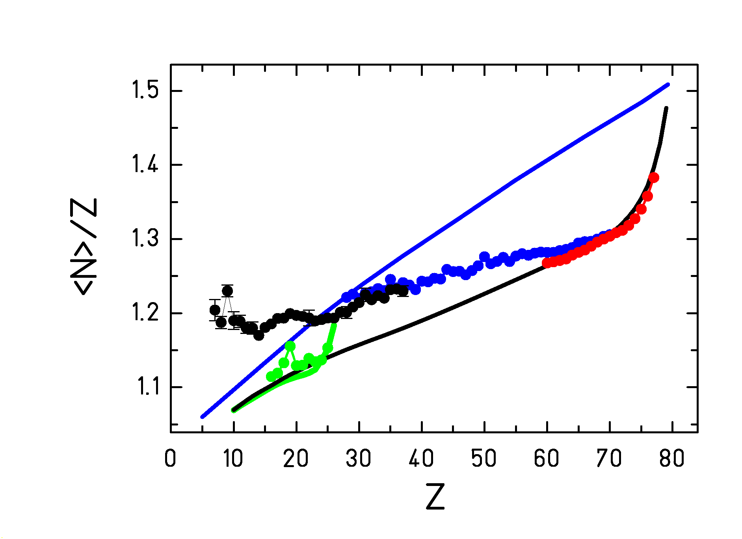
Mean N/Z of fragments (fission discharged)
— stability line
— EPAX, projectile = Au
— EPAX, projectile = Fe
● 800 A⋅MeV Au + p - F.Rejmund NPA 683 (2001)
● 414 A⋅MeV Fe + p - W.R.Webber AJ 508 (1998)
- 1000 A⋅MeV U + Pb - T.Enqvist NPA 658 (1999)
- 1000 A⋅MeV U + Ti - M.V. Ricciardi's thesis (2002)

Why do some data agree with EPAX
and some deviate?

What can we learn from ALADIN data?
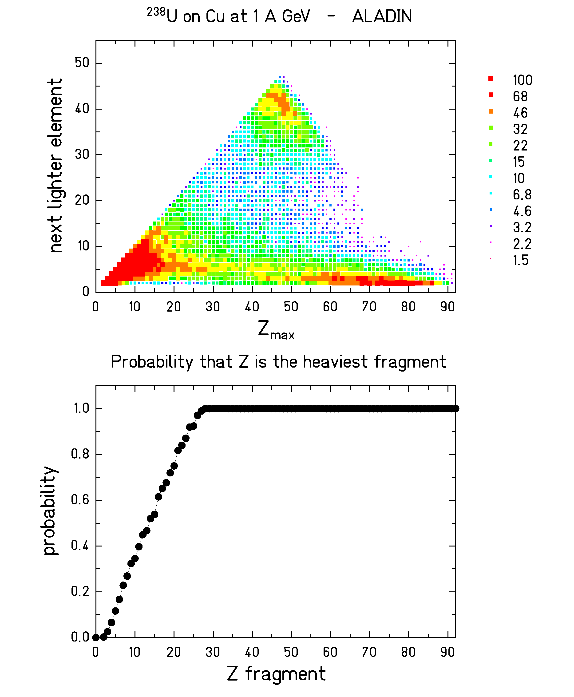

- Separation between multifragmentation and "spallation".
- Z>20 is the heaviest fragment in the reaction.

Consolidated knowledge
?
- Lighter residues originate from more violent collisions
- More violent collisions → larger excitation energy (ABRASION PICTURE)

SIMULTANEOUS BREAK-UP | BOTH | SEQUENTIAL  DECAY

SIMULTANEOUS BREAK-UP
SEQUENTIAL DECAY
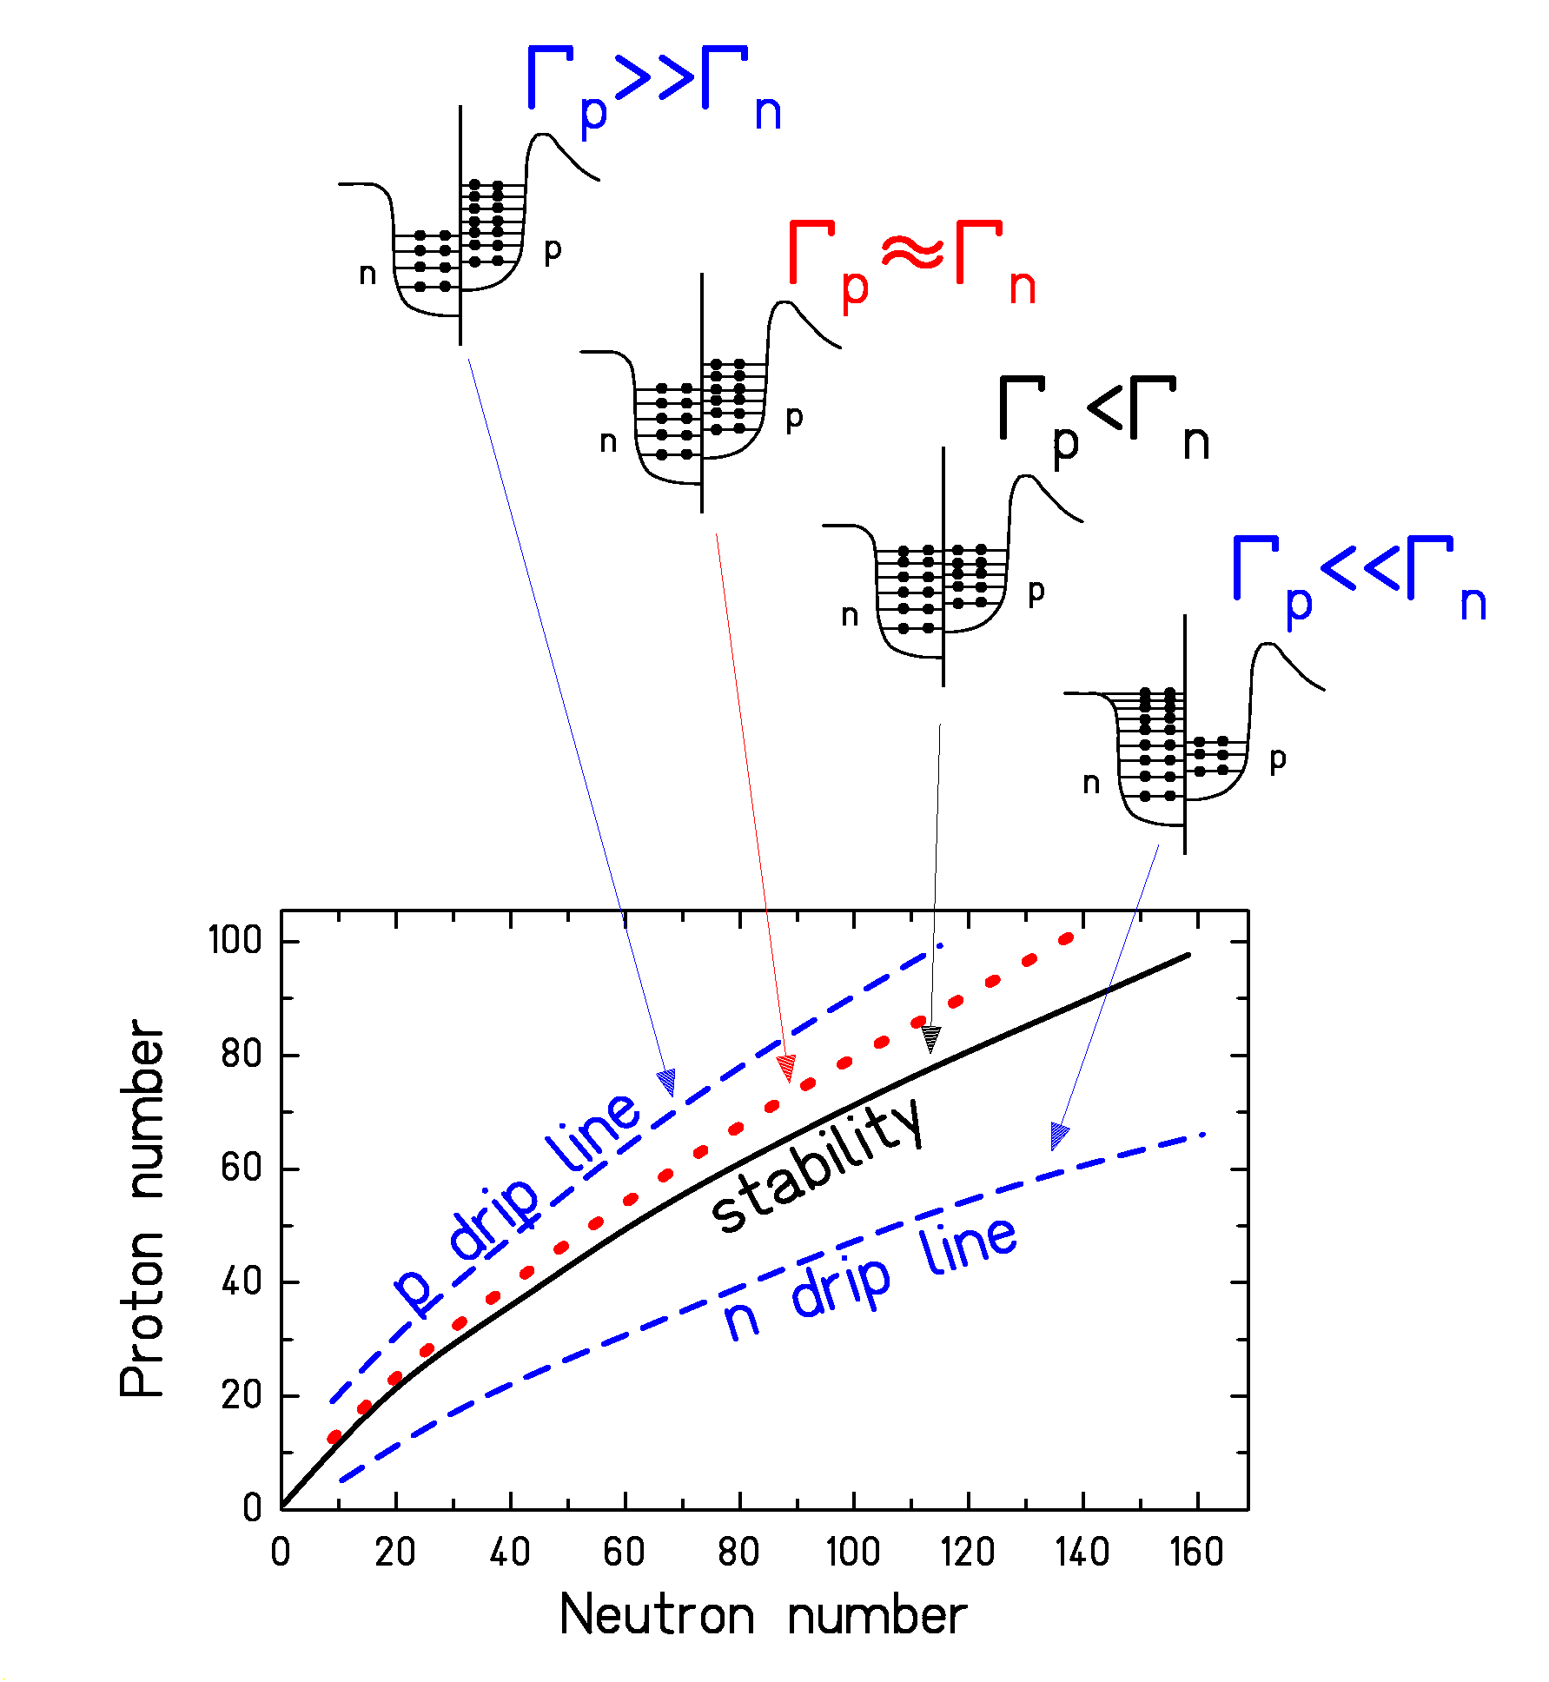

chain of processes !
"evaporation corridor"
or
"attractor line"
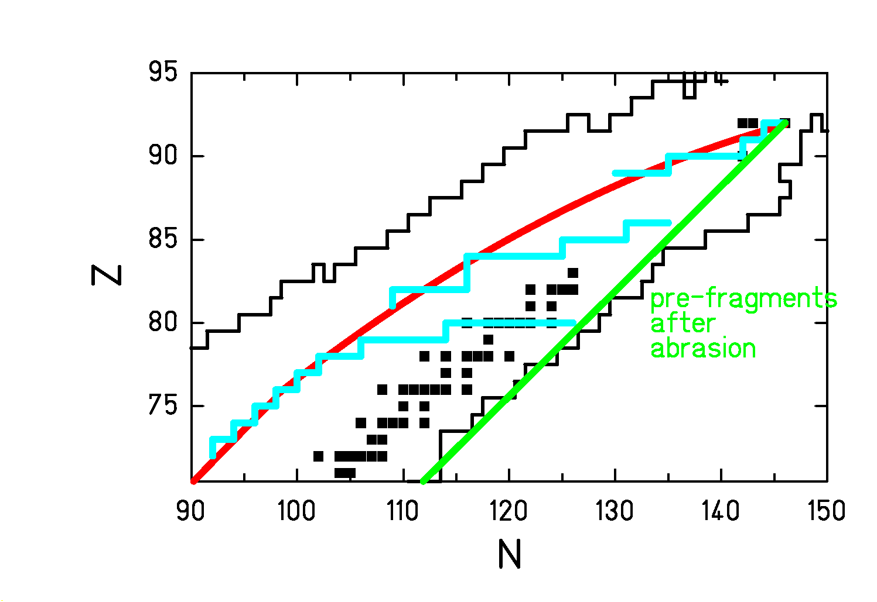
IDEA BEHIND LIMITING FRAGMENTATION
PRINCIPLE OF THE ISOSPIN THERMOMETER

Simplifying hypothesises:
- only n-evaporation
- 15 MeV consumed for every evaporated n
- the evaporation stops when <N_{final}>/Z = 1.25
ABRASION
+
SIMULTANEOUS BREAK-UP
+
SEQUENTIAL DECAY

COMPARISON WITH A THREE-STAGE MODEL

ABRASION / (BREAK-UP) / EVAPORATION
… complete but simplified…
COMPARISON WITH SMM CALCULATIONS
… not complete but more sophisticated…
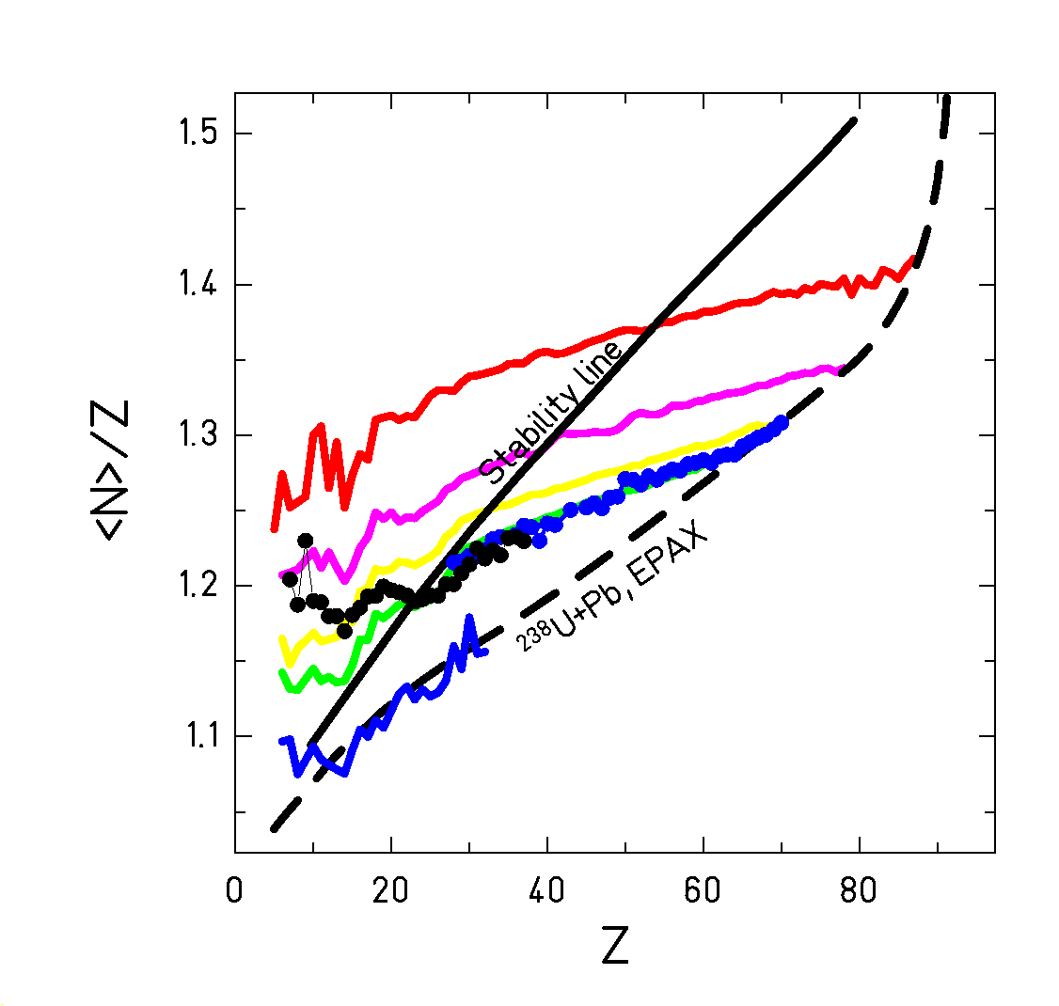
T = 5 MeV
• 1 A GeV ²³⁸U on Ti measured at FRS
• 1 A GeV ²³⁸U on Pb measured at FRS

A SHARP LIMITING TEMPERATURE?
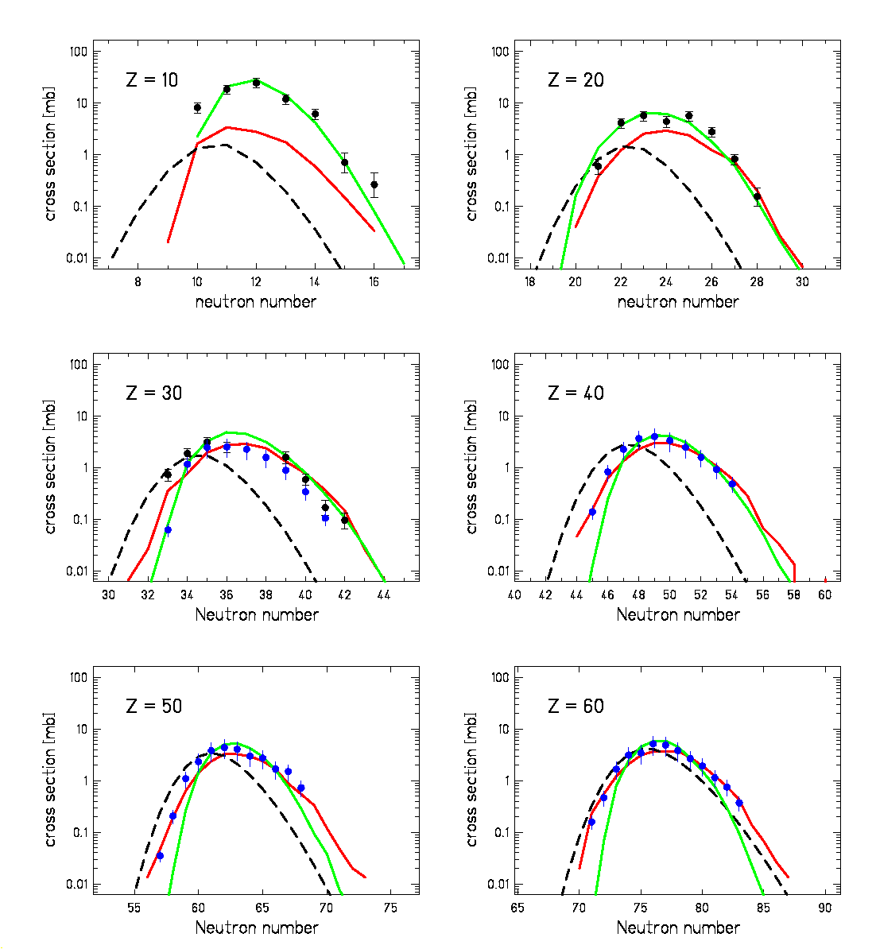
• 1 A GeV ²³⁸U on Ti measured at FRS
• 1 A GeV ²³⁸U on Pb measured at FRS
Three-stage model
SMM (arbitray normalised)
POSSIBLE SCENARIO OF MID-PERIPHERAL HIGH-ENERGY NUCLEUS-NUCLEUS COLLISIONS
CONCLUSIONS

 Some heavy residues produced in relativistic nucleus-nucleus collisions are unexpectedly neutron-rich

 This neutron excess was interpreted as an indication for a simultaneous-break-up phase

 The mean N/Z-ratio of the final elements can be used in combination with statistical-model codes in order to deduce the freeze-out temperature after break up (“isospin thermometer”)

 The average temperature of the break-up configuration at freeze out was determined to
T ≈ 5 MeV

 Consequence: The probability for an equilibrated compound nucleus to exist drops strongly above a limiting temperature of 5 MeV

http://www-wnt.gsi.de/kschmidt/talks.htm

