KPII seminar

Determination of the

freeze-out temperature

in the fragmentation of

relativistic ²³⁸U projectiles

by means of the

isospin thermometer

February 2003

M. Valentina Ricciardi

GSI

Karl-Heinz Schmidt, M. Valentina Ricciardi, Alexandre Botvina, Timo Enqvist,

Nuclear Physics A 710 (2002) 157–179

GLOSSARY

Isospin

Just an expression for N/Z

Freeze-out temperature
When “something” decouples from the hot source in the cooling process

Isospin thermometer
A specific thermometer based on the measurement of the N/Z

The liquid-gas phase transition in a nucleus

Exploring the nuclear-matter phase-diagram and identifying the different phases of nuclear matter is one of the main challenges of modern nuclear physics.

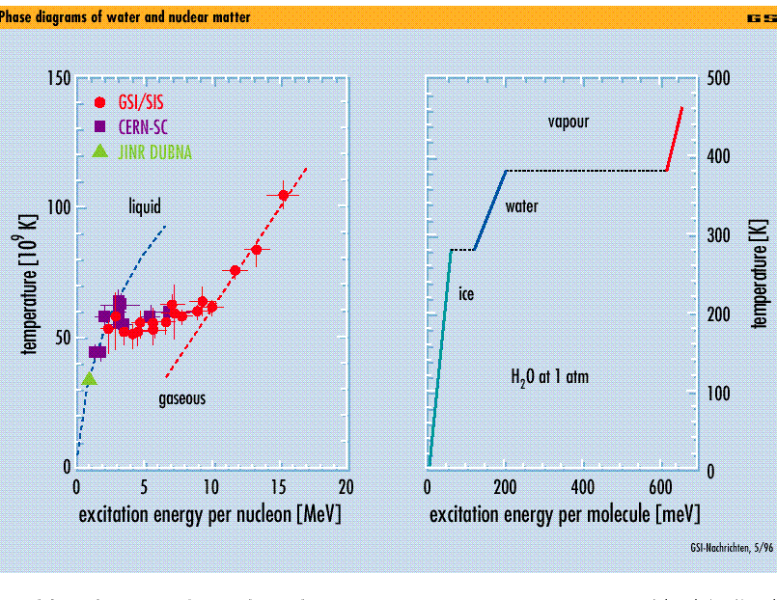
Up to now: Information gained with the observation
of light (A<20) fragments

Temperature → isotopic ratio

High-resolution magnetic spectrometer
--> Mass identification is achievable for all residues
OUTLINE

- Experiments: ²³⁸U → Pb at 1 A⋅GeV at FRS
²³⁸U → Ti at 1 A⋅GeV at FRS
- Comparison of the experimental data with the EPAX prediction -> N/Z is sensitive to the temperature
- Exploiting the new information: the isospin thermometer
- Possible scenario of mid-peripheral high-energy nucleus-nucleus collisions

THE EXPERIMENT AT THE FRS AT GSI

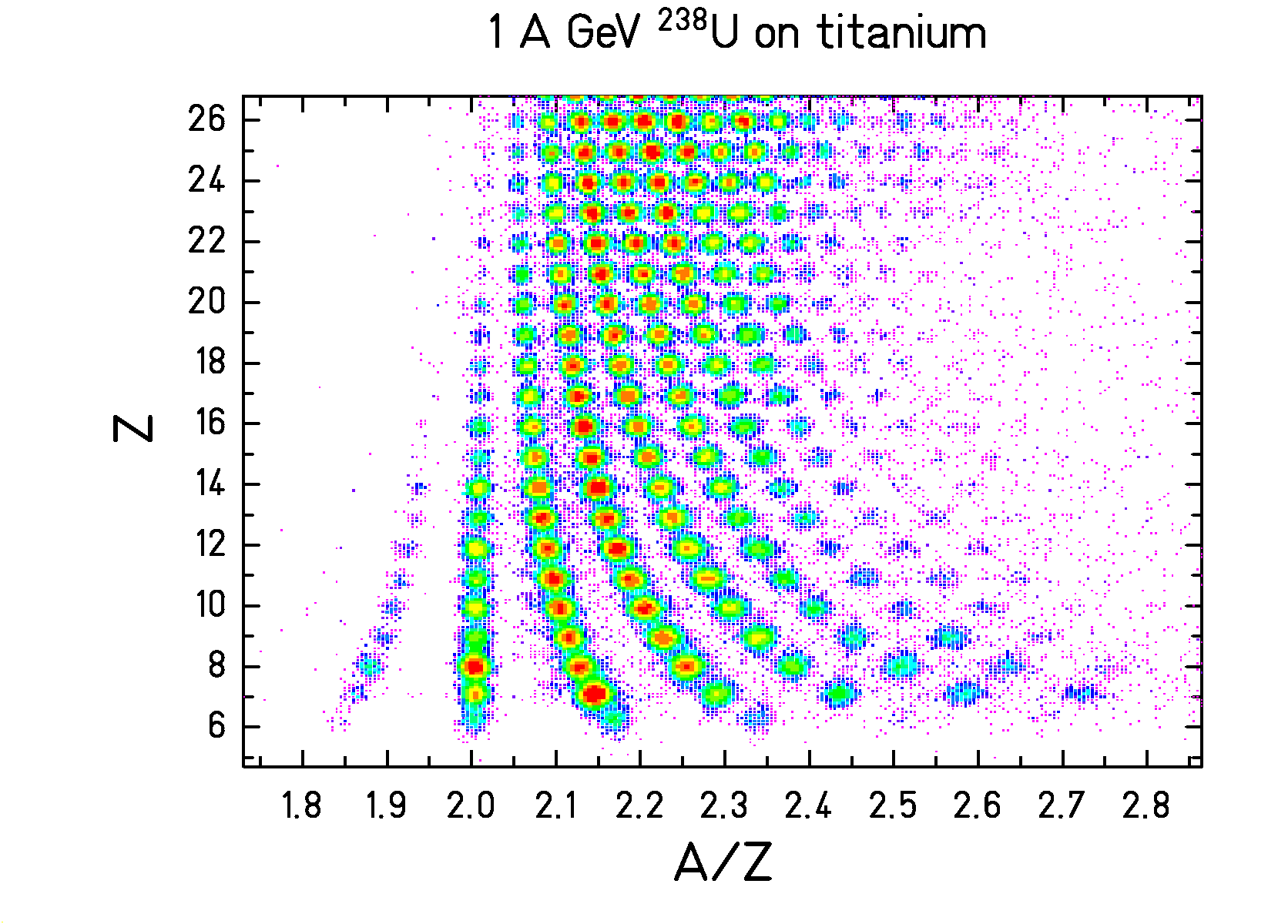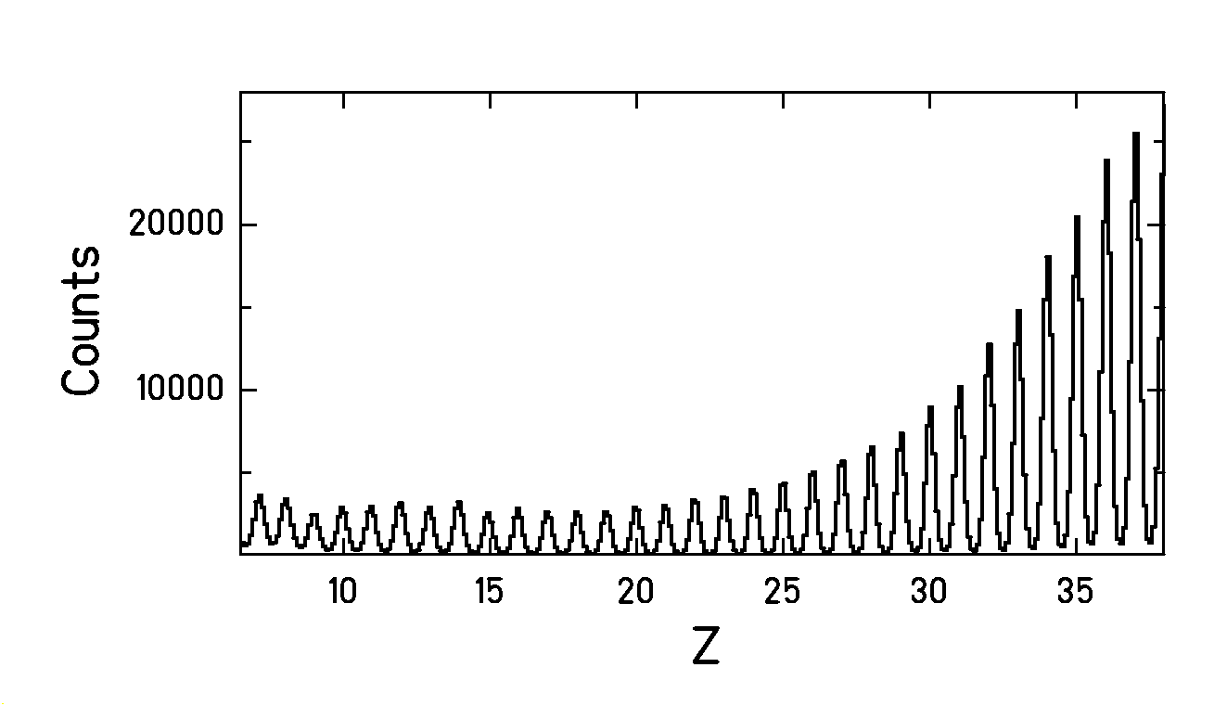
velocity is calculated from Bρ:
$γv=\text{Bρ}\frac{Z⋅e}{A⋅m_{0}}$ very precise evaluation!

DISCRIMINATION OF FISSION EVENTS

From electromagnetic-induced fission
to fragmentation of ²³⁸U
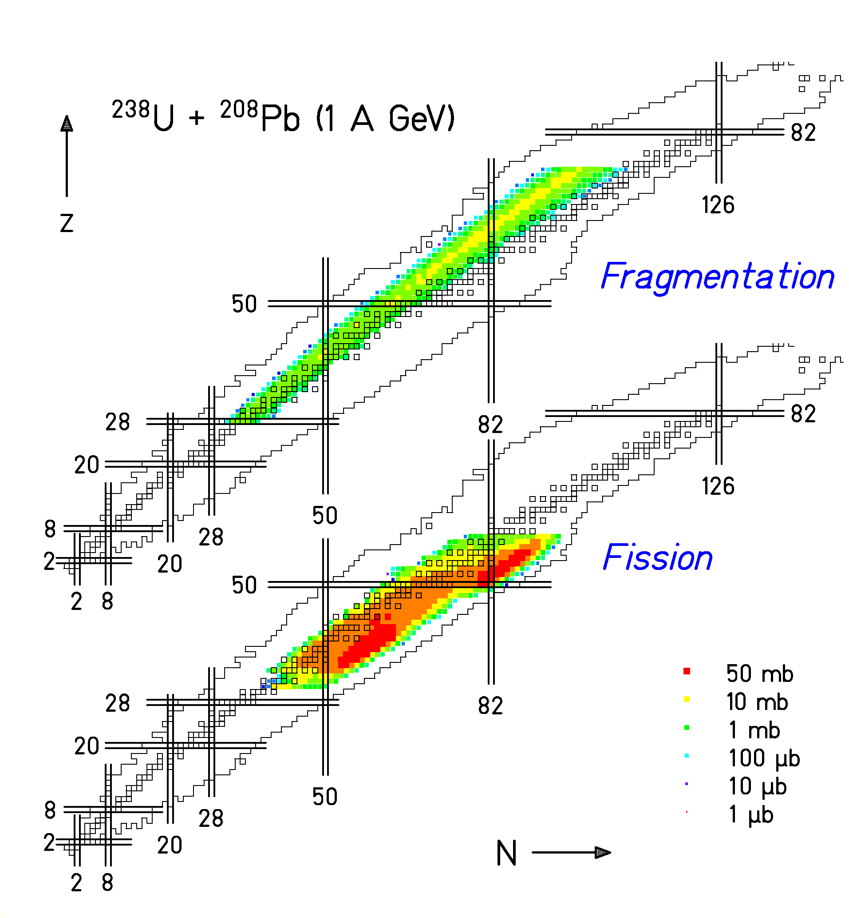

Fission from low and high excitation energies
- Fragmentation in high-energy nuclear collisions
Neutron excess reflects excitation energy induced.
Evaporation leaves traces which can be exploited!
EXPERIMENTAL RESULTS
(fission discharged)
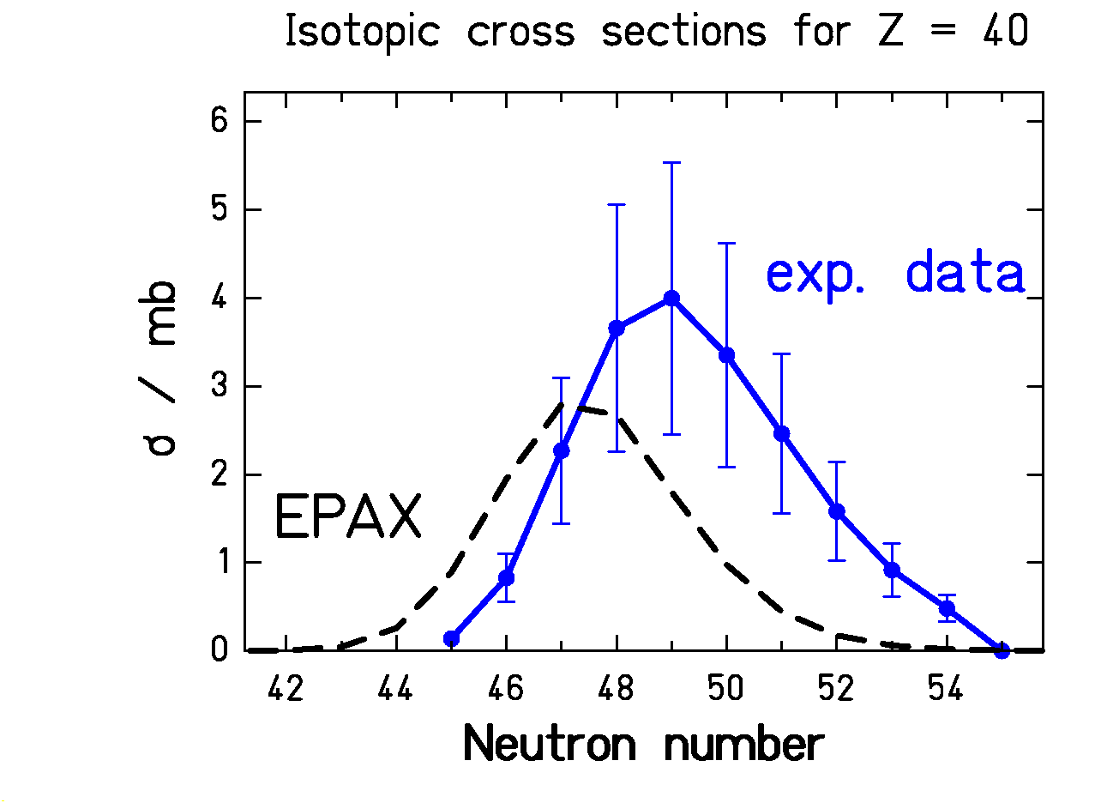
EPAX: a systematics of isotopic cross sections in projectile fragmentation
(K. Sümmerer, B. Blank, Phys. Rev. C (2000) 034607)
EPAX is based on the hypothesis of
limiting fragmentation
Mean N/Z of fragments (fission discharged)
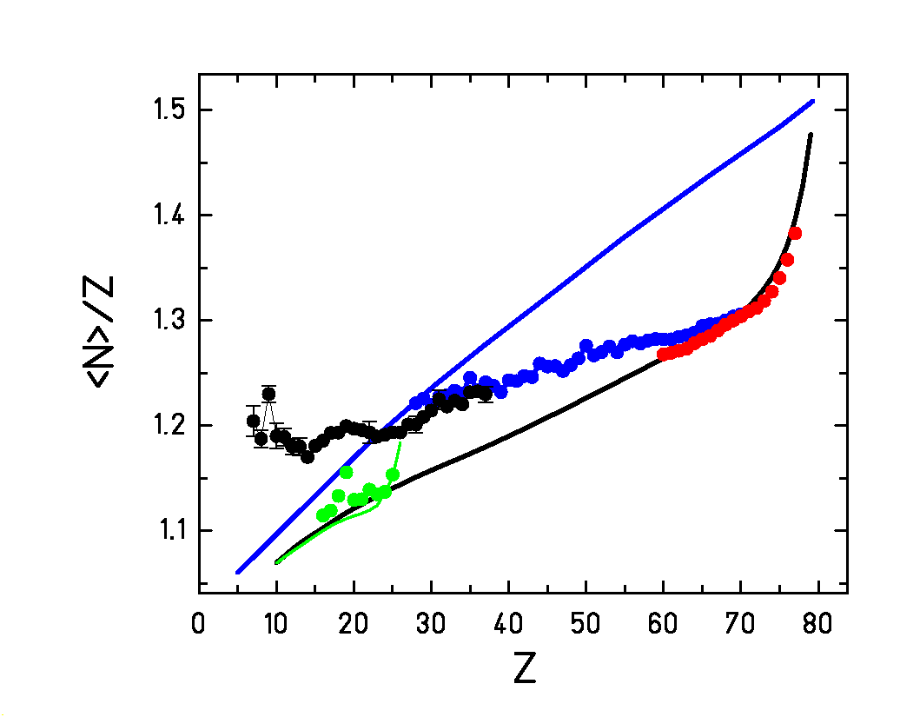
— stability line
— EPAX, projectile = Au
— EPAX, projectile = Fe
● 800 A⋅MeV Au + p - F.Rejmund NPA 683 (2001)
● 414 A⋅MeV Fe + p - W.R.Webber AJ 508 (1998)
- 1000 A⋅MeV U + Pb - T. Enqvist NPA 658 (1999)
- 1000 A⋅MeV U + Ti – this work

Why do some data agree with EPAX
and some deviate?

ABRASION
+
EVAPORATION

SEQUENTIAL DECAY
(EVAPORATION)
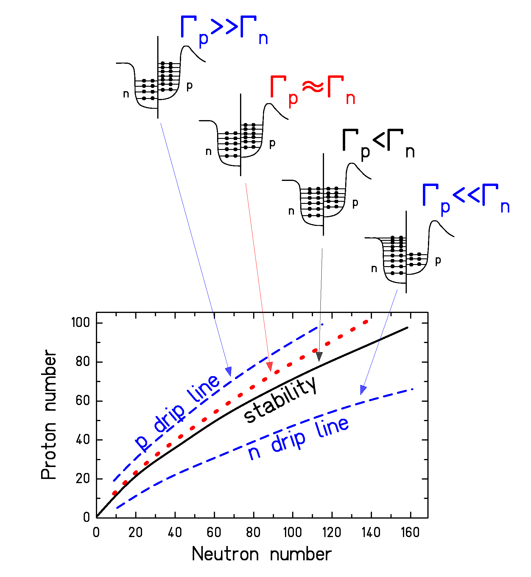
"evaporation corridor"
or
"attractor line"
IDEA BEHIND LIMITING FRAGMENTATION
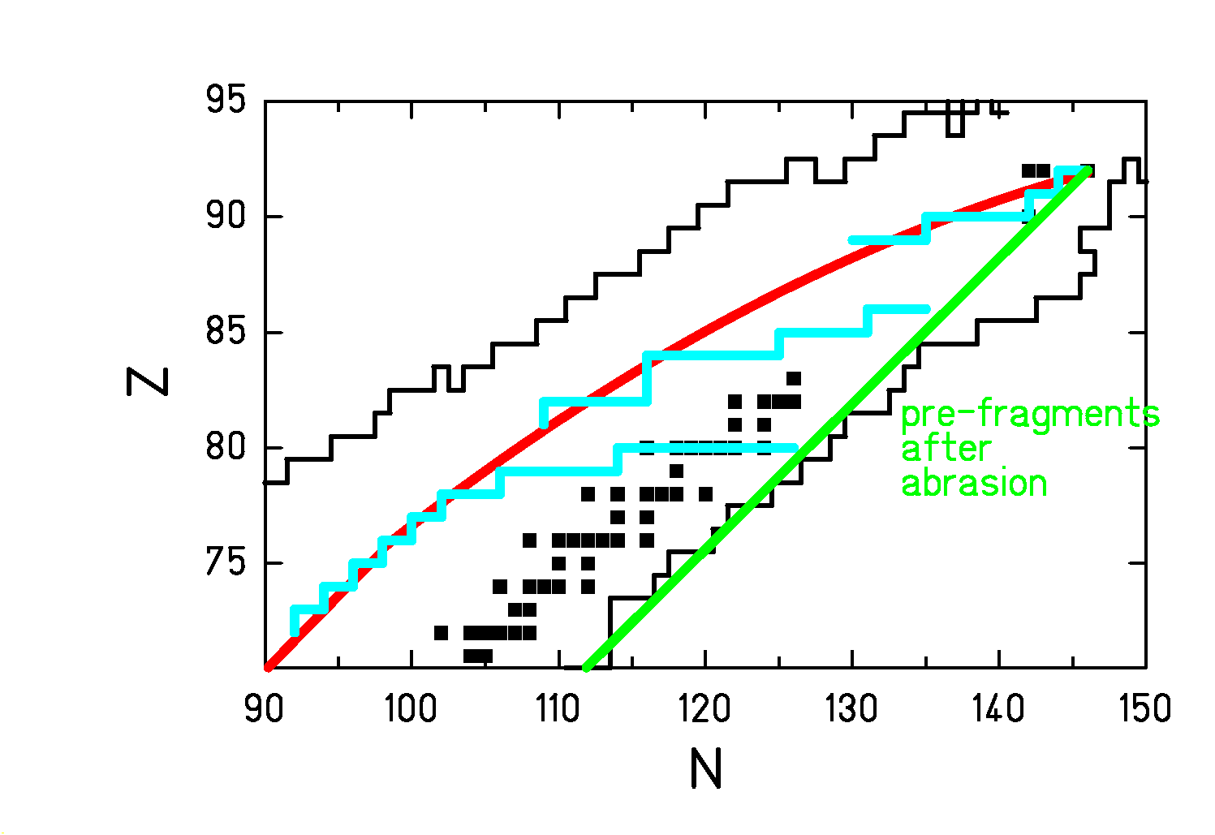

In more violent collisions the evaporation strats at lower excitation energies!
PRINCIPLE OF THE ISOSPIN THERMOMETER

Simplifying hypothesises:
- only n-evaporation
- 15 MeV consumed for every evaporated n
- the evaporation stops when <N_{final}>/Z = 1.25
ABRASION
+
SIMULTANEOUS BREAK-UP
+
EVAPORATION
COMPARISON WITH A THREE-STAGE MODEL

ABRASION / (BREAK-UP) / EVAPORATION

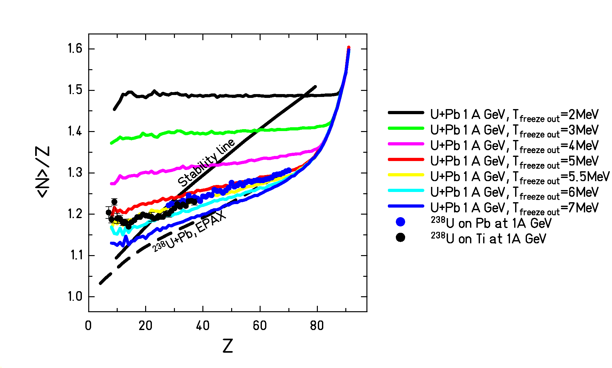
COMPARISON WITH SMM CALCULATIONS

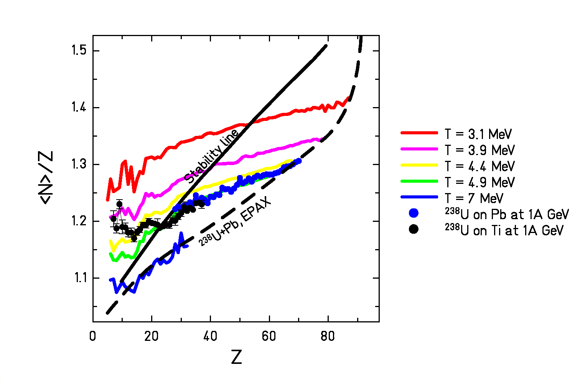
A SHARP CONSTANT TEMPERATURE?
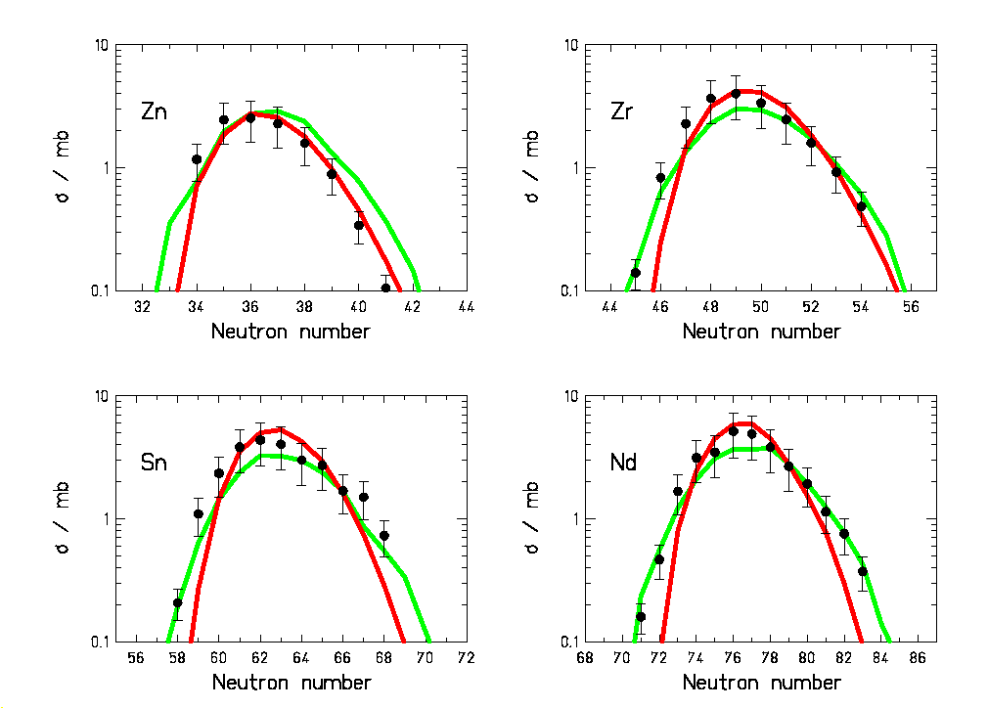
Experimental data
Three-stage model
SMM (arbitray normalised)

- no indications for important fluctuations in temperature

POSSIBLE SCENARIO OF MID-PERIPHERAL HIGH-ENERGY NUCLEUS-NUCLEUS COLLISIONS

IMFs
CONCLUSIONS

 Heavy residues produced in collisions of ²³⁸U with titanium and lead at 1⋅A GeV are unexpectedly neutron-rich

 The <N>/Z-ratio is an interesting quantity also for heavy masses produced in fragmentation

 Isotopic distributions of residual elements from neutron-rich projectile are sensitive to a simultaneous-emission phase

 The mean N/Z-ratio of the final elements can be used in combination with statistical-model codes in order to deduce the freeze-out temperature after break up (“isospin thermometer”)

 The average temperature of the break-up configuration at freeze out is T ≈ 5 MeV

 consequence: an equilibrated compound nucleus cannot exist above a limiting temperature of 5 MeV (EPAX is valid for T < 5MeV)

