The saddle clock as a tool for

dissipation studies in fission

Ch. SCHMITT, GSI, Darmstadt

What is the strength  of nuclear dissipation ?

 nuclide production for secondary-beam facilities
 survival of super heavy elements

OUR SCHEDULE:

✓ How does dissipation influence the evolution
of the system?

✓ The saddle clock concept:
suited experimental conditions and observables

✓ What is the motivation of such a study?

✓ Experimental set-up

✓ Dynamical ABRABLA* code

✓ Clear signatures of nuclear dissipation

✓ Data versus calculations: what can we learn?

✓ Conclusion and Outlook
HOW DOES DISSIPATION AFFECT THE DYNAMICAL EVOLUTION OF A NUCLEUS?

- Theoretical point of view

⇒ Equation of motion along the deformation path:
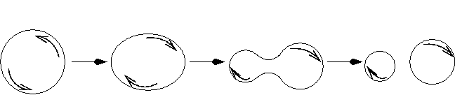
ground state scission

- Langevin: individual trajectory ‘step by step’
$\frac{\text{dq}}{\text{dt}}=\frac{p}{M(q)}$
$$\frac{\text{dp}}{\text{dt}}=\frac{1}{2}{\left(\frac{p}{M(q)}\right)}^{2}\frac{∂M(q)}{∂q}−\frac{∂V}{∂q} −β(q)p+\sqrt{β(q)/M(q)T}Γ_{L}(t)$$

- Fokker-Planck: probability distribution W(q,p;t)
$$\frac{∂}{∂t}W\left(q,p;t\right)=\left[−\frac{∂}{∂q}\frac{p}{M(q)}+\frac{∂}{∂p}\left(\frac{∂V}{∂q}+β(q)p\right)+\frac{∂^{2}}{∂p^{2}}β(q)/M(q)T\right]W(q,p;t)$$

 Fission decay width: $Γ_{f}(t)=$$ℏ\frac{\int_{−∞}^{+∞}{p⋅W(q_{b},p;t)\text{dp}}}{\int_{−∞}^{+q_{b}}{\text{dq}\int_{−∞}^{+∞}{W(q,p;t)\text{dp}}}}$

(NB: equation of motion coupled to Master equations for particle emission)
⇒ Solution of the equation of motion for _{f} (t):
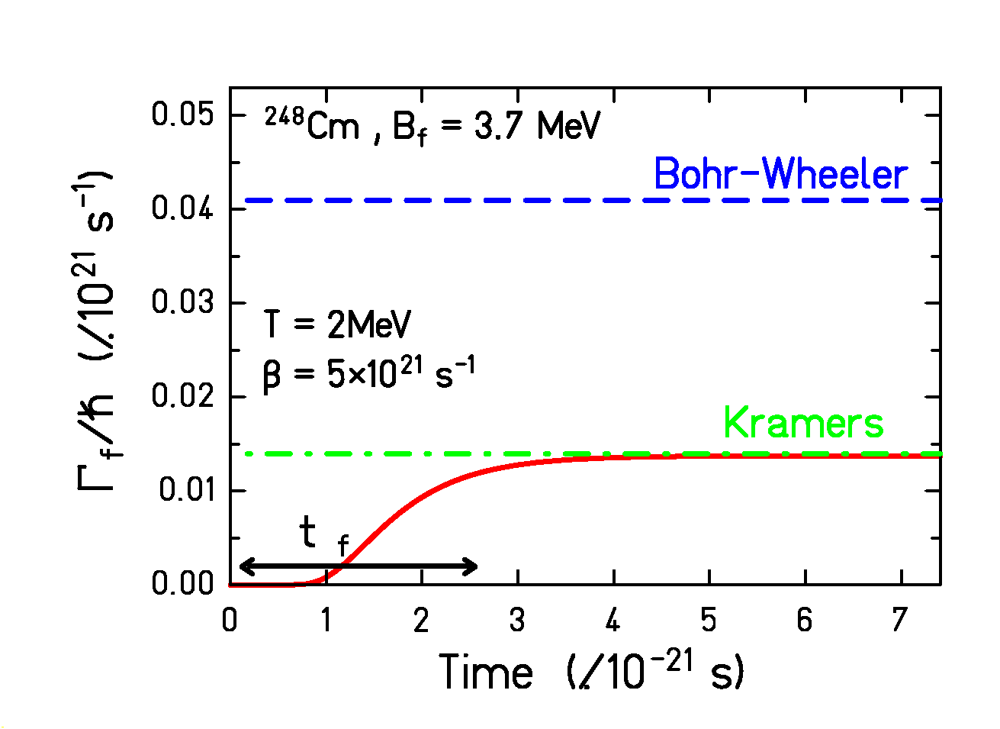

Nuclear dissipation slows the nucleus down
←
- effects of dissipation:
 reduction of the BW prediction  Kramers’ factor
 delay of fission  transient time _{f}

Short sequence of the story:
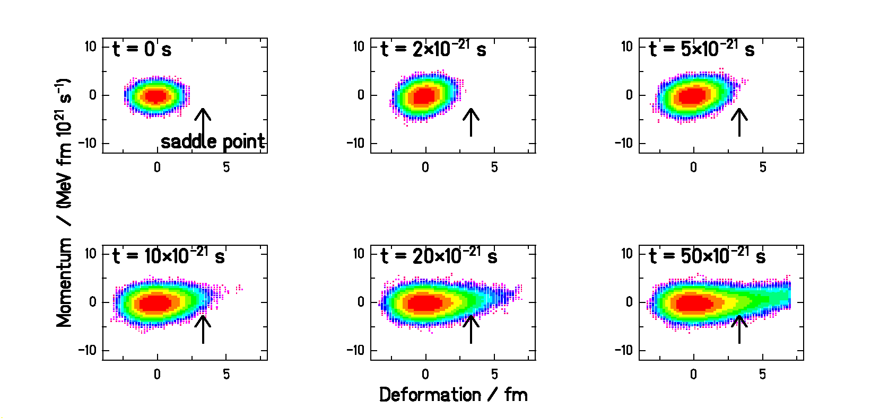
HOW DOES DISSIPATION AFFECT THE DYNAMICAL EVOLUTION OF A NUCLEUS?

- Experimental point of view

dissipation  delay of fission  more particle emitted

✓ cooling down of the remaining nucleus
 ✓ change of the fission properties: B_{f ,} Z²/A…
✓ increase of the particle multiplicities
✓ decrease of the fission cross section

Experimental signatures used previously to estimate  :

✓ fission and evaporation residue cross sections
✓ n, LCP and -rays pre-scission multiplicities

Particle clock as the tool to study dynamics

Results? … rather unclear in fact …

• deformation dependence ?
• temperature dependence ?
• complex side effects (L, deformation, …)
HOW TO GO FURTHER?

Starting point: in average, from the ground state up to scission
dissipation is rather large (10.10²¹s⁻¹)

Fröbrich and Gontchar (Phys.Rep.292, 1998)
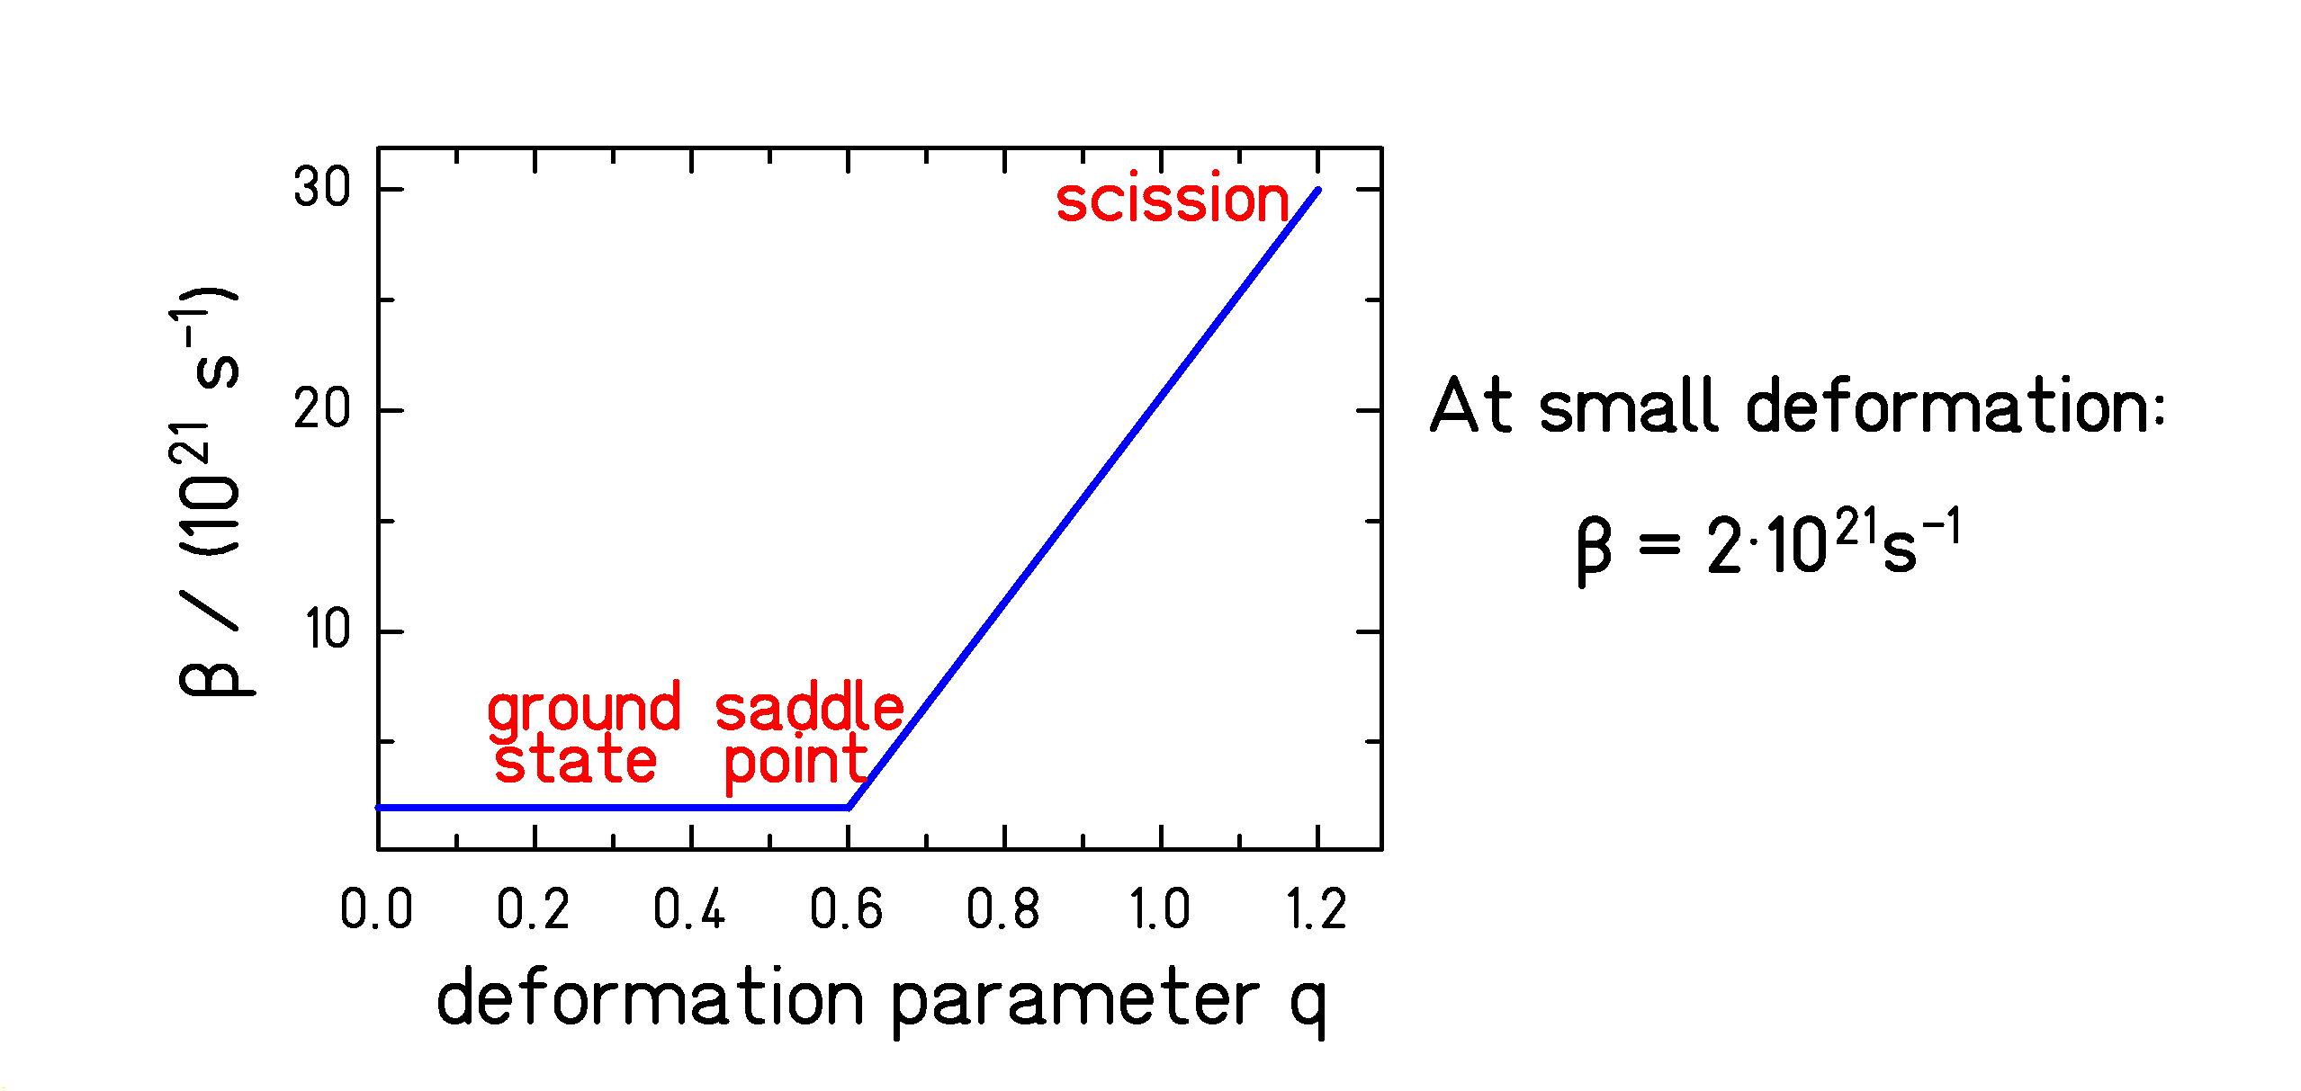

Study in the small deformation range  saddle clock!

_{saddle}  pre-saddle particle multiplicity
←
_{saddle}  E* at the saddle point
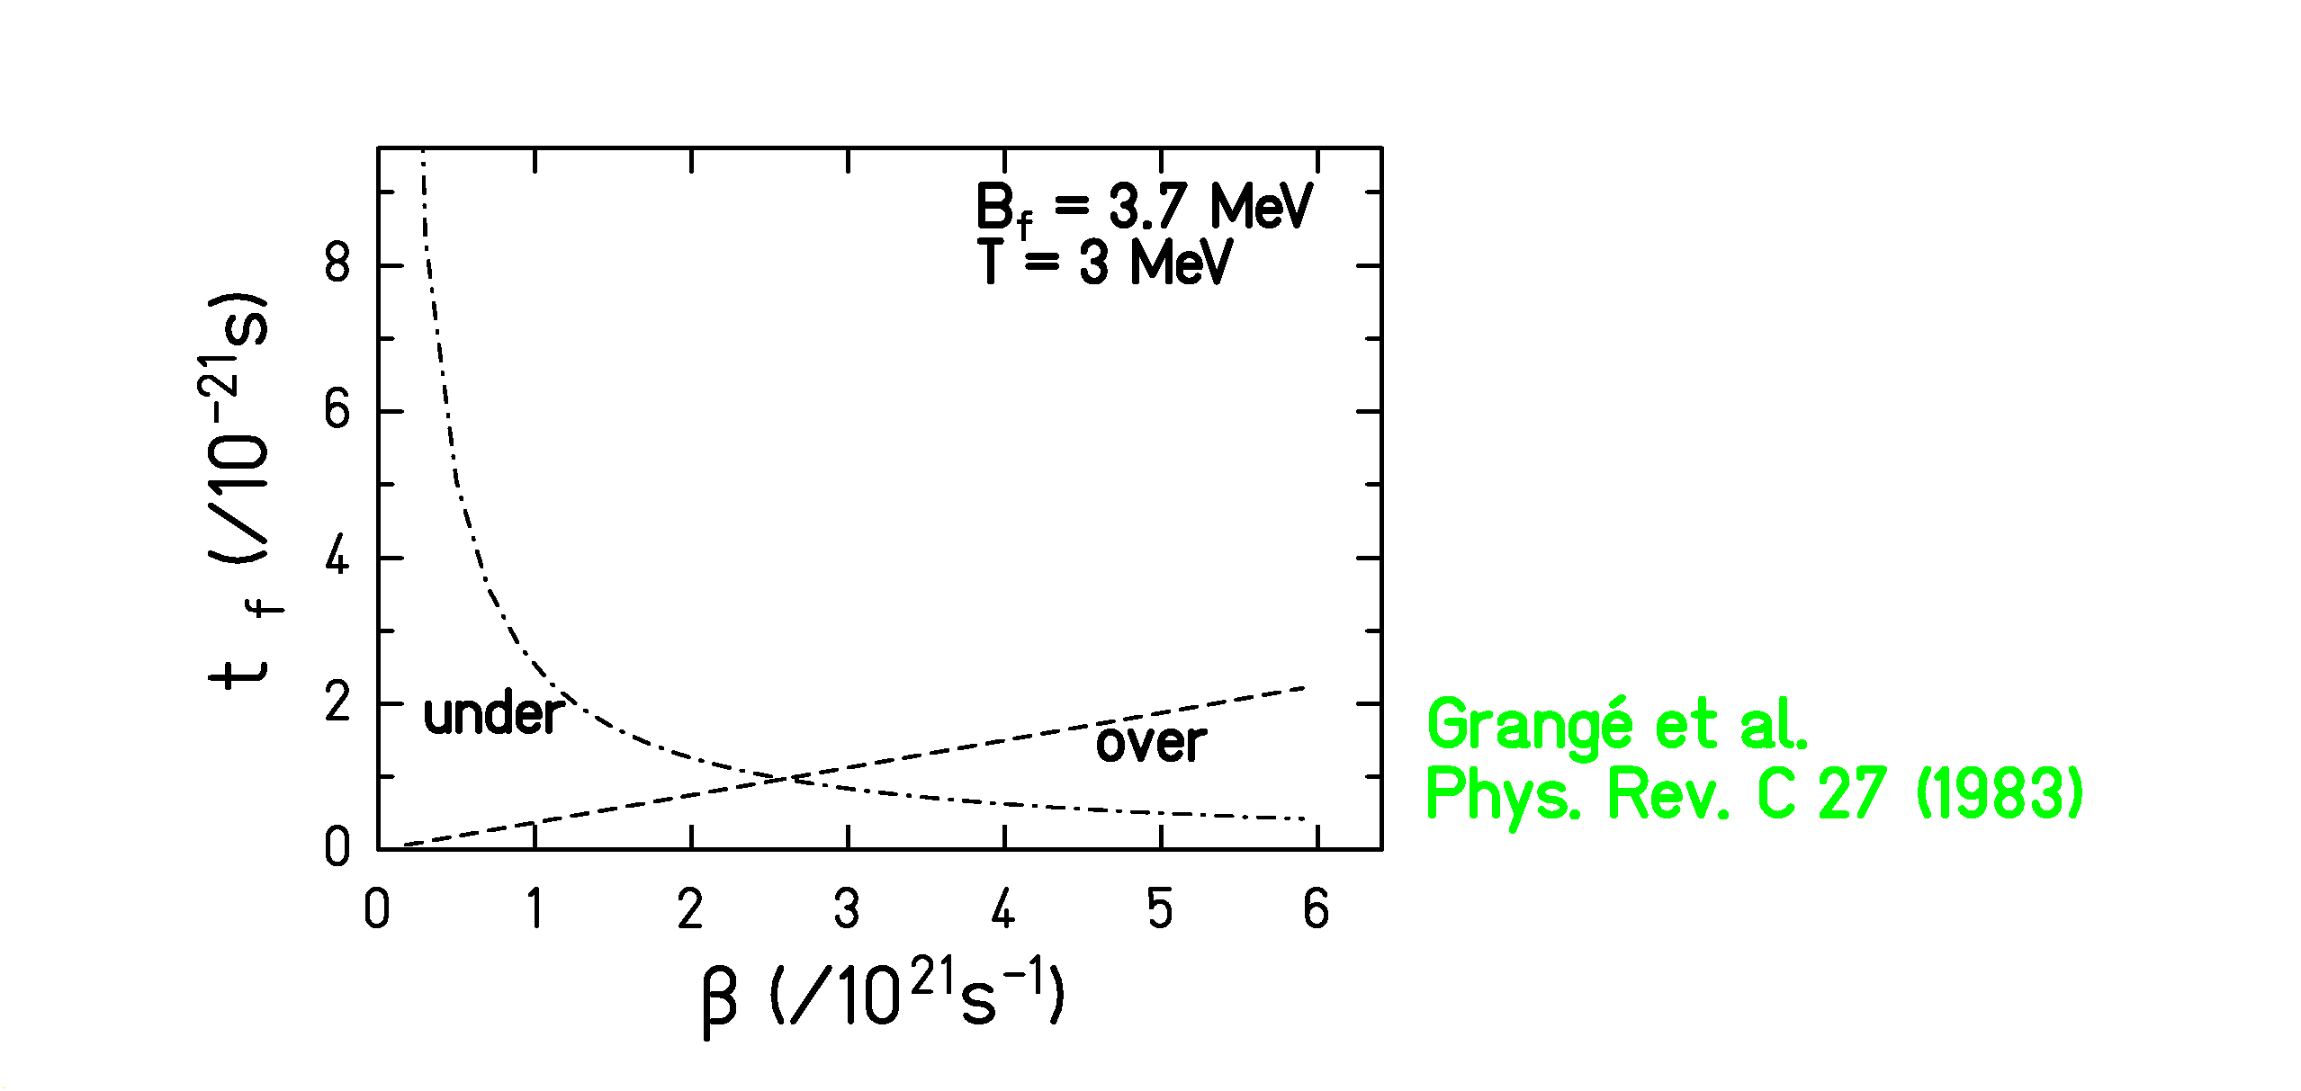
⇒ Fast clock: _{part} ~ _{f}
⇒ Reaction at high excitation energy (~250-300MeV)
MOTIVATIONS

Dissipation effects as shown up in spallation

full nuclide production (fragmentation+fission)

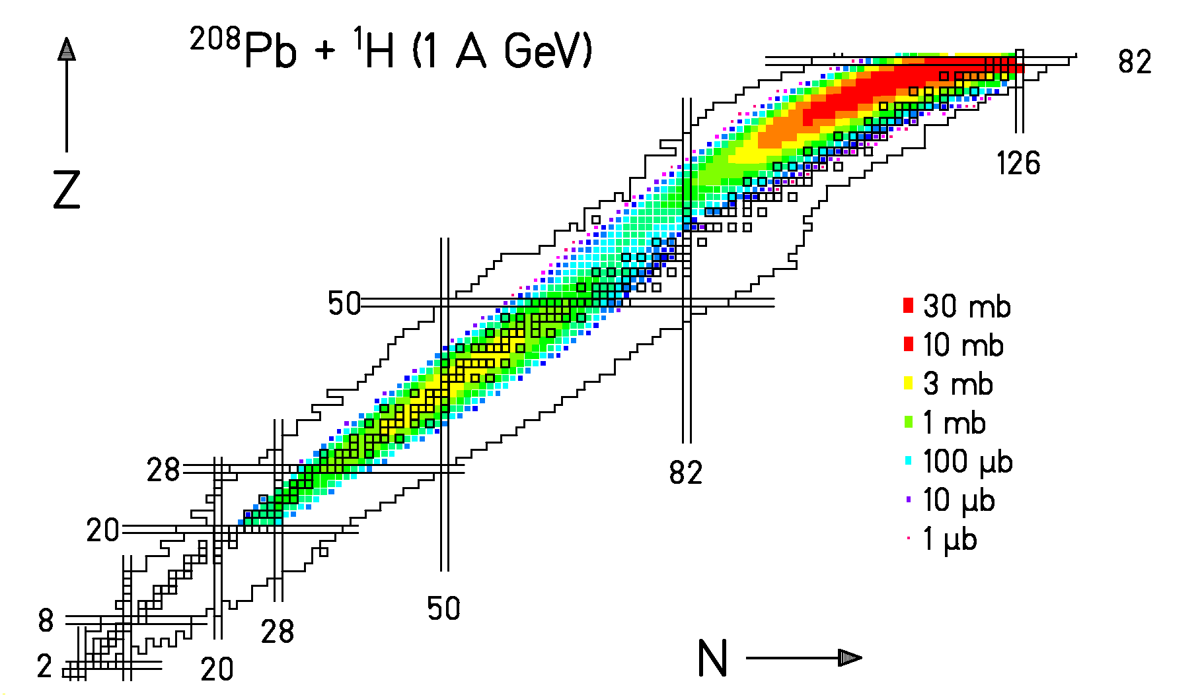

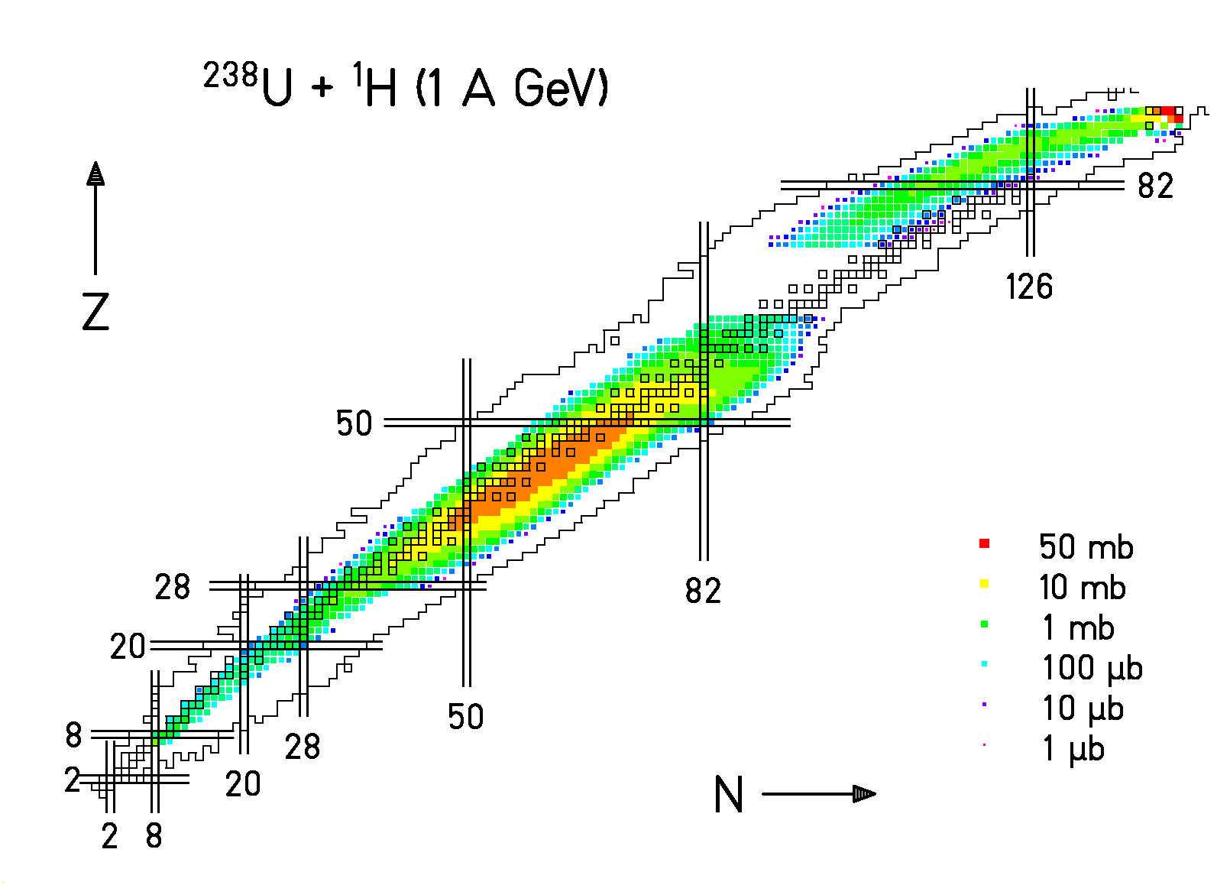

(Data analysed by M. Bernas, E. Casarejos, T. Enqvist, J. Pereira,
M. V. Ricciardi, J. Taieb, W. Wlazlo)
MOTIVATIONS

Dissipation effects as shown up in spallation

fragmentation residue production
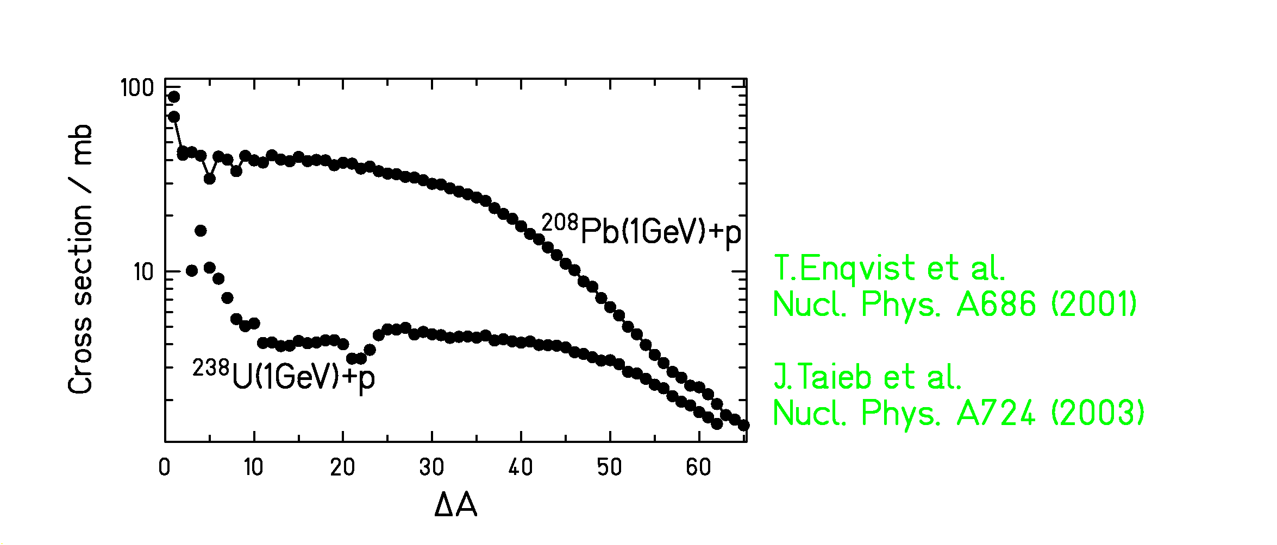

✓ nuclei between U and Pb do not survive due to high fissility
✓ the U curve joins the Pb curve for larger mass losses

⇒ clear proof that fission is hindered at high E*

MOTIVATIONS

Dissipation effects as shown up in spallation

fragmentation residue production
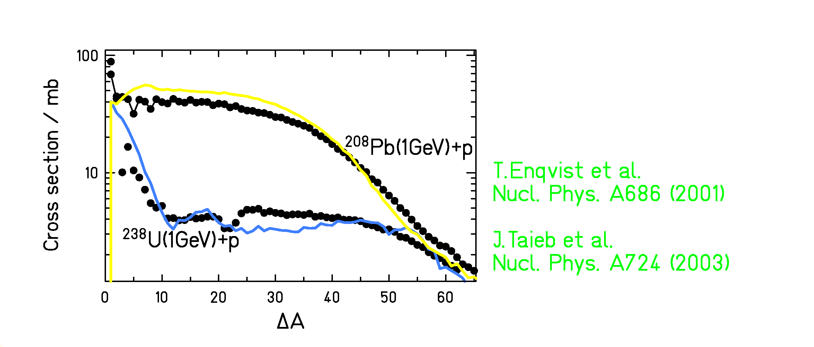

✓ nuclei between U and Pb do not survive due to high fissility
✓ the U curve joins the Pb curve for larger mass losses

⇒ clear proof that fission is hindered at high E*

⇒ how is the ‘gap’ between U and Pb filled ?

MOTIVATIONS

Dissipation effects as shown up in spallation

fragmentation residue production
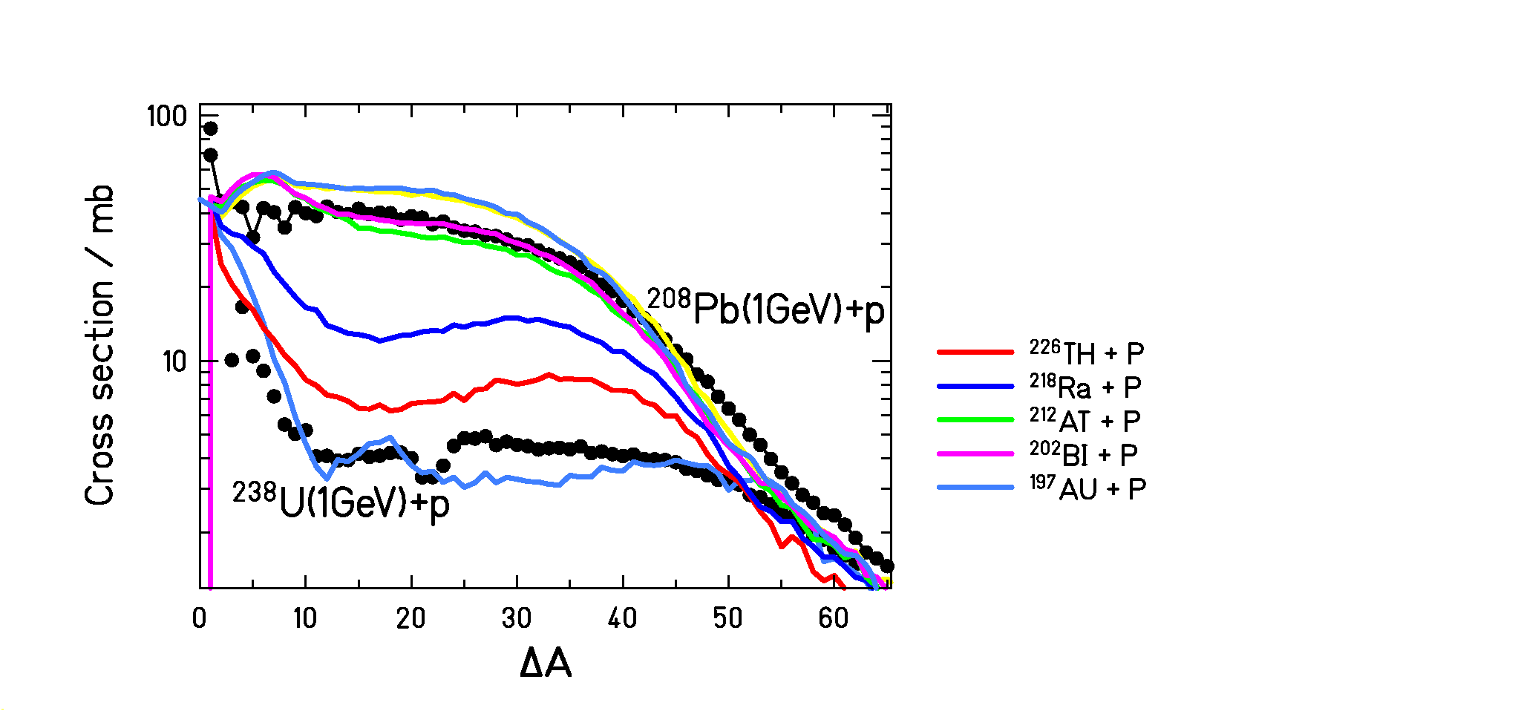

✓ nuclei between U and Pb do not survive due to high fissility
✓ the U curve joins the Pb curve for larger mass losses

⇒ clear proof that fission is hindered at high E*

⇒ what is the gap between U and Pb filled ?

⇒ measurement of more pertinent signatures needed

‘NEW’ EXPERIMENTAL TECHNIQUE

Peripheral heavy-ion collisions at relativistic energy

Advantages:
♠ high excitation energy
♠ small shape distortion
♠ small angular momenta

Set-up: secondary beam experiment

Two stages:
- production and separation of 58 radioactive beams
- set-up dedicated to fission studies
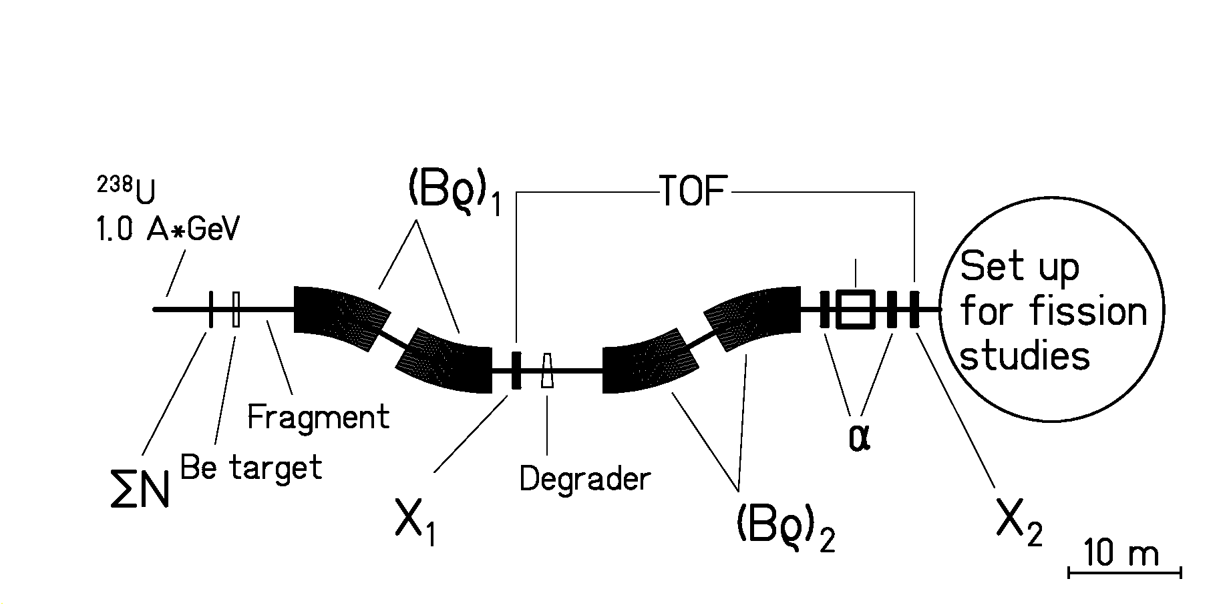

 Study of many fissioning actinides from U to At
at the same time
1st part: production and identification of the secondary beam

Identification in mass and charge:

- from position and Tof: A/Z = $\frac{e}{m_{0}}$$\frac{Bρ}{v⋅\sqrt{{\left[1−{\left(v/c\right)}^{2}\right]}^{−1}}}$

- from degrader: Z ²  E

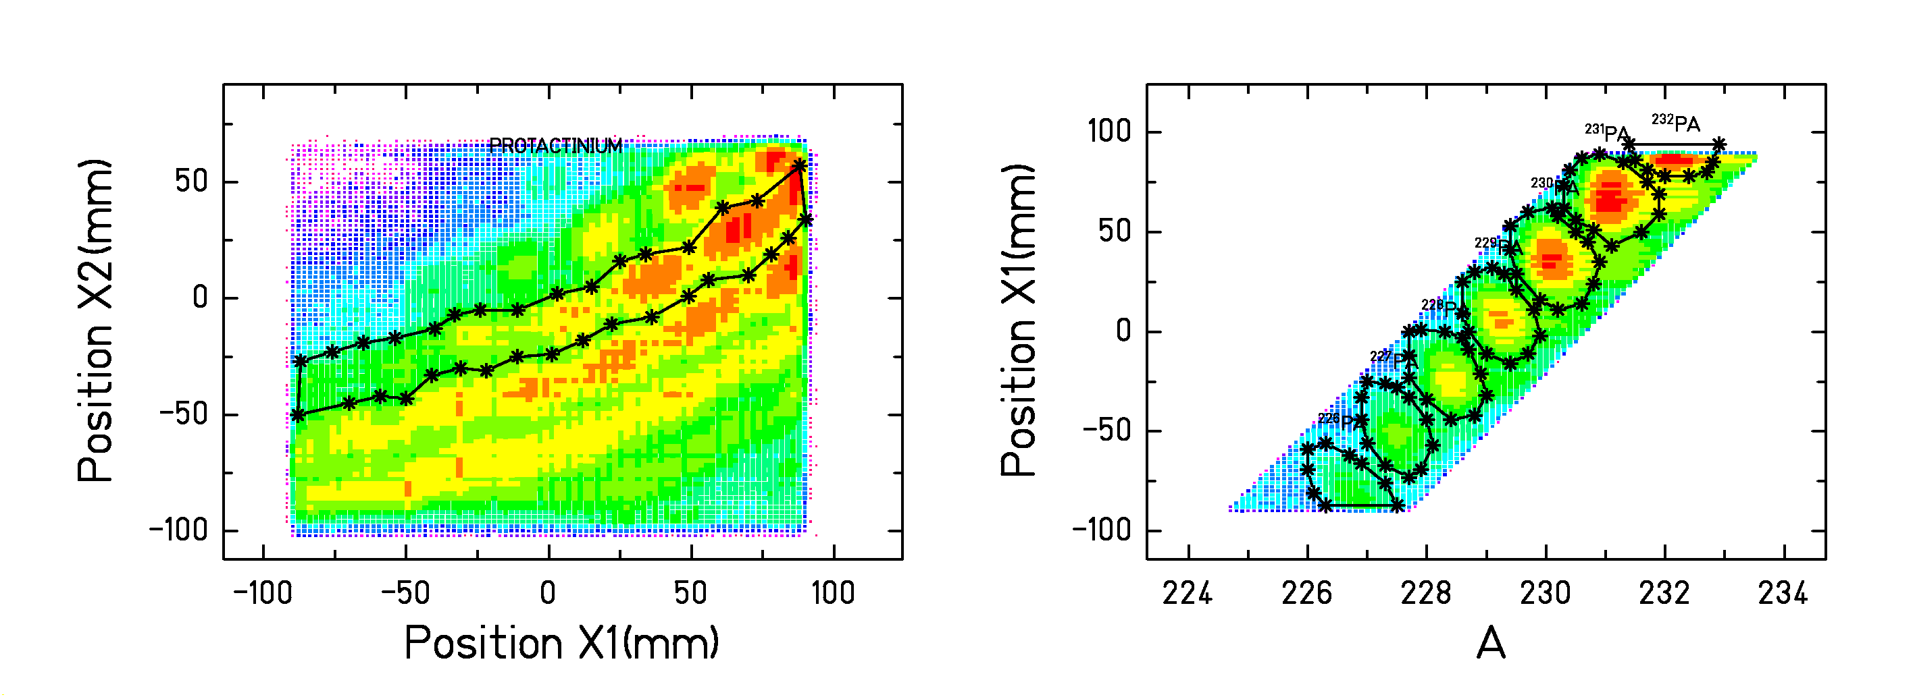
2nd part: identification of both fission fragments
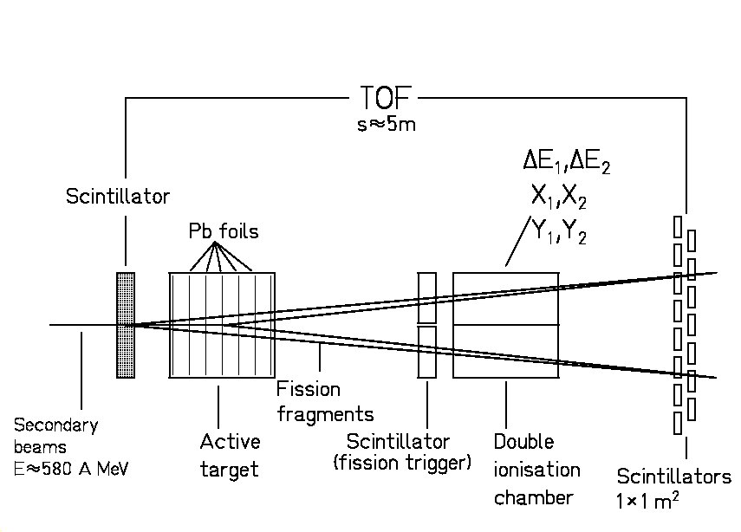

Active Pb target:
 Coulomb excitation: low energy fission
 nuclear induced fragmentation: high energy fission

Double Ionisation Chamber:
 identification of both fragments Z₁ and Z₂ (Z~0.4)
 charge of the fissioning element Z_{SUM} ~ Z₁+Z₂

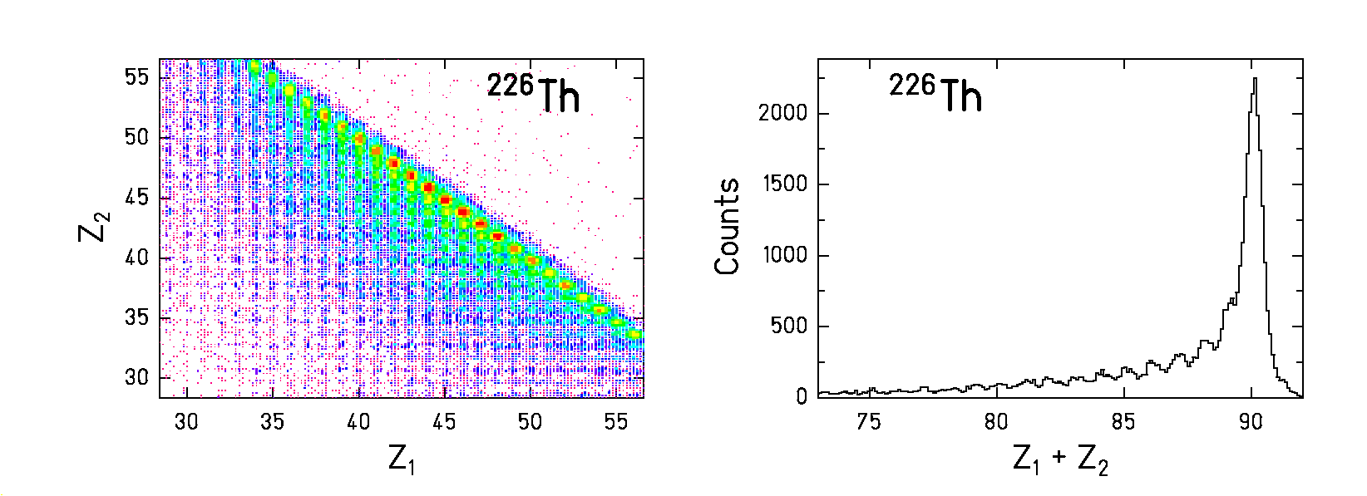

(NB: data corrected for secondary reactions between the target and DIC)
MODEL CALCULATIONS

- How to model dissipation in fission?

Langevin or FP approach: high computing time!
←
Evaporation code:

competition between different decay channels governed by the widths _{f} and _{part}

Delay of fission caused by dissipation 

Realistic code requires a time-dependent fission decay width _{f} (t)

 dynamical reaction code

How to get _{f} (t) ?

- exact expression from Langevin or FP solution
- analytical reliable approximation
MODEL CALCULATIONS

2. Analytical approximation of the time-dependent fission decay width _{f} (t)

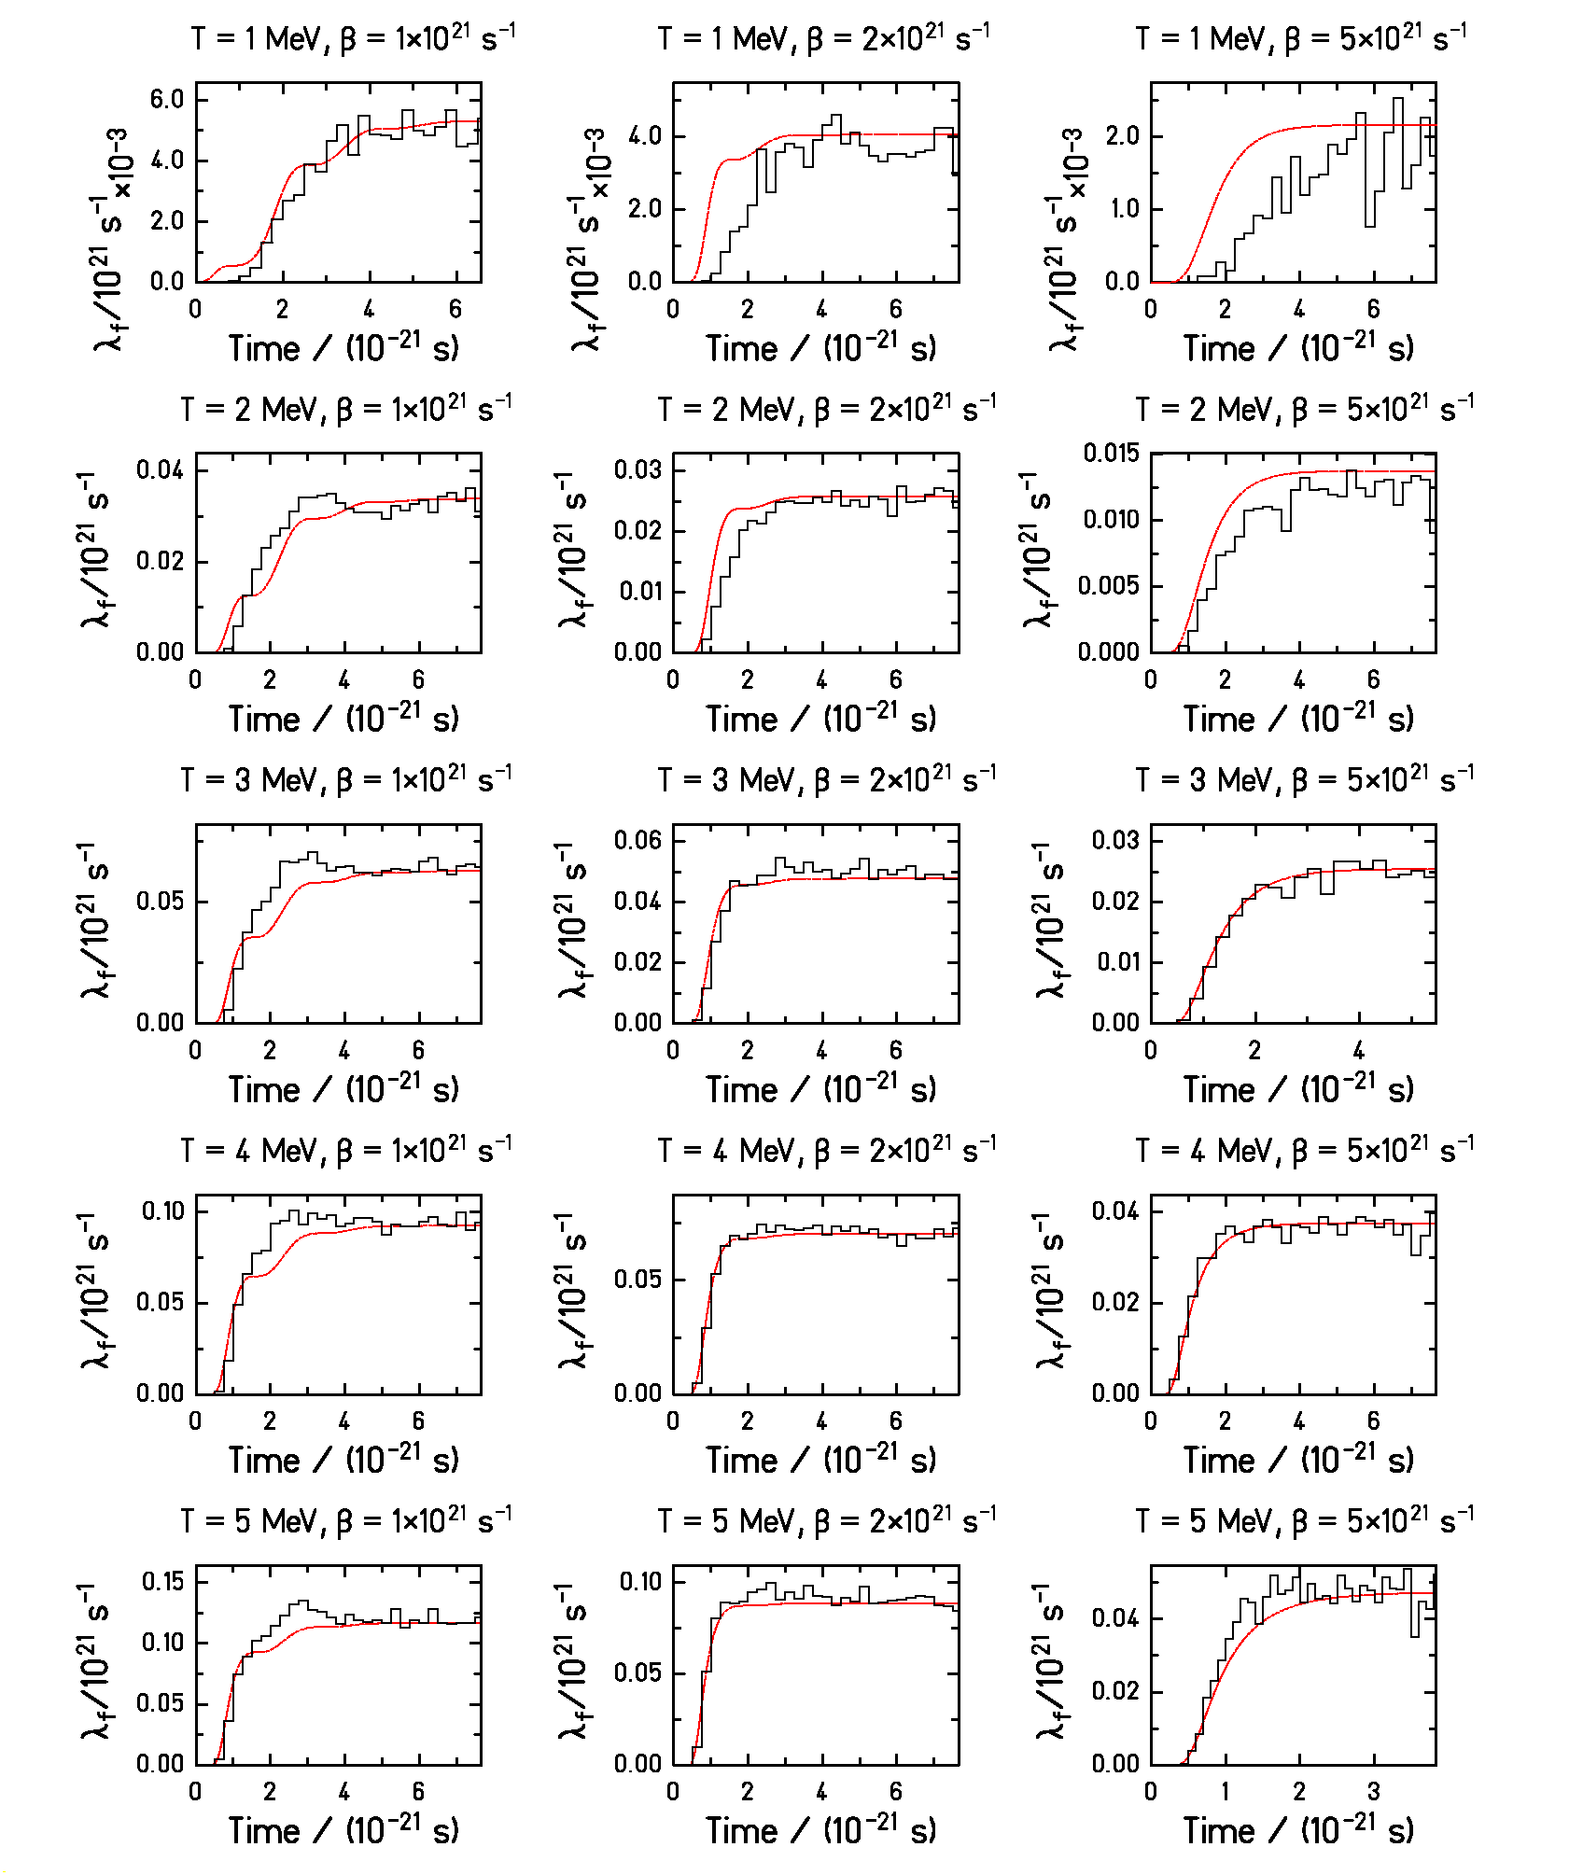
B.Jurado et al., Phys. Lett. B553 (2003)
 fastly calculable analytical expression for _{f} (t)
which can be easily plugged in an evaporation code
MODEL CALCULATIONS

3. Abrabla with _{f} (t)

Prefragment
Equilibrated nucleus
Fission

3 STEP-MODEL:

  - abrasion:

participation of projectile-target overlapping zone only
 <N>/Z ratio conserved
 ~27 MeV of E* induced per nucleon abraded

  - simultaneous break-up:

emission of LCP and clusters for T_{after abrasion} > 5 MeV
 <N>/Z ratio conserved
 T constant

  - competition evaporation-fission:

 Weisskopf theory for _{part}
 realistic analytical approximation for _{f} (t)
CONFRONTATION DATA-CALCUTATIONS

 to extract information about the value of 

Key question: Are transient effects observable?

Tool: model calculations with _{K} (no _{f} )
versus
model calculations with _{f} (t) (_{f}  0)

Total fission cross section:
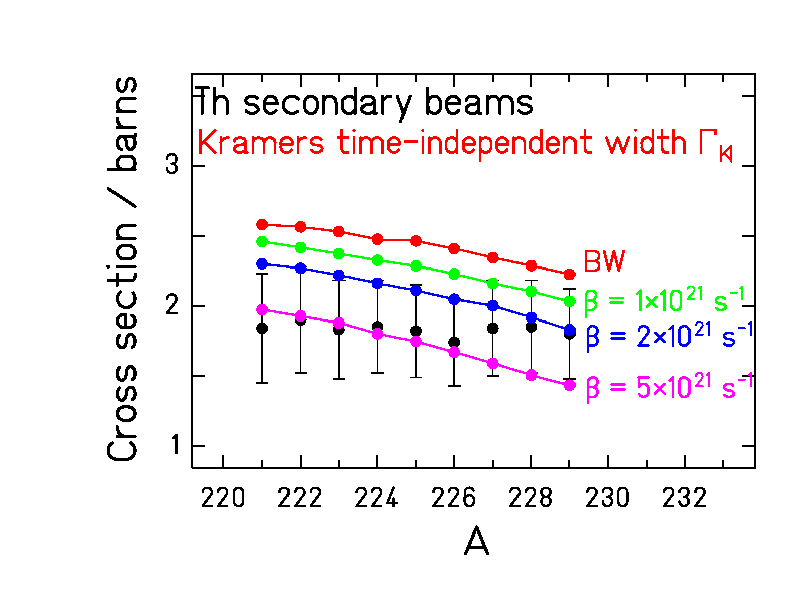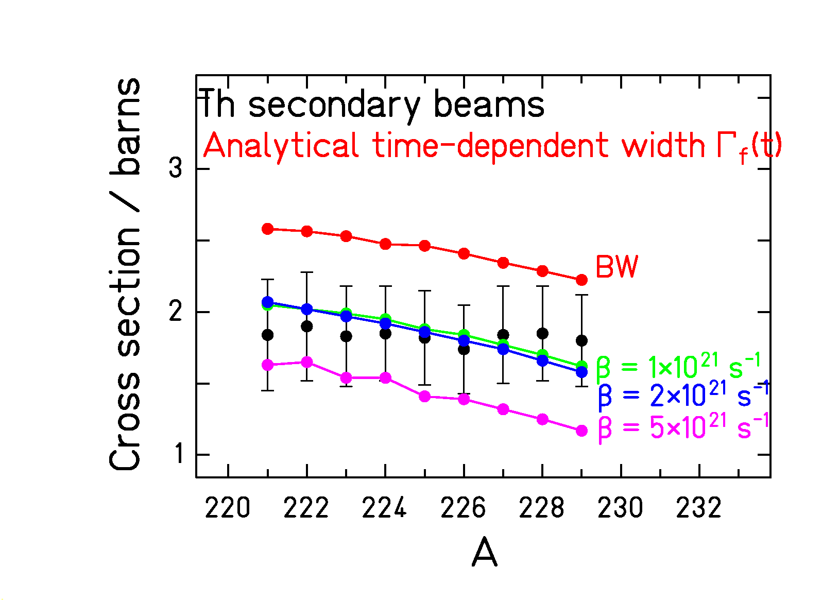

Conclusion:
 BW fails  dissipation is needed
 but no reliable conclusion:
- neither, about the strength  of dissipation
- nor, about the time-dependent shape of _{f}

 Total fission cross sections are not sensitive to
transient effects
NEW SIGNATURES OF TRANSIENT EFFECTS

_{saddle}  E* at the saddle point

- Partial fission cross sections

 neutron evaporation prior saddle modifies the fission properties
(E*_{saddle}, L, Z ²/A, …)
✓ time up to saddle affects the _{fission} for a given fissioning Z

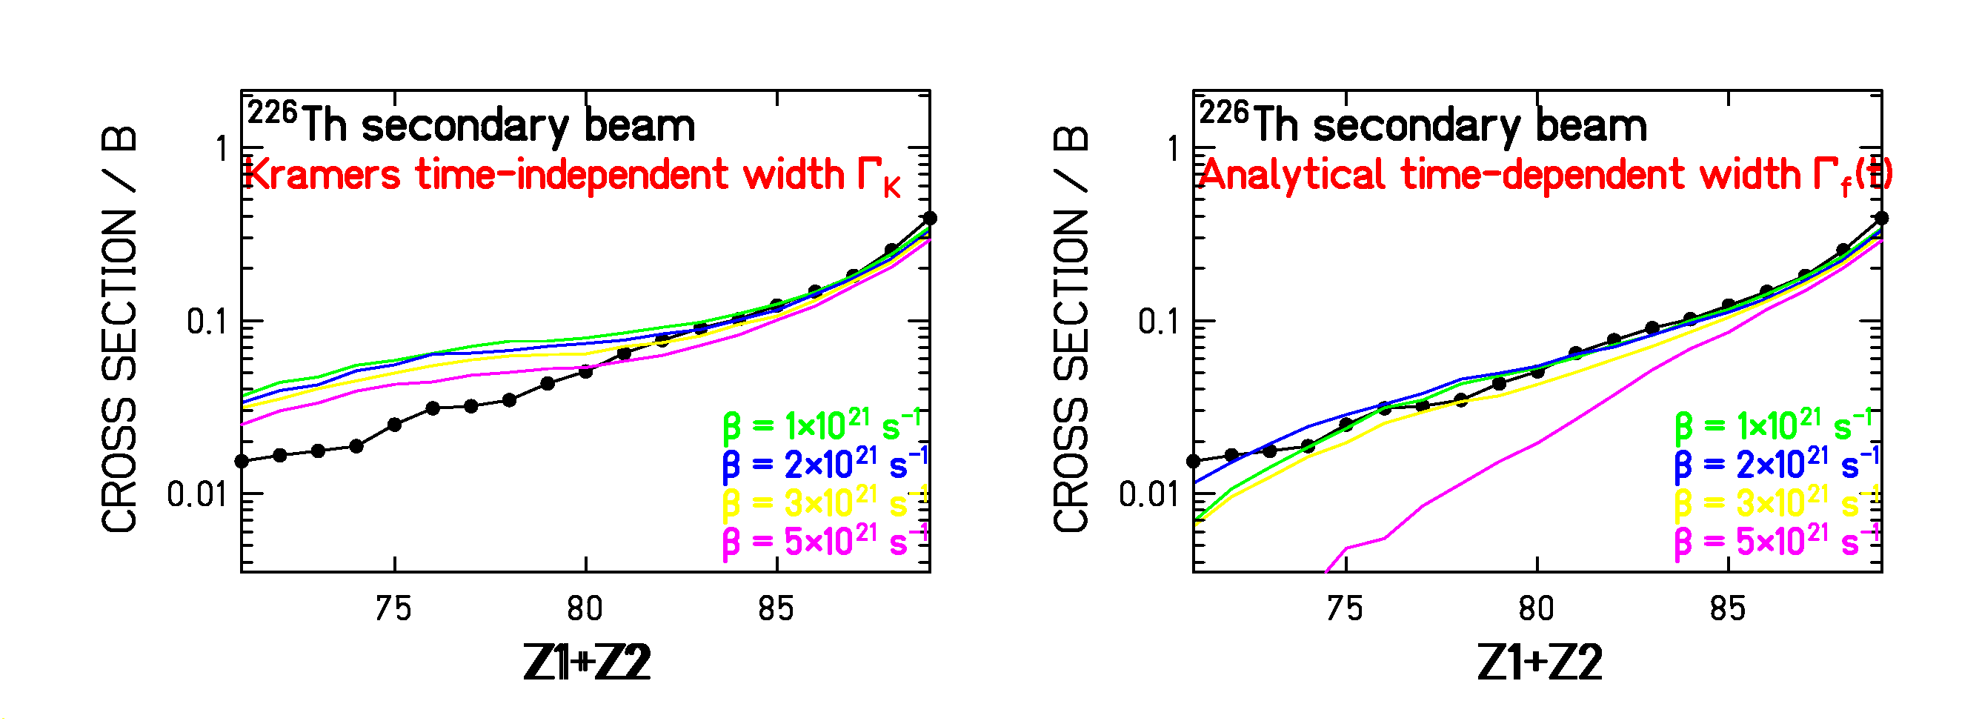
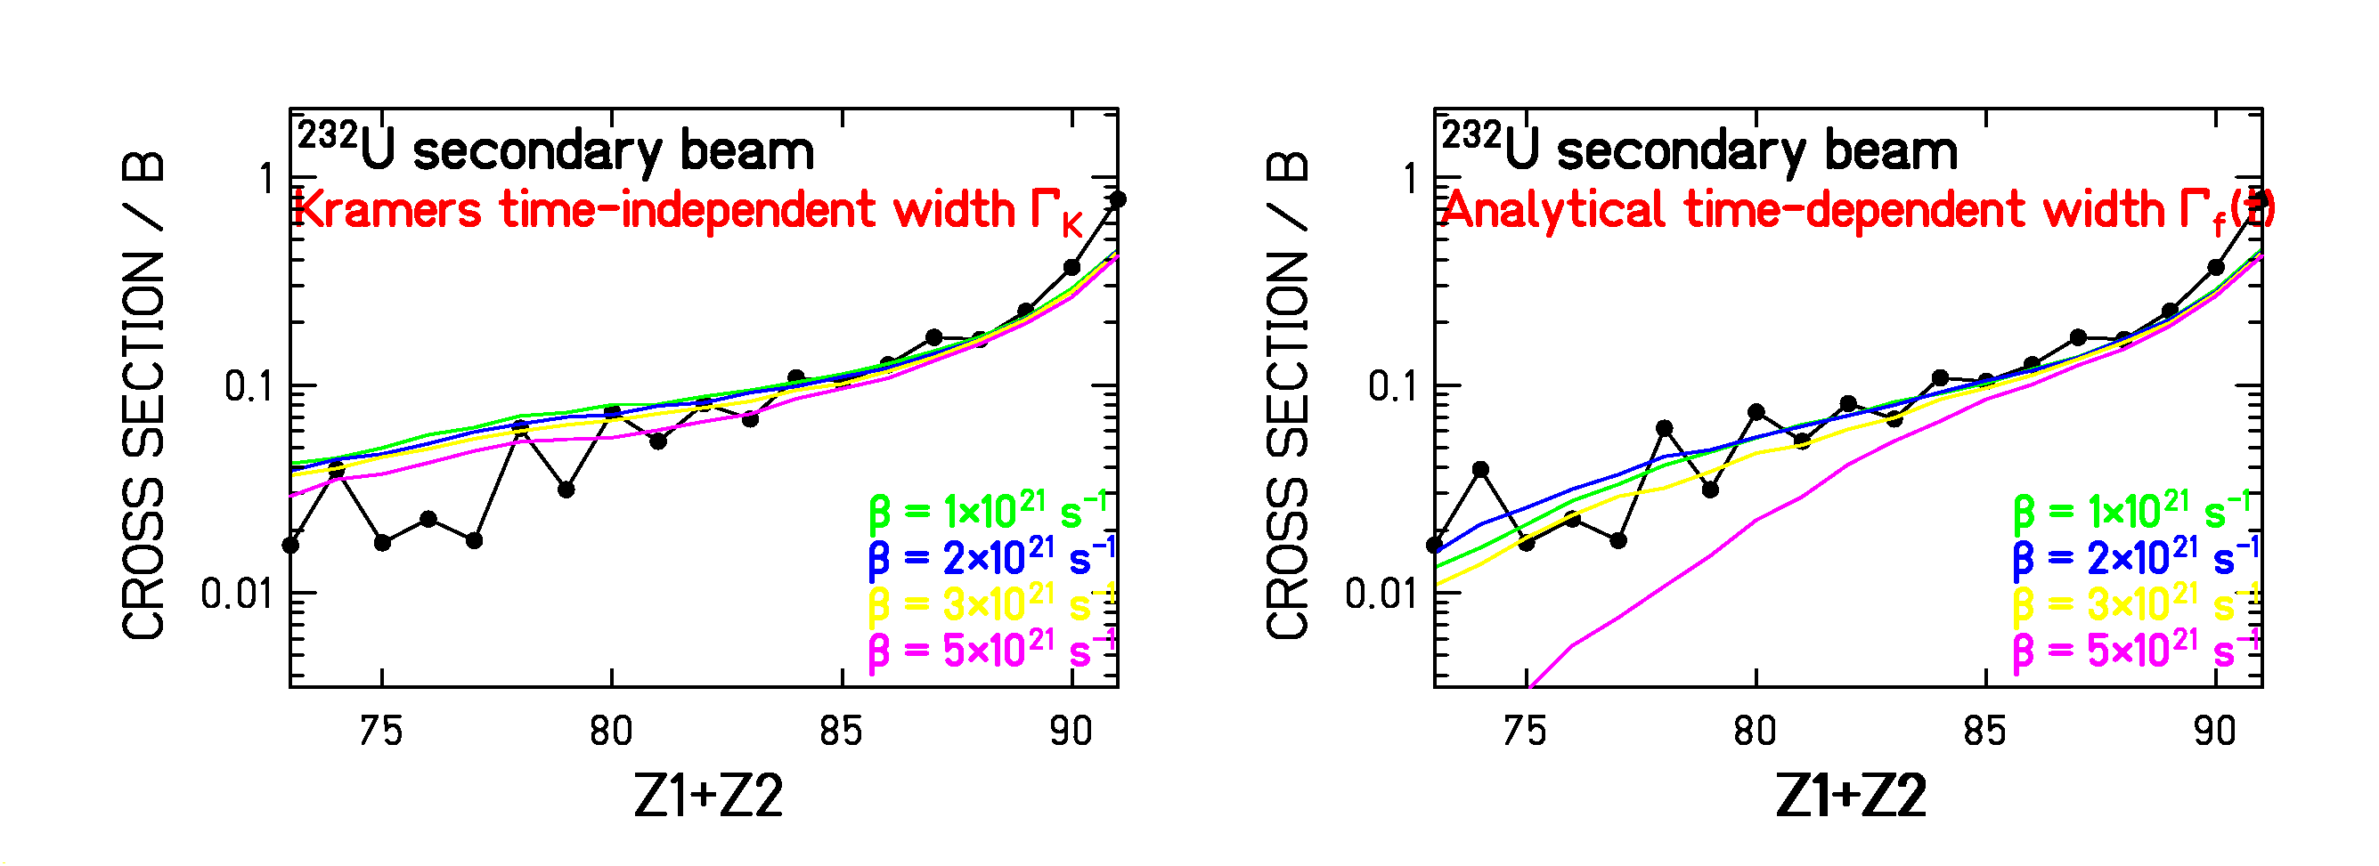

Conclusion: the time-independent width fails  _{f} is observable

 Partial fission cross sections are sensitive to
transient effects
- Fission fragment charge distribution widths

Statistical model + LDM: $σ_{Z}^{2}=T_{\text{saddle}}C_{Z}=\sqrt{{E_{\text{saddle}}^{}}/{a_{f}}}C_{Z}$

✓ the higher E_{saddle}*, the broader the Z distribution of the FF

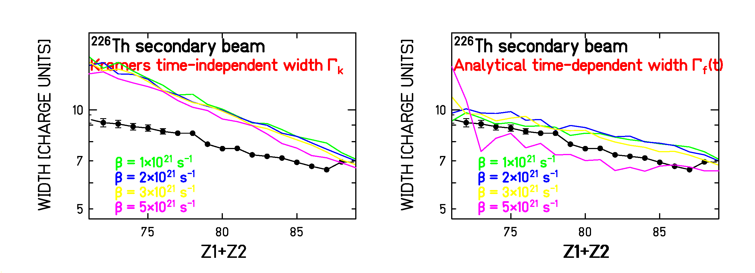

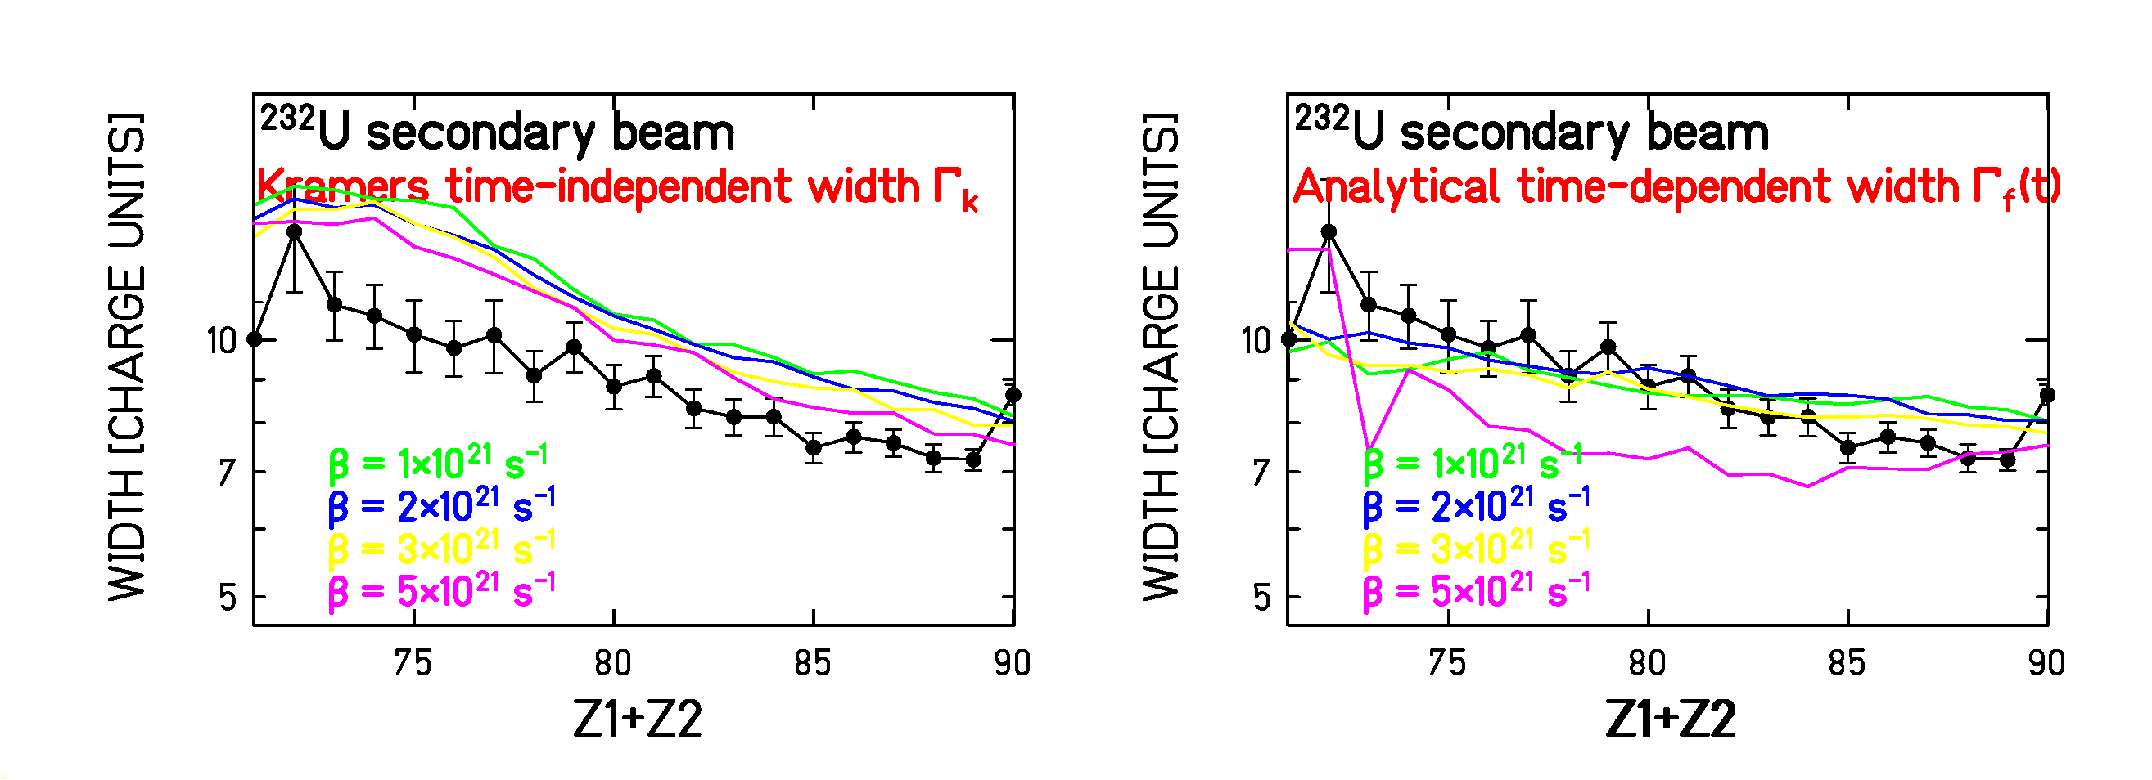

Conclusion: without _{f}  fission is not suppressed at high E*

 Fission fragment Z-widths are sensitive to transient effects
OVERVIEW OF THE WHOLE SET OF DATA

1. Uranium secondary beams

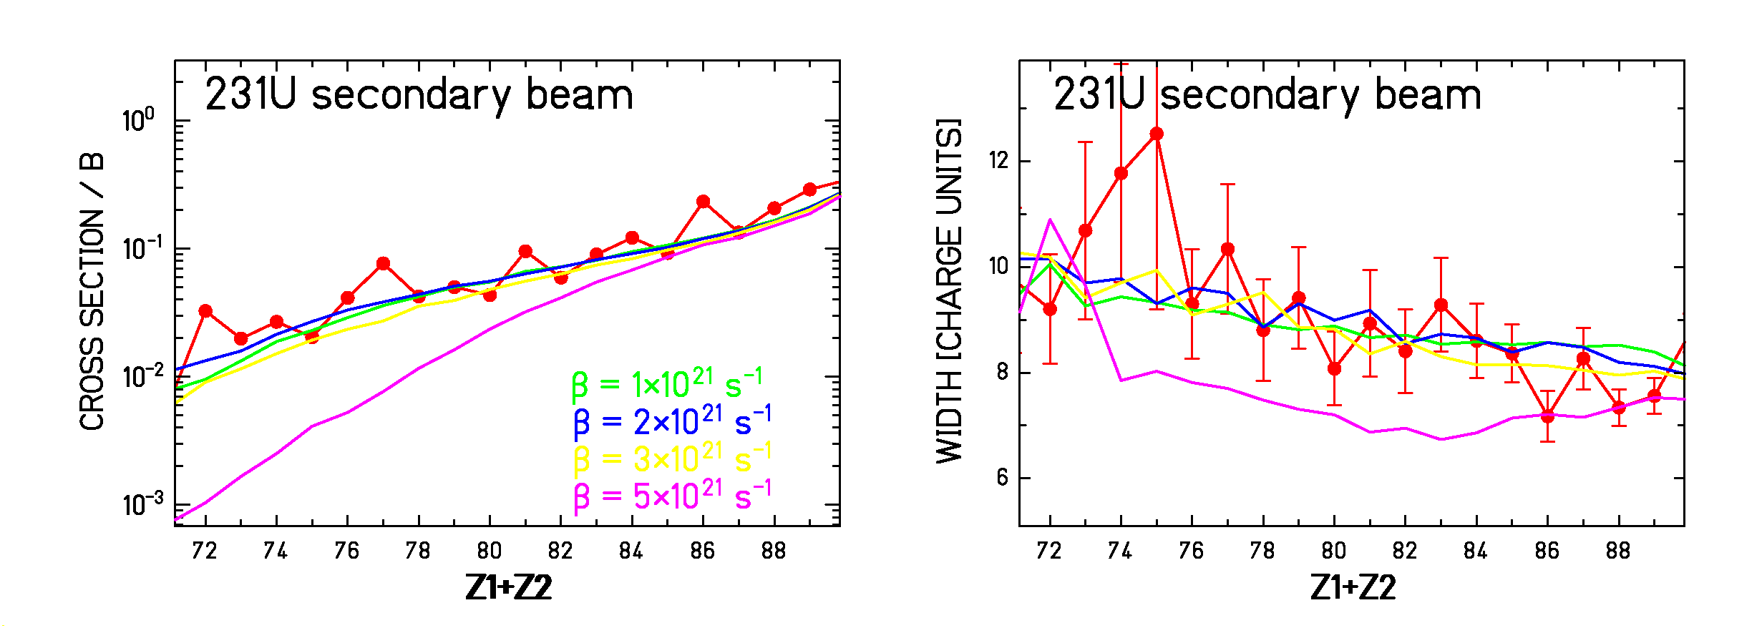

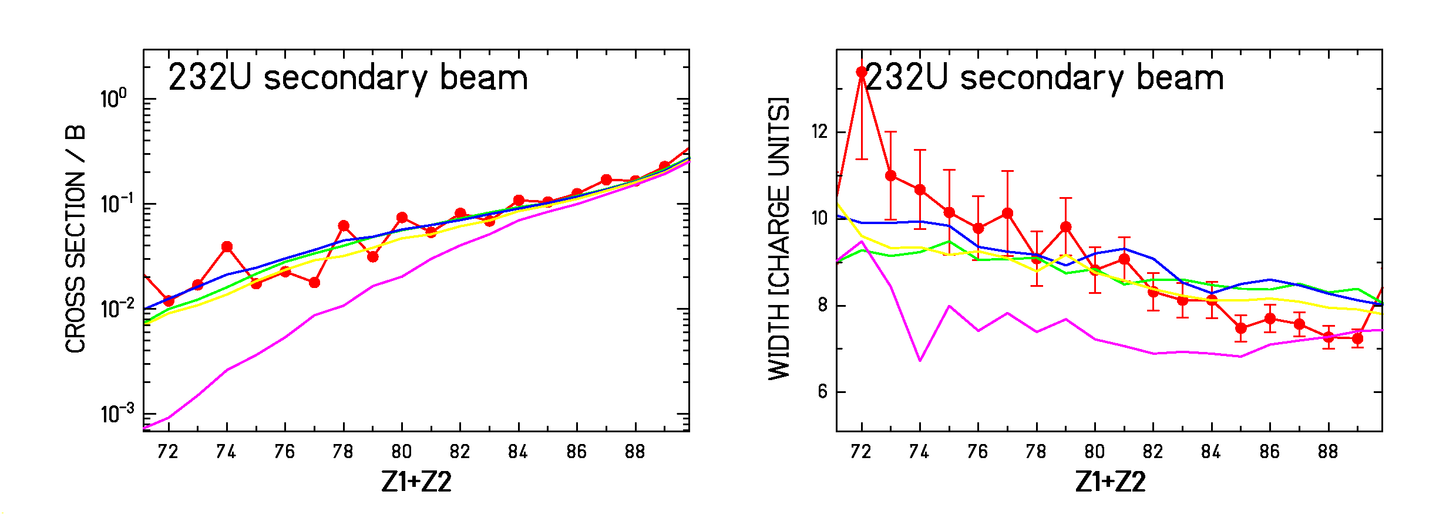

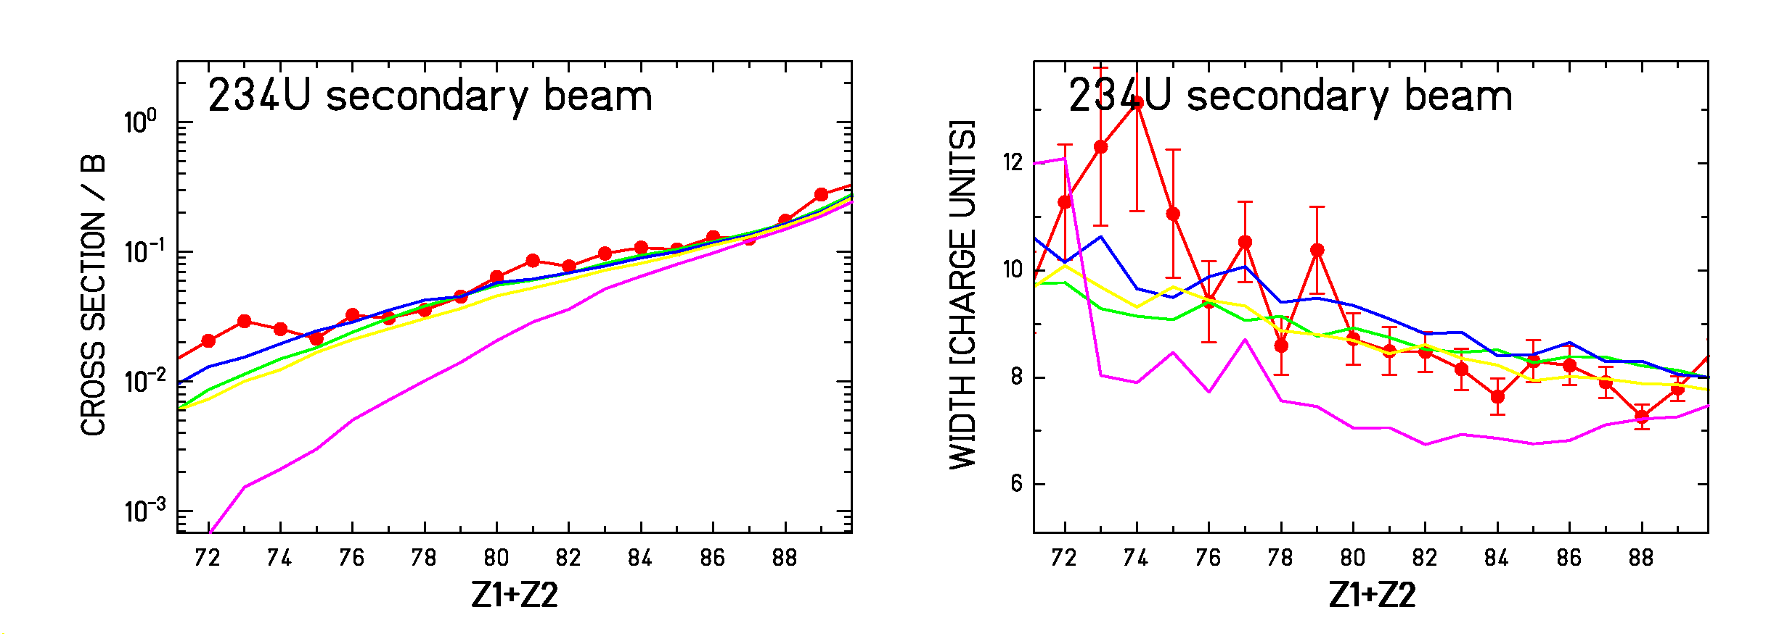

OVERVIEW OF THE WHOLE SET OF DATA

2. Protactinium secondary beams

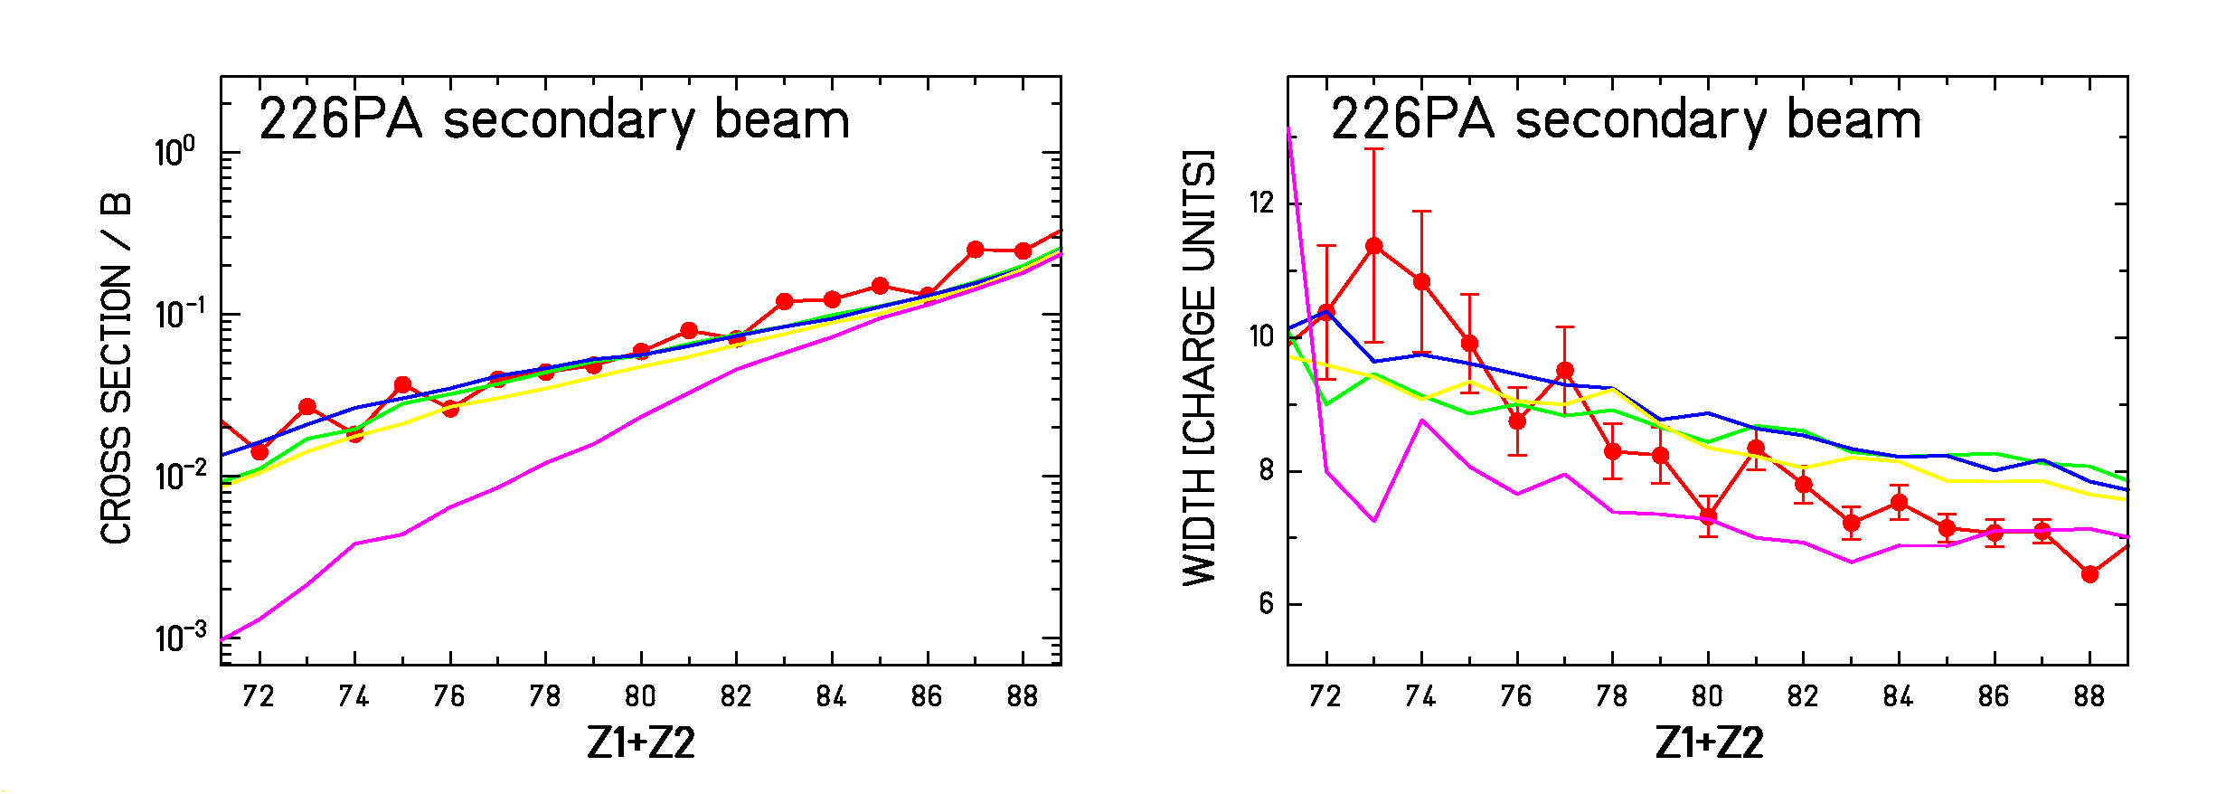

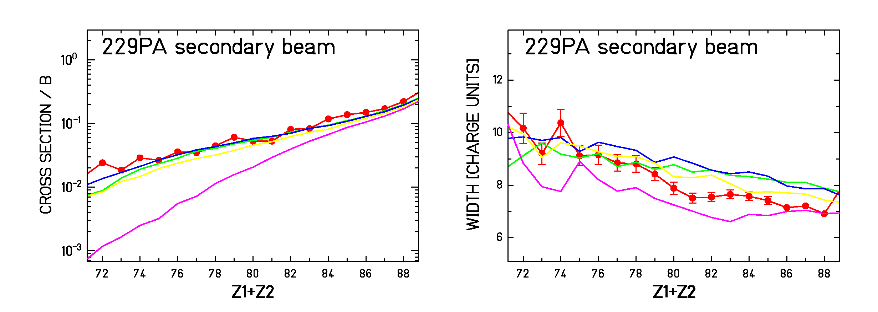

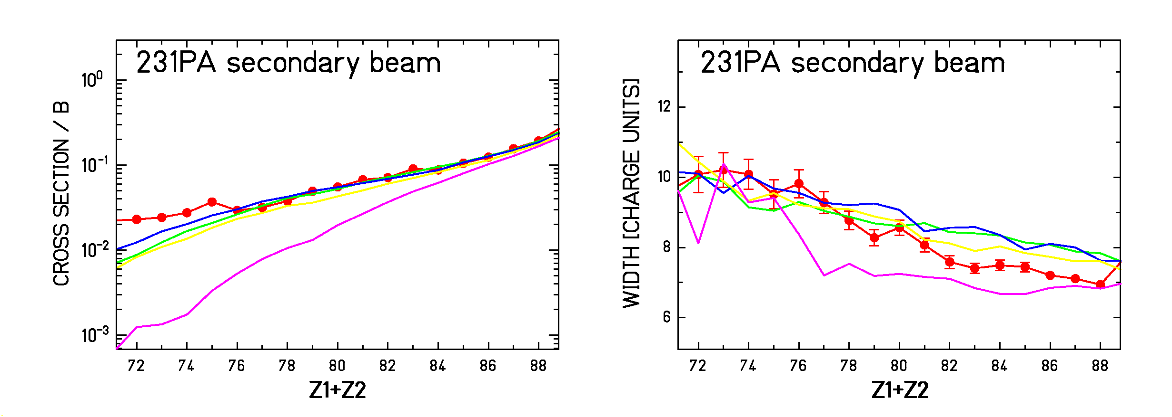

OVERVIEW OF THE WHOLE SET OF DATA

3. Thorium secondary beams

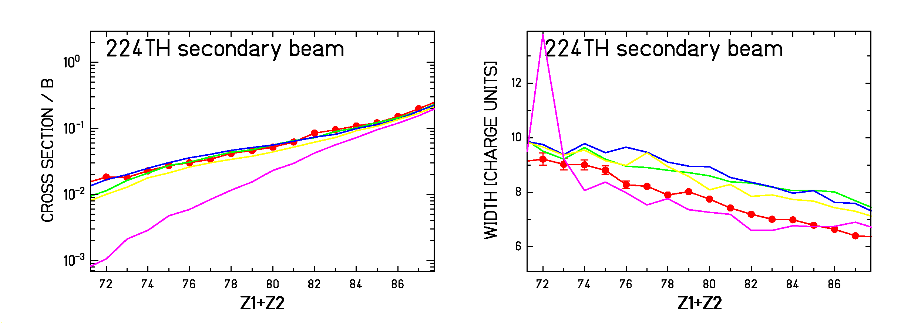

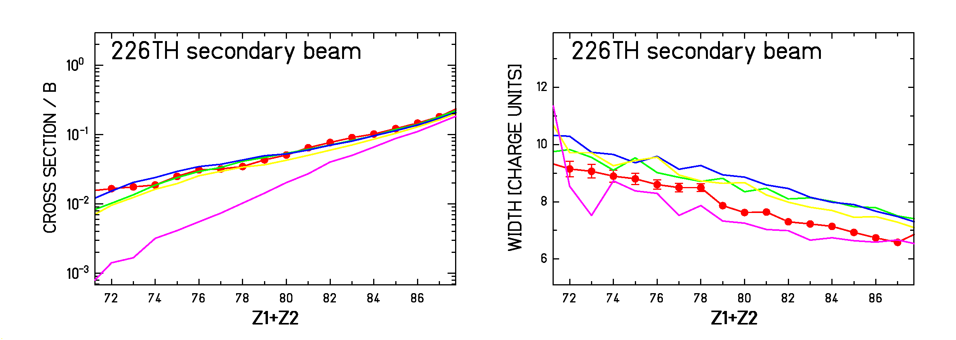

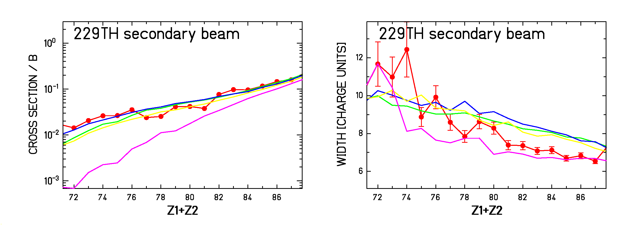

OVERVIEW OF THE WHOLE SET OF DATA

4. Actinium secondary beams

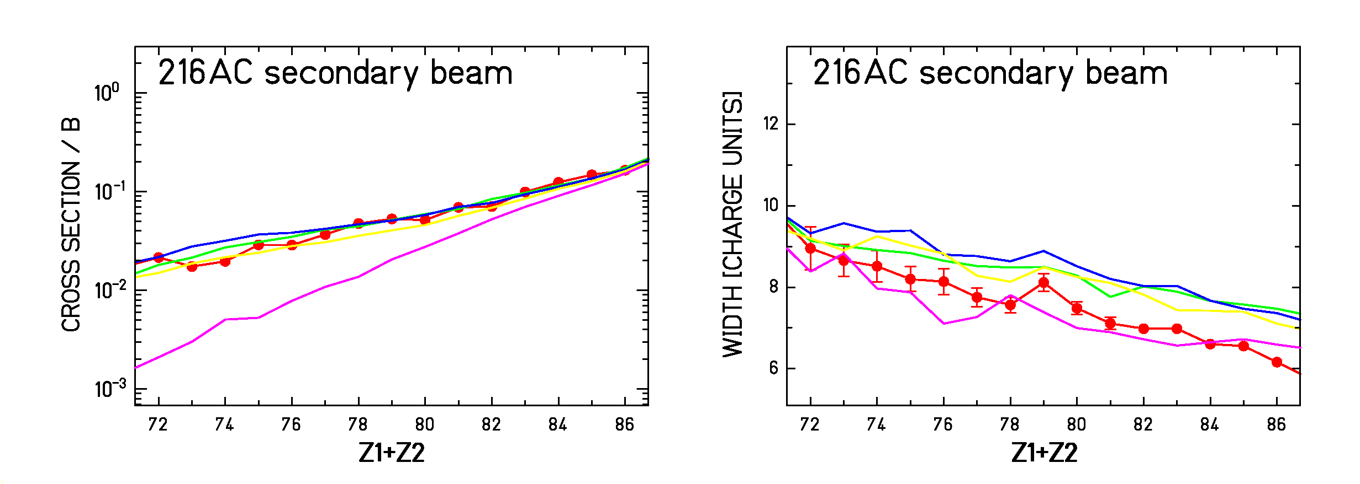

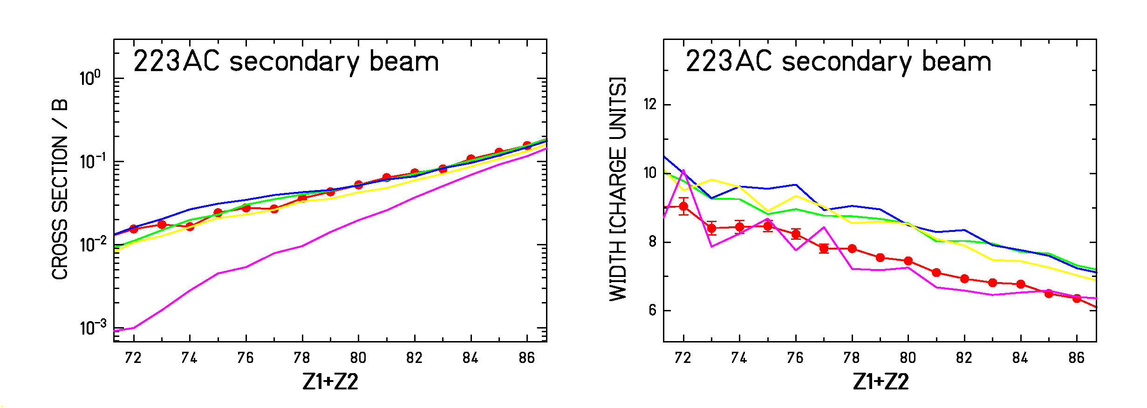

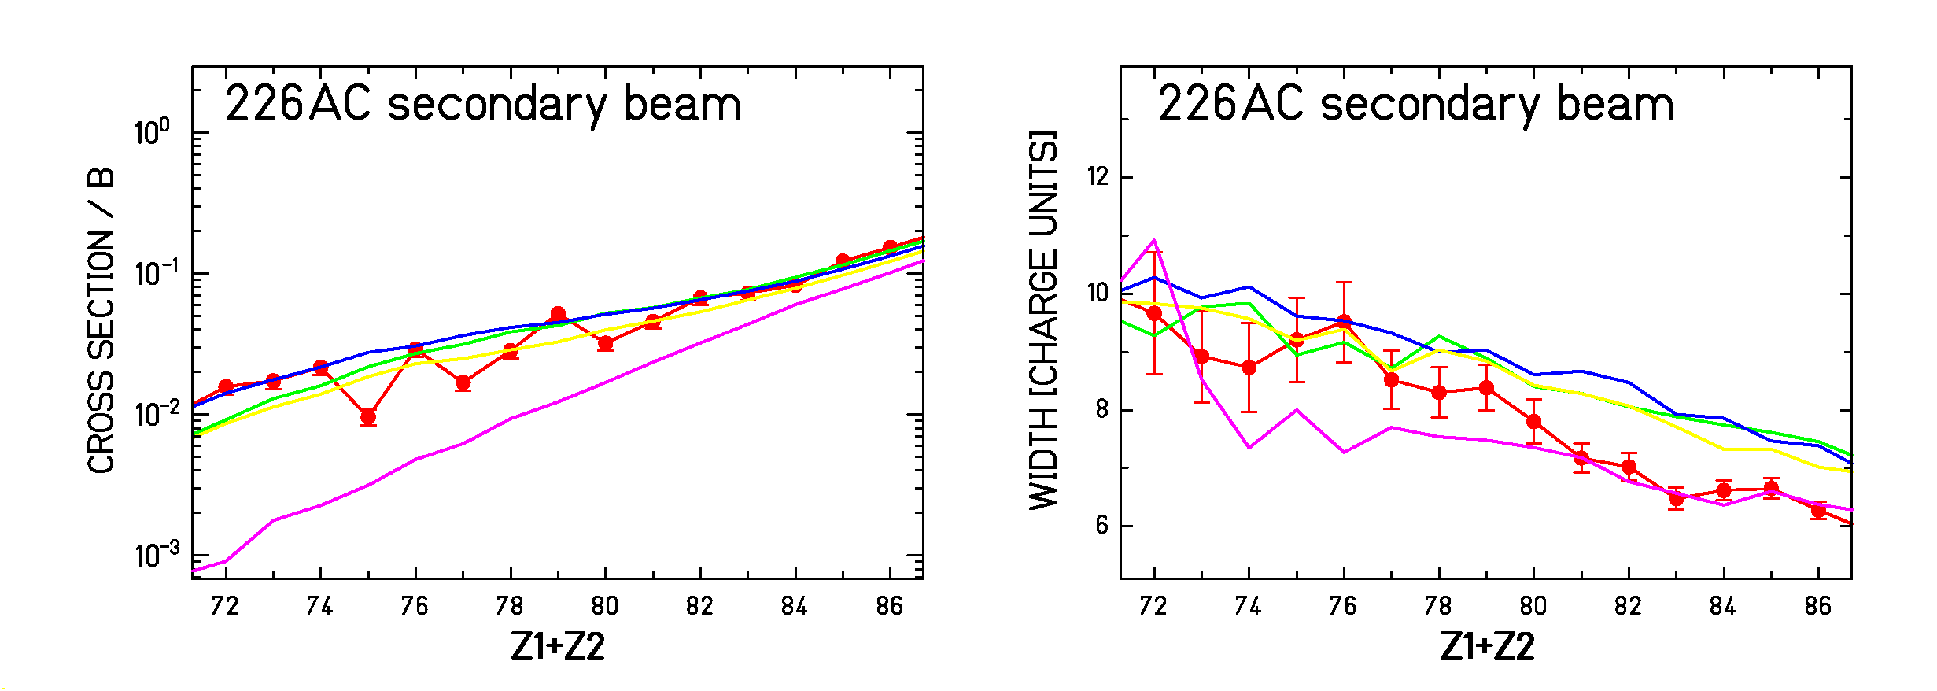

OVERVIEW OF THE WHOLE SET OF DATA

5. Francium secondary beams

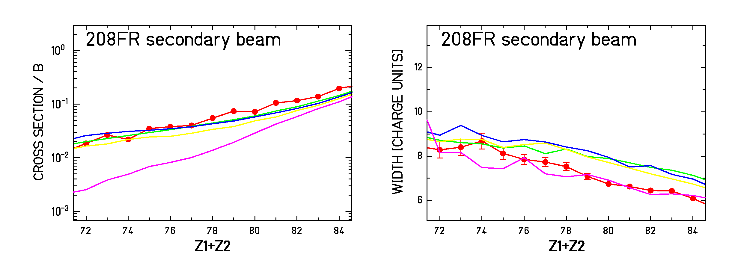
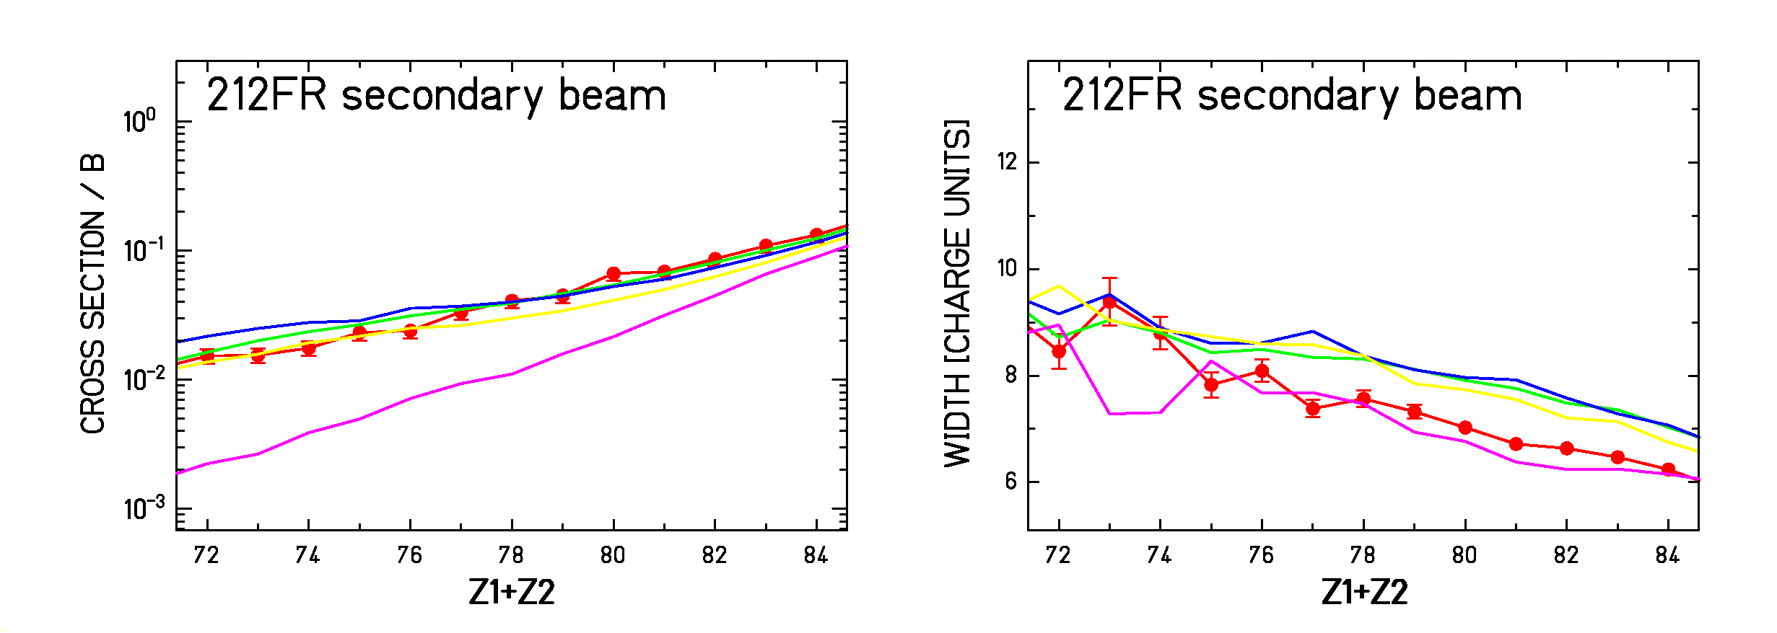
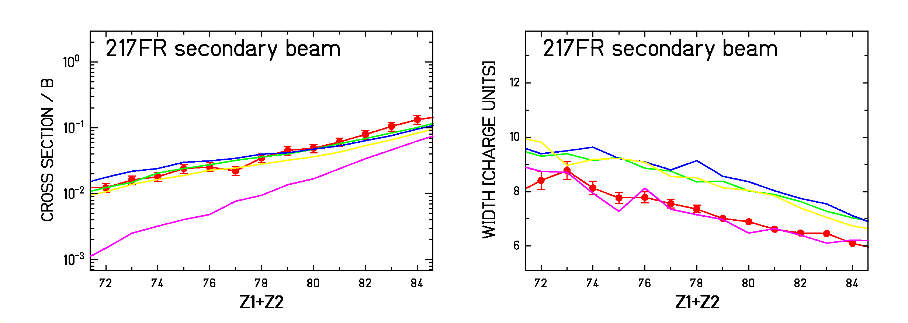

⇒ wide range of data reproduced with ~2-3.10²¹s⁻¹

SUMMARY

- Saddle clock concept

✓ inhibition of fission at earliest times

✓ the saddle-clock concept needs high enough E*

✓ peripheral heavy-ion collisions at relativistic
energy as a new experimental approach

- Pertinent set-up and reliable analysis code

✓ complete experimental information on fission

✓ appropriate time-dependent evaporation code

- What we have learnt

✓ transient effects are observable:
_{f} (t) is required in analysis codes

✓ clear signatures of transient effects:
partial fission cross sections
Z-distribution width of the fission fragment

✓ estimation over a great part of nuclear chart
 ~ 2-3.10²¹ s⁻¹  _{f} ~ 1.7.10⁻²¹ s
Comparison with previous results

our result over a great part of
the nuclear chart!
↓

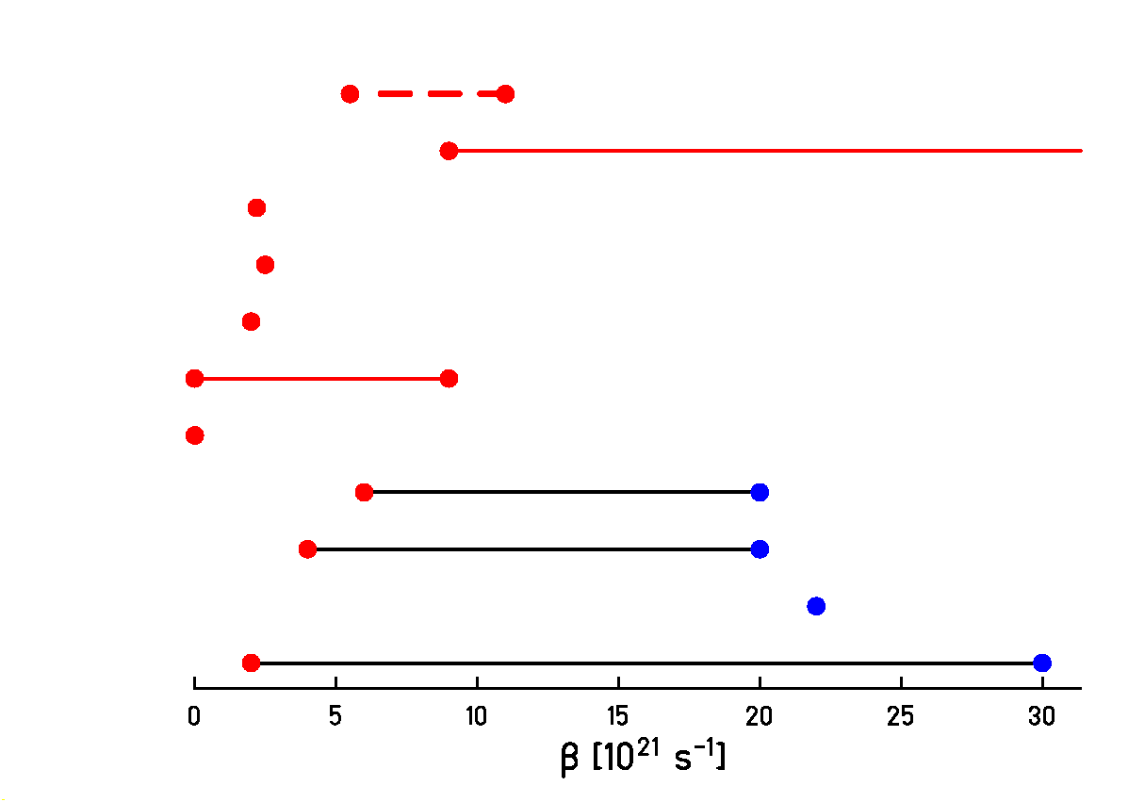
[FrG93]
[VeM99]
[ShD00]
[DiS01]
[HuS00, Dio01]
[JiP01]
[LoG01]
[BeA02]
[ChP02]
[NaA02]

OUTLOOK

✓ Our data cover a wide excitation range for a given
fissility Z²/A

⇒ information about the temperature dependence of  ?

⇒ measure of the mass of the fission fragment ?

 small deformation
 large deformation

 Large set of data: extraction of reliable information

 Deformation dependence confirmed

OUTLOOK

✓ Our data cover a wide excitation range for a given
fissility Z²/A

⇒ information about the temperature dependence of  ?

⇒ measurement of the mass of the fission fragment
and neutrons

 Extended experimental set up

1. FRS: secondary beam production

2. Large acceptance spectrometer (ALADIN?)
(identification of both fission fragments in A and Z)

3. Neutron measurements (LAND?)

⇩

MORE COMPLETE PICTURE OF THE PROCESS

Last but not least

Thanks to all my collaborators:

K.-H.Schmidt
B.Jurado
A.Kelić
A.Heinz
J.Taieb
A.Junghans
J.Benlliure
J.Pereira
M.V.Ricciardi
O.Yordanov
V.Henzl
D.Henzlova

… and many others …

