Production Mechanism of Exotic Nuclei

Karl-Heinz Schmidt

Gesellschaft für Schwerionenforschung, Darmstadt, Germany

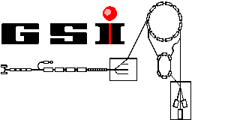

GSI is a heavy-ion research centre funded by the Federal Government of Germany and the state of Hesse. The laboratory performs basic and applied research in physics and related natural science disciplines using a heavy-ion accelerator facility

Production Mechanism of Exotic Nuclei
CONTENT

- How can one produce nuclei far from stability?
Fusion, fission, fragmentation, ...

- What is the physics involved in these reactions?
Collective effects near the Coulomb barrier.
Nucleon-nucleon collisions at relativistic energies.
De-excitation of hot nuclei - particle emission and fission.
- What is the experimental knowledge on production cross sections?
Experiments in normal and inverse kinematics.
The GSI technical equipment.
Data on full isotopic distributions.
- What are the limitations due to non-nuclear interactions in the target?
Limitation of usable target thickness.
Target heating.
Ionic charge-state distribution.
- How can one make accelerated radioactive ion beams from these exotic nuclei?
In-flight production and separation.
In-target production and re-acceleration.

A. HOW CAN ONE PRODUCE NUCLEI FAR FROM STABILITY?
Chart of the nuclides
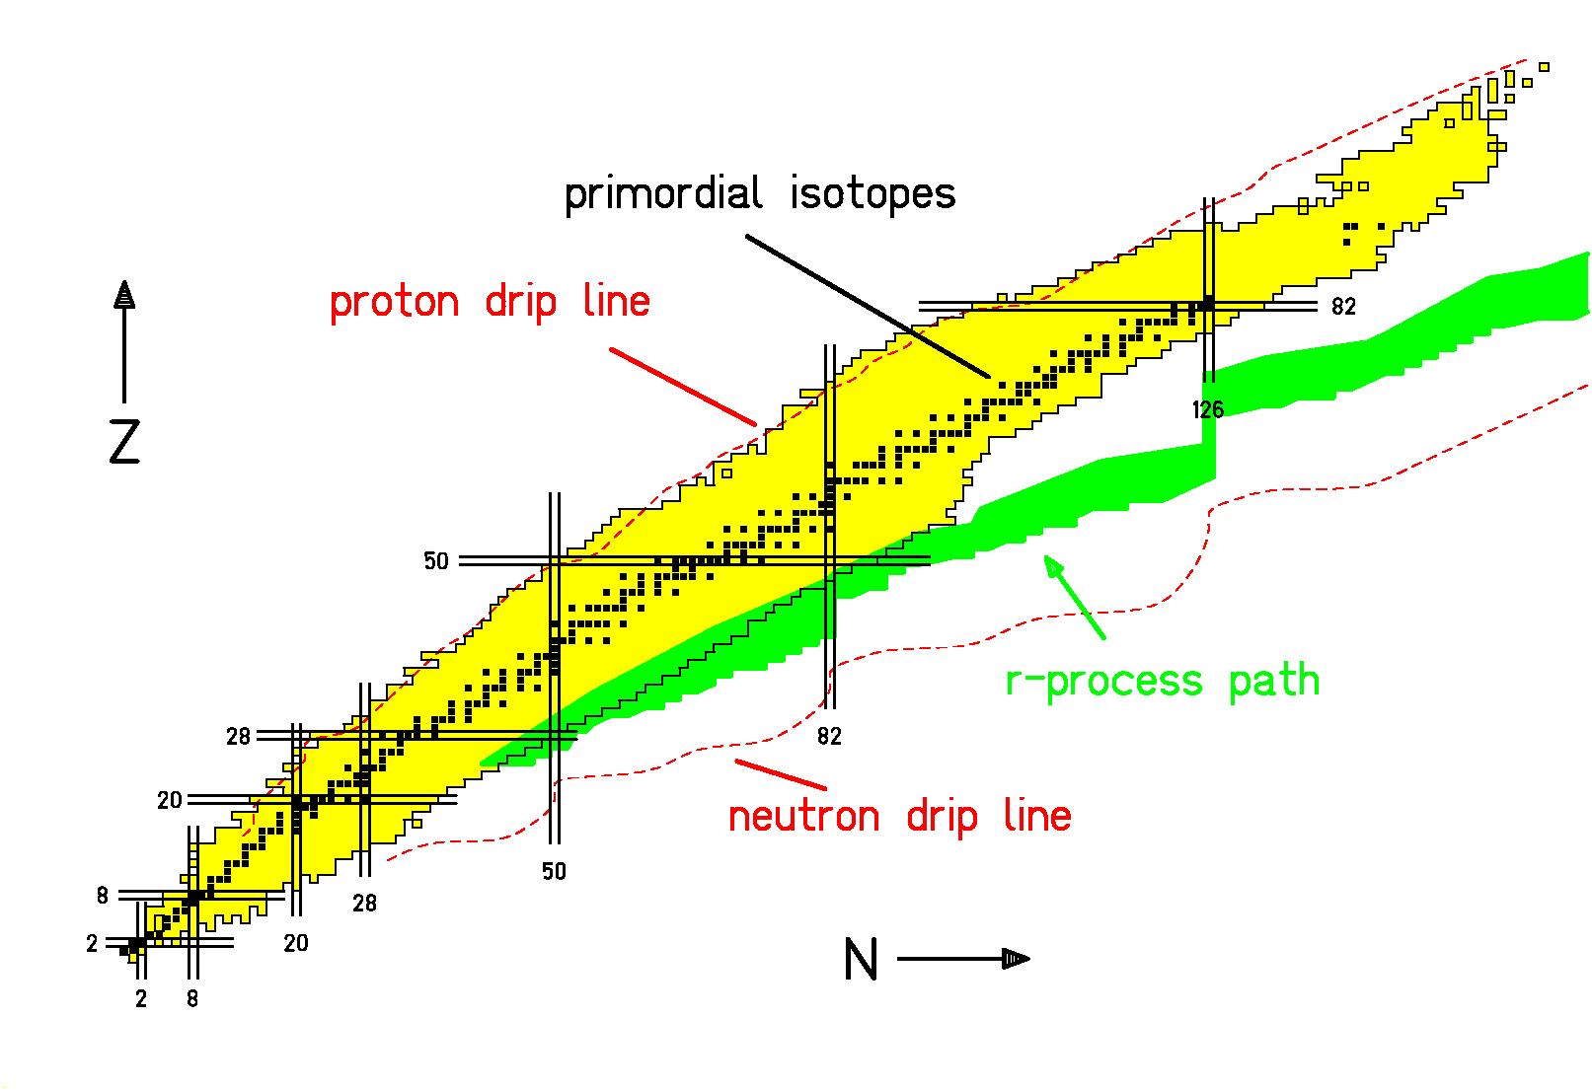
287 primordial nuclides exist in nature.

About 6000 nuclides are bound, only about half of them have been observed. Most of the unobserved nuclides are neutron-rich.

Experimental progress on nuclear structure relies on available beams of nuclei far from stability.

Particular interest to produce neutron-rich nuclei and to reach the nuclei involved in the astrophysical r-process.
Additional information to the preceding page:

Most heavy-ion accelerator facilities are able to deliver beams of primordial nuclides only, that means of those nuclides which can be found in natural resources. These nuclei are marked by black squares. They mark the valley of beta stability. Nuclei to the left are unstable against beta-plus decay or electron capture, nuclei to the right are unstable against beta-minus decay. Nuclides above ²⁰⁸Pb, even if they are beta-stable, decay by other kind of radioactivity, mostly alpha decay. The only heavy nuclides with sufficiently long half-lives to be still found on earth are ²³²Th and ^{234,235,238}U. The variation of the neutron-to-proton ratio to both sides of the valley of beta stability leads to a loss of binding. At the drip-lines, the next protons, respectively neutron is not bound any more. The lines representing the drip-lines in the figure have been calculated by a mass model. In particular the location of the neutron drip line is not well known. Also the size of a nucleus is limited due to fission. The exact location of this limitation is not known. Experiments to synthesise super-heavy elements search to explore this limit.

The number of primordial nuclei is 237, while about 6000 nuclei are supposed to "exist" in the sense that they live much longer than the time a nucleon takes to cross the nucleus with its Fermi velocity (τ >> 10⁻²² s). Only about half of them have been observed up to now. While the proton drip line is reached or almost reached over a large mass range, the neutron drip line is only reached for the lightest elements.

The limitation to projectiles of primordial nuclides is a severe restriction to the study of the properties of exotic nuclei. An important progress in the understanding of nuclear properties, even approaching the drip-lines in many cases, has been achieved by using projectiles of radioactive nuclides. More and more heavy-ion laboratories have invested efforts to provide radioactive beams. A new generation of dedicated experimental facilities is being planned.

The preceding figure also shows the nuclei involved in the r-process, an important scenario responsible for the production of the heavy nuclides in nature. The conditions of this astrophysical scenario are still badly understood, partly because the properties of the nuclei involved are not known experimentally. Therefore, there is a strong interest in the production of these very neutron-rich nuclei.

Limits of stability
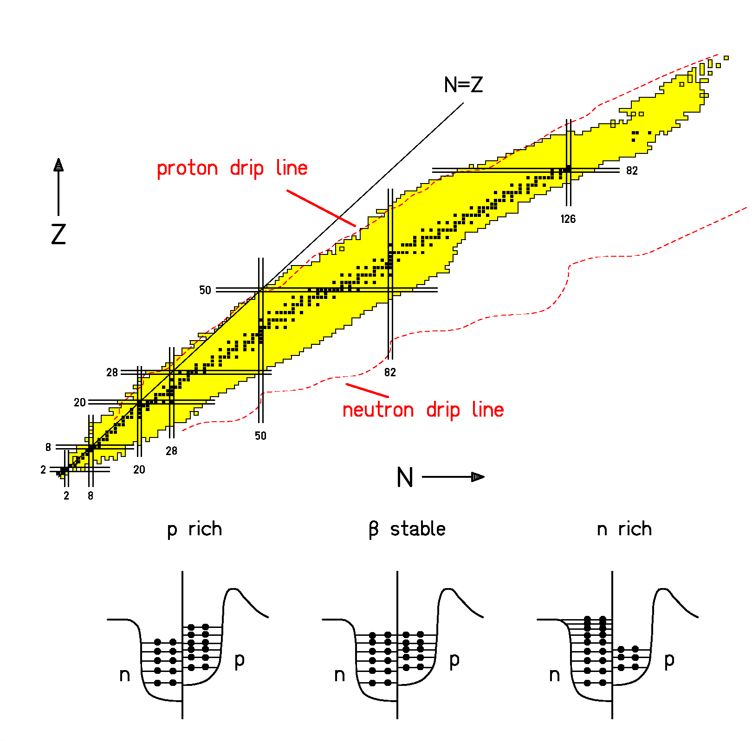
The nucleus: a two-component Fermionic system.

Definition of beta stability, separation energies, drip lines, Coulomb barrier.

Coulomb repulsion of protons favours neutron excess in heavy nuclei.

Very heavy nuclei are unstable against fission due to the Coulomb repulsion of the protons.
Additional information to the preceding page:

The forces between the nucleons in a nucleus can be approximated by a nuclear potential. Since neutrons and protons are Fermions, each of them occupies one state. In this way, they fill the potential well up to the Fermi level. Due to the repulsive Coulomb force between the protons, the well seen by the protons is less deep. The long-range Coulomb force in addition creates the Coulomb barrier.

In the valley of beta-stability, the Fermi levels of protons and neutrons are equal.
Adding more neutrons leads to a higher Fermi level for the neutrons. At the neutron drip-line, the Fermi level for the neutrons is equal to the potential far from the nucleus. Nuclei beyond the neutron drip-line can not exist, because the excess neutrons would leave the nucleus immediately. At the proton drip-line the Fermi level for the protons is equal to the potential far from the nucleus. Nuclei beyond the proton drip-line exist, because the excess protons first must tunnel through the Coulomb barrier, before they can leave. If tunneling of protons is comparable or faster than beta decay, spontaneous emission of protons is observed.

Another consequence of the Coulomb force is the curvature of the valley of beta stability: More and more heavy nuclei are more and more neutron-rich. The heaviest known nucleus with equal number of neutrons and protons (N = Z) is ¹⁰⁰Sn.

The repulsive Coulomb force also tends to destabilise very heavy elements against quadrupole deformations, leading to fission. This limitation is not shown in the preceding figure.

Overview on nuclear-reaction mechanisms

Decisive parameter:
de Broglie wavelength of a nucleon:$λ=\frac{h}{p}$ .

E/A | P | λ
10 MeV | 137 MeV/c | 9.03 fm
100 MeV | 443 MeV/c | 2.79 fm
1 GeV | 1692 MeV/c | 0.73 fm

λ ≥ nuclear radius (r = 1.16 fm × A^{1/3}):

Reactions controlled by nuclear potential and binding energies
Fusion, deep inelastic, transfer, fission

λ ≤ range of nuclear force (≈ 1 fm):

Collisions of individual nucleons (t=r/v≈10⁻²³ s)
Target (resp. projectile) fragmentation

Later stages of the reaction:

Formation of a compound nucleus (a few 10⁻²² s),
(Thermalisation)

Deexcitation of reaction products by
evaporation-fission competition (> 10⁻²¹ s)
(Nuclear potential and binding energies become
again important.)

Neutron capture - element synthesis in nature
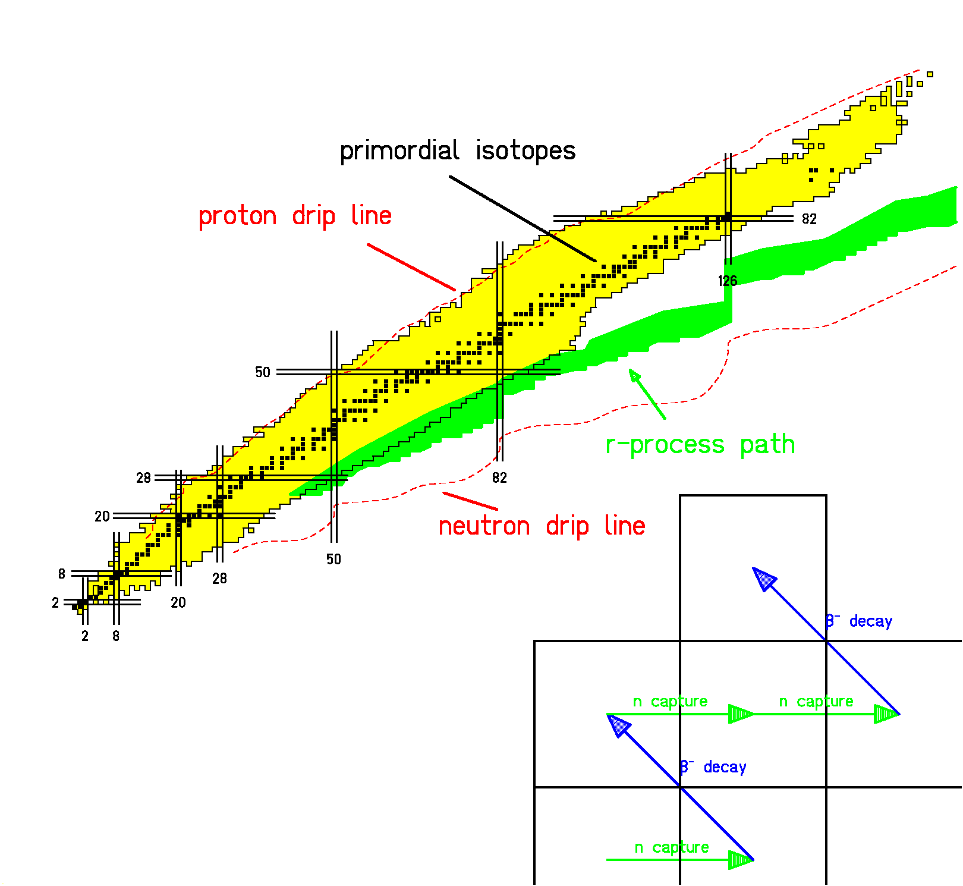
Astrophysical scenarios:
- Low neutron flux: s process (close to stability)
- High neutron flux: r process (neutron-rich)

Application: breeding of ²³⁹Pu from ²³⁸U in fission reactors.

Needs very high neutron fluxes to reach neutron-rich isotopes. Not applicable in laboratory for this purpose.

Additional information to the preceding page:

A direct way to produce neutron-rich nuclides is neutron capture. Most of the heavier nuclear species in the universe have been produced in cosmic scenarios by this reaction mechanism. Roughly two scenarios are considered according to the magnitude of the neutron flux. The s process ("slow" process) evolves close to the valley of beta stability. Since the time delay between two consecutive capture reactions is longer than most of the beta half-lives, the beta-unstable capture product decays, before the next neutron is captured. The r process ("rapid" process) evolves far from the valley of beta stability. The time between two consecutive capture reactions is smaller than the beta half-lives of the nuclei close to beta stability.

The application of neutron capture in laboratory under controlled conditions for the production of very neutron-rich nuclei is not possible, because too high neutron fluxes would be needed. Even nature did not reach the neutron drip line in the r process. (We disregard neutron stars which only exist due to the additional influence of gravitation.)

A technical application, with or without explicit intention, is the production of plutonium and minor actinides (actinides with small production yields) in fission reactors. They are formed by consecutive neutron capture and beta decay from ²³⁸U nuclei. However, the production follows closely the valley of beta stability.

The cosmic scenarios of nuclide production, however, give an important motivation for extending our knowledge on the properties of very neutron-rich nuclei. In particular, this will allow for a better understanding of the r process, the conditions of which are still rather unclear.
Fusion
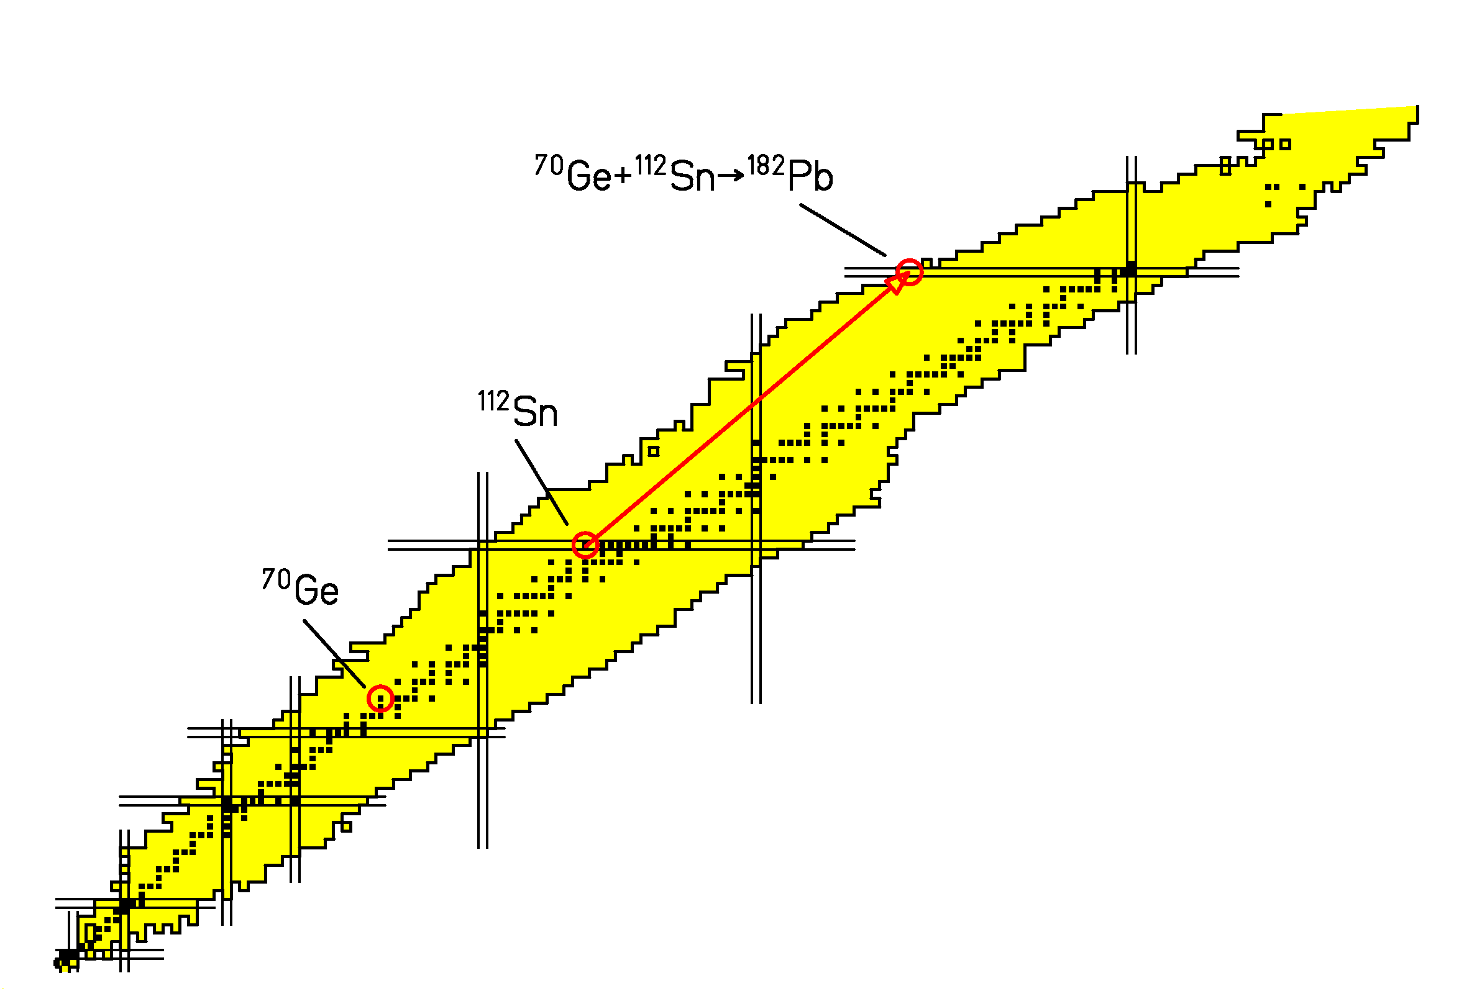
- Collision of heavy ions near the Coulomb barrier
- Main characteristics:
Curvature of stability valley.
→ Fusion products are neutron-deficient.
Nucleons of projectile and target add up.
→ Suited to reach super-heavy nuclei.
Additional information to the preceding page:

Two nuclei, gently brought into contact, may fuse due to the attractive nuclear forces. For lighter systems, this is the most important reaction mechanism at energies close to the Coulomb barrier. In very heavy systems, however, the Coulomb force tends to destabilise the merged system so that they re-separate immediately with higher probability.

Fusion reactions, in particular using heavy-ion beams, have proven to be well suited for the production of proton-rich nuclei up to the proton drip line. They have been an important tool for exploring the properties of exotic nuclei on the neutron-deficient side of the chart of the nuclides. Furthermore, fusion is the only tool applied to produce super-heavy elements.

Since the nucleons of projectile and target just add up, the nuclear composition of the fusion product is well defined. Only the evaporation process leads to a loss of a few nucleons.

Due to the curvature of the line of beta-stability, fusion is not suited for the production of neutron-rich nuclides. Another draw-back of fusion reactions is the low beam energy required which only allows for the application of thin targets, because the energy of the projectiles would become too low in a thicker target due to electronic interactions. Therefore, only a very small fraction of the projectiles goes into nuclear reactions.
Fission
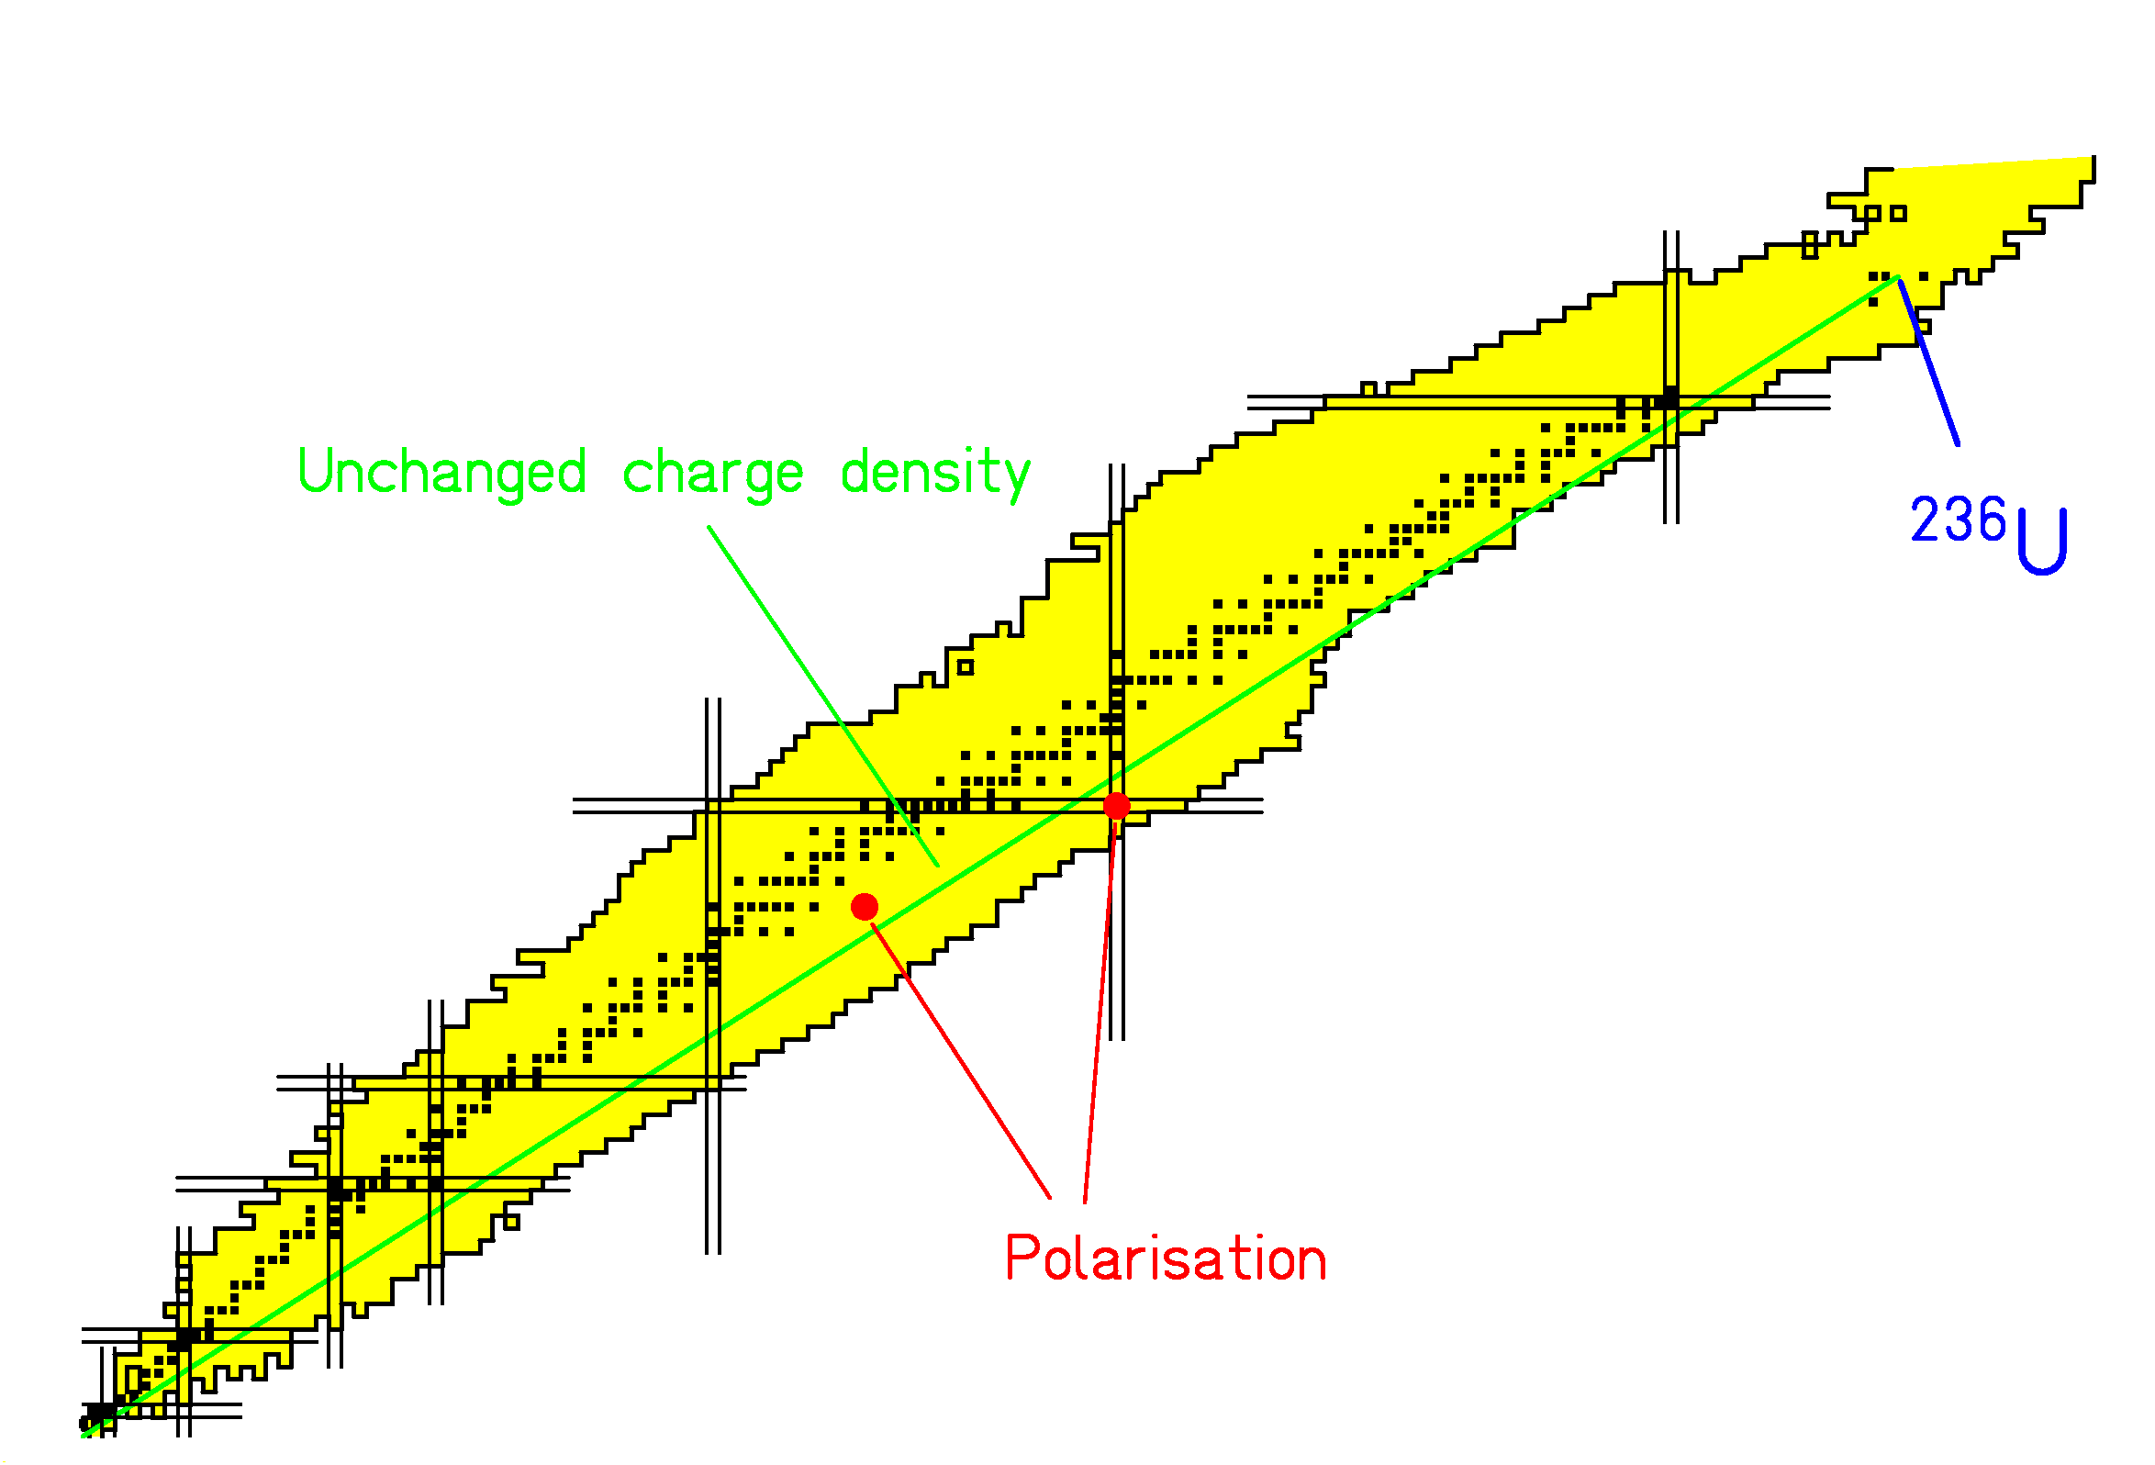
- Driven by Coulomb force, the nucleus splits in two.
- Main characteristics:
Curvature of stability valley.
→ Fission products are neutron-rich.
Larger neutron excess only by "charge polarisation".
→ One fragment is more, the other less neutron-rich.
Shell effects?
Fluctuations?

Reduction of neutron-excess by neutron evaporation.

Additional information to the preceding page:

Fission can be considered in some sense as the reverse of fusion. Here the process starts from heavy rather neutron-rich nuclei. As a consequence, the fission products normally are situated on the neutron-rich side of the chart of nuclides.

The production of nuclides which are more neutron rich than the fissioning system is only possible due to charge polarisation, that means that the two fission fragments are formed with different N-over-Z ratios.

Fluctuation phenomena as well shell effects might be responsible for charge polarisation. The figure shows the production of ¹³²Sn as an example. However, the restoring force due to the nuclear asymmetry energy is very strong. This limits the polarisation to rather low values.

Most fission fragments are formed with appreciable excitation energies, leading to neutron evaporation very shortly after fission. Therefore, the average N-over-Z ratio of the fission fragments is below the value of the fissioning nucleus.
Fragmentation
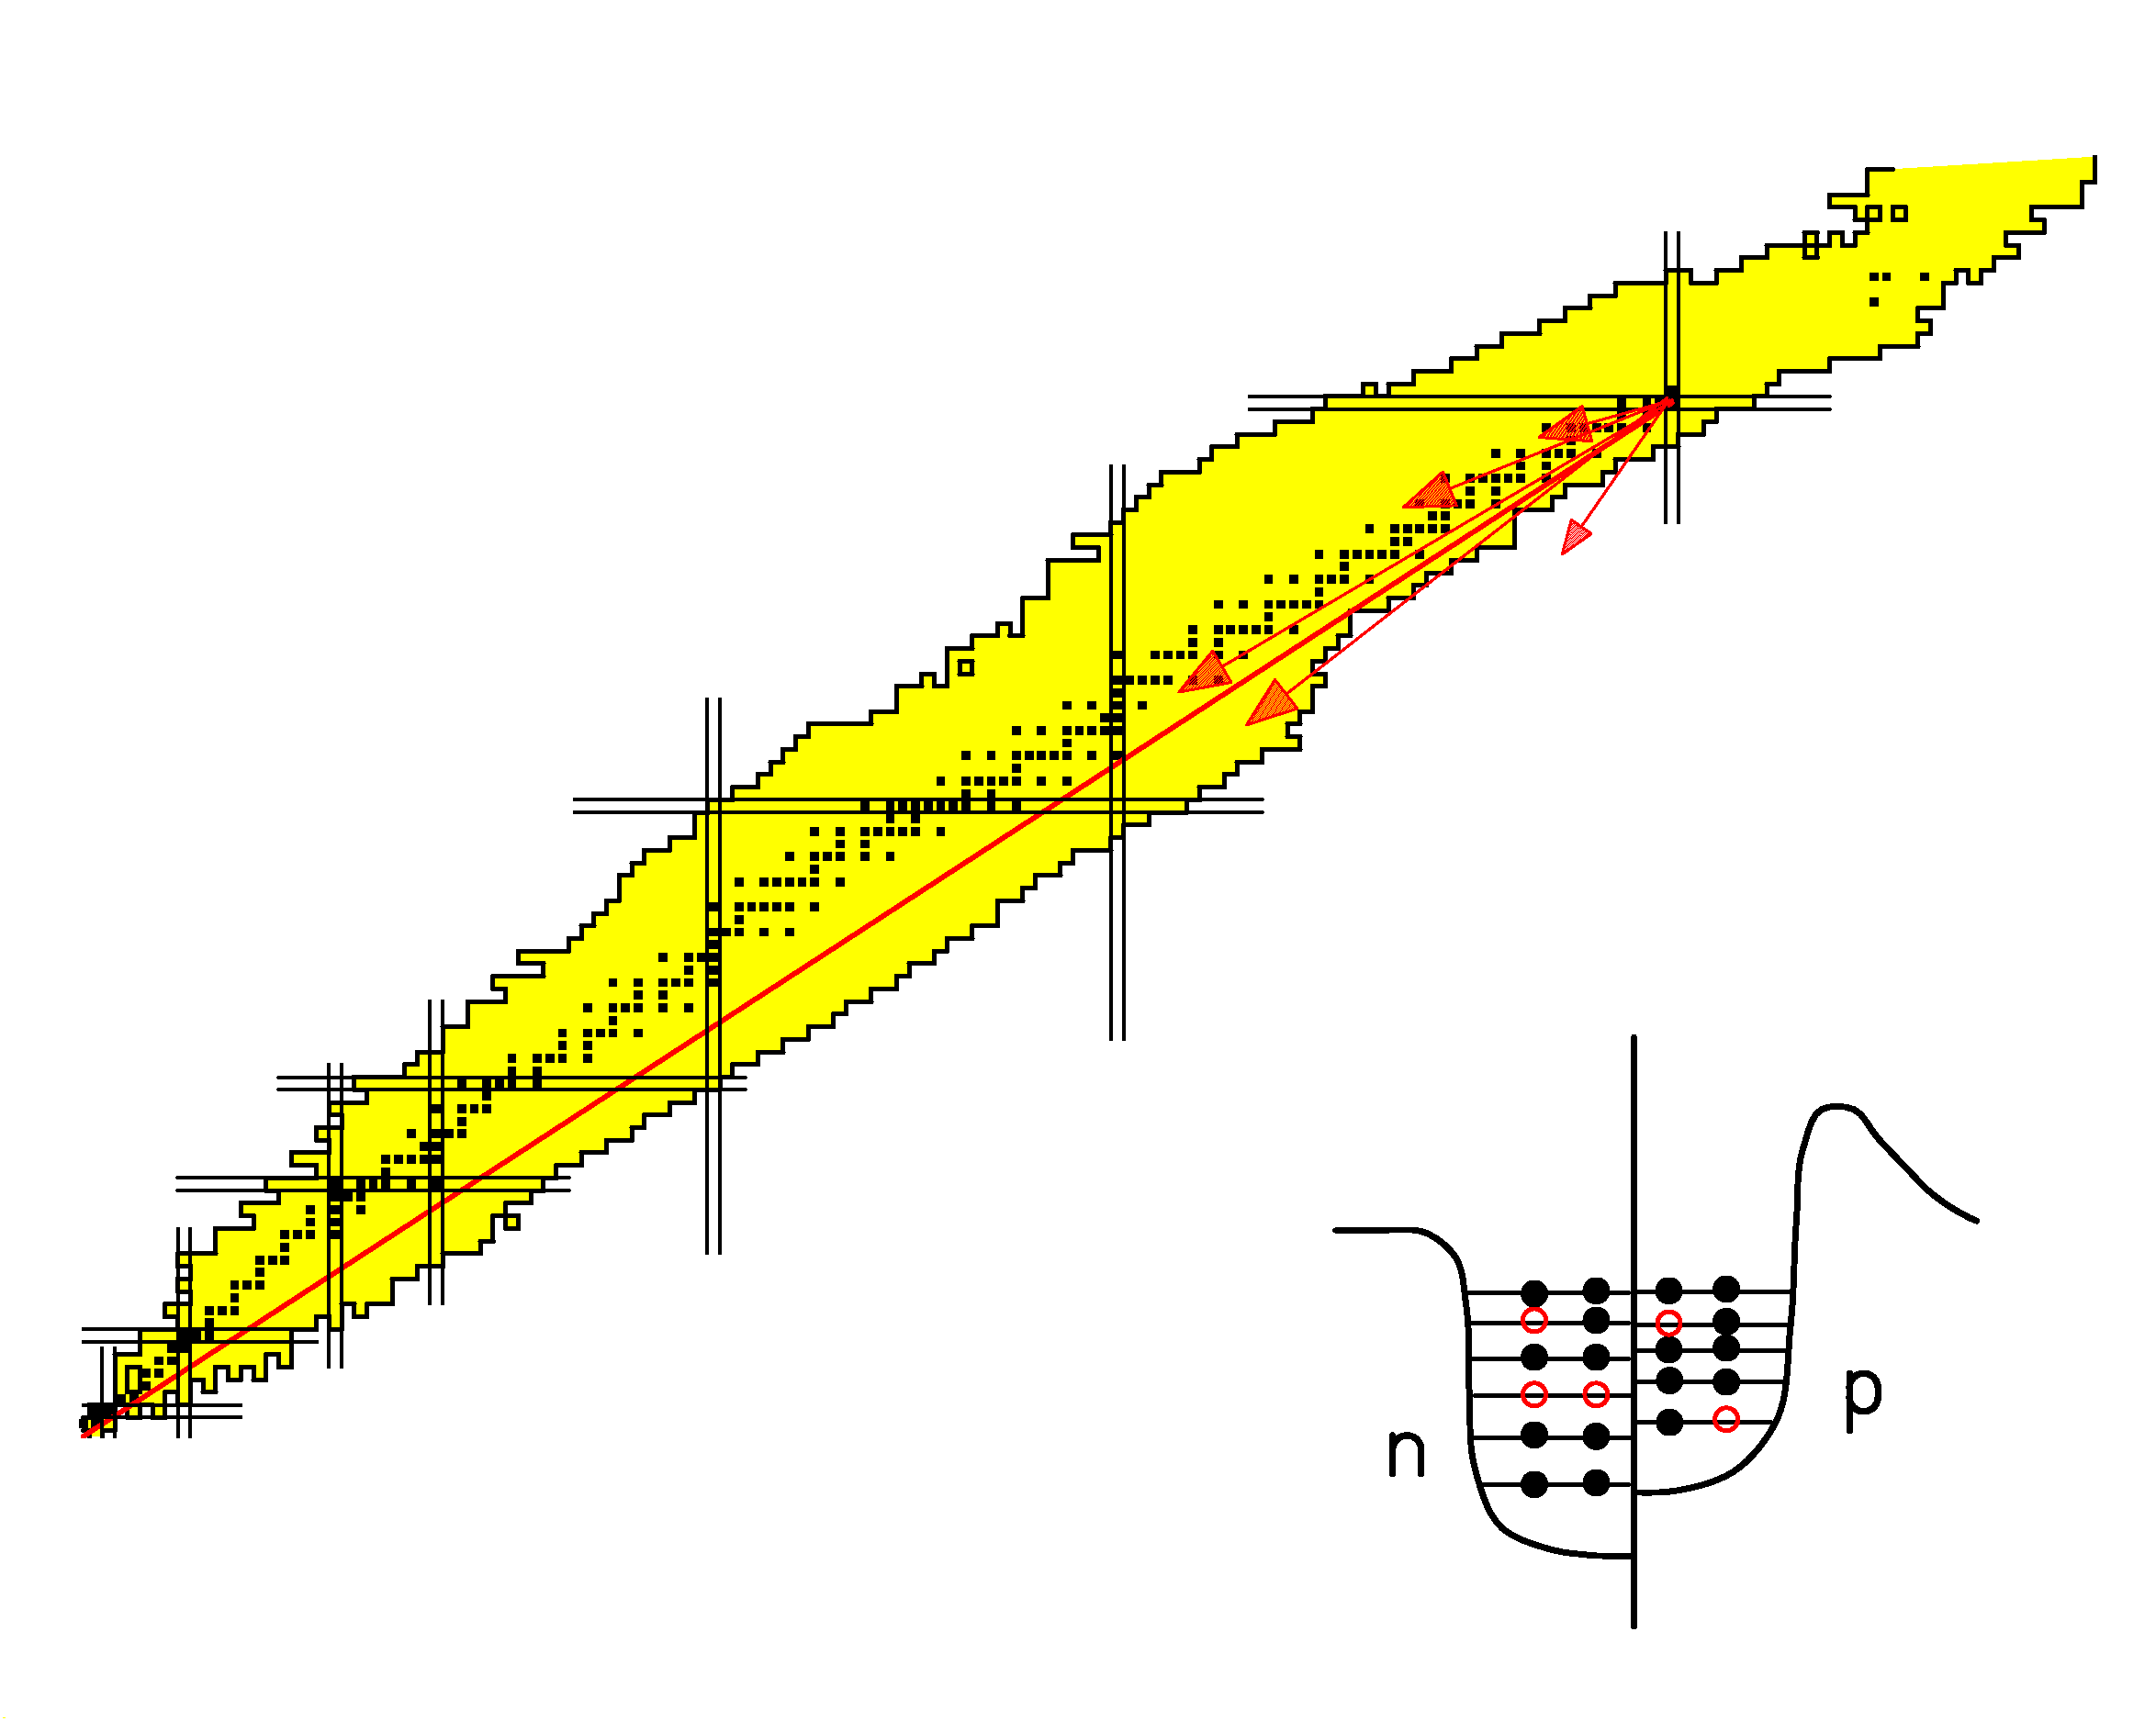
Removal of nucleons in quasi-free nucleon-nucleon collisions.

Basic characteristics:
- Large fluctuations in N/Z.
- Large fluctuations in excitation energy.

Highly excited fragments loose additional nucleons by evaporation.
Additional information to the preceding page:

Nuclear collisions at bombarding energies well above the Fermi energy can be considered as quasi-free nucleon-nucleon collisions. The collisions essentially remove a number of nucleons from the projectile respectively target nucleus. Collisions at large impact parameters are an interesting tool for the production of exotic nuclides.

(We use the term fragmentation for these reactions in which a large part of the projectile respectively target survives. This should not be confounded with multi-fragmentation in which very light nuclei are produced at more central collisions.)

An important feature of fragmentation reactions is the important statistical fluctuation. This leads to large variations in the N-over-Z ratio of the reaction products. Also the energy induced in the collision is subject to a large fluctuation and extends to rather high values. Therefore, the consecutive evaporation cascade has an important influence on the nuclear composition of the fragmentation products observed.

Fragmentation is a mechanism which produces a large number of nuclides, scattered over an extended region of the chart of the nuclides.
B. WHAT IS THE PHYSICS INVOLVED IN HIGH-ENERGY NUCLEAR REACTIONS?
Models for high-energy nuclear collisions

(From most elaborate to most approximate)

TDHF (Time-dependent Hartree-Fock)
Fermionic nuclear dynamics
Wavelets
(dynamics of quantum-mechanical wave functions)

BUU (Boltzmann, Ühling, Uhlenbeck)
VUU (Vlasov, Ühling, Uhlenbeck)
QMD (Quantum-molecular dynamics)
(fluid dynamics, classical transport of phase-space elements)

INC (Intra-nuclear cascade)
(elastic and inelastic collisions of individual nucleons)

Abrasion model
(geometric participant - spectator model)
The Abrasion Model

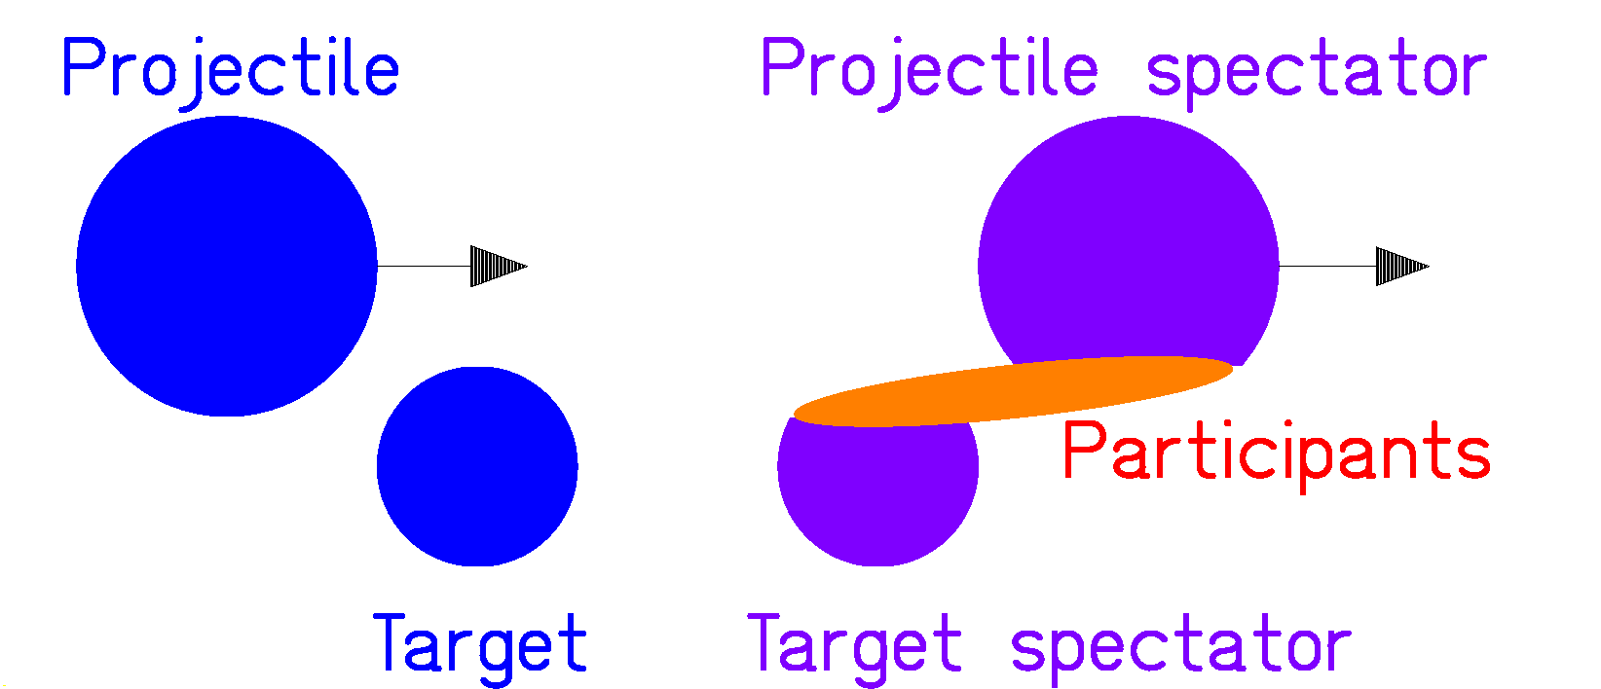
- Mass loss is given by geometrical cut.

Assumption: Trajectories of nucleons are straight lines.

Masses of projectile spectator and target spectator are given by the geometrical overlap as a function of impact parameter.

(Analytical formulae have been derived.
Realistic density profiles can be included.)

- Velocity of projectile fragment ≅ velocity of projectile
(friction is small)

- ΔN/ΔZ is given by collision statistics.

Hypergeometrical distribution (take ΔZ out of Z protons and ΔN out of N neutrons at random for fixed ΔA)

$P\left(ΔZ\right)=\frac{C\left(\frac{Z}{ΔZ}\right)⋅C\left(\frac{N}{ΔN}\right)}{C\left(\frac{A}{ΔA}\right)}$ , $ΔA=ΔZ+ΔN$

with

$$C\left(\frac{Z}{ΔZ}\right)=\frac{Z⋅\left(Z−1)⋅\text{.}\text{.}\text{.}⋅(Z−ΔZ\right)}{ΔZ⋅\left(ΔZ−1\right)⋅\text{.}\text{.}\text{.}⋅\left(1\right)}$$
4. E* is given by hole excitations. → Gaimard, 1991
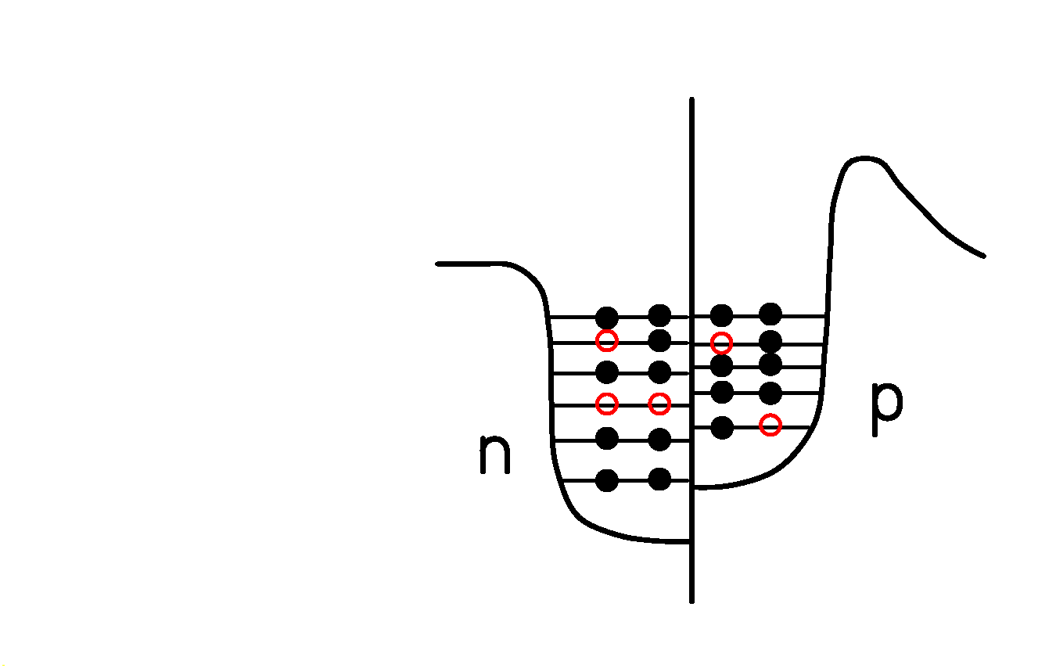
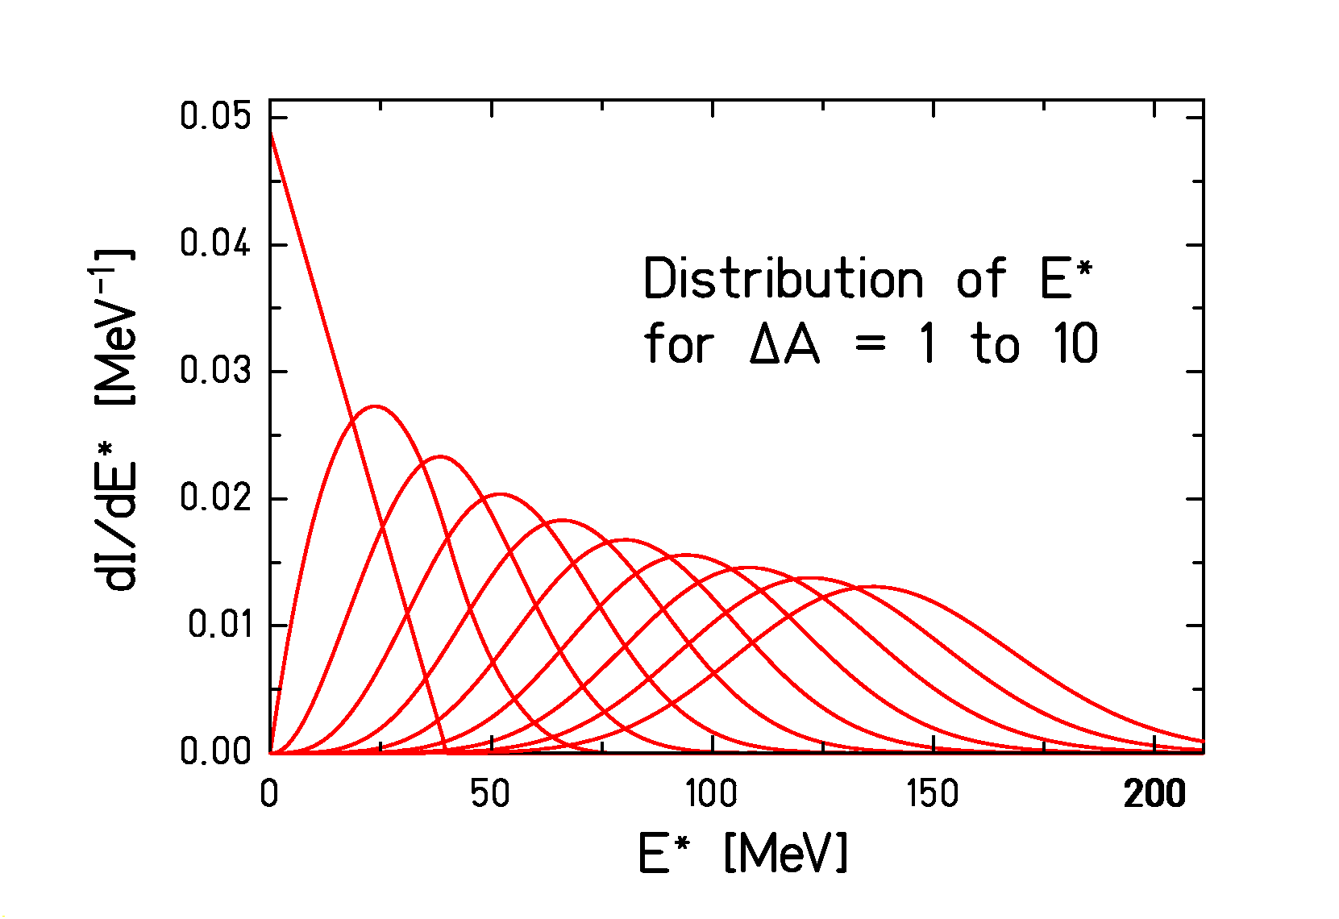
(not surface energy of the spectator! → Bowman, Swiatecki, Tsang, 1973)

Additional excitation energy by capture of participants?

- Linear momentum is given by the sum of the Fermi momenta of the holes. → Goldhaber, 1974

- Angular momentum is given by the sum of the angular momenta of the holes. → de Jong, 1997
C. DE-EXCITATION OF HOT NUCLEI:
EVAPORATION AND FISSION
Evaporation process (Weißkopf)

Basic principle: Thermo-dynamical equilibrium

Boiling liquid - Condensation from a gas
Evaporation - Capture

$$\frac{{dW}_{n}\left(E_{ν}\right)}{{dE}_{ν}}⋅ρ_{A}\left(E_{A}^{}\right)=\frac{dN}{{dE}_{ν}}⋅W_{c}\left(E_{ν}\right)⋅ρ_{B}\left(E_{B}^{}\right)$$

E_{ν} : kinetic energy of evaporated particle
E_{A} : excitation energy of mother nucleus
E_{B} : excitation energy of daughter nucleus
W_{n}: evaporation probability
ρ_{A} : state density of mother nucleus
W_{c} : capture probability
ρ_{B} : state density of daughter nucleus
dN/dE_{ν}: kinematical phase-space density

$$W_{c}\left(E_{ν}\right)=σ_{c}\left(E_{ν}\right)⋅Φ_{ν}$$
σ_{ν} (E_{ν}) : capture cross section, $Φ_{ν}=\frac{v}{V}$ : particle flux.
Finally:
$$Γ_{ν}=\frac{{\text{gm}}_{ν}}{π^{2}ℏ^{3}ρ_{A}\left(E_{A}^{}\right)}\int_{0}^{E_{ν}^{\text{max}}}{σ_{c}\left(E_{ν}\right)}ρ_{B}\left(E_{A}^{}−S_{ν}−E_{ν}\right) E_{ν}{\text{dE}}_{ν}$$
g: spin degeneracy
Fermi gas

Volume in phase space $Ω=\frac{4}{3}{πr}^{3}×\frac{4}{3}{πp}^{3}$

Number of states $N=\frac{Ω}{h^{3}}=\frac{\frac{4}{3}{πr}^{3}×\frac{4}{3}{πp}^{3}}{h^{3}}$

Number of states per momentum interval

$dN=\frac{\frac{4}{3}{πr}^{3}×4{πp}^{2}}{h^{3}}dp$

Volume in space $\frac{4}{3}{πr}^{3}=V$
Momentum - energy $p^{2}=2\text{mE}$
$p^{2}\text{dp}=\sqrt{2m^{3}E} dE$

Number of states per energy interval

$$dN=V×\frac{4π\sqrt{2m^{3}}}{h^{3}}\sqrt{E} dE$$

(additional factor of 2 for spin degeneracy)

Partial widths Γ_{n} and Γ_{p} for emission of neutrons and protons.

$$Γ_{n}=\frac{2{\text{mR}}^{2}g}{ℏ^{2}2\text{πρ}\left(E^{}\right)}\int_{0}^{E^{}−S_{n}}{\text{ερ}\left(E^{}−S_{n}−ε\right)}dε$$

$$Γ_{p}=\frac{2{\text{mR}}^{2}g}{ℏ^{2}2\text{πρ}\left(E^{}\right)}\int_{ε_{c}}^{E^{}−S_{p}}{ε\left(1−\frac{ε_{c}}{ε}\right)ρ\left(E^{}−S_{p}−ε\right)}dε$$

(Approximation without considering tunneling,
geometrical cross sections inserted)

S_{n}, S_{p} are the separation energies.
Γ_{p} is reduced by the Coulomb barrier ε_{c}.
Nuclear level density

Nuclear level density in the single-particle picture:

$$ρ\left(E^{}\right)=\frac{dN}{{dE}^{}}$$

Number of combinations of all single-particle excitations, leading to a certain energy interval dE*.

Approximate result:

$$ρ\left(E^{}\right)∝e^{2\sqrt{{\text{aE}}^{}}}$$
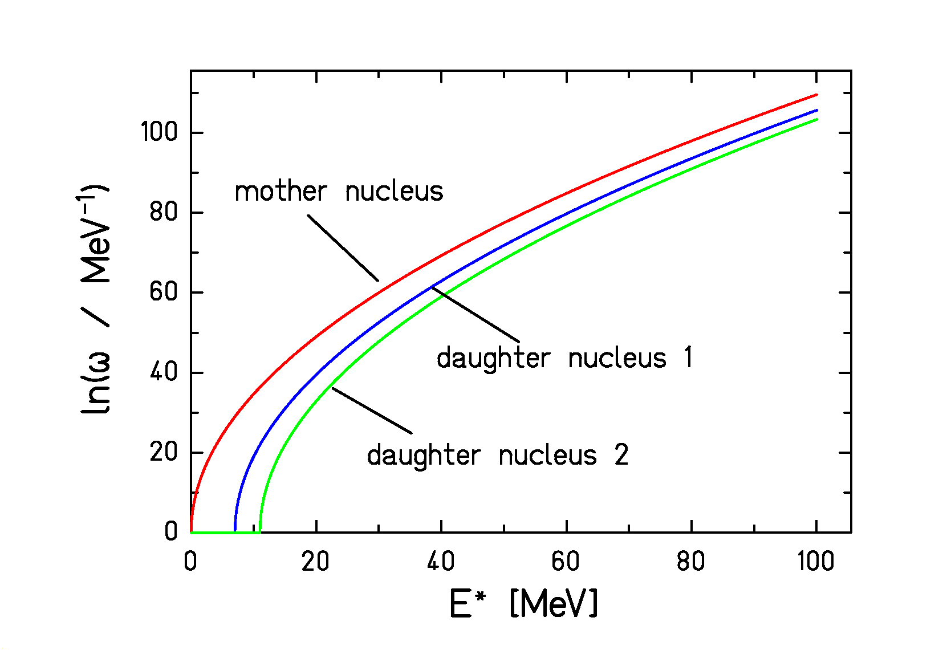
Competition between different decay channels is governed by the level densities above the thresholds.
Evaporation Corridor

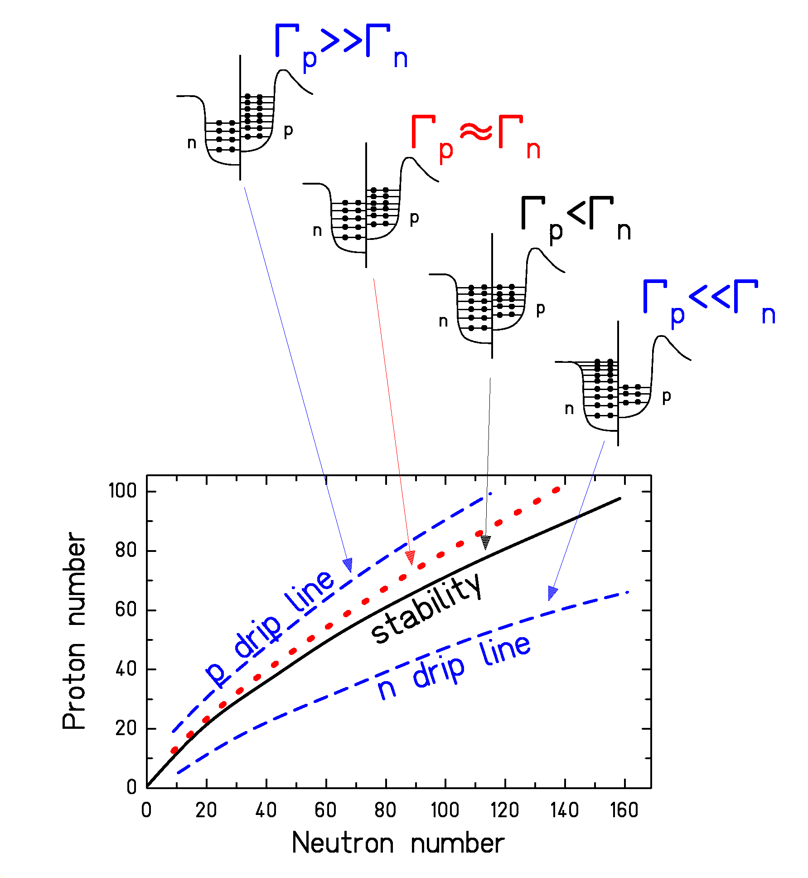
Evaporation is like a diffusion process.
→ Residues concentrate on an "evaporation corridor".

Proton evaporation is hindered by the Coulomb barrier.
→ The "evaporation corridor" is neutron-deficient.
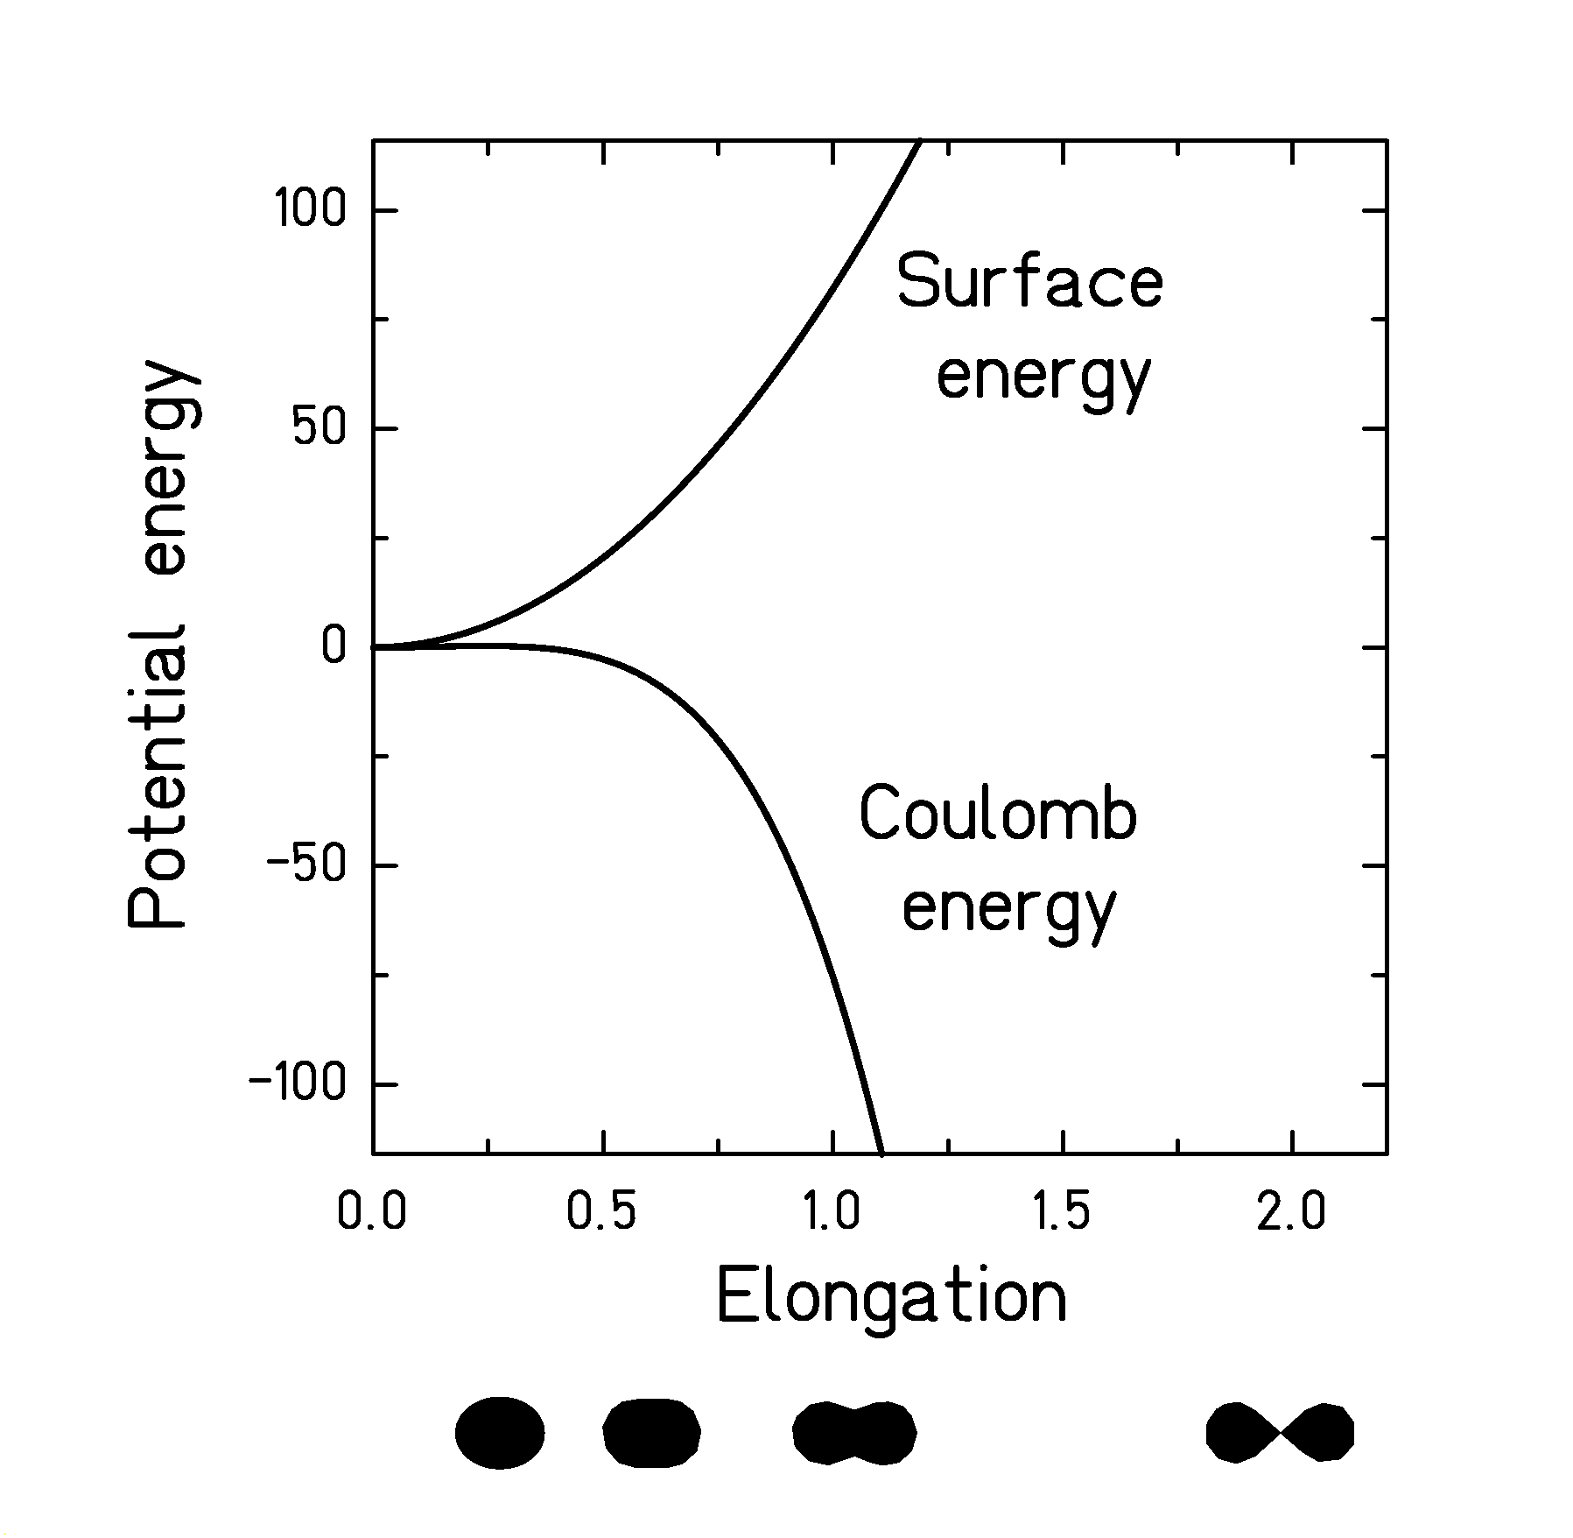
Stability against Fission
(Deformation dependence of surface and Coulomb energy)
Surface and Coulomb energy have different deformation dependence. This is the reason for the stability of heavy nuclei against fission, although the fission fragments are more bound.

Nuclei are stable against fission if the positive curvature of E_{s} is larger than the negative curvature of E_{c} for small deformation:

$$E_{s}=a_{s}A^{\frac{2}{3}}+{ΔE}_{s}\left(ε\right); {ΔE}_{s}\left(ε\right)=a_{s}A^{\frac{2}{3}}⋅\frac{2}{5}ε^{2}+\text{.}\text{.}\text{.}$$

$$E_{c}=a_{c}Z^{2}A^{−\frac{1}{3}}+{ΔE}_{c}\left(ε\right); {ΔE}_{c}=a_{c}Z^{2}A^{−\frac{1}{3}}⋅\frac{1}{5}ε^{2}+\text{.}\text{.}\text{.}$$
Nuclei with a fissility parameter Z²/A ≥ 51 are unstable against fission.
Mass-asymmetry potential at saddle
(Asymmetry dependence of surface and Coulomb energy)

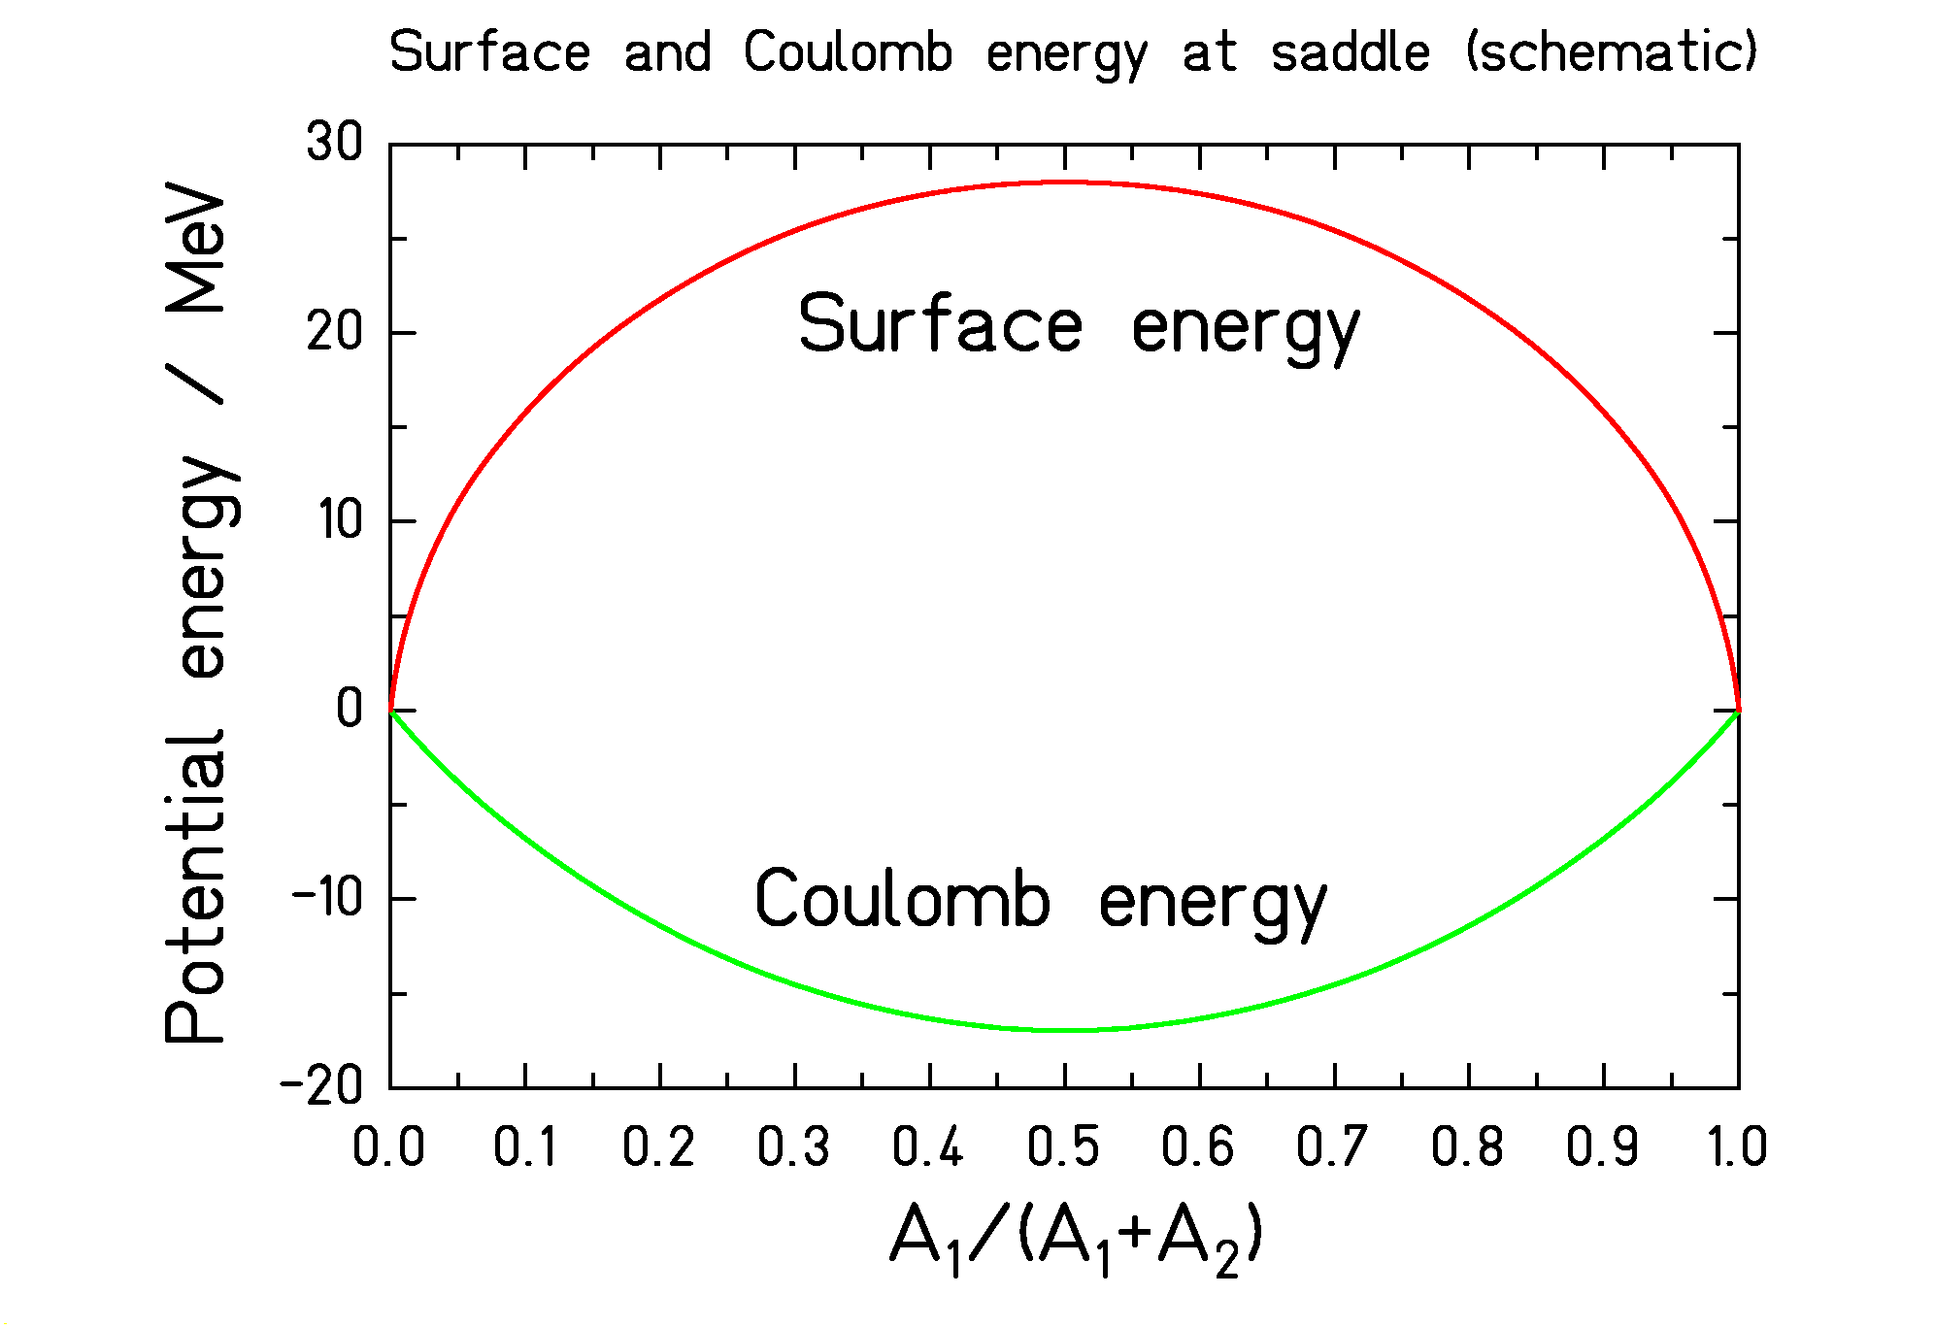
Surface energy is maximum at mass symmetry;
Coulomb energy is minimum at mass symmetry.

Mass dependence of saddle-point energy is given by the sum of surface and Coulomb energy.

Light nuclei: Surface energy dominates.
Heavy nuclei: Coulomb energy dominates.

(Exercise: One can easily estimate the behaviour given in the above figure by the relations of the liquid drop for a touching-sphere configuration where the main dependencies are qualitatively similar.)

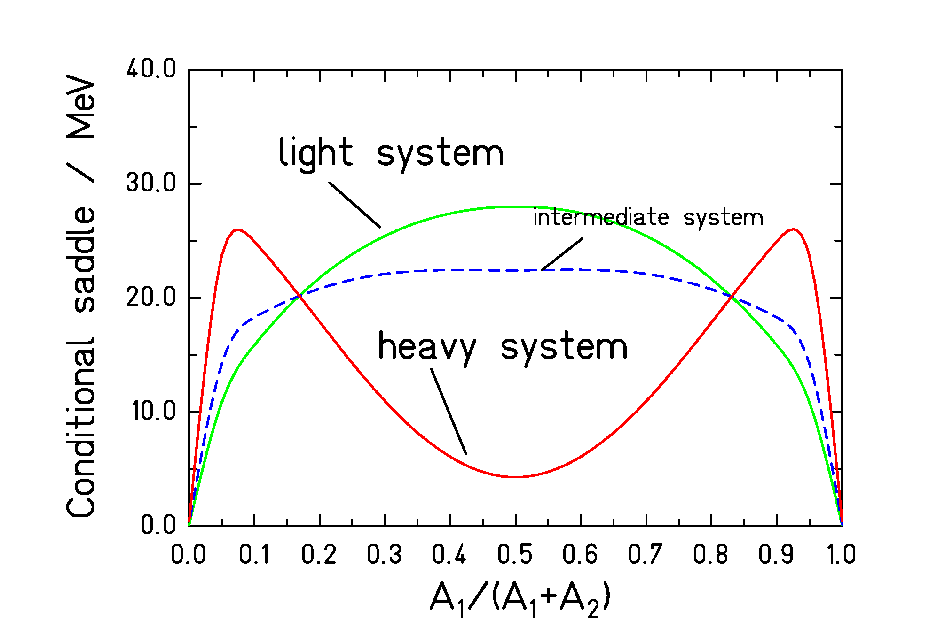
Mass asymmetry in fission

The figure shows the fission barrier height for a given mass split for a light, an intermediate and a heavy system.

- Light system: The surface energy dominates.
Maximum at symmetry!
This is the behaviour we know from water drops or soap bubbles: If two drops or bubbles come into contact, the larger one "eats" the smaller one.

- Intermediate system: The Businaro-Gallone condition is characterised by curvature zero at mass symmetry.

- Heavy system: The Coulomb energy dominates.
Minimum at symmetry!
Fission and evaporation are divided by a maximum barrier height, but there is a smooth transition!
The curvature of the potential defines the stiffness of the saddle-point configuration against mass-asymmetric distortions.
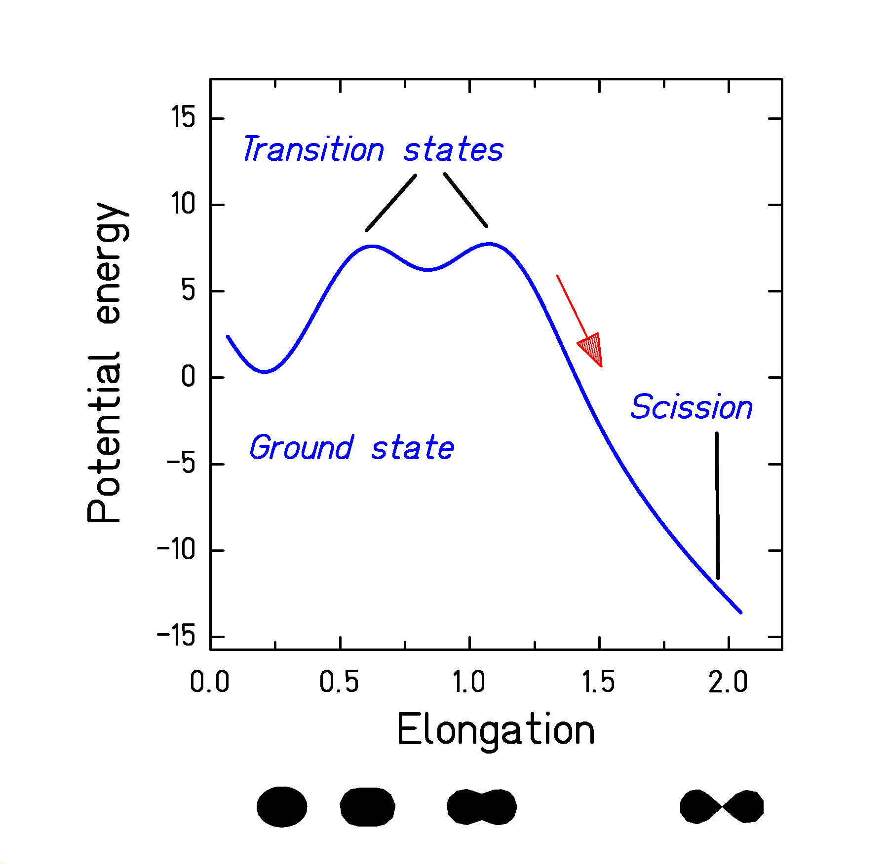
Fission competition
Bohr and Wheeler recognised that the fission probability is governed by the number of states above the fission barrier ("transition states") (not by the number of states of the final fission fragments).

$$Γ_{f}=\frac{1}{2\text{πρ}\left(E^{}\right)}\int_{0}^{E^{}−B_{f}}{ρ_{\text{saddle}}\left(E\right)dE}$$

The picture is complicated by shell effects: three configurations have to be considered: ground state, inner saddle, outer saddle.

The decision whether fission occurs is made at the outer saddle, there is no return possible beyond this point.
Structure effects in the level density

Shell effects (additional binding at low energies → kind of "condensation" ≈ values up to typically 10 MeV)

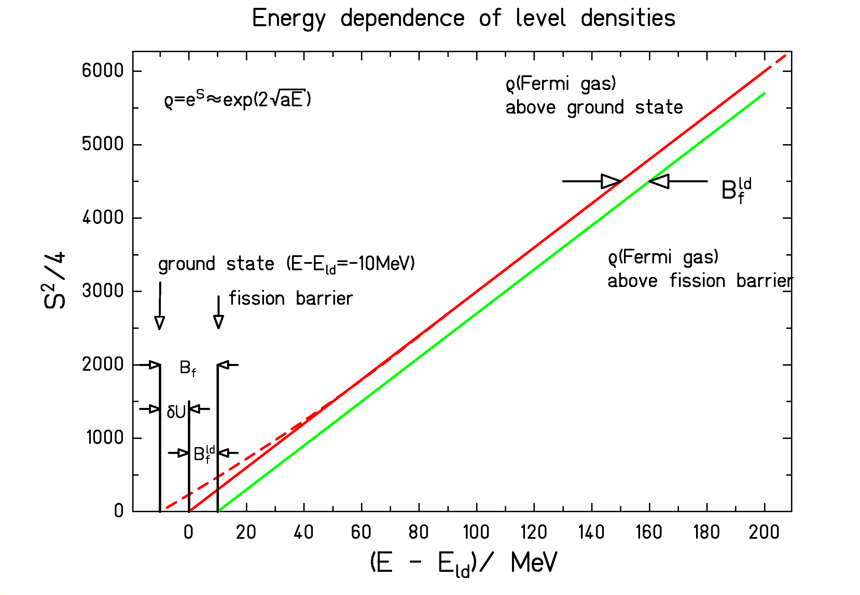
The figure shows a schematic presentation of S²/4 above the ground state and above the fission barrier for a nucleus with a shell effect of δU = -10 MeV. (The entropy S is related to the level density.)

Pairing correlations (additional binding below the critical temperature → condensation energy ≈ 3 MeV)

Collective excitations (vibrations or rotations build on each intrinsic level → multiplication of level density at low energies ≈ 10 to 100)
Nuclide production by Fission
- Basic characteristics:
Curvature of stability valley due to Coulomb repulsion.
→ Fission products are neutron-rich.
Shell effects (¹³²Sn!) or fluctuations in polarisation.
→ The only ways to reach even more neutron-rich.
The asymmetry term in the liquid drop is large.
→ Polarisation is small.
- Excitation energy leads to opposite effects
Fluctuations in polarisation increase.
→ Tail extends to more neutron-rich isotopes.
Excited fission fragments evaporate neutrons.
→ Final fission products are less neutron-rich.

Modelling the Width in A and N/Z
of Fission-Product Isotopic Distributions

Approximated parabolic potential

$$U\left(η\right)=C_{η}⋅{\left(η−η_{o}\right)}^{2}$$

Statistical population:

$Y\left(η\right)∝\text{exp}\left\{2\sqrt{a\left(U_{0}−U\left(η\right)\right)}\right\}$ →

$Y(η)∝\text{exp}\left\{−\frac{{\left(η−η_{0}\right)}^{2}}{2σ_{η}^{2}}\right\}$ with

$$2σ_{η}^{2}=\frac{T}{C_{η}}$$

U = potential energy,
η = either A (mass split) or N/Z (polarisation),
$C_{η}$ = stiffness of the potential,
T = nuclear temperature.
Low-energy fission of actinides

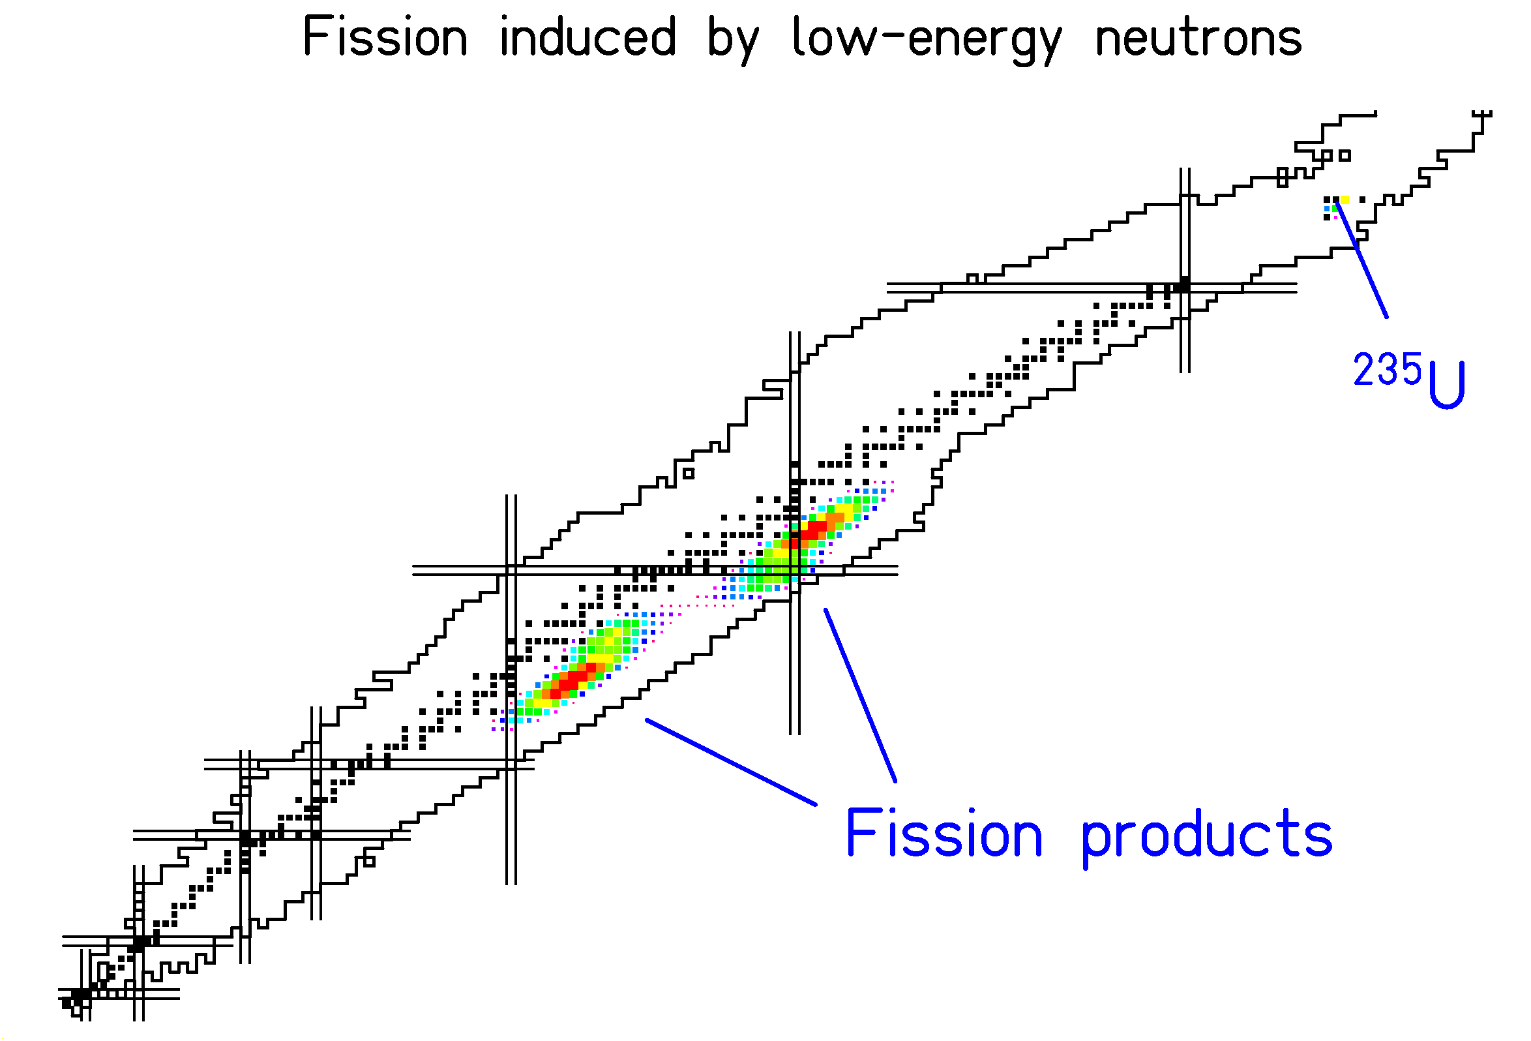
Fission of actinides from low excitation energies
induced by neutrons, protons, electrons, photons.

Shell effects cause structures in mass distribution and charge polarisation.

Production of moderately neutron-rich isotopes of a few elements.

Fission: Variation of Excitation Energy
(Calculations)

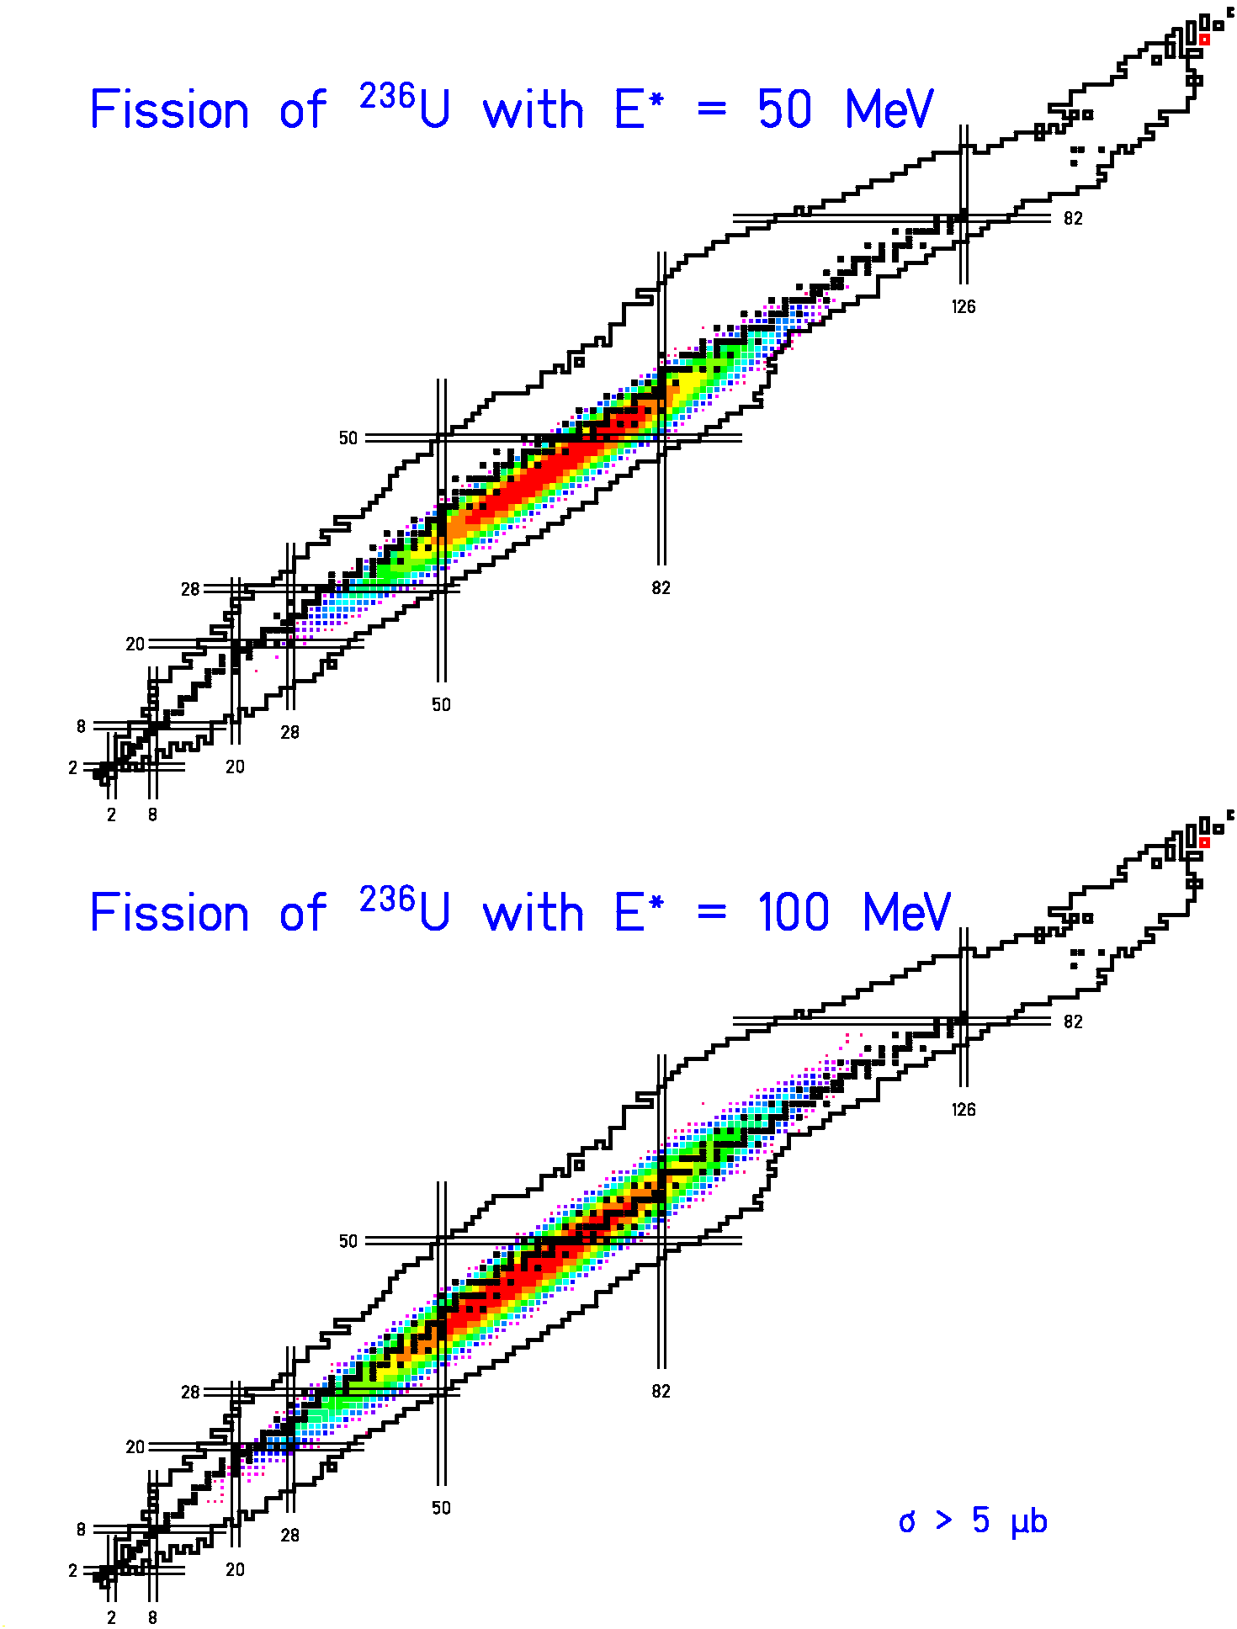
Higher E* → larger fluctuations in A
→ less neutron-rich

D.WHAT DO WE KNOW EXPERIMENTALLY ABOUT PRODUCTION CROSS SECTIONS?
Why Inverse Kinematics?

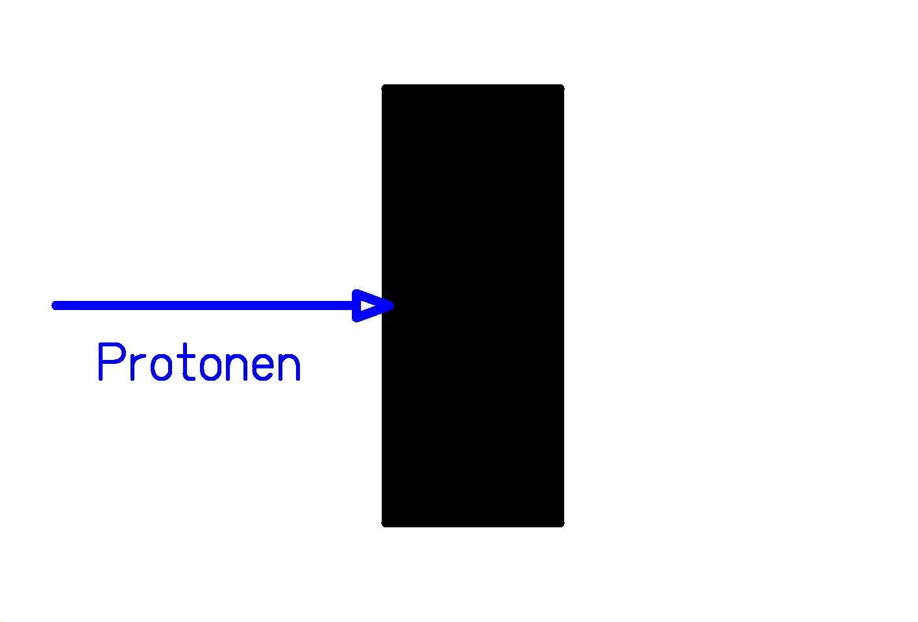
Target fragmentation (e.g. by protons):
Target-like fragments stick in the target.
Identification by radioactive decay
→ Insensitive to short-lived nuclides

Projectile fragmentation:

Projectile-like fragments leave the target with high velocity
Identification in-flight
→ Sensitive to all nuclides
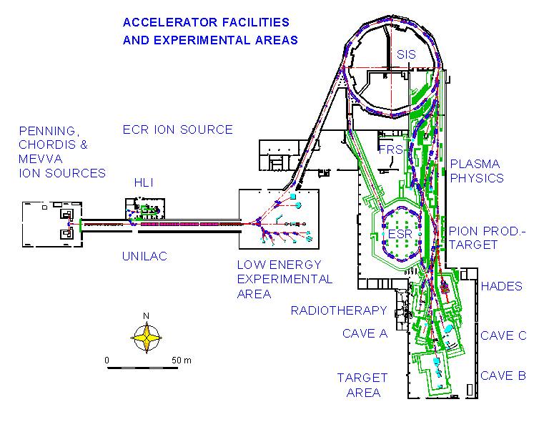
The facilities of GSI

Installations for secondary beams:
UNILAC: Universal linear accelerator (E ≤ 20 A MeV).
SIS18: Heavy-ion synchrotron (E ≤ 1 ... 2 A GeV).
FRS: Magnetic spectrometer for separation of radioactive
beams of projectile-like residues.
ESR: Experimental storage ring.
CAVE B: Large-acceptance magnet ALADIN.

The Fragment Separator

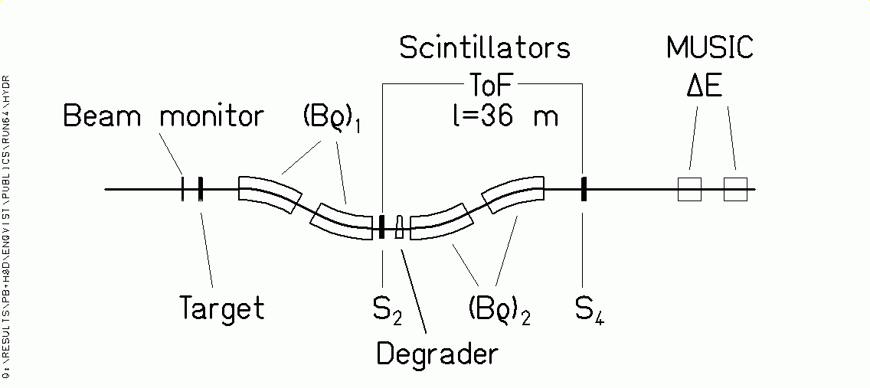

Projectile-like fragments:

Transmitted with ΔBρ/ Bρ = 3% and Θ_{max}=15 mr.

Identification in Z and A by magnetic deflection in FRS, tracking, ToF and ΔE (in energy degrader and MUSIC).

Bρ = m₀ A c β γ / (e Z)

ΔE ∝ Z² / v²

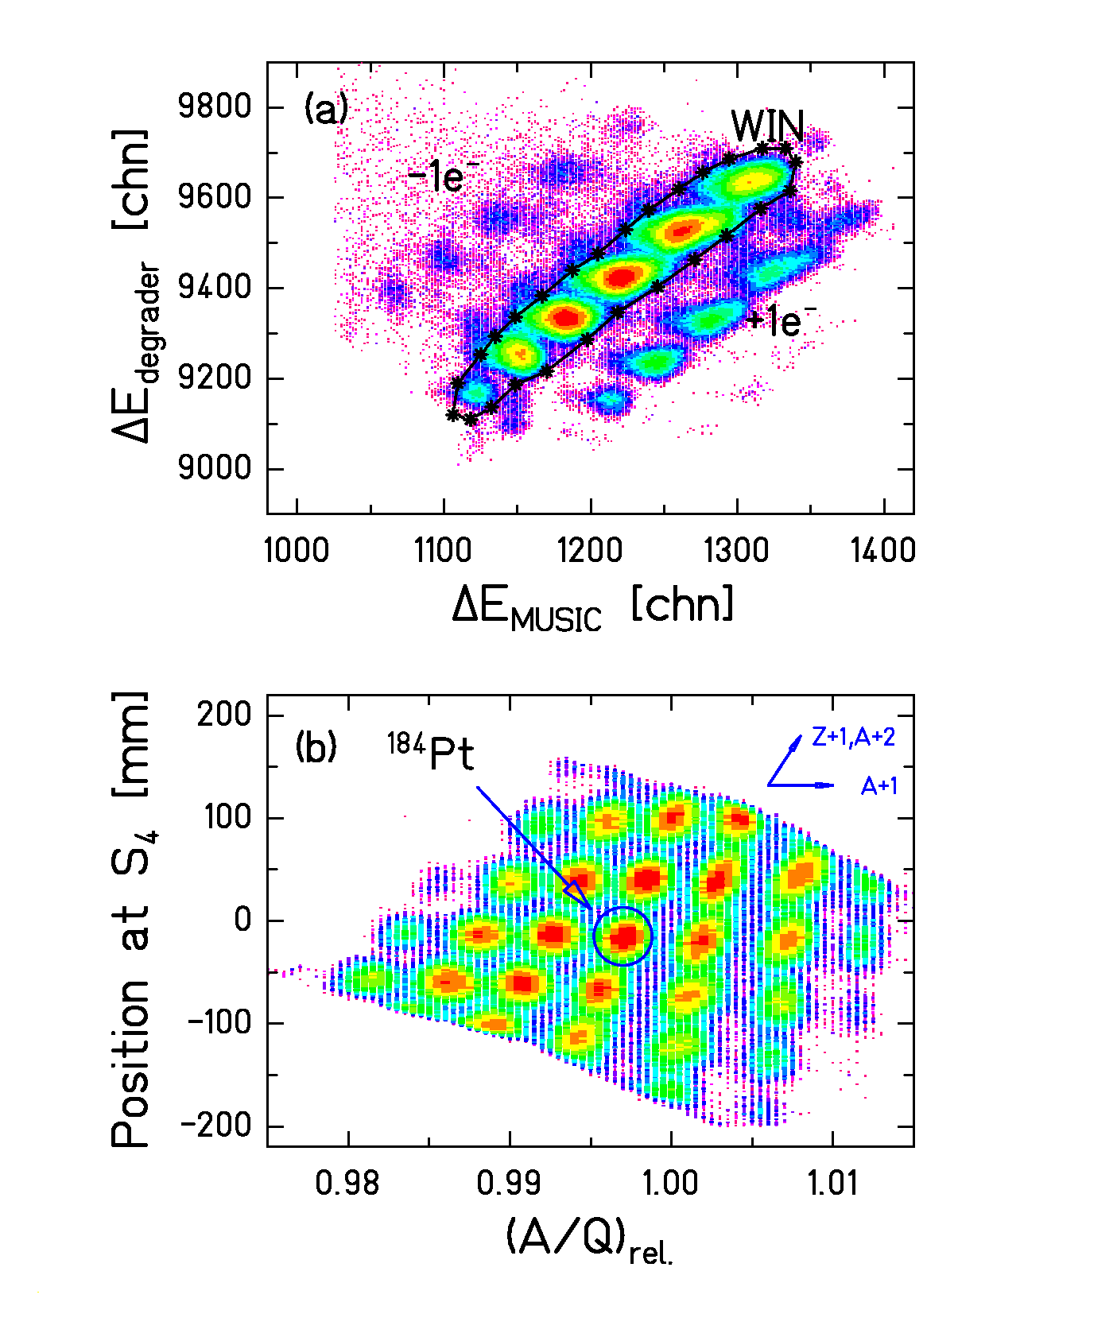
Isotopic identification
Suppression of ionic charge states (above) and isotopic identification (below).

(Data: ²⁰⁸Pb (1 A GeV) + ¹H, Timo Enqvist)
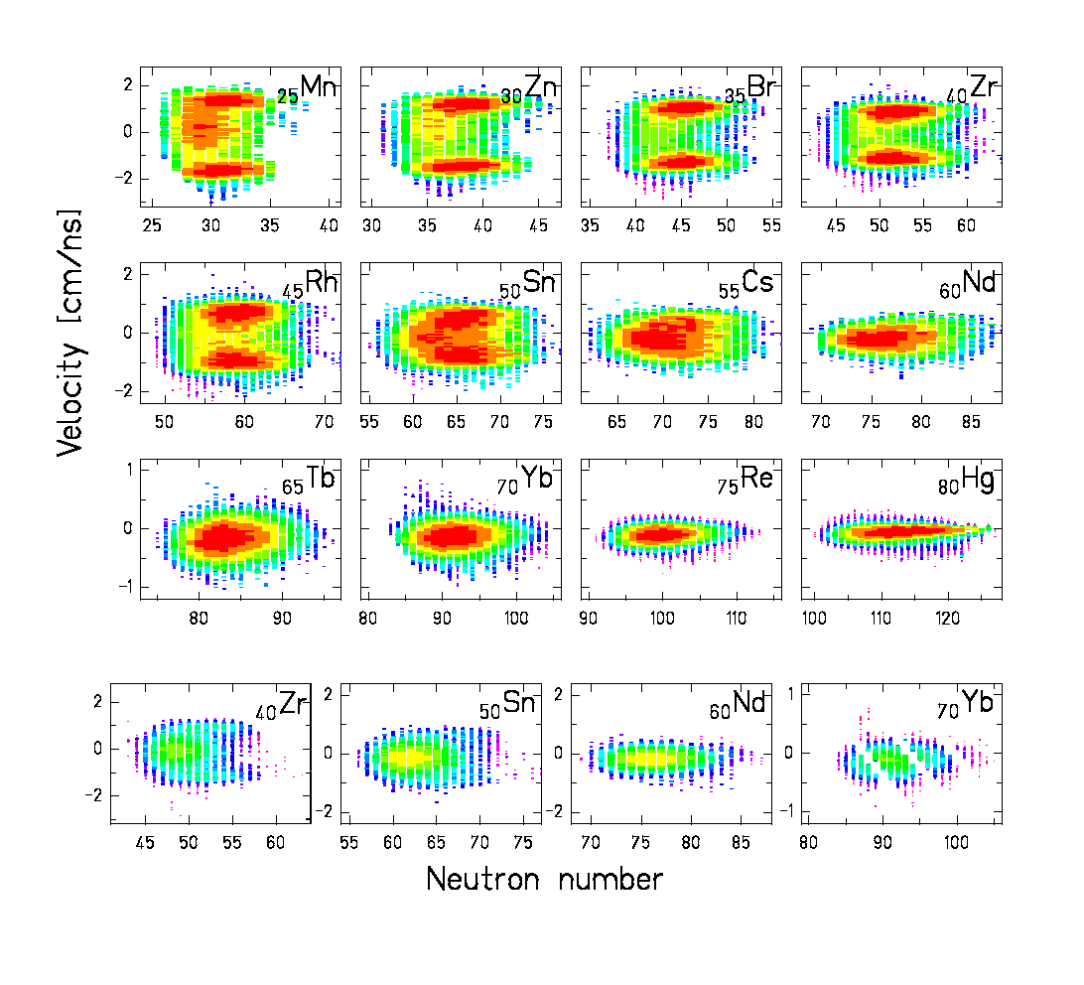
Fragment velocities
Reactions in H₂ target (above) and Ti windows (below).

Signature of the reaction mechanism:

Fragmentation (single peak) and fission (two peaks).

(Data: ²⁰⁸Pb (1 A GeV) + ¹H, Timo Enqvist)

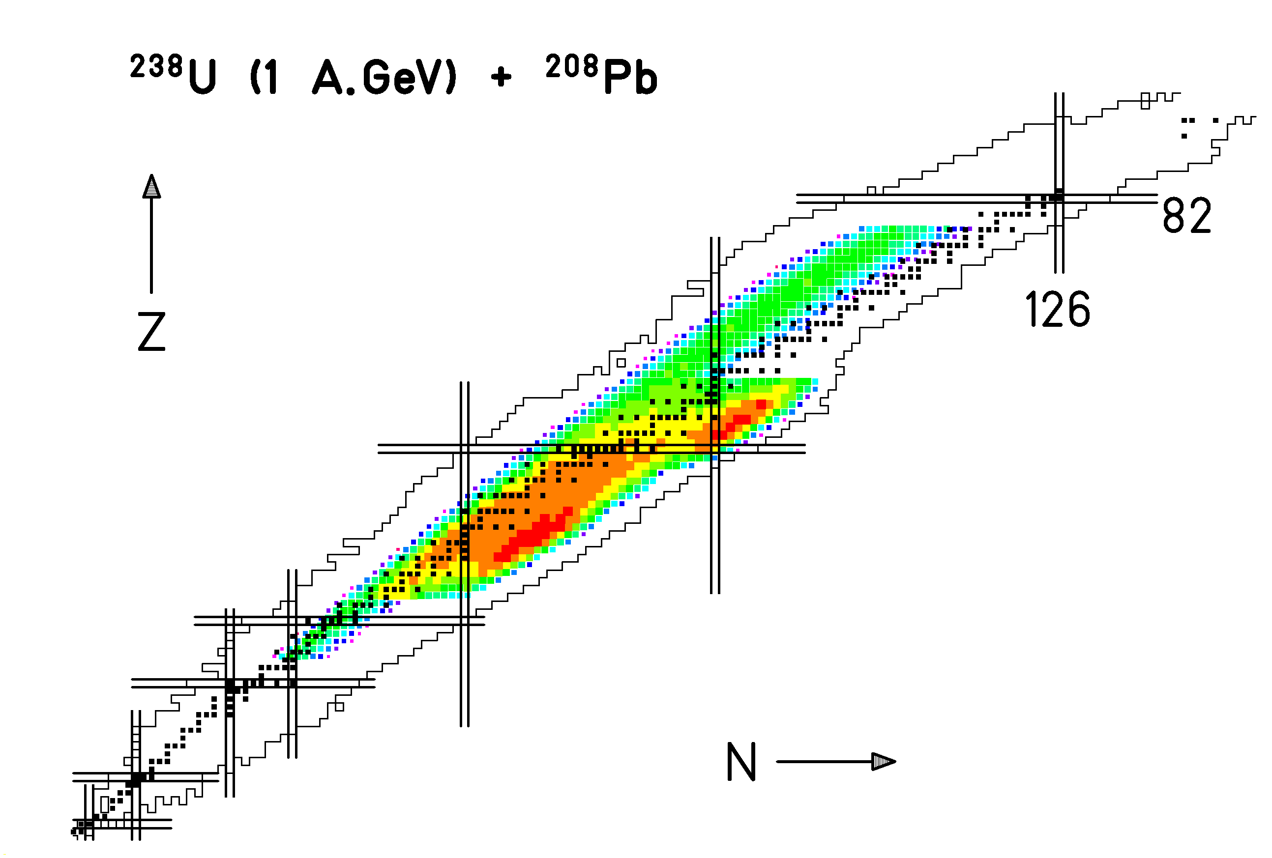
Fragmentation of ²³⁸U

Full mapping of the nuclide production between Z=23 and Z=75.

Combination of different reaction mechanisms:

- Fragmentation: Evaporation-residue corridor.

- Electromagnetic-induced fission: Low-energy asymmetric fission under the influence of shell structure.

- Nuclear-induced fission: High-energy symmetric fission, maximum close to beta-stability.

(Data: ²³⁸U (1 A GeV) + ²⁰⁸Pb, Timo Enqvist)
New Knowledge

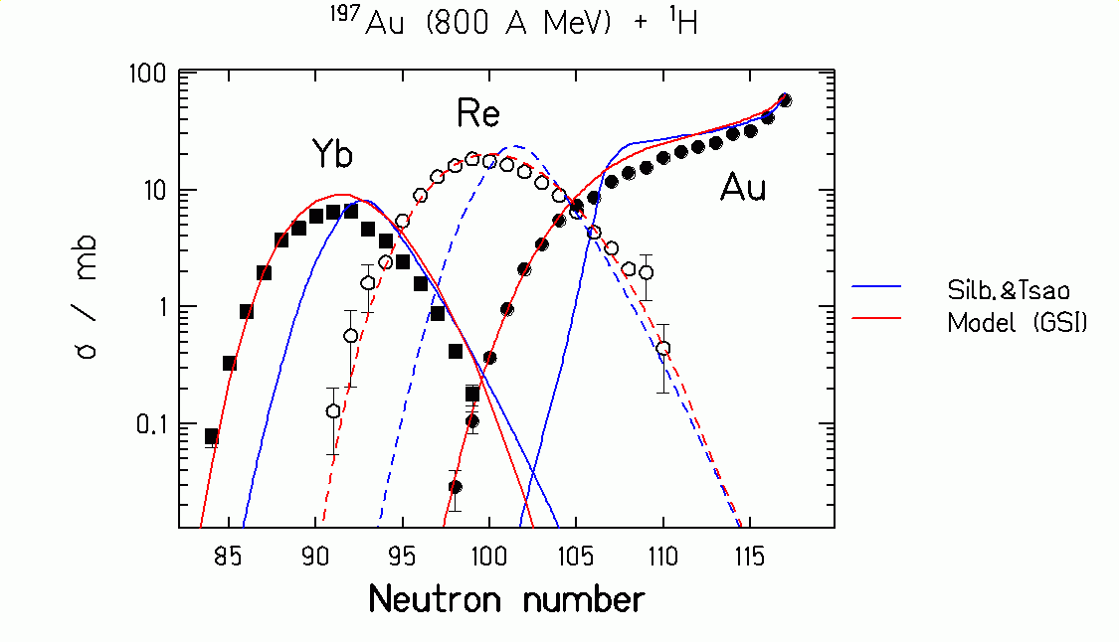

Silberberg and Tsao: Empirical systematics of previous knowledge.

Data points: New data on isotopic cross sections of gold, rhenium and ytterbium.
Data from F. Rejmund et al., submitted to Nucl. Phys. A

GSI model: New model description.
Proton-induced fragmentation of gold

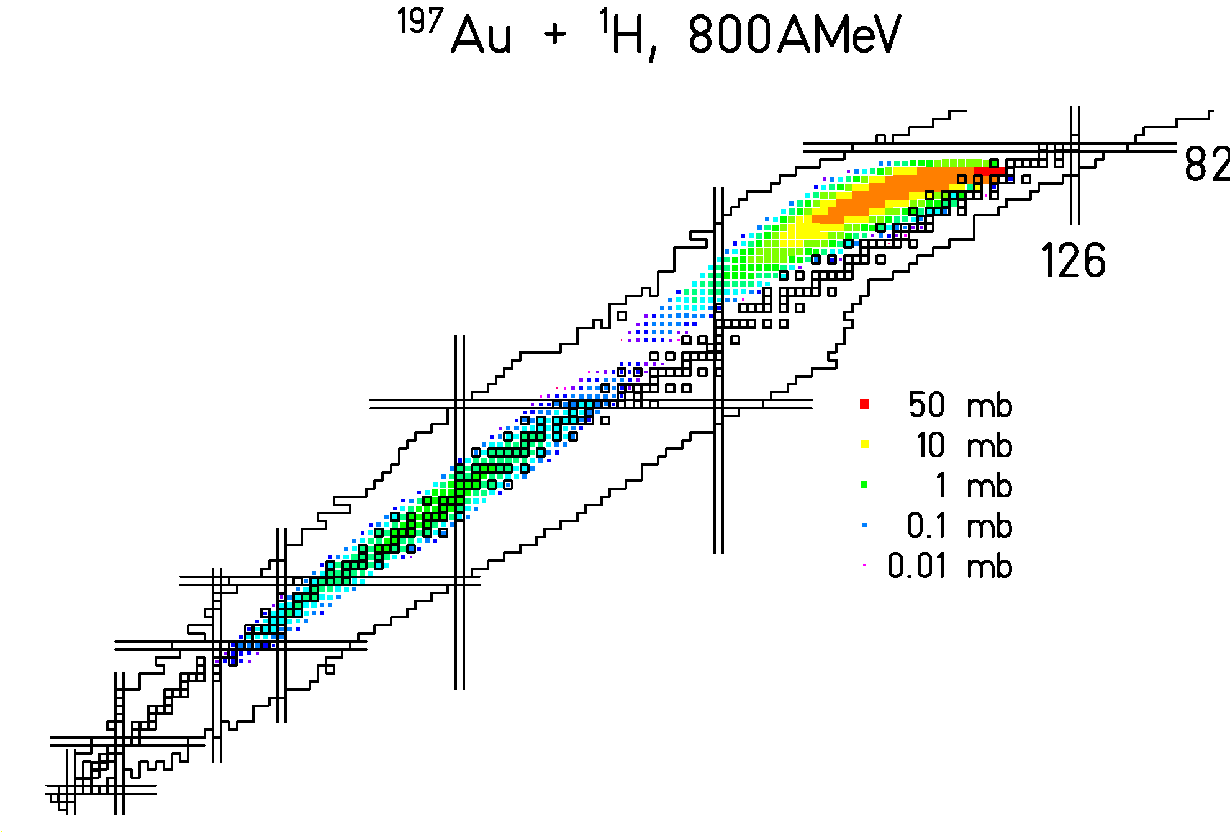

Data from F. Rejmund et al., submitted to Nucl. Phys. A

and J. Benlliure et al. submitted to Nucl. Phys. A

Full isotopic distribution mapped

General characteristics of the model description

- Nucleus-nucleus collision
→ scattering cascade of quasi-free nucleons
  - Mass removed from the projectile
  - Excitation energy induced
  - Angular momentum

- Thermalisation
→ compound nucleus

- Deexcitation
→ boiling drop of nuclear matter
  - n, p, α, LCP evaporation
  - Fission

Critical features

- Transition from cascade collisions to de-excitation.
(The continuous process is artificially divided.)

- Transmission coefficients for particle emission from hot exotic nuclei.
(Only cold stable nuclei are tested by fusion.)

- Nuclear viscosity.
(Statistical model is not valid for fission.)
Excitation energy of the pre-fragments

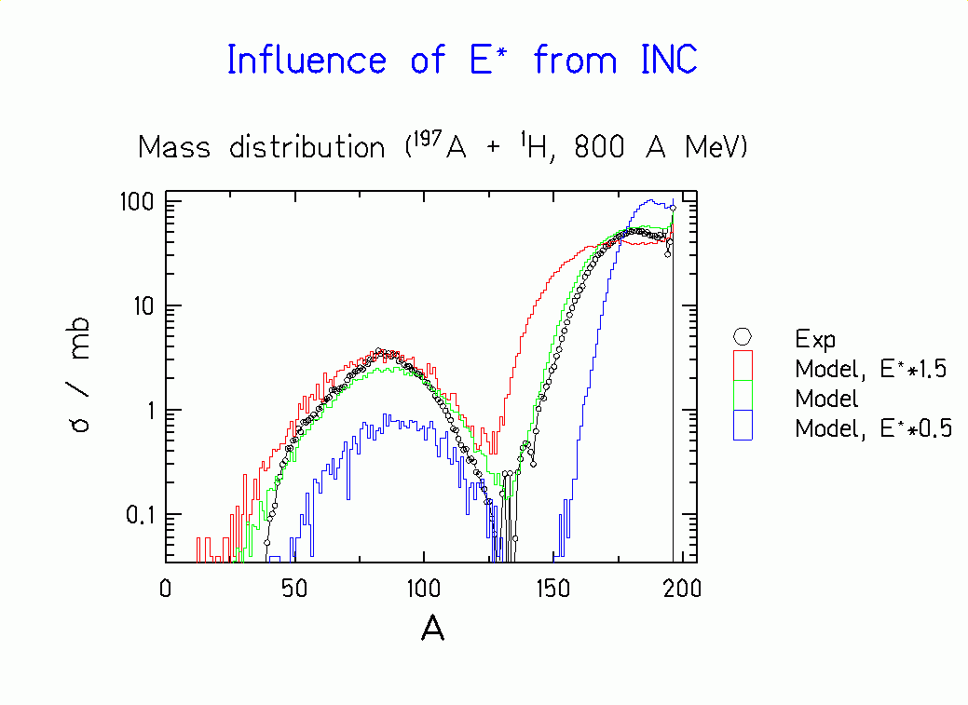
Measured mass distribution (¹⁹⁷Au, 800 A MeV + ¹H) in comparison with different calculations.

The new data give a clear answer!
Viscosity of nuclear matter

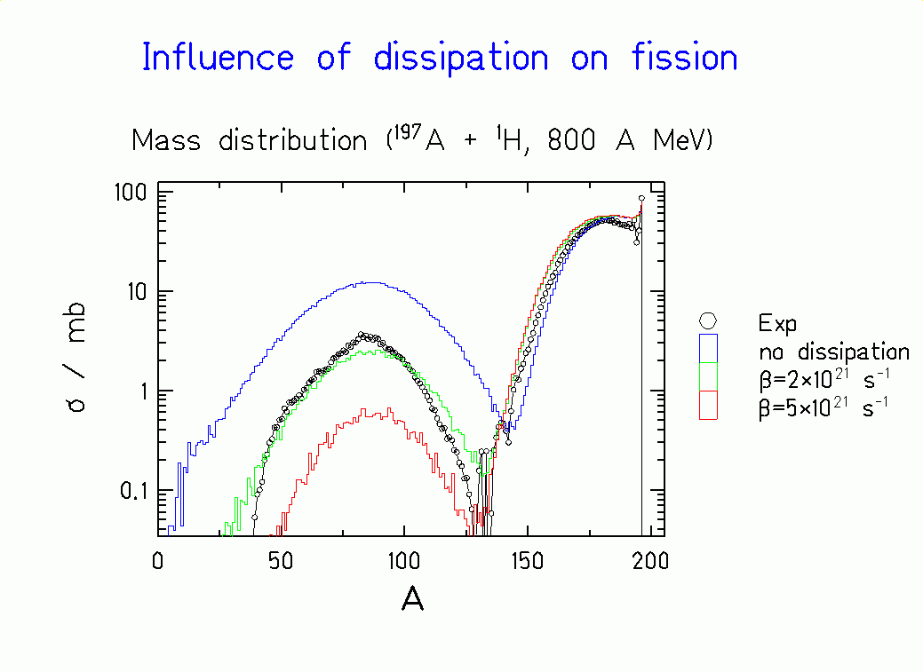
Measured mass distribution (¹⁹⁷Au, 800 A MeV +¹H) in comparison with different calculations.

Strong influence of dissipation on fission!

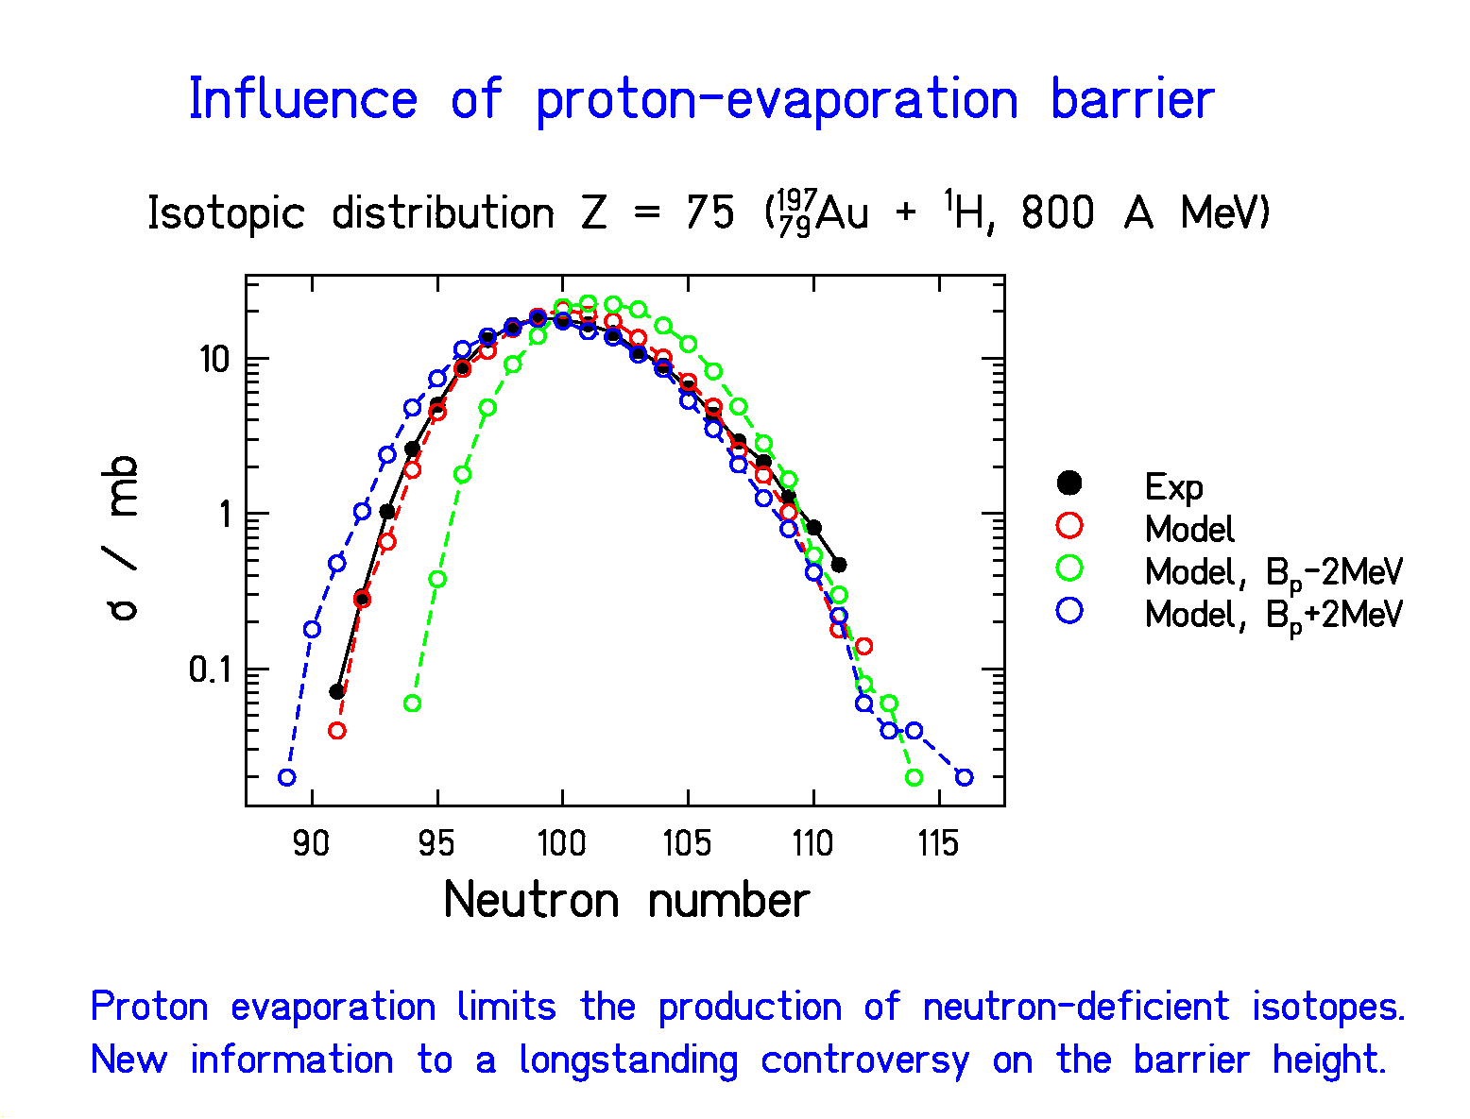
Data from F. Rejmund et al., submitted to Nucl. Phys. A

Systematic view on different projectile-target combinations (calculated)

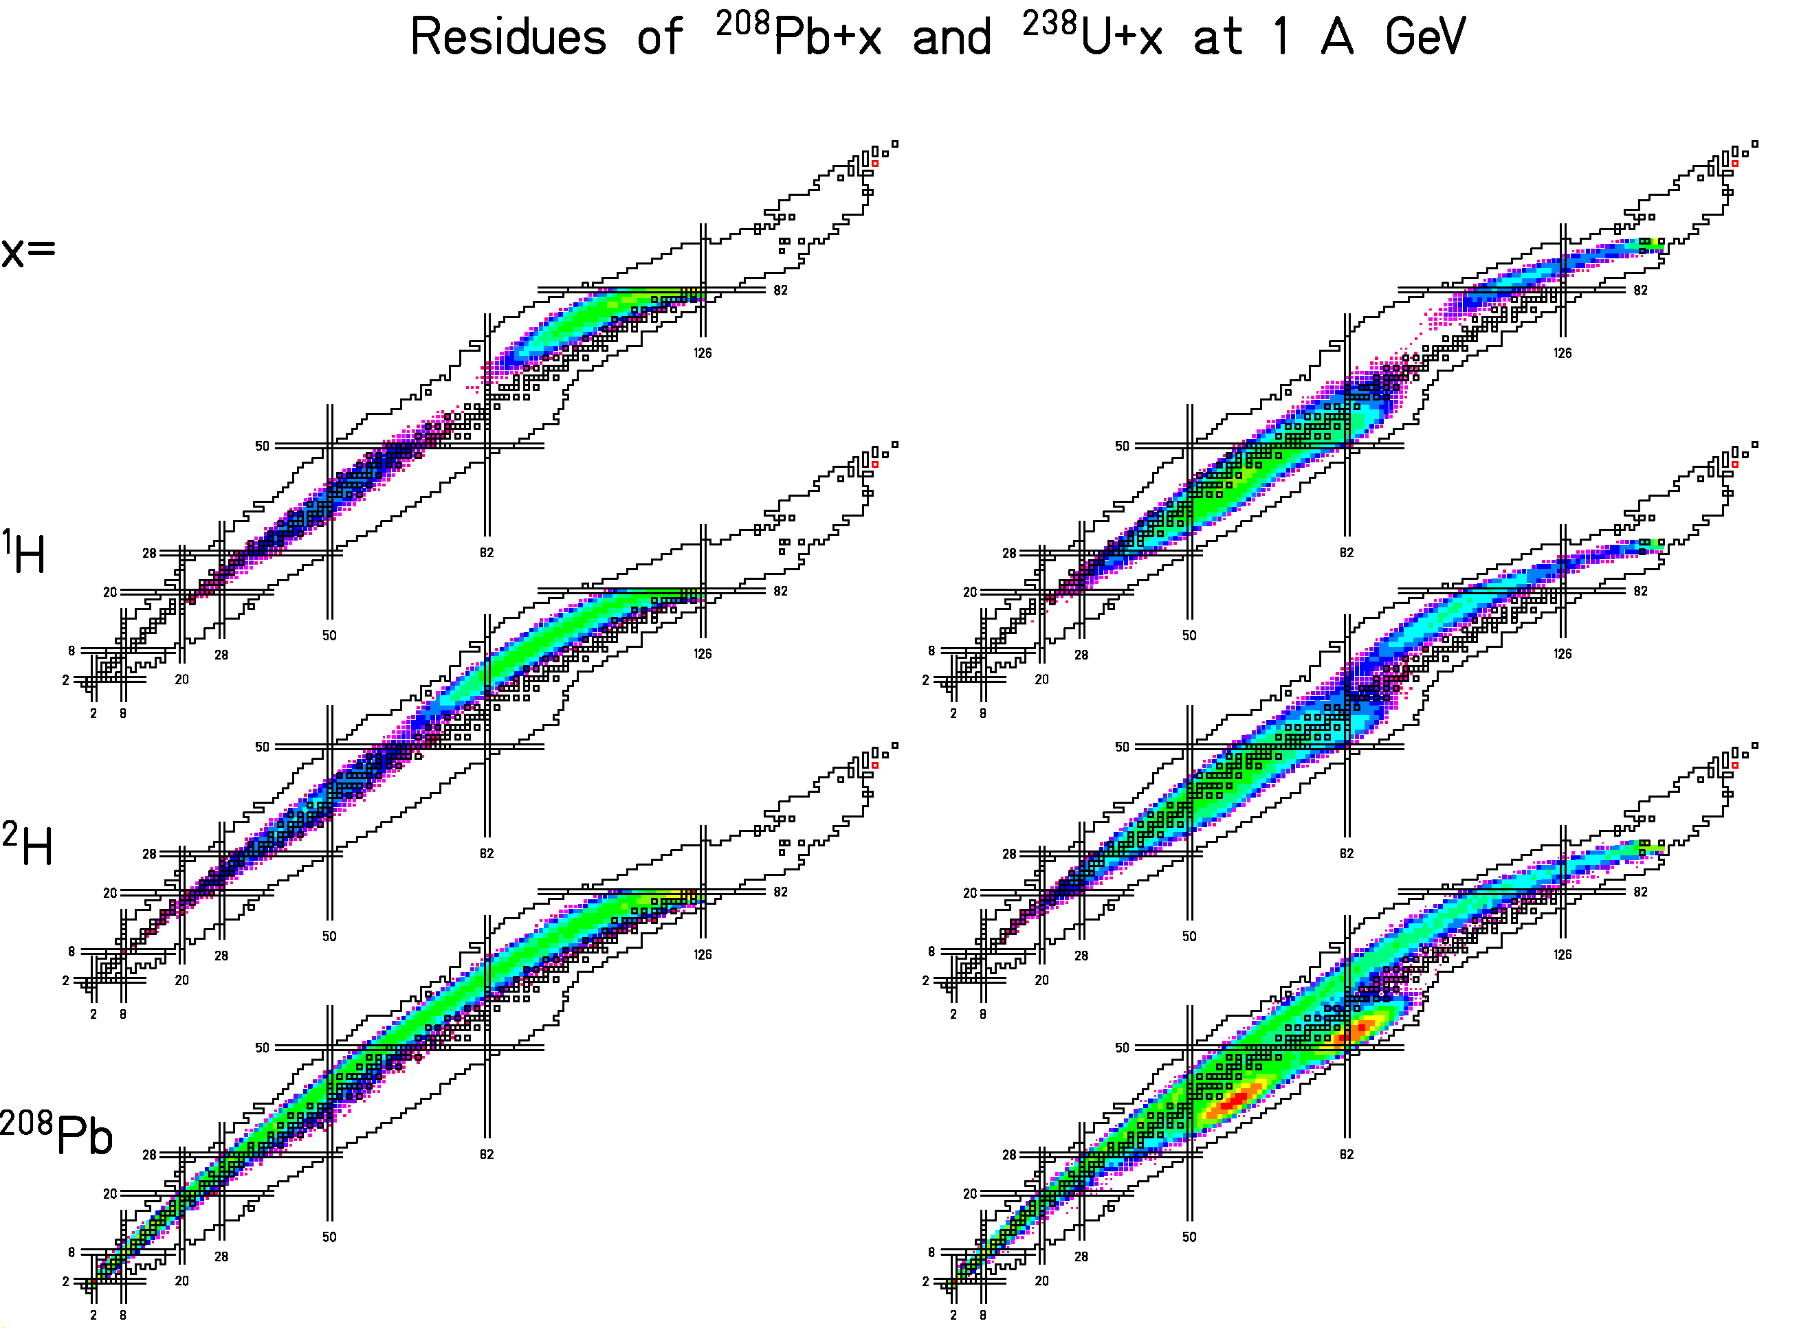

Very different isotopic distributions for different projectile-target combinations.

Kinematic Properties of Potassium Produced from ²³⁸U in Different Targets

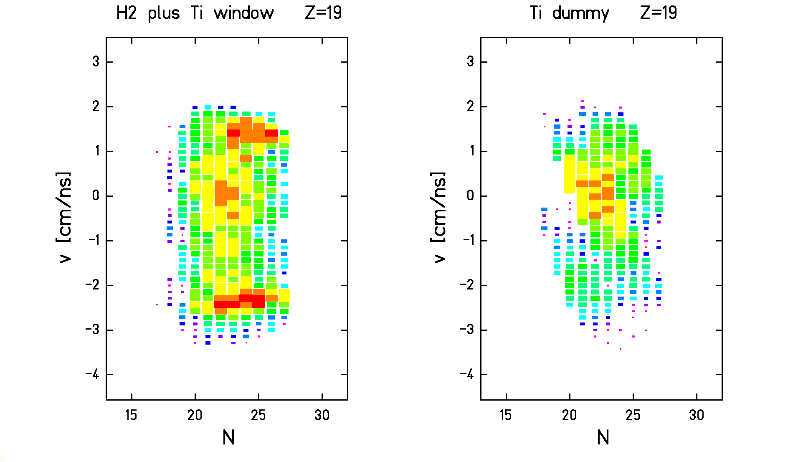
Projectile: ²³⁸U, 1 A GeV
Target left: hydrogen (+ titanium window)
right: titanium

Velocity distributions of potassium isotopes
→ Production in hydrogen target
from very asymmetric fission.
→ Production in titanium target
from projectile fragmentation.

Data from M. V. Ricciardi, GSI, thesis in preparation.

Production of Potassium in p + ²³⁸U
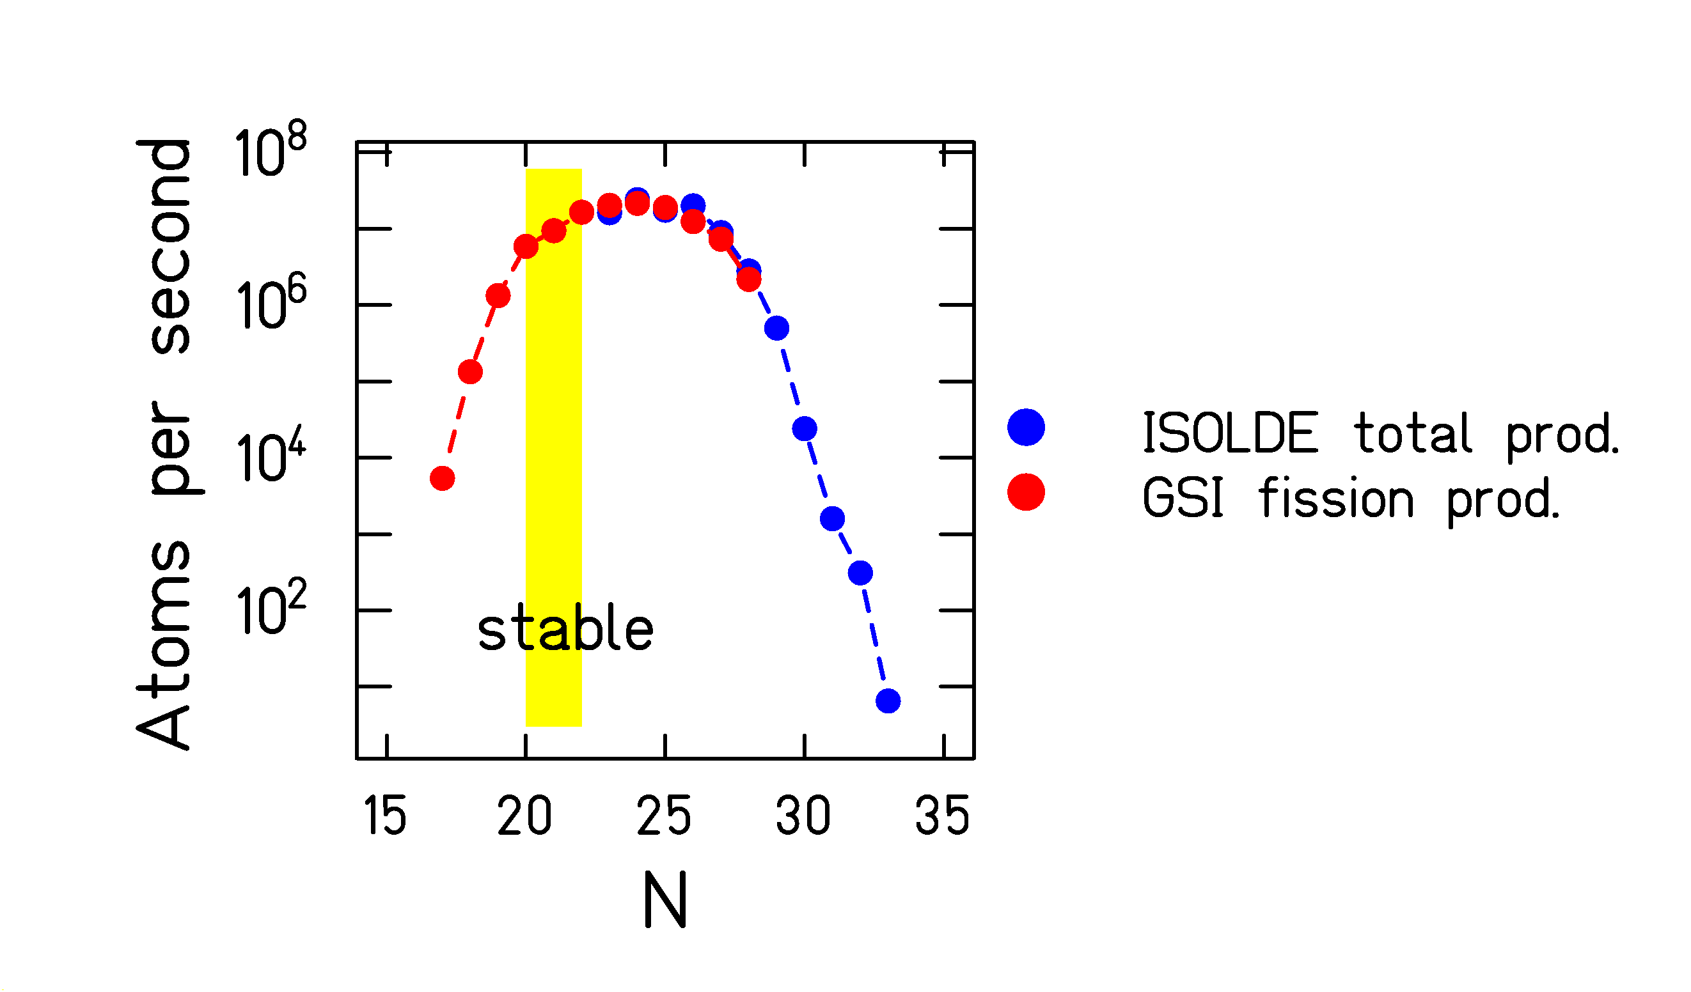
Isotopic yields from 600 MeV protons on ²³⁸U (ISOLDE)
and
fission-product yields from 1 A GeV ²³⁸U + hydrogen (GSI)

No absolute cross sections from ISOLDE yields.

The distributions fit together:
ISOLDE yields of light elements from fission!

Data from
H.-J. Kluge, ISOLDE user's guide, CERN 86-05 (1986) and
M. V. Ricciardi, GSI, thesis in preparation

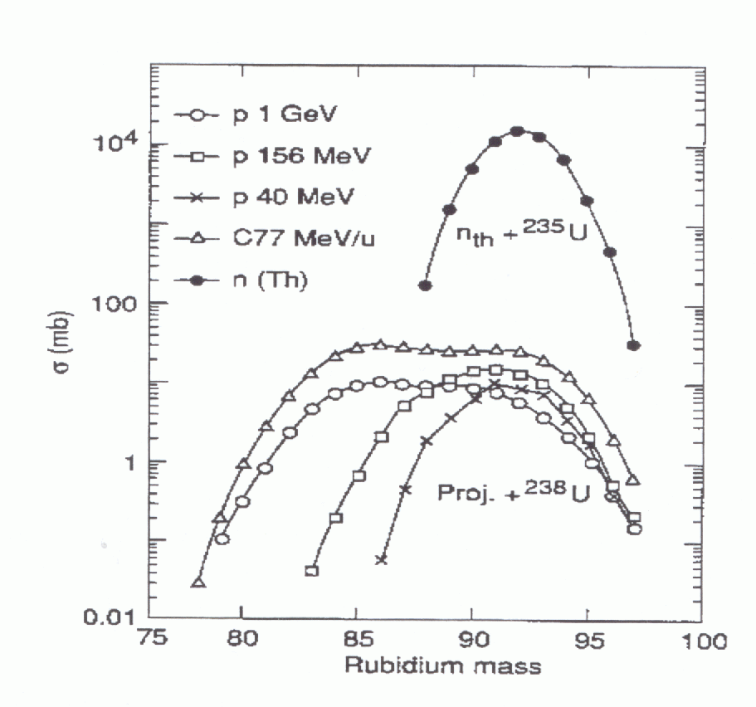
Systematics of isotopic production of Rb

Production cross sections of neutron-rich fragments are almost independent of the projectile.

From H. L. Ravn et al. Nucl. Instr. Meth. B88 (1994) 441

Exploring the limits of neutron-rich isotopes
by fragmentation-fission reactions

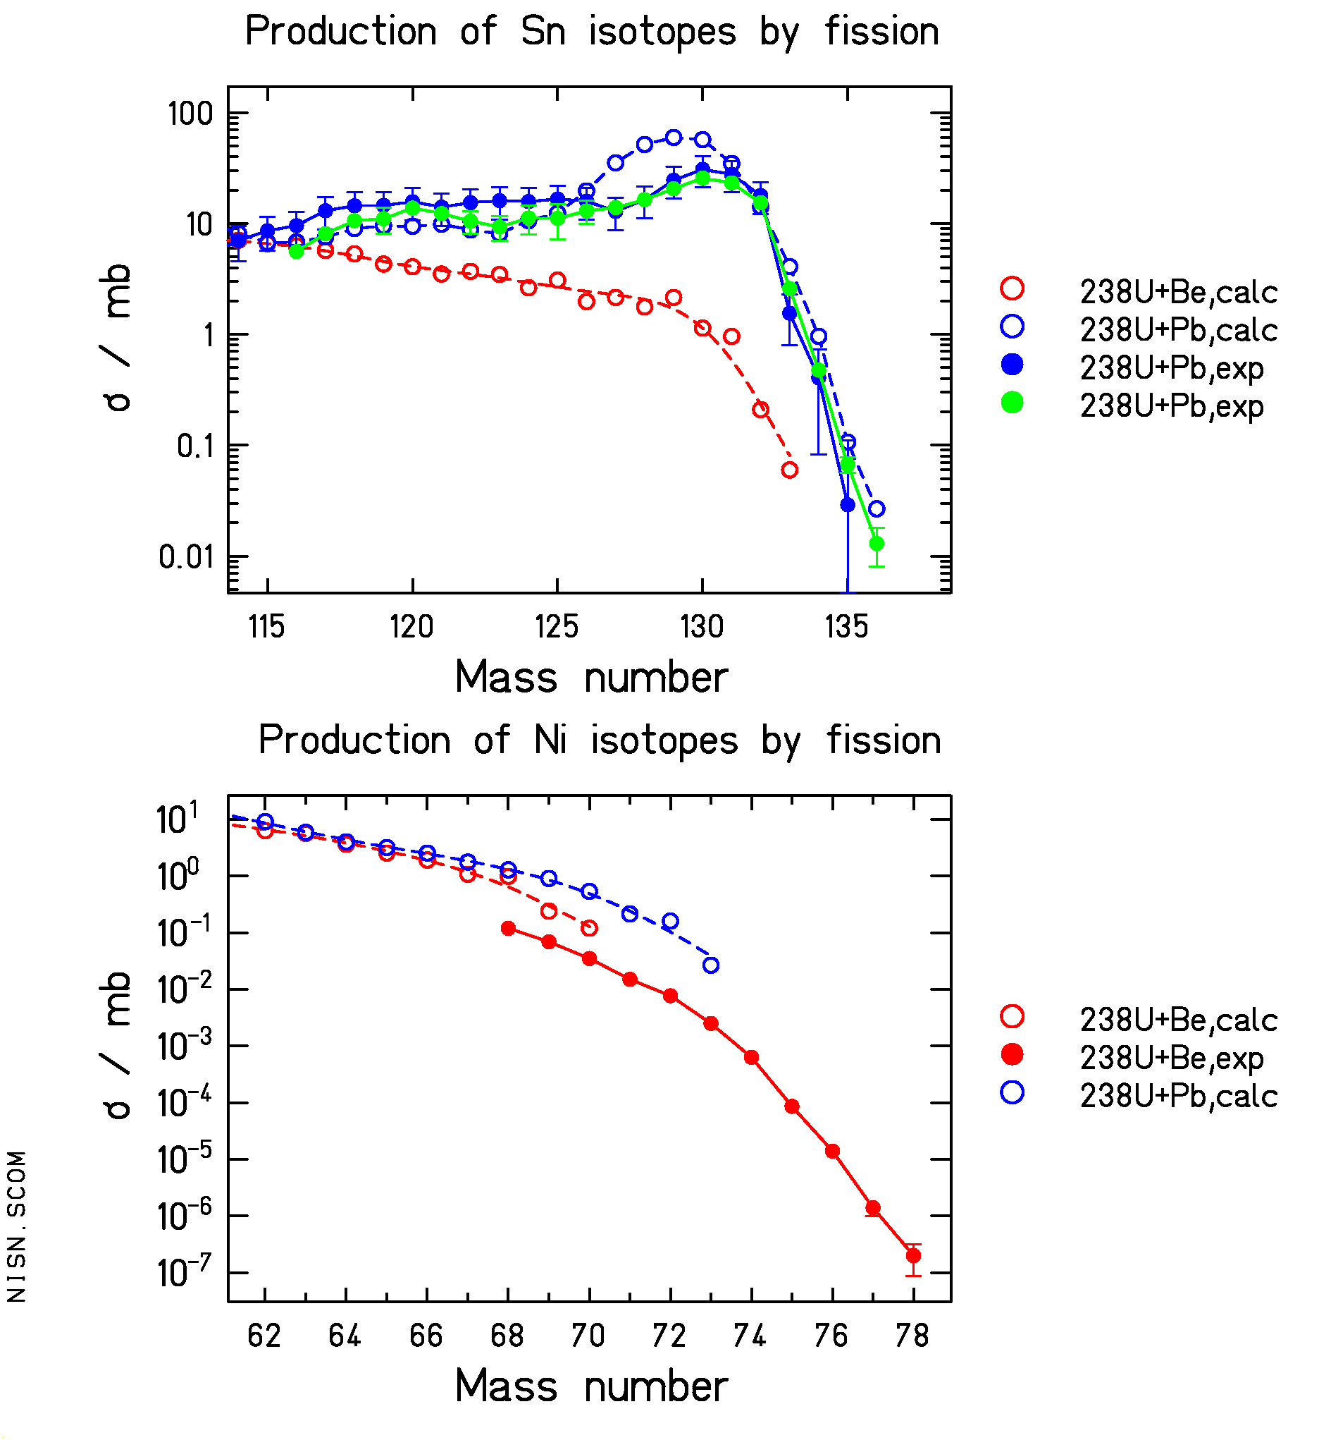
Data from T. Enqvist et al., Nucl. Phys. A 658 (1999) 47,
C. Donzaud et al., Eur. Phys. J. A1 (1998) 407,
C. Engelmann et al., Z. Phys. A 352 (1995) 351.

Steep decrease of cross sections due to limitation of charge polarisation in fission.
Fission of relativistic ²³⁸U for production of neutron-rich isotopes

Successfully applied:

"DISCOVERY AND CROSS-SECTION MEASUREMENT OF 58 NEW FISSION PRODUCTS IN PROJECTILE-FISSION OF 750 A MeV 238U"
B. Bernas, C. Engelmann, P. Armbruster, S. Czajkowski, F. Ameil, C. Böckstiegel, Ph. Dessagne, C. Donzaud, H. Geissel, A. Heinz, Z Janas, C. Kozhuharov, Ch. Miehe, G. Münzenberg, M. Pfützner, W. Schwab, C. Stephan, K. Sümmerer, L. Tassan-Got, B. Voss
Phys. Lett. B 415 (1997) 111-116
"PRODUCTION AND IDENTIFICATION OF HEAVY Ni ISOTOPES: EVIDENCE FOR THE DOUBLY MAGIC NUCLEUS 78Ni"
Ch. Engelmann, F. Ameil, P. Armbruster, M. Bernas, S. Czajkowski, Ph. Dessagne, C. Donzaud, H. Geissel, A. Heinz, Z. Janas, C. Koshuharov, Ch. Miehe, G. Münzenberg, M. Pfützner, C. Röhl, W. Schwab, C. Stephan, K. Sümmerer, L. Tassan-Got, B. Voss
Z. Phys. A 352 (1995) 351-352

Low-energy fission → Yield concentrated on a few rather neutron-rich fission fragments.

High-energy fission → Broader distributions in mass and N/Z; better conditions for extremely neutron-rich?
Fragmentation

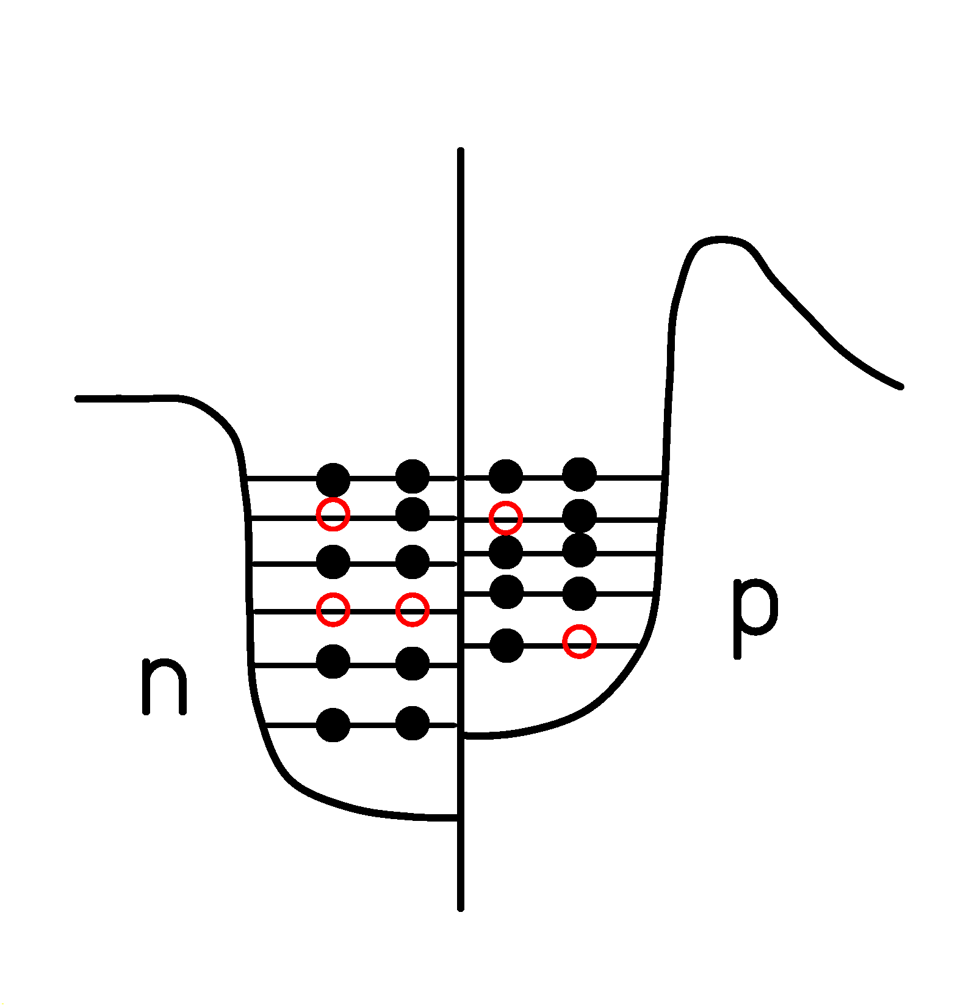
Removal of nucleons in quasi-free nucleon-nucleon collisions.

- Large fluctuations in N/Z (hyperg. distr.).
- Large fluctuations in excitation energy (hole exc.).
Going neutron-rich by cold abrasion of protons?
Dedicated study of proton-removal channels
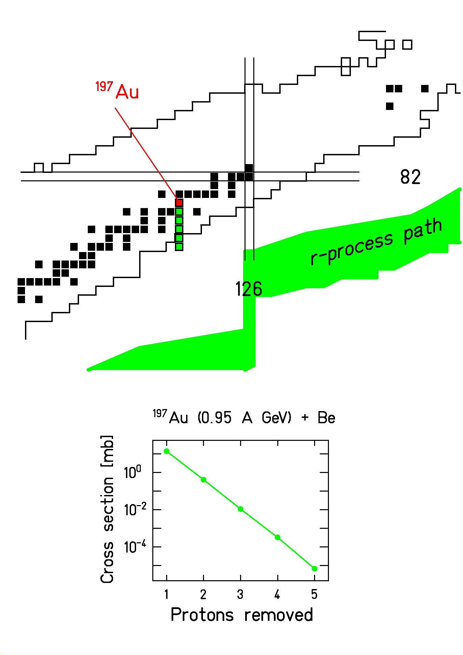
Data from J. Benlliure et al., Nucl. Phys. A 660 (1999) 87.

Abrasion of protons only, no evaporation of neutrons
=> "Cold Fragmentation".
Promising results for producing neutron-rich nuclei.
Reaching extremely neutron-rich isotopes by cold fragmentation
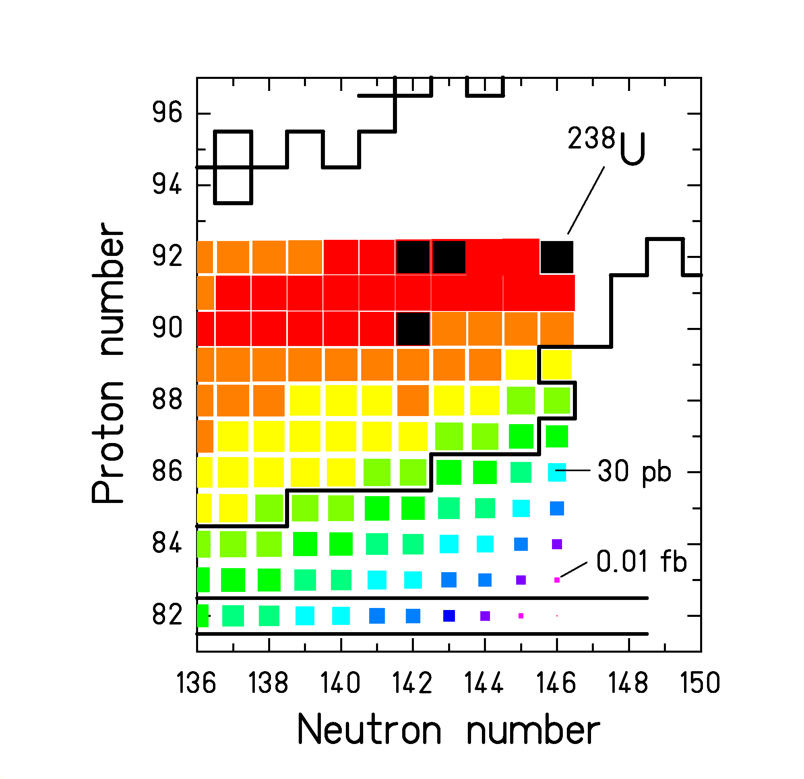
Result of a model calculation^{a)} on cold fragmentation ²³⁸U (1 A GeV) + Be. Many new neutron-rich isotopes in reach, but low cross sections!

^{a)} The model is described in J. Benlliure et al., Nucl. Phys. A 660 (1999) 87

E.WHAT ARE THE LIMITATIONS DUE TO NON-NUCLEAR INTERACTIONS IN THE TARGET?
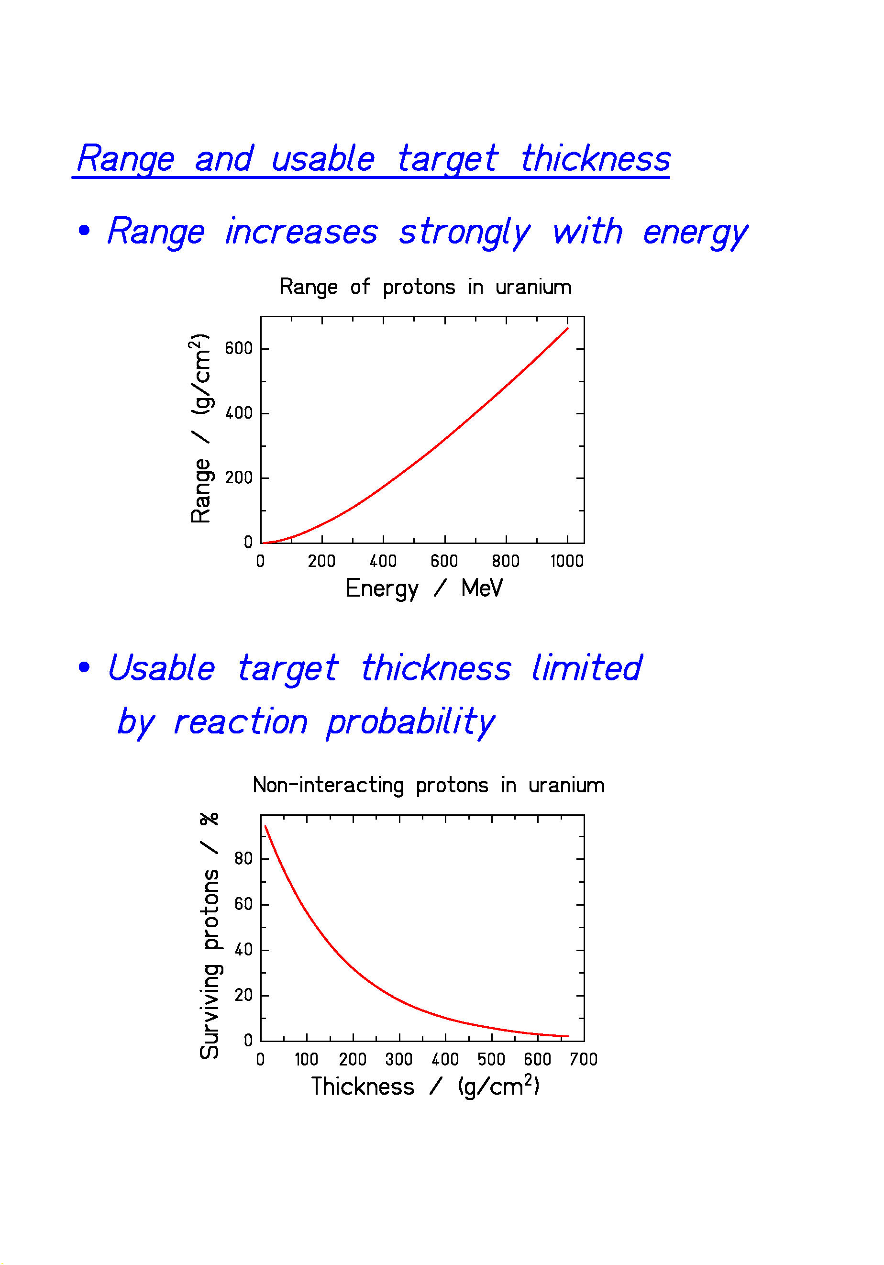
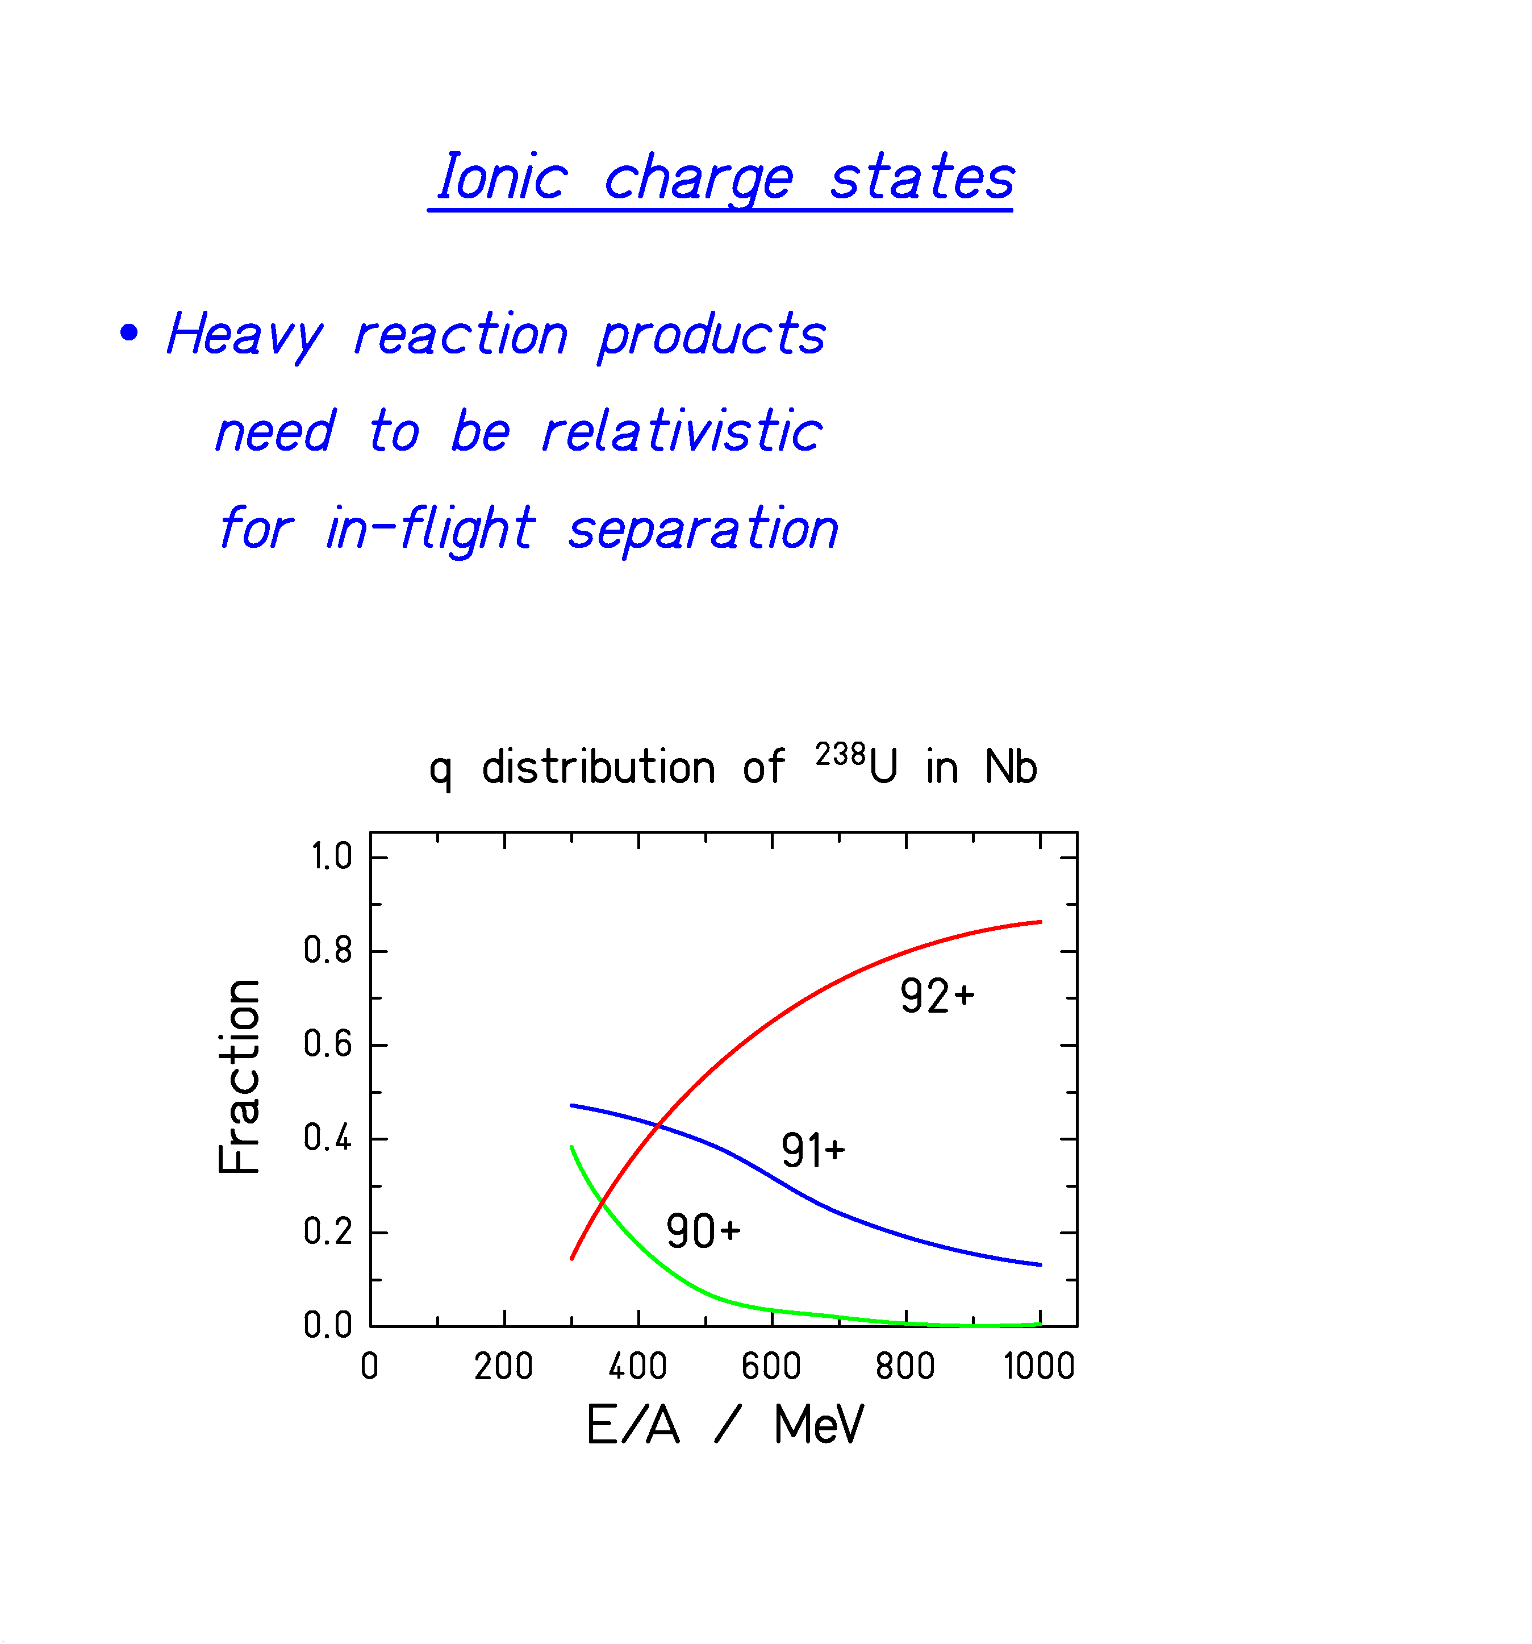
F. HOW CAN ONE MAKE ACCELERATED RADIOACTIVE-ION BEAMS?
Methods for the production of secondary beams
(Some examples)

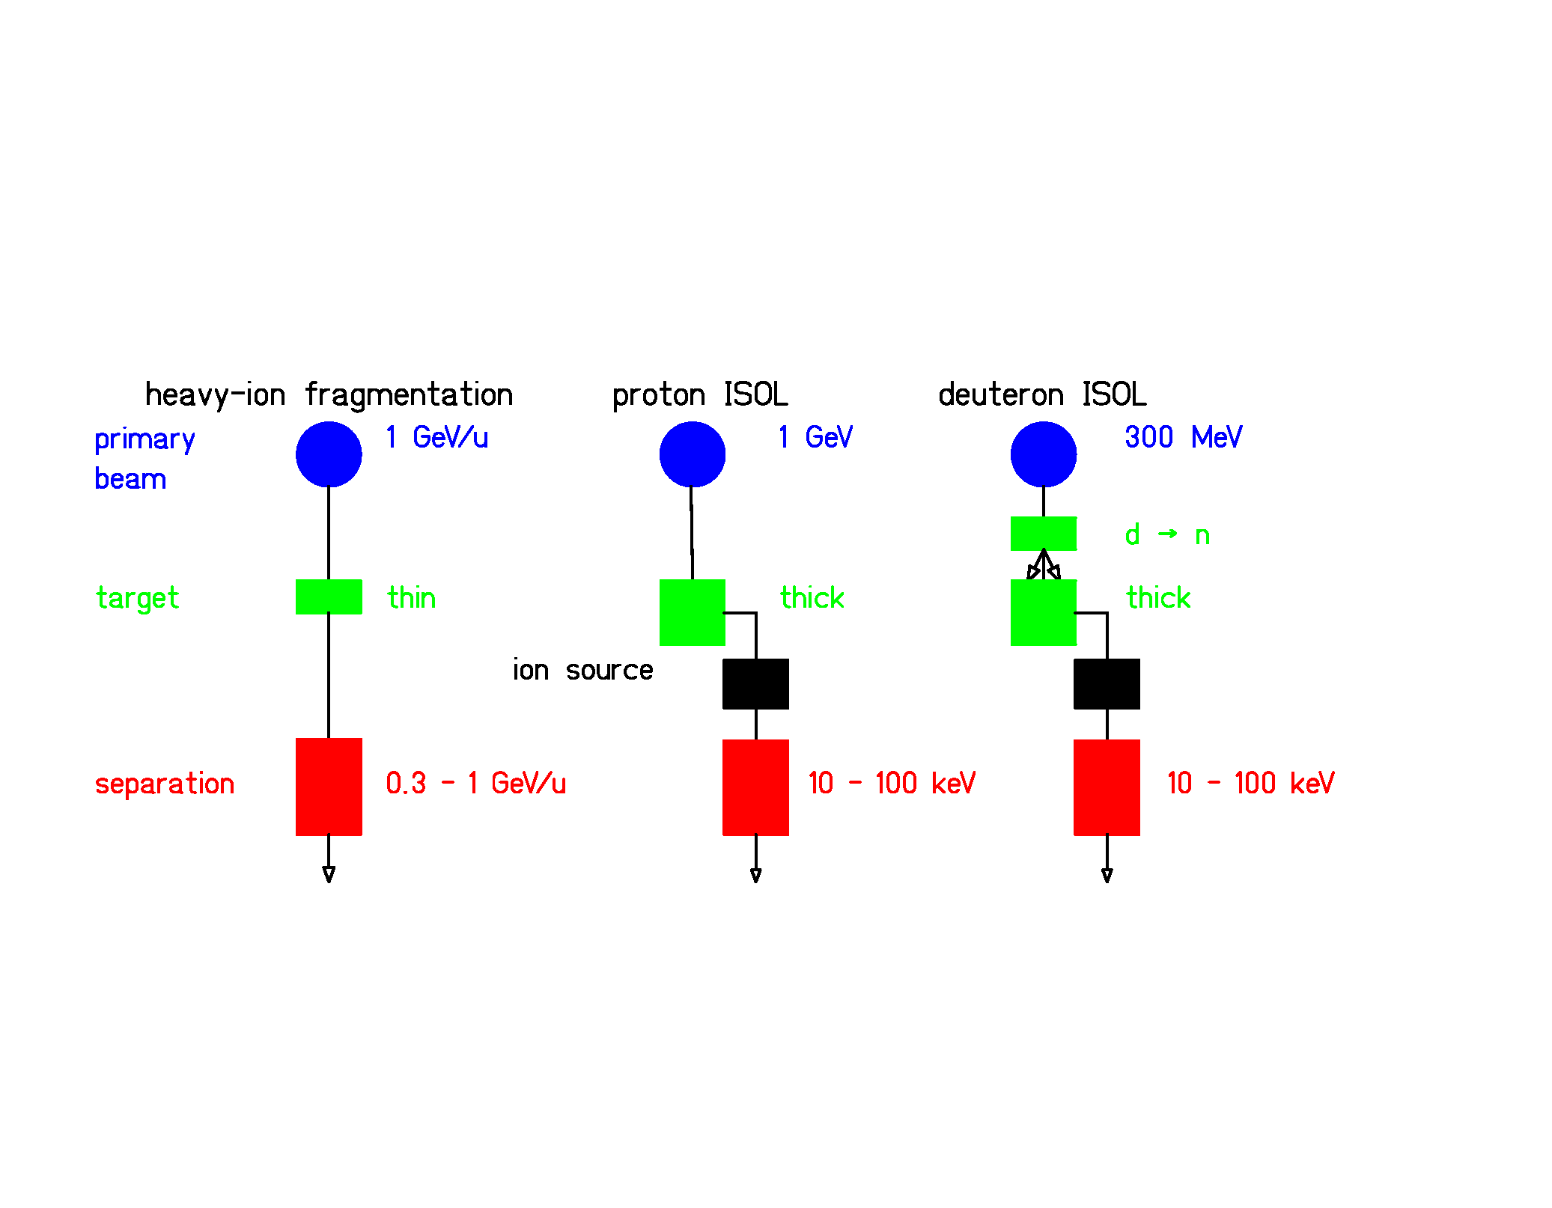

Projectile fragmentation → GSI option
Special requirements on prim.-beam selection and energy.
Needs powerful equipment for in-flight separation.
Not restricted by radioactive decay and chemistry.
Provides high-energy radioactive beams.

Target fragmentation + ISOL
Post-acceleration de-couples production and sec.-beam energy.

Deuteron - neutron conversion + target fragmentation + ISOL
Avoids heating by electronic energy loss in production target.

Projectile fragmentation - gas stopping - re-acceleration (RIA)
Avoids ISOL extraction from target (slow process, sensitivity to chemical properties)
In-flight separation by momentum-loss achromat
(e.g. fragment separator of GSI)

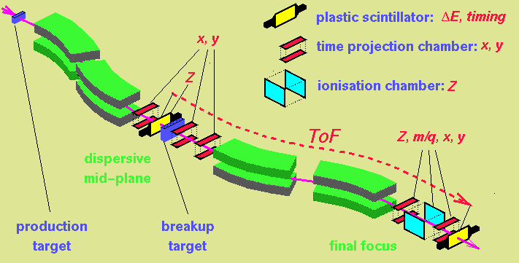

A two-stage magnetic spectrometer with

- dispersive intermediate image plane and
- achromatic final image plane.

Optical analogon of the momentum-loss achromat (prototype: energy-loss spectrometer)
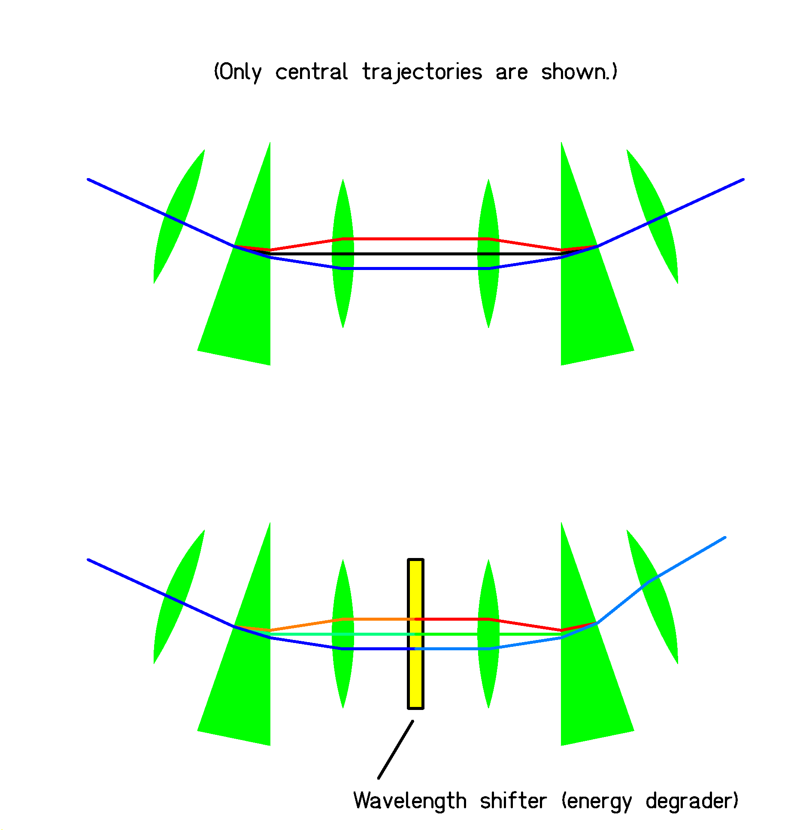
Position in central plane → wavelength
(in FRS: p/q ≈ A/Z)

Position in exit plane → wavelength shift
(in FRS: ΔE ≈ Z²)
In-flight isotopic separation
with the momentum-loss achromat
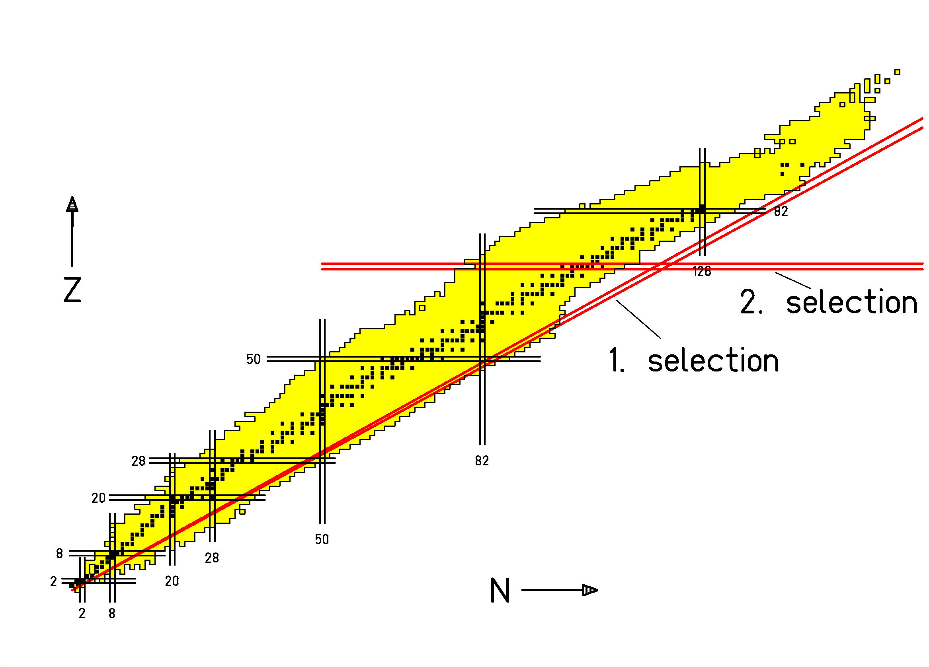
The two selection criteria (A/Z and Z) allow to separate a specific nuclide and to prepare a secondary beam of a single nuclide.

Simple tuning on a desired nuclide by adjusting 2 magnetic fields and the thickness of the energy degrader.
Operation domain of the momentum-loss achromat
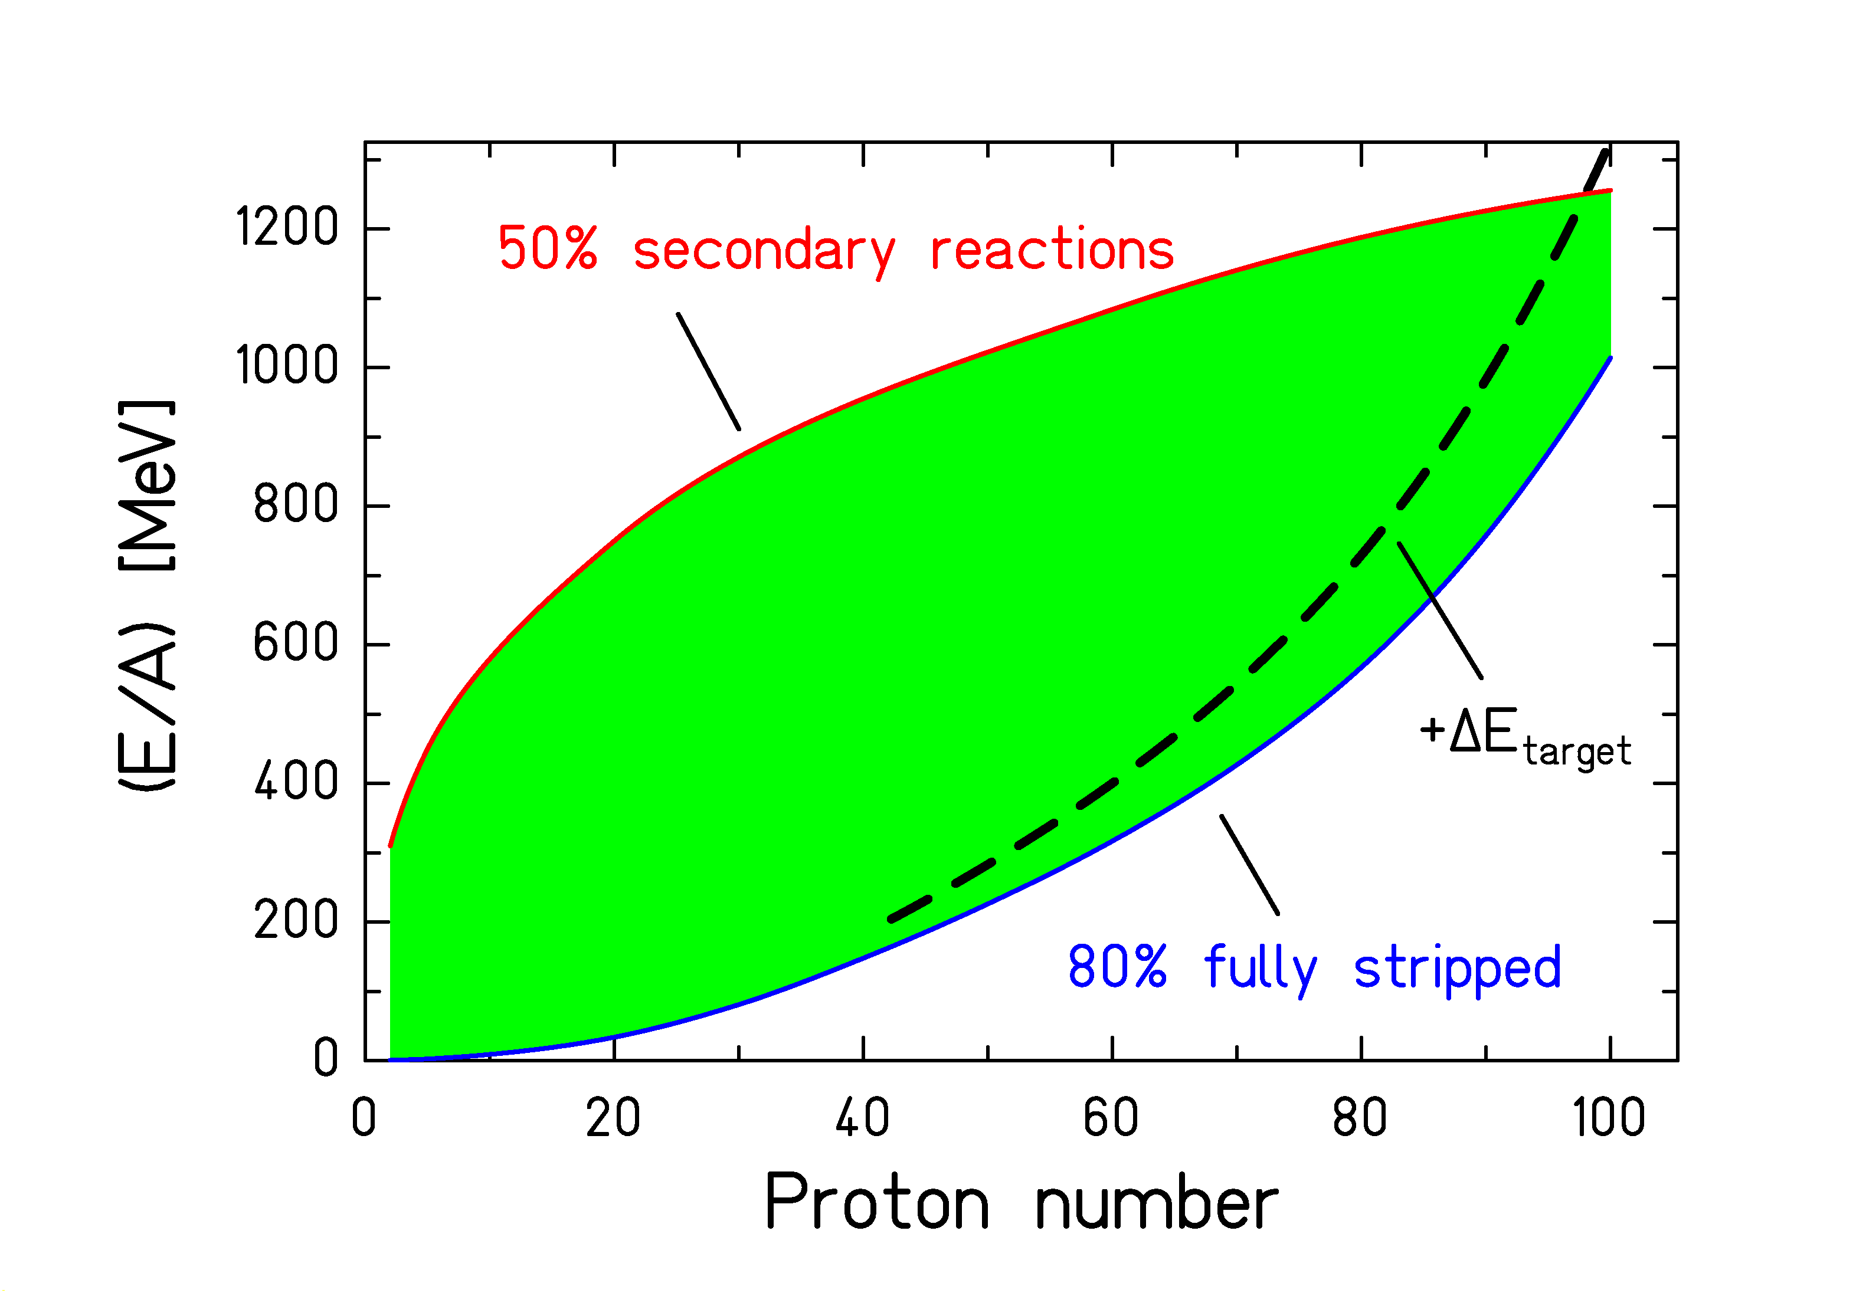
Green area: Energy limits in the first half of the separator.
Lower limit: 80% fully stripped in a Nb target stripper.
Upper limit: 50% secondary reactions in an Al degrader.
Dashed line: Energy in front of Be target (30% range of projectile).

Conclusion: 1 A GeV is required for uranium.
References of related publications:

(some preprints of recent work can be found in
http://www-wnt.gsi.de/kschmidt/publications.htm )

"STATISTICS AND NUCLEAR REACTIONS"
V. F. Weisskopf
@ Phys. Rev. 52 (1937) 295-303
# THEORY; NUCLEAR REACTIONS, statistical model

"THE MECHANISM OF NUCLEAR FISSION"
N. Bohr, J. A. Wheeler
@ Phys. Rev. 56 (1939) 426-50
# THEORY; NUCLEAR REACTIONS; nuclear fission

"ABRASION AND ABLATION OF HEAVY IONS"
J. D. Bowman, W. J. Swiatecki, C. E. Tsang
@ LBL-2908 (1973), UNCLAS Reprint
# THEORY; NUCLEAR REACTIONS, fragmentation, abrasion-ablation model

"STATISTICAL MODELS OF FRAGMENTATION PROCESSES"
A. S. Goldhaber
@ Phys. Lett. B 53 (1974) 306-8
# THEORY; NUCLEAR REACTIONS, Heavy ions, relativistic energies,
fragmentation reactions; momentum distribution; Fermi-gas model

"PHENOMENOLOGICAL DESCRIPTION OF THE ENERGY DEPENDENCE
OF THE LEVEL DENSITY PARAMETER"
A. V. Ignatyuk, G. N. Smirenkin, A. S. Tiskin
@ Yad. Fiz. 21 (1975) 485-490 (Sov. J. Nucl. Phys. 21 (1975) 255-257)
# THEORY; NUCLEAR PROPERTIES, level density, analytic formula, shell effect

"THE ROLE OF COLLECTIVE EFFECTS IN THE SYSTEMATICS OF NUCLEAR
LEVEL DENSITIES"
A. V. Ignatyuk, K. K. Istekov, G. N. Smirenkin
@ Yad. Fiz. 29 (1979) 875-83 (Sov. J. Nucl. Phys. 29 (1979) 450-54)
# THEORY; NUCLEAR PROPERTIES; level density, shell effects, collective levels

"HEAVY FRAGMENTS PRODUCED IN PROTON-NUCLEUS AND NUCLEUS-NUCLEUS COLLISIONS AT RELATIVISTIC ENERGIES"
J. Huefner
@ Phys. Rep. 125 (1985) 129-185
# THEORY; NUCLEAR REACTIONS; fragmentation; relativistic energies; nucleus-nucleus collisions; proton-nucleus collisions; spallation; multifragmentation; fission

"THE MOMENTUM-LOSS ACHROMAT - A NEW METHOD FOR THE ISOTOPICAL
SEPARATION OF RELATIVISTIC HEAVY IONS"
K.-H. Schmidt, E. Hanelt, H. Geissel, G. Muenzenberg, J.-P. Dufour
@ Nucl. Instr. Meth. A 260 (1987) 287-303
# INSTRUMENT, projectile fragmentation, isotopic separation, secondary beams

"PROTON-NUCLEUS INTERACTION AT HIGH ENERGY"
J. Cugnon
@ Nucl. Phys. A 462 (1987) 751-80
# THEORY; NUCLEAR REACTIONS, spallation, intranuclear-cascade model

"A GUIDE TO MICROSCOPIC MODELS FOR INTERMEDIATE-ENERGY HEAVY-ION
COLLISIONS"
G. F. Bertsch, S. Das Gupta
@ Phys. Rep. 160 (1988) 189-233
# REVIEW; NUCLEAR REACTIONS, Heavy ions, intermediate energies,
Nuclear collisions, Cascade, BUU VUU models

"A REEXAMINATION OF THE ABRASION-ABLATION MODEL FOR THE
DESCRIPTION OF THE NUCLEAR FRAGMENTATION REACTION"
J.-J. Gaimard, K.-H. Schmidt
@ Nucl. Phys. A 531 (1991) 709-745
# THEORY; NUCLEAR REACTIONS, heavy ions, relativistic energies,
fragmentation reaction, statistical abrasion model, diffusion evaporation model

"THE GSI PROJETILE FRAGMENT SEPARATOR (FRS) - A VERSATILE MAGNETIC
SYSTEM FOR RELATIVISTIC HEAVY IONS"
H. Geissel, P. Armbruster, K.-H. Behr, A. Bruenle, K. Burkard, M. Chen, H. Folger,
B. Franczak, H. Keller, O. Klepper, B. Langenbeck, F. Nickel, E. Pfeng, M.
Pfuetzner, E. Roeckl, K. Rykaczewsky, I. Schall, D. Schardt, C. Scheidenberger,
K.-H. Schmidt, A. Schroeter, T. Schwab, K. Suemmerer, M. Weber, G. Muenzenberg, T.
Brohm, H.-G. Clerc, M. Fauerbach, J.-J. Gaimard, A. Grewe, E. Hanelt, B.
Knoedler, M. Steiner, B. Voss, J. Weckenmann, C. Ziegler, A. Magel, H. Wollnik,
J.-P. Dufour, Y. Fujita, D. J. Vieira, B. Sherrill
@ Nucl. Instrum. Methods B70 (1992) 286-297
# INSTRUMENT; fragmentation, secondary beams, isotopic separation,
magnetic spectrometer

"PROTON REMOVAL IN PERIPHERAL NUCLEAR COLLISIONS AT RELATIVISTIC
ENERGIES"
K.-H. Schmidt, K. Suemmerer, H. Geissel, G. Muenzenberg, F. Nickel,
M. Pfuetzner, M. Weber, B. Voss, T. Brohm, H.-G. Clerc, M. Fauerbach,
J.-J. Gaimard, A. Grewe, E. Hanelt, M. Steiner, J. Weckenmann,
C. Ziegler, A. Magel
@ Nucl. Phys. A 542 (1992) 699-714
# EXPERIMENT; NUCLEAR REACTIONS, fragmentation; 136Xe (E=0.8GeV*A) + Be,
197Au (E=1GeV*A) + Al, proton-removal cross sections,
parallel-momentum distributions; intranuclear cascade,
statistical abrasion model
http://www.elsevier.nl/npe/9/25/13/18/index.htt

"DISTRIBUTION OF Ir and Pt ISOTOPES PRODUCED AS FRAGMENTS OF 1 A GeV 197Au PROJECTILES - A THERMOMETER FOR PERIPHERAL NUCLEAR COLLISIONS"
K.-H. Schmidt, T. Brohm, H.-G. Clerc, M. Dornik, M. Fauerbach, H. Geissel, A. Grewe, E. Hanelt, A. Junghans, A. Magel, W. Morawek, G. Muenzenberg, F. Nickel, M. Pfuetzner, C. Scheidenberger, K. Suemmerer, D. Vieira, B. Voss, C. Ziegler
@ Phys. Lett. B 300 (1993) 313-316
# EXPERIMENT; NUCLEAR REACTIONS; fragmentation, Au projectiles,
E=1 A GeV, Al target, cross sections of Ir and Pt isotopes,
deduced prefragment excitation energies, N/Z distribution

"STATISTICAL ABRASION OF NUCLEONS FROM REALISTIC NUCLEAR-MATTER
DISTRIBUTIONS"
T. Brohm, K.-H. Schmidt
@ Nucl. Phys. A569 (1994) 821-832
# THEORY; NUCLEAR REACTIONS; fragmentation, abrasion-ablation model,
Glauber model
http://www.elsevier.nl/npe/9/52/12/19/index.htt

"SECONDARY EXOTIC NUCLEAR BEAMS"
H. Geissel, G. Muenzenberg, K. Riisager
@ Ann. Rev. Nucl. Part. Sci. 45 (1995) 163-203
# REVIEW; NUCLEAR REACTIONS; INSTRUMENT; isotope separation,
secondary-beam facilities, dripline nuclei, heavy elements

"Statistical properties of fermionic molecular dynamics"
J. Schnack and H. Feldmeier
@ Nucl. Phys. A 601 (1996) 181-194
# THEORY; NUCLEAR REACTIONS; fermion system; molecular dynamics;
thermodynamic properties; fluctuations; ergodic assumption
http://www.elsevier.nl/npe/9/84/11/13/index.htt

"LOW-ENERGY FISSION INVESTIGATED IN REACTIONS OF 750 A MeV 238U-IONS WITH
Pb and Be TARGETS"
P. Armbruster, M. Bernas, S. Czajkowski, H. Geissel, T. Aumann, Ph. Dessagne,
C. Donzaud, E. Hanelt, A. Heinz, M. Hesse, C. Kozhuharov, Ch. Miehe,
G. Muenzenberg, M. Pfuetzner, K.-H. Schmidt, W. Schwab, C. Stephan,
K. Suemmerer, L. Tassan-Got, B. Voss
@ Z. Phys. A 355 (1996) 191-201
# EXPERIMENT; NUCLEAR REACTIONS; nuclear fission, fragmentation,
electromagnetic excitations, fission-fragment nuclear-charge distributions,
magnetic spectrometer FRS
http://link.springer.de/link/service/journals/00218/papers/6355002/63550191.pdf

"Angular momentum in peripheral fragmentation reactions"
M. de Jong, A. V. Ignatyuk, K.-H. Schmidt
@ Nucl. Phys. A 613 (1997) 435
# THEORY; NUCLEAR REACTIONS; nuclear fragmenation; angular momentum
statistical model
http://www.elsevier.nl/npe/9/127/16/20/index.htt

"LOW-ENERGY FISSION INVESTIGATED IN REACTIONS OF 750 A MeV 238U-IONS
ON 208Pb. ISOTOPIC CROSS SECTIONS"
C. Donzaud, S. Czajkowski, P. Armbruster, M. Bernas, C. Boeckstiegel,
Ph. Dessagne, H. Geissel, E. Hanelt, A. Heinz, C. Kozhoharov, Ch. Miehe,
G. Muenzenberg, M. Pfuetzner, W. Schwab, C. Stephan, K. Suemmerer,
L. Tassan-Got, B. Voss
@ Eur. Phys. J. A 1 (1998) 407-426
# EXPERIMENT; NUCLEAR REACTIONS; nuclear fission, electromagnetic excitations,
production cross sections, fission channels, Brosa model
http://www.edpsciences.com/articles/epja/pdf/1998/04/epja021.pdf

"FISSION OF HIGHLY EXCITED FRAGMENTS FROM COLLISIONS OF 750 A MeV 238U-IONS ON 208Pb"
W. Schwab, M. Bernas, P. Armbruster, S. Czajkowski, Ph. Dessagne, C. Donzaud,
H. Geissel, A. Heinz, C. Kozhuharov, C. Miehe, G. Muenzenberg, M. Pfuetzner,
C. Stephan, K. Suemmerer, L. Tassan-Got, B. Voss
@ Eur. Phys. J. A 2 (1998) 179-191
# EXPERIMENT; NUCLEAR REACTIONS; nuclear fission; heavy-ion collisions;
fission after nuclear collisions of 238U (750 A MeV) with 238Pb;
mass and nuclear-charge distributions
http://www.edpsciences.com/articles/epja/pdf/1998/06/epja074.pdf

"Production of medium-weight isotopes by fragmentation in
750 A MeV 238U on 208Pb collisions"
J. Benlliure, P. Armbruster, M. Bernas, C. Boeckstiegel, S. Czajkowski,
C. Donzaud, H. Geissel, A. Heinz, C. Koshuharov, Ph. Dessagne,
G. Muenzenberg, M. Pfuetzner, C. Stephan, K.-H. Schmidt, K. Suemmerer,
W. Schwab, L. Tassan-Got, B. Voss
@ Eur. Phys. J. A2 (1998) 193-198
# EXPERIMENT; NUCLEAR REACTIONS; projectile fragmentation;
isotopic cross sections; effective proton evaporation barriers
http://www.edpsciences.com/articles/epja/pdf/1998/06/epja065.pdf

"Fragmentation cross sections of relativistic 208Pb projectiles"
M. de Jong, K.-H. Schmidt, B. Blank, C. Boeckstiegel, T. Brohm, H.-G. Clerc,
S. Czajkowski, M. Dornik, H. Geissel, A. Grewe, E. Hanelt, A. Heinz, H. Irnich,
A. R. Junghans, A. Magel, G. Muenzenberg, F. Nickel, M. Pfuetzner,
A. Piechaczek, C. Scheidenberger, W. Schwab, S. Steinhaeuser, K. Suemmerer,
W. Trinder, B. Voss, C. Ziegler
@ Nucl. Phys. A 628 (1998) 479-492
# EXPERIMENT; NUCLEAR REACTIONS; projectile fragmentation; isotopical separation;
measured isotopical yields; proton removal; abrasion-ablation model;
empirical parametrization EPAX
http://www.elsevier.nl/IVP/03759474/628/479

"PROJECTILE-FRAGMENT YIELDS AS A PROBE FOR THE COLLECTIVE ENHANCEMENT IN THE NUCLEAR LEVEL DENSITY"
A. R. Junghans, M. de Jong, H.-G. Clerc, A. V. Ignatyuk, G. A Kudyaev, K.-H. Schmidt
@ Nucl. Phys. A 629 (1998) 635-655
# EXPERIMENT; NUCLEAR PROPERTIES; nuclear level density, collective enhancement;
NUCLEAR REACTIONS; projectile fragmentation, nuclear fission
http://www.elsevier.nl/IVP/03759474/629/635

"Calculated nuclide production yields in relativistic collisions of fissile nuclei"
J. Benlliure, A. Grewe, M. de Jong, K.-H. Schmidt, S. Zhdanov
@ Nucl. Phys. A 628 (1998) 458-478
# THEORY; NUCLEAR REACTIONS; projectile fragmentation, fission,
production cross sections, intensities of secondary beams, stellar r process,
http://www.elsevier.nl/IVP/03759474/628/458

"Partial Cross Sections of Nucleus-Nucleus Reactions"
C. H. Tsao, R. Silberberg, A. F. Barghouty
@ Astrophys.J. 501, 920 (1998)
# SYSTEMATICS; NUCLEAR REACTIONS C(Fe,X),E=0.6,1.05 GeV/nucleon; Sn,Pb(197Au,X),E=10.6 GeV/nucleon; Ag(16O,X),E=2.1 GeV/nucleon; Pb(Fe,X),E=1.05 GeV/nucleon; C, 27Al,Cu(La,X), (197Au,X),E <100 GeV/nucleon;
27Al,Cu,Ag,Pb(S,X),E=200 GeV/nucleon; calculated fragments isotopic yields.
Scaling of proton-nucleus results. Comparison with data.

"Updated Partial Cross Sections of Proton-Nucleus Reactions"
R. Silberberg, C. H. Tsao, A. F. Barghouty
@ Astrophys.J. 501, 911 (1998)
# SYSTEMATICS; NUCLEAR REACTIONS 1H(Si,X), (Ca,X), (Cr,X), (Fe,X), (Kr,X), Ag,X), (139La,X), (197Au,X), (16O,X), (22Ne,X), (32S,X), (11B,X), (20Ne,X), (24Mg,X), (28Si,X), (Mo,X),
E » 0.4-2.1 GeV/nucleon; analyzed isotopic yield data; deduced parameters.
Application to cosmic ray studies discussed.

"SYSTEMATIC EXPERIMENTAL SURVEY ON PROJECTILE FRAGMENTATION AND FISSION INDUCED IN COLLISIONS OF 238U AT 1 A GeV WITH LEAD"
T. Enqvist, J. Benlliure, F. Farget, K.-H. Schmidt, P. Armbruster, M. Bernas,
L. Tassan-Got, A. Boudard, R. Legrain, C. Volant, C. Boeckstiegel, M. de Jong,
J. P. Dufour
@ Nucl. Phys. A 658 (1999) 47-66
# EXPERIMENT; NUCLEAR REACTIONS; projectile fragmentation, nuclear fission,
isotopic cross sections, velocity distributions,
evidence for expansion in fragmentation, deduced fissioning nuclei
http://www.elsevier.nl/IVP/03759474/658/47

"CROSS SECTIONS OF SPALLATION RESIDUES PRODUCED IN 1 A GeV 208Pb ON PROTON REACTIONS"
W. Wlazlo, T. Enqvist, P. Armbruster, J. Benlliure, M. Bernas, A. Boudard,
S. Czajkowski, R. Legrain, S. Leray, B. Mustapha, M. Pravikoff, F. Rejmund,
K.-H. Schmidt, C. Stephan, J. Taieb, L. Tassan-Got, C. Volant
@ Phys. Rev. Lett. 84 (2000) 5736
# EXPERIMENT; NUCLEAR REACTIONS; spallation reaction 1 GeV protons on 208Pb;
inverse kinematics; fragment separator; measured isotopic cross sections
http://publish.aps.org/abstract/PRL/v84/p5736

"Modified Empirical Parametrization of Fragmentation Cross Sections"
K. Suemmerer, B. Blank
@ Phys. Rev. C 61 (2000) 034607
# SYSTEMATICS; NUCLEAR REACTIONS; heavy-ion collisions; relativistic energies;
limiting fragmentation; cross sections of heavy residues; analytical formula
http://publish.aps.org/abstract/PRC/v61/p034607

