The experimental facility of GSI for production and isotopic identification of radioactive beams.

(Karl-Heinz Schmidt, GSI Darmstadt)

- Physics goals far from stability.
- Methods for producing radioactive beams.
- Requirements for a versatile in-flight facility.
- The components of the GSI facility.
- Separation and identification.
- Some representative experiments

Some physics goals far from stability

1. Ground-state properties (masses, moments)

2. Systematics of nuclear excitations (spectroscopy)

3. Nuclear structure at the extremes
(extreme N/Z ratio, extreme deformation)

4. The continuum structure of nuclei (halos)

5. Limits of bound nuclei (driplines, superheavy elements)

6. Astrophysics (reaction rates, waiting points,
the r-process path)

Methods for the production of secondary beams
(Some examples)

Projectile fragmentation → GSI option
Special requirements on prim.-beam selection and energy.
Needs powerful equipment for in-flight separation.
Not restricted by radioactive decay and chemistry.
Provides high-energy radioactive beams.

Target fragmentation + ISOL
Post-acceleration decouples production and sec.-beam energy.

Deuteron - neutron conversion + target fragmentation + ISOL
Avoids heating by electronic energy loss in production target.
Requirements for a versatile in-flight secondary-beam facility

- Availability of all stable nuclei as primary beam.
- Energy of primary beam from Coulomb barrier to full stripping of uranium.
- Full separation and identification of secondary beams.
- Powerful spectrometers and other analysis devices.

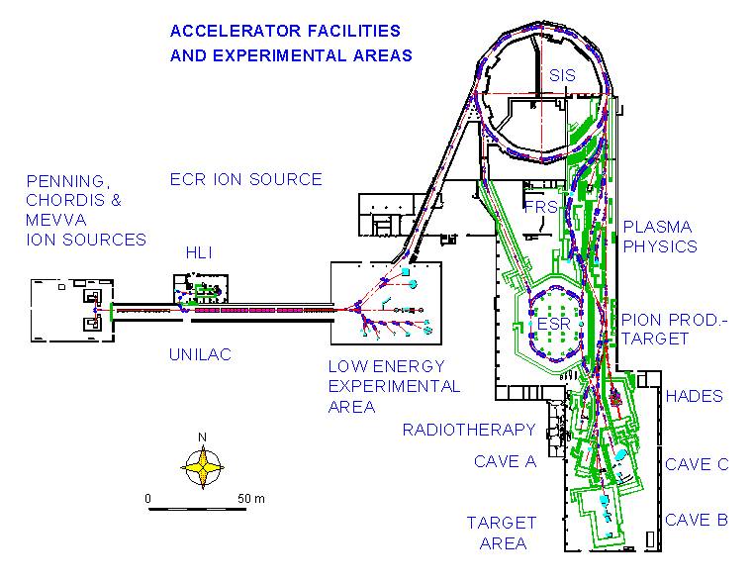
The facilities of GSI

Installations for secondary beams:
UNILAC: Universal linear accelerator (E ≤ 20 A MeV).
SIS18: Heavy-ion synchrotron (E ≤ 1 ... 2 A GeV).
FRS: Magnetic spectrometer for separation of radioactive
beams of projectile-like residues.
ESR: Experimental storage ring.
CAVE B: Large-acceptance magnet ALADIN.

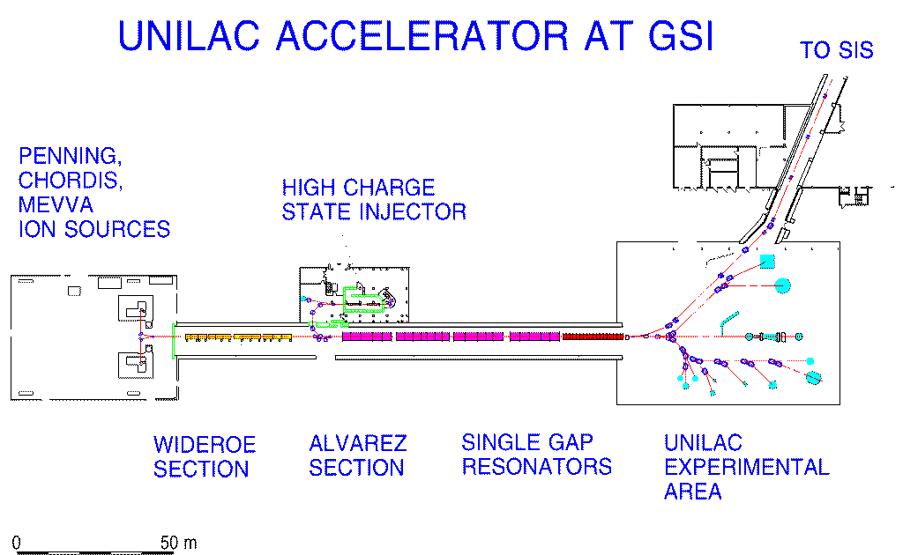
UNILAC

The universal linear accelerator for all stable isotopes to energies above the Coulomb barrier (energy per nucleon up to 20 MeV).

Acceleration in small steps in many HF cavities.

Strippers are inserted to increase ionic charge for efficient acceleration.
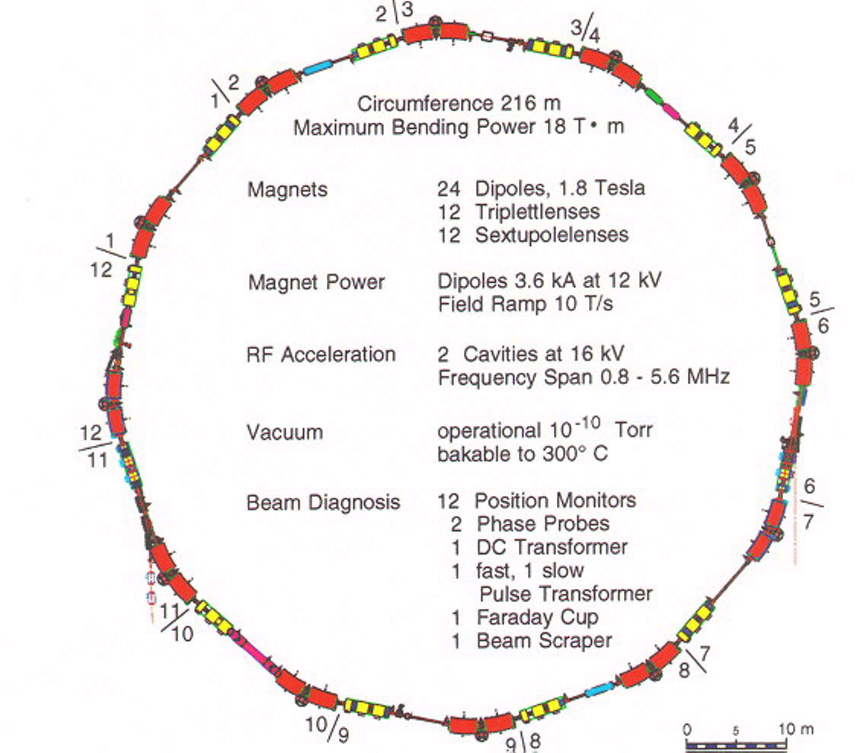
SIS18

Operation cycle:
Injection - acceleration - extraction

Only short injection time.
Only 1 cavity needed for acceleration.
Ramping of magnets synchronised to acceleration.
No stripping possible.
High energy - ionic charge far from equilibrium
-> needs very good vacuum.
Fast or slow extraction.
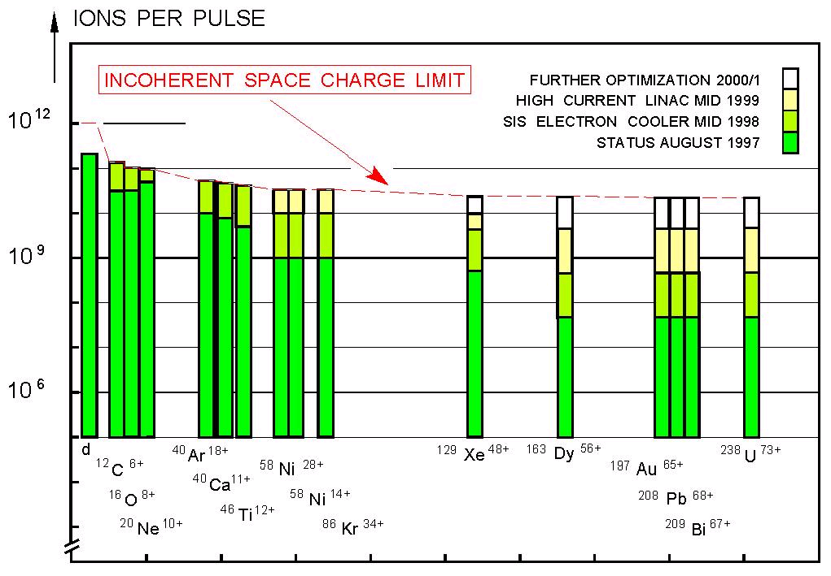
Intensities of ion beams from SIS

Fragment Separator

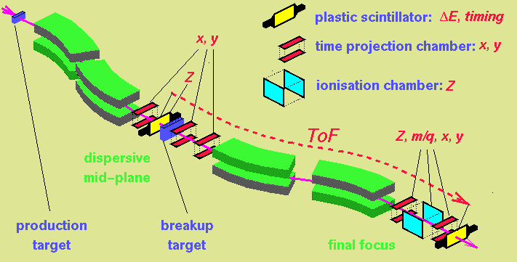

A two-stage magnetic spectrometer with

- dispersive intermediate image plane and
- achromatic final image plane.

Analogon of energy-loss spectrometer

Position in central plane → wavelength
(in FRS: p/q ≈ A/Z)

Position in exit plane → wavelength shift
(in FRS: ΔE ≈ Z²)
The Fragment Separator

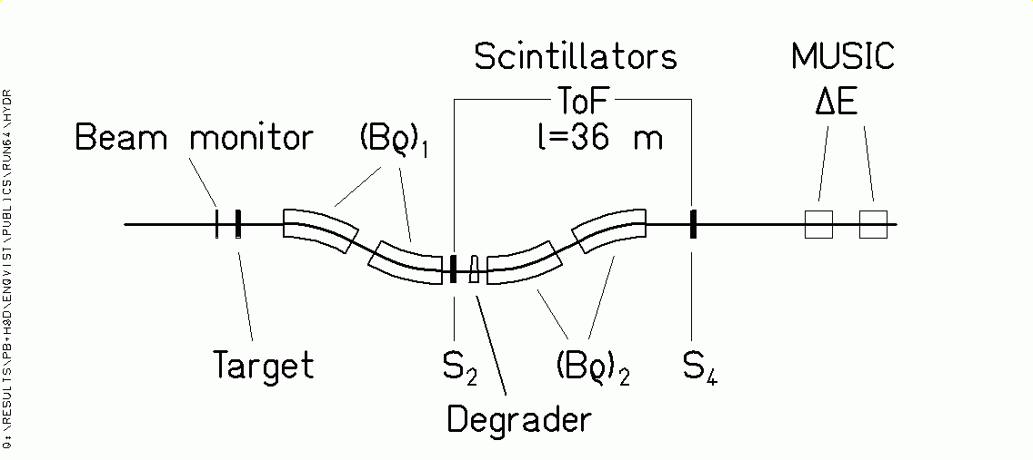

Projectile-like fragments:

Transmitted with ΔBρ/ Bρ = 3% and Θ_{max}=15 mr.

Identification in Z and A by magnetic deflection in FRS, tracking, ToF andΔE.

Bρ = m₀ A c β γ / (e Z)

ΔE ∝ Z² / v²

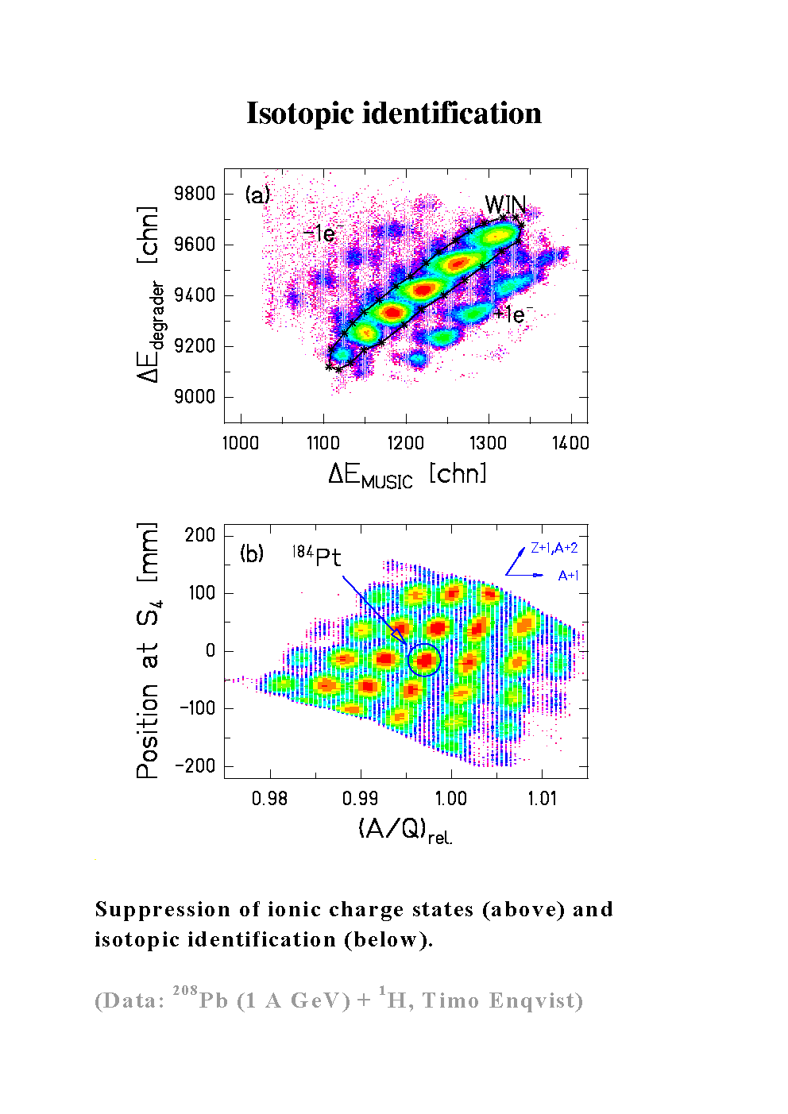
Operation domain of the FRS

Green area: Energy limits in the first half of the FRS.
Lower limit: 80% fully stripped in a Nb target stripper.
Upper limit: 50% secondary reactions in an Al degrader.
Dashed line: Energy in front of Be target (30% range of projectile).

Conclusion: 1 A GeV is required for uranium.

Nucl. Phys. A 665 (2000) 221

Nucl. Phys. A 665 (2000) 221

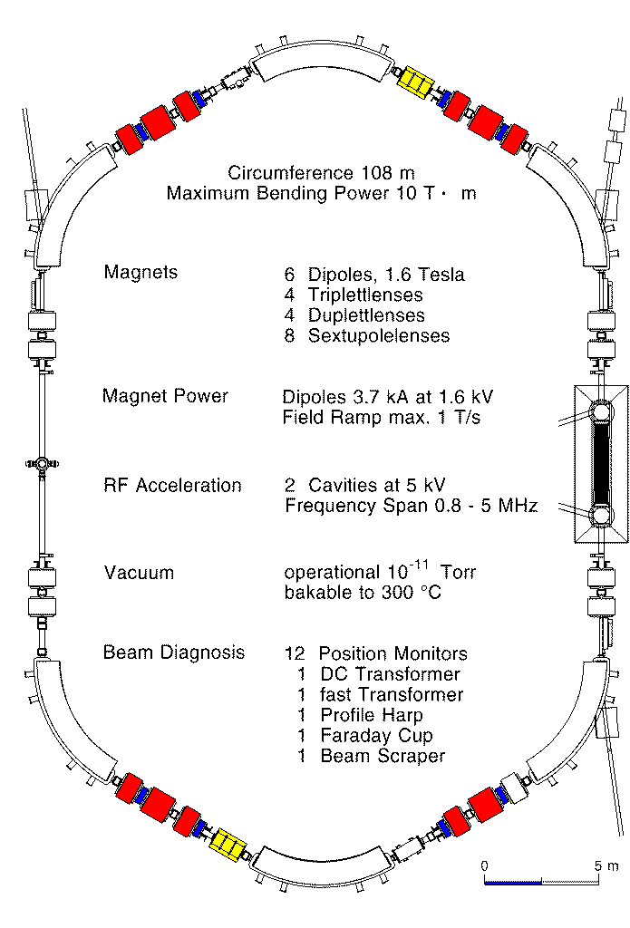
Experimental Storage Ring (ESR)
Mass measurements by Schottky Scan in ESR

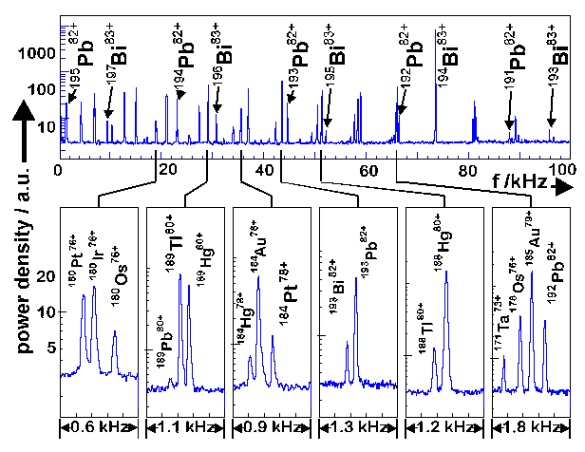
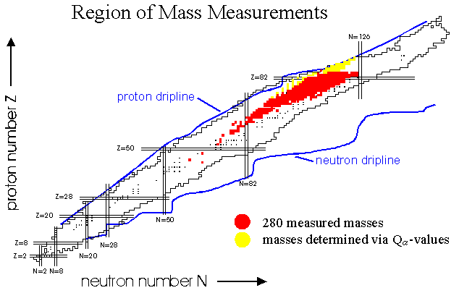
T. Radon et al.

