Prospects for the production of neutron-rich nuclei

(Karl-Heinz Schmidt, GSI Darmstadt)

1. Arguments for an optimum beam energy
2. Nuclear reactions below the Fermi energy
3. Nuclear reactions above the Fermi energy
4. Fusion
5. Evaporation
6. Fission
7. Fragmentation
8. Two-step reactions?

Finding best conditions to go beyond the present limits

Even nature did not reach the neutron drip line (r-process)

How to produce these neutron-rich nuclei in laboratory?
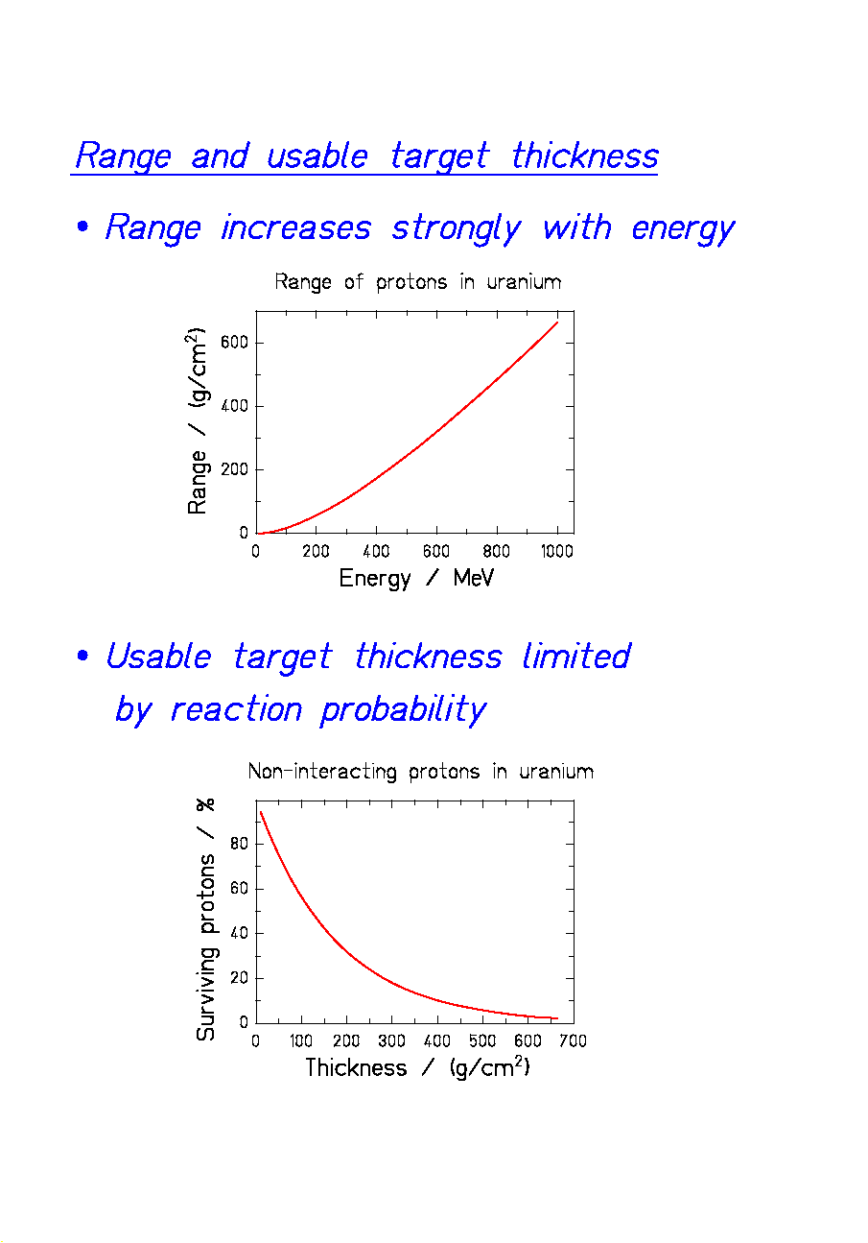
General arguments for an "optimum" beam energy

P_{reac} = nuclear-reaction probability of projectile
ΔE = energy deposit in target per projectile
Red lines: target thickness = range of projectiles
typical for ISOL-type facilities.
Green lines: target thickness = 0.1 × range of projectiles
typical for in-flight facilities.

⇒ High reaction probabilities and low heat load
at E ≈ 1 A GeV.

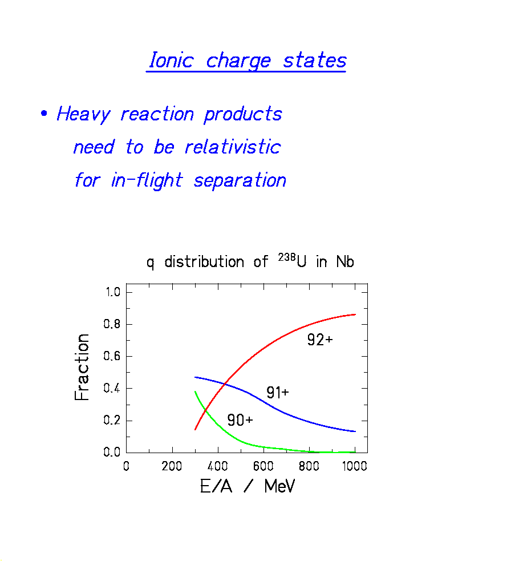
Reaction mechanisms

E/A < E_{fermi}
Low reaction probabilities

Reactions controlled by nuclear potential and binding energies
Fusion, deep inelastic, transfer, fission

E/A > E_{fermi}
High reaction probabilities

Two stages:
1. Collisions of individual nucleons
Target (resp. projectile) fragmentation

2. Deexcitation: nuclear potential and binding
energies are again important
Deexcitation of prefragments by
evaporation-fission competition

Fusion

- Basic characteristics:
Curvature of stability valley due to Coulomb repulsion.
→ Fusion products are neutron-deficient.
Nucleons of projectile and target add up.
→ Suited to reach super-heavy nuclei.

Partial widths Γ_{n} and Γ_{p} for emission of neutrons and protons.

$$Γ_{n}=\frac{2{\text{mR}}^{2}g}{ℏ^{2}2\text{πρ}\left(E−E_{r}^{\text{gs}}\right)}\int_{0}^{E−B_{n}}{\text{ερ}\left(E−B_{n}−ε\right)}dε$$

$$\begin{aligned}Γ_{p}=\frac{2{\text{mR}}^{2}g}{ℏ^{2}2\text{πρ}\left(E−E_{r}^{\text{gs}}\right)} \\ \int_{ε_{c}}^{E−B_{p}}{ε\left(1−\frac{ε_{c}}{ε}\right)ρ\left(E−B_{p}−ε\right)}dε\end{aligned}$$

(Approximation without considering tunneling.)

Γ_{p} is reduced by the Coulomb barrier ε_{c}.
Evaporation Process

Evaporation is like a diffusion process.
→ Residues concentrate on an evaporation corridor.

Proton evaporation is hindered by the Coulomb barrier.
→ The evaporation corridor is neutron-deficient.

Modelling the Width in A and N/Z
of Fission-Product Isotopic Distributions

Approximated parabolic potential

$$U\left(η\right)=C_{η}⋅{\left(η−η_{o}\right)}^{2}$$

Statistical population:

$Y\left(η\right)∝\text{exp}\left\{2\sqrt{a\left(U_{0}−U\left(η\right)\right)}\right\}$ →

$Y(η)∝\text{exp}\left\{−\frac{{\left(η−η_{0}\right)}^{2}}{2σ_{η}^{2}}\right\}$ with

$$2σ_{η}^{2}=\frac{T}{C_{η}}$$

U = potential energy,
η = either A (mass split) or N/Z (polarisation),
$C_{η}$ = stiffness of the potential,
T = nuclear temperature.
Fission

- Basic characteristics:
Curvature of stability valley due to Coulomb repulsion.
→ Fission products are neutron-rich.
Shell effects (¹³²Sn!) or fluctuations in polarisation.
→ The only ways to reach even more neutron-rich.
The asymmetry term in the liquid drop is large.
→ Polarisation is small.
- Excitation energy leads to opposite effects
Fluctuations in polarisation increase.
→ Fission extends to more neutron-rich isotopes.
Excited fission fragments evaporate neutrons.
→ Final fission products are less neutron-rich.
Fission of actinides

Fission of actinides from low excitation energies
induced by neutrons, protons, electrons, photons.

Production of moderately neutron-rich isotopes of a few elements.

Fission: Variation of Excitation Energy
(Calculations)

Higher E* → larger fluctuations in A
→ less neutron-rich
Exploring the limits of neutron-rich isotopes
by fragmentation-fission reactions

Data from T. Enqvist et al., Nucl. Phys. A 658 (1999) 47,
C. Donzaud et al., Eur. Phys. J. A1 (1998) 407,
C. Engelmann et al., Z. Phys. A 352 (1995) 351.

Steep decrease of cross sections due to limitation of charge polarisation in fission.
Kinematic Properties of Potassium Produced from ²³⁸U in Different Targets

Projectile: ²³⁸U, 1 A GeV
Target left: hydrogen (+ titanium window)
right: titanium

Velocity distributions of potassium isotopes
→ Production in hydrogen target
from very asymmetric fission.
→ Production in titanium target
from projectile fragmentation.

Data from M. V. Ricciardi, GSI, thesis in preparation.
Production of Potassium in p + ²³⁸U

Isotopic yields from 600 MeV protons on ²³⁸U (ISOLDE)
and
fission-product yields from 1 A GeV ²³⁸U + hydrogen (GSI)

No absolute cross sections from ISOLDE yields.

The distributions fit together:
ISOLDE yields of light elements from fission!

Data from
H.-J. Kluge, ISOLDE user's guide, CERN 86-05 (1986) and
M. V. Ricciardi, GSI, thesis in preparation

Fragmentation

Removal of nucleons in quasi-free nucleon-nucleon collisions.

- Large fluctuations in N/Z.
- Large fluctuations in excitation energy.
Dedicated study of proton-removal channels

Data from J. Benlliure et al., Nucl. Phys. A 660 (1999) 87.

Abrasion of protons only, no evaporation of neutrons
=> "Cold Fragmentation".
Promising results for producing neutron-rich nuclei.
Expected production cross sections by cold fragmentation

The empirical systematics EPAX which has carefully been adjusted to available experimental data has been used to estimate isotopic production cross sections of extremely neutron-rich isotopes by cold fragmentation. Since EPAX does not consider fission, the prediction of neutron-deficient isotopes is not realistic.

K. Sümmerer, B. Blank, Phys. Rev. C 61 (2000) 034607
Reaching extremely neutron-rich isotopes by cold fragmentation

Result of a model calculation^{a)} on cold fragmentation ²³⁸U (1 A GeV) + Be. Many new neutron-rich isotopes in reach, but low cross sections!

^{a)} The model is described in J. Benlliure et al., Nucl. Phys. A 660 (1999) 87

