Experiments with gold, lead and uranium ion beams and their technical and theoretical interest.

(Karl-Heinz Schmidt, GSI Darmstadt)

- The Problem of Nuclear Waste

  - Nuclear Reactor
  - Transmutation and Incineration
  - The Hybrid System

- Research at GSI

  - Benefit of Inverse Kinematics
  - Results

- Theoretical Interest

  - Two-stage Nuclear Models
  - Excitation Energy of Prefragments
  - Barriers for Charge-particle Evaporation
  - Dissipation in Fission
Energy release in fission

In the fission of heavy nuclei one gains ≈ 200 MeV.

The fission barrier stabilises the nucleus

Excitation over the barrier leads to fission
Primordial heavy nuclei

232Th: Z = 90, N = 142
234U: Z = 92, N = 142, (0,0055%)
235U: Z = 92, N = 143, (0,72%)
238U: Z = 92, N = 146, (99.2745%)

Excitation by thermal neutrons
Only nuclei with odd neutron number fission after capture of thermal neutrons.

Nuclei with even neutron number are fertile.
(By capture of thermal neutrons, a nucleus with odd neutron number is formed.)

The only natural nuclear fuel for conventional fission reactors is 235U.

Nuclear Reactor
Controlled chain reaction

"Fuel" 235U enriched from 0,72% to 3,5%.

Fission → 2.2 to 3 neutrons,
exactly one of those induces another fission
(criticality = 1)

Control of reactor possible due to delayed neutrons.

Variation of criticality by rods, absorbing neutrons.
The Problem of Nuclear Waste

Which kind of waste?

Fission products

Plutonium —
Dangerous waste or fuel?

Minor actinides

The time scale

Possible solutions

Deposition — safe?, accepted?

Transmutation and incineration by nuclear reactions —
"Cleaning up" in reasonable time?
Nuclear Reactions in the Reactor

Fission

Breeding
List of the Reaction Products

- 235U: Fuel (total reserves for ≈ 200 years)

- Fission products:

Isotope | Life time | 900 MW, 1 year
79Se | 70000 years | 0.1 kg
93Zr | 1.5 million years | 15.5kg
99Tc | 210000 years | 17.7 kg
107Pd | 6.5 million years | 4.4 kg
126Sn | 10000 years | 0.44 kg
129I | 15.7 million years | 3.9 kg
135Cs | 2 million years | 7.7 kg

- 239Pu: Fuel or dangerous waste?

Isotope | Life time | 900 MW, 1 year
239Pu | 24119 year | 123.1 kg

- Other actinides produced by breeding:
Many not fissile by thermal neutrons

Balance: After a few years, the fuel is consumed. Problem: Increased neutron capture
→ poisoning
Transmutation of Radioactive Waste

- By spallation neutrons?
High energy consumption!

- By an hybrid reactor (ADS)?
A subcritical reactor with additional neutrons produced by 1 GeV protons.
The Hybrid System (ADS)

Principle:

- Slightly under-critical.
- Controllable by spallation neutrons, produced by 1 GeV protons.

Advantages:

Can be operated with 232Th→233U.
- 232Th reserves sufficient for 21000 years.

Supports some "poisoning".
- Can transmute or incinerate nuclear waste.
- Is insensitive to some variation of the criticality during long operation.
- Long operation of fuel rods.

Problems:

Nuclear reactions up to 1 GeV must be known.
- Yield of spallation neutrons.
- Production of radioactive nuclei by spallation.
- Material damages due to irradiation.
The Research Program at GSI for Transmutation and Incineration of Radioactive Nuclear Waste

Precision measurements of isotopic yields

- 197Au ( 800 A MeV) + 1H

- 208Pb (1 A GeV) + 1H

- 208Pb (1 A GeV) + 2H

- 208Pb (500 A MeV) + 1H

- 238U (1 A GeV) + 1H

- 238U (1 A GeV) + 2H

- 238U (1 A GeV) + 208Pb

- planned:

- 56Fe (1 A GeV) + 1H

Development of nuclear-reaction models
International Collaborations

Experiments on residue production at GSI
GSI Darmstadt, Germany
Universidad Santiago de Compostela, Spain
IPN Orsay, France
CEA Saclay, France
CEN Bordeaux-Gradignan, France

Network on nuclear data for ADS
UCL Louvain-la-Neuve, Belgium
Subatech Nantes, France
LPC Caen, France
RuG Groningen, Netherlands
UU Upsala, Sweden
ZSR Hannover, Germany
PTB Braunschweig, Germany
IPP Zürich, Switzerland
PSI Zürich, Switzerland
FZJ Jülich, Germany
CEA Saclay, France
CEA Bruyères-le-Châtel, France
GSI Darmstadt, Germany
Universidad Santiago de Compostela, Spain
Ulg Liège, Belgium
NRG Petten, Netherlands

Why Inverse Kinematics?

Experiments with proton beams:

The products stick in the target.
Identification by radioactive decay
→ Insensitive to short-lived nuclides

Experiments with heavy-ion beams:

The products leave the target with high velocity
Identification in-flight
→ Sensitive to all nuclides
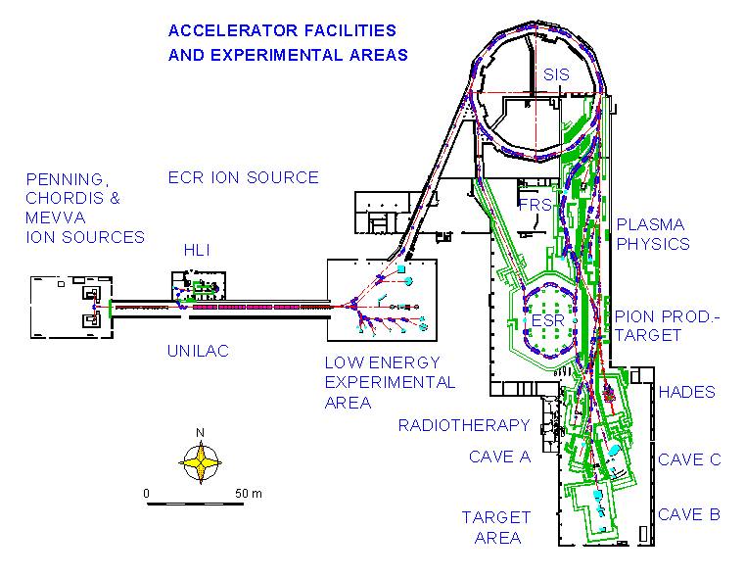
The facilities of GSI

Heavy nuclei (¹⁹⁷Au, ²⁰⁸Pb, ²³⁸U) are accelerated and hit a liquid-hydrogen target. The projectile-like residues are identified in-flight with the fragment separator (FRS).
The Fragment Separator

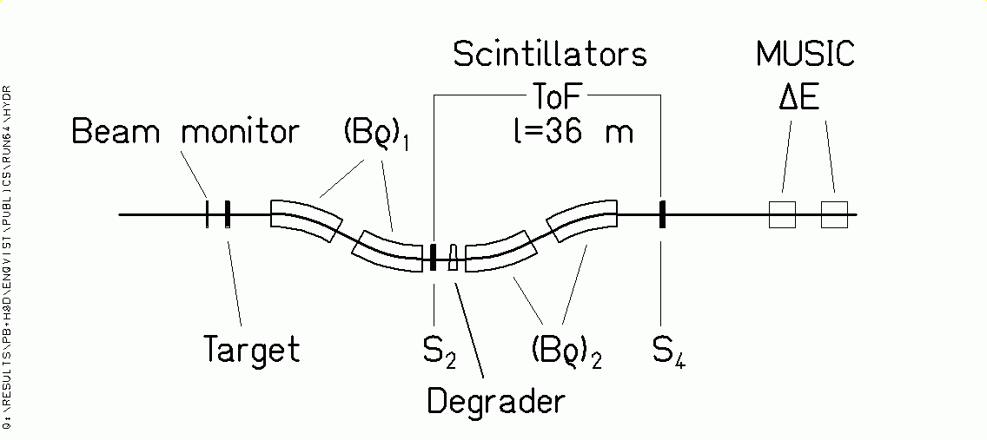

Projectile-like fragments:

Transmitted with ΔBρ/ Bρ = 3% and Θ_{max}=15 mr.

Identification in Z and A by magnetic deflection in FRS, tracking, ToF andΔE.

Bρ = m₀ A c β γ / (e Z)

ΔE ∝ Z² / v²

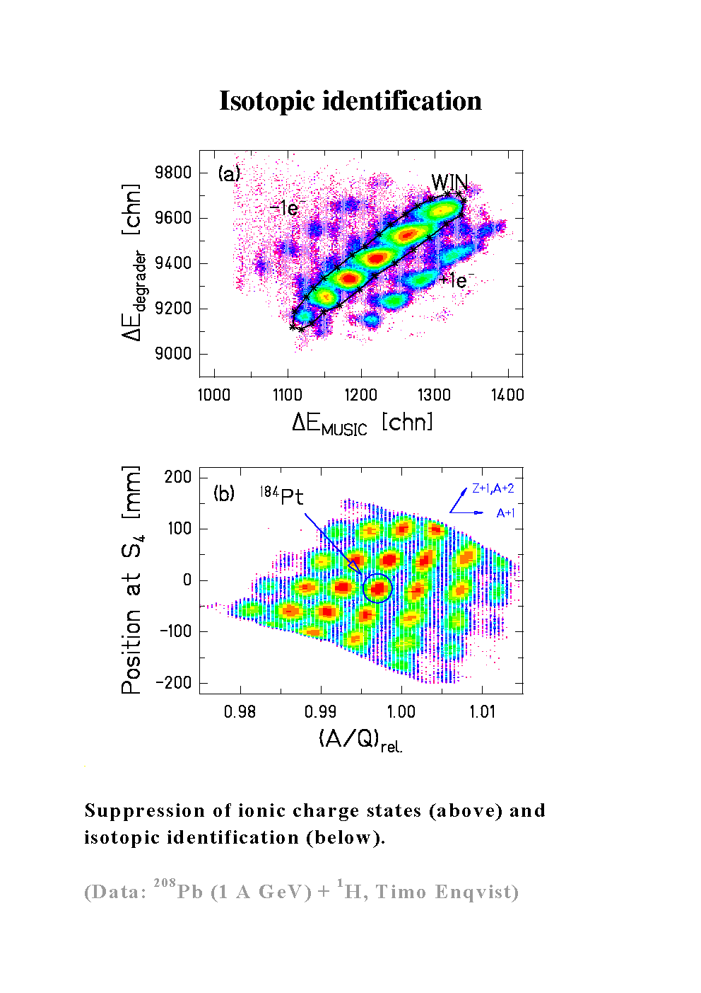
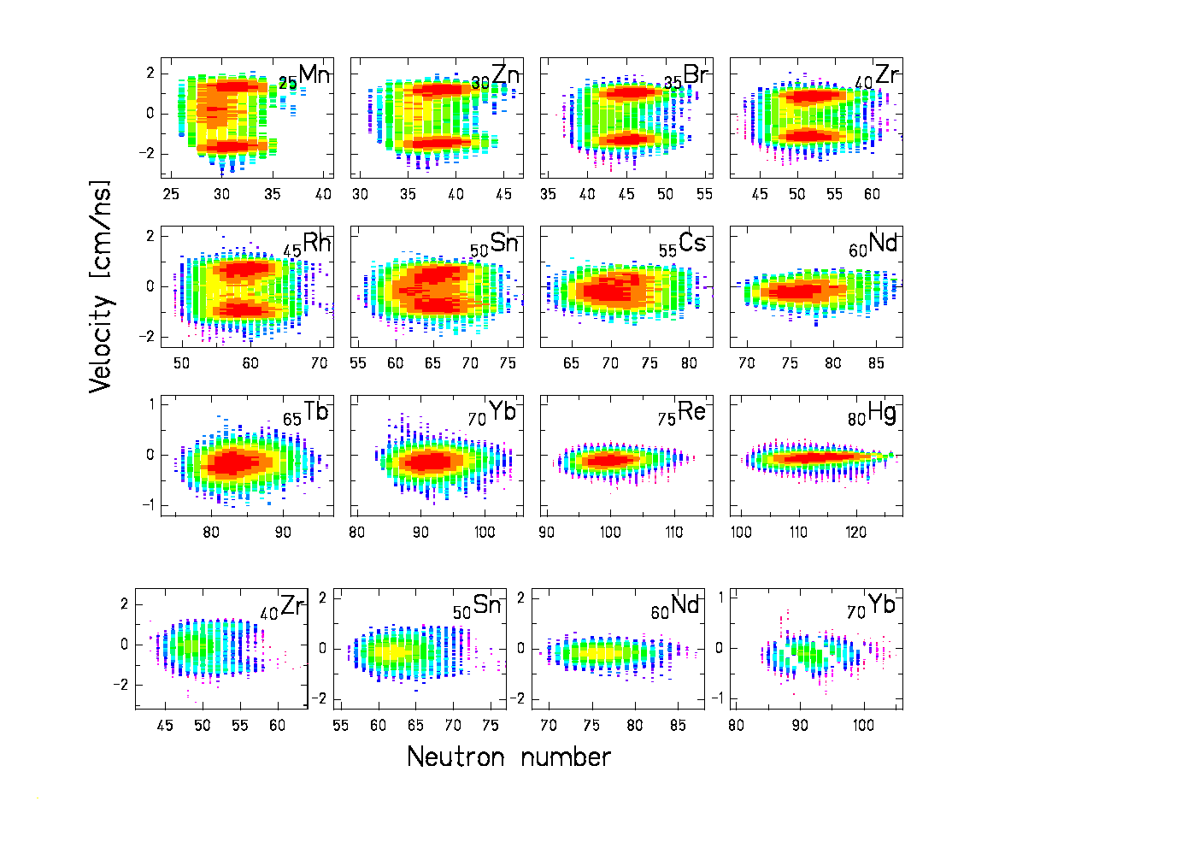
Fragment velocities
Reactions in H₂ target (above) and Ti windows (below).

Signature of the reaction mechanism:
Fragmentation (single peak) and fission (two peaks).

(Data: ²⁰⁸Pb (1 A GeV) + ¹H, Timo Enqvist)
Proton-induced fragmentation of gold

Data from F. Rejmund et al., submitted to Nucl. Phys. A

and J. Benlliure et al. submitted to Nucl. Phys. A

Full isotopic distribution mapped

Comparison with Previous Data

¹⁹⁷Au + ¹H (800 A MeV), fragmentation products
Isotope | σ(Michel et al.)/mb | σ(GSI)/mb
¹⁹³Hg | 7.47±1.2 | 4.38±0.66
¹⁹⁶Au | 66.0±7.0 | 58.4±5.5
¹⁹⁴Au | 29.0±2.8 | 31.2±2.9
¹⁹²Ir | 2.91±0.230 | 3.8±0.6
¹⁹⁰Ir | 4.67±0.400 | 6.05±0.9
¹⁶⁸Tm | 0.283±0.0472 | 0.036±0.005
¹⁴⁸Eu | 0.149±0.0141 | 0.08±0.013

¹⁹⁷Au + ¹H (800 A MeV), fission products
Isotope | σ(Michel et al.)/mb | σ(Kaufman et al)/bm | σ(GSI)/mb
¹⁰²Rh | 0.80±0.13 |  | 0.53±0.08
⁹⁶Tc | 0.78±0.06 | 0.72±0.09 | 0.58±0.08
⁸⁸Y | 2.45±0.19 |  | 1.36±0.20
⁸⁶Rb | 2.41±0.37 |  | 0.96±0.18
⁸⁴Rb | 2.01±0.16 | 1.44±0.25 | 1.54±0.25
⁸²Br | 0.93±0.17 |  | 0.76±0.21
⁷⁴As | 1.37±0.11 | 1.38±0.13 | 1.07±0.10
⁶⁰Co | 0.75±0.09 |  | 0.51±0.05
⁵⁸Co | 0.96±0.09 | 0.41±0.06 | 0.27±0.03
⁵⁴Mn | 0.30±0.05 | 0.44±0.04 | 0.31±0.06
⁴⁶Sc | 0.17±0.02 | 0.38±0.05 | 0.21±0.04

Previously measured in normal kinematics: 18 isotopic cross sections
GSI experiment in inverse kinematics: 749 isotopic cross sections
New Knowledge

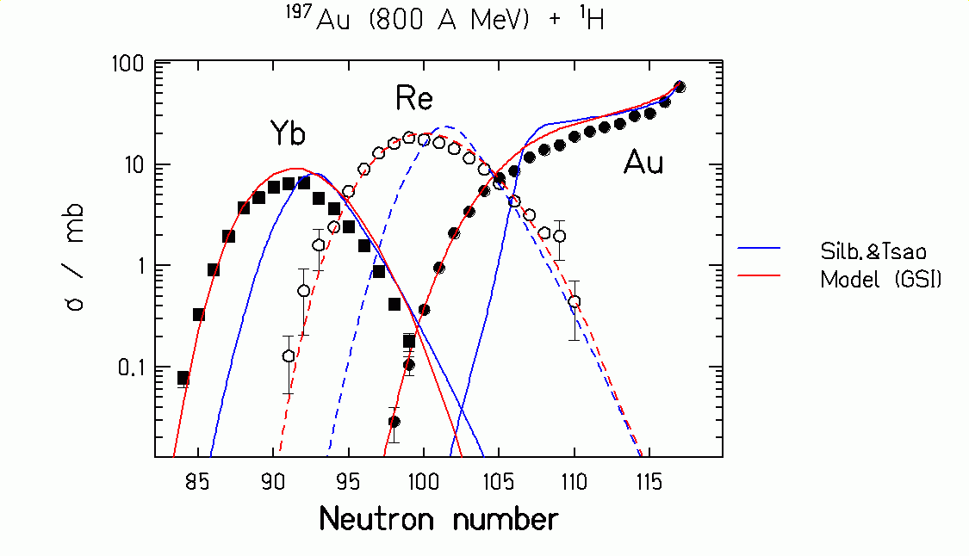

Silberberg and Tsao: Empirical systematics of previous knowledge.

Data points: New data on isotopic cross sections of gold, rhenium and ytterbium.
Data from F. Rejmund et al., submitted to Nucl. Phys. A

GSI model: New model description.
General characteristics of the model description

- Nucleus-nucleus collision
→ scattering cascade of quasi-free nucleons
  - Mass removed from the projectile
  - Excitation energy induced
  - Angular momentum

- Thermalisation
→ compound nucleus

- Deexcitation
→ boiling drop of nuclear matter
  - n, p, α, LCP evaporation
  - Fission

Critical features

- Transition from cascade collisions to de-excitation.
(The continuous process is artificially divided.)

- Transmission coefficients for particle emission from hot exotic nuclei.
(Only cold stable nuclei are tested by fusion.)

- Nuclear viscosity.
(Statistical model is not valid for fission.)
Excitation energy of the pre-fragments

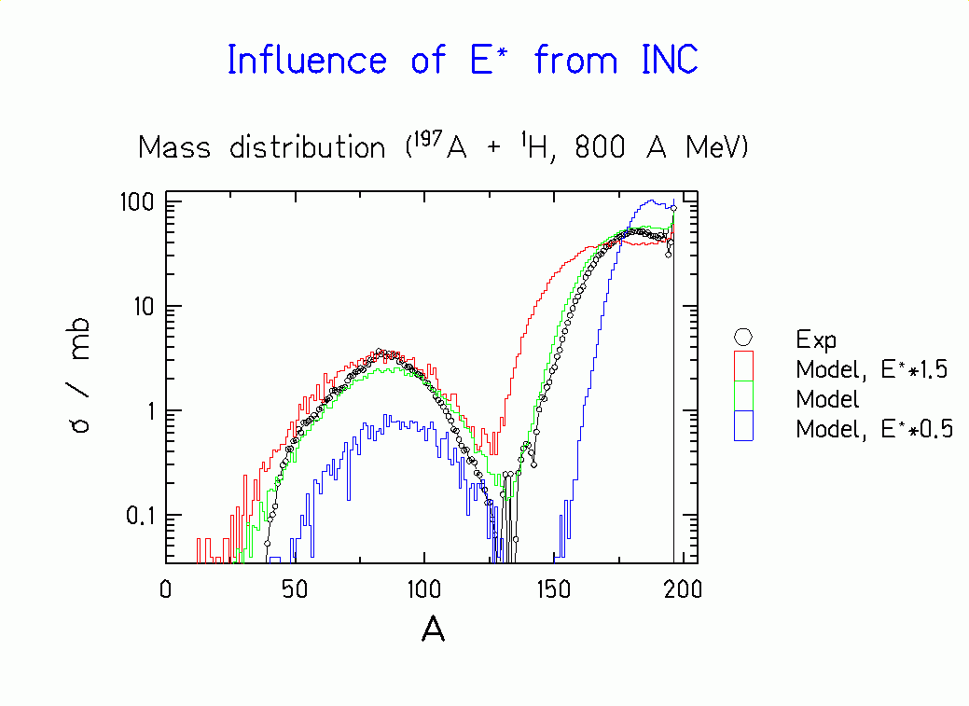
Measured mass distribution (¹⁹⁷Au, 800 A MeV + ¹H) in comparison with different calculations.

The new data give a clear answer!
Viscosity of nuclear matter

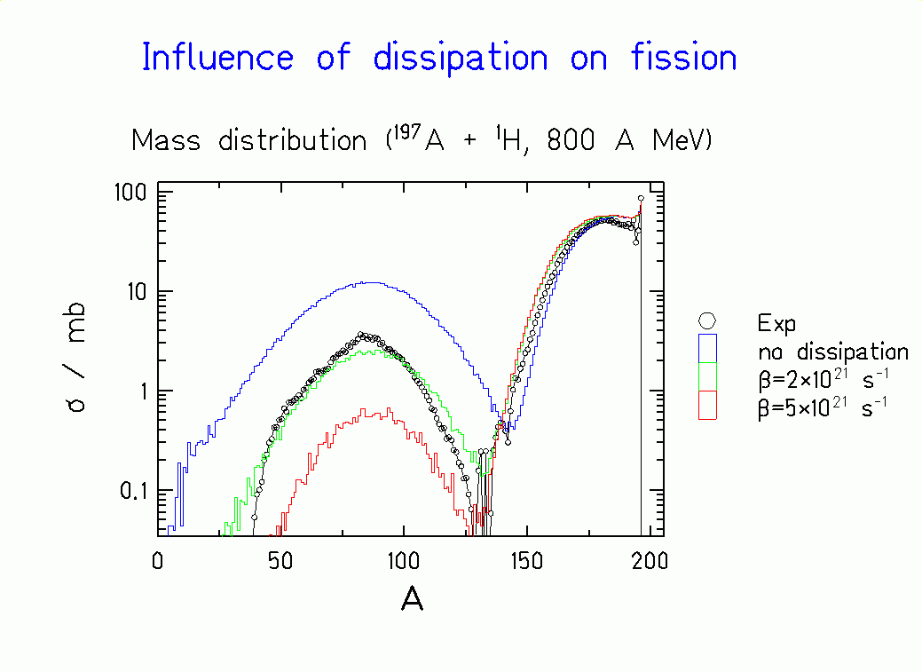
Measured mass distribution (¹⁹⁷Au, 800 A MeV +¹H) in comparison with different calculations.

Strong influence of dissipation on fission!

Data from F. Rejmund et al., submitted to Nucl. Phys. A

Calculated Cross Sections

Very different isotopic distributions for different projectile-target combinations.

Applications of improved
nuclear-reaction models

Basis data for the design of hybrid reactors (ADS)

The many projectile-target combinations and reaction energies cannot be covered by experiment alone.

Calculations for the design of next-generation secondary-beam facilities.

Best operation parameters and the intensities of secondary beams can be estimated.

Experiments with gold, lead and uranium ion beams and their technical and theoretical interest.

(Karl-Heinz Schmidt, GSI Darmstadt)

Additional information

Publications:

"Research for the Incineration of Nuclear Waste"
GSI-Nachrichten 2/99, also available in the WEB:
http://www-aix.gsi.de/~lantzsch/0299/PDF/Inzineration_e.pdf

Articles on the treatment of nuclear waste:
LA RECHERCHE, Nr. 301, Septembre 1997, p. 63 ff

"Hybrid nuclear reactors"
H. Nifenecker, S. David, J. M. Loiseaux, A. Giorni
Progress in Particle and Nuclear Physics 43 (1999) 683-827

Experiments on the production cross sections of heavy residues, performed at GSI:
K.-H. Schmidt et al., Nucl. Phys. A 542 (1992) 699
K.-H. Schmidt et al., Phys. Lett. B 300 (1993) 313
M. Bernas et al., Phys. Lett. B 331 (1994) 19
M. Bernas et al., Phys. Lett. B 415 (1997) 111
C. Donzaud et al., Eur. Phys. J. A 1 (1998) 407
W. Schwab et al., Eur. Phys. J. A 2 (1998) 179
J. Benlliure et al., Eur. Phys. J. A 2 (1998) 193
M. de Jong et al., Nucl. Phys. A 628 (1998) 479
A. R. Junghans et al., Nucl. Phys. A 629 (1998) 635
C. Engelmann et al., Z. Phys. A 352 (1995) 351
J. Reinhold et al., Phys. Rev. C 58 (1998) 247
T. Enqvist et al., Nucl. Phys. A 658 (1999) 47
W. Wlazlo et al., submitted to Phys. Rev. Lett.
F. Rejmund et al., submitted to Nucl. Phys. A
J. Benlliure et al., submitted to Nucl. Phys. A

WEB dokumentation:

Research at GSI on the production cross sections of heavy residues:
http://www-wnt.gsi.de/kschmidt/

