Nuclear-Data* Experimental Programs at GSI

Karl-Heinz Schmidt

Gesellschaft für Schwerionenforschung (GSI)
Darmstadt, Germany

* We understand nuclear-data experiments in an extended sense:
- Provide high-quality data,
- Enable a good understanding of the physics.
.
The GSI Facility

Installations used for the experiments on nuclear data:
________________________________
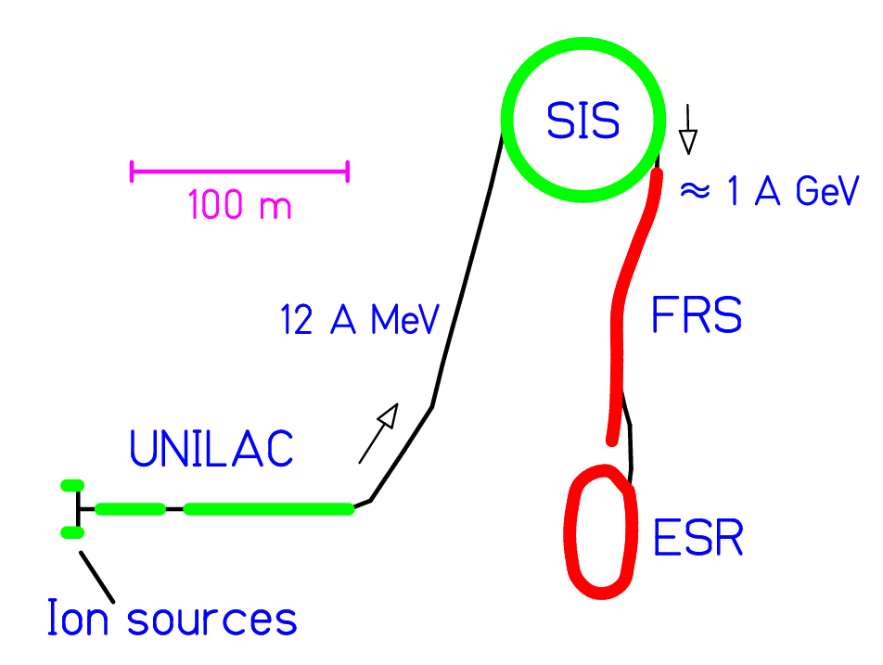
________________________________

Universal linear accelerator UNILAC Heavy-ion synchrotron SIS
Fragment separator FRS
Experimental storage ring ESR
The Experimental Approach:
Inverse Kinematics

Conventional experiments detect target-like reaction products
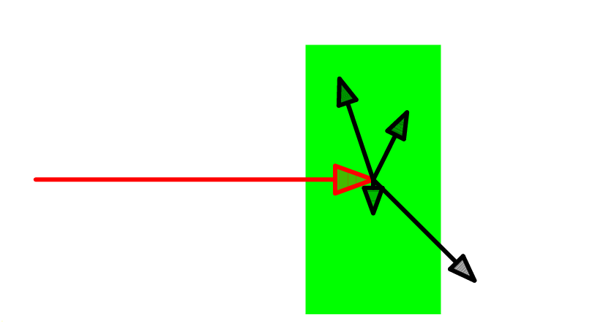
Suffer from:
- Stopping of the products in the target
- Insufficient energy to register or identify the products
_________________________________

GSI-experiments investigate projectile-like reaction products in-flight
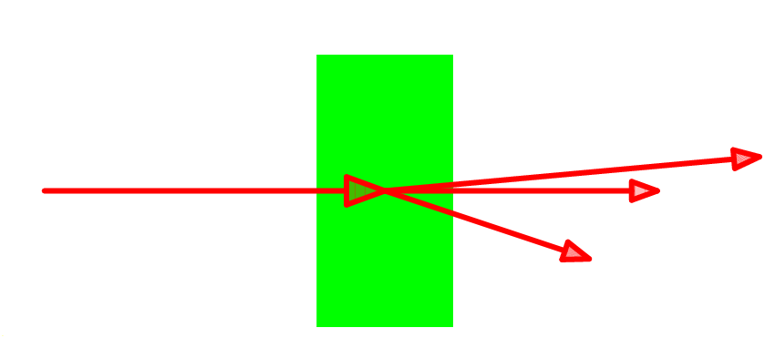
Requires:
- A powerful heavy-ion accelerator
- Adapted high-resolution in-flight detection devices
The Fragment Separator
(FRS)

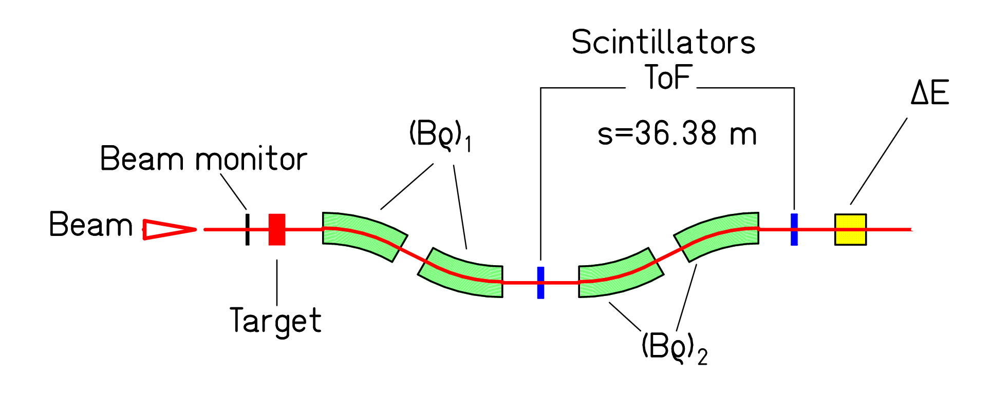

- A/Z identified by (Bρ)₂ and ToF in FRS

Bρ = p/q ~ A·γ·v/Z

- Z identified by ΔE in ionization chamber

ΔE ~ Z² / v²

→ Z and A are exactly known.

- Velocity precisely determined by (Bρ)₁

Bρ = p/q ~ A·γ·v/Z

→ Relative precision 5·10⁻⁴

Nuclide Identification Pattern

¹³⁶Xe + Pb, 1 A GeV
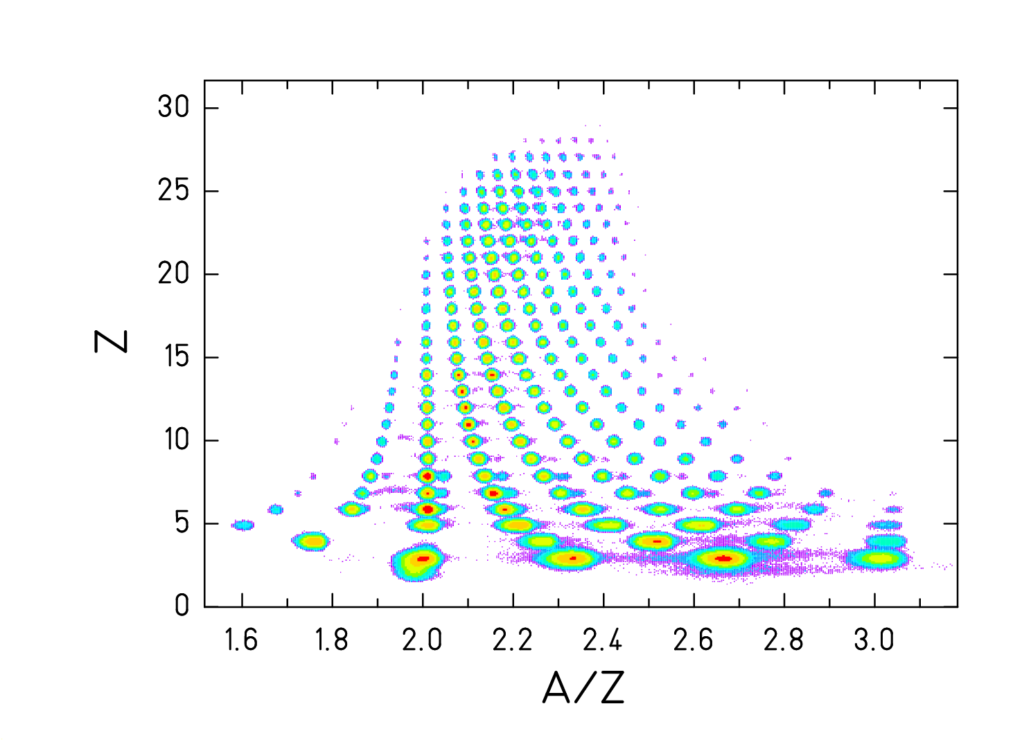

D. Henzlova, PhD thesis
Nuclide distributions
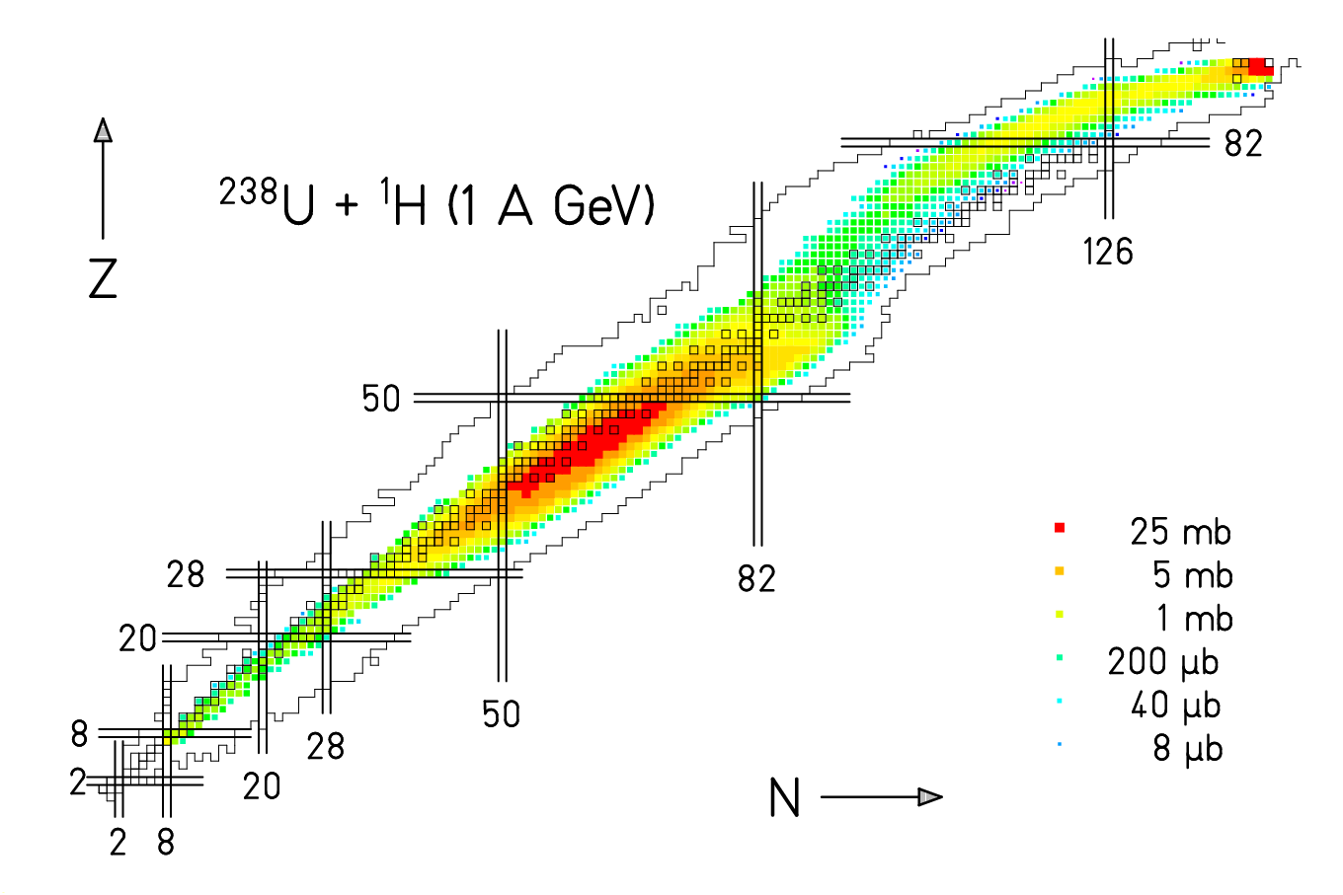
J. Taieb et al., Nucl. Phys. A 724 (2003) 413
M. Bernas et al., Nucl. Phys. A 725 (2003) 213
M. V. Ricciardi et al., in preparation
________________________________________
Systems investigated: (analyzed by)
²³⁸U + ^{1,2}H,Ti,Pb (J. Taieb*, M. Bernas, M. V. Ricciardi*,
E. Casarejos*, J. Pereira*, T. Enqvist)
²⁰⁸Pb + ^{1,2}H, Ti (T. Enqvist, B. Fernandez*, A. Kelic)
¹⁹⁷Au + ¹H (F. Rejmund, J. Benlliure)
^{124,136}Xe + ¹H,²⁰⁸Pb (P. Napolitani*, D. Henzlova*,
M. Fernandez*)
⁵⁶Fe + ¹H,Ti (C. Villagrasa*, P. Napolitani*)
¹⁹⁷Au + ¹⁹⁷Au (V. Henzl*)
Energies: 0.2 to 1.5 A GeV
*PhD thesis
The Isospin Thermometer
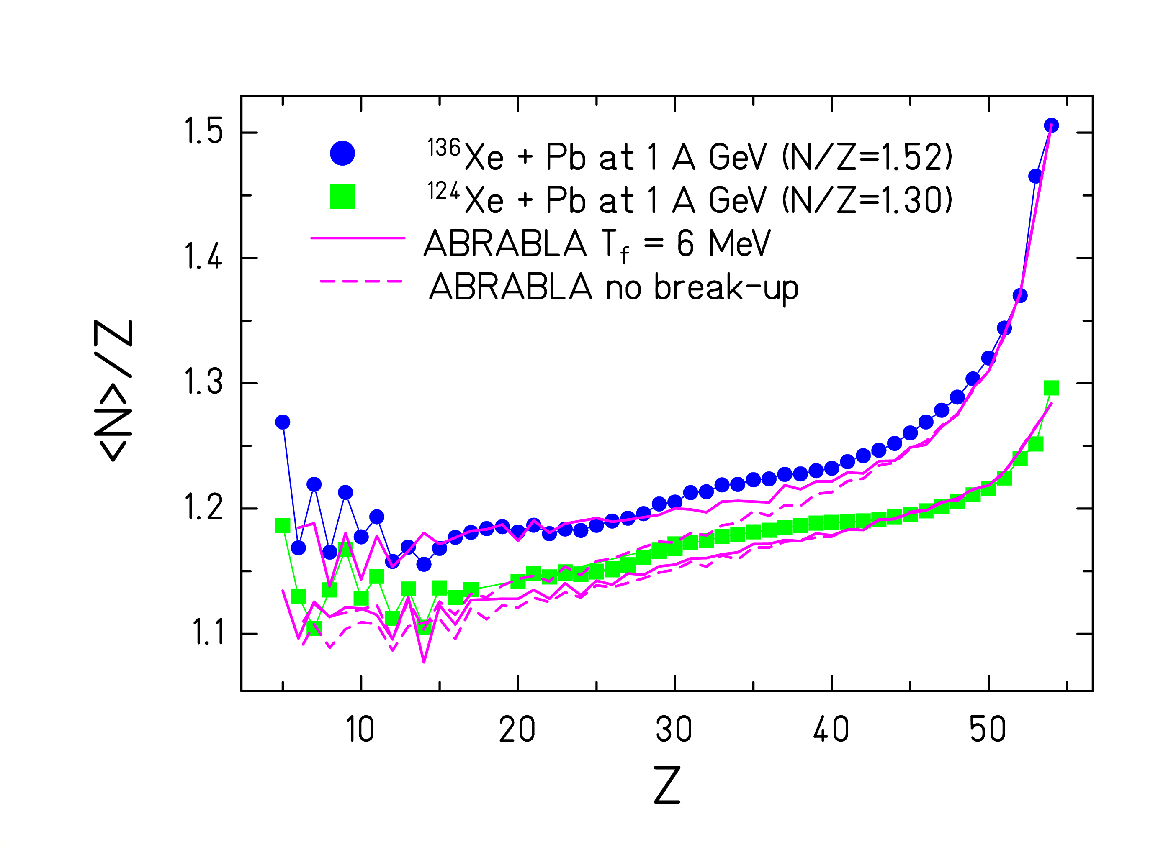
- Memory on N/Z of projectile is preserved for all fragments.
- The data are reproduced with a three-stage model:
Abrasion – Break-up – Evaporation.
- The freeze-out temperature after break-up is 6 MeV.

M. V. Ricciardi, D. Henzlova, PhD theses
K.-H. Schmidt et al., Nucl. Phys. A 710 (2002) 157
Participant's blast on the spectators

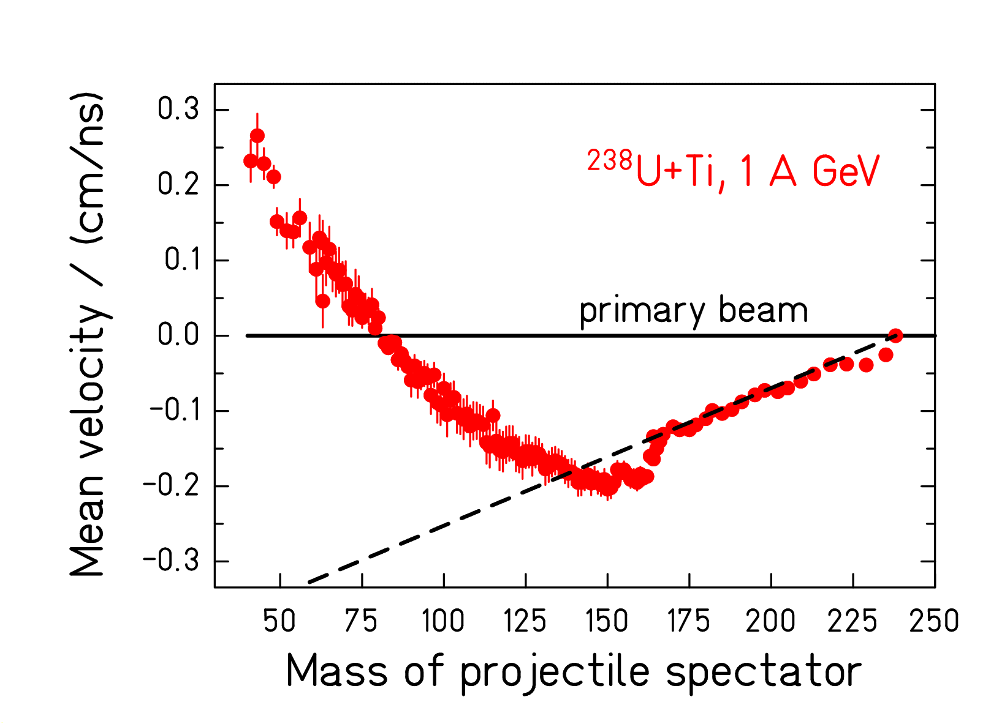
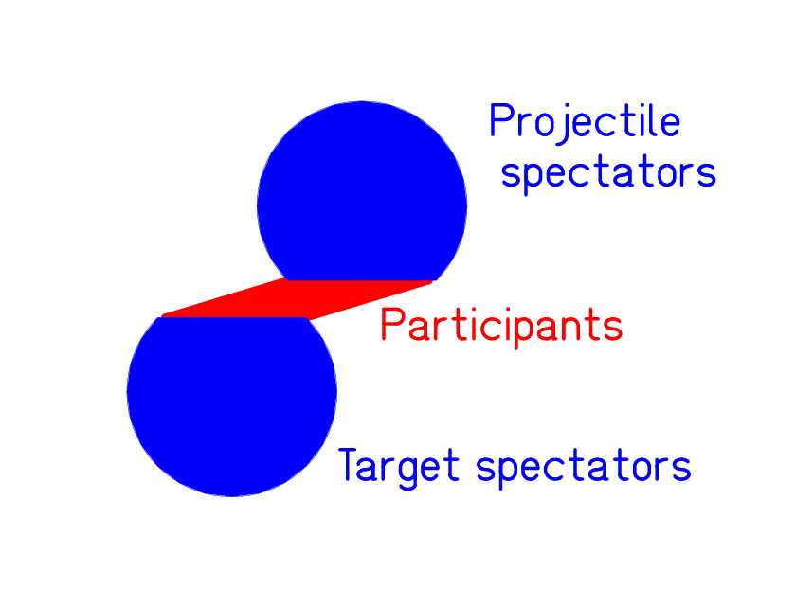

- Unexpected acceleration in violent collisions.
- Valuable information on the EOS of nuclear matter.

M.V. Ricciardi, V. Henzl, PhD theses
M. V. Ricciardi et al., Phys. Rev. Lett. 90 (2003) 212302
Nuclear Charge-Exchange Reaction

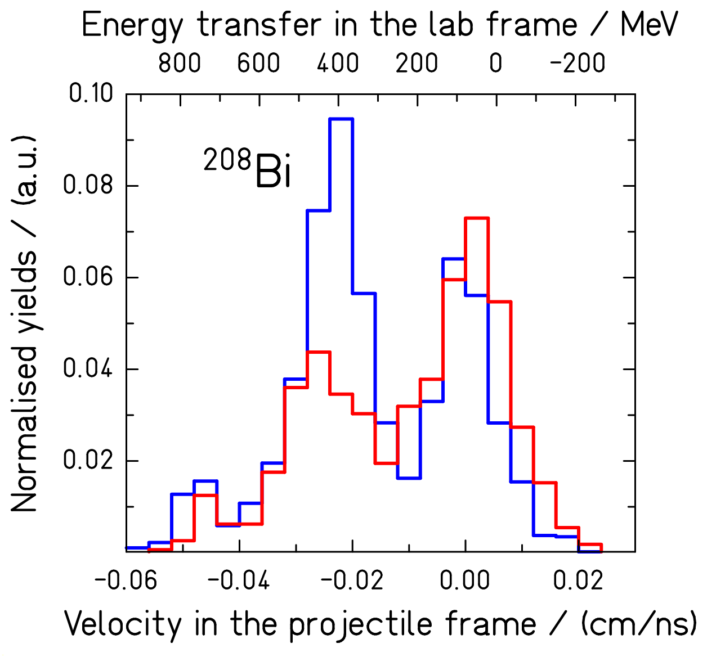

- Charge-exchange reactions:
¹H(²⁰⁸Pb,²⁰⁸Bi)x, ²H(²⁰⁸Pb, ²⁰⁸Bi)x at 1 A GeV
- Quasielastic scattering and
excitation of the Δ(1232) resonance
- Excitation of the nucleon in the nuclear medium

A. Kelic, Phys. Rev. C, submitted

Fission channels

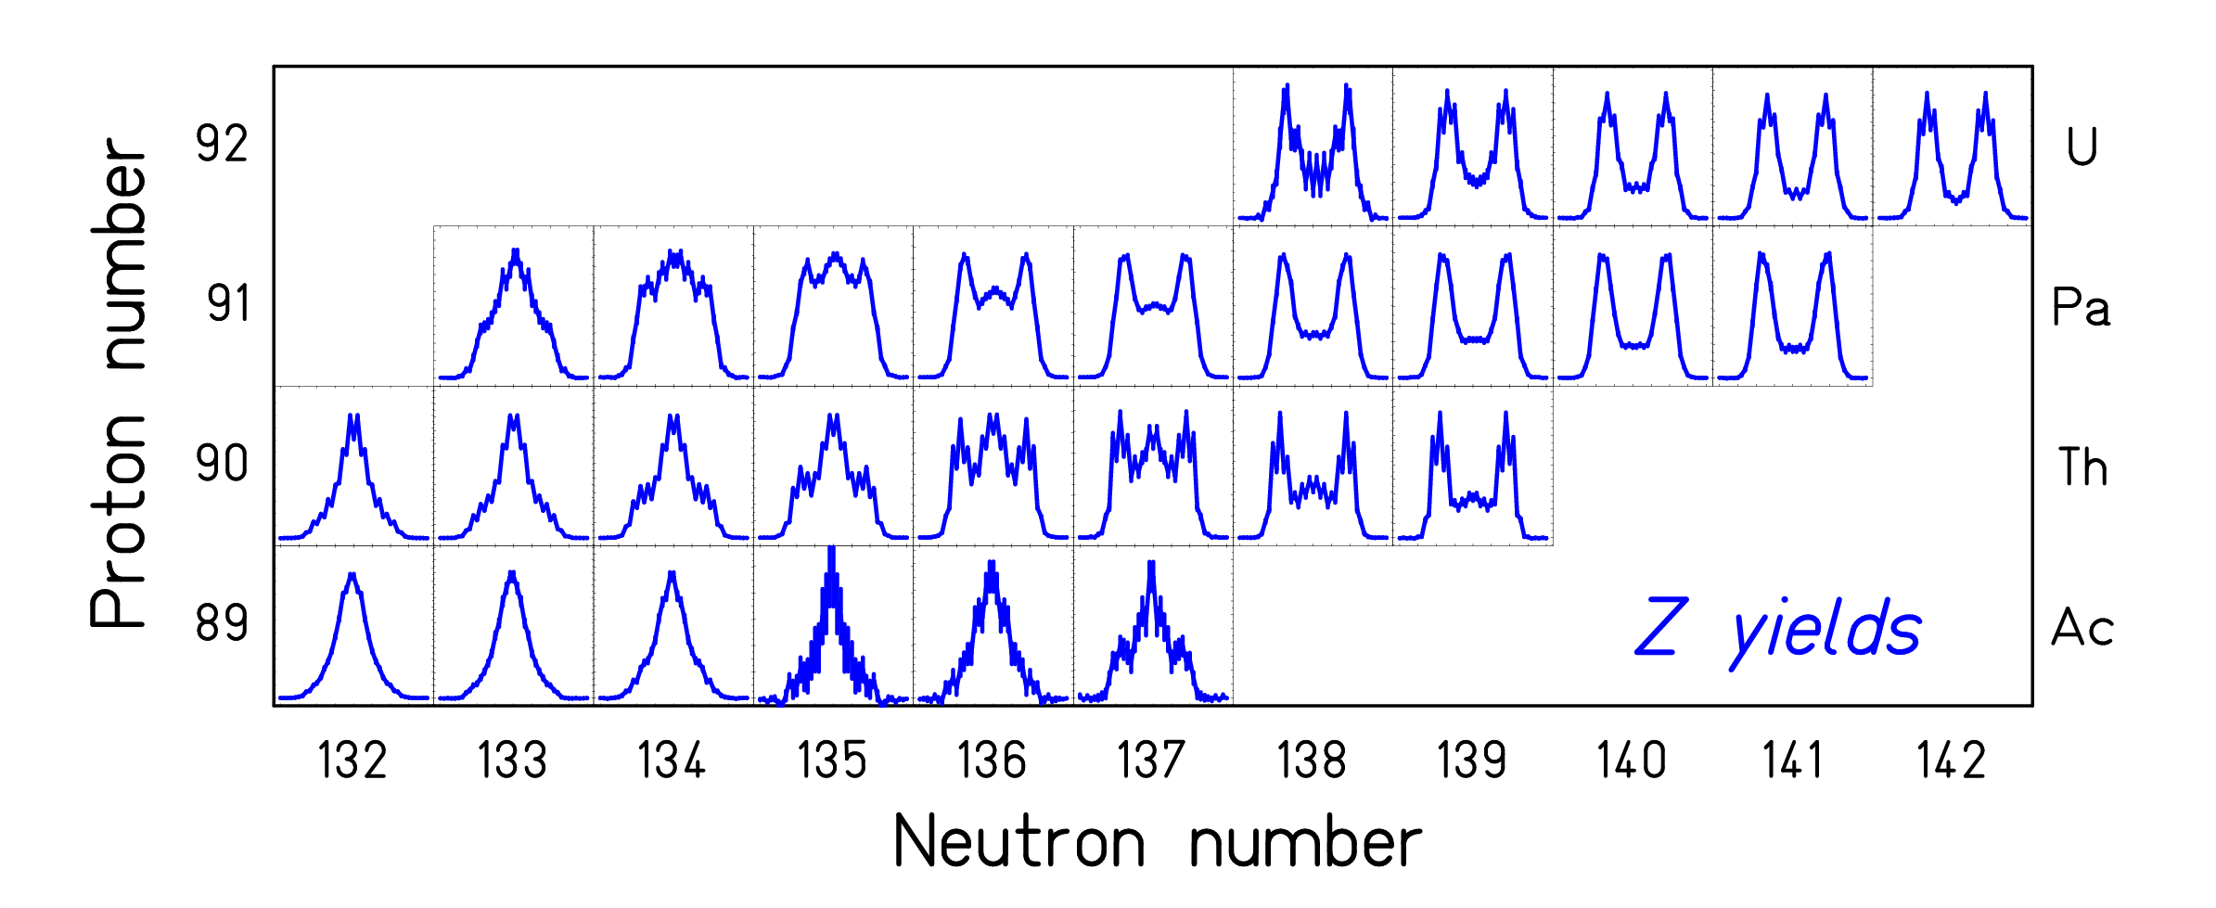

- Z-distributions from e.m.-induced fission
of 70 secondary beams (E* ~ 11 MeV).
- Transition from asymmetric to symmetric fission mapped.
.
K.-H. Schmidt et al., Nucl. Phys. A 665 (2000) 221
The Experimental Storage Ring
(ESR)

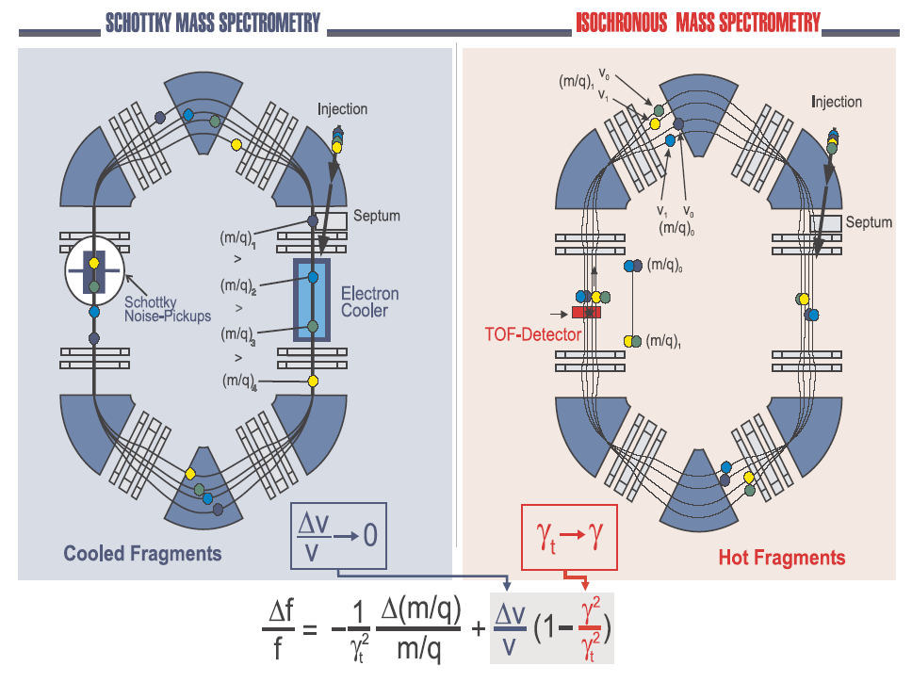

Schottky mass spectrometry
Fourier analysis of the circulation frequency
- Needs cooling (t_{1/2} > 30 s)
- Uncertainty ~ 30 keV

Time-of-flight spectroscopy
Timing detectors measure revolution time
- t_{1/2} > 10 μs
- Uncertainty ~ 100 keV
.
Mass Measurements

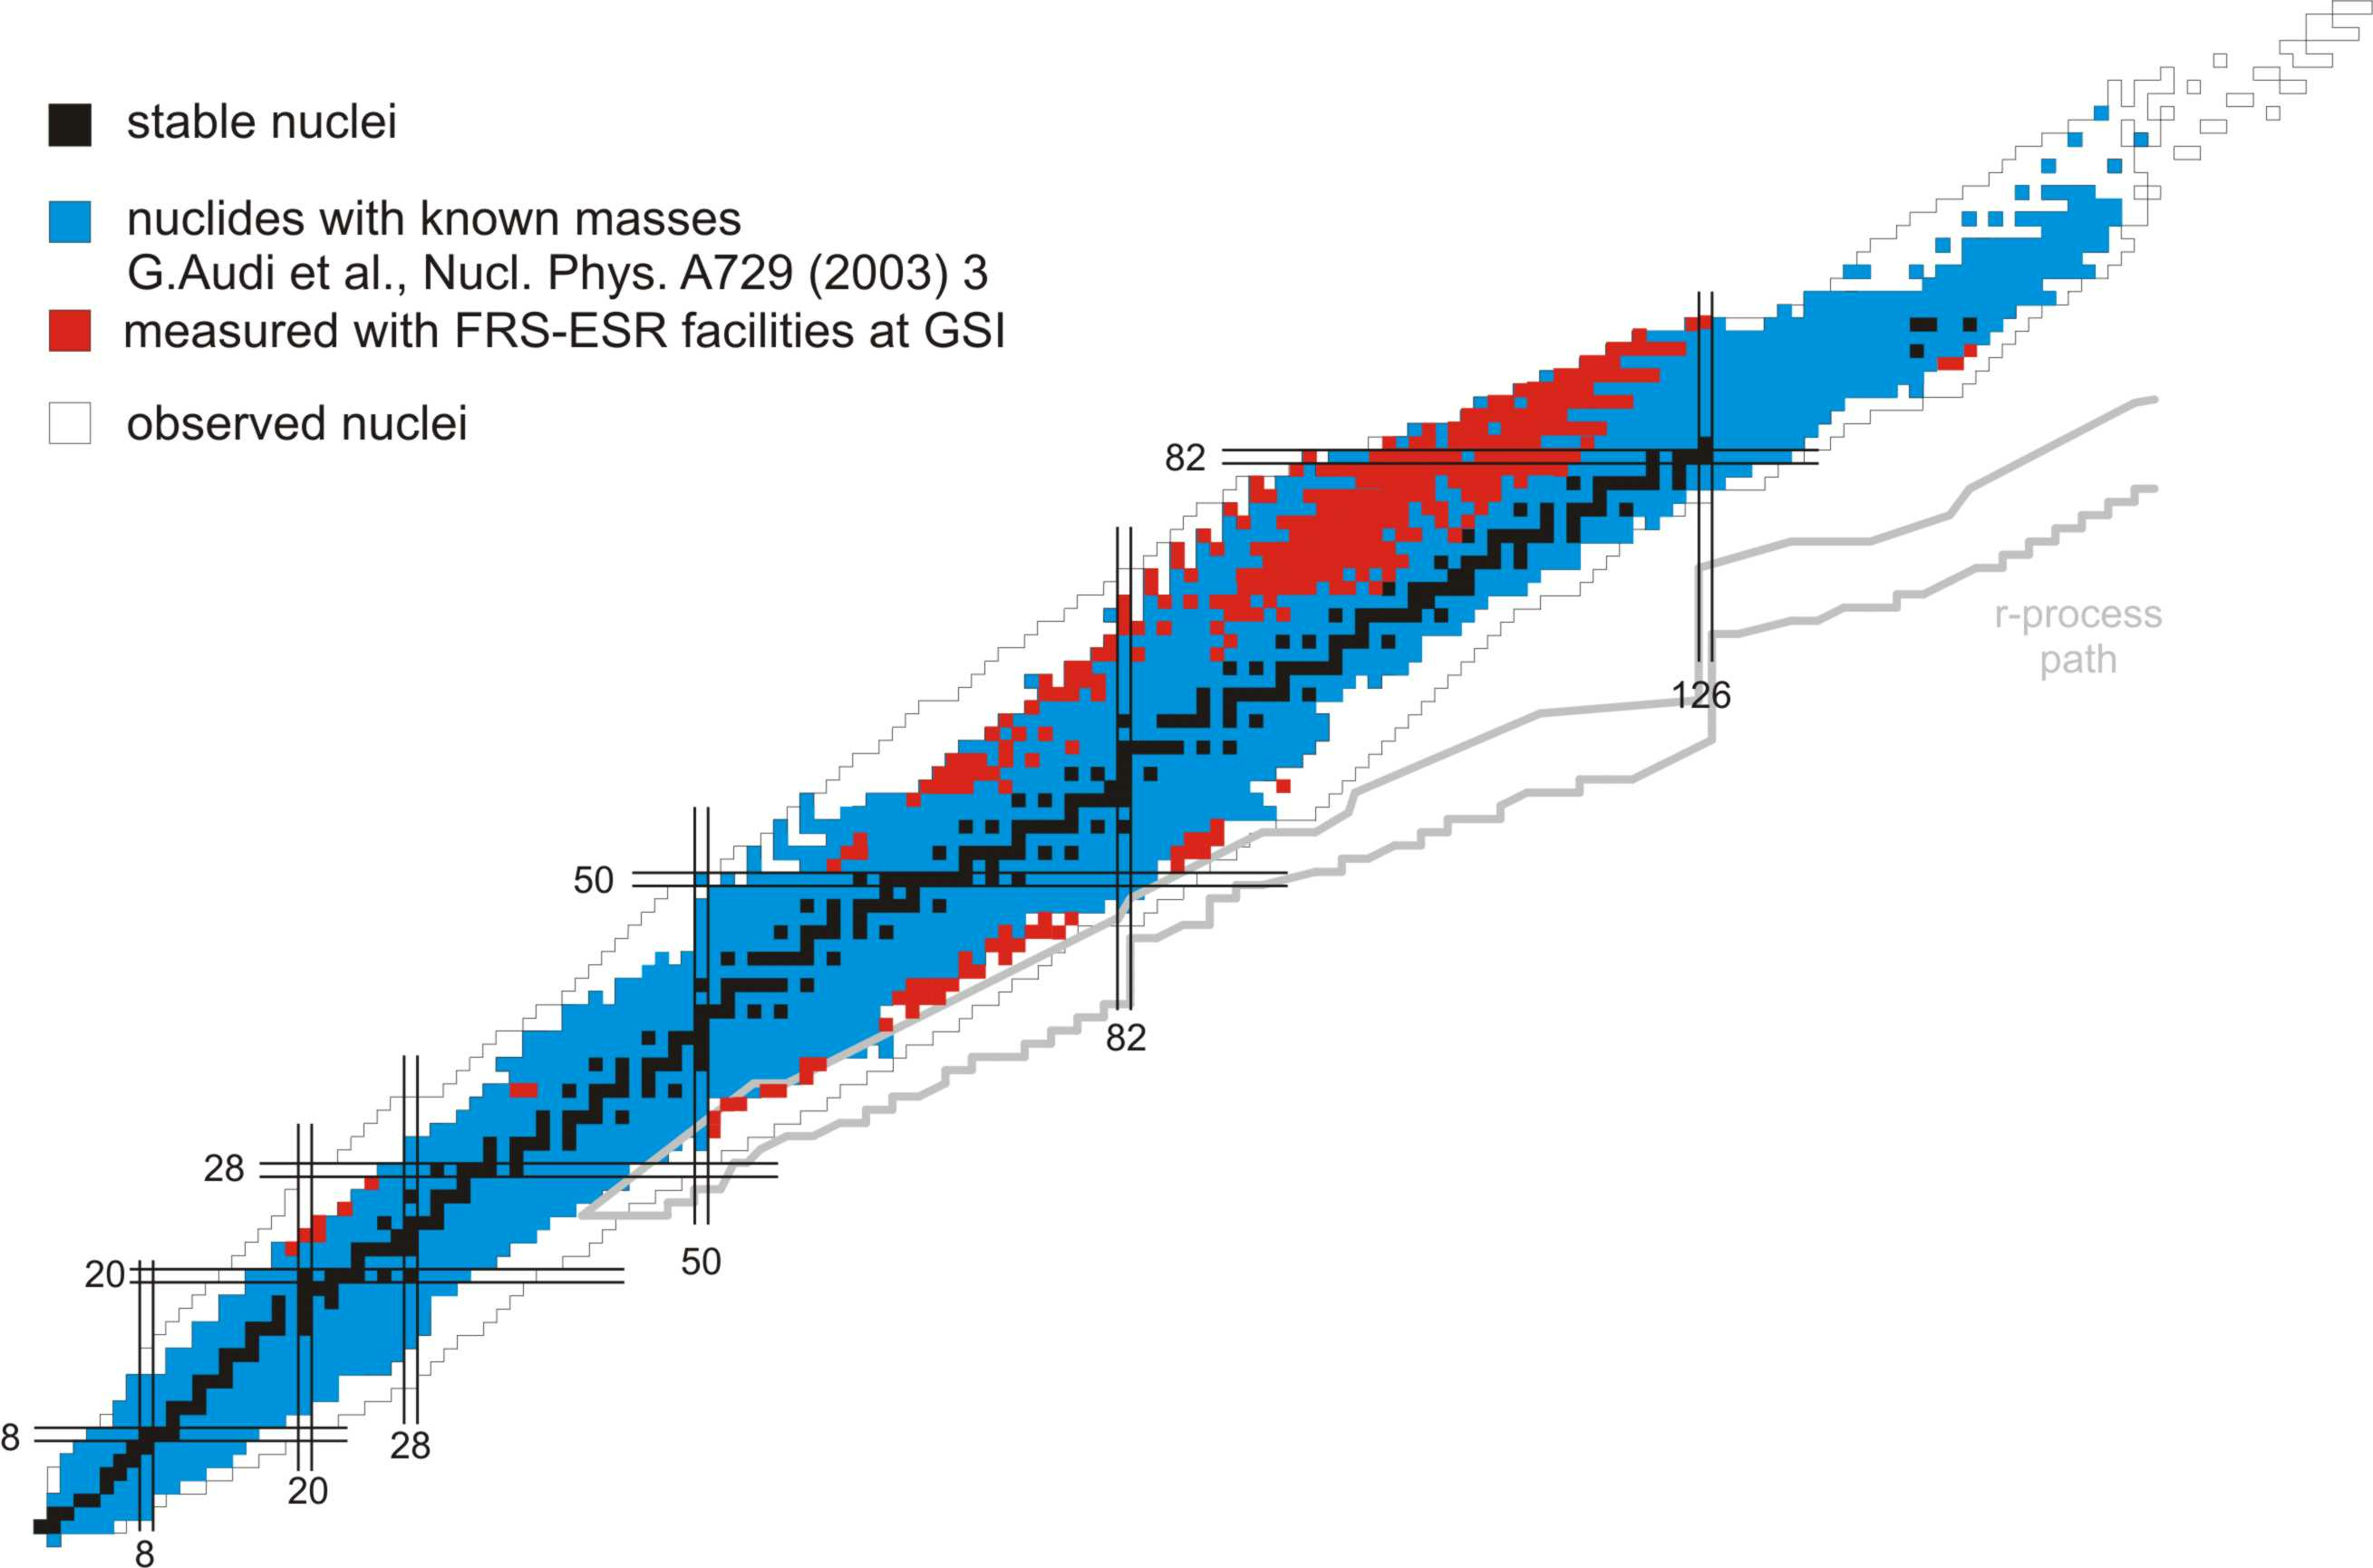

- Mapping of large areas on the chart of the nuclides.
- Ground-state masses of 332 nuclei measured for the first time.

Yu. A. Litvinov et al., Nucl. Phys. A 734 (2004) 473c
T. Radon et al., Nucl. Phys. A 677 (2000) 75
Y. Novikov et al., Nucl. Phys. A 697 (2002) 92
Y. Litvinov, PhD thesis, Univ. Giessen, 2003
E. Kaza, PhD thesis, Univ. Giessen, 2004
M. Hausmann et al., Hyp. Inter. 132 (2001) 291
J. Stadlmann et al., Phys. Lett. B 586 (2004) 27
M. Matos, PhD thesis, Univ. Giessen , 2004

The FAIR Project

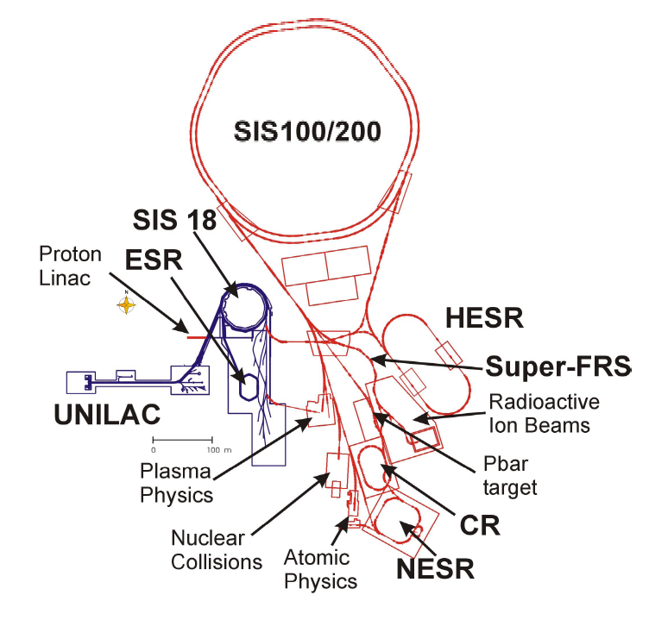

Improved experimental possibilities for nuclear-data experiments by
- Higher beam intensities
- Higher beam energies
- New spectrometers and rings
.
Summary

- In-flight investigations of projectile-like reaction products at the GSI heavy-ion facility.
- Mapping of nuclide production cross sections.
- Indications for a break-up phase from N/Z ratios.
- Acceleration of projectile fragments (EoS).
- Excitation of the nucleon in peripheral collisions.
- Mapping of the fission channels.
- Mapping of nuclear ground-state masses.
- ... and many more observations
(see also http://www-w2k.gsi.de/kschmidt)

Mass Measurements
F. Attallah, K. Beckert, P. Beller, F. Bosch, D. Boutin,
T. Buervenich, H. Eickhoff, T. Faestermann, M. Falch,
B. Franczak, B. Franzke, H. Geissel, M. Hausmann,
M. Hellström, E. Kaza, Th. Kerscher, O. Klepper,
H.-J. Kluge, R. Koyama, C. Kozhuharov, K.-L. Kratz, K.E.G. Löbner, S.A. Litvinov, Yu.A. Litvinov, M. Matoš,
L. Maier, G. Münzenberg, F. Nolden, Yu.N. Novikov,
T. Ohtsubo, A.Ostrowski, A. Ozawa, Z. Patyk, B. Pfeiffer, M. Portillo, B.W. Quint, T. Radon, C. Scheidenberger,
V. Shishkin, C.J. Stadlmann, M. Steck, K. Sümmerer,
T. Suzuki, M.B. Trzhakovskaya, S. Typel, D.J. Vieira,
S. Watanabe, P. Walker, H. Weick, M. Winkler,
H. Wollnik, T. Yamaguchi

Measurements on Nuclear Reactions
P. Armbruster, L. Audouin, C.-O. Bacri, J. Benlliure,
M. Bernas, B. Berthier, A. Boudard, E. Casarejos,
J. J. Connell, S. Czajkowski, P. Danielewicz,
J.-E. Ducret, T. Enqvist, B. Fernandez, J. S. George,
A. Heinz, K. Helariutta, V. Henzl, D. Henzlova,
A. R. Junghans, B. Jurado, A. Kelić, A. Krasa,
R. Legrain, S. Leray, B. Mustapha, P. Napolitani,
M. F. Ordonez, J. Pereira, M. Pfützner, R. Pleskac,
M. Pravikoff, B. Ranjan Behera, F. Rejmund,
M. V. Ricciardi, K.-H. Schmidt, C. Schmitt,
S. Steinhäuser, C. Stéphan, J. Taïeb,
L. Tassan-Got, C. Villagrasa, F. Vivès, C. Volant,
B. Voss, A. Wagner, W. Wlazlo, O. Yordanov

