New Results on
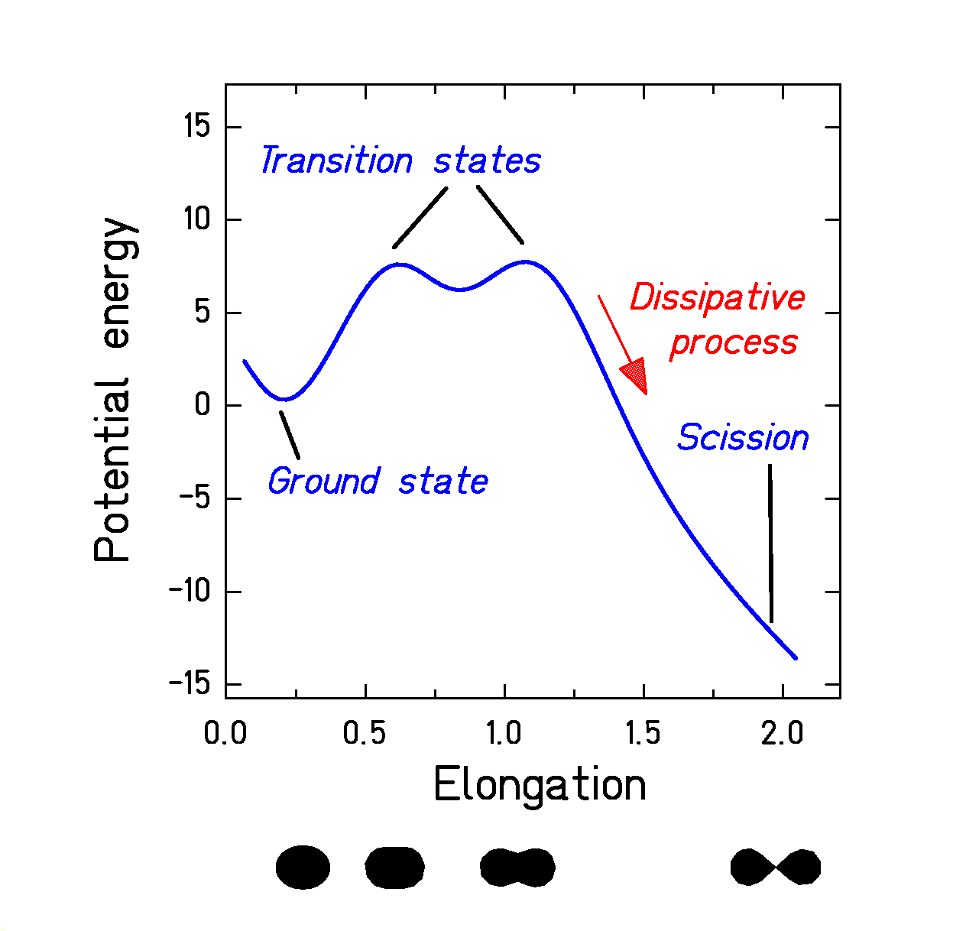
Structure Effects in Nuclear Fission

Low-energy fission: a dramatic reordering of cold nuclear matter.

- Influence of nuclear structure on dynamics.
- Nuclear structure at large deformation.
- Dissipation in cold nuclei.
Many observables, but we restrict to fission-fragment distributions in A and Z.
(E.g. important for secondary-beam production).
Element distribution of fission products from ²²⁶Th as an examples for structural effects in fission (new data)

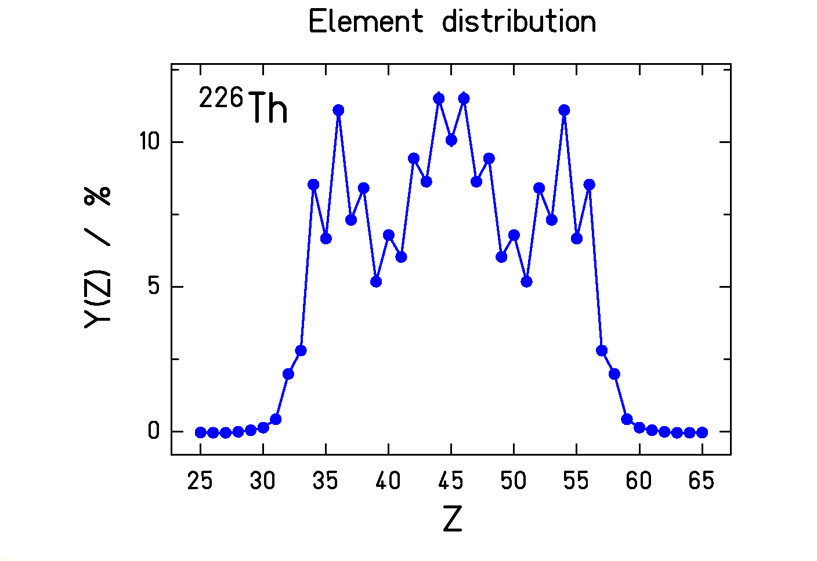
Structures are very pronounced!
Gross structure from shell effects.
Fine structure from pairing correlations.

Previous knowledge on systematics of shell structure (example)
Asymmetric fission of actinides

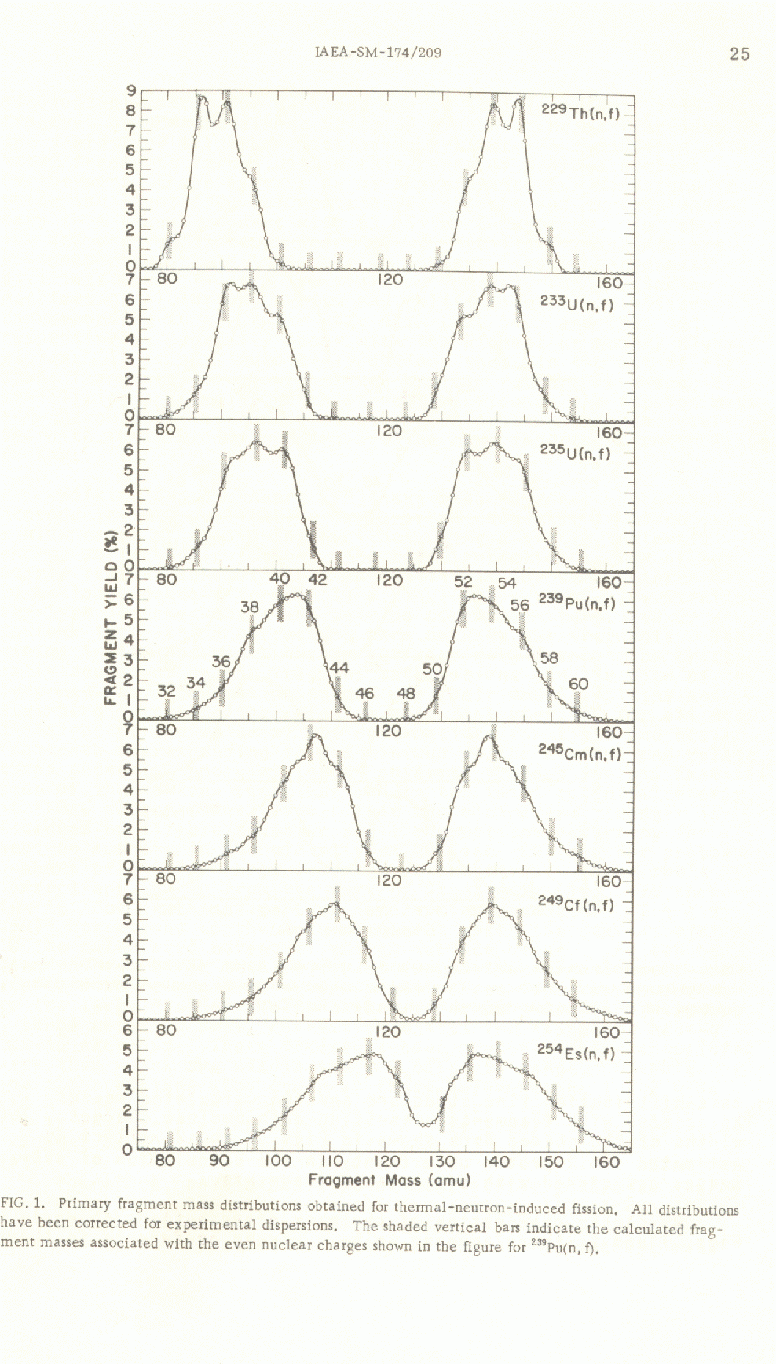

229Th(n,f)

233U(n,f)

235U(n,f)

239Pu(n,f)

245Cm(n,f)

249Cf(n,f)

254Es(n,f)

Mean mass of heavy component almost stationary.
(Dominant influence of shells in heavy fragment.)
Mass width increases for heavier systems.
J. P. Unik et al. (1974)
Experimental results of conventional experiments (overview)

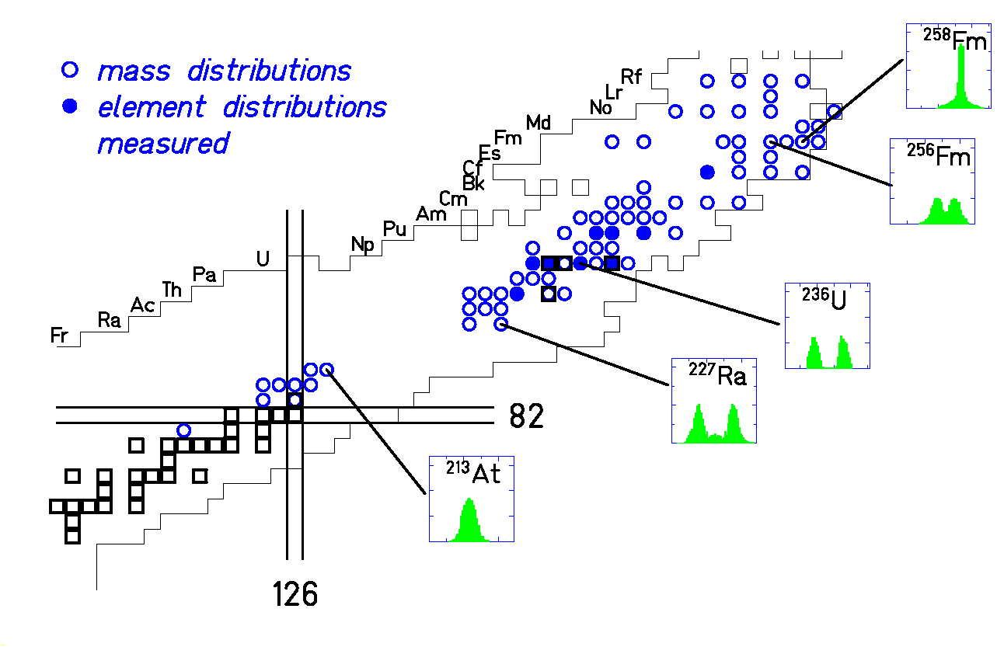
- Asymmetric fission of actinides.
- Symmetric fission near 2×¹³²Sn.
(Partly accessible by spontaneous fission.)
- Symmetric fission below ²¹³Ac.
(Intermediate region not accessible due to lack of targets.)
78 mass distributions and
9 element distributions measured.
No systematic coverage of fissioning systems!
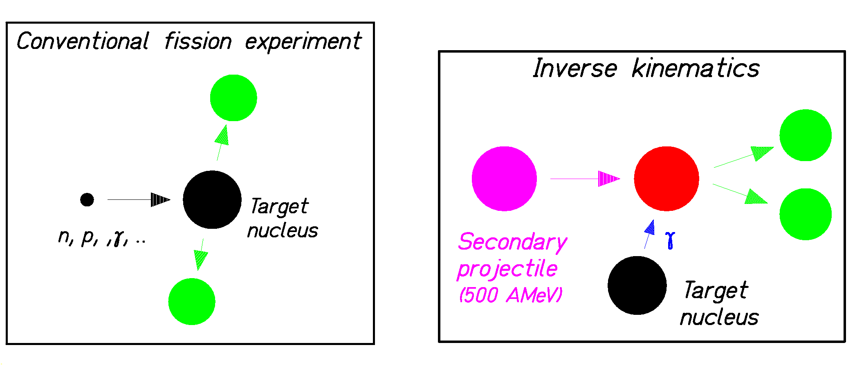
New possibilities for fission studies with secondary beams in inverse kinematics at GSI

Experiments with secondary beams:
- Fragmentation of relativistic ²³⁸U (1 A GeV) + isotopic separation (with FRS):
Several hundred fissile nuclei accessible (+)
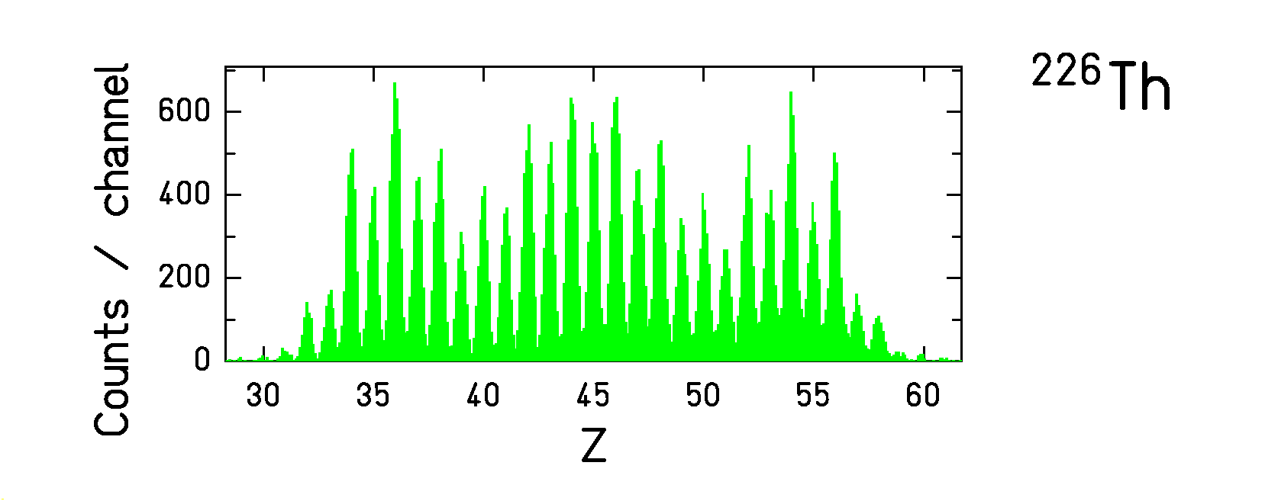
- Coulomb excitation (mostly GDR):
Distribution of excitation energies (-)
- Fission fragments are fully stripped:
Excellent Z resolution (+)
Measured element distributions

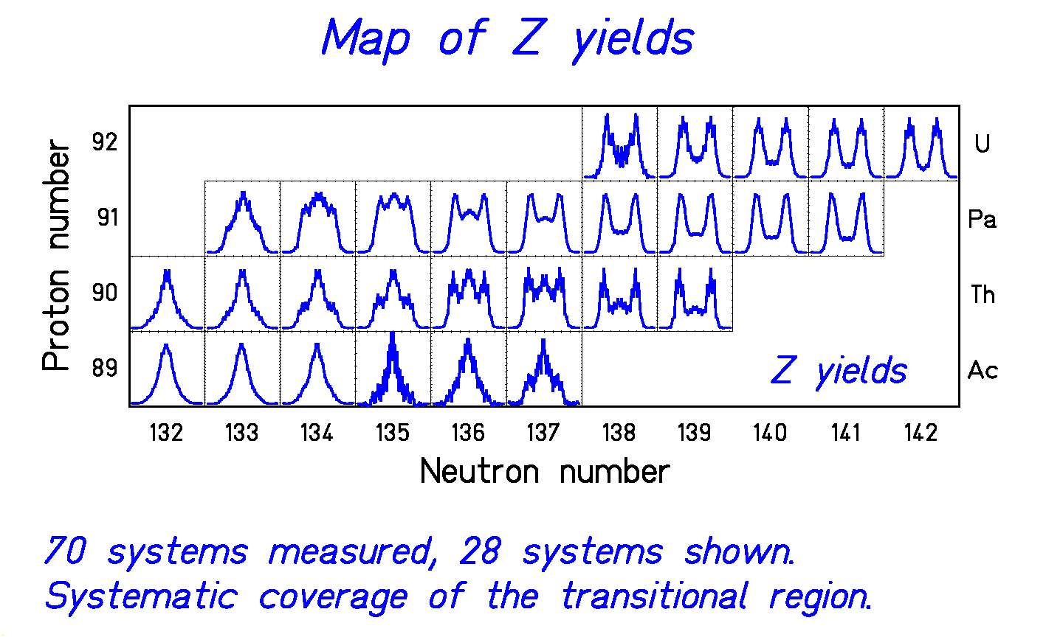

- Gradual transition from symmetric to asymmetric fission systematically mapped.
K.-H. Schmidt et al., Nucl. Phys. A 665 (2000) 221
Macroscopic-microscopic conditional transition-state model
$Y\left(A\right)∝ρ\left(A\right)$ (Phase space at conditional saddle)
$ρ\left(A\right)∝e^{2\sqrt{\text{aE}}}$ with $E=E^{}−V(A)$
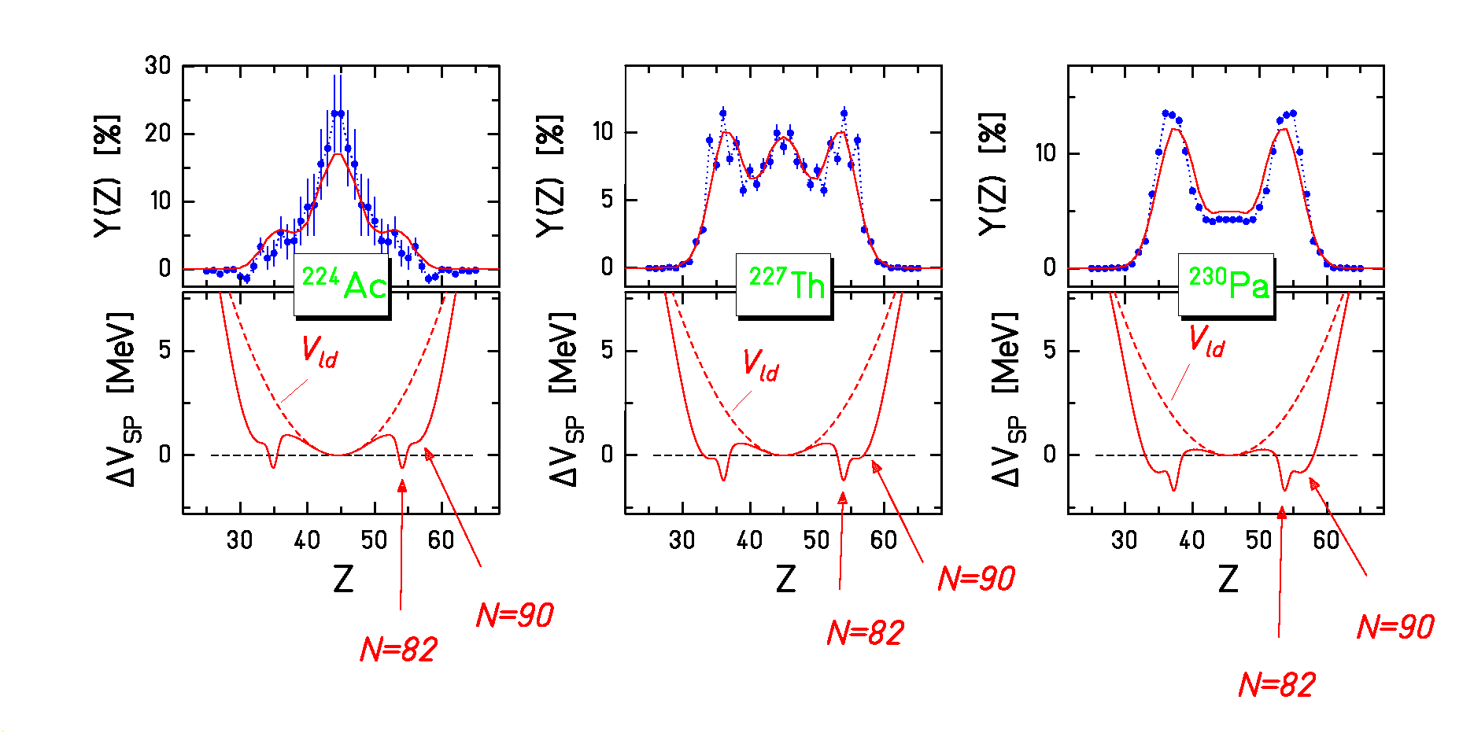
$\text{aE}=\tilde{a}\left[E+δU\left(1−e^{E/E_{d}}\right)\right]$ with $E_{d}=\text{18}\text{MeV}$
$V_{\text{ld}}\left(A\right)=C⋅{\left(A−\frac{A_{\text{cn}}}{2}\right)}^{2}$,
Stiffness C from empirical systematics of mass distributions: $σ^{2}\left(A\right)=\frac{T}{2C}$;

N=82 and N=90 shells adjusted only to ²²⁶Th.
→ Competition between symmetric and asymmetric fission: Shells move down (up) for heavier (lighter) nuclei on liquid-drop potential.
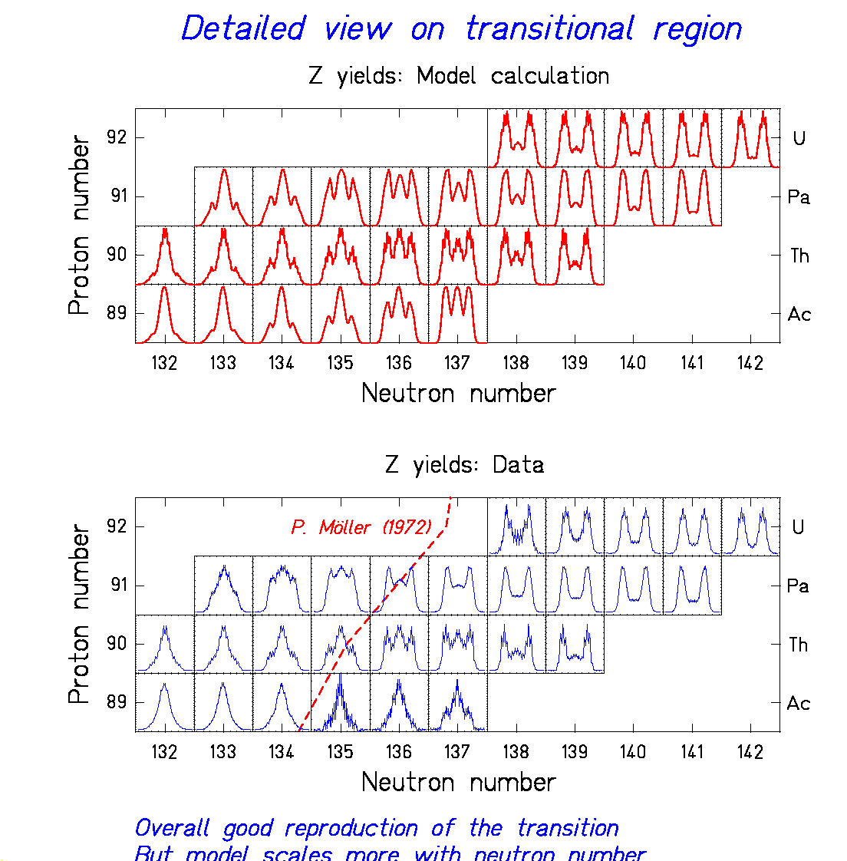
Systematic comparison of model and data

Good reproduction of global trends!

Transition explained by competition of liquid drop (→ symmetry) and shells (→ asymmetry).

Prediction of Möller (1972): wrong slope of transition;
new calculations underway.
Previous knowledge on systematics of even-odd structure (example)

Global even-odd effect in element yields for even-Z fissioning nuclei

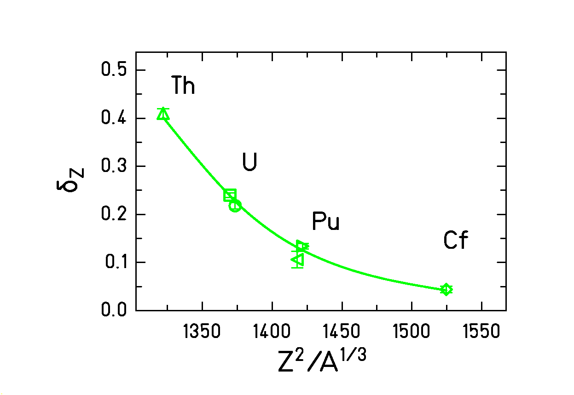
$δ_{Z}=\frac{\sum{Y\left(Z=\text{even}\right)}−\sum{Y\left(Z=\text{odd}\right)}}{\sum{Y\left(Z=\text{even}\right)}+\sum{Y\left(Z=\text{odd}\right)}}$
Structure decreases for heavier systems.
First systematic study of odd-Z fissioning systems
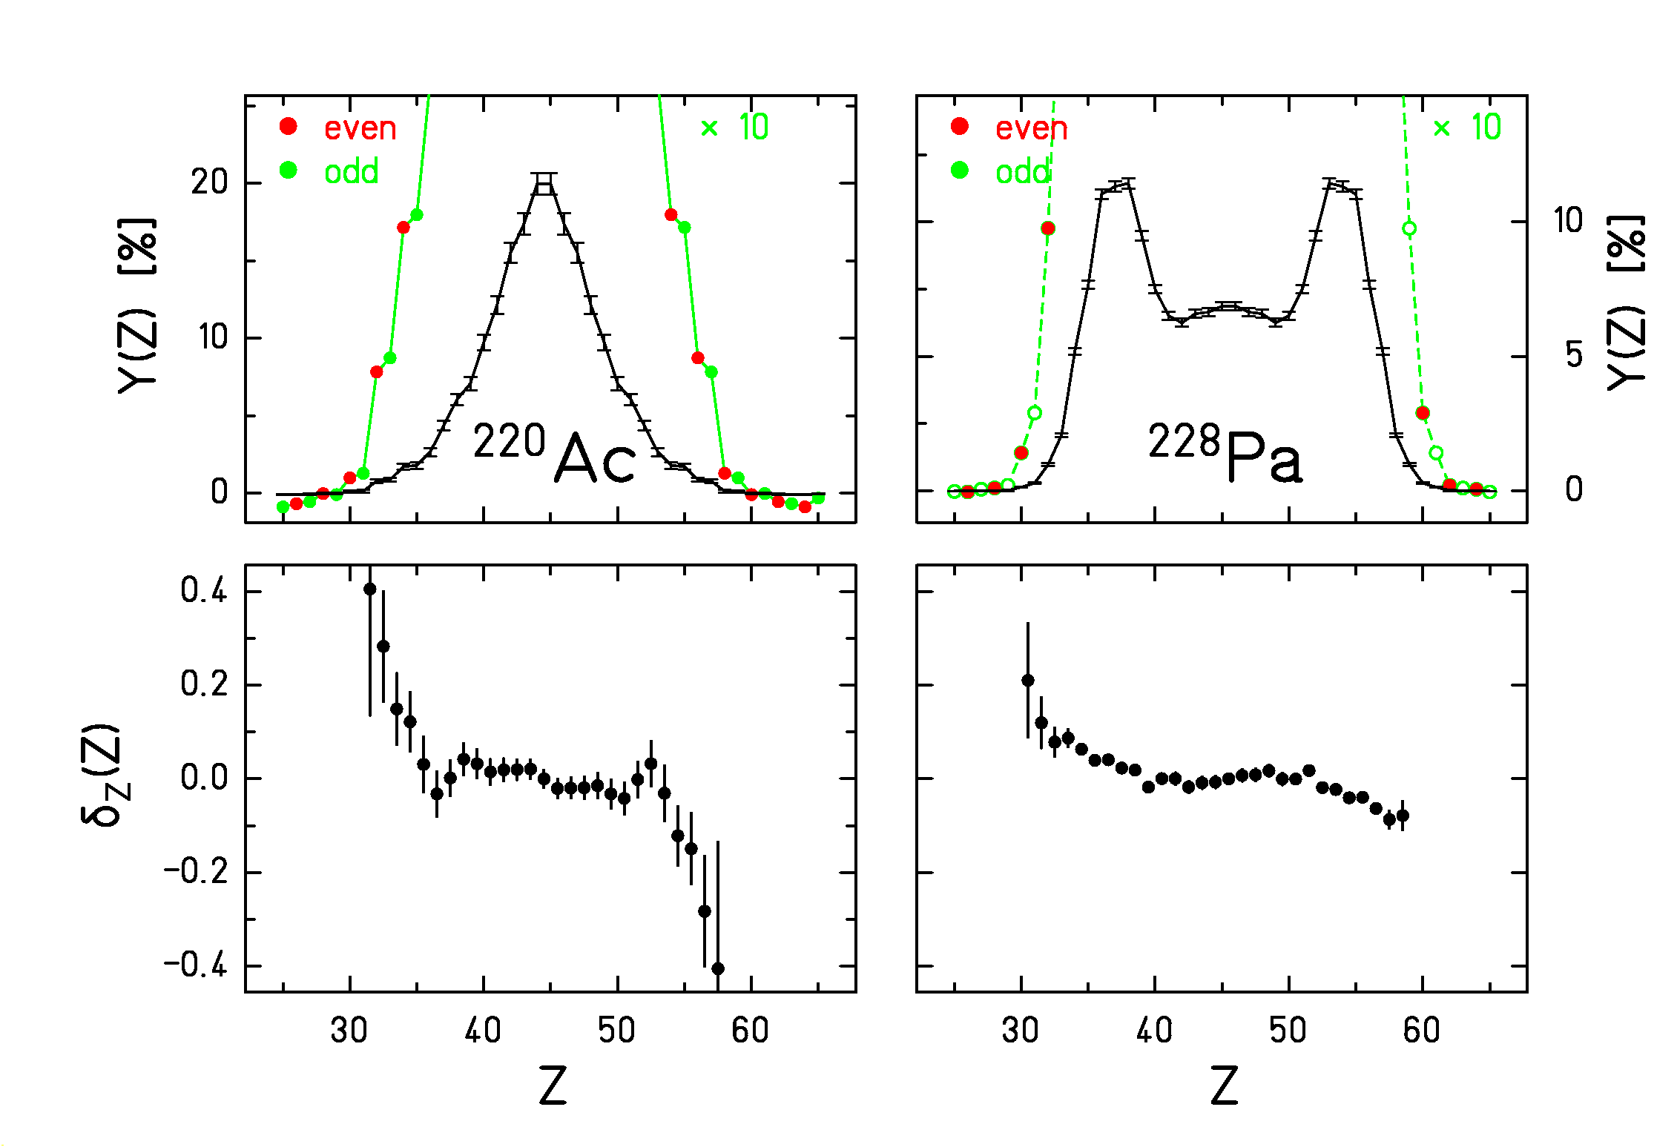
New finding: Local even-odd effect
$$\begin{aligned}δ_{Z}\left(Z+1\text{.}5\right)=\frac{1}{8}{\left(−1\right)}^{Z+1}⋅\left[\text{ln}Y\left(Z+3\right)−3\text{ln}Y\left(Z+2\right)+3\text{ln}Y\left(Z+1\right)−\text{ln}Y\left(Z\right)\right]\end{aligned}$$
in asymmetric splits!

Interpretation:
- Single-particle level density ∝ nuclear volume.
- Unpaired protons prefer heavy fragment!
St. Steinhäuser et al., Nucl. Phys. A 643 (1998) 89

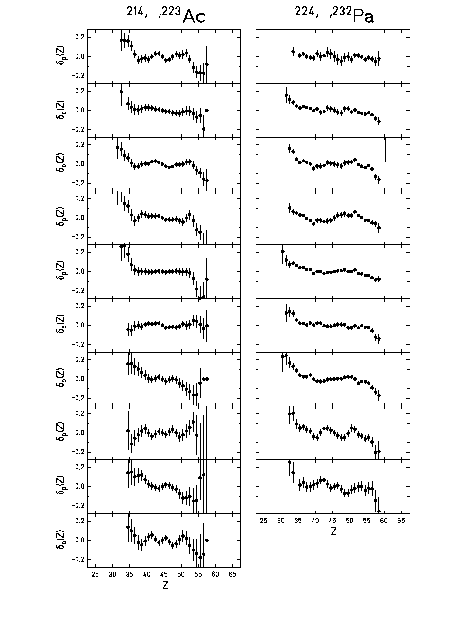
Systematic overview on odd-Z fissioning systems
First study of even-Z fissioning systems with strong symmetric component
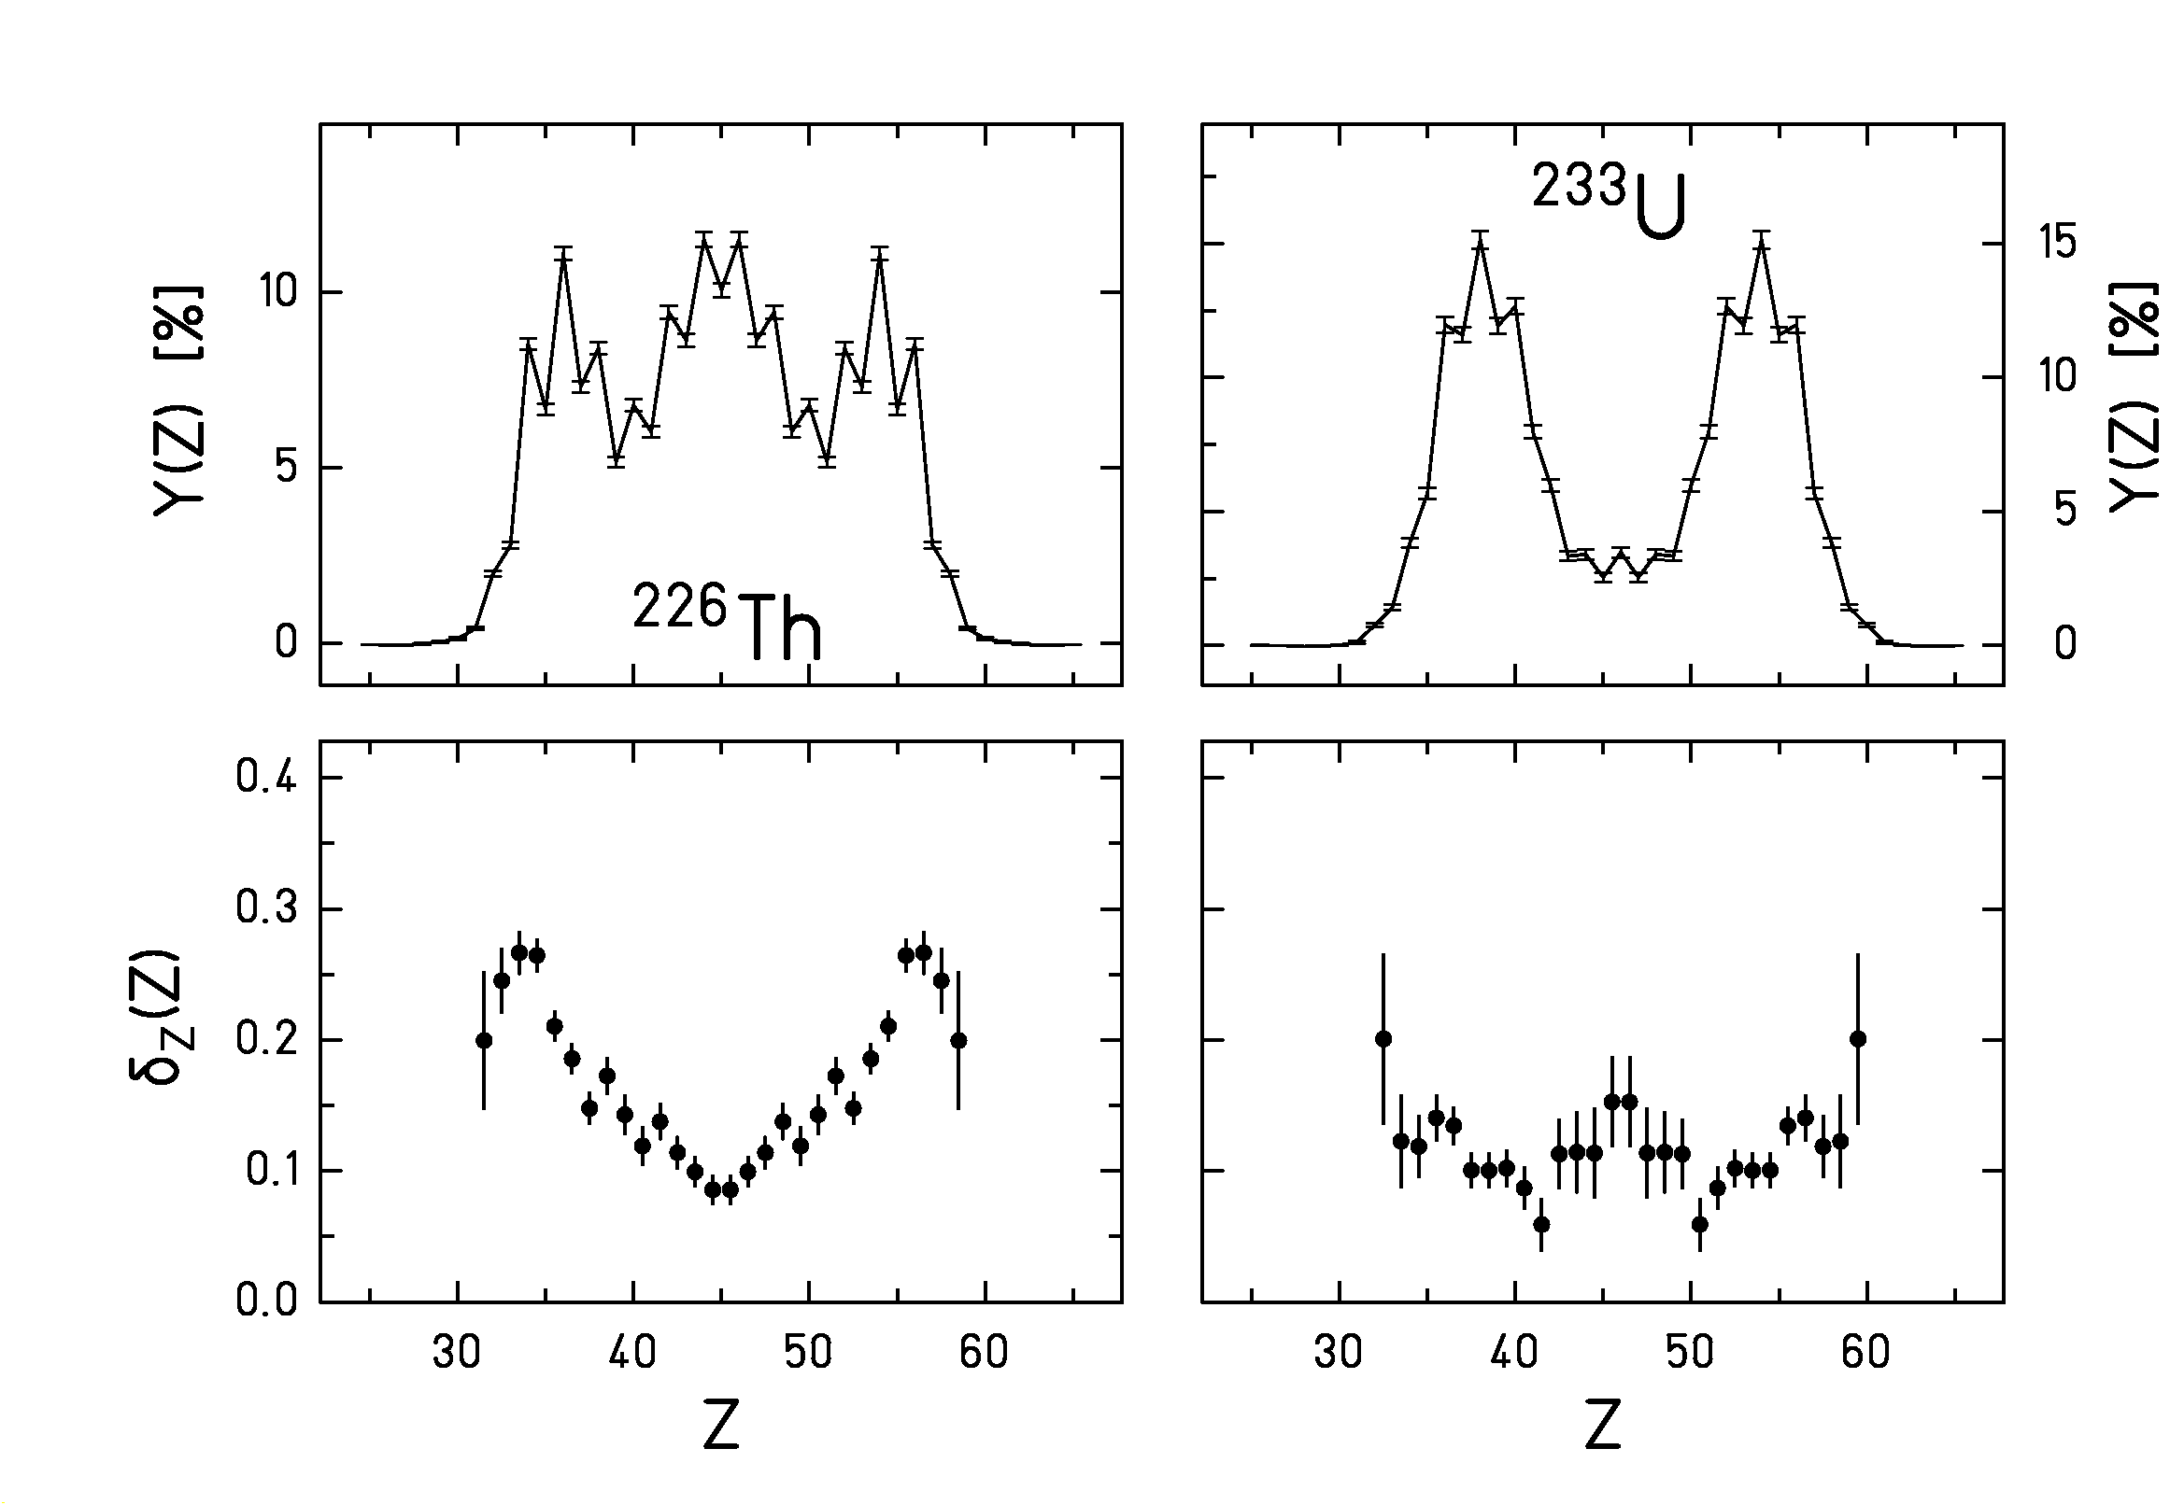

- Increase of even-odd effect in asymmetric splits.
- Same effect with 2 unpaired protons as in odd-Z fissioning systems.
- Not to be interpreted as "colder" fission!
St. Steinhäuser et al., Nucl. Phys. A 643 (1998) 89

Systematic overview on even-Z fissioning systems
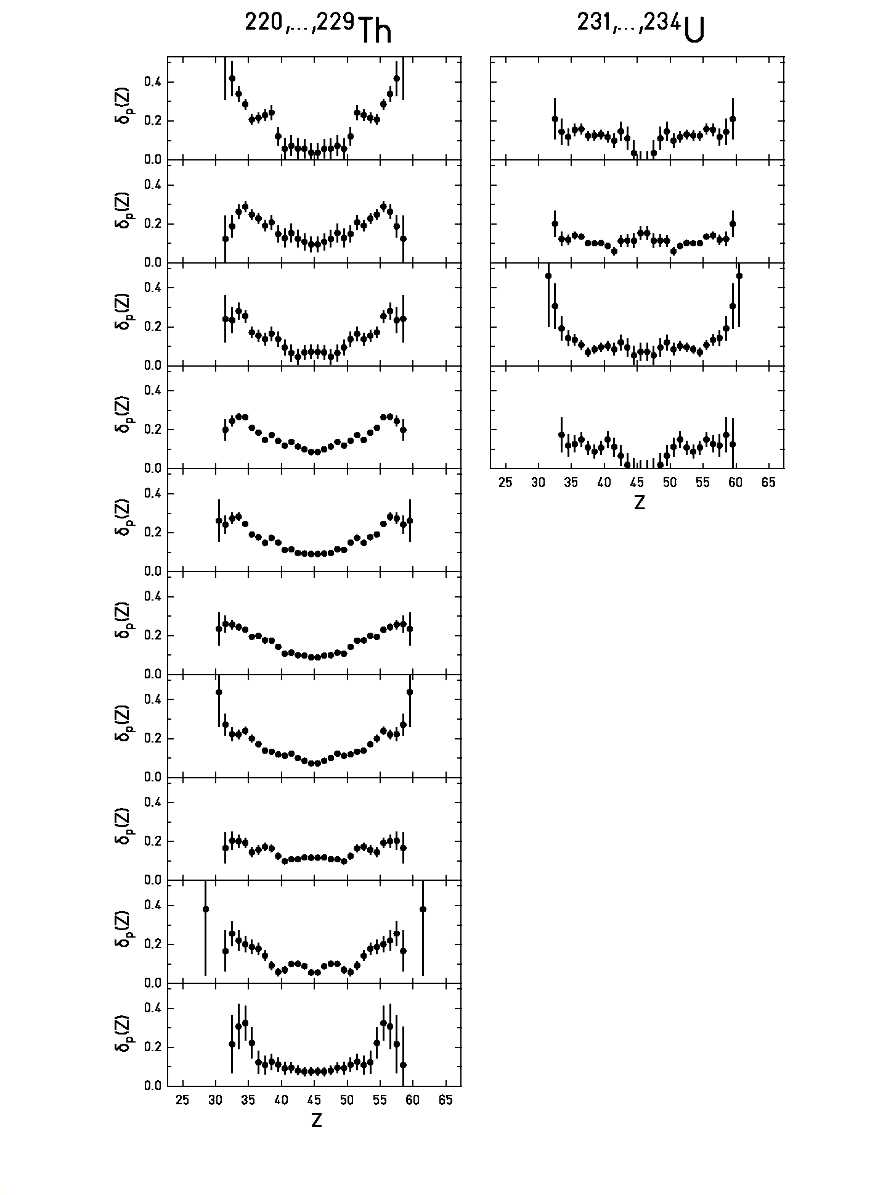
New statistical interpretation of even-odd effect
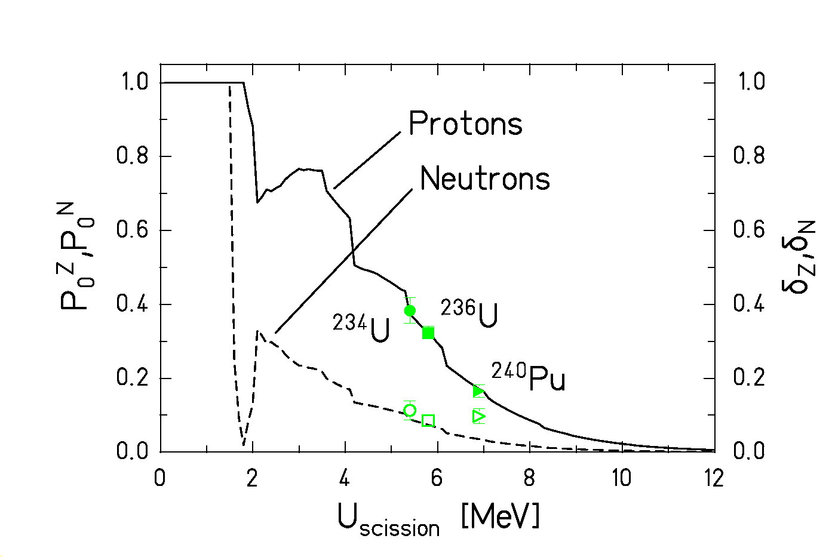
(Inspired by the success of statistical considerations for the interpretation of the new data)

Data: Previously measured δ_{Z}, δ_{N} at high TKE.
Lines: $P_{0}^{Z}(E^{})=\sum_{n_{N}}{ρ_{n_{Z}=0,n_{N}}\left(E^{}\right)}/\sum_{n_{Z},n_{N}}{ρ_{n_{Z},n_{N}}\left(E^{}\right)}$
Two-component superfluidity:
Proton or neutron subsystems may survive
unexcited above pairing gap.

Explains the larger even-odd effect in proton number!

F. Rejmund, A. V. Ignatyuk, A. R. Junghans, K.-H. Schmidt, accepted by Nucl. Phys. A

Summary

Nuclear fission is a unique laboratory, (e.g. unlike metallic clusters):
- Volume charge (repelling Coulomb force acts on whole volume) -> "true" fission.
- Two-component superfluidity (complexity in pair breaking).
Experiments with secondary beams using elaborate experimental installations opened up new possibilities.
The new results are consistent with statistical concepts.
Although the full understanding of the dynamics is still missing, one came closer to a quantitative description of structure effects in fission.

