Nuclear-structure effects
deduced from the number of bound states

Systematic studies of global nuclear properties of isotopically separated nuclei have been extremely successful

Established global observables:
- masses ↓ pairing correlations and shell effects
- total interaction cross sections ↓ halo nuclei

New global observable:
- nuclide production cross-sections in nucleus-nucleus collisions ↓ complex phenomena of nuclear structure

Example: ²³⁸U → Ti at 1 A⋅GeV at the FRS (GSI)

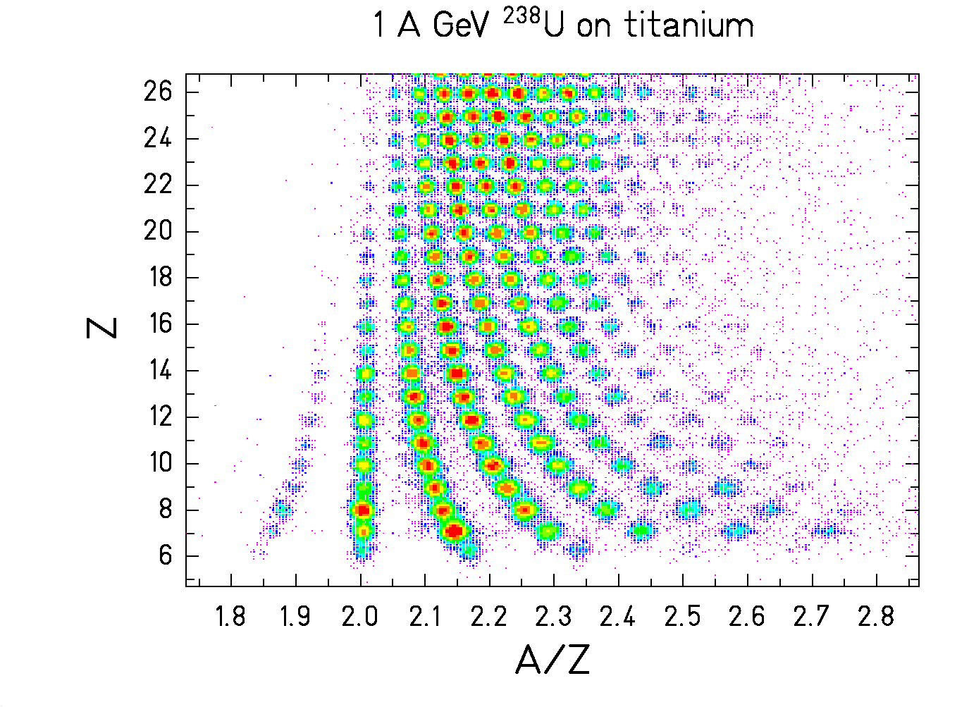

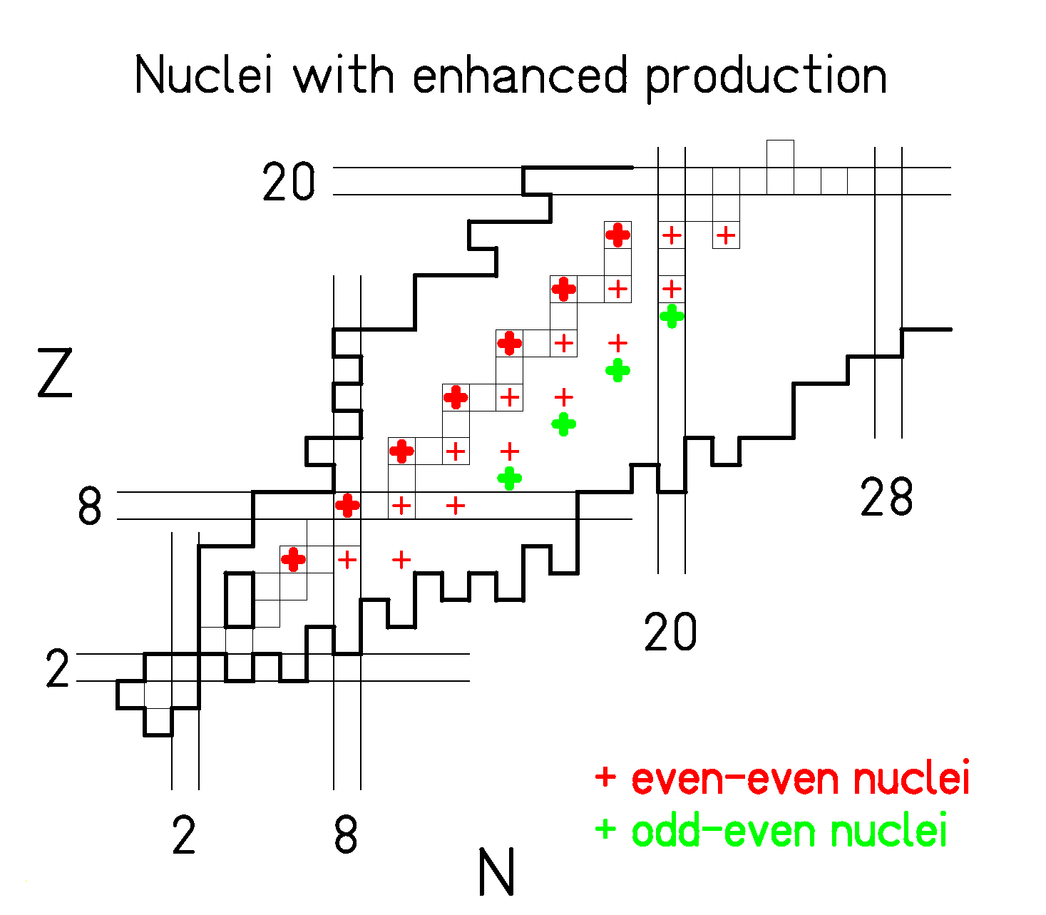
EXPERIMENT

PhD Thesis M.V. Ricciardi

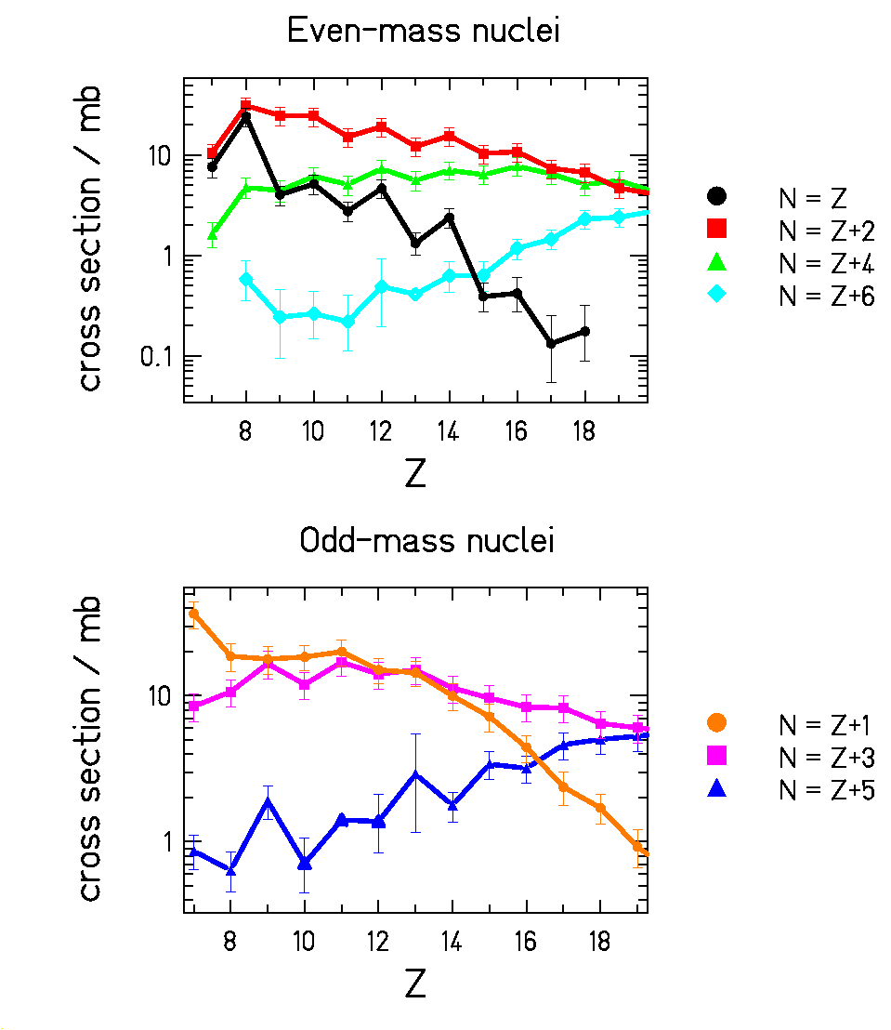

CALCULATION
δ_{oo}= 0
δ_{oe}= δ_{eo}= Δ
δ_{ee}= 2Δ
M = M_{LD} - δ
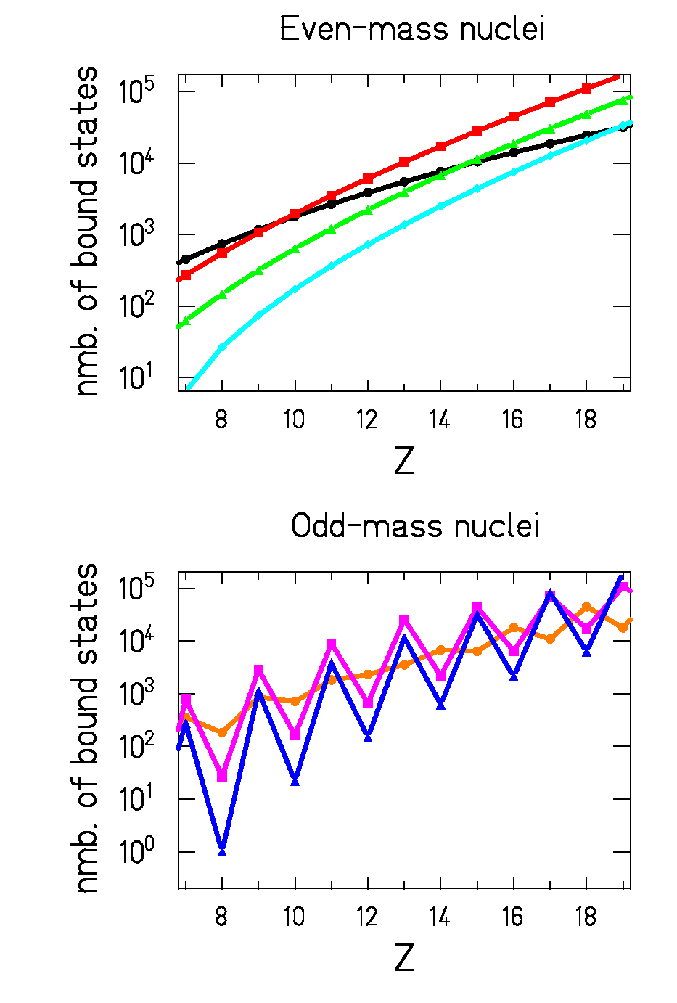
$ρ$~ $\text{exp}\left(2\sqrt{a\left(E−δ\right)}\right)$

OUTLOOK

even-odd structure of even-mass nuclei reveals higher-order structural effects:

- mean-field contribution to pairing effect

- alpha clustering

- neutron-proton pairing

The yield from highly excited nuclei
reflecting the number of bound states
is a new global observable
probing complex nuclear structure phenomena

