Structural effects in nuclide distributions from fission and fragmentation

M. V. Ricciardi, K.-H. Schmidt, P. Napolitani,
GSI Darmstadt
F. Rejmund, IPN Orsay
- V. Ignatyuk, IPPE Obninsk

- Structural effects in low-energy fission.
  - Even-odd structure.
  - Fission channels.

- Structural effects in fragmentation products.
  - Enhancement of specific classes of nuclei.

- Recent experimental results.
- Theoretical interpretation.
- Speculative ideas.

Invited talk given at the

284. WE-Heraeus-Seminar

“Symposium on Nuclear Clusters: from Light Exotic to Superheavy Nuclei“

at Rauischholzhausen Castle (near Marburg, Hessen, Germany)
5-9 August 2002
Even-odd structure in low-energy fission

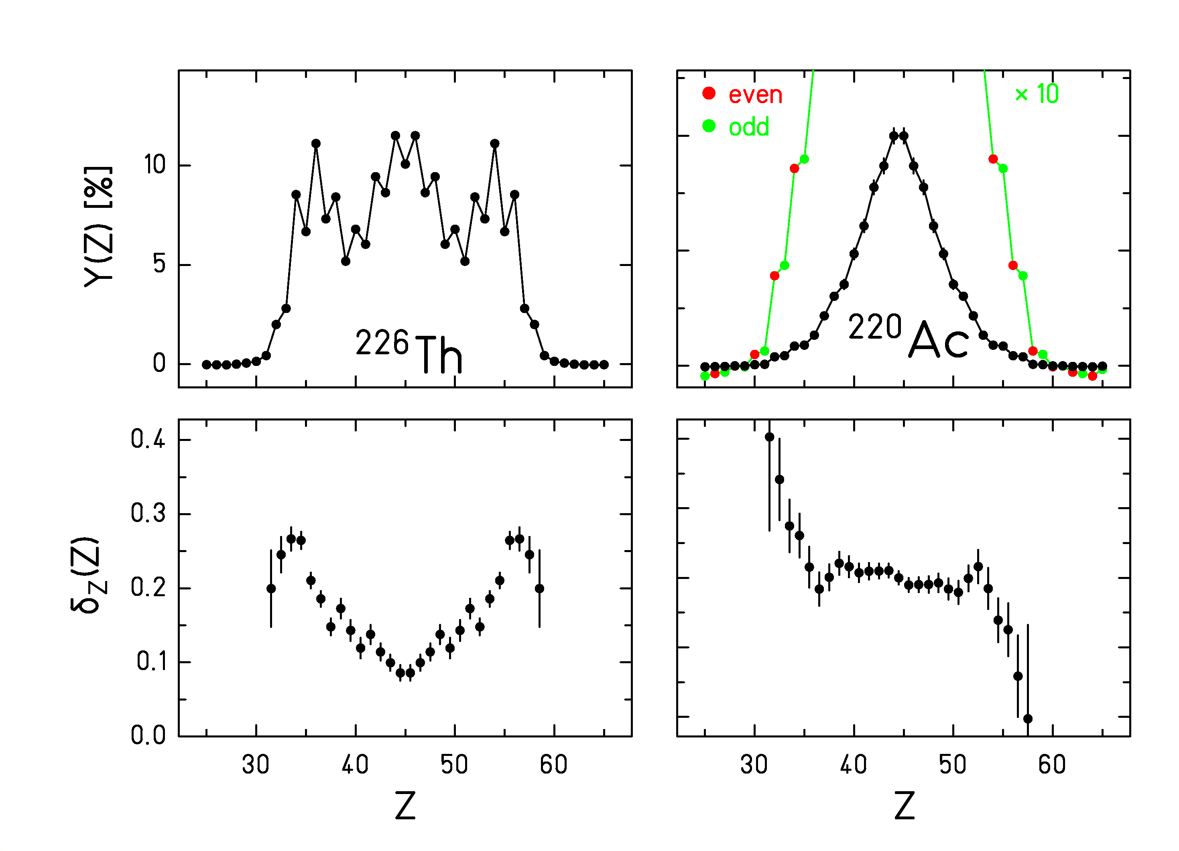
Results from e.m.-induced fission of 70 different secondary projectiles (Steinhäuser et al., NPA634 89, 1998)

[δ_{Z} is a measure of the deviation of 4 yields from a Gaussian curve (Tracy et al., PRC5 222, 1972)]

Strong even-odd effect at asymmetry:
Odd protons prefer heavy fragment

Even-odd effect for even-Z systems at symmetry:

Measure of pairing correlations
Survival of cold proton (neutron) subsystem

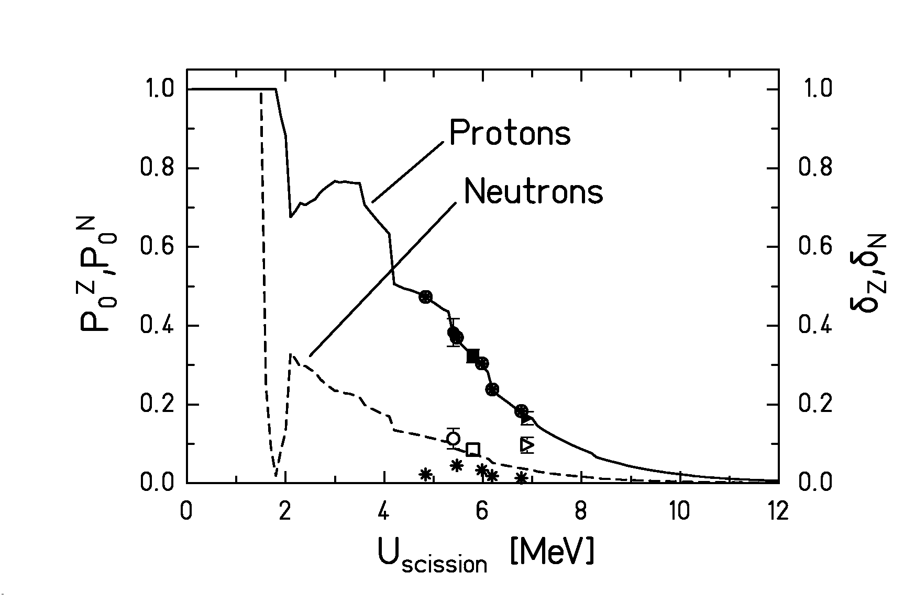

New idea (F. Rejmund et al., NPA678, 215, 2000)

Even-odd structure due to survival of completely paired configuration.

P₀^{Z} = Probability for completely paired proton configuration:

$$P_{0}^{Z}=\frac{\sum_{n_{N}}{ρ_{n_{z}=0,n_{N}}}}{\sum_{n_{Z},n_{N}}{ρ_{n,n_{N}}}}$$

δ_{Z} = Local proton even-odd effect
Fission channels in low-energy fission
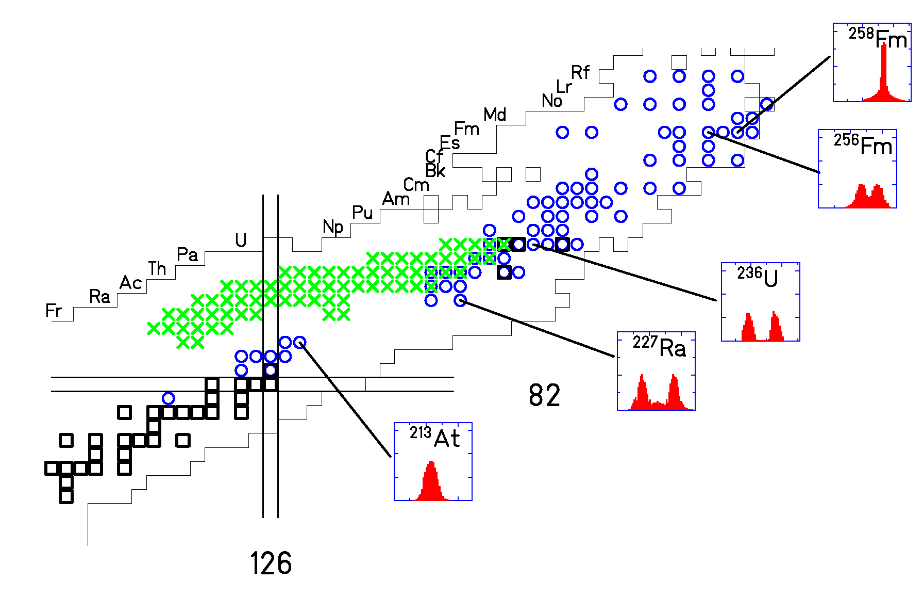
Mass distributions (conventional experiments)

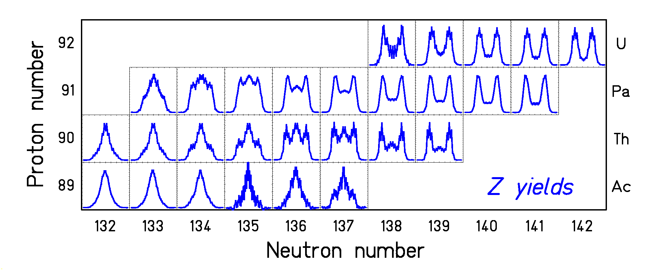

Z distributions (secondary beams)
(K.-H. Schmidt et al., NPA655, 221, 2000)

Survival of shell structure at saddle → scission

Structural effects in fragmentation, overview

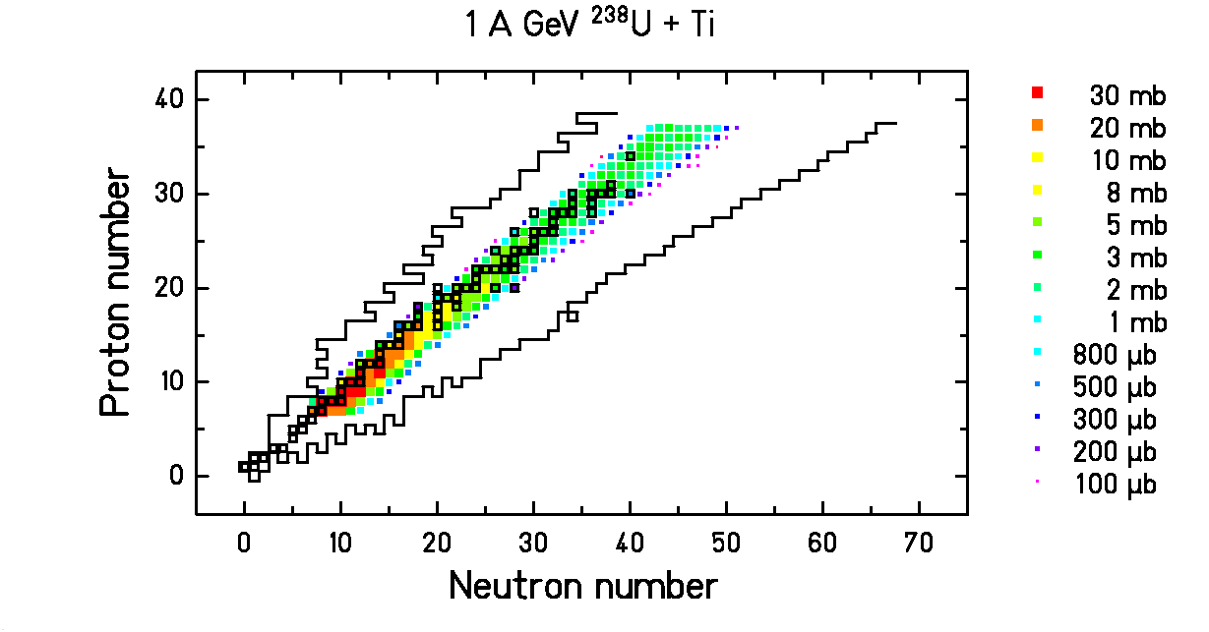

Light fragments of ²³⁸U (1 A GeV) produced in collisions in a Ti target

M. V. Ricciardi, PhD in preparation

First analysis of fine structure in fragmentation with individual production yields of fully identified nuclides.
Cuts with fixed N-Z

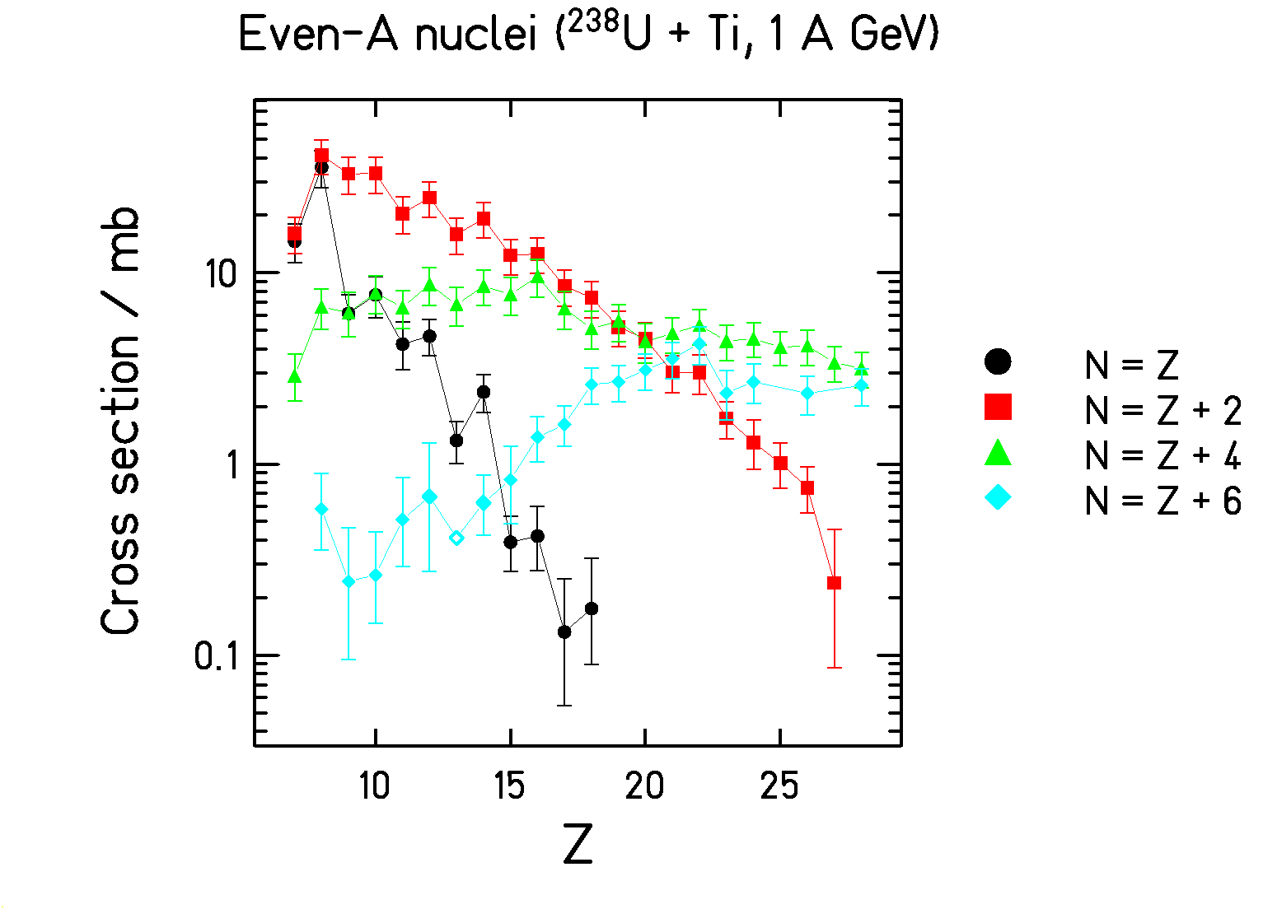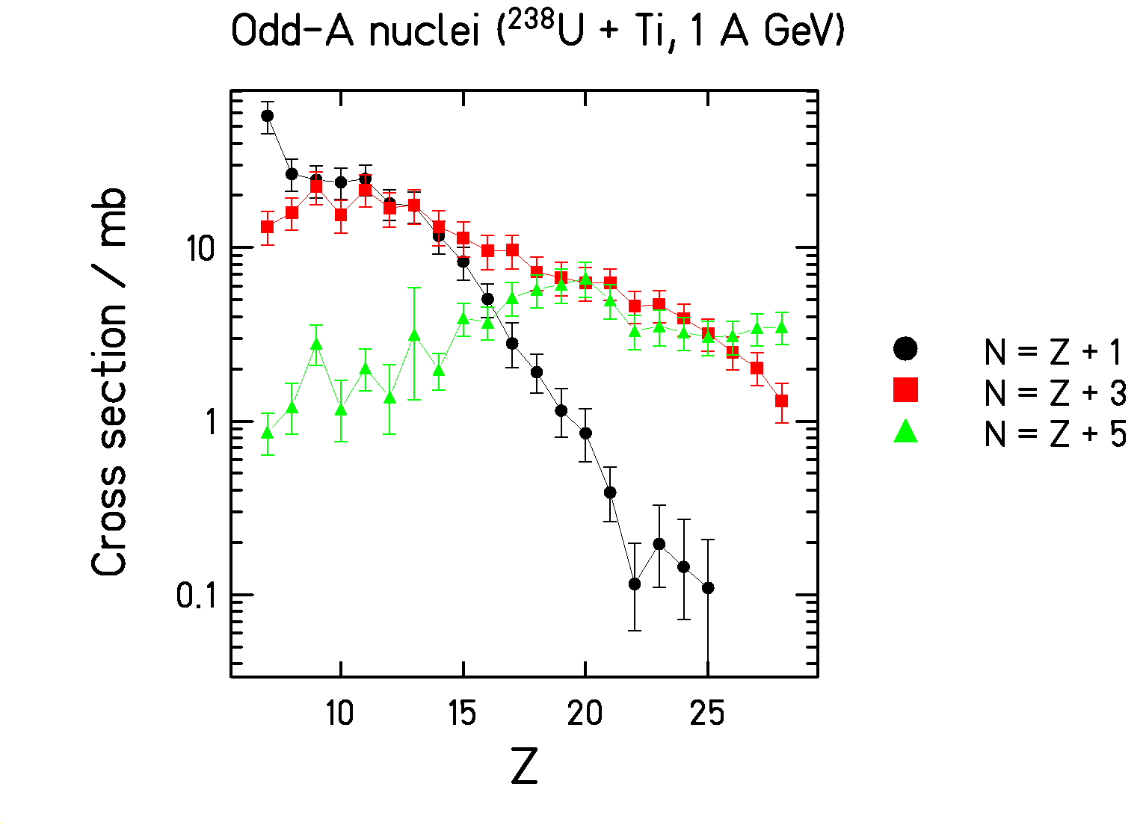

Complex fine structure:
- Even-even enhanced
- Multiples of alpha particles strongly enhanced
- Very neutron-rich odd-Z (even-N) enhanced
Local even-odd effect (Tracy)

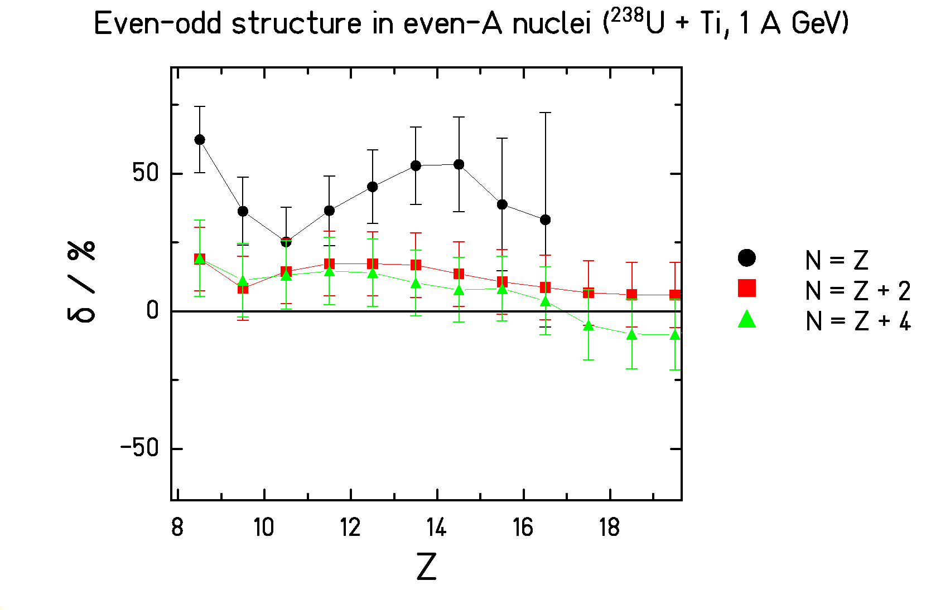

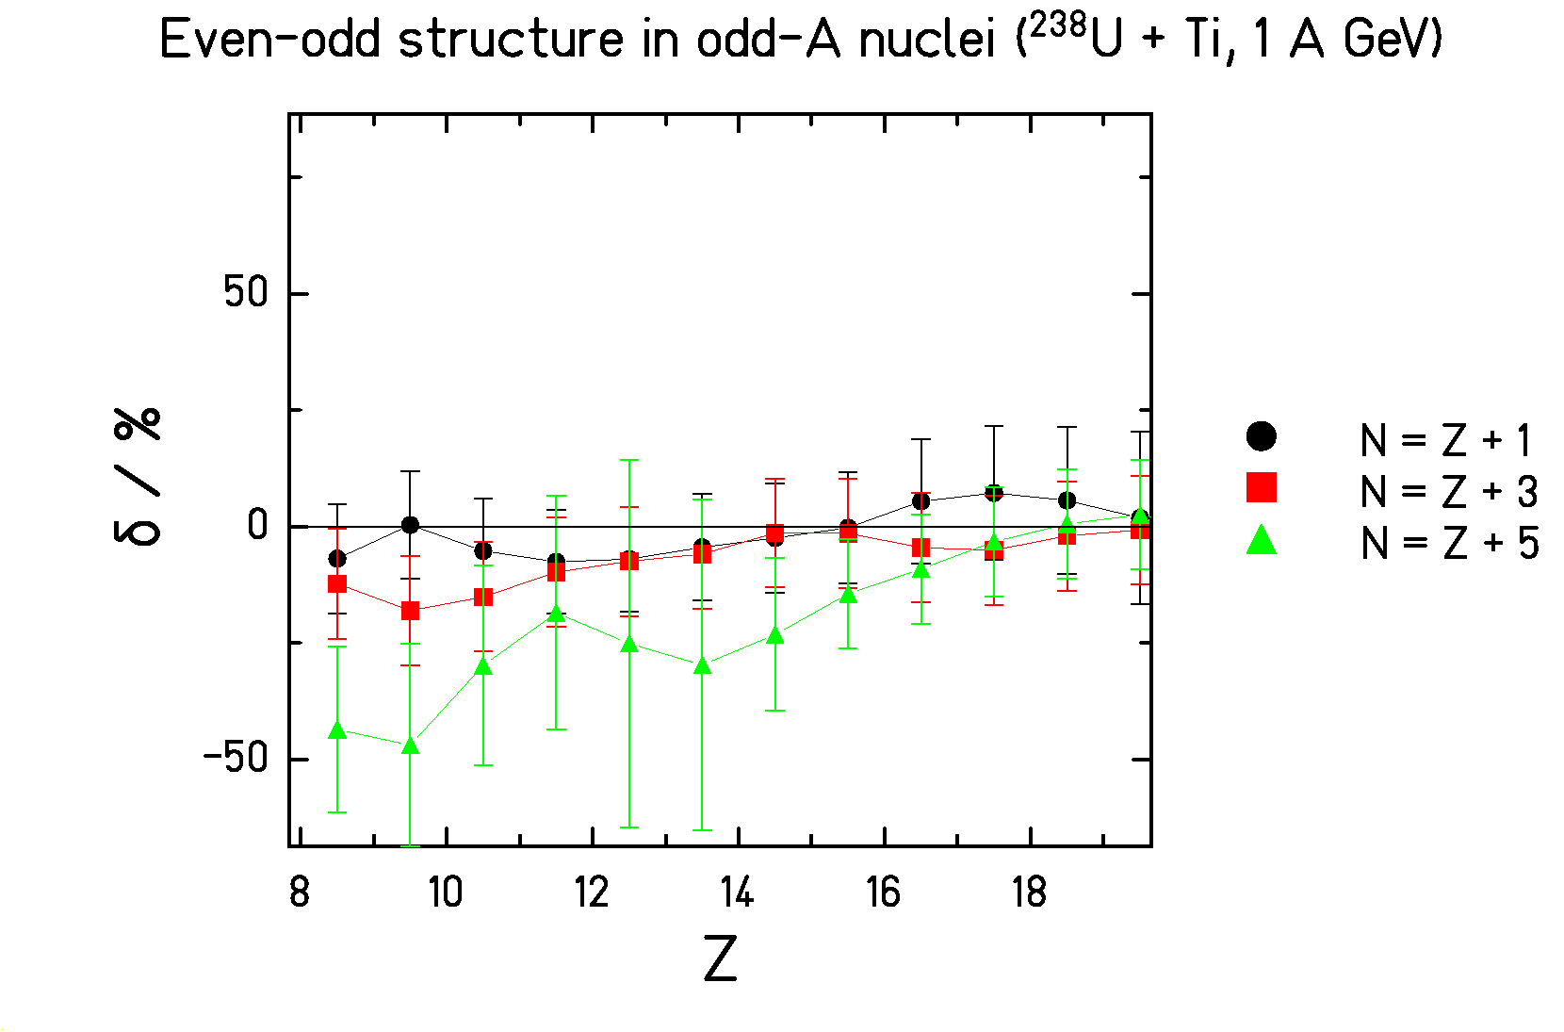

Quantitative measure of even-odd effect.

Observations of fine structure in fragmentation

Authors | Publication | Reaction | Beam energy
B. Blank et al. | NIM A 286 (1990) 160 | 40Ar + 12C | 403 A MeV
W. R: Webber et al. | PRC 41 (1990) 547 | 56Fe + 12C | 600 A MeV
C. N. Knott et al. | PRC 53 (1996) 347 | e.g. 32Si + 1H | e.g. 571 A MeV
C. Zeitlin et al. | PRC 56 (1997) 388 | 56Fe + div. | 1.05 A GeV
Sl. Cavallaro et al. | PRC 57 (1998) 731 | 35Cl + 24Mg | 8 A MeV
L. B. Yang et al. | PRC 60 (1999) 041602(R) | 58Fe + 58Fe  58Ni + 58Ni | 45 to 105 A MeV
E. M Winchester et al. | PRC 63 (2000) 014601 | 40Ca + 58Ni  40Ar + 58Fe | 25 A MeV
M. V. Ricciardi | PhD | 238U + Ti | 1 A GeV

Fine structure appears over wide range of
- projectile,
- target,
- energy!

Hypothesis: Fine structure measures the phase space of bound levels at the end of the evaporation process.

Expectation from conventional models

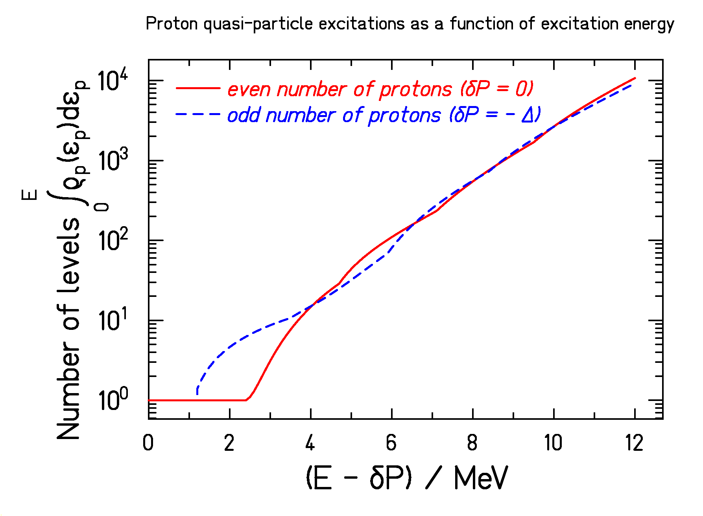
Proton quasiparticle excitations in the Boltzmann-gas model (Strutinski, 1958)

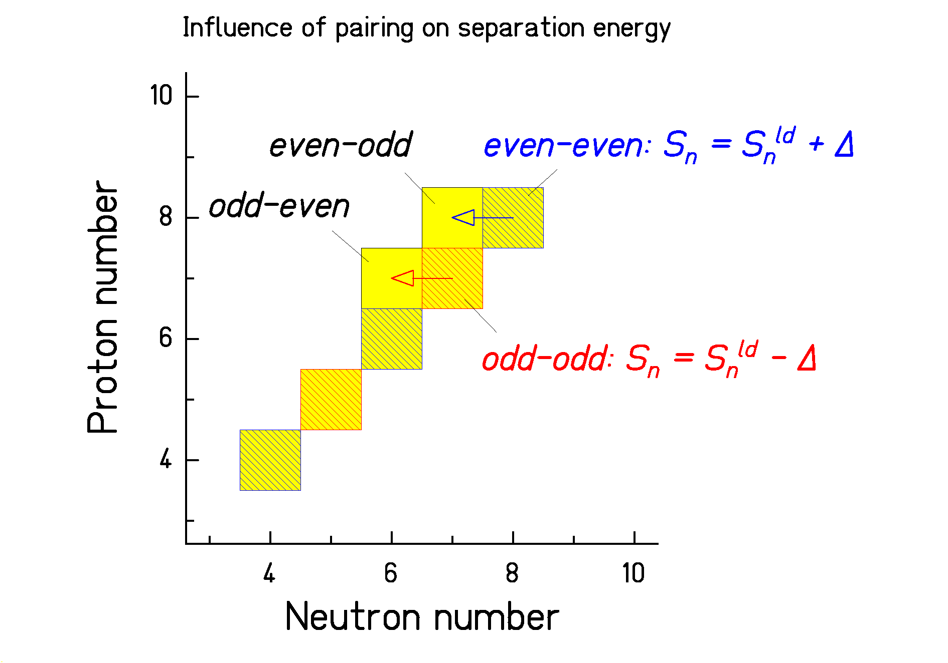
Fluctuation of S_{n} = backshift in ρ
[Ericson, AP9 425 (1960)]

Number of bound levels below S_{n} is “smooth”.
Experimental information on excited levels

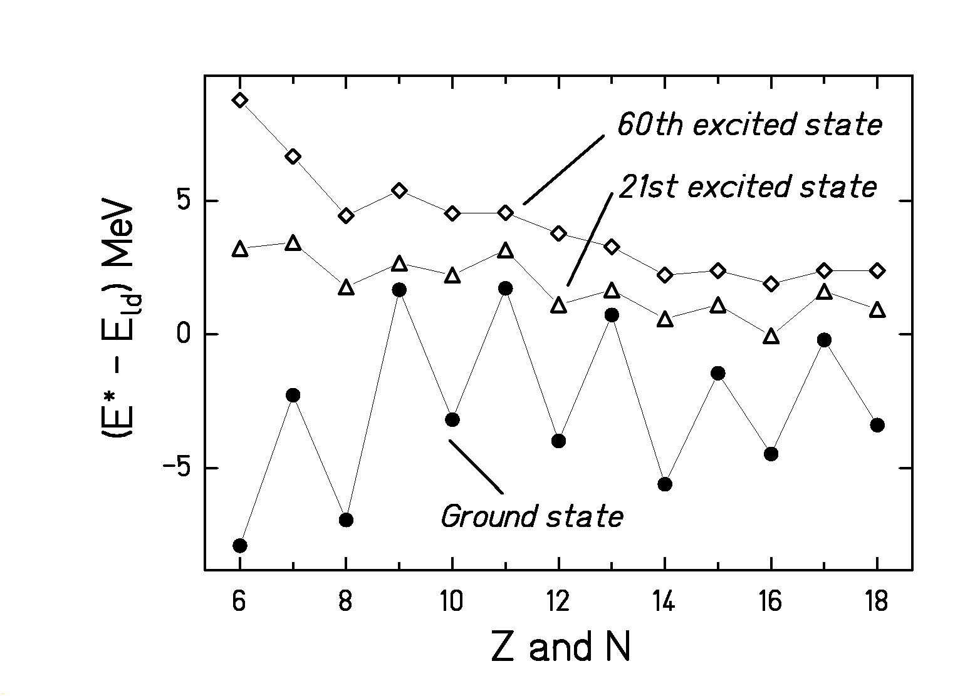

Excitation energy – energy of liquid drop
for N = Z nuclei.

Small part of even-odd structure is preserved in excited levels!

Complex nuclear-structure phenomena which go beyond the conventional understanding.
Even-odd structure in binding energies

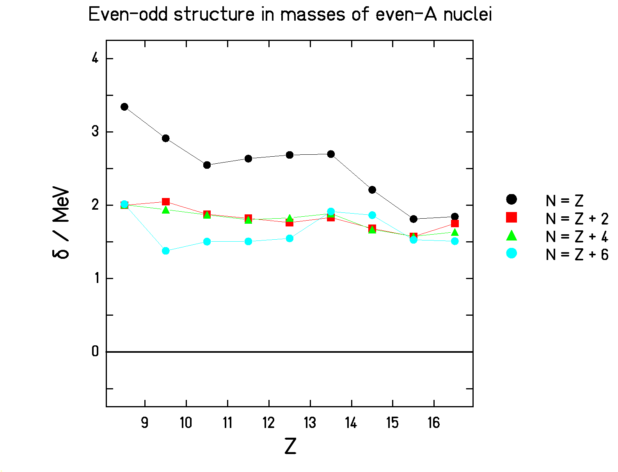

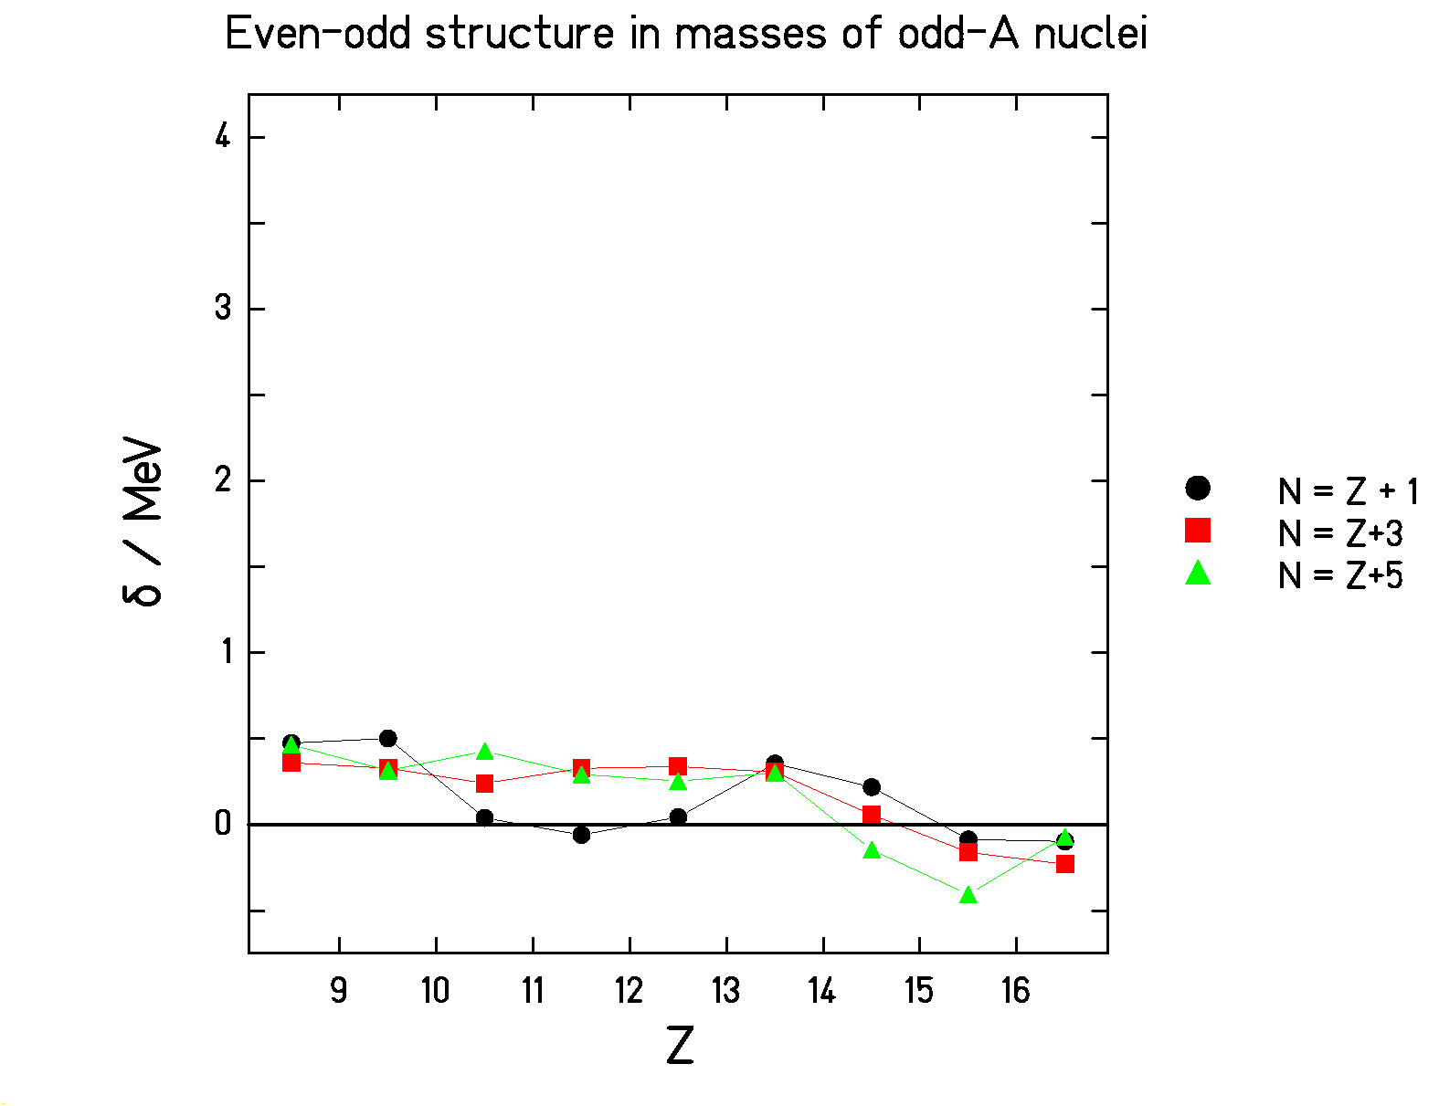

δ is a measure of the deviation of 4 masses from a parabola.

Exceptionally strong even-odd structure along N=Z.
- Alpha clustering?
- Neutron-proton pairing?
Speculative list of phenomena

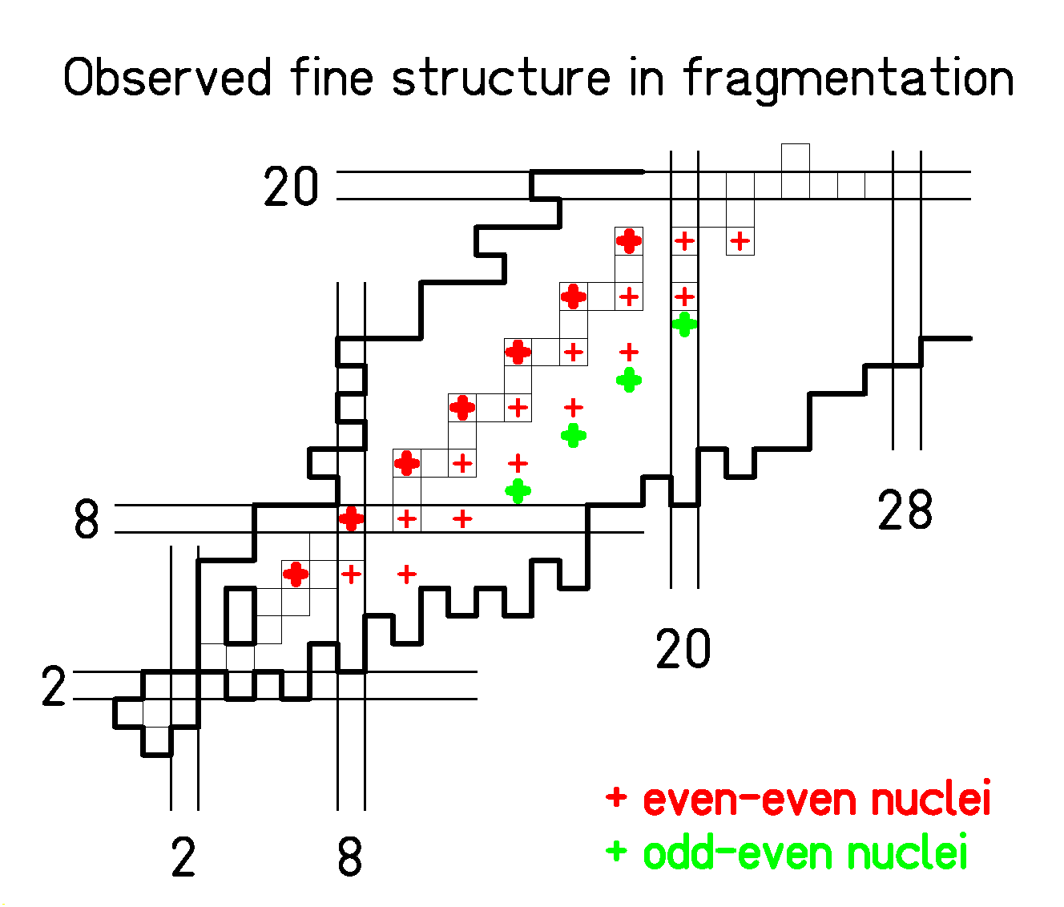

- All even-even nuclei enhanced:

Mean-field contributions to pairing effects?

- Even-even N=Z nuclei strongly enhanced:

Alpha clustering?
  - Neutron-proton pairing?
  - Congruence energy, Wigner term?

- Neutron-rich odd-Z even-N nuclei enhanced:

Continuum effects on neutron pairing?

Conclusion

Structural effects in low-energy fission:
- Survival of pairing and shells in cold nuclei.
- Qualitatively explained by conventional models.
- Quantitative prediction needs more advanced dynamical models.

Structural effects in fragmentation etc.:
- Appearance of complex structures after the deexcitation of highly excited systems:
Even-even nuclei
N = Z nuclei
Neutron-rich odd-Z, even-Z nuclei
- Not explained by conventional models.
- New experimental information on complex nuclear-structure phenomena.

