New insight into the fission process
from experiments
with relativistic heavy ions

Aleksandra Kelic
Maria Valentina Ricciardi

Karl-Heinz Schmidt

GSI Darmstadt

Lay out

- Introduction
- Characteristics of the inverse-kinematics approach
- Multimodal fission after electromagnetic excitations
- Nuclide production in spallation fission reactions
- Model developments
- Future

Previous experimental knowledge on low-energy fission
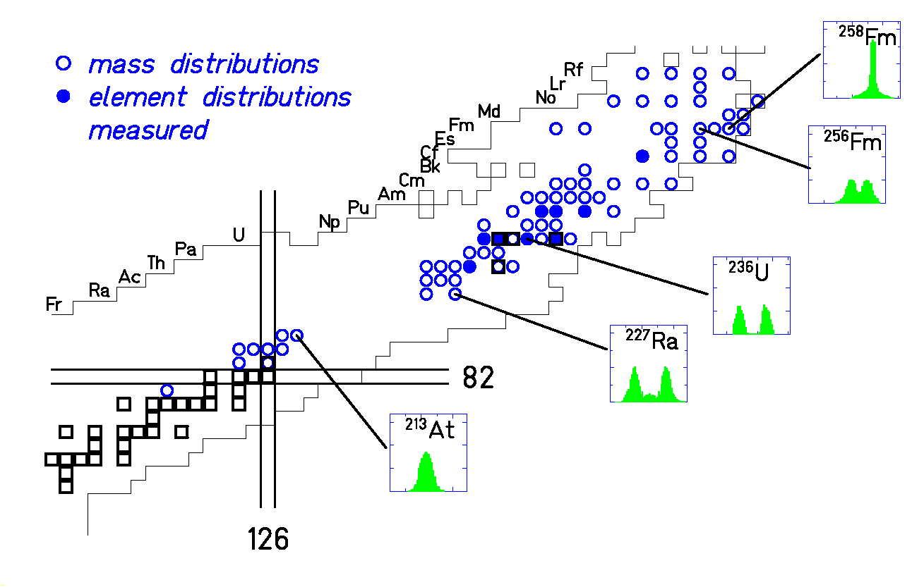
Fission channels
- variation with E*
- variation with A and Z
of the fissioning system
(rather limited choice)

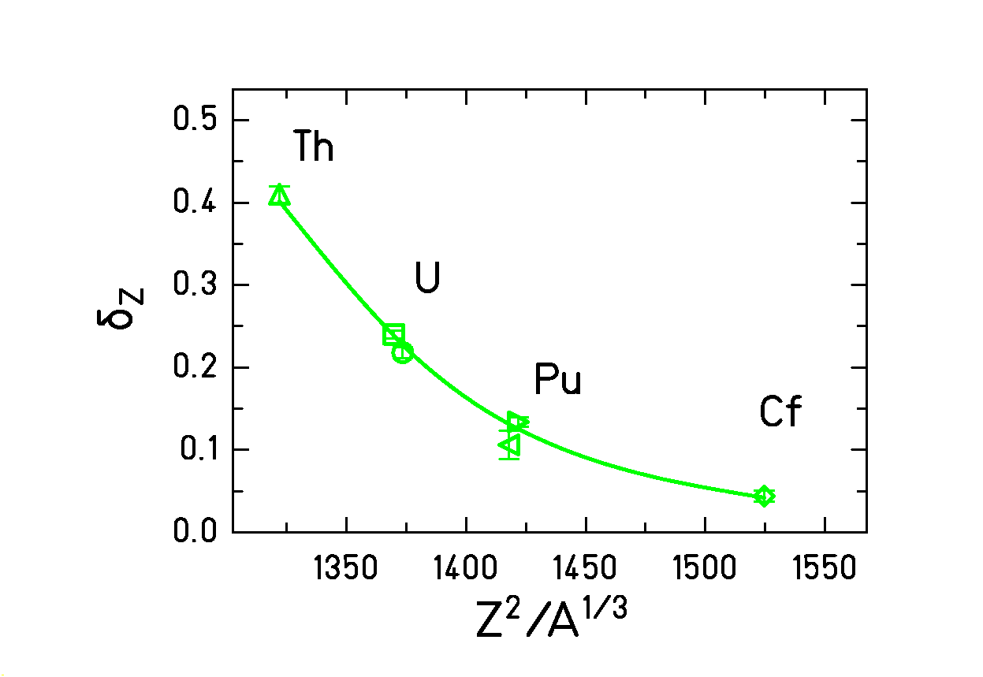
Even-odd effect in the Z yields
- variation with E*
- variation with Z²/A^{1/3}

Neutron yields,

Kinetic energy,
…
Our method; the inverse-kinematics approach
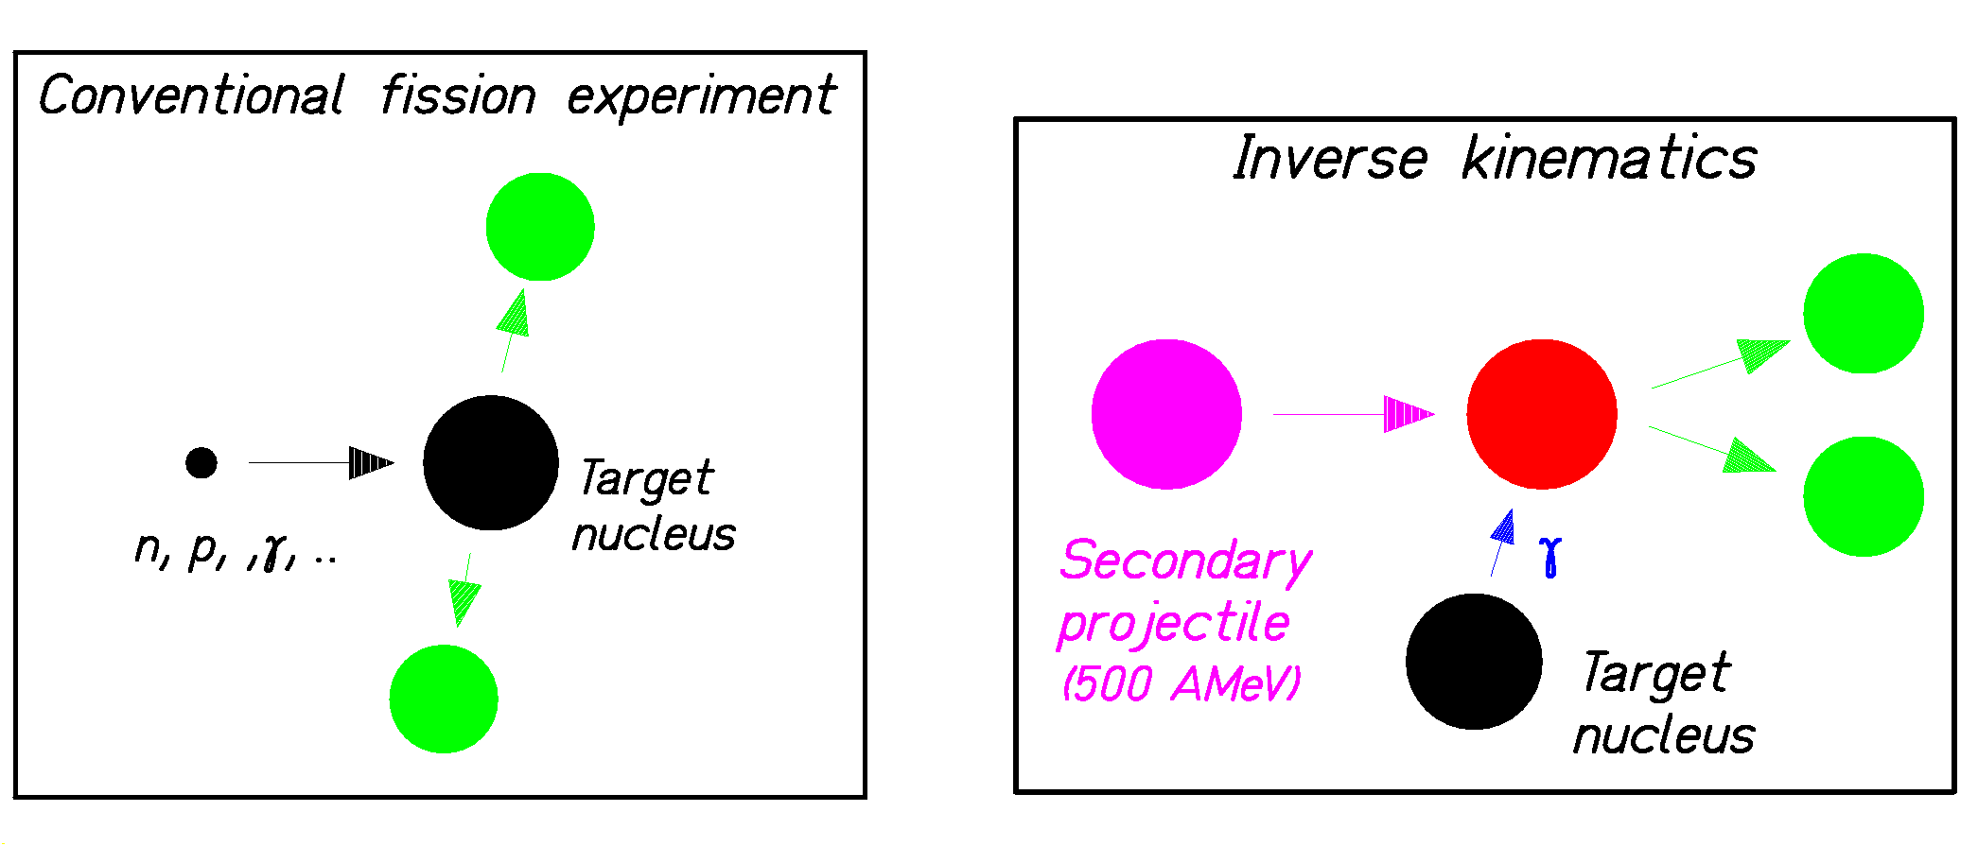

Fission of target nuclei Fission of projectile nuclei
1. Better means for detection by the
high velocity of the products!
2. Short-lived nuclei accessible!

Experimental progress
brought by the inverse-kinematics approach

Methods for the detection of fission fragments

- discovery of fission (1939) ► chemical identification in Z
- kinetic energy of the fragments ► ionisation chamber
- cumulative yields (after ß decay) ► gamma spectroscopy
- ≈ A₁ and A₂ ► double E, double ToF
- elements Z ► X rays
- A and Z of the light fragments ► Spectrographe (Lohengrin) + energy loss
(limited to target material with long half-lives and thermal neutrons)
- A and Z ► in-flight identification in inverse kinematics
- Z₁ and Z₂ ► in-flight identification in inverse kinematics
- A and Z ► high-resolution mass measurement (traps), normalisation?

Choice of the fissionning system

- Primordial nuclides (²³⁸U, ²³⁵U, ²³²Th) ► target
- Fission reactors (neutron capture - ß) ► target (long-lived nuclides)
- Nuclear explosions (neutrons capture – ß) ► target (long-lived nuclides)
- Products of direct reactions ► target (long-lived nuclides)
- Projectile fragmentation (A < 238) ► beam (half-life > 100 ns)

Excitation mechanisms:

- neutrons (thermal, fast, mono energetic)
- electrons
- photons (bremsstrahlung, mono energetic)
- protons and other charged particles (fusion, direct reactions)
- spontaneous fission
- electromagnetic and nuclear interaction in inverse kinematics
  - nuclear target (GSI) -> distribution in E* (≈ RGD in e.m. and E* ↑ in nucl.)
  - electron collider – ions (FAIR) -> well-defined E*

The installations of GSI actually used
for fission studies
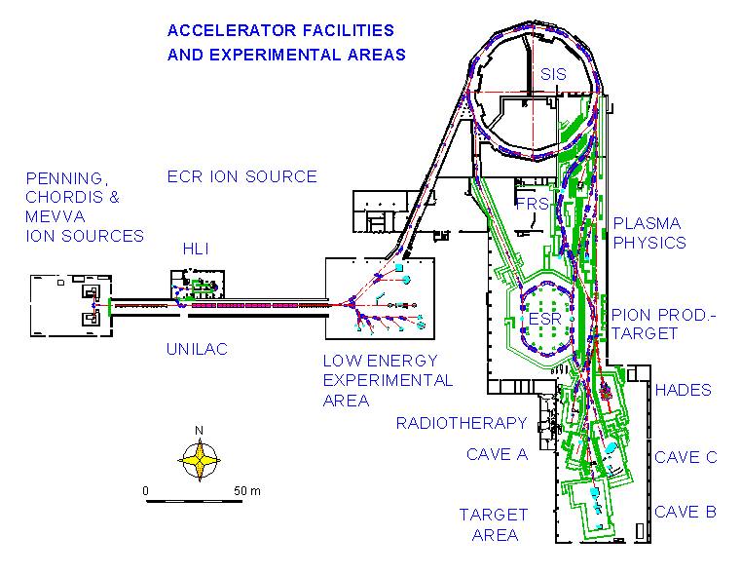

      - Z identification of both fission fragments

(Applicable also to short-lived radioactive fissile systems)

Double ionisation chamber – time-of-flight wall
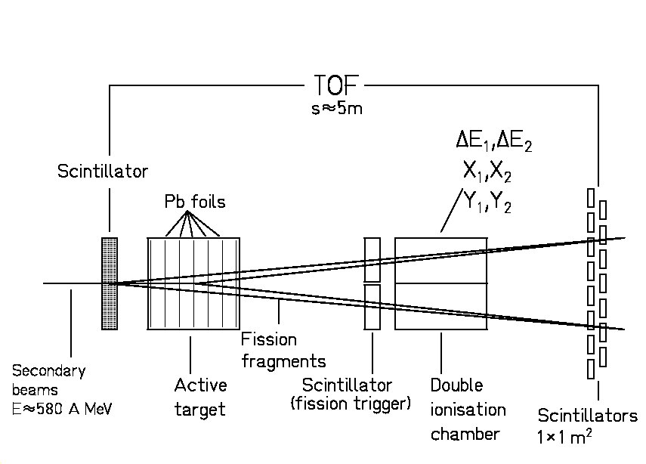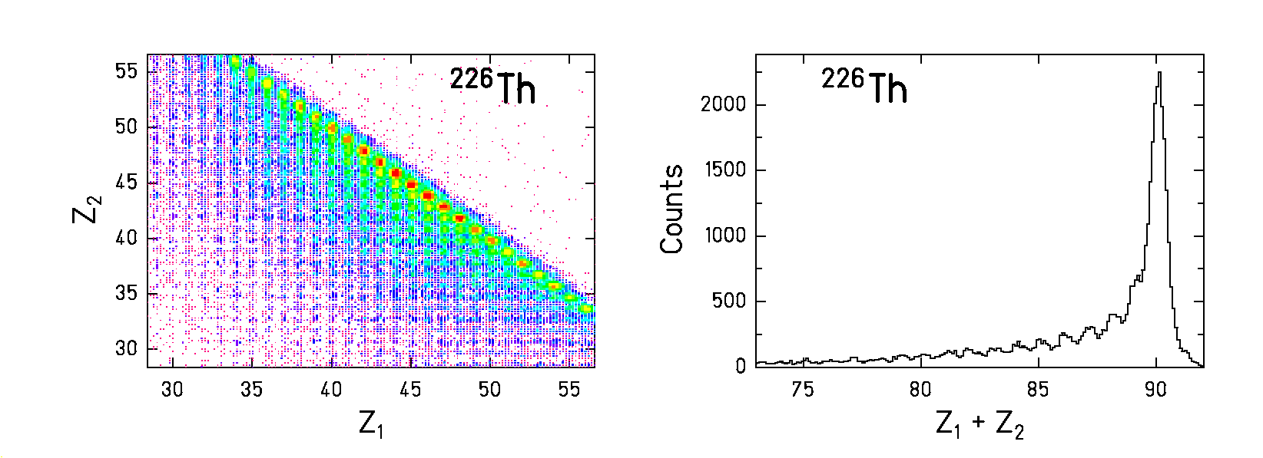

The detectors Identification of both
fragments in Z

Z distributions

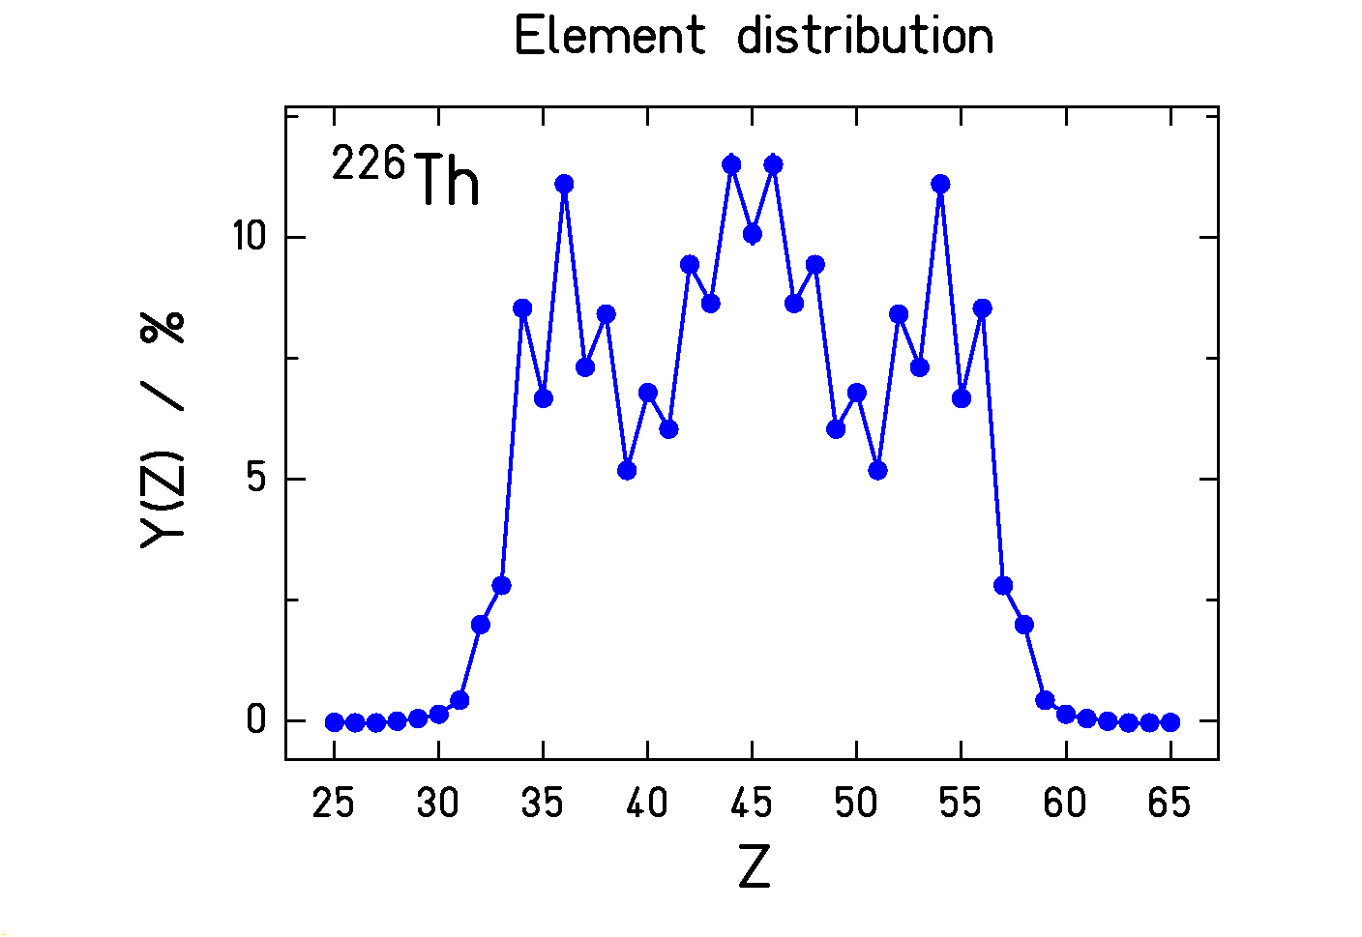

Fission after excitation of the giant dipole resonance (E* ≈ 11 MeV)
(t_{1/2} of ²²⁶Th = 31 minutes !)
Appearance of an even-odd effect
for odd-Z fissioning nuclei
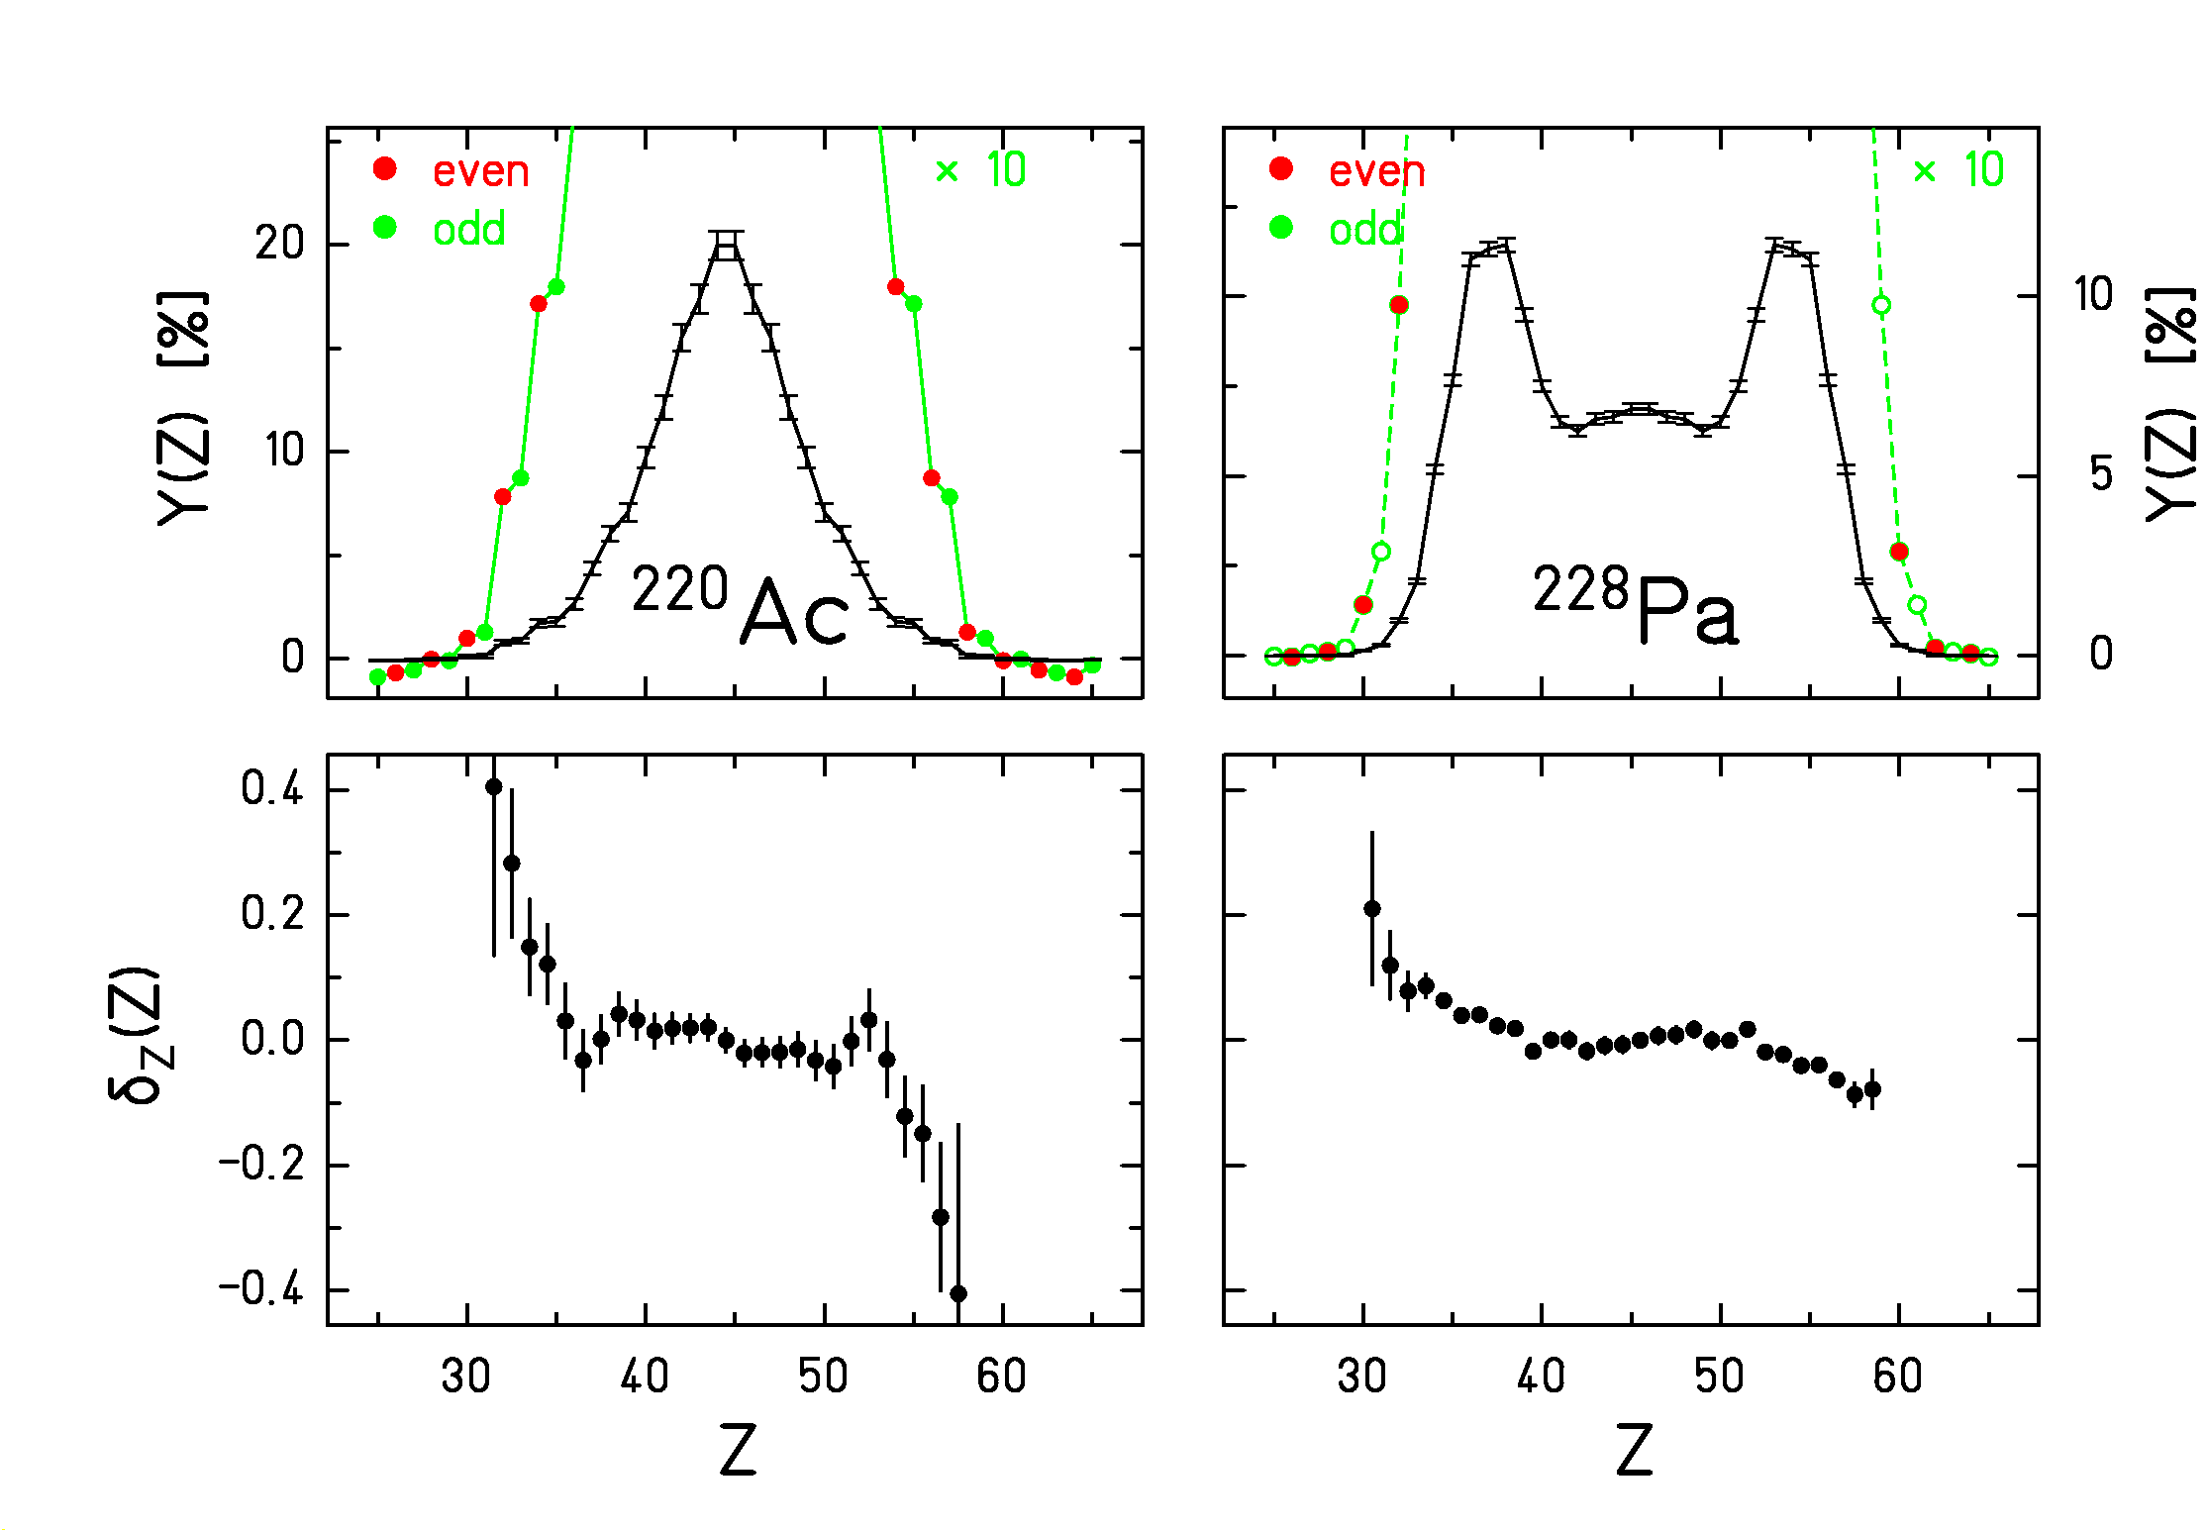
Statistical explication by the phase space available for one individual proton in the two fragments at scission (g ~ A).

Bimodal fission of the neutron-deficient actinides

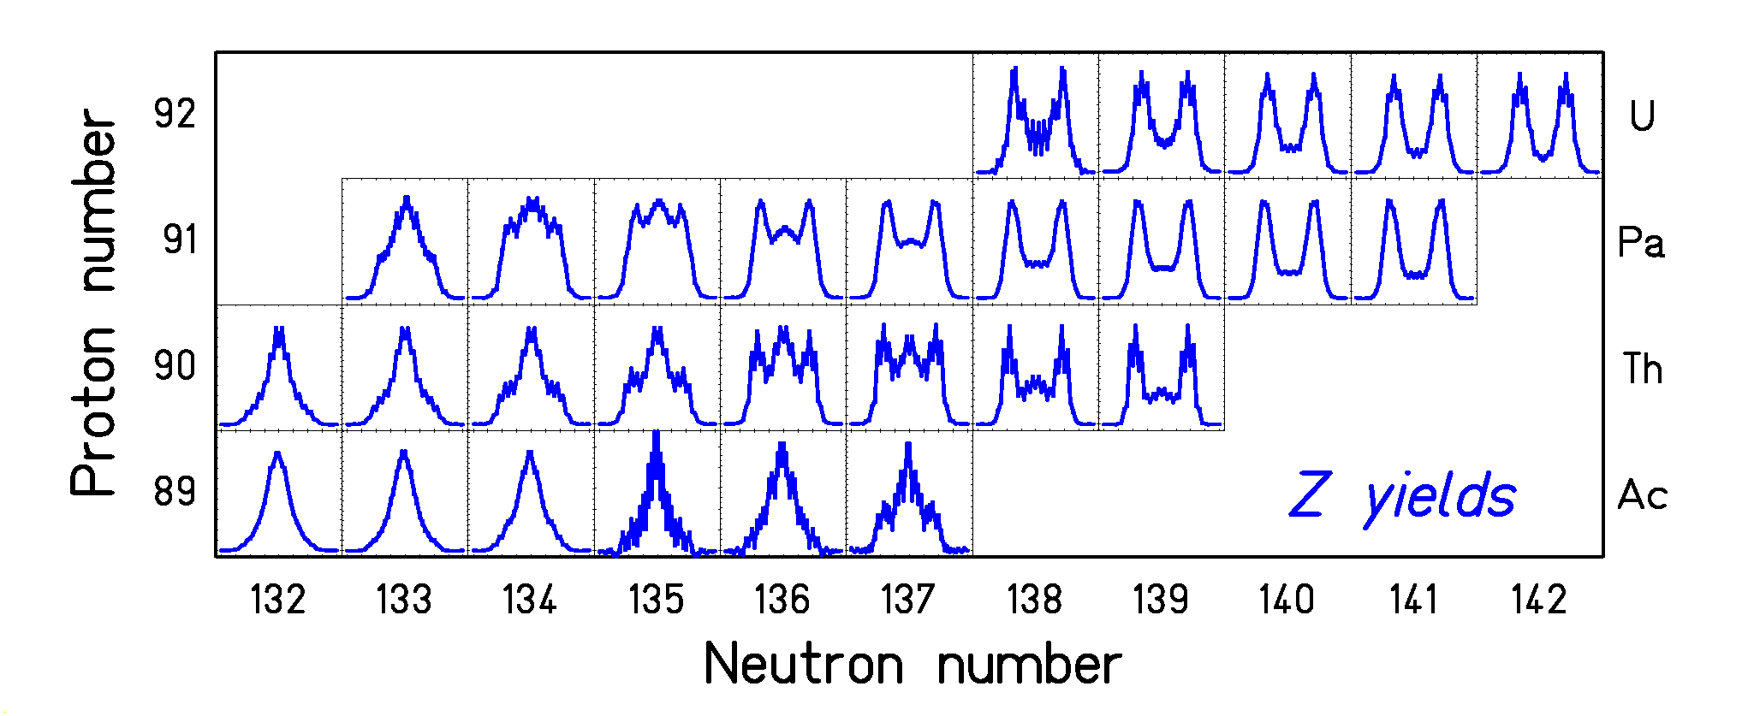

Z distributions after excitation of the GDR (E* ≈ 11 MeV)
(K.-H. Schmidt et al., NPA 665 (2000) 221)
General view on the experimental results on fission of light actinides
by use of secondary beams of radioactive nuclides.

Improved experimental knowledge

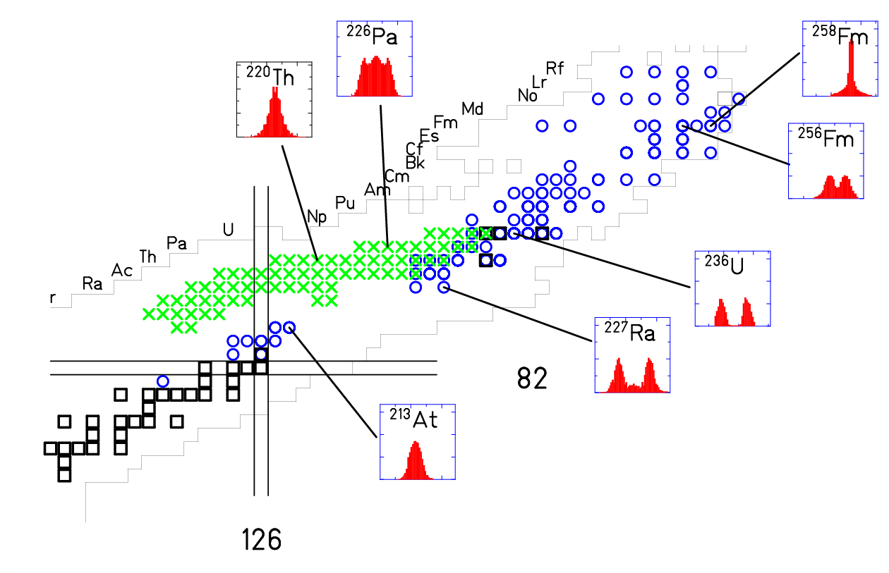

2. Full identification of one fission fragments in Z and A

The fragment separator as a magnetic spectrometer

²³⁸U (1A GeV) + ¹H
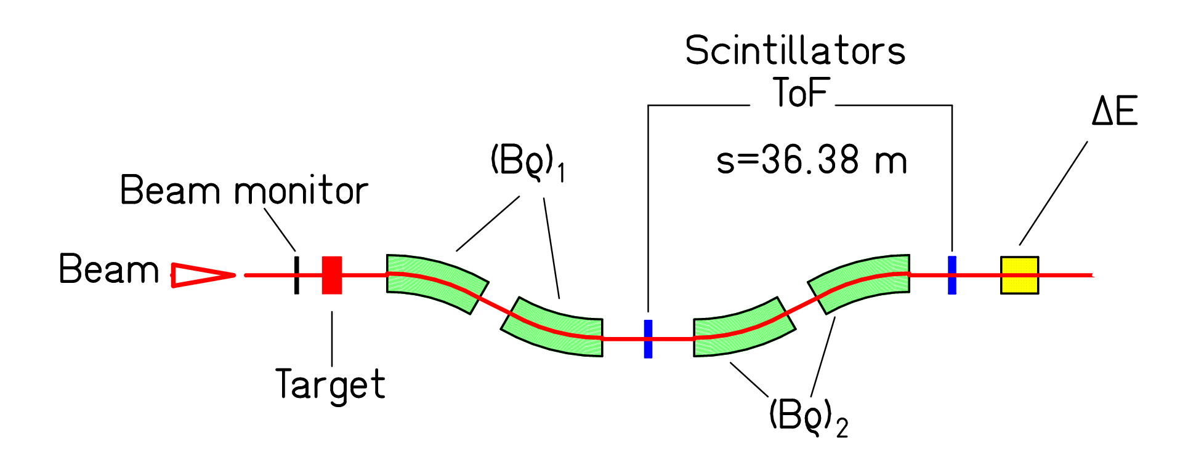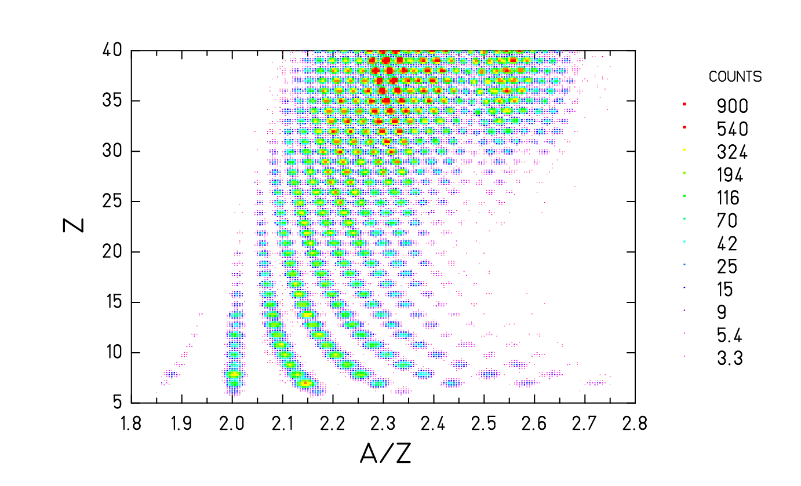
Spectrometer Nuclide identification
(M. V. Ricciardi)
Resolution p/Δp ≈ 2000.
Acceptance ΔBρ/ Bρ = 3% and Θ_{max}=15 mr.
Identification in Z and A by magnetic deflection, tracking, ToF and ΔE.
Basic equations: Bρ = m₀ A c β γ / (e Z) and ΔE ∝ Z² / v²

Kinematical signature of fission
(²³⁸U + ¹H in Ti container)

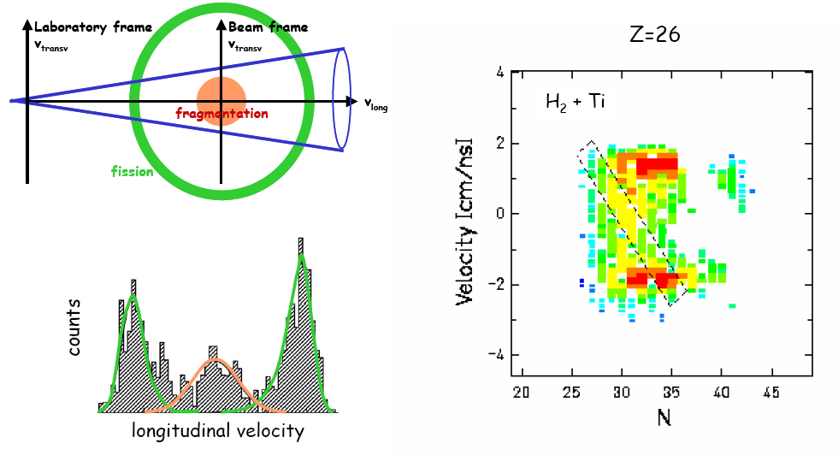
The Coulomb repulsion of the fission fragments causes a double-humped profile in the measured velocity distribution.

Experimental progress by inverse-kinematics method

Example: Fission of lead induced by ≈ 500 MeV protons
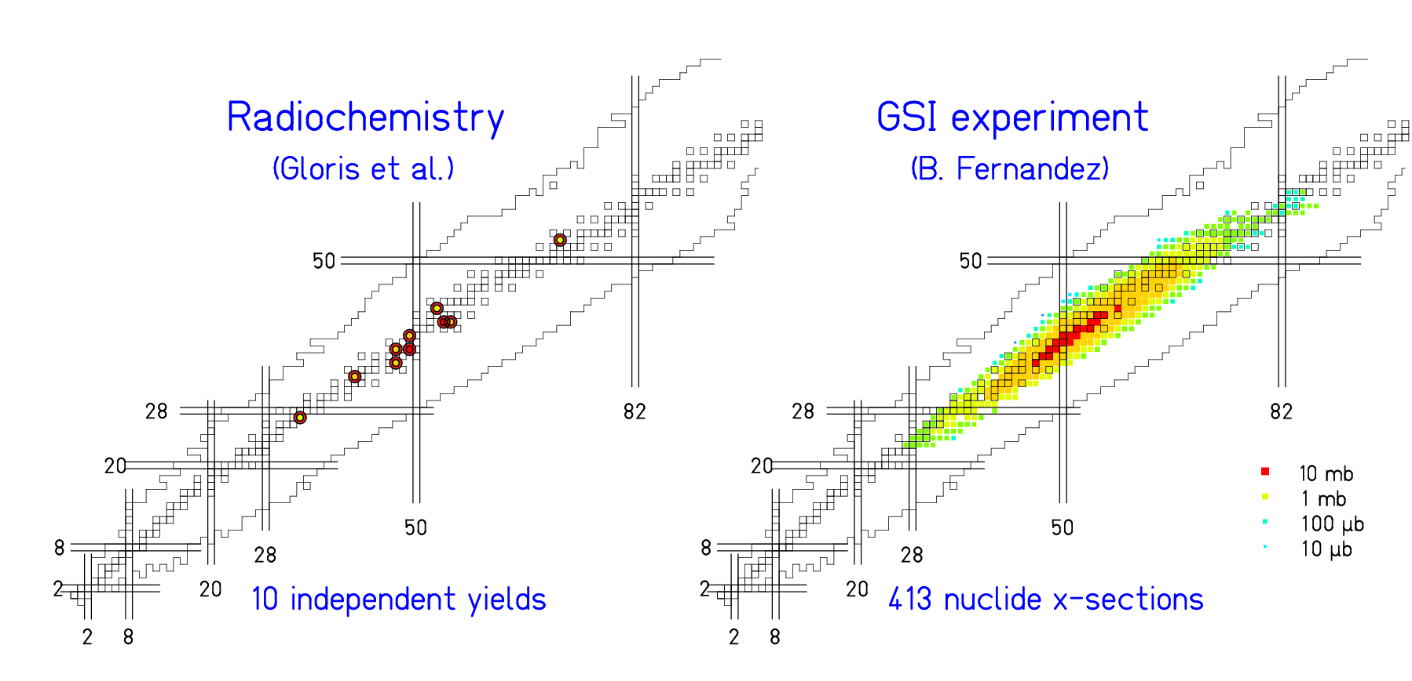
protons (553 MeV) on lead ²⁰⁸Pb (500 A MeV) on hydrogen

Some systems investigated (7732 data points)
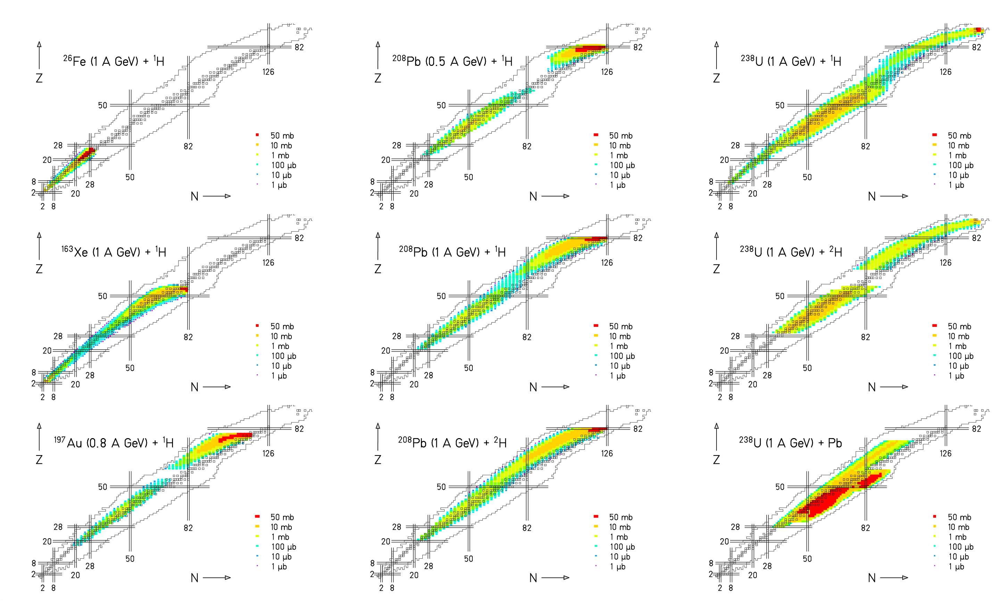

List of systems investigated
⁵⁶Fe (0.3 to 1.5 A GeV) + ¹H C. Villagrasa, PhD thesis
P. Napolitani et al., PRC 70 (2004) 054607
¹³⁶Xe(0.2 to 1 A GeV) + ^{1,2}H P. Napolitani, PhD thesis
L. Giot, in preparation
M. Fernandez, in preparation
¹⁹⁷Au (0.8 A GeV) + ¹H F. Rejmund et al., NPA 683 (2001) 540
J. Benlliure et al., NPA 683 (2001) 513
²⁰⁸Pb (1 A GeV) + ^{1,2}H T. Enqvist et al., NPA 686 (2001) 481
T. Enqvist et al., NPA 703 (2002) 435
A. Kelić et al., PRC 70 (2004) 064608
²⁰⁸Pb (0.5 A GeV) + ¹H B. Fernandez et al., NPA 747 (2005) 227
L. Audouin et al., arXiv-nucl-ex/0503021
²³⁸U (1 A GeV) + ^{1,2}H M. V. Ricciardi et al., arXiv-nucl-ex/0508027
M. Bernas et al., NPA 725 (2003) 213
M. Bernas et al., submitted
J. Taieb et al., NPA 724 (2003) 413
J. Pereira, PhD thesis
E. Casarejos, PhD thesis
P. Armbruster et al., PRL 93 (2004) 212701
²³⁸U (1 A GeV) + Pb T. Enqvist et al., NPA 658 (1999) 47
Applications

- Spallation neutron source
- ADS (accelerator-driven system) for nuclear waste
- 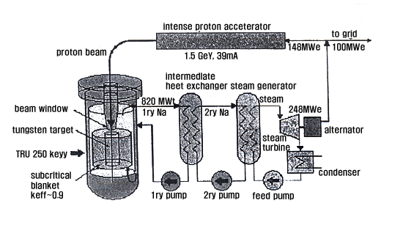
- Production of secondary beams (EURISOL)
Comparison of two systems

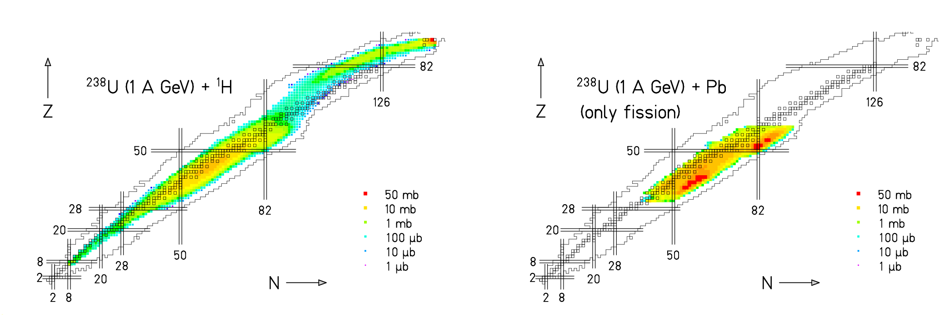

Fission of ²³⁸U induced in a hydrogen and a lead target:
Very different nuclide distributions.
Can we understand this?

Model developments (ABRABLA code)

- Collision stage
- Abrasion model

- Evaporation stage
- Weisskopf approach with extension to IMFs

- Fission
- Semiempirical macroscopic-microscopic approach

(Time-dependent fission-decay width,
statistical population of fission channels,
evaporation from CN, saddle-scission, fragments)

Systematics of mass width for high-energy fission (Rusanov et al.)
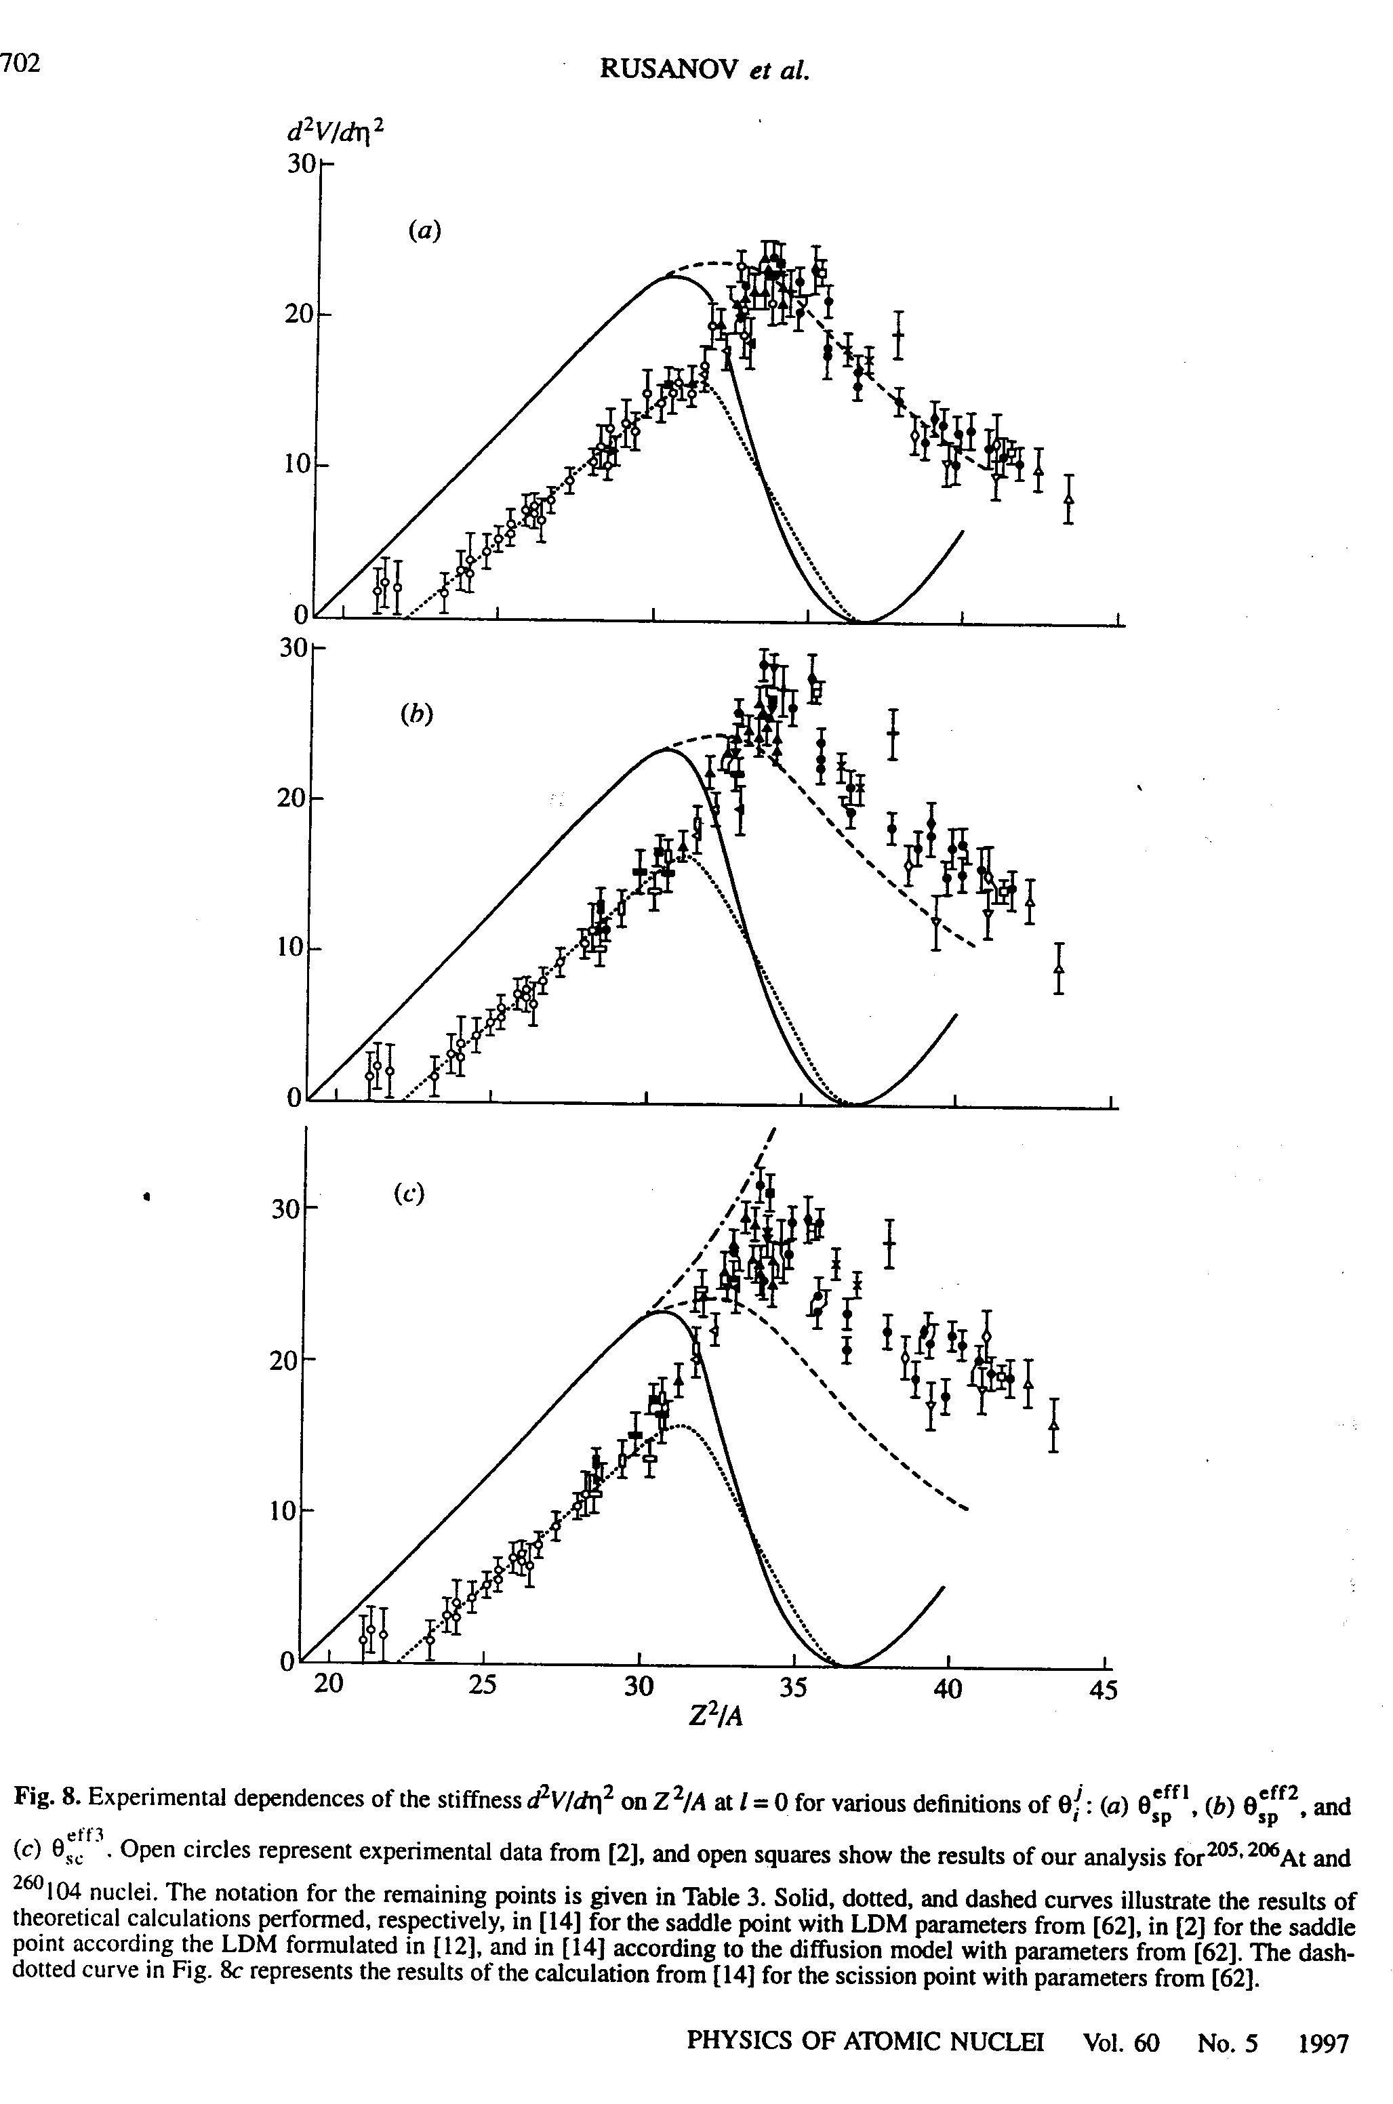

$$σ_{A^{2}}=\frac{T}{c_{A}}$$

Population of mass-asymmetry degree of freedom

follows relations of statistical model.

c_{A} is the curvature of the potential at the elongation

where the decision on the A distribution is made.

To be extended to low energies!

Structural effects on potential important at low energies
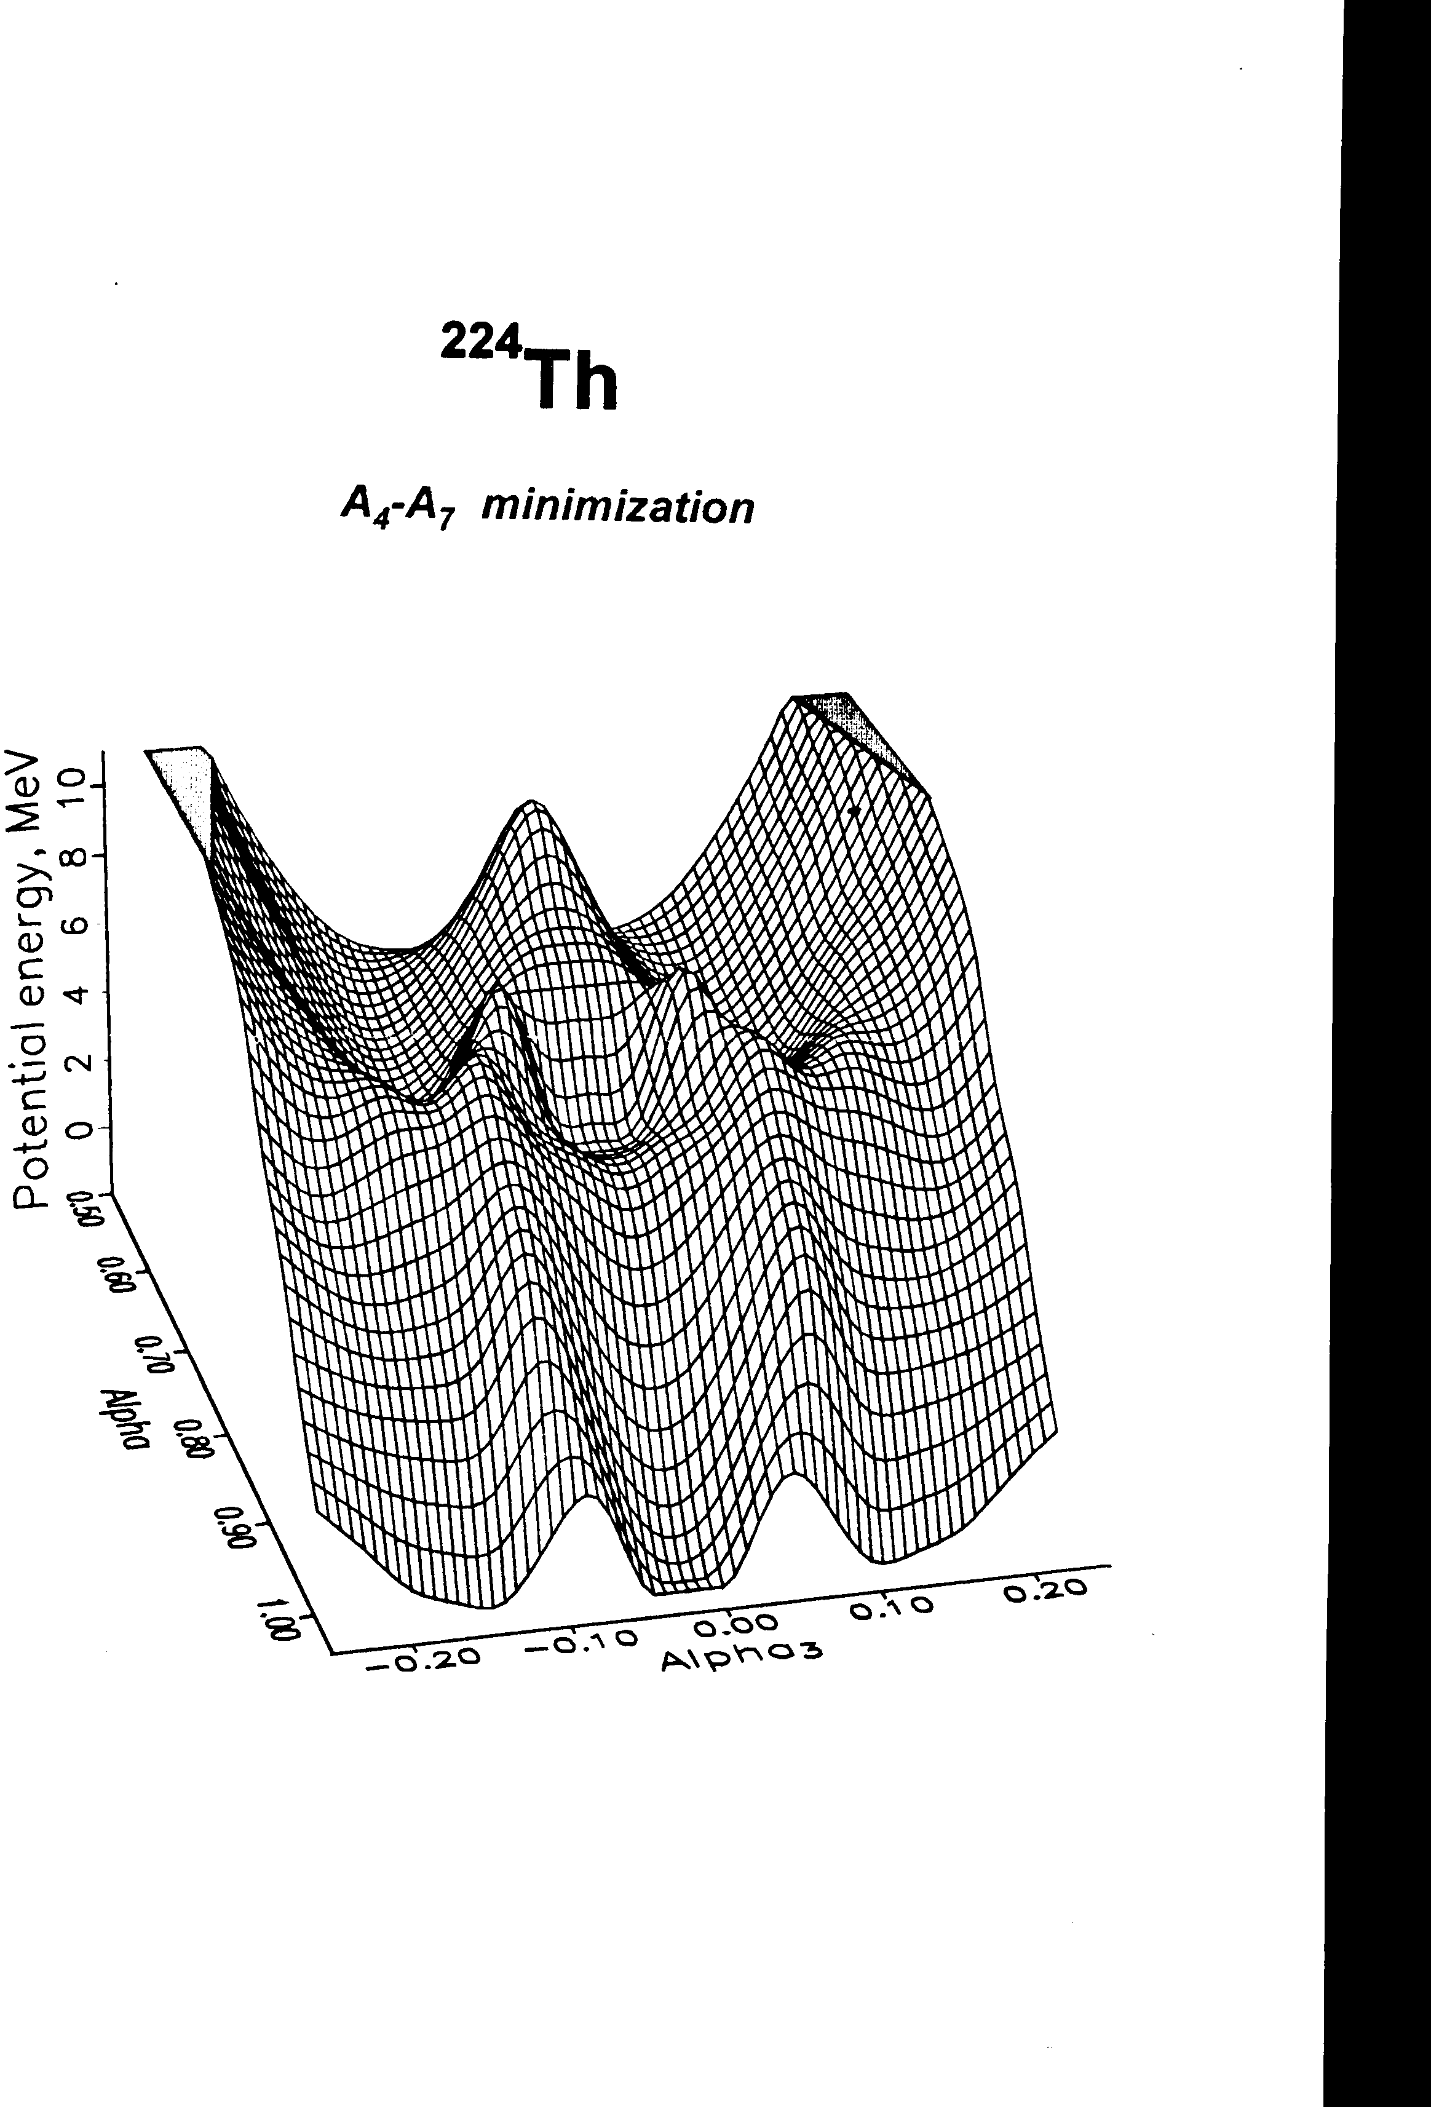

Shell effects responsible for fission channels.

Parabolic potential (Rusanov):
macroscopic potential

Shell corrections can be deduced from
measured mass distributions

(as Rusanov et al. did for deducing the macroscopic potential)

← Calculation by Pashkevich
Shell effects of fragments
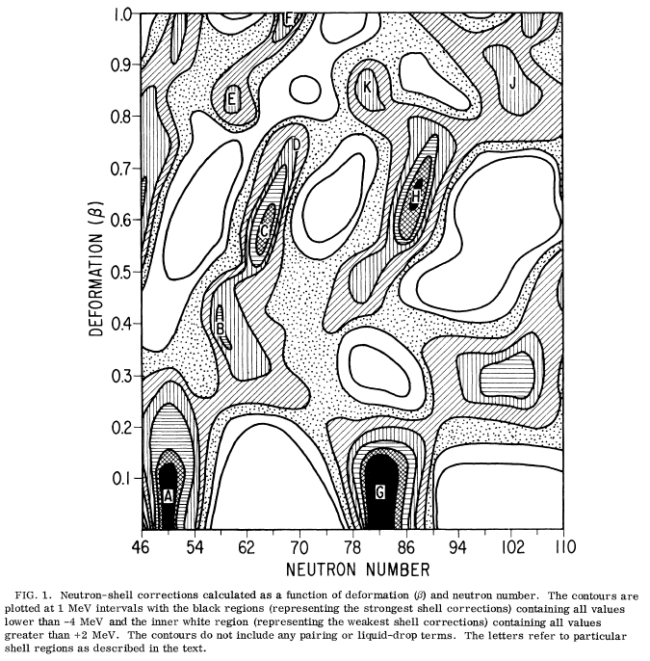
Shells on the potential-energy
from outer saddle to scission
are rather properties of the
fragments!

(Maruhn & Greiner, Pashkevich)

← Shell-model calculations. Wilkins et al.
Variation of potential due to shells 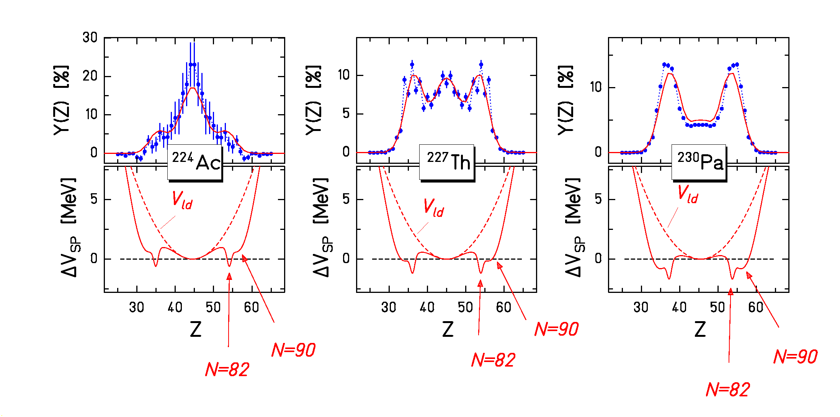
Transition from single-humped to double-humped distributions investigated experimentally (K.-H. Schmidt et al., NPA 665 (2000) 221) and explained by macroscopic (CN) and microscopic (nascent fragments) properties of the potential-energy landscape near saddle

Essential ingredient: Vanishing of shell effects with increasing excitation energy.

(J. Benlliure et al., Nucl. Phys. A 628 (1998) 458).

Evolution of the fission Z distribution as a function of A and E*
220Th 223Th 226Th 229Th 232Th
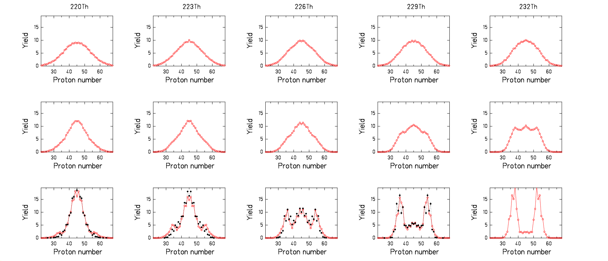

60 MeV

20 MeV

10 MeV

red: PROFI calculations, black: experimental data (K.-H. Schmidt et al., NPA 665 (2000) 221)

Nuclide distribution in spallation: superposition of fission from different nuclei at different E*.

Variation with A: checked by comparison with experiment.

Variation with E*: predicted by systematics of microscopic calculations.

Reproduction ²³⁸U + n (1.7 .. 13 MeV) (same parameters!)

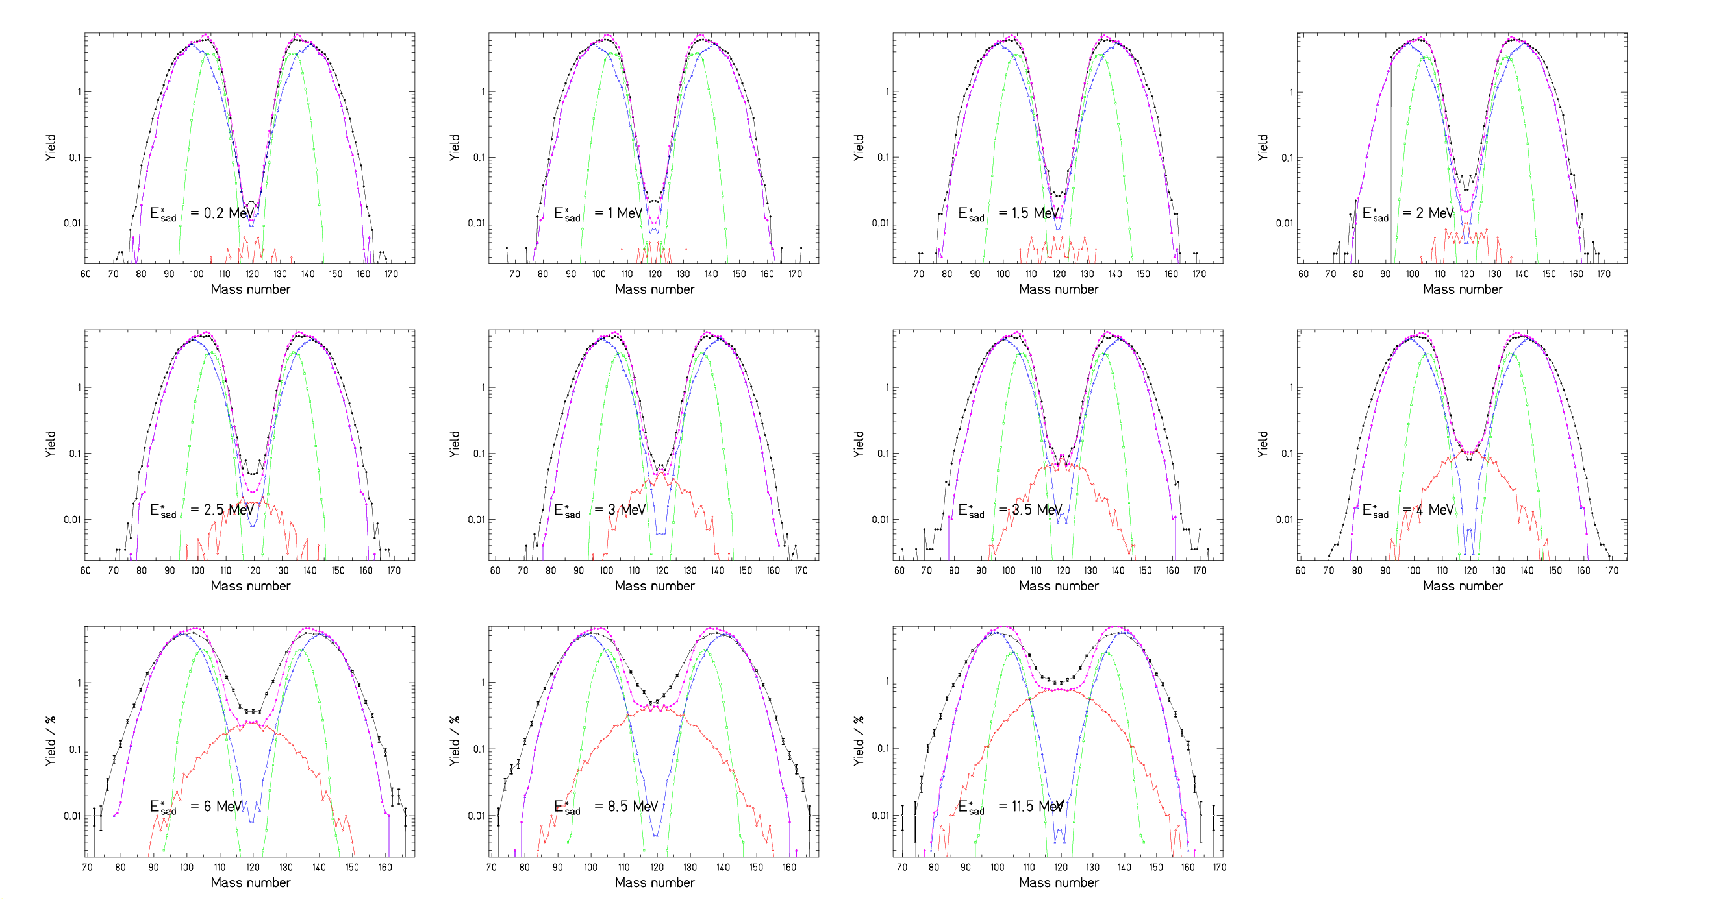

Reproduction ²³⁸U (1 A GeV) + ¹H
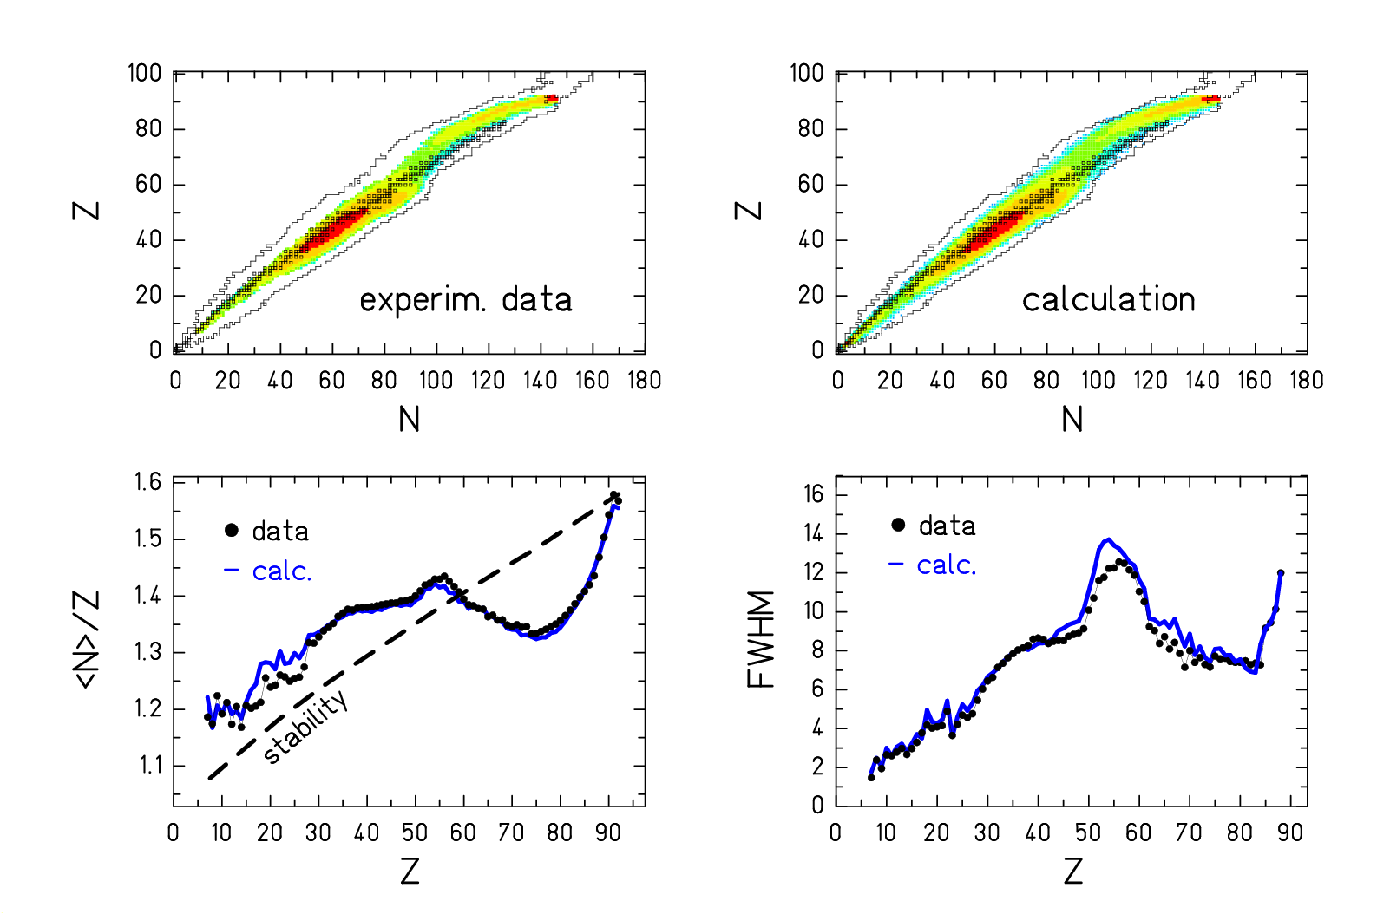
Fission model coupled to spallation – evaporation models

Basic ideas of our macroscopic-microscopic fission approach

(Inspired by Smirenkin, Maruhn, Pashkevich, Rusanov, Itkis, ...)

Macroscopic:

Potential near saddle from exp. mass distributions at high E* (Rusanov)

Macroscopic potential is property of fissioning system ( ≈ f(Z_{CN}²/A_{CN}))

Microscopic: assumptions based on 2-centre shell-model calculations (Karpov)

Shells near outer saddle "resemble" shells of final fragments (but weaker)

Properties of shells from exp. nuclide distributions at low E*

Microscopic corrections are properties of fragments (= f(N_{f},Z_{f}))

Dynamics: → approximations based on Langevin calculations (Nadtochy)

τ (mass asymmetry) >> τ (saddle scission) : decision near saddle
τ (N/Z) << τ (saddle scission) : decision near scission

Population of available states with statistical weight (near saddle or scission)

Comparison with other fission models:

Statistical model (A near saddle, N/Z near scission)

(Fong, Wilkins et al. applied the statistical model at scission.)

Quantitative population of fission channels

(Brosa proposed a qualitative fission-channel approach)

Macroscopic-microscopic approach

(Spirit like Strutinsky approach, but quantitative values from experiment)

Macroscopic potential = f( Z_{CN}²/A_{CN}) / microscopic potential = f(Z_{f},N_{f})

(Powerful separation and generalisation, few free parameters, robust extrapol))

Disappearance of shell effects

(From systematics of microscopic calculations)

Systematics of model calculations

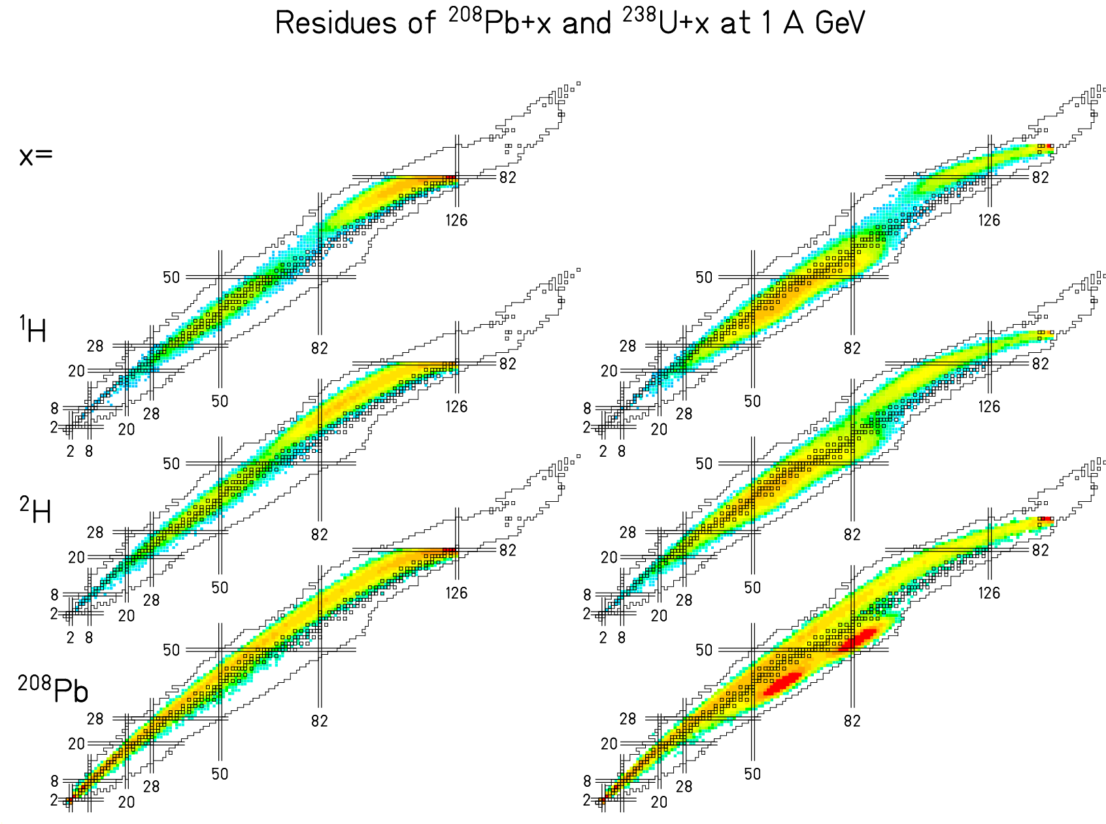

Very different isotopic
distributions for different
projectile-target
combinations!

Experimental data are
well reproduced.

Large-acceptance spectrometer (in preparation)
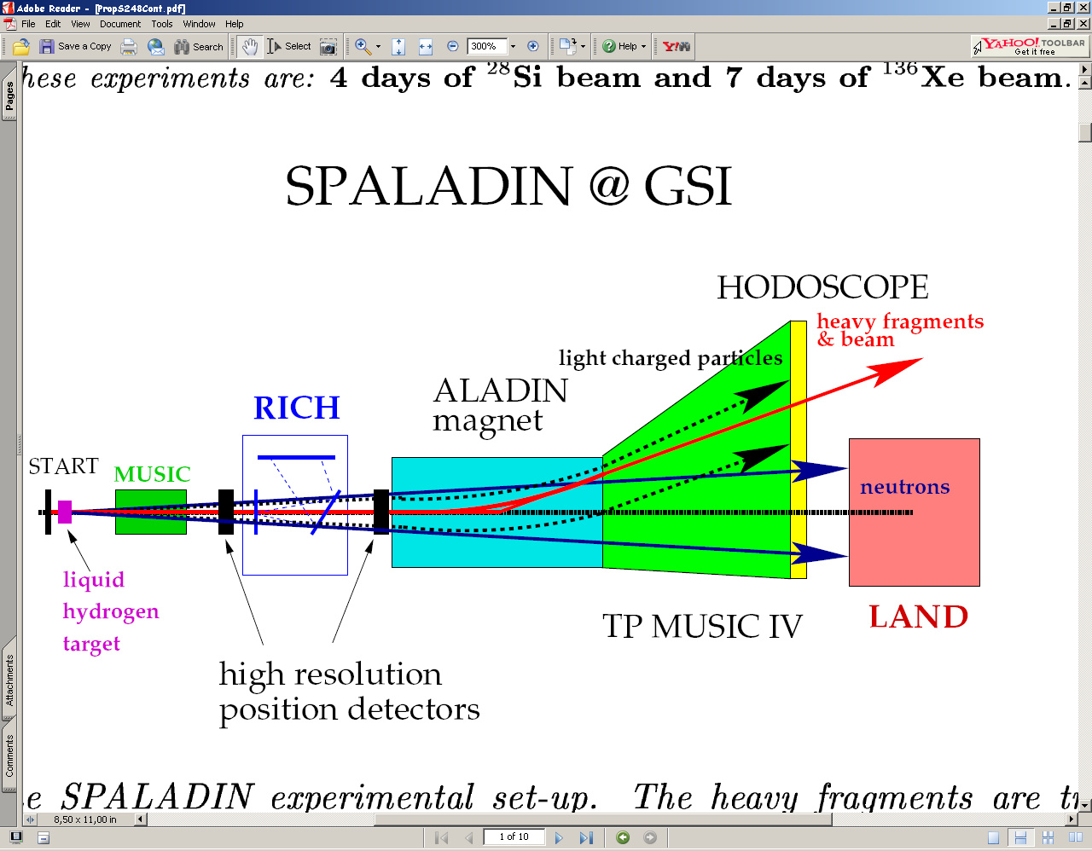

Detection of neutrons, charged particles / but limited mass resolution

The FAIR project
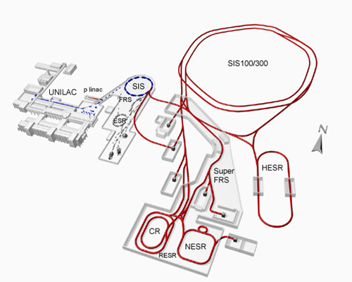

Beams with higher energy and higher intensity

Spectrometers with larger acceptance / higher resolution

Storage rings, electron — ion collider

Electron-ion collider – the ideal tool ?

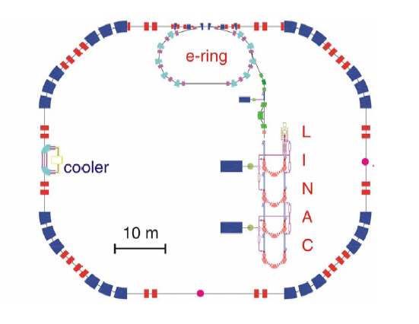
Determination of the excitation
energy by inelastic electron
electron scattering.

No angular straggling in target.
No contribution from nuclear
reactions.

Needs of a spectrometer with
large acceptance for the
fission fragments.

Conclusion
- The HI-accelerator and spectrometer complex of GSI Darmstadt is unique world-wide
- Experimental progress due to application of inverse kinematics
- Multimodal fission around ²²⁶Th studied in detail
- Break-through in measuring full nuclide distributions in spallation reactions
in a French-Spanish-German collaboration
- Comprehensive data tables established (→ www-w2k.gsi.de/charms)
- New insight into global features of spallation and fission
- Model for nuclide production in fission on the basis of E_{pot} and ρ
- Successful modelling of all aspects of spallation-fission reactions
- Even better experimental conditions in the future FAIR facility
The CHARMS collaboration
Peter Armbruster, Antoine Bacquias, Lydie Giot, Vladimir Henzl, Daniela Henzlova, Aleksandra Kelić, Strahinja Lukić, Pavel Nadtochy, Radek Pleskač, Maria Valentina Ricciardi, Karl-Heinz Schmidt, Florence Vivès , Bernd Voss, Orlin Yordanov
GSI, Planckstr. 1, D-64291 Darmstadt, Germany
Laurent Audouin, Charles-Olivier Bacri, Monique Bernas, Brahim Mustapha, Claude Stéphan, Laurent Tassan-Got
IPN Orsay, B.P. n. 1, F-91406 Orsay, France
Alain Boudard, Jean-Erique Ducret, Beatriz Fernandez, Sylvie Leray, Claude Volant, Carmen Villagrasa, Wojczek Wlaslo
DAPNIA/SPhN, CEA Saclay, F-91191 Gif sur Yvette Cedex, France
Julien Taieb
DEN/DM2S/SERMA/LENR, CEA Saclay, F-91191 Gif sur Yvette Cedex, France
Christelle Schmitt
IPNL, Université Lyon, Groupe Matiere Nucleaire, 4, rue Enrico Fermi, F-69622 Villeurbanne Cedex, France
Serge Czajkowski, Beatriz Jurado, Michael Pravikoff
CENBG, Le Haut Vigneau, F-33175 Bordeaux-Gradignan, Cedex, France
Paolo Napolitani, Fanny Rejmund
GANIL, B.P. 5027, F-14076 Caen Cedex 5, France
Jose Benlliure, Jorge Pereira, Enrique Casarejos, Manuel Fernandez, Teresa Kurtukian
Univ. Santiago de Compostela, E-15706 Santiago de Compostela, Spain
Arnd Junghans
Forschungszentrum Rossendorf, Postfach 510119, D-01314 Dresden, Germany

