How much can we heat a nucleus?

M. V. Ricciardi, J. Benlliure, A. Botvina, T. Enqvist, D. Henzlova,
A. Kelić, P. Napolitani, J. Pereira, K.-H. Schmidt

Another „spin-off“ of the research on nuclear data for the incineration of nuclear waste from the (background) experiments with the Ti target container.

Fragment Separator (FRS) of GSI

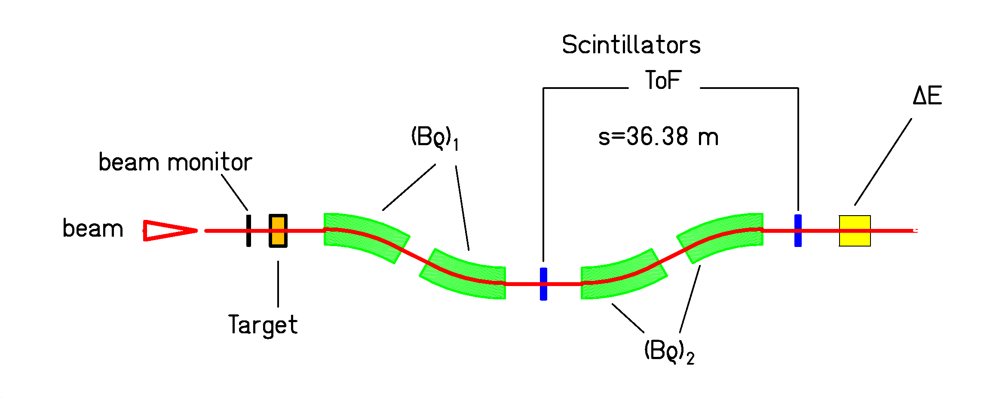

Experiments with Hydrogen target (+ titanium container)
Deuterium target (+ titanium container)

Titanium target container
Measured nuclide distributions (without fission fragments)

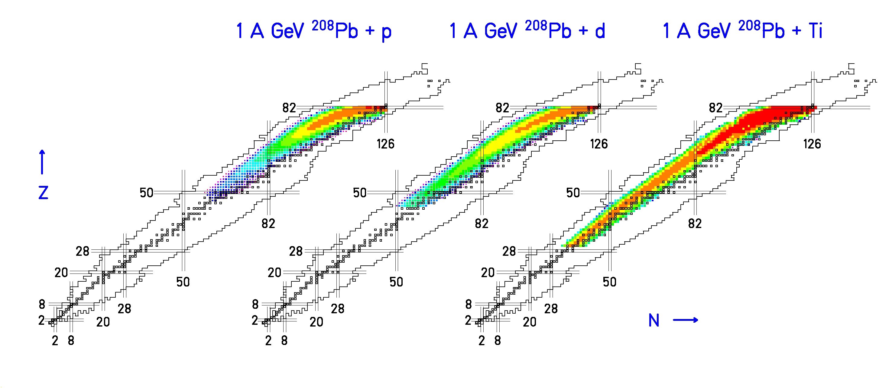
Strong variation with cm energy (Data: Timo Enqvist)
Larger cm energy → production extends to lighter nuclei
Indications for the nuclear liquid-gas phase transition

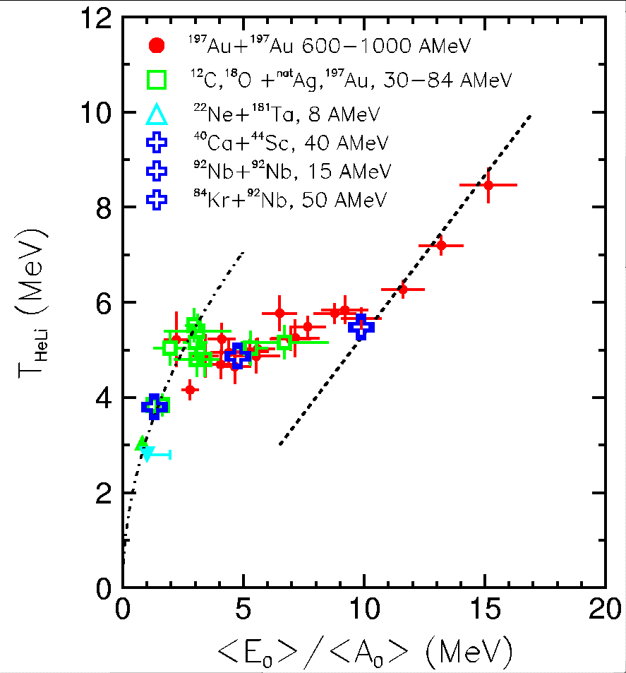

Caloric curve from ALADIN (GSI)
J. Pochodzalla et al., Phys. Rev. Lett. 75 (1995) 1040

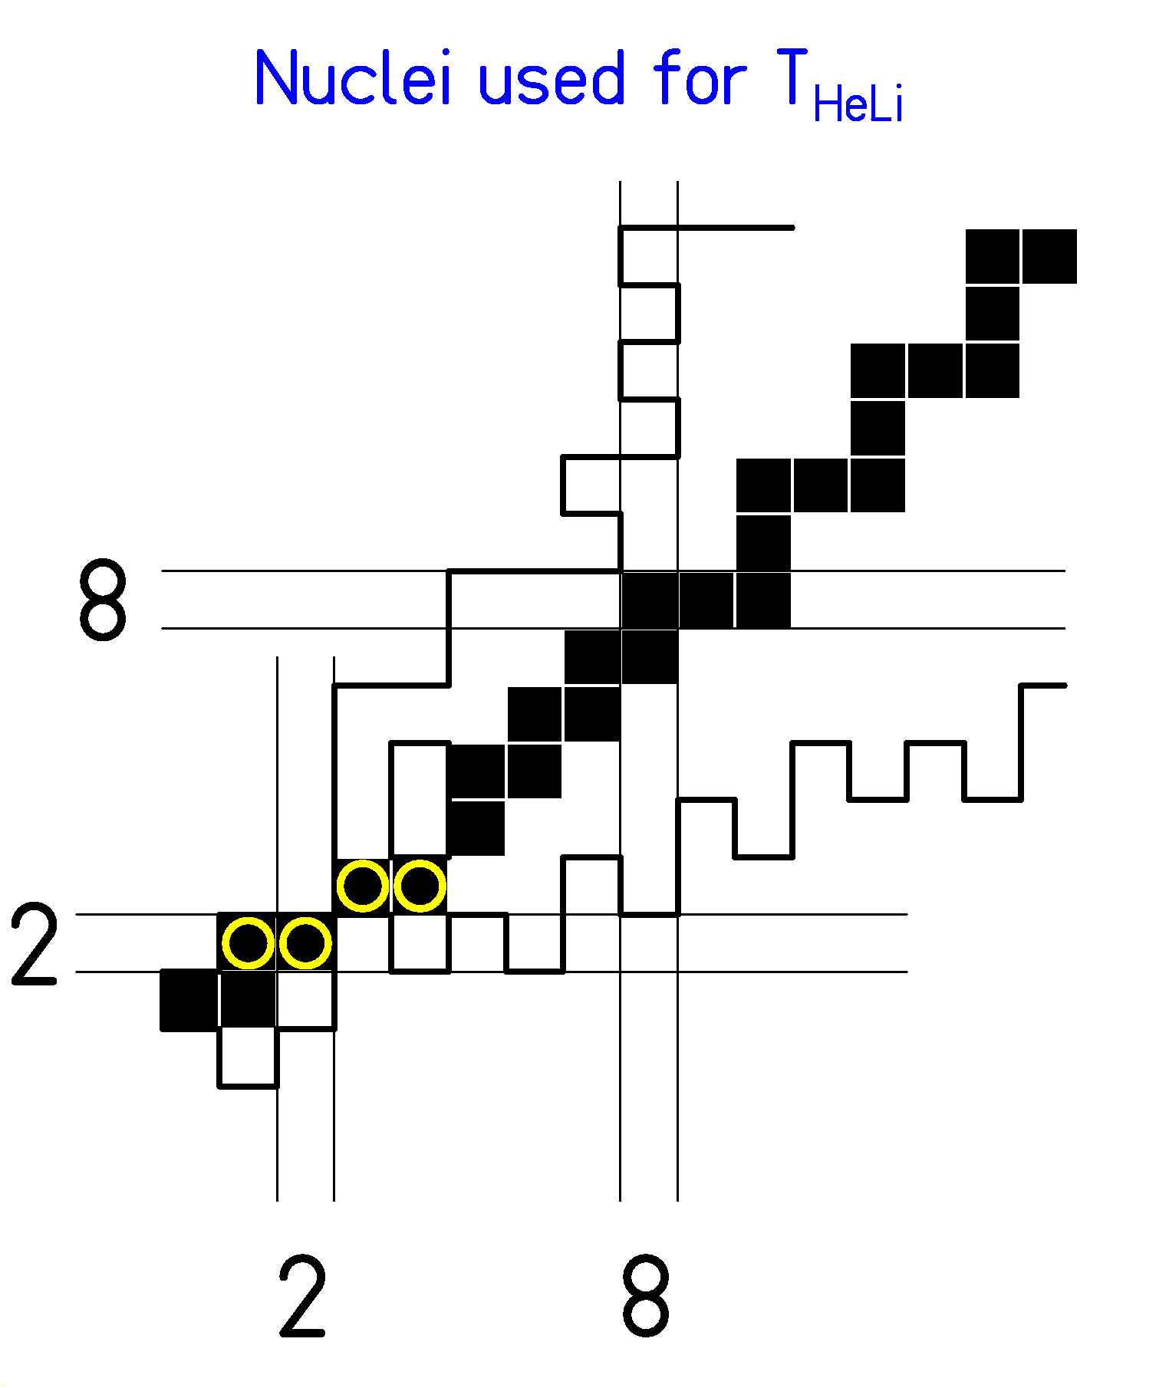

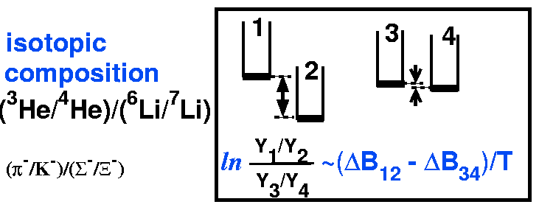

Double-isotopic ratio,

experimental binding energies → T_{HeLi}

Excitation energy introduced in the nuclear collision
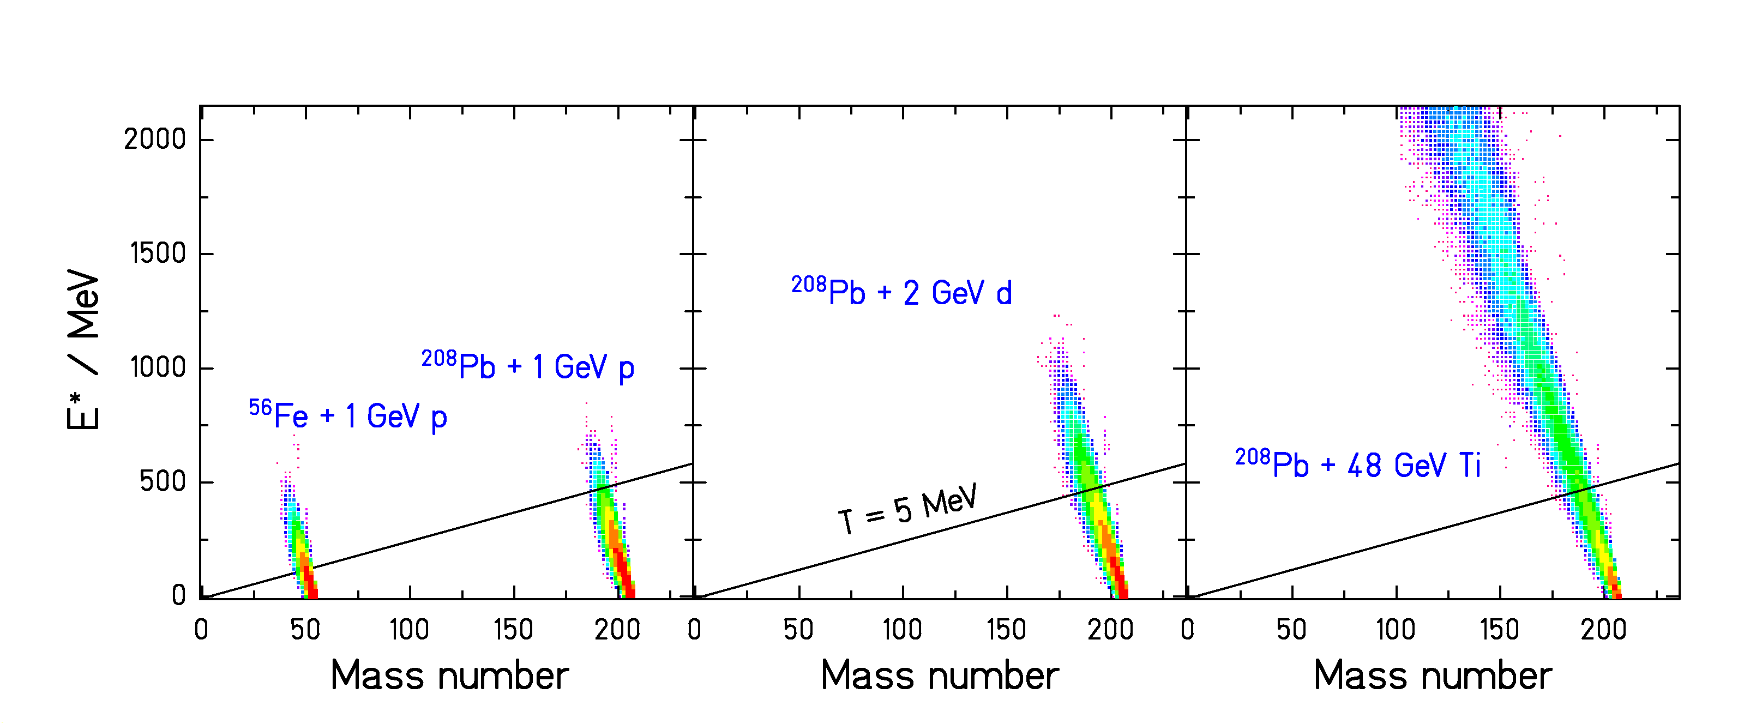

(Calculations with INCL3 and an abrasion model.)

- Spallation of light nuclei (e.g. Fe) leads to high temperatures!
- Features of thermal instabilities expected.
The diabatic approach to dissipative collective nuclear motion -
A dynamical model for the break-up process

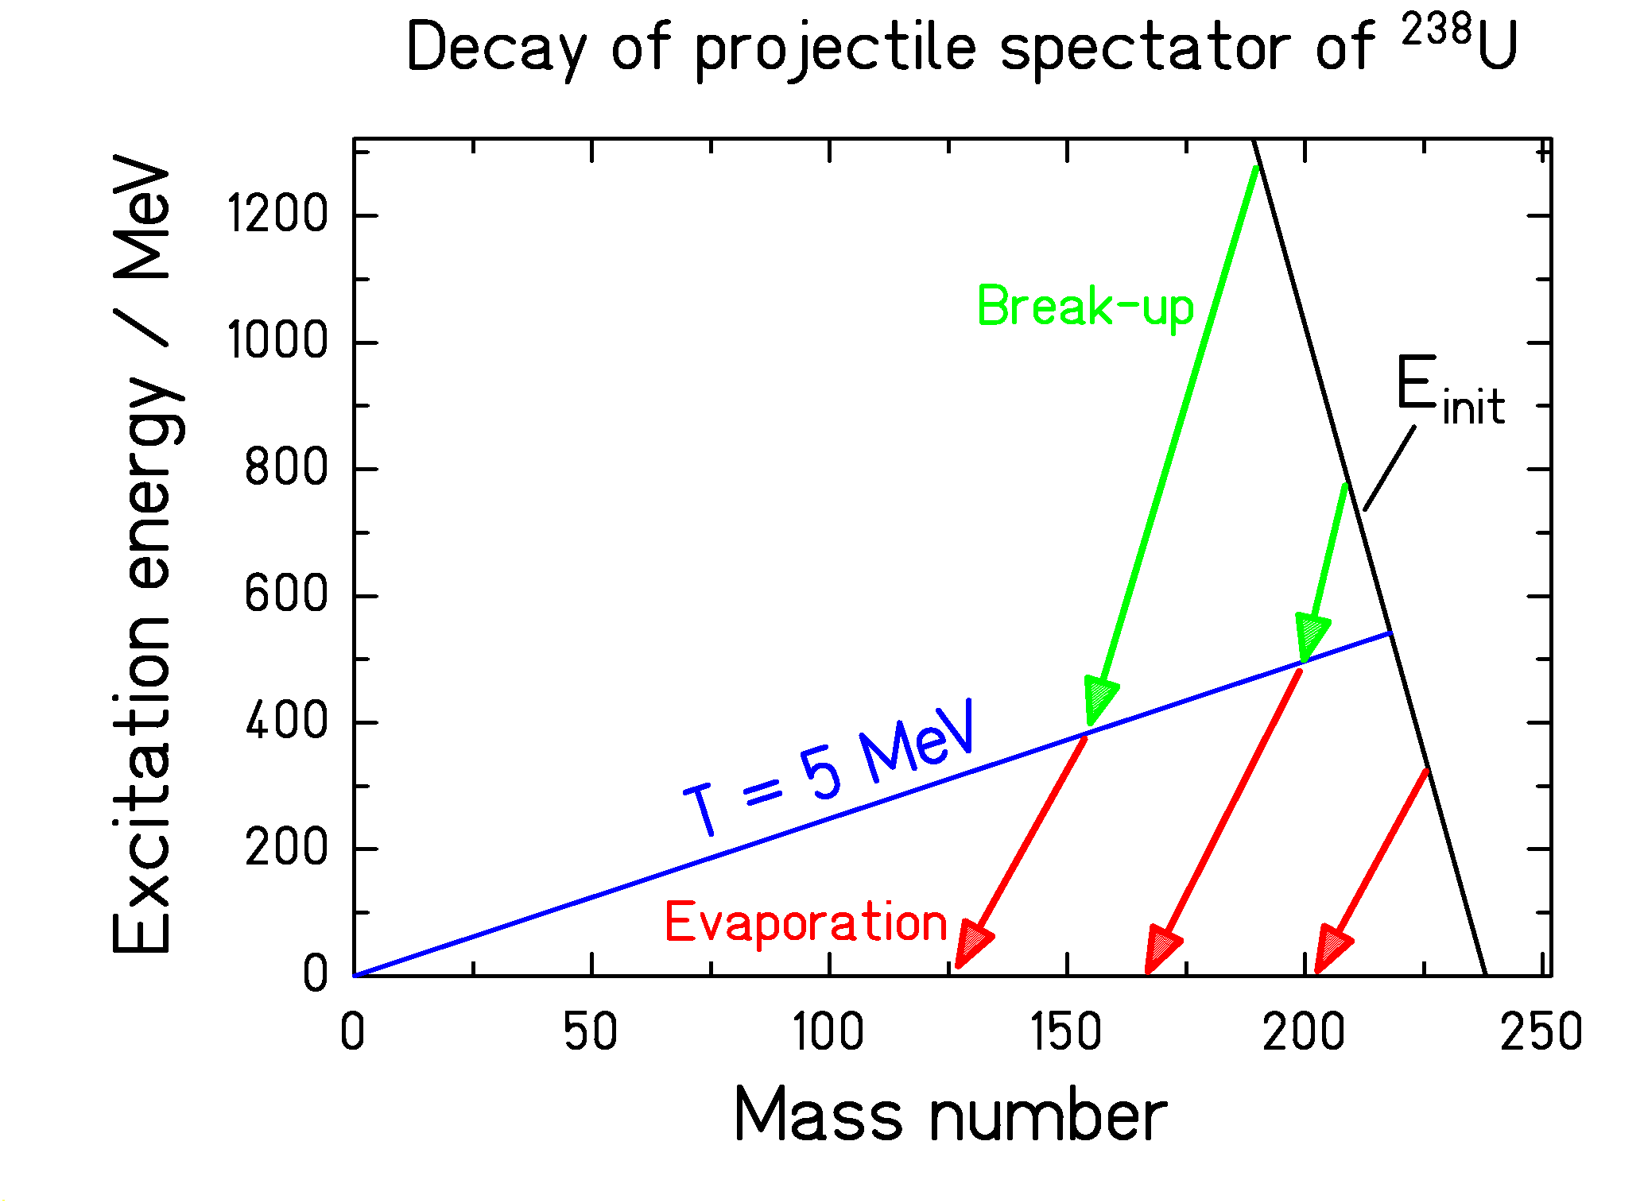

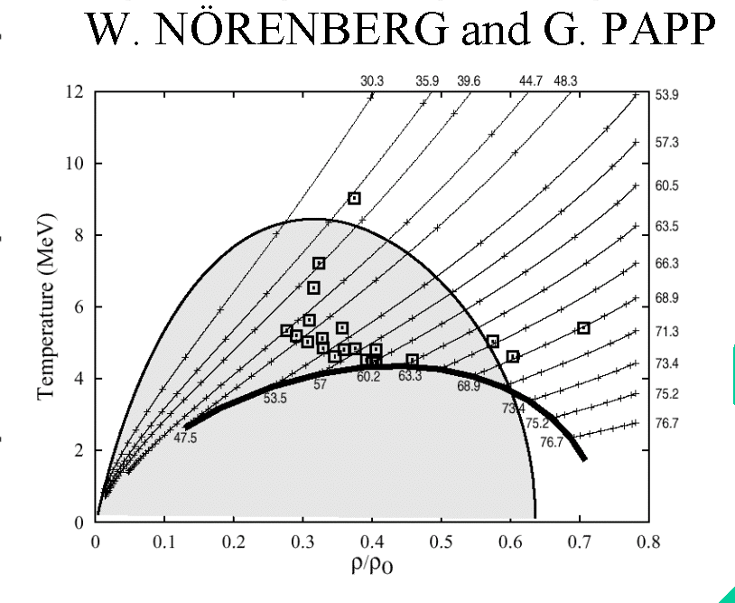

T

ρ/ρ₀

Dynamical picture
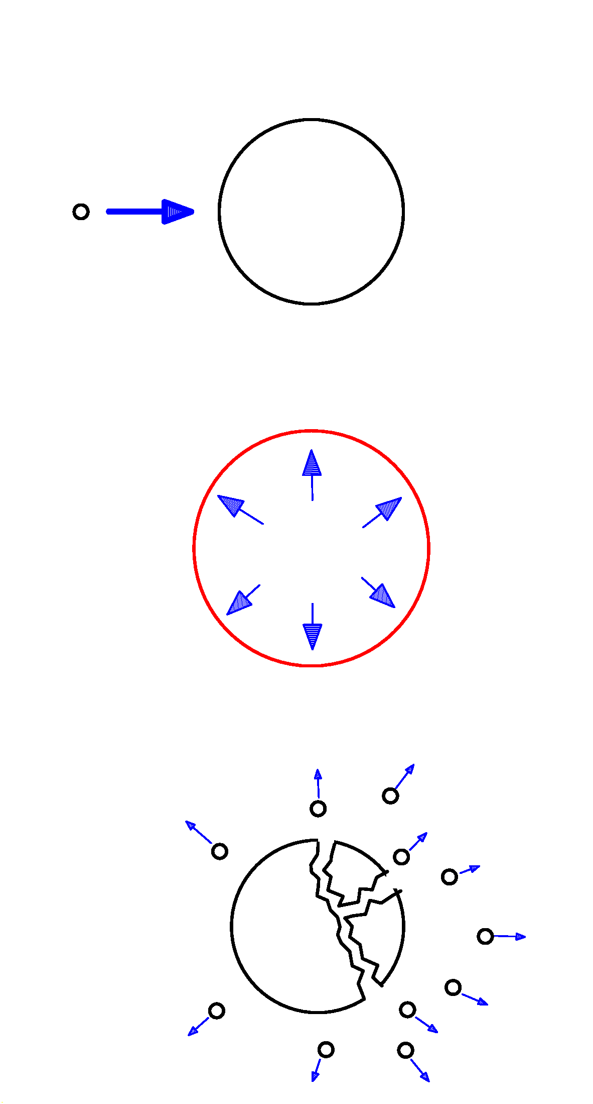

Nuclear collision: Exciting the nucleus

Thermal expansion

Entering a region of spinodal instability

Partly vaporizing
Liquid phase: Multifragmentation

(Nörenberg, Papp, Rozmej, EPJA 327, 2000)

Phase transitions in two-component systems

Similarities expected between
- heating and cooling of nuclear matter and
- distillation of alcohol.

Nucleus

The two components:
protons -- neutrons

most stable: N ≅ Z
most volatile: neutron matter
or proton matter

Wine

The two components
water -- alcohol

most stable: water
most volatile: alcohol

-------------------------------------------------------------------------------------------------
Variation of N/Z ratio in gas and liquid phase: “Isospin physics”.

- Evaporation of neutrons from hot but liquid nuclear matter.
- Distillation of neutrons in liquid-gas phase transition.

FRS data

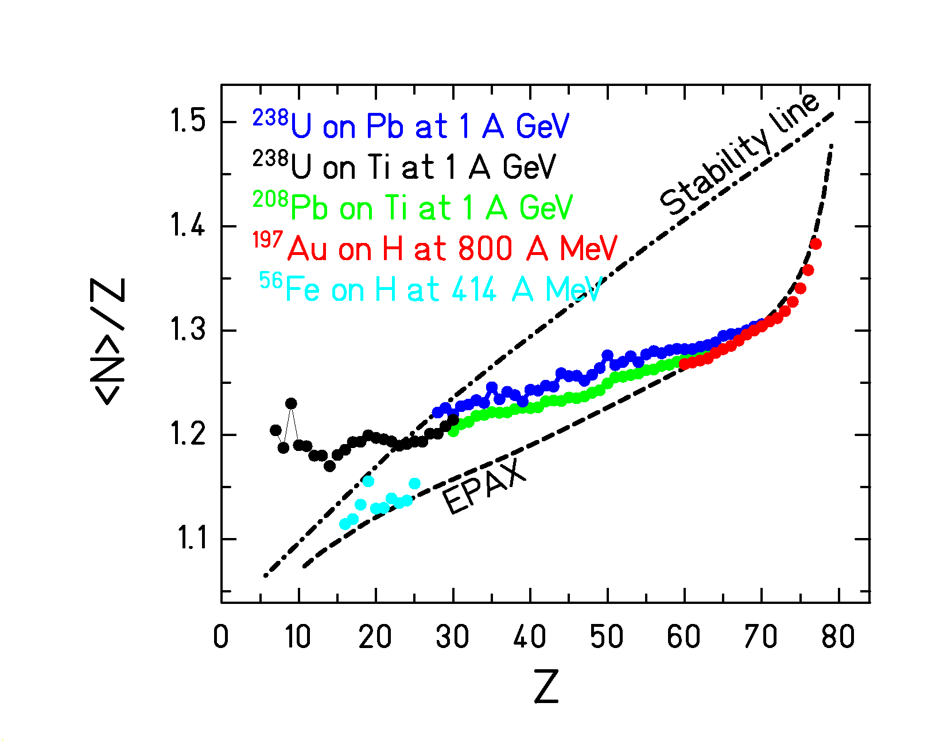

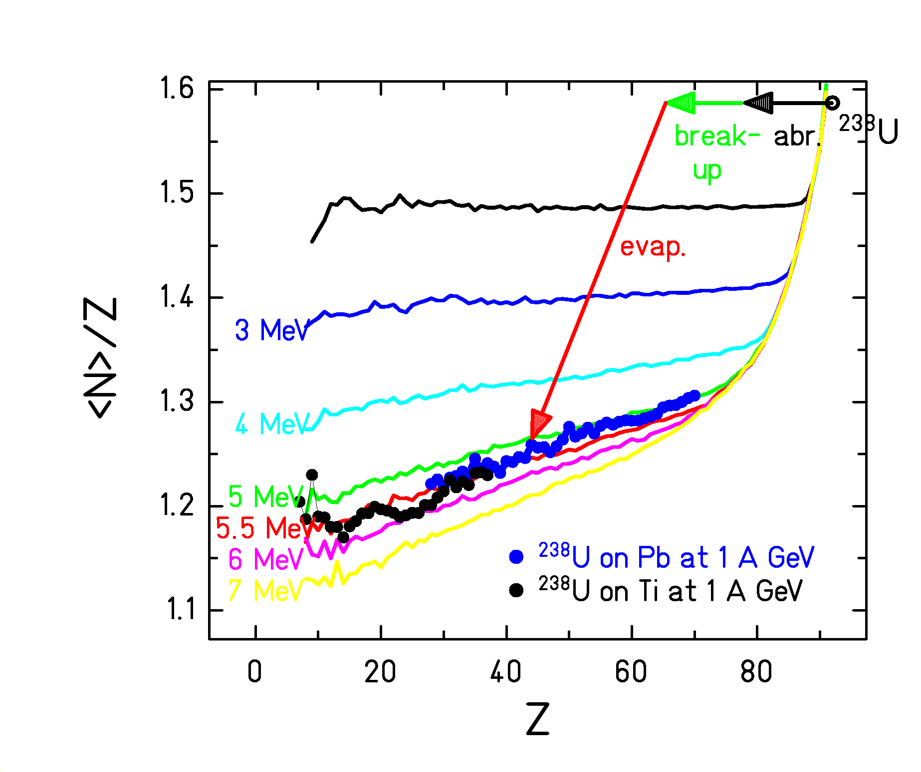

<N>/Z of fragmentation residues compared to EPAX and
3-stage code ABRABLA (with different freeze-out temperatures)
K.-H. Schmidt, M. V. Ricciardi, A. Botvina, T. Enqvist, Nucl. Phys. A 710 (2002) 157

Regarding “isospin” variation in evaporation only: T_{freeze-out} ≈ 5 MeV
This result is compatible with the caloric curve of ALADIN.

FRS experiments extend Isospin physics to higher masses!

Summary

Incineration experiments provide first complete survey on nuclide distributions.

Extension of isospin physics to heavier masses.

Consistent indications on breakup, when a nucleus is heated at T > 5 MeV.
Influence on spallation (especially of light nuclei) expected.
(see poster of P. Napolitani)

