Collaboration meeting, ECT Trento, April 22-26, 2002

Fission at finite thermal excitations

⎯⎯⎯⎯⎯⎯

Introduction into experimental aspects

(KHS)

Fission:

A large-scale collective motion, driven by
surface tension and Coulomb repulsion.

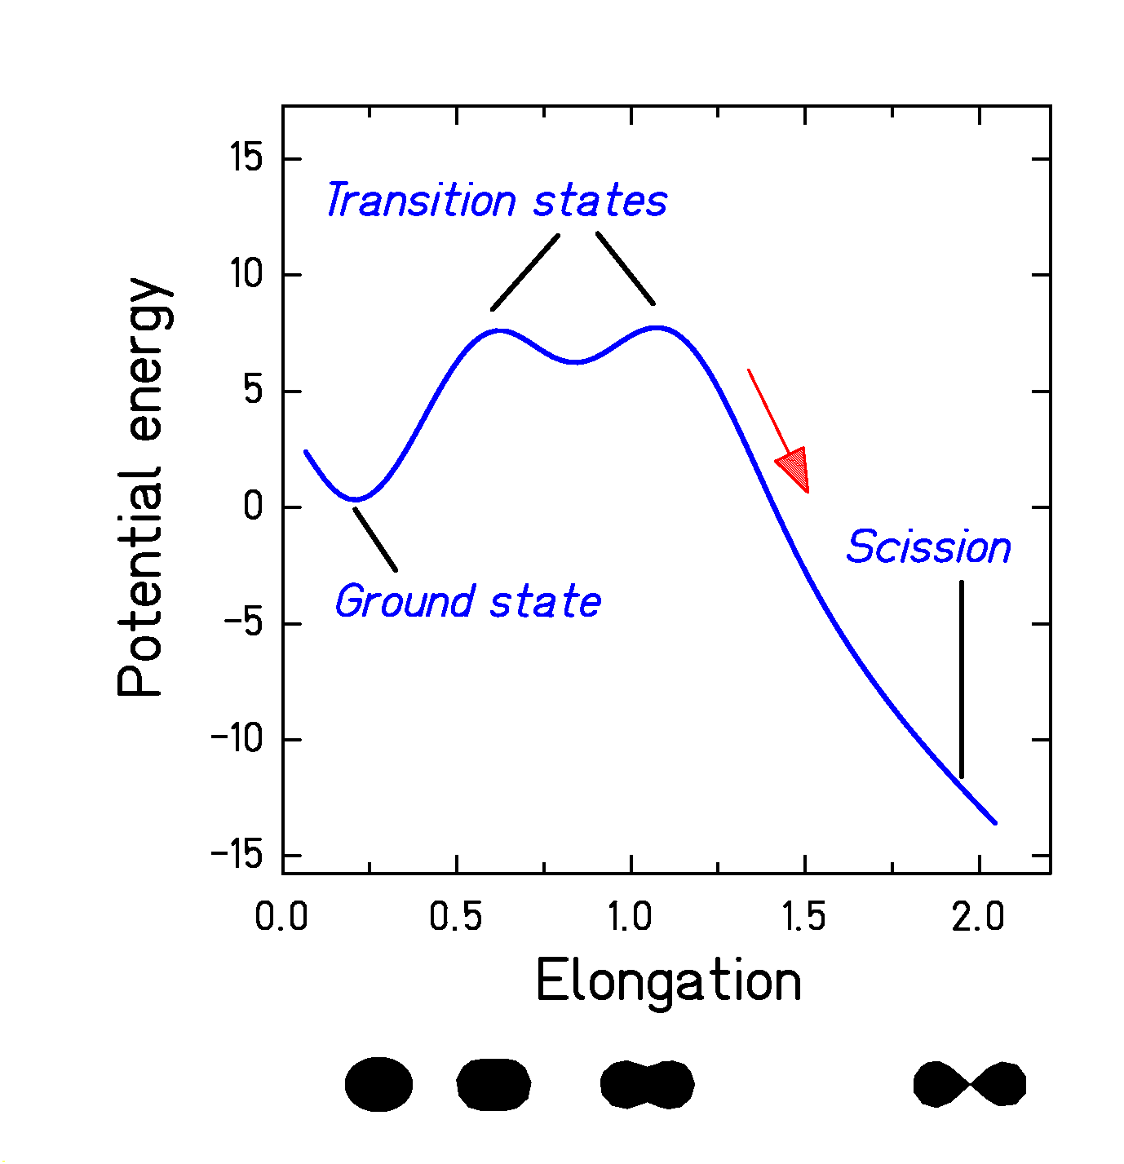

It is our aim to understand the dynamics of this process.
What are the tools, what are the signatures?
What is the actual status of our knowledge?
What are the unsolved questions?
Different behavior in different regions:
(Important for the interpretation of experimental data.)
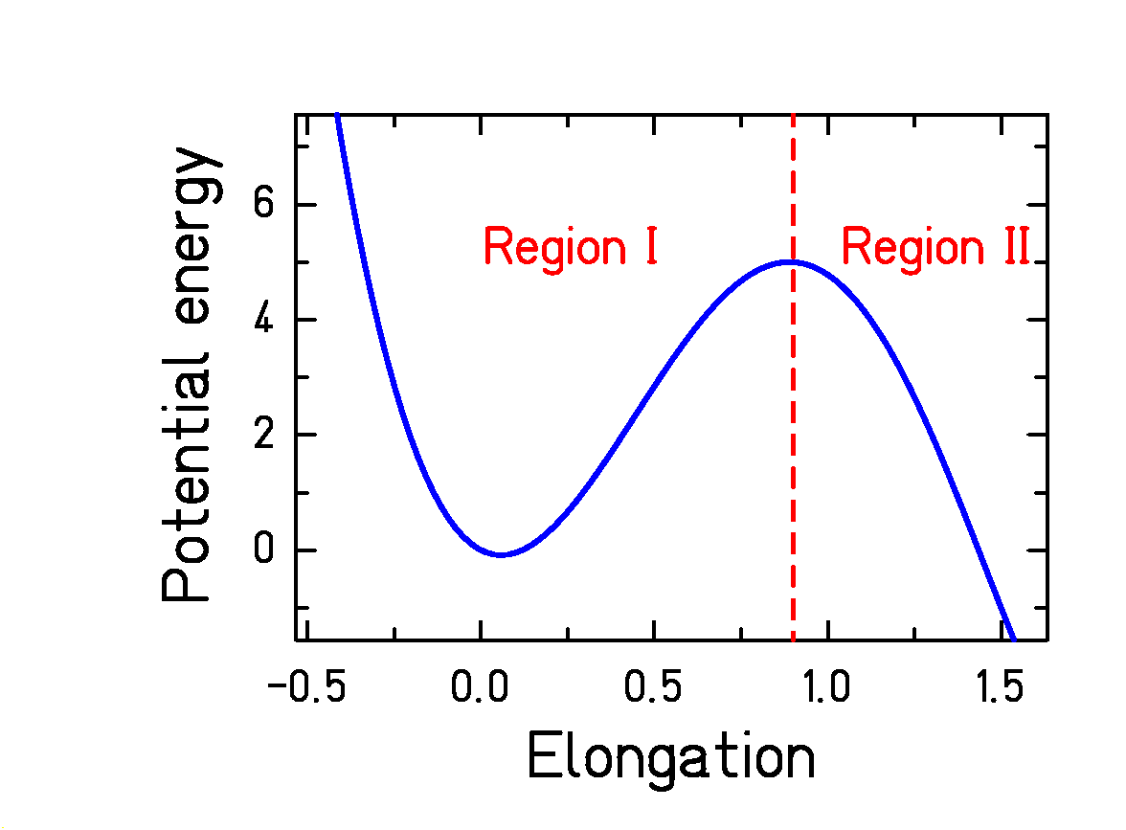

Region I (inside saddle):
- For B_{f} > T: (Typical for lighter systems: B_{f} is high, scission is near to saddle.)
System develops towards thermodynamic equilibrium with small escape rate.
- For B_{f} < T: (Typical for heavy system and large angular momentum.)
Non-equilibrium process; escape dominates.

Region II (saddle to scission):
(Important for heavier systems only.)

Non-equilibrium motion towards scission
Characteristic time evolution

1. Initial conditions defined by the
reaction mechanism:
- Excitation energy
- Angular momentum
- Distribution in deformation space
- Initial dynamics
Nuclear reactions used (some examples)

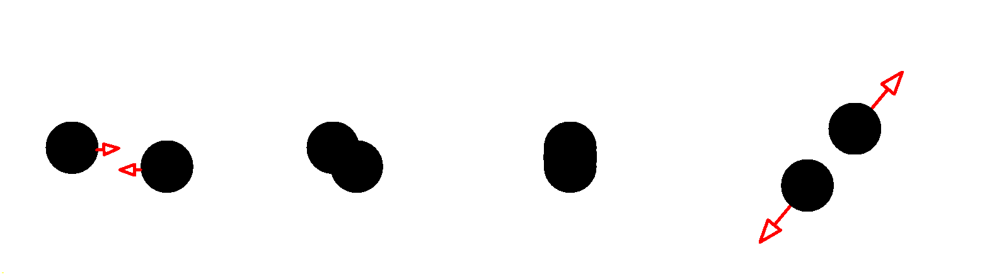

Heavy-ion collisions near the Coulomb barrier
Starting with large shape distortions and
large angular momentum
  - Fusion-fission
(Forming a compound nucleus – equilibration)
  - Fast fission – quasi fission
(Directly moving to fission without intermediate equilibrated state)

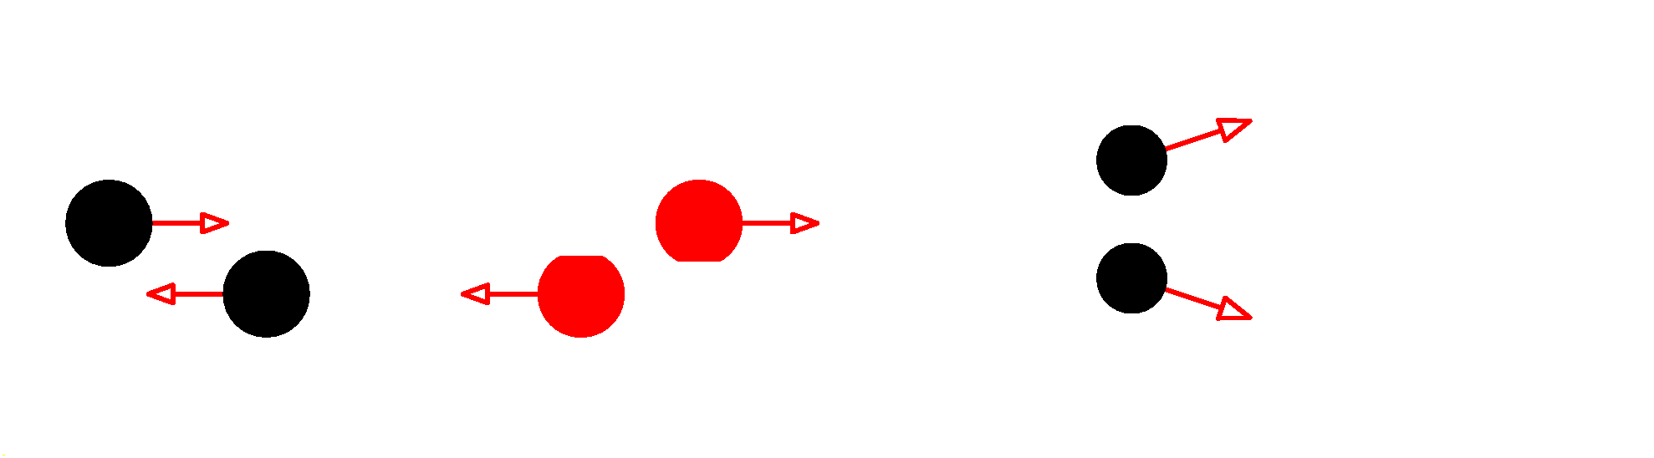

Annihilation of anti protons, Spallation, Abrasion
Starting with small shape distortions and
small angular momentum

Essentially introduces only excitation energy
  - Highest excitation energy in abrasion, even used to induce multifragmentation (→ break-up).

2. Dynamic evolution defined by properties of the system:
- Region I (inside saddle), B_{f} > T:
Evolution towards quasi-equilibrium
“Transient time”
  - Distribution in deformation space (velocity, position)
  - Escape rate over the barrier
Specific features:
  - Time delay of fission (Grange, Weidenmüller)
  - Reduction of stationary fission width (Kramers)
Specific observables:
  - Evaporation-residue cross sections
  - Fission cross sections

- Region I (inside saddle), Bf < T
and
Region II (saddle to scission):
Directed dissipative motion towards scission.

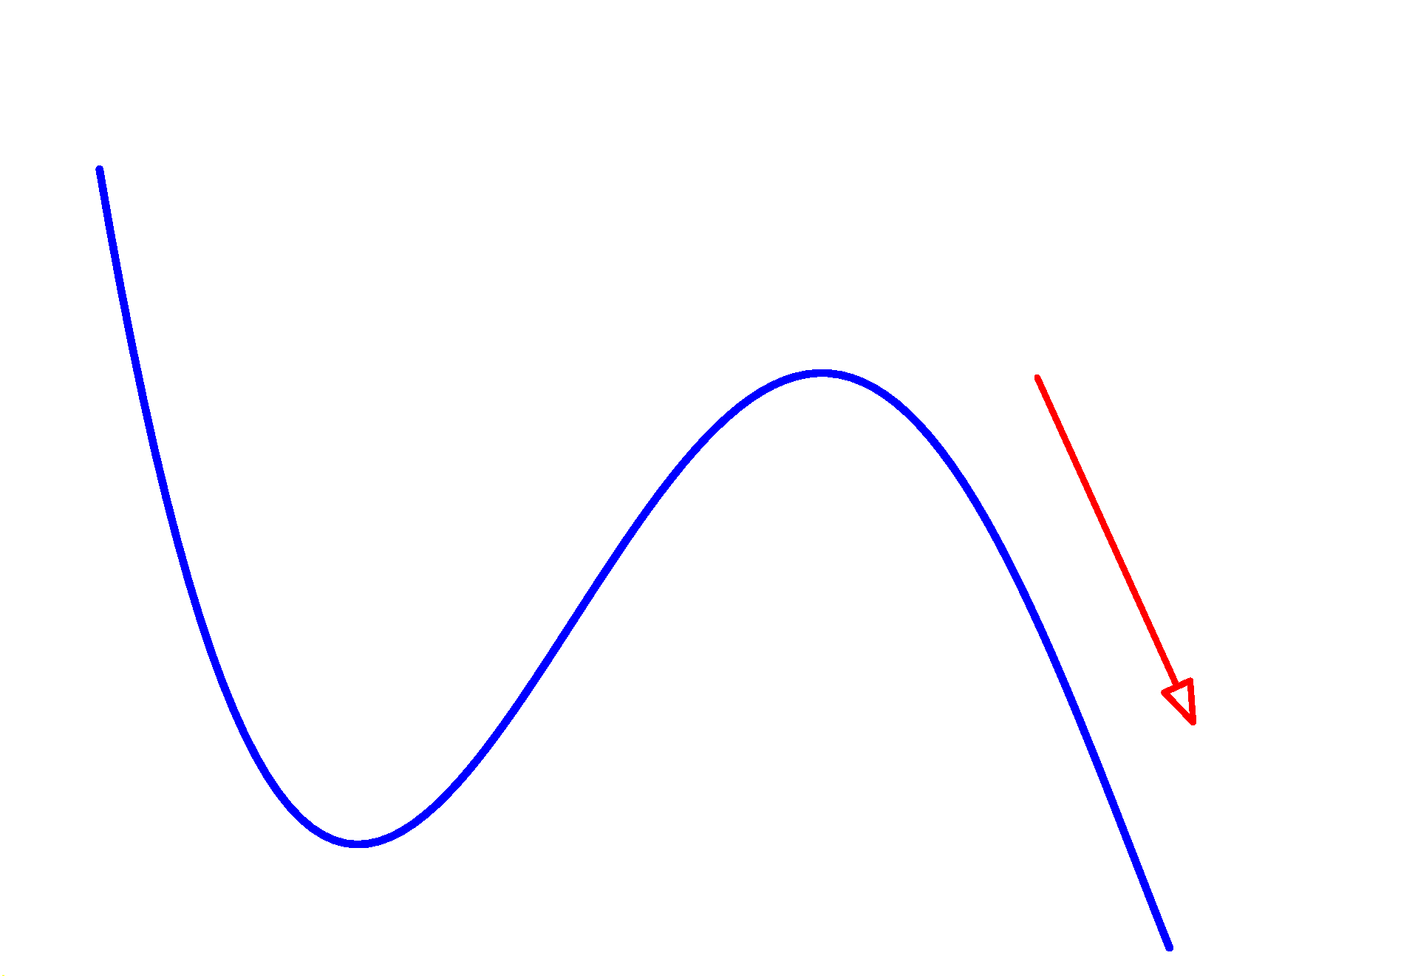
  - Distribution of trajectories in deformation space. (Fluctuations!)
  - Part of energy gain dissipated.
  - Process slowed down by dissipation.
Specific observables:
    - Even-odd effect
    - TKE
    - Pre-scission neutrons and charged part.
    - Pre-scission GDR
    - Blocking
Experimental methods with their time-sensitivity range
(from Hilscher and Rossner, 1992)

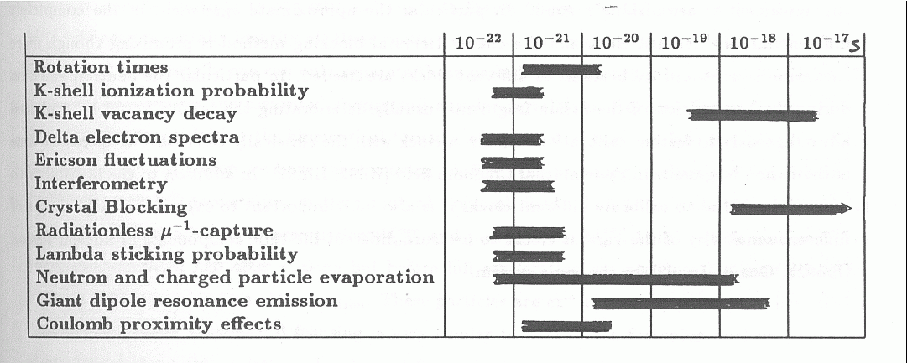
Status of experimental results in 1992
(From Hilscher and Rossner)

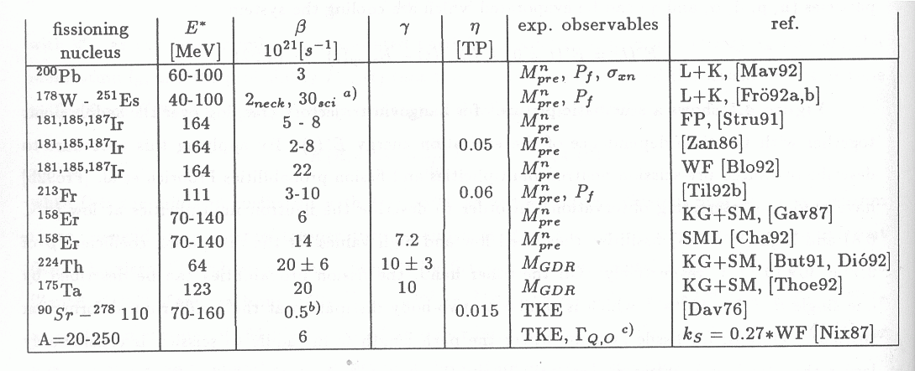
Some important developments after 1992
in last century

Methods:
- Dynamic calculations for interpretation of data from non-equilibrium reactions
  - (HICOL + evaporation)

Results:
- Systematically lower dissipation coefficient inside saddle than outside saddle.
  - Empirical description of Fröbrich et al.
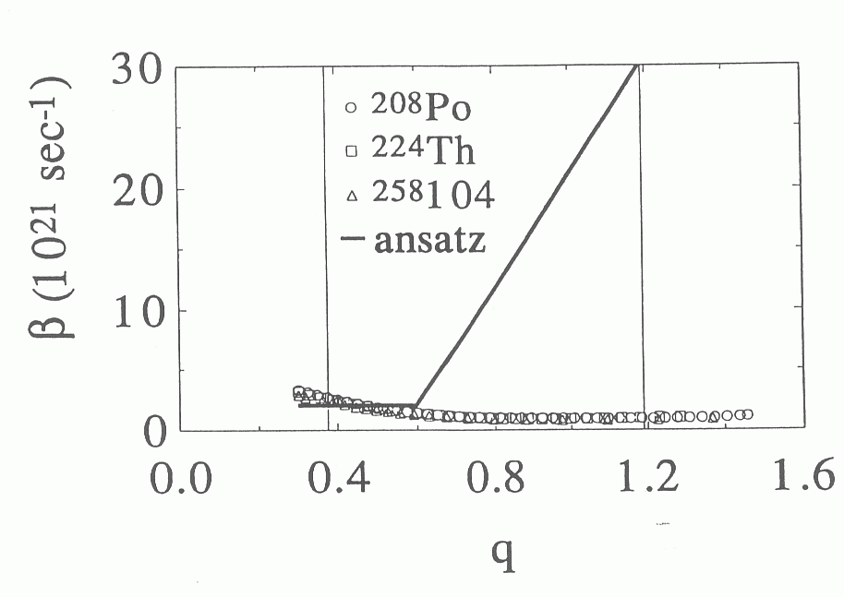

- Extraction of temperature-dependent dissipation coefficient
(not without contradiction)
  - Wilszinski, Rudolf and Kelić, Rubchenya and many others
Latest improvements

New techniques and new observables:

Reaction | Observable
Fusion-fission | Spin distribution of E. R.
Abrasion | Partial fission cross sections
Spallation and abrasion | Width of A or Z distribution
EM-induced fission | Systematics of even-odd effect

Analysis:

- Full dynamic calculation for non-equilibrium reactions including fluctuations
Langevin equation + evaporation
- More realistic level densities
Shell effects, deformation dependence
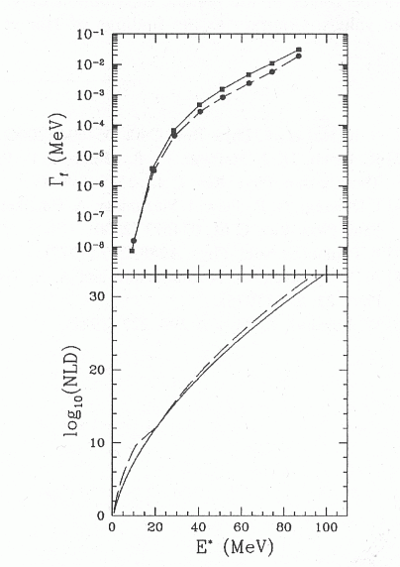
(e. g. Ignatyuk approach in CASCADE)

System: ¹⁹F+¹⁷⁵Lu

Dashed line:

Original description from Pühlhofer.

Full line:
Washing out of shell effects by Ignatyuk description.

I. Dioszegi, PRC 64, 2001

More realistic in-growth function
(E.g. new analytical approximation)

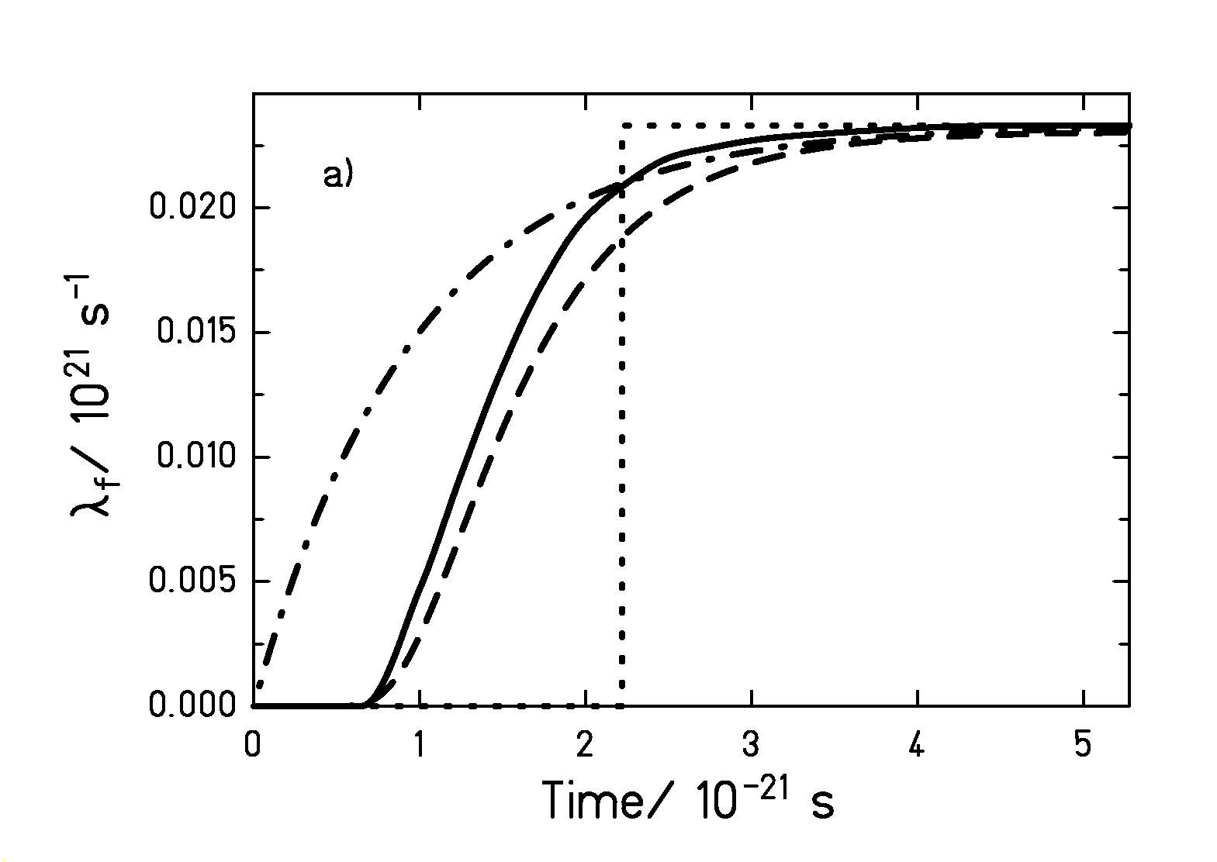
Full line: a numerical solution of the FPE
Dot-dashed line: (1-exp(t/τ))
Dotted line: step function
Dashed line: new analytical approximation
From B. Jurado et al., in preparation

Results
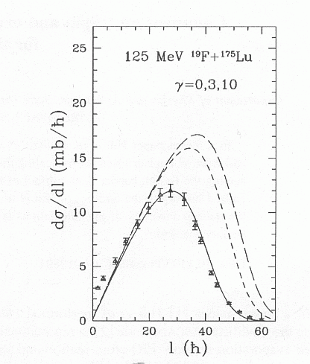

Measured spin distribution shows no influence of dissipation.

I.Dioszegi, PRC 64, 2001

²³⁸U,1AGeV+CH₂

Critical damping result from data in abrasion reactions in inverse kinematics.

B.Jurado et al., PhD thesis

- Many consistent results on low dissipation inside saddle.
- General confirmation on overdamped motion from saddle to scission.
Results on dissipation in a cold nuclear system

Pair breaking in fission (E* ≈ 11 MeV)
Electromagnetic-induced fission of secondary projectiles:
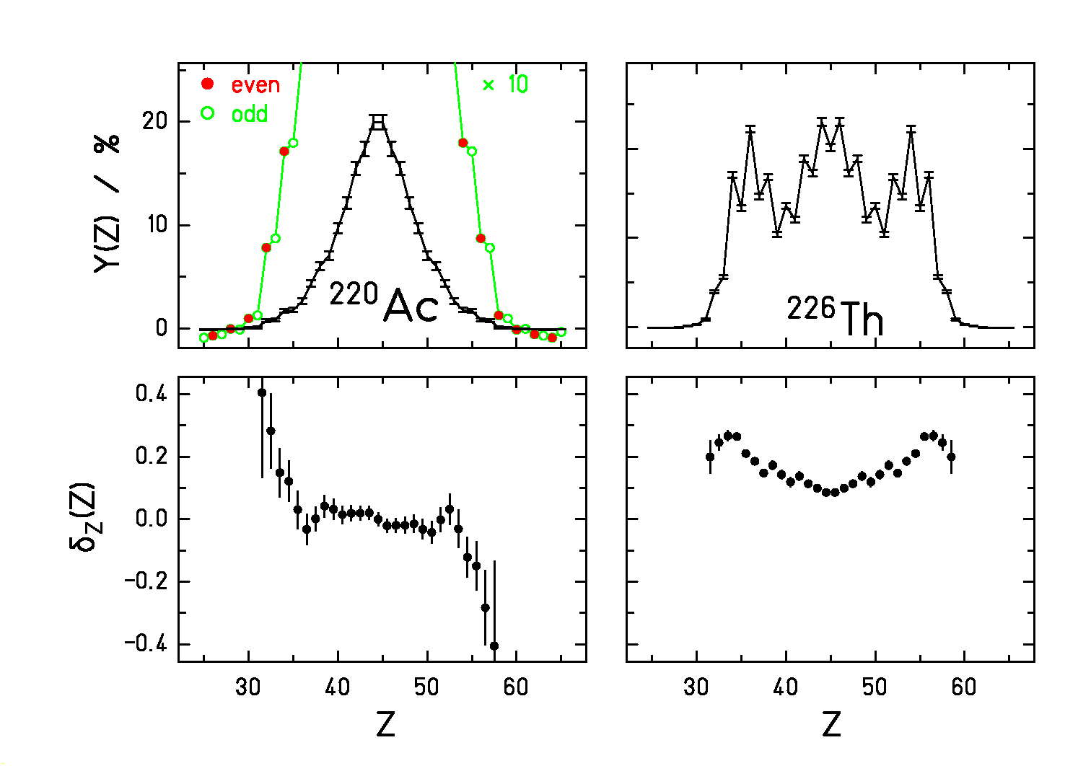
(δ_{Z}(Z) = local even-odd effect)
Even-odd effect for odd-Z fissioning nucleus (₈₉Ac)
Even-odd effect at symmetry for even-Z nucleus (₉₀Th)
Strong increase of even-odd effect in asymmetric fission

Interpretation: Nucl. Phys. A 634 (1998) 89,
Nucl. Phys. A 678 (2000) 215

Crucial problems (personal view)

Contradiction between different results
- Different analysis methods, model parameters
- Confound statistical and dynamical times
- Different weighting over the process
  - (Eg. neutron clock measures E ∼ ln(t), while blocking measures <t>.)
Deformation and temperature dependence of dissipation
- Deformation dependence seems to be established
- Temperature dependence is unclear
  - (Ambiguities in the description of data must be removed.)

Proper tools for analysis of data

- Consistency with related relevant data
  - Check consistent description with full systematics of E.-R. cross sections)
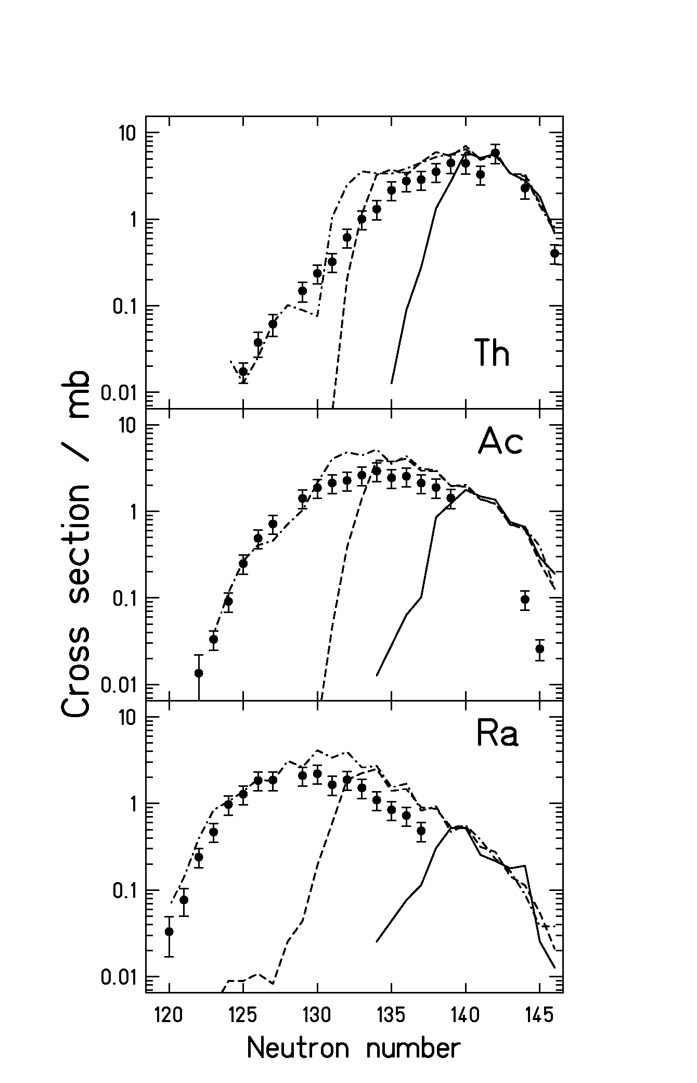

Example:

Cross sections in 238U(1AGeV) + Cu compared to calculations with different options for the level density.

A. Junghans et al., NPA 629 (1998) 635

  - Avoid fitting parameters to individual data.

- Realistic level densities (shell effects, collective enhancement, deformation dependence)
  - e.g. the particular behaviour of proton-rich nuclei near N=126
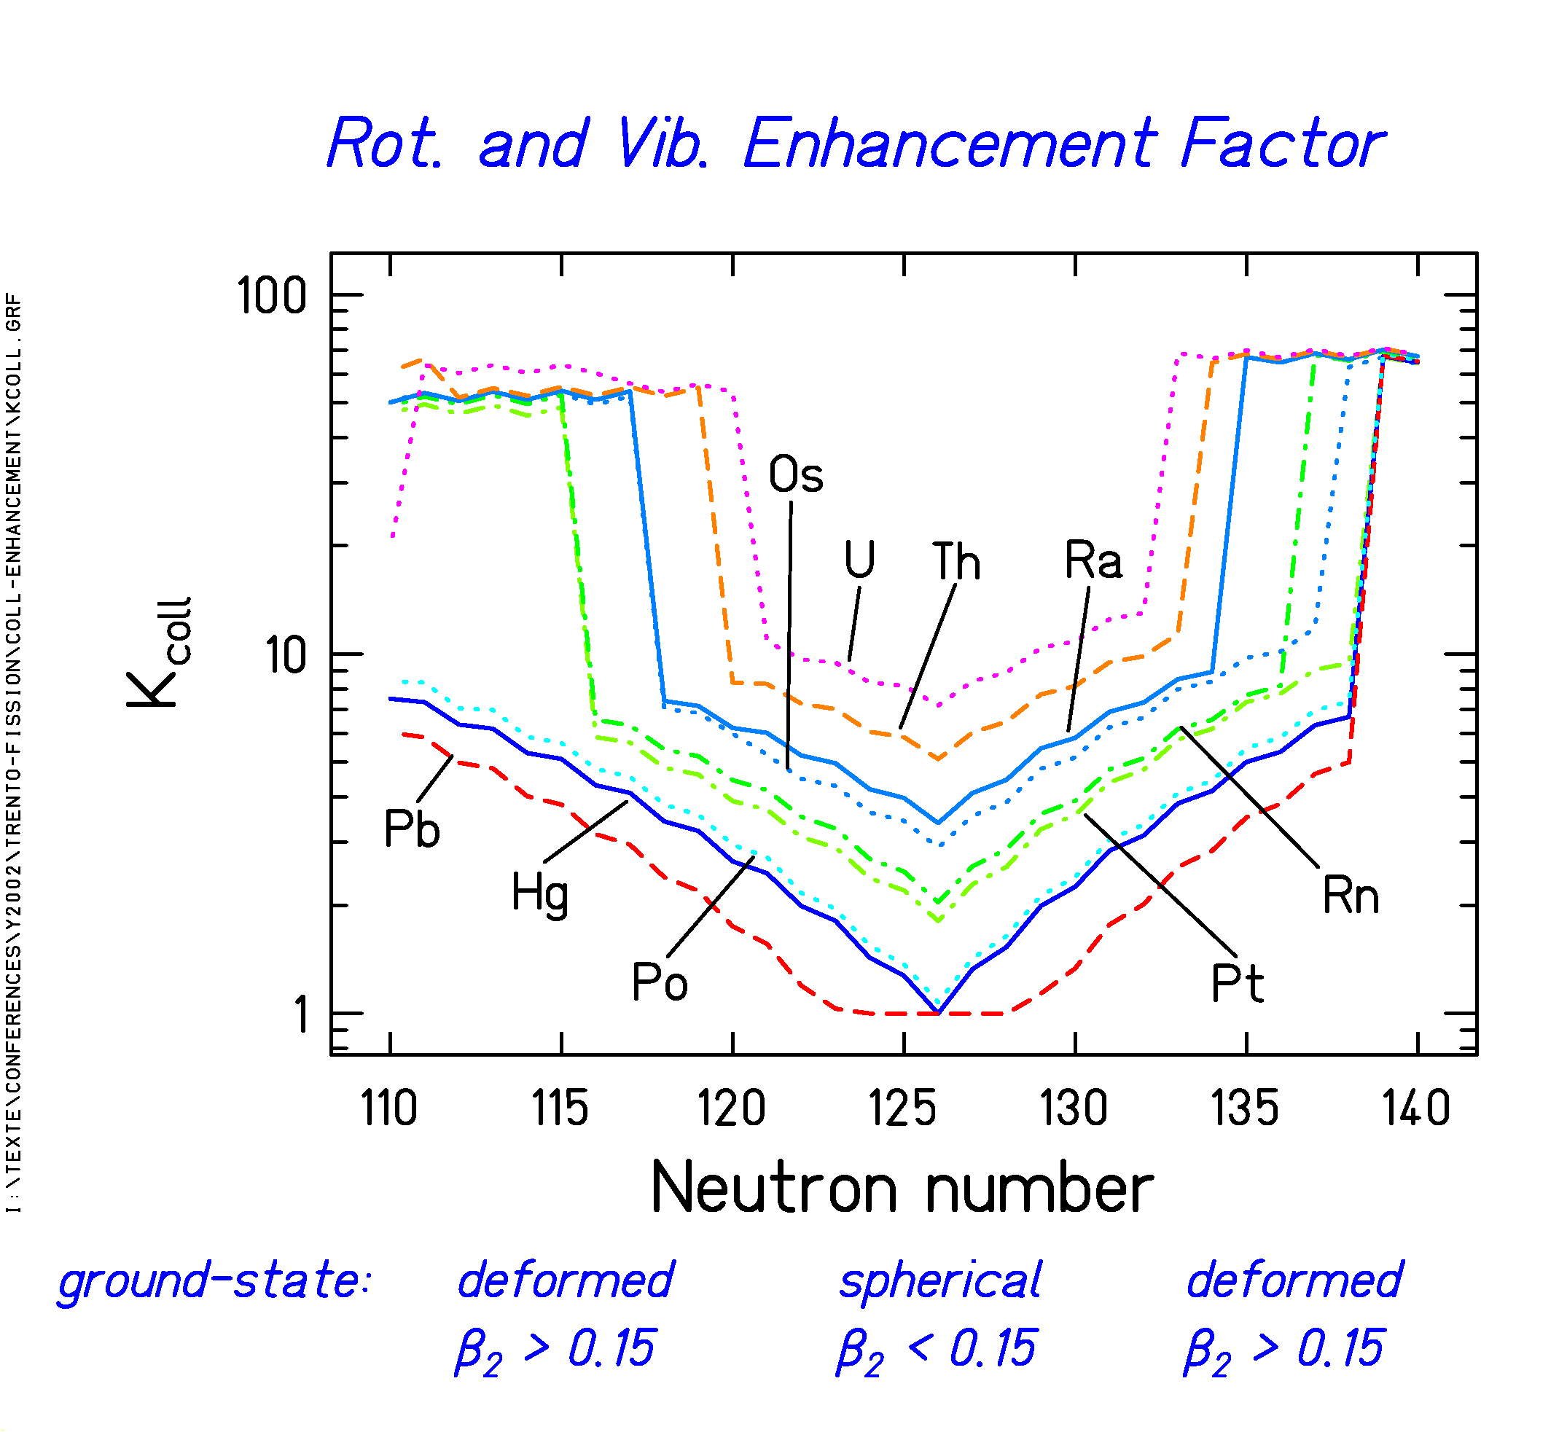
A.Junghans et al., NPA 629 (1998) 635

- Avoid inappropriate approximations
  - (e.g. use realistic in-growth function,
full dynamical treatment for non-equilibrium processes)

