Beam preparation for EURISOL

Karl-Heinz Schmidt, GSI

- EURISOL concept
- Primary beam
- Target geometries
- Nuclear reactions
- The ISOL process
- Restrictions on target materials
- Restrictions on extracted elements
- Restrictions on half life
- ¹³²Sn – a favourable case
- Unconventional options
  - Use of heavy projectiles
  - Use of 2 GeV beam
  - Fragmentation of ¹³²Sn
- Conclusion

EURISOL concept:

1. Production of the nuclide by nuclear reactions
2. Release from the target by ISOL technique
3. Ionization
4. Acceleration

Experiments at EURISOL will rely on the required exotic nuclide with sufficient intensity to be available

Nuclear reaction, release, ionization determine the technological limits.

Primary beam

Standard option: 1 GeV protons
(Guided by experience at ISOLDE, because it has been successful for producing long isotopic chains of many elements.)

Alternative options?

Target

The different aspects
- production
- heat load by the beam and nuclear reactions
- release
must be combined.

- Direct target
  - Protons interact directly with the target material
- Indirect target
  - Spallation neutron source (most of the heat load)
  - Production target (few-MeV neutrons and release)

Nuclear reactions

- Direct-target option
  - Spallation-evaporation with ≤ 1 GeV protons
  - Spallation-fission with ≤ 1 GeV protons
  - Fission with secondary neutrons

- Indirect-target option
  - Fission with few-MeV neutrons

Nuclear reactions: experimental results from GSI – 1.

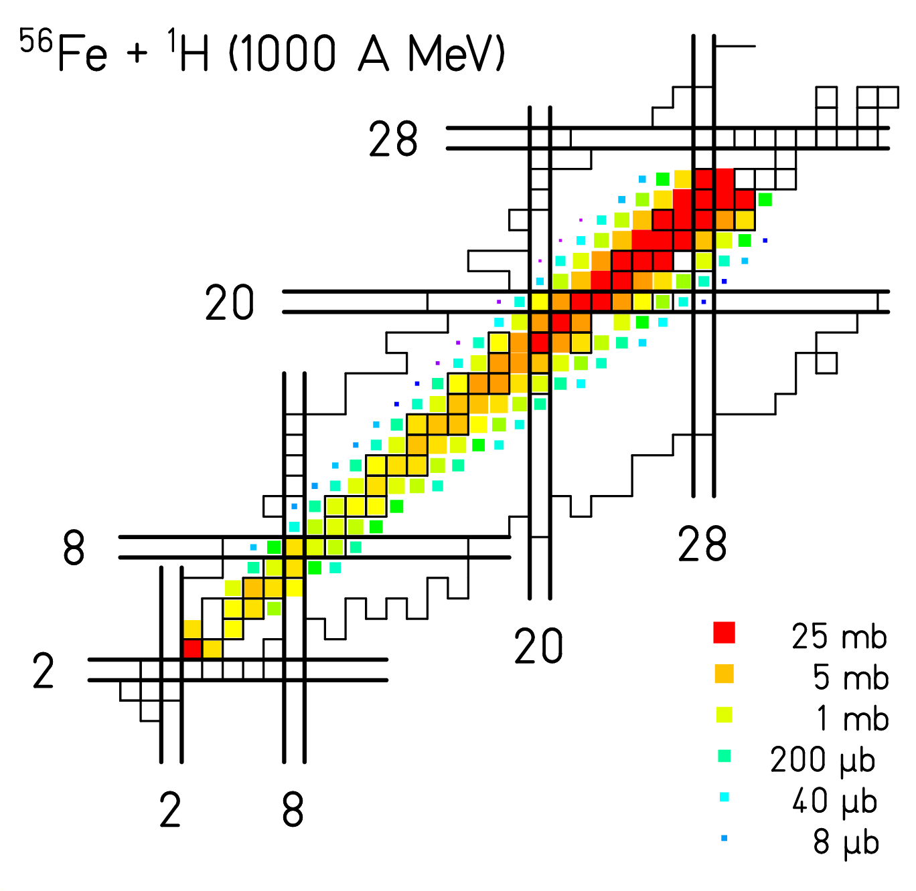

Nuclear reactions: experimental results from GSI – 2.
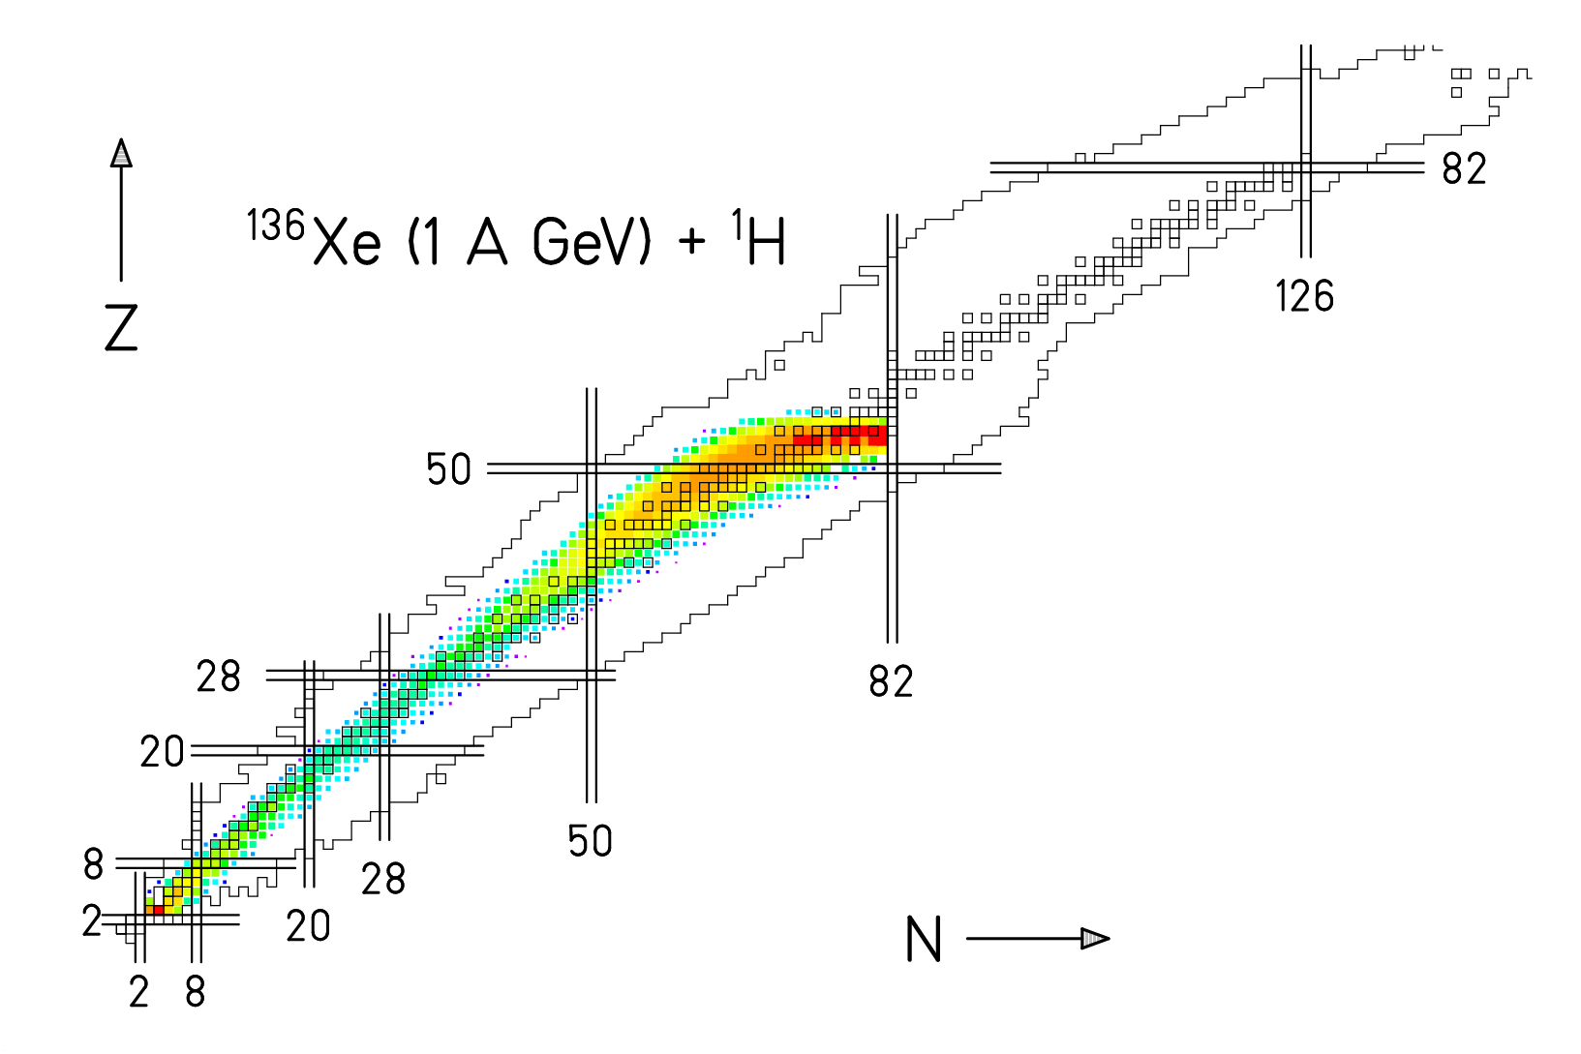

Nuclear reactions: experimental results from GSI – 3.
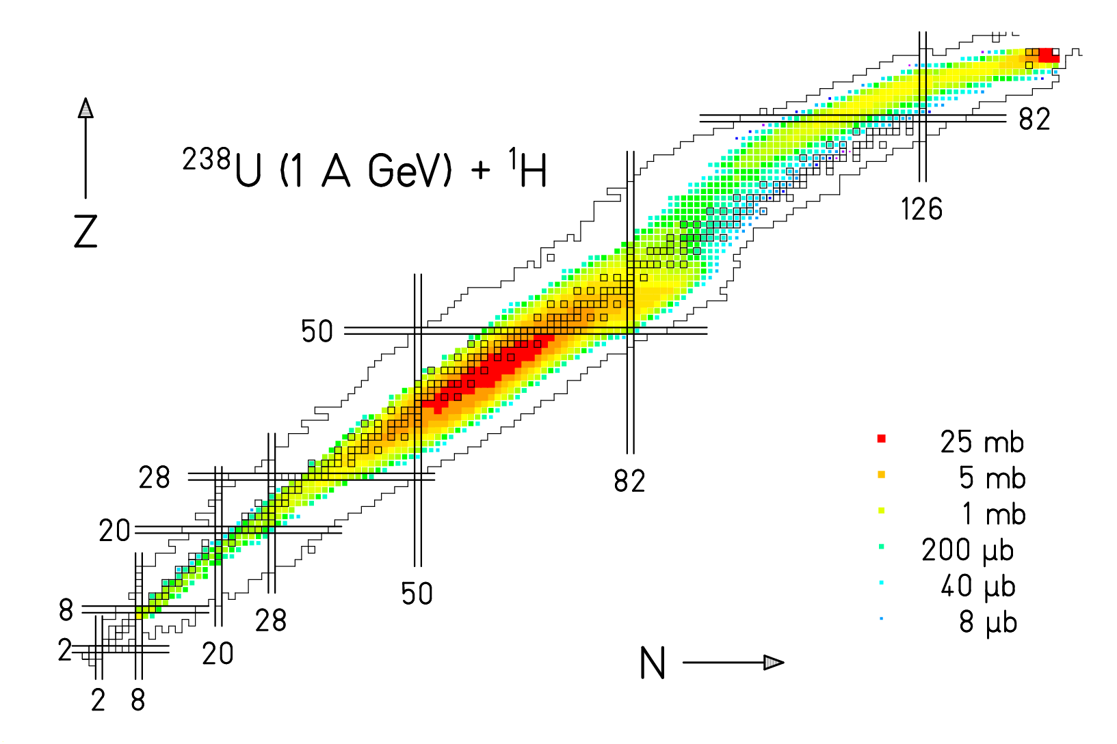

Nuclear reactions: model calculation
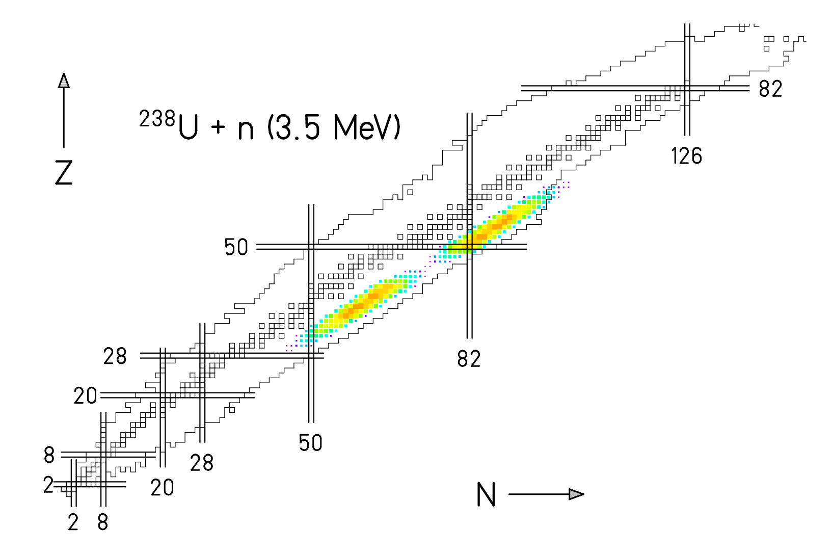

Nuclear reactions: summary

1 GeV proton projectiles:

Neutron-rich spallation-evaporation residues over 5 elements

Proton-rich spallation-evaporation residues over 10 elements

Spallation-fission residues with actinide targets for Z < 60

Few-MeV neutron projectiles:

Neutron-rich low-energy fission products 30 ≤ Z ≤ 60, dip at Z ≈ 46

The ISOL process: Target materials

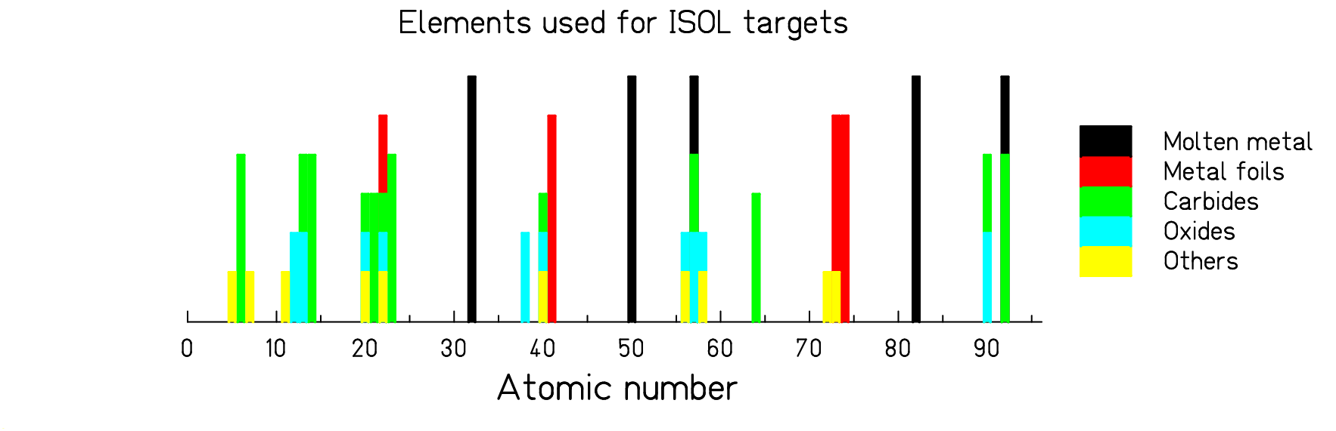

- Only few elements are suited as ISOL targets.
- There exist gaps of about 20 elements for suitable targets.

ISOL Process: Release

Z-dependent features:
- Volatility (refractory elements)
- Ionisation
- Isobaric contaminations

Features depending on half-life:
- Decay losses

Typical elements available with ISOL

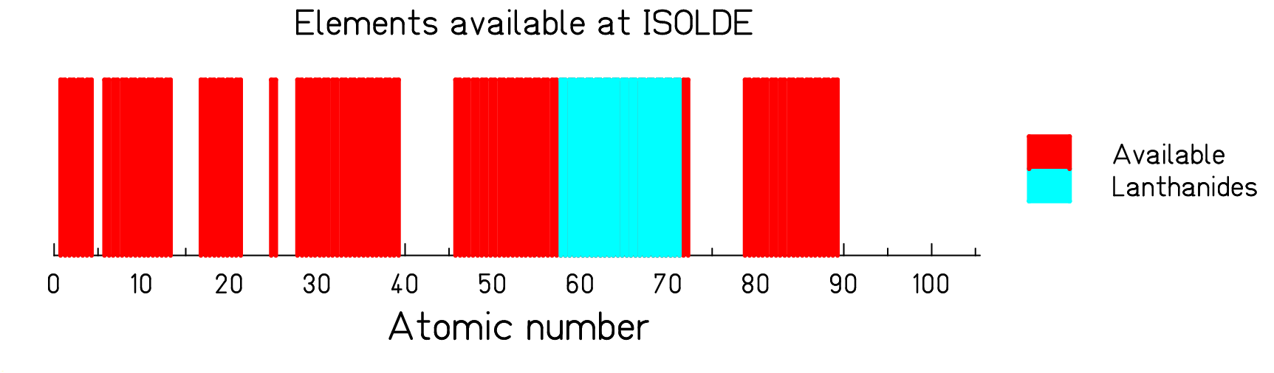
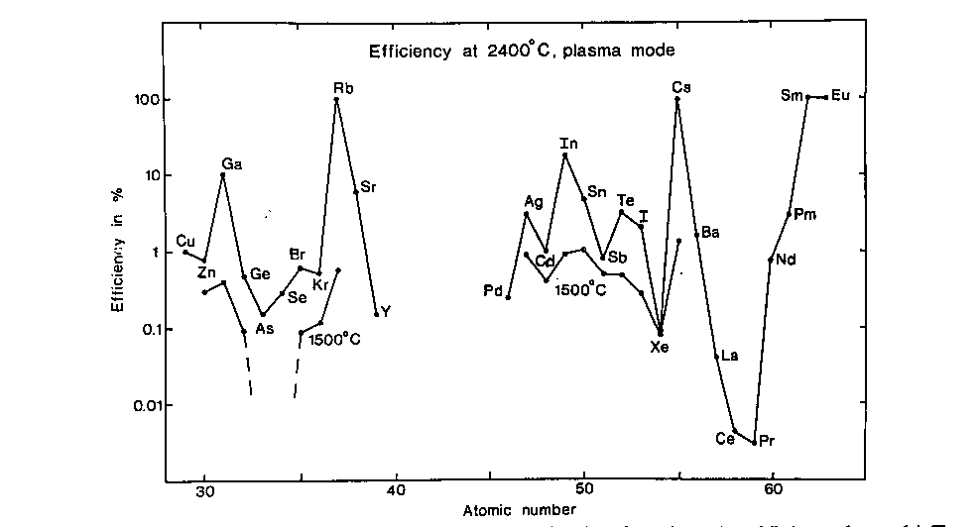

Nuclear-reaction model for in-target production – ²³⁸U + p
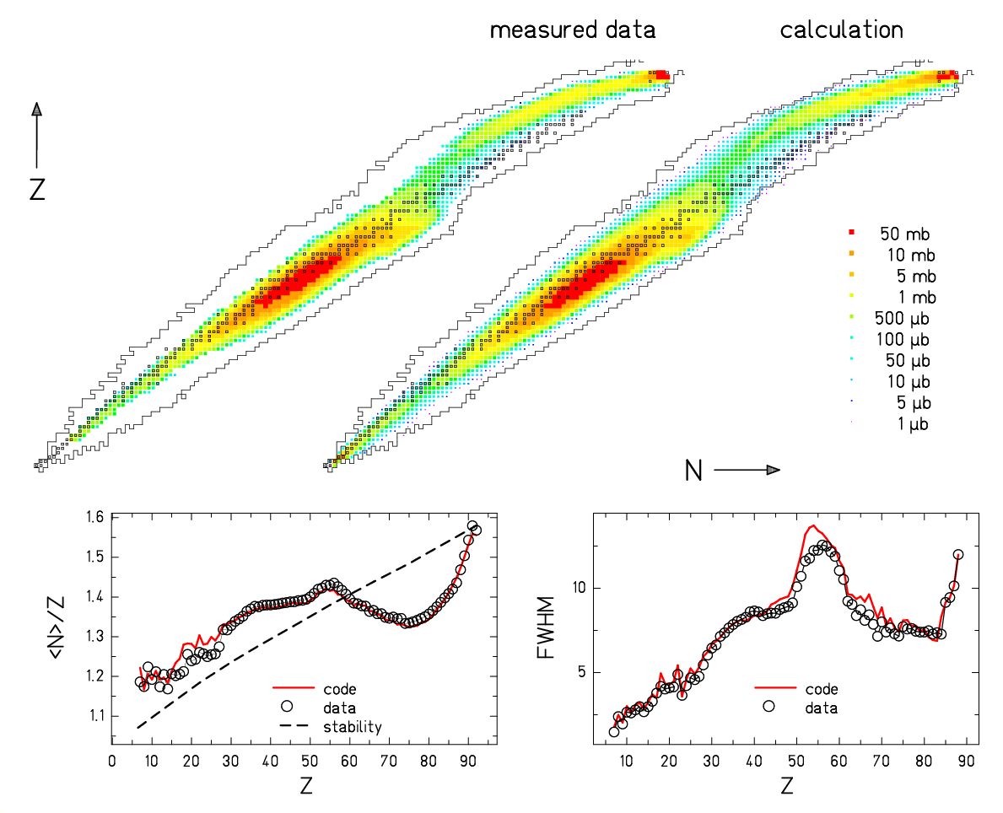
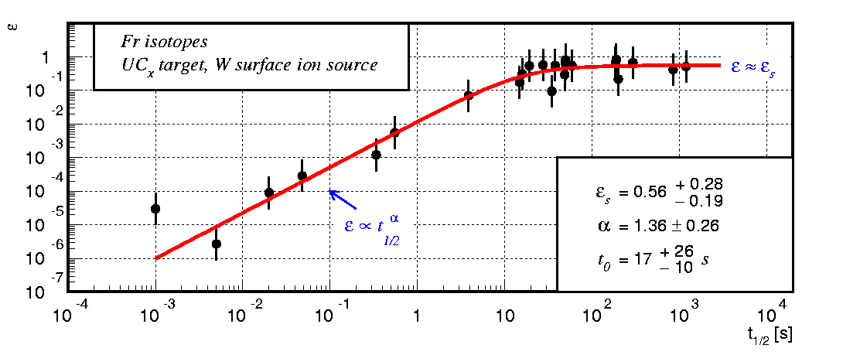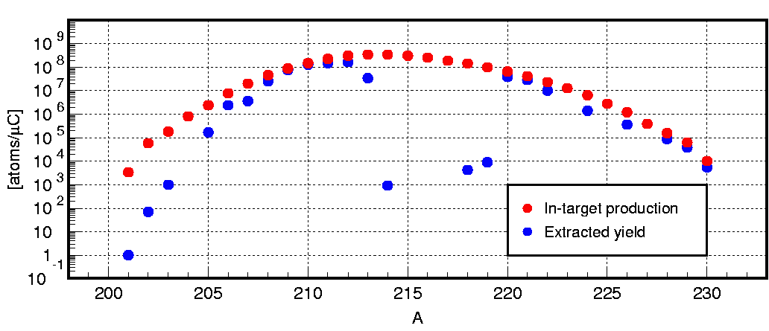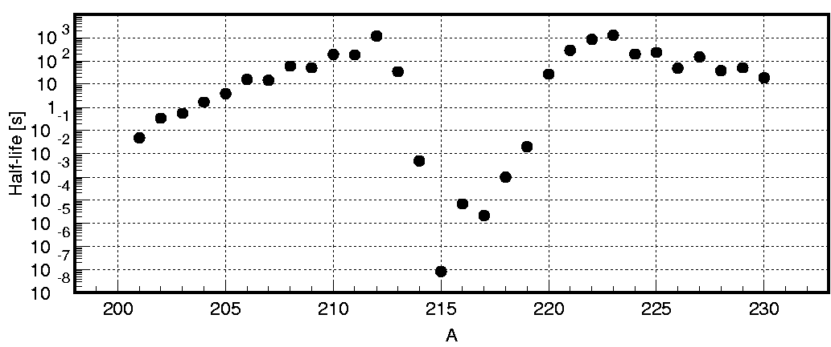
Correlation of ISOL yields with isotope half-life
Comparison of ISOLDE-SC yields† to in-target production rates
Ratio yield/produced → overall extraction efficiency for the nuclide.
For a given element – target – ion source, the efficiency is correlated with the isotope half-life
(S. Lukic)
†H.-J. Kluge, Isolde users guide, CERN, Geneva, 1986, web: http://isolde.cern.ch
Same general behavior found in many cases.

Another case …

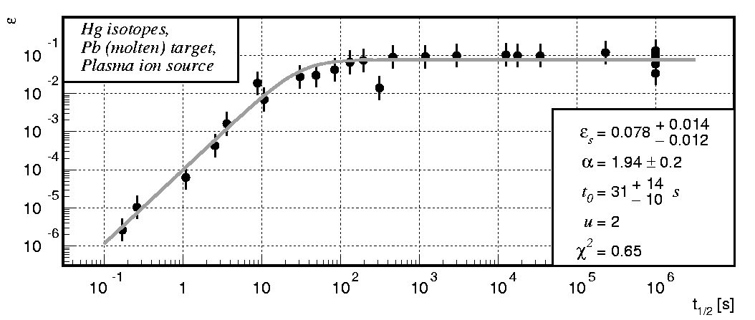

Universal behaviour, described by three parameters.

Systematics of decay losses

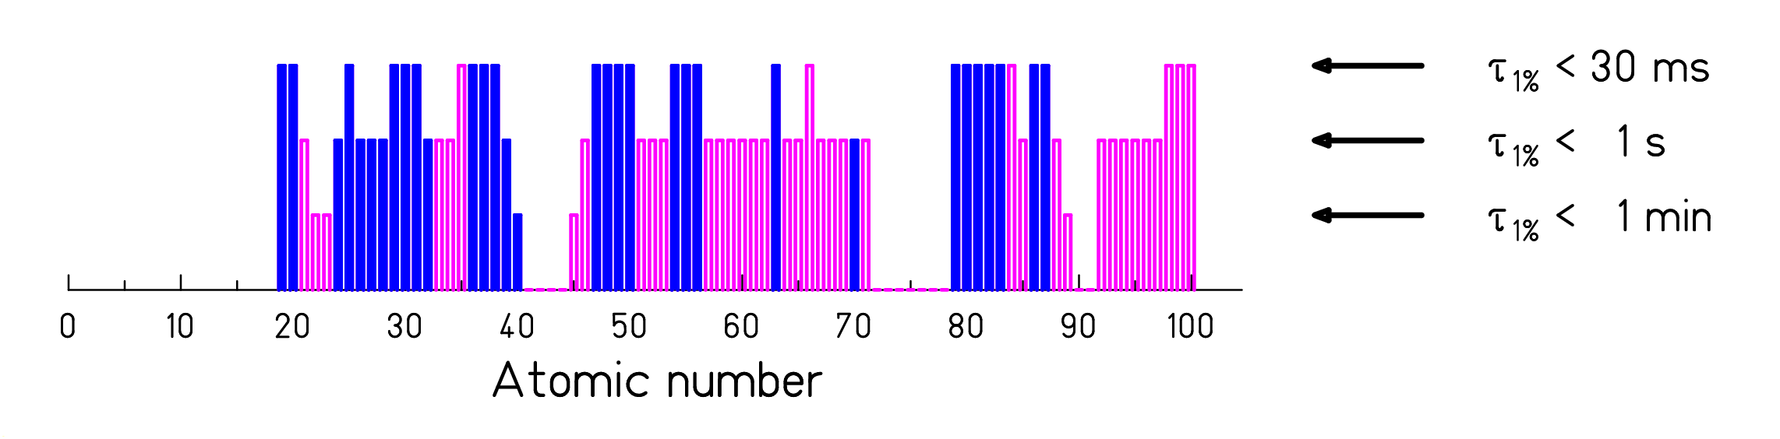

Composed by R. Kirchner from mg-target measurements at the GSI mass separator.

Pink: Z separation requires Laser ionization.

General rule: Slower release with increasing size and density of target!

Decay losses on the chart of the nuclides
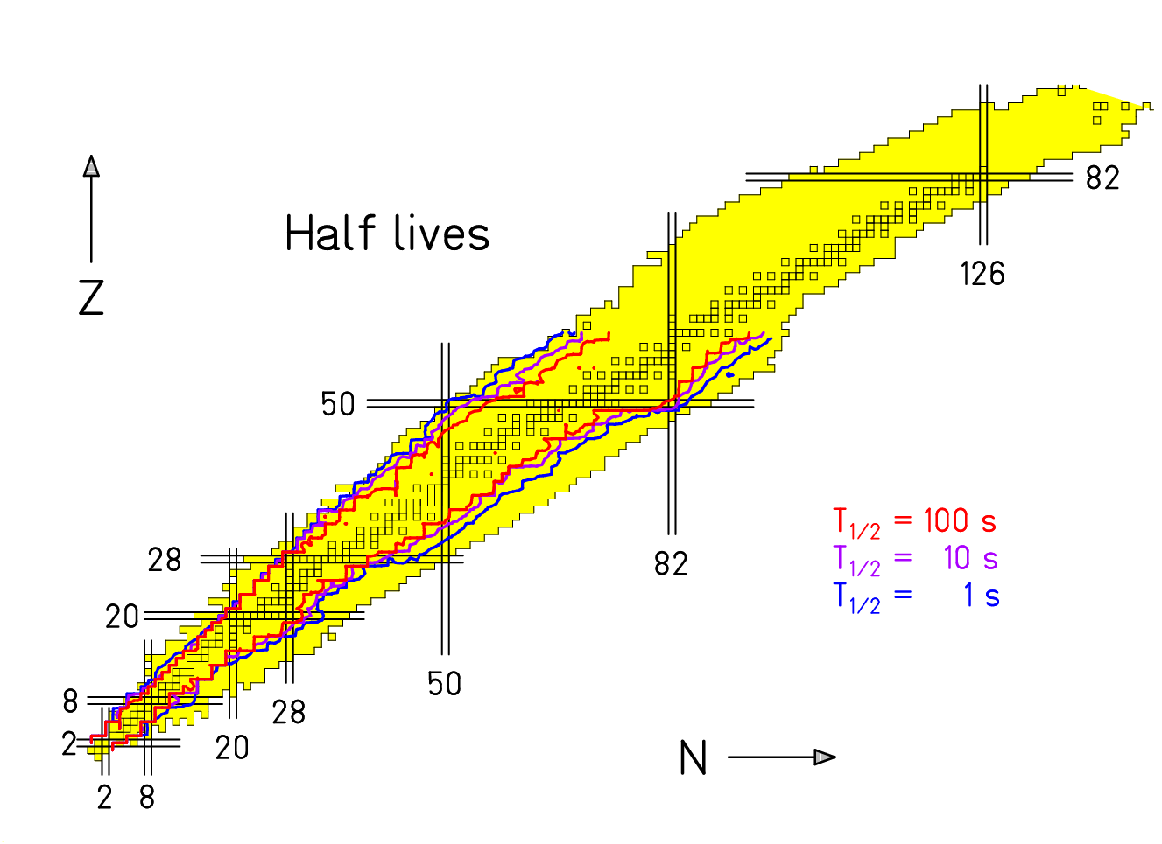

Loss by ¼ from one isotope to the next exotic for T_{1/2} < t₀.

¹³²Sn – a very specific case

Double shell closure:
- In mass range produced by low-energy fission
- Enhanced production of neutron-rich isotopes (polarisation)
- Long half-life (small decay losses, even for large targets)
- Special scientific interest for nuclei around ¹³²Sn (doubly magic, r-process)

In addition:
- High ISOL release efficiencies

Alternative options

Alternative projectiles for ISOL approach:
- Use of heavy projectiles at Fermi energy (replaces unavailable target material, exploits isospin diffusion)
- Use of 2 GeV primary beam (³He)

Complex scenario:
- p-n conversion
- Fission of ²³⁸U
- Fragmentation of ¹³²Sn

Other options?

Benefit of 2 GeV beam (GSI experiments)
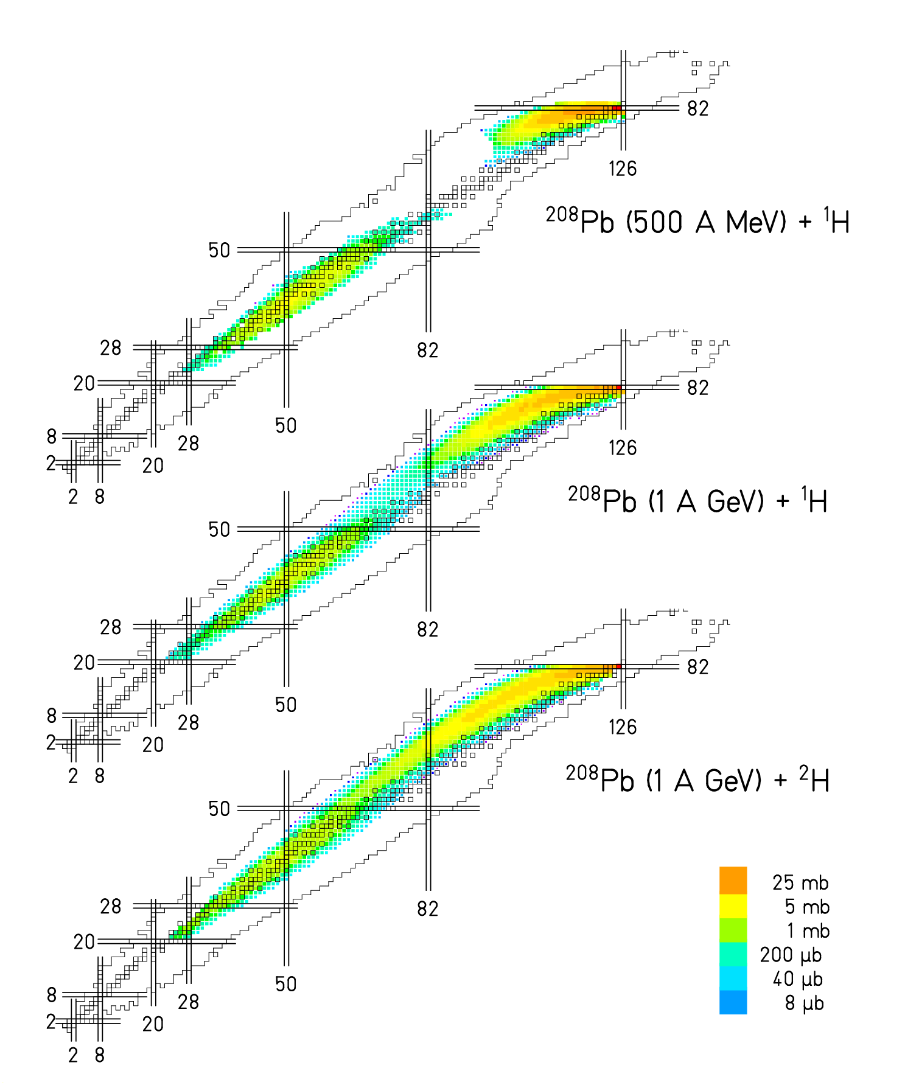

Fragmentation of ¹³²Sn (exemplified on ¹³⁶Xe)

Production of neutron-rich isotopes by cold fragmentation
- Filling the gap of refractive elements
- Avoiding decay losses for short-lived isotopes

Fragmentation of ¹³²Sn
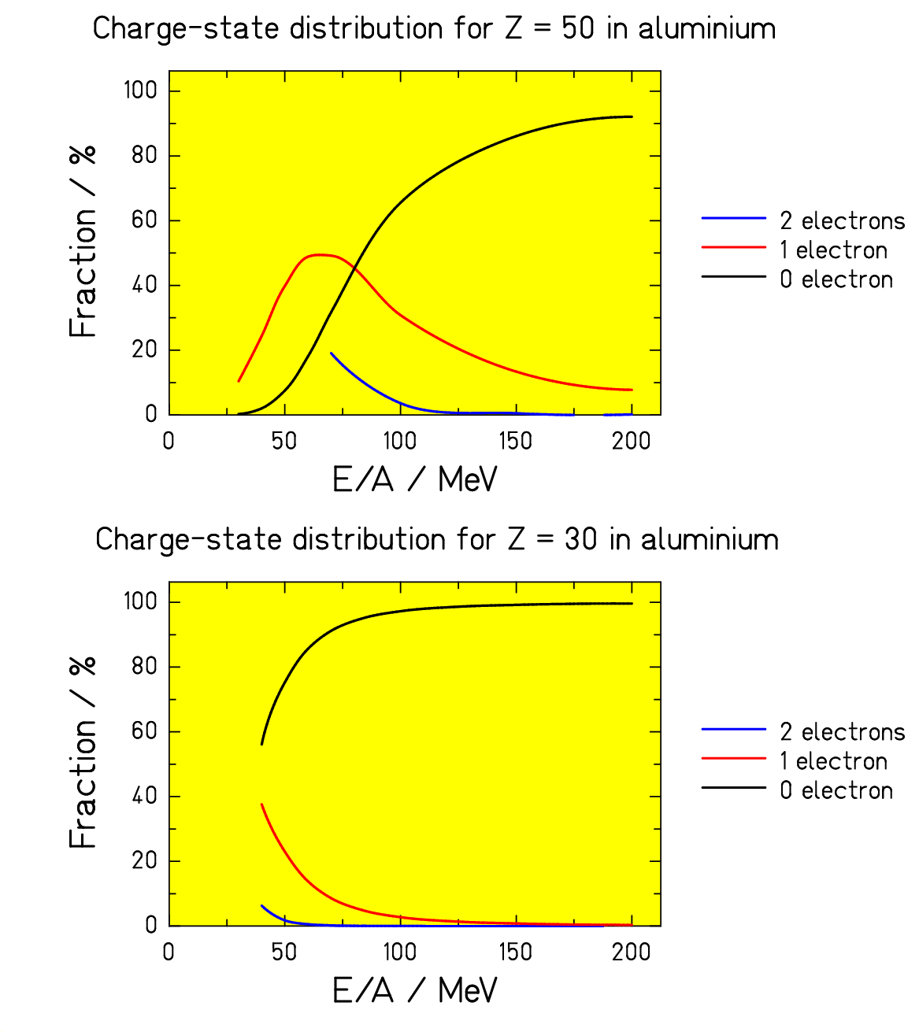
Arguments for the energy
of the post-accelerator:

Charge-states might cause
impurity problems!
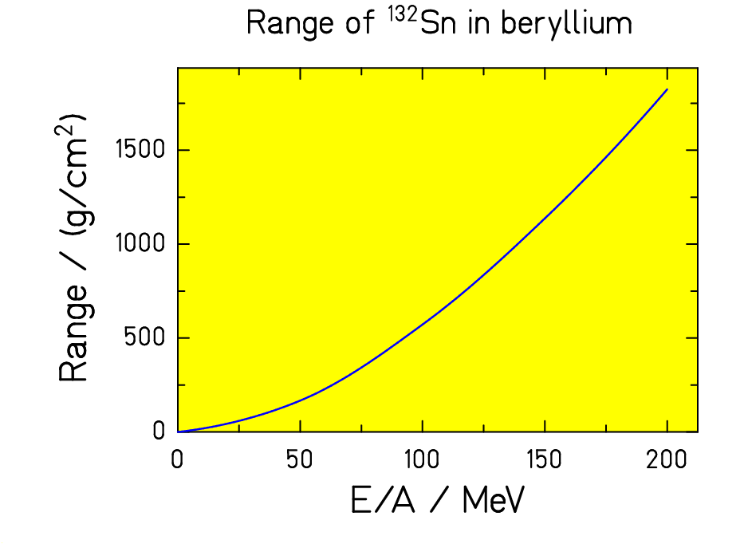

Conclusion

In-target production:

X + p (1 GeV) : good experimental knowledge from GSI experiments
²³⁸U + n : rather well understood

ISOL process (subject to improvements by R&D):
- Restriction on target material (gaps of 20 elements)
- Release from target not for all elements
- Decay losses increase by factor of 4 for 1 neutron number
- Ionization may have low efficiency

Extended options:
- Consideration cost versus benefit – depend on demands

Please contribute with additional requests / ideas!

(Not all sources are given. Please look to www-w2k.gsi.de/charms!)

