Signatures of multifragmentation
in spallation reactions

Karl-Heinz Schmidt

GSI, Darmstadt

Layout:
- Introduction
  - What is a spallation reaction? Where is it important?
  - Conventional models
  - Thermal expansion
  - Thermal multifragmentation
- Some important experimental signatures characterising multifragmentation
  - Emission times
  - Mass yields
  - Kinematics
- Systematics from new-generation GSI experiments
  - Nuclide yields
  - Kinematics
- Conclusion

What is a spallation reaction?

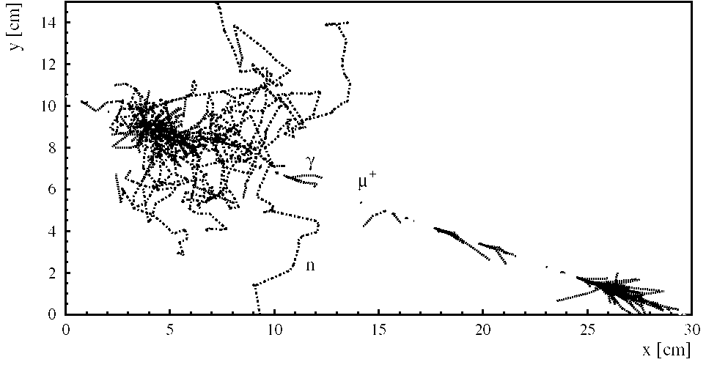

Collision of a μ⁺ of 41.2 GeV with an iron nucleus, recorded with the KARMEN detector.

- Collision of a high-energetic particle with a heavy nucleus.
- Production of a large number of light particles.
- First observed by Schopper et al. (Naturw. 25 (1937) 557): interaction of cosmic rays in a track detector.

Mass distribution of spallation products

Experiment: Typical U-shaped mass distribution

Model: Hadron-string cascade model,

QMD,

Non-equilibrium percolation model.

← Reaction: 12 GeV protons on gold.

A

Data: Kaufmann et al., Phys. Rev. C 14 (1976) 1121

Model: Hirata et al., Nucl. Phys. A 707 (2002) 193

Importance of spallation reactions

- Nucleosynthesis in interactions of cosmic rays with interstellar matter.
- Spallation neutron source for neutron-physics experiments (e.g. ISIS at the Rutherford Lab., UK).
- Accelerator-driven system (ADS) for the incineration of nuclear waste.

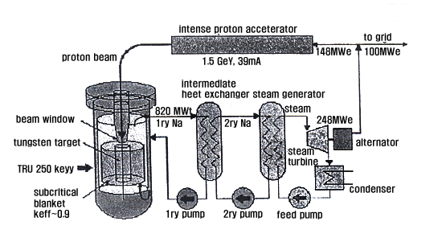

Conventional nuclear-reaction codes to model spallation

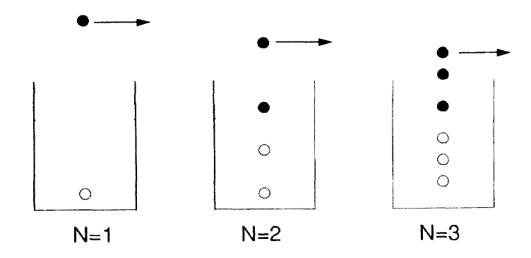

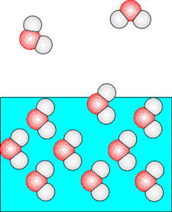

2. Excition model
            - Thermalization process
            - Pre-equilibrium emission

1. Intra-nuclear cascade 3. Statistical model
- Elastic scattering of nucleons ● Evaporation from a
- Classical concept compound nucleus
- Quantum-mechanical features (nucleons, LCP, γs)
added (Fermi motion, Pauli principle) ● Fission

Since long time, there has been great scientific interest
in other features
which go beyond the conventional models.

They are connected with the density degree of freedom!

Thermal expansion

Single-particle levels Single-particle levels

at normal nuclear density at reduced density

Compression energy and density-dependent level density lead to thermal expansion.

Thermal multifragmentation

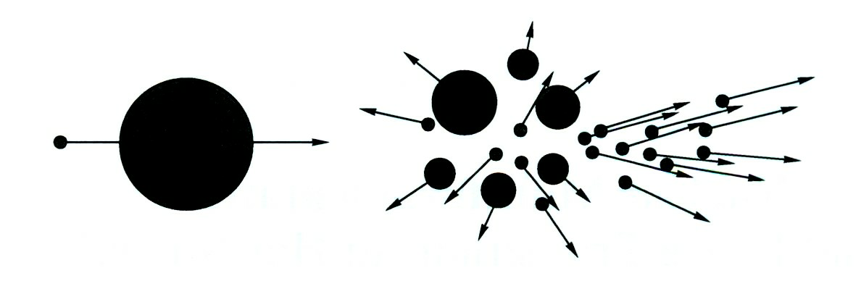

Stages of a thermal multifragmentation event:
- Intranuclear cascade
- Pre-equilibrium emission
- Thermal expansion
- Spinodal instabilities (inhomogeneous mixture of gaseous and liquid phases -> fog),
(like boiling of hot water when the pressure is reduced)
leads to the simultaneous formation of several fragments (Details in talk of A. Botvina!)
- Explosion of fragments due to Coulomb force
- Evaporation from the fragments

Multifragmentation goes beyond the traditional description
of spallation reactions

New features are expected, which are related to expansion and
the nuclear liquid-gas phase transition

What are the experimental signatures?

Emission times

Multifragmentation products are emitted simultaneously.

Coulomb repulsion does not allow detection of several fragments under the same angle.
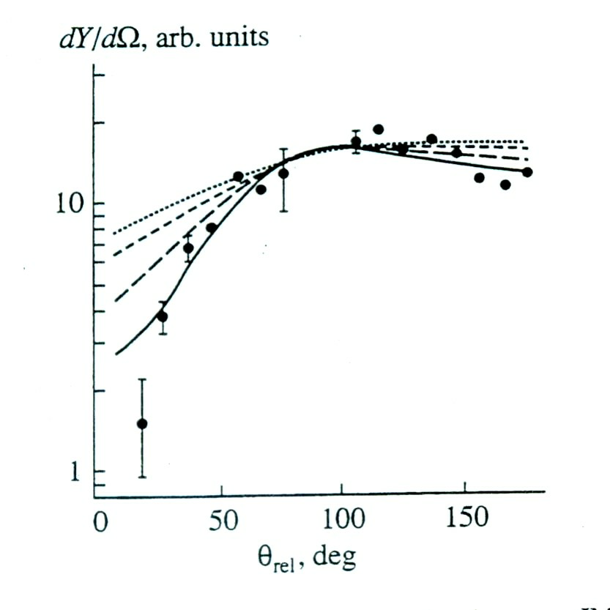

Relative angles between IMFs (6 ≤ A ≤ 30) in
¹⁹⁷Au + ⁴He at 3.65 A GeV. Curves from mean lifetime 0 fm/c (full line) to 800 fm/c (dotted line). (Shmakov et al., Phys. At. Nuclei 58 (1995) 1635)

Angular correlation gives the direct proof of simultaneous emission.

Only observable in correlation experiments.

No direct importance for nuclide yields and kinematics.

Mass yields – power law
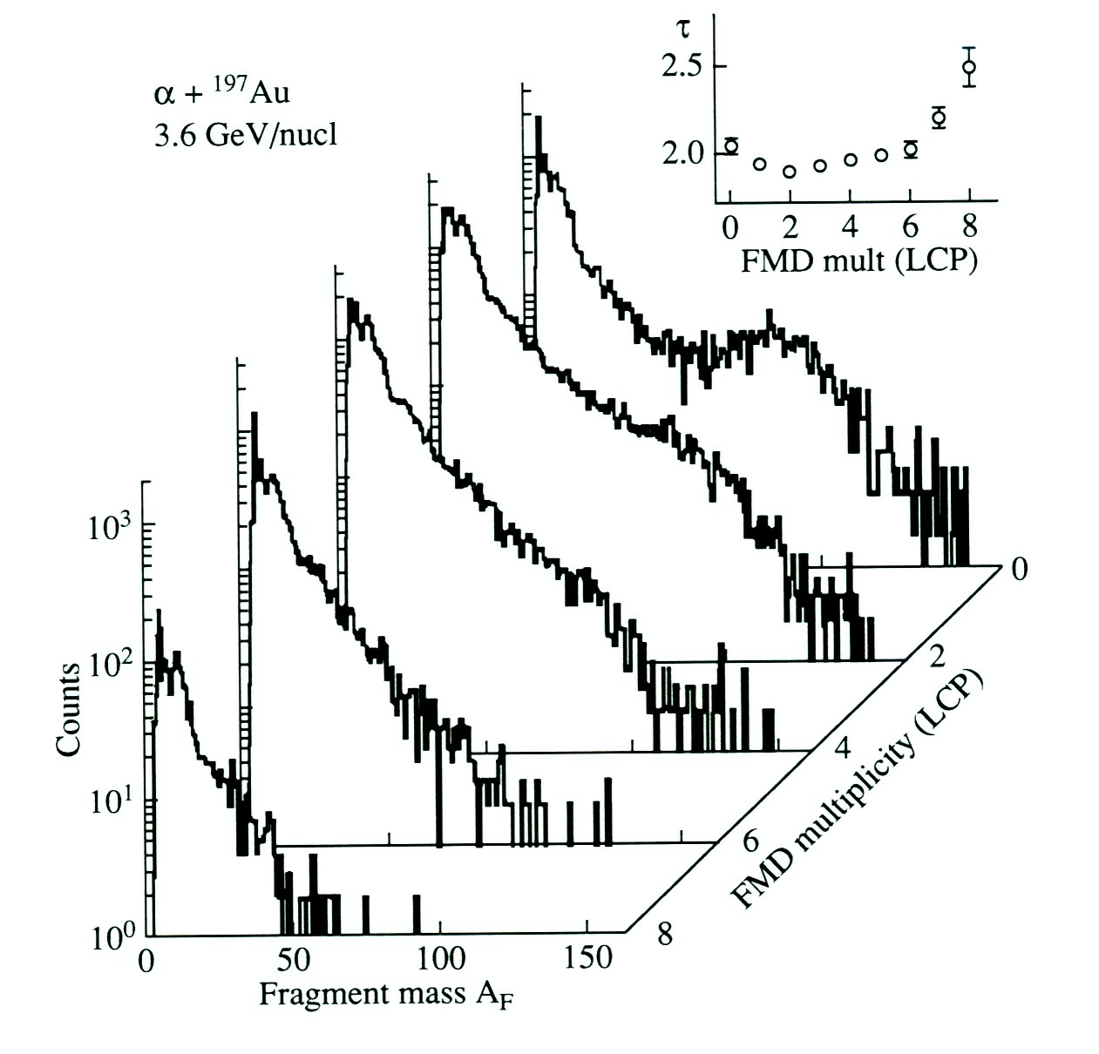

Mass spectra for ⁴He + ¹⁹⁷Au at 3.6 A GeV as a function of LCP multiplicity (V. A Karnaukov, Phys. Part. Nucl. 37 (2006) 165.)

The mass spectra have the shape of a power law:

$$\frac{dσ}{\text{dA}}∝A^{−τ}$$

with $τ≈2$.

Mass yields – dependence on available energy

Hüntrup et al., Phys. Rev. C 61 (2000) 034903 (Track detectors)

Kinematics

Comparison of fusion-evaporation reactions with multifragmentation reactions

Fusion-evaporation Spallation - multifragmentation

1. Fusion: Formation of a CN with │ 1. Nucleon-nucleon collisions (INC stage)
$p_{\text{CN}}=p_{\text{projectile}}$ │ Fluctuations in p of pre-fragment due to

│ Fermi motion of nucleons

│ Partial momentum transfer

│ 2. Expansion and formation of fragments

│ 3. Freeze-out (no nuclear interactions)

2. Evaporation │ a) Fermi momentum

$\frac{dσ}{dε}∝ε⋅e^{−ε/T}$ │ $\frac{\text{dI}}{dε}∝\sqrt{ε}⋅e^{−eτ}$ (τ is not a temperature !)

(Maxwell-Boltzmann distribution) │ b) Thermal motion

│ c) Radial flow

3. Acceleration in Coulomb field │ 4. Acceleration in Coulomb field

→ Many sources of fluctuations in kinematics of multifragmentation products (Napolitani!).

Energy spectra

Deduced slope parameters

(From independent measurement:

Energy spectra of light charged particles T ≈ 5 to 6 MeV!)
and fragments with Z ≤ 4 at 150°, integrated
over 20 ≤ Z_{bound} ≤ 60 (Au + Au at 1 A GeV). Slope parameter reflects Fermi motion

Odeh et al., Phys. Rev. Lett. 84 (2000) 4557 and/or expansion.

New generation of experiments on nuclide yields and kinematics at GSI

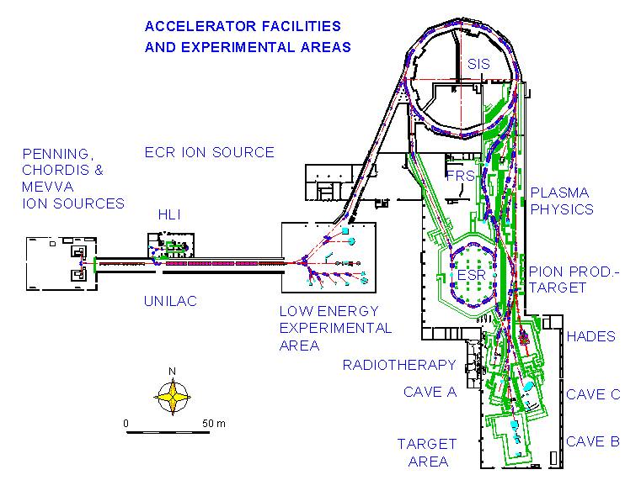

Relativistic heavy-ion beams + liquid H₂ target + powerful magnetic spectrometer
→ Experiments in inverse kinematics (Details in talk of A. Kelic!)
- Full identification of all spallation products in Z and A.
- High-precision measurements of velocities.

Systematics of nuclide yields
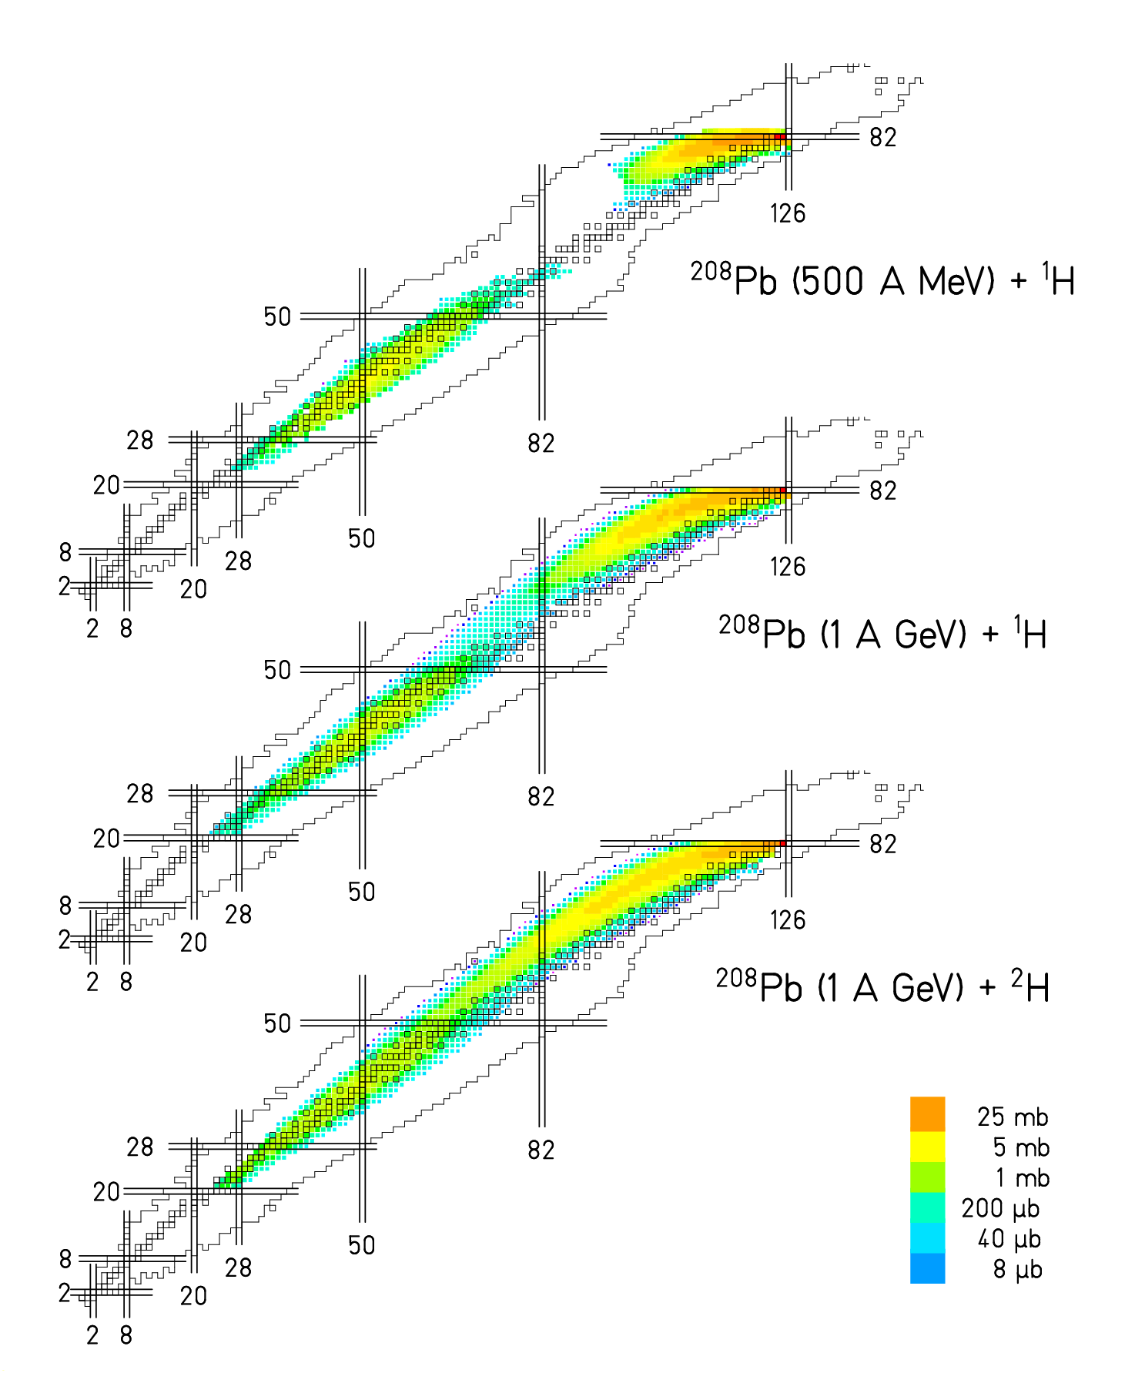
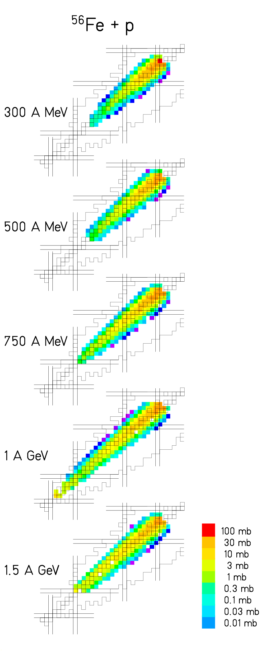

T. Enqvist, B. Fernandez, L. Audouin C. Villagrasa, P. Napolitani

Systematics of mass yields I

C. Villagrasa, P. Napolitani

Systematics of mass yields II

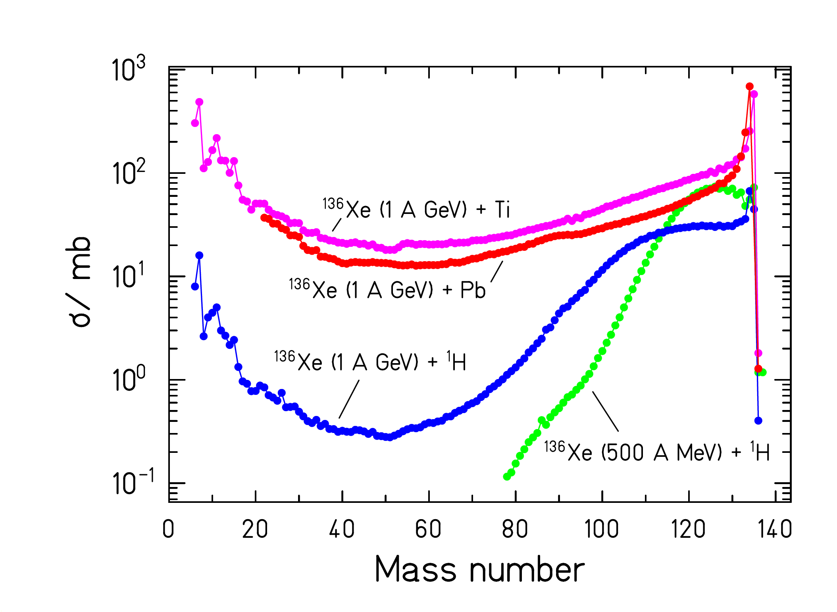

L. Giot, P. Napolitani, D. Henzlova

Systematics of kinematical properties
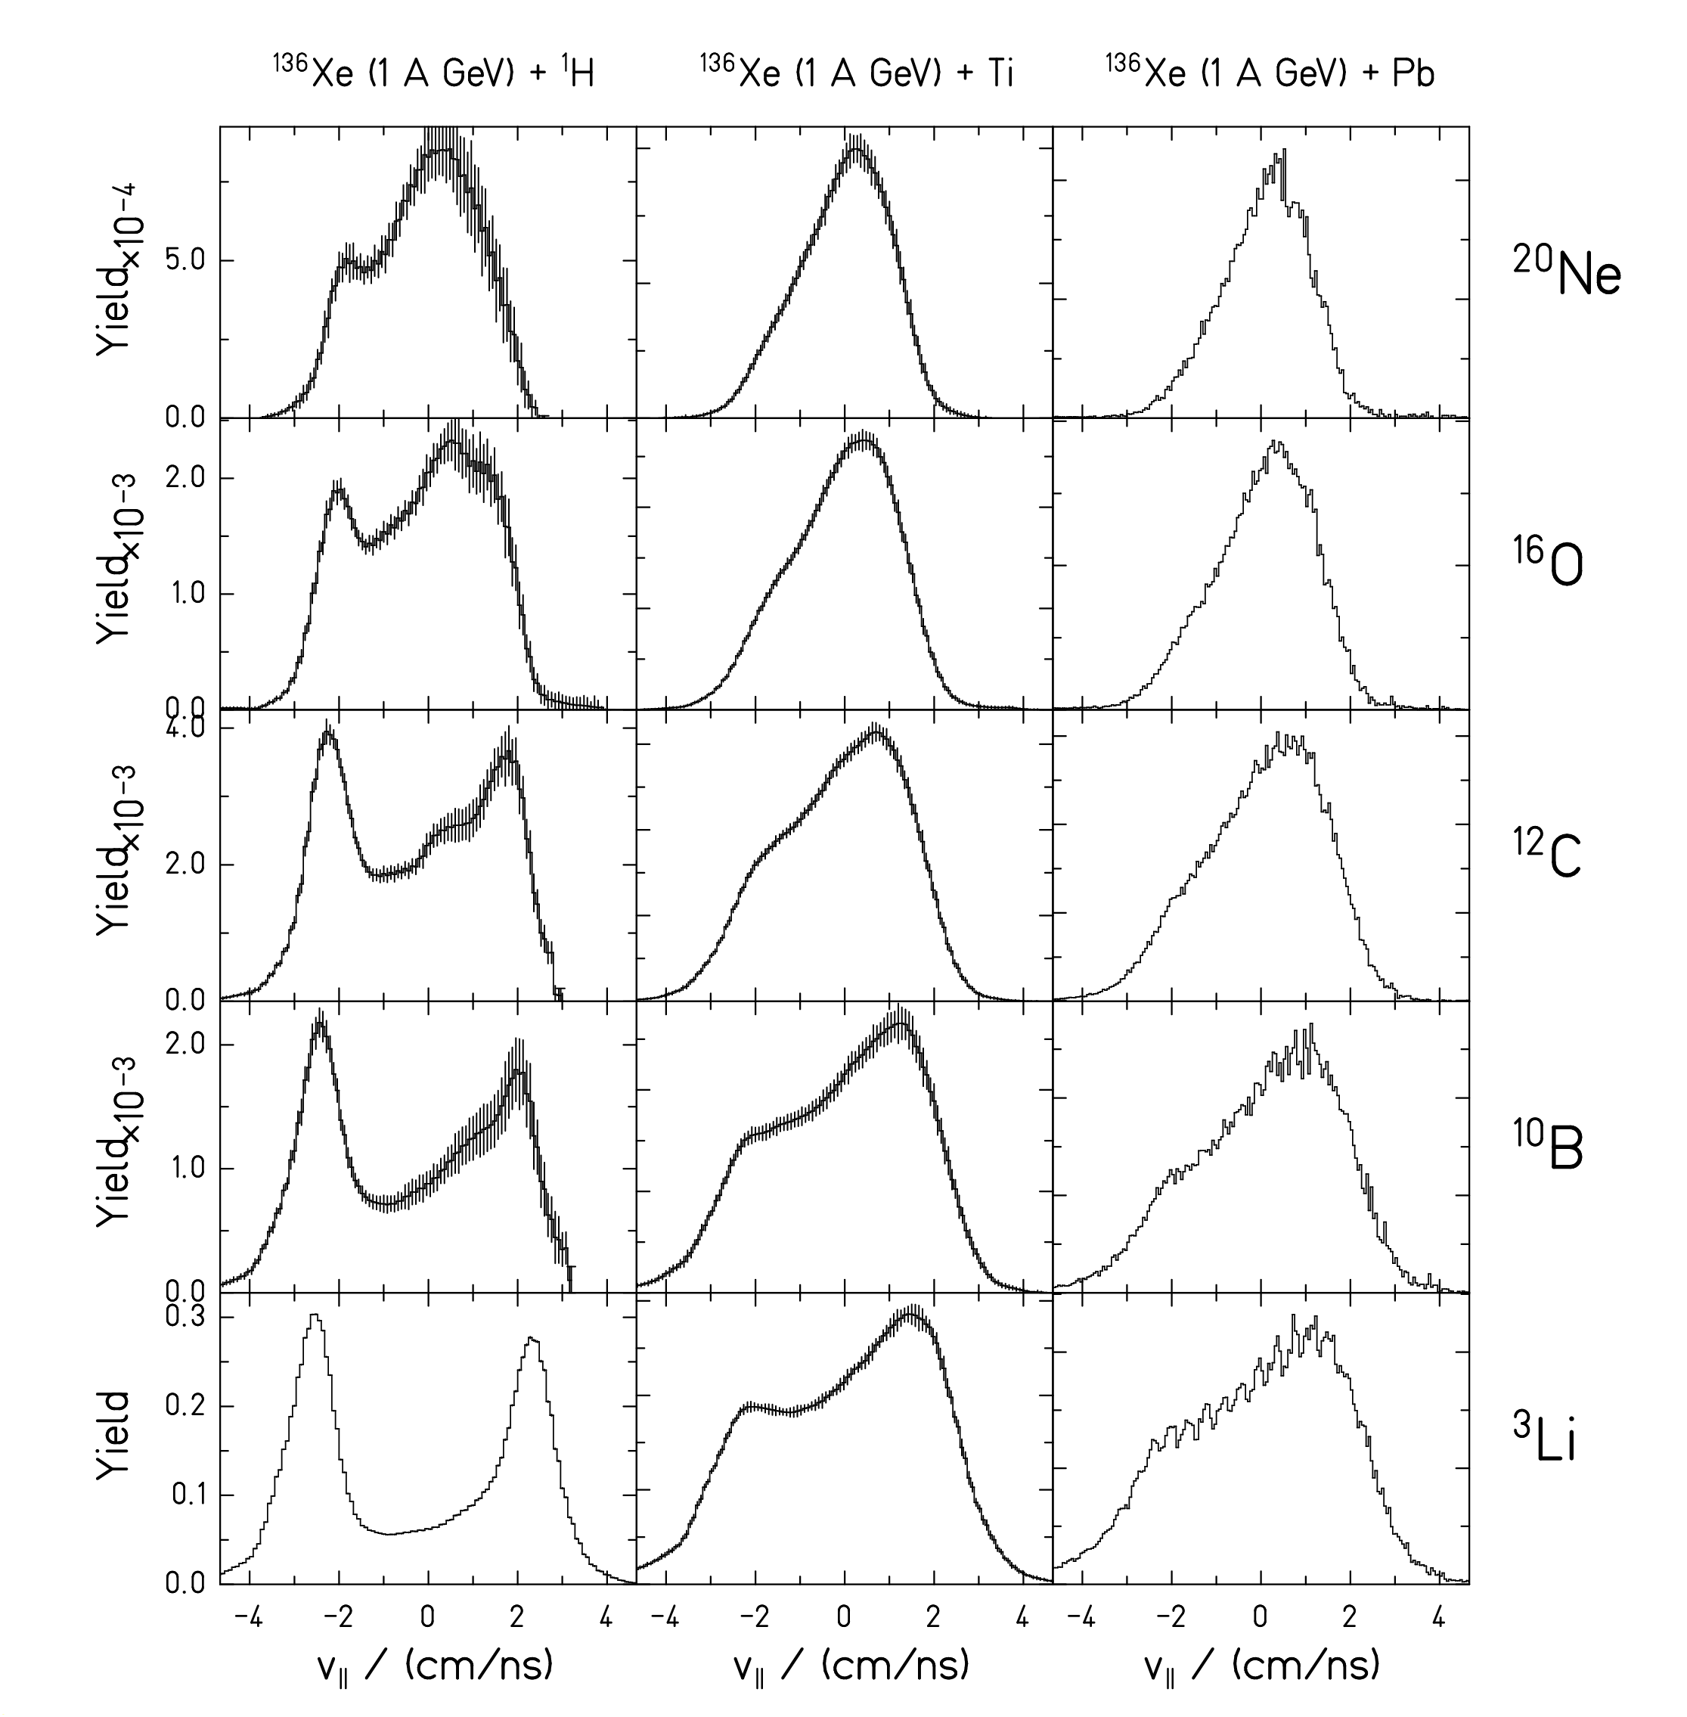

¹³⁶Xe (1 A GeV) + p:

Strong influence of Coulomb

repulsion from heavy partner.

¹³⁶Xe (1 A GeV) + Ti, Pb

Complex shapes

(binary decay + multifragm.)

(Details in talk of P. Napolitani!)

←

Longitudinal velocity distributions

of fragments emitted in beam

direction (invariant cross section).

P. Napolitani, D. Henzlova

Conclusion

Spallation reactions (high-energy particle – nucleus collisions) produce a large number of light fragments.

After sufficient heating, simultaneous emission of IMFs (multifragmentation) occurs. (Heavier than evaporation products and lighter than fission products.)

Conventional nuclear-reaction codes for spallation reactions
INC + pre-equilibrium + evaporation/fission
do not explain multifragmentation.

Thermal expansion and liquid-gas instabilities are thought to be responsible for multifragmentation.

Kinematics of multifragmentation products is complex.

Invariant cross sections (v distributions) seem to be a key information for the nature of multifragmentation.
The CHARMS collaboration
Peter Armbruster, Antoine Bacquias, Lydie Giot, Vladimir Henzl, Daniela Henzlova, Aleksandra Kelić, Strahinja Lukić, Pavel Nadtochy, Radek Pleskač, Maria Valentina Ricciardi, Karl-Heinz Schmidt, Florence Vivès , Bernd Voss, Orlin Yordanov
GSI, Planckstr. 1, D-64291 Darmstadt, Germany
Laurent Audouin, Charles-Olivier Bacri, Monique Bernas, Brahim Mustapha, Claude Stéphan, Laurent Tassan-Got
IPN Orsay, B.P. n. 1, F-91406 Orsay, France
Alain Boudard, Jean-Erique Ducret, Beatriz Fernandez, Sylvie Leray, Claude Volant, Carmen Villagrasa, Wojczek Wlaslo
DAPNIA/SPhN, CEA Saclay, F-91191 Gif sur Yvette Cedex, France
Julien Taieb
DEN/DM2S/SERMA/LENR, CEA Saclay, F-91191 Gif sur Yvette Cedex, France
Christelle Schmitt
IPNL, Université Lyon, Groupe Matiere Nucleaire, 4, rue Enrico Fermi, F-69622 Villeurbanne Cedex, France
Serge Czajkowski, Beatriz Jurado, Michael Pravikoff
CENBG, Le Haut Vigneau, F-33175 Bordeaux-Gradignan, Cedex, France
Paolo Napolitani, Fanny Rejmund
GANIL, B.P. 5027, F-14076 Caen Cedex 5, France
Jose Benlliure, Jorge Pereira, Enrique Casarejos, Manuel Fernandez, Teresa Kurtukian
Univ. Santiago de Compostela, E-15706 Santiago de Compostela, Spain
Arnd Junghans
Forschungszentrum Rossendorf, Postfach 510119, D-01314 Dresden, Germany

